Supplementary Information

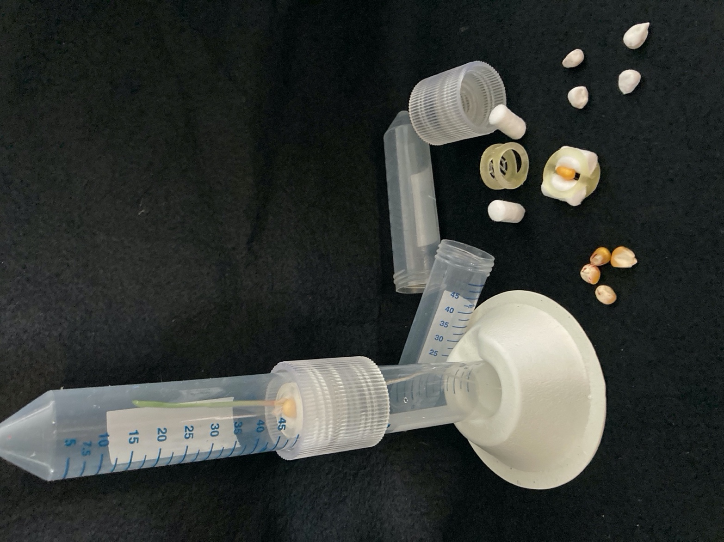
Fig. S1 Seed germination studies were carried out using a specifically designed test tube system (left). Seeds (control seeds: left; hairy seeds: right) were secured between two cotton plugs at the junction of two test tubes held together by a threaded sleeve created with a 3-D printer.
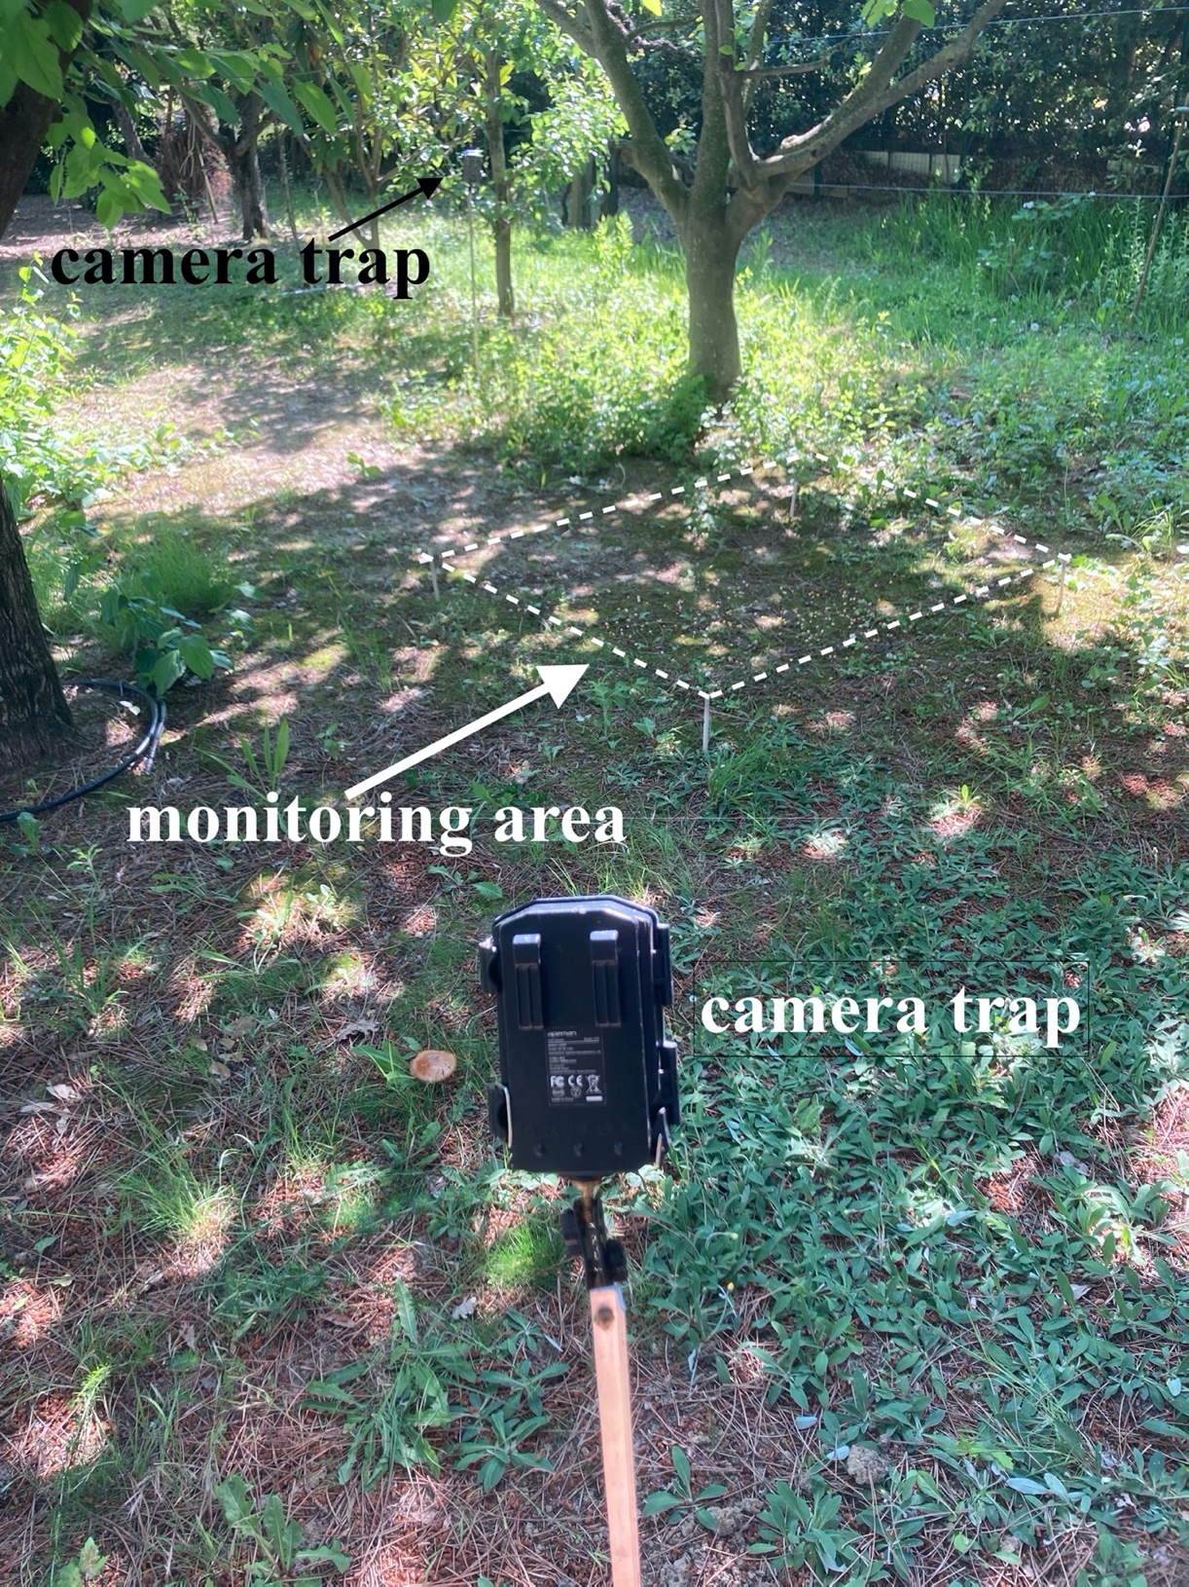
Fig. S2 Example of a bird monitoring site. Testing materials were randomly placed on the ground of a 1-m² area provided with two camera traps.

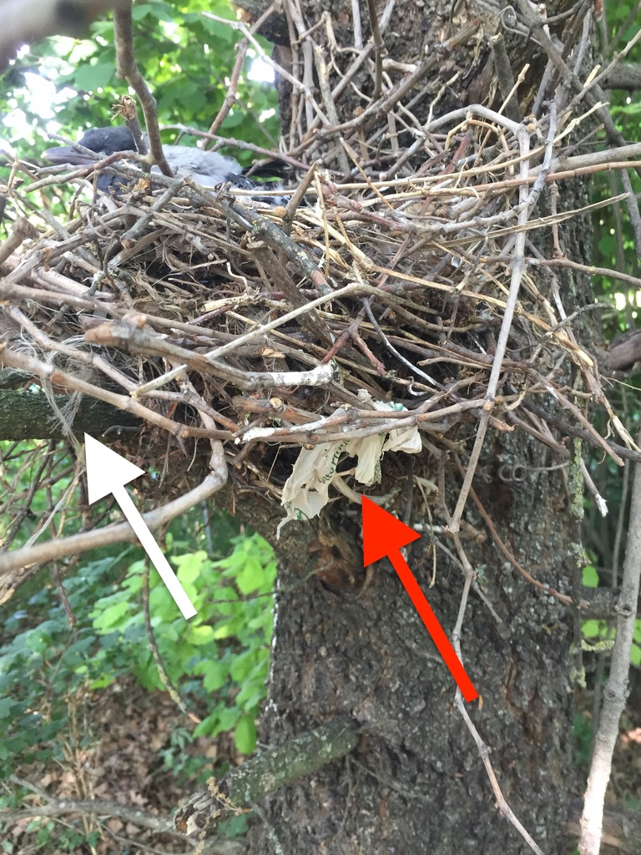
Fig. S3 Nest of a Hooded Crow (Corvus cornix) with a film fragment from a compostable bag (red arrow) and nylon ropes (white arrow). The photo was taken in Cadriano, near Bologna, Italy, one of the five selected observing sites.

