Phase II Study of Allogeneic Hematopoietic Stem Cell Transplantation for Children with High-Risk Neuroblastoma Using a Reduced-Intensity Conditioning Regimen: Results from the AIEOP trial

Arcangelo Prete¹, Edoardo Lanino², Francesco Saglio³, Alessandra Biffi⁴, Elisabetta Calore⁴, Maura Faraci², Roberto Rondelli¹, Claudio Favre⁵, Marco Zecca⁶, Gabriella Casazza⁷, Fulvio Porta⁸, Roberto Luksch⁹, Simone Cesaro¹⁰, Marco Rabusin¹¹, Rosanna Parasole¹², Rosa Maria Mura¹³, Luca Lo Nigro¹⁴, Davide Leardini^{1,*}, Daria Pagliara¹⁵, Franco Locatelli^{15,16}, Franca Fagioli^{3,17}; on behalf of the AIEOP-BMT Group

¹ Pediatric Oncology and Hematology, IRCCS Azienda Ospedaliero-Universitaria di Bologna, Bologna, Italy;
² Hematopoietic Stem Cell Transplantation Unit, IRCSS Istituto Giannina Gaslini, Genoa, Italy;
³ Pediatric Oncohematology, Stem Cell Transplantation and Cell Therapy Division, A.O.U. Città della Salute e della Scienza-Regina Margherita Children's Hospital, Turin, Italy;
⁴ Pediatric Hematology, Oncology and Stem Cell Transplant Division, University-Hospital of Padua, Padua, Italy;
⁵ Department of Pediatric Hematology/Oncology and Hematopoietic Stem Cell Transplantation, Meyer Children's University Hospital, Florence, Italy;
⁶ Department of Pediatric Hematology/Oncology, Fondazione IRCCS Policlinico San Matteo, Pavia, Italy;
⁷ Oncoematologia Pediatrica, Azienda Ospedaliero Universitaria Pisana, Pisa, Italy
⁸ Pediatric Oncohematology and Bone Marrow Transplant Unit, Children's Hospital, ASST Spedali Civili of Brescia, Brescia, Italy;
⁹ Pediatric Oncology Unit, Fondazione IRCCS Istituto Nazionale dei Tumori, Milan, Italy;
¹⁰ Pediatric Hematology Oncology Unit, Department of Mother and Child, Azienda Ospedaliera Universitaria Integrata, Verona, Italy;
¹¹ Department of Pediatrics, Institute for Maternal and Child Health, IRCCS Burlo Garofolo, Trieste, Italy;
¹² Department of Pediatric Hemato-Oncology and cellular therapy, Azienda sanitaria di rilievo nazionale Santobono-Pausilipon, Napoli, Italy;
¹³ Pediatric Oncology Unit, Azienda Ospedaliera Brotzu, Cagliari, Italy;
¹⁴ Centro di Riferimento Regionale di Ematologia ed Oncologia Pediatrica, Azienda Policlinico "G. Rodolico - San Marco", Catania, Italy;
¹⁵ Department of Pediatric Hematology and Oncology, Bambino Gesù Children’s Hospital, Istituto di Ricovero e Cura a Carattere Scientifico (IRCCS), Rome, Italy;
¹⁶ Catholic University of the Sacred Heart, Rome, Italy.
¹⁷ University of Turin, Turin, Italy.
* Corresponding author

Supplementary Material
Supplementary Methods

To compare the TRM with patients not receiving reduced intensity conditioning, results were compared with the patients with the same disease receiving allo-HCT as per physician choice not enrolled in the protocol and reported in the AIEOP registry.

Institutions that participated in the study

Azienda Ospedale Università Padova, Padova, Italy;
Azienda Ospedaliera Santobono Pausilipon, Napoli, Italy;
Azienda Ospedaliera Universitaria Integrata, Verona, Italy;
Azienda Ospedaliero Univerisitaria Pisana, Pisa, Italy;
Azienda Ospedaliero-Universitaria Meyer, Firenze, Italy;
Azienda socio-sanitaria locale, Cagliari, Italy;
IRCCS Azienda Ospedaliero-Universitaria di Bologna, Bologna, Italy;
IRCCS Bambino Gesù, Roma, Italy;
IRCCS Burlo, Trieste, Italy;
IRCCS Istituto “Giannina Gaslini”, Genova, Italy;
IRCCS S. Matteo, Pavia, Italy;
Ospedale Civile, Brescia, Italy;
Ospedale Regina Margherita, Torino, Italy;
Ospedale San Gerardo-Fondazione MBBM, Monza, Italy;
Presidio Ospedaliero Gaspare Rodolico, Catania, Italy.

Supplementary Fig S1: Comparison of Kaplan-Mayer estimated for TRM for the study cohort and registry cohort. TRM: transplant-related mortality.

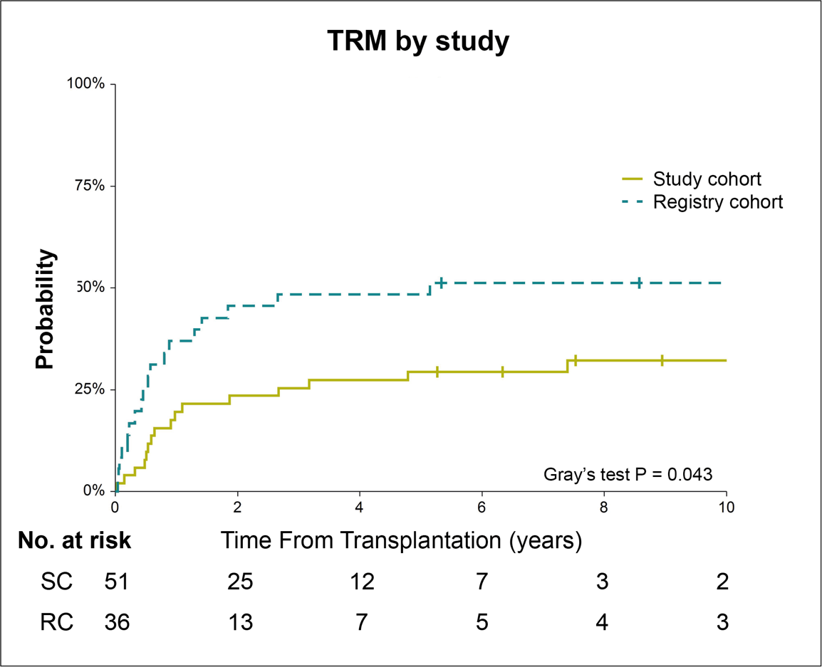
Supplementary Tables
Supplementary Table S1: Characteristics of patients receiving allo-HCT not enrolled in the phase II trial. BM: bone marrow; CB: cord blood; CR: complete remission; MFD: matched family donor; MUD: matched unrelated donor; HCT: hematopoietic stem cell transplantation; PBSC: peripheral blood stem cells; PMFD: partially matched family donor.
 | Patients in the study  (n = 51) | Patients in the AIEOP registry (n = 36) | p
Age at diagnosis – yrs – median (IQR) | 4.3 (3.0-6.3) | 4.0 (2.6-5.3) | .783
Gender - no. (%) |  |  | .228
Male | 32 (62.7) | 27 (75.0)
Female | 19 (37.3) | 9 (25.0)
Number of previous auto-HCT |  |  | < .001
0 | 12 (23.5) | 9 (25.0)
1 | 39 (76.5) | 15 (41.7)
2 | 0 (0) | 11 (30.6)
3 | 0 (0) | 1 (2.7)
Disease state before HCT |  |  | .298
CR | 9 (17.6) | 7 (19.4)
Very good partial response | 10 (19.6) | 7 (19.4)
Partial response | 20 (39.2) | 14 (38.9)
Stable disease | 12 (23.6) | 8 (22.3)
MYCN status |  |  | .675
MYCN amplified | 10 (19.6) | 10 (27.8)
MYCN gain | 9 (17.6) | 5 (13.9)
MYCN non amplified | 21 (41.2) | 16 (44.4)
n.e. | 11 (21.6) | 5 (13.9)
Age at HCT - yrs - median (IQR) | 7.1 (5.3-9.1) | 6.9 (4.8-8.5) | .960
Time from diagnosis to HCT - yrs - median (IQR) | 2.2 (1.4-3.0) | 2.0 (1.2-3.2) | .986
Type of donor |  |  | < .001
MFD | 27 (51.9) | 13 (36.1)
MUD | 24 (47.1) | 7 (19.4)
PMFD | 0 (0) | 16 (33.5)
Stem cell source |  |  | < .001
BM | 45 (88.2) | 18 (50.0)
PBSC | 6 (11.8) | 17 (47.2)
CB | 0 (0) | 1 (2.8)
Conditioning regimen |  |  | < .001
Thiotepa+Melphalan | 51 (100.0) | 3 (8.3)
Thiotepa+Melphalan+Fludarabine | 0 (0) | 6 (16.7)
Thiotepa+Treosulfan+Fludarabine | 0 (0) | 5 (13.9)
Busulfan+Melphalan | 0 (0) | 4 (11.1)
Fludarabine+Melphalan | 0 (0) | 3 (8.3)
Other* | 0 (0) | 15* (61.7)
Sex mismatch (D/R) |  |  | .277
F/F | 9 (17.6) | 4 (11.1)
F/M | 12 (23.6) | 13 (36.1)
M/F | 10 (19.6) | 3 (8.3)
M/M | 18 (35.3) | 9 (25.0)
Missing | 2 (3.9) | 7 (19.4)
CMV serological status (D/R) |  |  | .864
-/- | 10 (19.6) | 4 (11.1)
-/+ | 11 (21.6) | 7 (19.4)
+/- | 5 (9.8) | 3 (8.3)
+/+ | 21 (41.2) | 15 (41.7)
Missing | 4 (7.8) | 7 (19.4)
Median follow up after HCT - mo (IQR) | 21.7 (7.6-38.1) | 12.7 (5.5-30.5) | .689
* Cyclophosphamide + TBI (1), Fludarabine (1), Fludarabine + Melphalan + TBI (1), Fludarabine + Etoposide + Melphalan (2), Melphalan + Etoposide (1), Thiotepa + Treosulfan (1), Thiotepa + Melphalan + Treosulfan (1), Treosulfan + Cyclophosphamide (1), Treosulfan + Cyclophosphamide + Melphalan (2), Treosulfan + Fludarabine (1), Treosulfan + Melphalan (2), Etoposide + Carboplatin + Melphalan (1).

