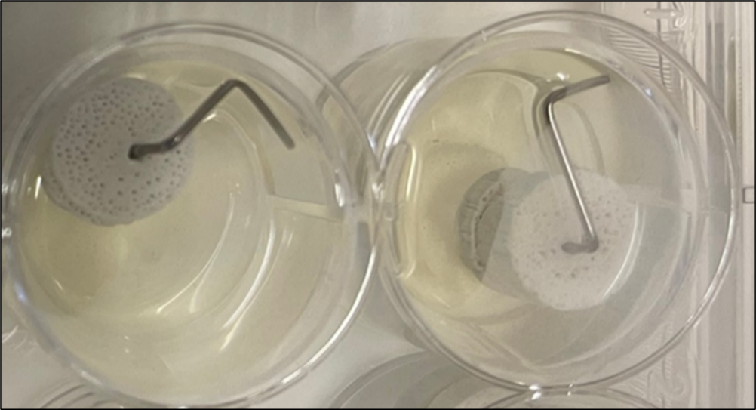
Supplementary Figure 1: Representative image of the 3D bone fracture model.

Supplementary Table 1: Details of primers used for gene expression analysis (QuantiTect Primer Assay, Qiagen).
Gene | Gene specification | Amplicon Lenght | Annealing Temperature
GAPDH | Hs_GAPDH_1_SG | 95 bp | 55°C
RUNX2 | Hs_RUNX2_1_SG | 101 bp | 55°C
ALPL | Hs_ALPL_1_SG | 110 bp | 55°C
COL1A1 | Hs_COL1A1_1_SG | 118 bp | 55°C
BGLAP | Hs_BGLAP_1_SG | 90 bp | 55°C

Supplementary Table 2. XRD results for selected peaks with Miller indices (hkl), 2 θ values.
No. | Pos. [°2θ] | Attibution | Miller Indices (hkl)
1 | 10,894 | HA | 010
2 | 13,792 | β-TCP | 104
3 | 16,905 | HA | 011
4 | 17,182 | β-TCP | 110
5 | 18,900 | HA | 110
6 | 21,819 | HA | 020
7 | 22,915 | HA | 111
8 | 25,915 | HA | 002
9 | 28,148 | HA | 012
10 | 28,946 | HA | 120
11 | 29,960 | β-TCP | 300
12 | 31,300 | β-TCP | 20-10
13 | 31,806 | HA | 121
14 | 32,231 | HA | 112
15 | 32,924 | HA | 030
16 | 34,107 | HA | 022
17 | 34,672 | β-TCP | 220
18 | 35,567 | HA | 031
19 | 35,946 | β-TCP | 2110
20 | 39,229 | HA | 122
21 | 39,829 | HA | 310
22 | 41,992 | HA | 311
23 | 43,899 | HA | 113
24 | 45,430 | HA | 023
25 | 46,698 | HA | 222
26 | 47,379 | β-TCP | 4010
27 | 48,115 | HA | 312
28 | 48,625 | HA | 320
29 | 49,494 | HA | 123
30 | 50,487 | HA | 231
31 | 51,282 | HA | 410
32 | 52,105 | HA | 042
33 | 53,217 | HA | 004
34 | 55,930 | HA | 232
35 | 57,158 | HA | 133
36 | 58,038 | HA | 051
37 | 59,953 | HA | 420
38 | 60,477 | HA | 331
39 | 61,690 | HA | 214
40 | 63,036 | HA | 331
41 | 64,012 | HA | 034
42 | 65,026 | HA | 151
43 | 66,410 | HA | 413
44 | 71,608 | HA | 341
45 | 72,238 | HA | 250
46 | 74,037 | HA | 423
47 | 74,970 | HA | 324
48 | 75,587 | HA | 125
49 | 77,005 | HA | 414
50 | 78,162 | HA | 522

Supplementary Table 3: Vancomycin and gentamicin values calculated as a percentage of the initial drug load (1000ug) at each time point (Mean ± SD, n=3).
Timepoint | Vancomycin released (%) | Gentamicin released (%)
30 min | 14.6 ± 5.6 | 3.4 ± 0.04
1h | 22.6 ± 8.5 | 7.9 ± 2.9
2h | 35.1 ± 8.9 | 35.2 ± 6.4
4h | 49.6 ± 3.0 | 60.9 ± 3.1
6h | 50.7 ± 3.3 | 67.1 ± 3.2
24h | 67.6 ± 7.1 | 75.9 ± 3.7
48h | 71.5 ± 3.4 | 84.0 ± 1.8
168h | 103.5 ± 6.9 | 100.2 ± 2.1
336h | 103.5 ± 6.9 | 100.2 ± 2.1

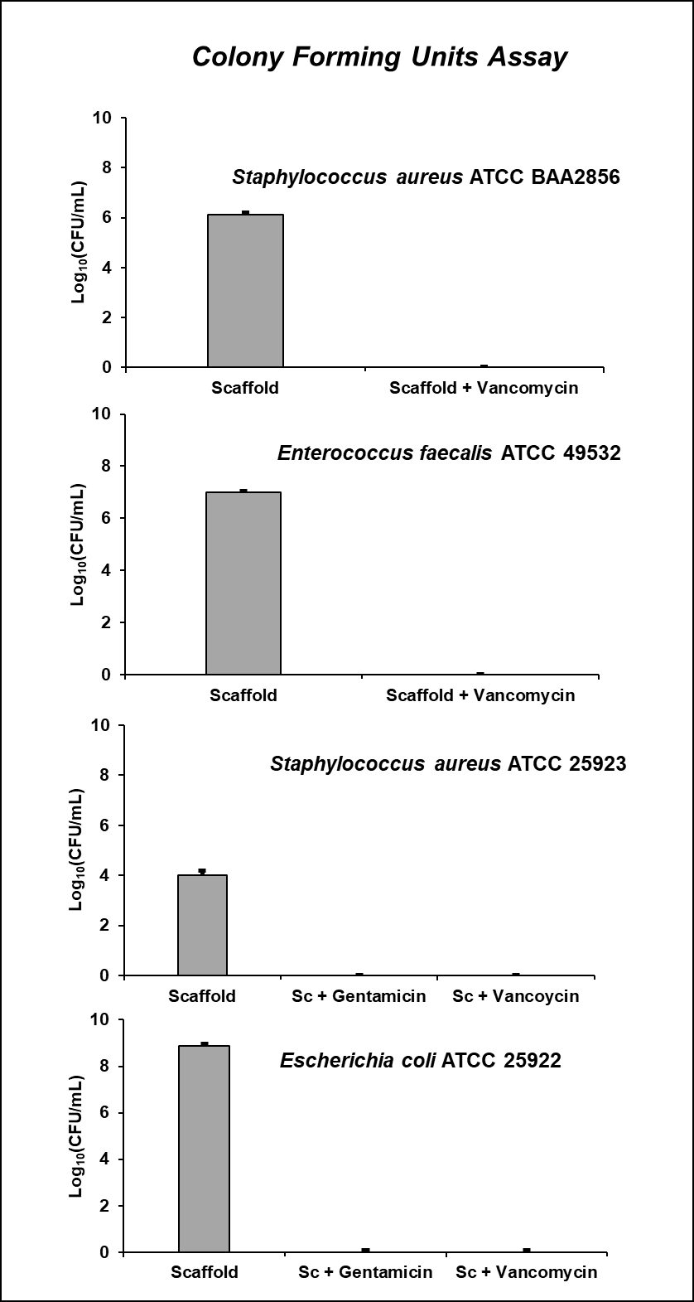

Supplementary Figure 2. Biofilm inhibition test was performed on disc loaded with 5 mg of gentamicin sulphate or 10 mg of vancomycin hydrochloride or unloaded GB disc for each bacterial strain after 24h. A figure, each graph summarizes the colony forming unit (CFU) count after removal of adherent bacteria from the disc at each time point.

