Recycling Polyamide 6 Fishing Nets and Carbon Fibers for the Development

of Novel Sustainable Composites: Properties and LCA Process Analysis
Francesco Pasciucco ¹, Damiano Rossi ^{2,*}, Emanuele Maccaferri ³,
Isabella Pecorini ¹, Loris Giorgini ³, Maurizia Seggiani ²
¹ Department of Engineering for Energy, Systems, Territory and Constructions (DESTEC), University of Pisa, Via Carlo Francesco Gabba 22, 56122, Pisa, Italy
² Department of Civil and Industrial Engineering (DICI), Università di Pisa, Largo Lucio Lazzarino 1, 56122 Pisa, Italy
³ Department of Industrial Chemistry "Toso Montanari", Viale del Risorgimento 4, Bologna, 40136, Italy
* Corresponding author: damiano.rossi@unipi.it

Supplementary material

Tab. S1 - Main technical specifications of electric forklift.
Parameter | Unit | Value | Reference
Maximum speed | km/h | 15 | *
Maximum load | kg | 3,500 | *
Maximum lifting height | m | 4.8 | *
Battery charging time | h | 2.7 | *
Battery life | h | 4 | *
Capacity | Ah | 250 | *
Voltage | V | 80 | *
*data provided by commercial producer.

Tab. S2 - Main technical specifications of diesel-powered crane.
Parameter | Unit | Value | Reference
Maximum load | ton | 2.82 | *
Maximum lifting height | m | 8.7 | *
Maximum working radius | m | 8.205 | *
Power | kW | 6.57 | *
Fuel tank capacity | L | 12 | *
*data provided by commercial producer.

Tab. S3 - Main technical specifications of conveyor belt.
Parameter | Unit | Value | Reference
Belt length | mm | 6,500 | *
Belt width | mm | 560 | *
Maximum height | mm | 3,150 | *
Power | kW | 2 | *
Maximum capacity | ton/h | 1 | *
*data provided by commercial producer.

Tab. S4 - Main technical specifications of industrial shredder for recycling applications.
Parameter | Unit | Value | Reference
Feeding hopper | m³ | 2 | *
Blades thickness | mm | 50 - 30 | *
Shedder chamber size | mm | 850 x 1,000 | *
Power | kW | 37 | *
*data provided by commercial producer.

Tab. S5 - Main technical specifications of screw conveyor.
Parameter | Unit | Value | Reference
Pipe diameter | mm | 160 | *
Length | mm | 2,100 | *
Height | mm | 450 | *
Power | kW | 3 | *
Maximum capacity | ton/h | 1 | *
*data provided by commercial producer.

Tab. S6 - Average characterization of wastewater from fishing net washing.
Parameter | Unit | Value | Reference
pH | - | 7.2 – 7.7 | (Ozgur et al. 2023)
Chemical oxygen demand (COD) | mg/L | 1,400 | (Ozgur et al. 2023)
Conductivity | µs/cm | 28,000 | (Ozgur et al. 2023)
Total organic carbon (TOC) | mg/L | 790 | (Ozgur et al. 2023)
Color | 465 nm Pt-Co | 6,160 | (Ozgur et al. 2023)
Salinity | mg/L | 10,000 | (Pasciucco et al. 2021)

Tab. S7 - Inventory data of reverse osmosis treatment (per m³ treated water).
Parameter | Unit | Value | Reference
Electricity consumption | kWh | 4 | (Tarnacki et al. 2012)
Chlorine consumption | kg | 7,06E-03 | (Tarnacki et al. 2012)
Ferric chloride consumption | kg | 7,06E-03 | (Tarnacki et al. 2012)
Sodium bisulfite consumption | kg | 1,41E-02 | (Tarnacki et al. 2012)
Sulphuric acid consumption | kg | 5,88E-02 | (Tarnacki et al. 2012)
Sodium hypochlorite consumption | kg | 5,88E-03 | (Tarnacki et al. 2012)
Reclaimed water | % | 67 | (Qasim et al. 2019)
COD removal | % | 85 | (Thirugnanasambandham et al. 2016)
Salinity removal | % | 91 | (Thirugnanasambandham et al. 2016)
Brine production | % | 33 | (Qasim et al. 2019)

Tab. S8 - Inventory data for pyro-gasification process.
Parameter | Unit | Value | Reference
Heating rate | °C/min | 8 | (Ciacci et al. 2022)
Pyrolysis temperature | °C | 510 | (Ciacci et al. 2022)
Pyrolysis time | min | 20 | (Ciacci et al. 2022)
Gasification temperature | °C | 510 | (Ciacci et al. 2022)
Gasification time | min | 120 | (Ciacci et al. 2022)
Electricity consumption | kWh/kg_{rCF} | 8.33 | (Ciacci et al. 2022; Witik et al. 2013)
Nitrogen consumption | kg/kg_{rCF} | 0.182 | (Ciacci et al. 2022; Xayachak et al. 2023)
Oxygen consumption | kg/kg_{rCF} | 1.173 | (Ciacci et al. 2022; Xayachak et al. 2023)
Liquefied petroleum gas consumption | kg/kg_{rCF} | 0.08 | (Ciacci et al. 2022; Xayachak et al. 2023)
Ash production | %_{CFRP} | 8 | (Ciacci et al. 2022; Witik et al. 2013)
CO emission | g_{CO}/g_{CFRP} | 0.08 | (Ciacci et al. 2022; Dao et al. 2016)
CO₂ emission | g_{CO2}/g_{CFRP} | 1.6 | (Ciacci et al. 2022; Dao et al. 2016)

Tab. S9 - Inventory data for virgin carbon fiber production.
From acrylonitrile to polyacrylonitrile
Parameter | Unit | Value | Reference
Acrylonitrile consumption | kg | 1.75 | (Meng et al. 2017)
Vinyl Acetate consumption | kg | 0.16 | (Meng et al. 2017)
Steam consumption | kg | 31.4 | (Meng et al. 2017)
Electricity consumption | MJ | 117 | (Meng et al. 2017)
From polyacrylonitrile to carbon fiber
Parameter | Unit | Value | Reference
Water consumption | kg | 2.77 | (Meng et al. 2017)
Sizing solids consumption | kg | 0.01 | (Meng et al. 2017)
Sulphuric acid consumption | kg | 0.02 | (Meng et al. 2017)
Electricity consumption | MJ | 32.4 | (Meng et al. 2017)
Natural gas consumption | MJ | 177.8 | (Meng et al. 2017)

Tab. S10 - Life cycle impact assessment
Impact category | Scenario 0 | Scenario 1 | Scenario 2
Abiotic depletion [kg Sb eq.] | 7.07E-02 | -3.28E-02 | -6.04E-02
Abiotic depletion (fossil fuels) [MJ] | 2.03E+05 | 1.10E+05 | -9.77E+04
Global warming [kg CO₂ eq.] | 1.37E+04 | 4.26E+03 | -5.74E+03
Ozone layer depletion [kg CFC-11 eq.] | 1.57E-04 | 2.33E-04 | -4.04E-05
Human toxicity [kg 1,4-DB eq.] | 1.78E+04 | 2.83E+04 | -3.18E+03
Freshwater aquatic ecotoxicity [kg 1,4-DB eq.] | 3.68E+03 | 5.97E+03 | -3.55E+02
Marine aquatic ecotoxicity [kg 1,4-DB eq.] | 1.05E+07 | 1.67E+07 | -9.43E+05
Terrestrial ecotoxicity [kg 1,4-DB eq.] | 1.30E+02 | 1.86E+02 | -3.36E+01
Photochemical oxidation [kg C₂H₄ eq.] | 2.26E+00 | 5.37E-01 | -8.86E-01
Acidification [kg SO₂ eq.] | 4.49E+01 | 1.50E+00 | -3.21E+01
Eutrophication [kg PO₄ eq.] | 1.75E+01 | 1.05E+01 | -1.36E+01

Tab. S11 - Percentage differences in the environmental impacts generated by the alternative scenarios in sensitivity analysis (WWTP 50 km away) compared to default LCA.
Impact category | Scenario 1 | Scenario 2
Abiotic depletion [kg Sb eq.] | 7% | 4%
Abiotic depletion (fossil fuels) [MJ] | -51% | -58%
Global warming [kg CO₂ eq.] | -83% | -62%
Ozone layer depletion [kg CFC-11 eq.] | -17% | -96%
Human toxicity [kg 1,4-DB eq.] | -4% | -38%
Freshwater aquatic ecotoxicity [kg 1,4-DB eq.] | -11% | -192%
Marine aquatic ecotoxicity [kg 1,4-DB eq.] | -15% | -271%
Terrestrial ecotoxicity [kg 1,4-DB eq.] | 46% | 253%
Photochemical oxidation [kg C₂H₄ eq.] | -43% | -26%
Acidification [kg SO₂ eq.] | -126% | -6%
Eutrophication [kg PO₄ eq.] | 43% | 33%

Tab. S12 - Percentage differences in the environmental impacts generated by the alternative scenarios in sensitivity analysis (WWTP 150 km away) compared to default LCA.
Impact category | Scenario 1 | Scenario 2
Abiotic depletion [kg Sb eq.] | 56% | 30%
Abiotic depletion (fossil fuels) [MJ] | -2% | -3%
Global warming [kg CO₂ eq.] | 12% | 9%
Ozone layer depletion [kg CFC-11 eq.] | 11% | 62%
Human toxicity [kg 1,4-DB eq.] | 51% | 457%
Freshwater aquatic ecotoxicity [kg 1,4-DB eq.] | 22% | 377%
Marine aquatic ecotoxicity [kg 1,4-DB eq.] | 21% | 366%
Terrestrial ecotoxicity [kg 1,4-DB eq.] | 101% | 556%
Photochemical oxidation [kg C₂H₄ eq.] | 61% | 37%
Acidification [kg SO₂ eq.] | 315% | 15%
Eutrophication [kg PO₄ eq.] | 61% | 47%
Tab. S13 - Percentage differences in the environmental impacts generated by the alternative scenarios in sensitivity analysis (WWTP 200 km away) compared to default LCA.
Impact category | Scenario 1 | Scenario 2
Abiotic depletion [kg Sb eq.] | 81% | 44%
Abiotic depletion (fossil fuels) [MJ] | 22% | 25%
Global warming [kg CO₂ eq.] | 59% | 44%
Ozone layer depletion [kg CFC-11 eq.] | 24% | 141%
Human toxicity [kg 1,4-DB eq.] | 79% | 705%
Freshwater aquatic ecotoxicity [kg 1,4-DB eq.] | 39% | 662%
Marine aquatic ecotoxicity [kg 1,4-DB eq.] | 39% | 684%
Terrestrial ecotoxicity [kg 1,4-DB eq.] | 128% | 708%
Photochemical oxidation [kg C₂H₄ eq.] | 114% | 69%
Acidification [kg SO₂ eq.] | 536% | 25%
Eutrophication [kg PO₄ eq.] | 71% | 54%

Tab. S14 - Percentage differences in the environmental impacts generated by the alternative scenarios in sensitivity analysis (WWTP 250 km away) compared to default LCA.
Impact category | Scenario 1 | Scenario 2
Abiotic depletion [kg Sb eq.] | 106% | 57%
Abiotic depletion (fossil fuels) [MJ] | 47% | 53%
Global warming [kg CO₂ eq.] | 106% | 79%
Ozone layer depletion [kg CFC-11 eq.] | 38% | 220%
Human toxicity [kg 1,4-DB eq.] | 107% | 952%
Freshwater aquatic ecotoxicity [kg 1,4-DB eq.] | 56% | 946%
Marine aquatic ecotoxicity [kg 1,4-DB eq.] | 57% | 1003%
Terrestrial ecotoxicity [kg 1,4-DB eq.] | 155% | 860%
Photochemical oxidation [kg C₂H₄ eq.] | 166% | 100%
Acidification [kg SO₂ eq.] | 756% | 35%
Eutrophication [kg PO₄ eq.] | 80% | 62%

Fig. S1 - TGA of vCF and rCF. Temperature profile: T_{room} to 900 °C (10 °C/min in N₂); 900 °C to 1300 °C (10 °C/min in air).
a | b
Fig. S2 - TGA of rPA6, PvCFX (a), and rPA6, PrCFX (b). Temperature profile: T_{room} to 900 °C (10 °C/min in N₂); 900 °C to 1300 °C (10 °C/min in air).

a | b
Fig. S3 - DSC thermograms of rPA6, PvCFX (a), and rPA6, PrCFX (b). Data referring to the 2nd heating scan at 10 °C/min from -50 °C to 330 °C.

Fig. S4 - contribution analysis for abiotic depletion potential.

Fig. S5 - Contribution analysis for abiotic depletion (fossil fuel) potential.

Fig. S6 - Contribution analysis for human toxicity potential.

Fig. S7 - Contribution analysis for freshwater aquatic ecotoxicity potential.

Fig. S8 - Contribution analysis for marine aquatic ecotoxicity potential.

Fig. S9 - Contribution analysis for terrestrial ecotoxicity potential.

Fig. S10 - Contribution analysis for photochemical oxidation potential.

Fig. S11 - Contribution analysis for acidification potential.

Fig. S12 - Percentage differences in the environmental impacts compared to the reference (Scenario 0) – sensitivity analysis (WWTP 100 km away).

Fig. S13 - Percentage differences in the environmental impacts compared to the reference (Scenario 0) – sensitivity analysis (WWTP 50 km away).

Fig. S14 - Percentage differences in the environmental impacts compared to the reference (Scenario 0) – sensitivity analysis (WWTP 150 km away).

Fig. S15 - Percentage differences in the environmental impacts compared to the reference (Scenario 0) – sensitivity analysis (WWTP 200 km away).

Fig. S16 - Percentage differences in the environmental impacts compared to the reference (Scenario 0) – sensitivity analysis (WWTP 250 km away).

 | rCF after pyro-gasification | vCF T830H Torayca® | rPA6 fishing nets
Materials | 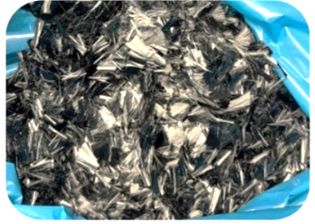 | 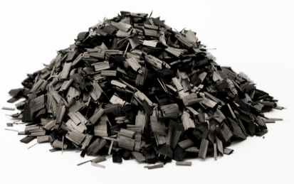 | 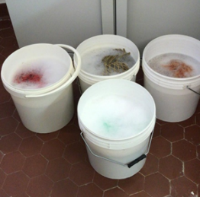 | 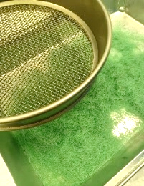
Materials | Single-screw extruder | CF-rPA6 filaments | CF-rPA6 granules
Extrusion Compounding | 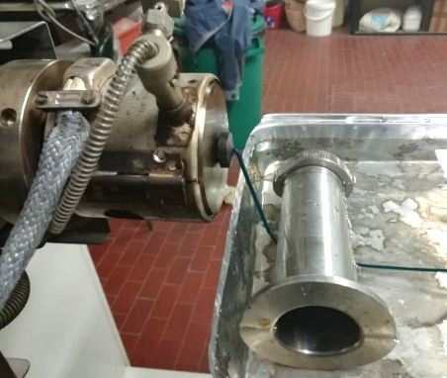 | 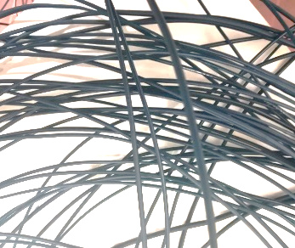 | 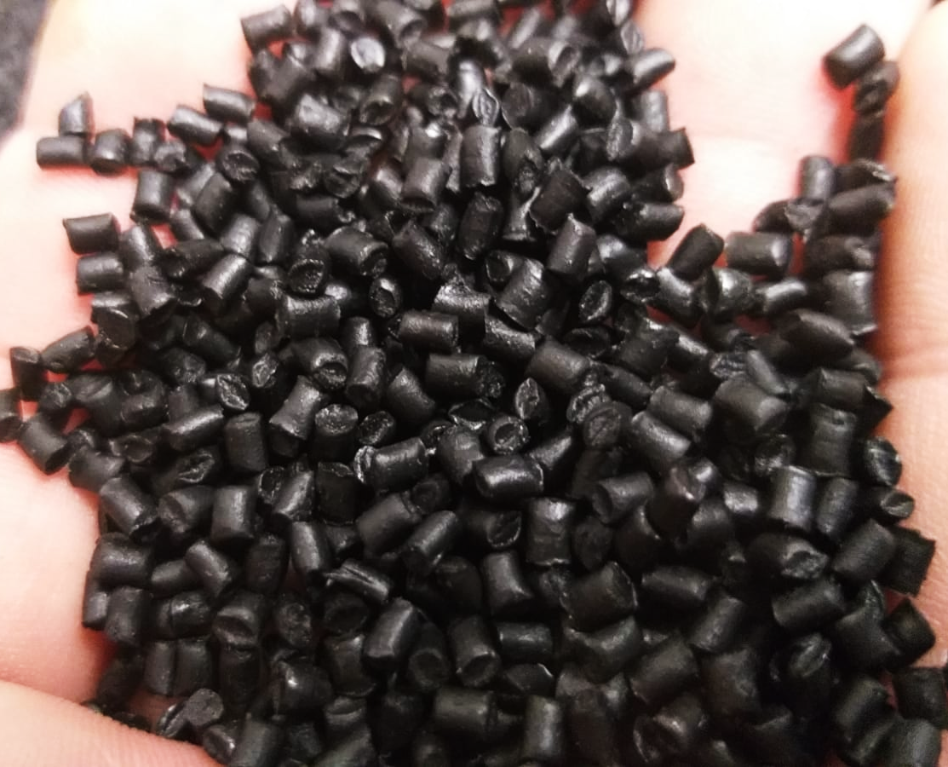
Extrusion Compounding | Dog-bones specimens | Tensile tests
Mechanical Characterization | 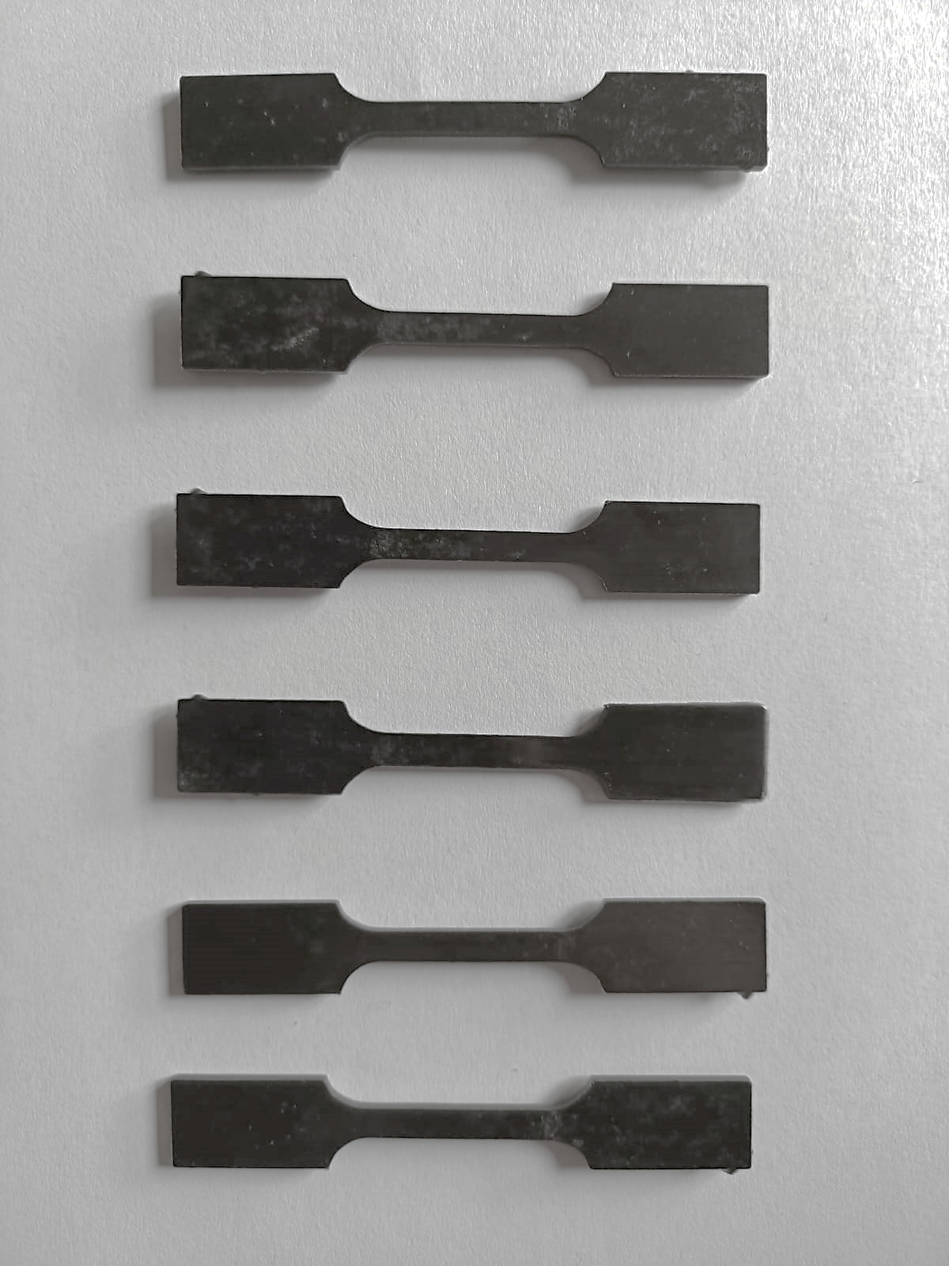 | 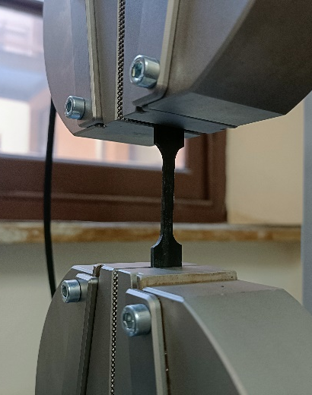
Fig. S17 - Images of raw materials, extrusion process, and characterization of the composites.

References
Ciacci, L., Zattini, G., Tosi, C., Berti, B., Passarini, F., & Giorgini, L. (2022). Carbon Fibers Waste Recovery via Pyro-Gasification: Semi-Industrial Pilot Plant Testing and LCA. Sustainability (Switzerland), 14(7). https://doi.org/10.3390/su14073744
Dao, D. Q., Rogaume, T., Luche, J., Richard, F., Bustamante Valencia, L., & Ruban, S. (2016). Thermal degradation of epoxy resin/carbon fiber composites: Influence of carbon fiber fraction on the fire reaction properties and on the gaseous species release. Fire and Materials, 40(1). https://doi.org/10.1002/fam.2265
Meng, F., McKechnie, J., Turner, T. A., & Pickering, S. J. (2017). Energy and environmental assessment and reuse of fluidised bed recycled carbon fibres. Composites Part A: Applied Science and Manufacturing, 100. https://doi.org/10.1016/j.compositesa.2017.05.008
Ozgur, C., Senel, K., Aykut-Senel, B., & Bekaroglu, S. S. K. (2023). Treatment of net washing wastewater by Fenton process. Global Nest Journal, 25(6). https://doi.org/10.30955/gnj.005088
Pasciucco, F., Pecorini, I., Di Gregorio, S., Pilato, F., & Iannelli, R. (2021). Recovery strategies of contaminated marine sediments: A life cycle assessment. Sustainability (Switzerland), 13(15). https://doi.org/10.3390/su13158520
Qasim, M., Badrelzaman, M., Darwish, N. N., Darwish, N. A., & Hilal, N. (2019). Reverse osmosis desalination: A state-of-the-art review. Desalination, 459, 59–104. https://doi.org/10.1016/j.desal.2019.02.008
Tarnacki, K., Meneses, M., Melin, T., van Medevoort, J., & Jansen, A. (2012). Environmental assessment of desalination processes: Reverse osmosis and Memstill®. Desalination, 296, 69–80. https://doi.org/10.1016/j.desal.2012.04.009
Thirugnanasambandham, K., Sivakumar, V., & Shine, K. (2016). Optimization of reverse osmosis treatment process to reuse the distillery wastewater using taguchi design. Desalination and Water Treatment, 57(51). https://doi.org/10.1080/19443994.2016.1141323
Witik, R. A., Teuscher, R., Michaud, V., Ludwig, C., & Månson, J. A. E. (2013). Carbon fibre reinforced composite waste: An environmental assessment of recycling, energy recovery and landfilling. Composites Part A: Applied Science and Manufacturing, 49. https://doi.org/10.1016/j.compositesa.2013.02.009
Xayachak, T., Haque, N., Lau, D., Parthasarathy, R., & Pramanik, B. K. (2023). Assessing the environmental footprint of plastic pyrolysis and gasification: A life cycle inventory study. Process Safety and Environmental Protection, 173. https://doi.org/10.1016/j.psep.2023.03.061

