SUPPORTING INFORMATION
Untreated bamboo biochar as anode material
for sustainable Lithium Ion Batteries

Mario J. Barbosa Nogueira,ª Susana Chauque,^{b} Valeria Sperati,^{b,c} Letizia Savio,^{d} Giorgio Divitini,^{b} Lea Pasquale,^{b} Sergio Marras,^{b} Paola Franchi,^{e} Sidnei Paciornik,ª Remo Proietti Zaccaria,^{b} Omar Ginoble Pandoli. ^{b,f,g*}

ªDepartamento de Engenharia Química e de Materiais, Pontifícia Universidade Católica do Rio de Janeiro (PUC-Rio), Rua Marquês de São Vincente, 225, 22451-900, Rio de Janeiro, Brazil.
^{b} Istituto Italiano di Tecnologia (IIT), Via Morego 30, 16163, Genova, Italy.
^{c}GAME Lab, Department of Applied Science and Technology, Politecnico di Torino, Corso Duca degli Abruzzi, 24, 10129, Turin, Italy.
^{d}Istituto dei Materiali per l’Elettronica e il Magnetismo del Consiglio Nazionale delle Ricerche, UOS Genova, Via Dodecaneso 33, Genova, Italy.
^{e}Department of Chemistry "Giacomo Ciamician", University of Bologna, Via P. Gobetti 85, 40129, Bologna, Italy.
^{f}Departamento de Química, Pontifícia Universidade Católica do Rio de Janeiro (PUC-Rio), Rua Marquês de São Vincente, 225, 22451-900, Rio de Janeiro, Brazil.
^{g}Dipartimento di Farmacia, Università degli Studi di Genova, Viale Cembrano 4, Genova, Italy.

E-mail: omarpandoli@puc-rio.br , omar.ginoblepandoli@unige.it , omar.ginoble@iit.it https://orcid.org/0000-0002-2220-7817

Table S1. ICP-EOS analysis of metal extracted with HNO₃ from B-1000 powder.
Bamboo powder | Sample A | Sample B
 | Concentration  (ppm) or (mg/Kg) |  |  | Average (mg/Kg) | Stand. Dev. (mg/Kg) | Average mass (mg) | (%)
K | 2560 | 3364 |  | 2962,0 | 568,51 | 1,0071 | 0,296
Ca | 2444 | 2748 |  | 2596,0 | 214,96 | 0,8826 | 0,260
Mg | 1459 | 1821 |  | 1640,0 | 255,97 | 0,5576 | 0,164
Fe | 1346 | 1765 |  | 1555,5 | 296,28 | 0,5289 | 0,156
P | 896 | 1189 |  | 1042,4 | 207,24 | 0,3544 | 0,104
Na | 1027 | 1043 |  | 1035,0 | 11,31 | 0,3519 | 0,104
S | 799 | 902 |  | 850,7 | 72,62 | 0,2892 | 0,085
Cu | 190 | 262 |  | 226,0 | 50,34 | 0,0769 | 0,023
Cr | 120 | 156 |  | 137,9 | 25,10 | 0,0469 | 0,014
Zn | 36 | 33 |  | 34,2 | 2,20 | 0,0116 | 0,003
Sr | 12 | 14 |  | 13,0 | 1,41 | 0,0044 | 0,001
Al | 10,7 | 12,4 |  | 11,5 | 1,22 | 0,0039 | 0,001
Mn | 8,0 | 10,0 |  | 9,0 | 1,43 | 0,0031 | 0,001
Ba | 5,1 | 5,9 |  | 5,5 | 0,60 | 0,0019 | 0,001
Mo | < 5.0 | < 5.0 |  | < 5.0 |  | 0,0017 | 0,001
Ni | < 1.0 | < 1.0 |  | < 1.0 |  | 0,0003 | 0,000
V | < 1.0 | < 1.0 |  | < 1.0 |  | 0,0003 | 0,000
Mass extracted from 340 mg |  |  |  |  |  | 4,1227 | 1,213

Table S2. ICP-EOS analysis of metal extracted with HNO₃ from B-800 powder.
Bamboo powder | Sample A | Sample B
 | Concentration  (ppm) or (mg/Kg) |  | Average (mg/Kg) | Stand. Dev. (mg/Kg) | Average mass (mg) | (%)
K | 3617 | 4541 | 4079,0 | 653,37 | 1,4839 | 0,408
Ca | 3201 | 3512 | 3356,5 | 219,91 | 1,2211 | 0,336
Mg | 2377 | 2854 | 2615,5 | 337,29 | 0,9515 | 0,262
Fe | 1840 | 2168 | 2004,0 | 231,93 | 0,7291 | 0,200
P | 1490 | 1781 | 1635,1 | 205,63 | 0,5948 | 0,164
S | 908 | 1029 | 968,5 | 85,63 | 0,3523 | 0,097
Na | 944 | 946 | 944,5 | 1,41 | 0,3436 | 0,094
Cr | 141 | 164 | 152,4 | 16,24 | 0,0554 | 0,015
Zn | 31 | 27 | 29,0 | 2,87 | 0,0106 | 0,003
Sr | 19 | 22 | 20,2 | 2,16 | 0,0074 | 0,002
Mn | 12,2 | 14,1 | 13,1 | 1,30 | 0,0048 | 0,001
Ba | 10,4 | 12,1 | 11,3 | 1,25 | 0,0041 | 0,001
Al | 5,9 | 6,7 | 6,3 | 0,62 | 0,0023 | 0,001
Mo | < 5.0 | < 5.0 | < 5.0 |  | 0,0018 | 0,001
Cu | 4,0 | 5,0 | 4,5 | 0,68 | 0,0016 | 0,000
Ni | < 1.0 | < 1.0 | < 1.0 |  | 0,0004 | 0,000
V | < 1.0 | < 1.0 | < 1.0 |  | 0,0004 | 0,000
Mass extracted from 364 mg |  |  |  |  | 5,7651 | 1,585

Table S3. XRF mapping Analysis of bamboo B1000 onto the transversal sections (external, middle, internal part) and longitudinal section.
Element | Atomic  number | wt% Transversal sections |  |  | wt% Longitudinal section | wt% Mean | Stand. Dev. | wt% Natural Bamboo
Element | Atomic  number | External | Middle | Internal
Ca | 20 | 44,96 | 45,93 | 40,01 | 47,27 | 44,54 | 2,42 | 44,94
K | 19 | 29,19 | 28,59 | 30,56 | 29,87 | 29,55 | 0,74 | 20,28
Mg | 12 | 10,73 | 9,01 | 9,59 | 8,38 | 9,43 | 0,64 | 11,47
P | 15 | 6,44 | 7,84 | 13,4 | 5,62 | 8,33 | 2,78 | 4,53
S | 16 | 6,01 | 6,35 | 4,23 | 3,78 | 5,09 | 0,87 | 7,71
Si | 14 | 1,31 | 0,57 | 0,57 | 2,04 | 1,12 | 0,33 | 2,90
Al | 13 | 0,48 | 0,63 | 0,52 | 1,45 | 0,77 | 0,06 | 4,16
Fe | 26 | 0,32 | 0,39 | 0,45 | 0,66 | 0,46 | 0,04 | 1,48
Sr | 38 | 0,2 | 0,30 | 0,32 | 0,28 | 0,28 | 0,05 | 0,90
Cu | 29 | 0,13 | 0,14 | 0,16 | 0,23 | 0,17 | 0,01 | 0,82
Ti | 22 | 0,09 | 0,11 | 0,08 | 0,24 | 0,13 | 0,01 | 0,47
Zn | 30 | 0,14 | 0,14 | 0,13 | 0,17 | 0,15 | 0,00 | 1,20

Table S4. XRF mapping Analysis of bamboo B800 onto the transversal section (external, middle, internal part) and longitudinal section.
Element | Atomic number | wt% Transversal section |  |  | wt% Longitudinal section | wt% Mean | Stand. Dev. | wt% Natural Bamboo
Element | Atomic number | External | Middle | Internal
Ca | 20 | 43,34 | 45,06 | 39,59 | 48,86 | 44,21 | 2,05 | 44,94
K | 19 | 32,61 | 33,12 | 37,43 | 30,37 | 33,38 | 2,03 | 20,28
Mg | 12 | 9,62 | 8,08 | 6,5 | 7,43 | 7,91 | 1,04 | 11,47
P | 15 | 5,83 | 7,25 | 9,56 | 5,6 | 7,06 | 1,34 | 4,53
S | 16 | 2,82 | 3,71 | 4,11 | 3,1 | 3,44 | 0,48 | 7,71
Si | 14 | 3,33 | 0,38 | 0,37 | 1,56 | 1,41 | 1,31 | 2,90
Al | 13 | 0,51 | 0,50 | 0,52 | 0,64 | 0,54 | 0,01 | 4,16
Fe | 26 | 0,45 | 0,52 | 0,59 | 0,72 | 0,57 | 0,05 | 1,48
Zn | 30 | 0,46 | 0,28 | 0,33 | 0,35 | 0,36 | 0,07 | 1,20
Sr | 38 | 0,21 | 0,33 | 0,34 | 0,33 | 0,30 | 0,06 | 0,90
Cu | 29 | 0,18 | 0,20 | 0,22 | 0,32 | 0,23 | 0,01 | 0,82
Ti | 22 | 0,11 | 0,14 | 0,11 | 0,21 | 0,14 | 0,01 | 0,47

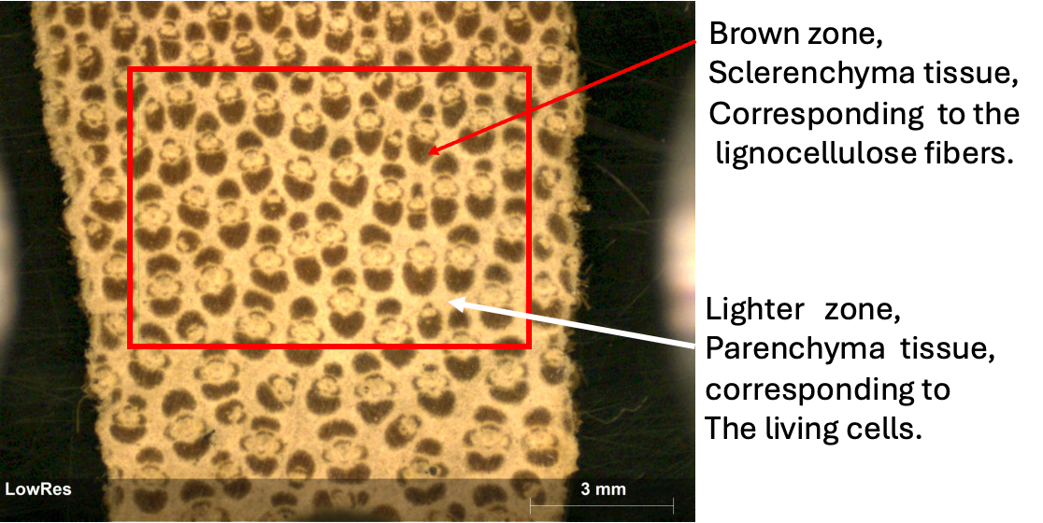
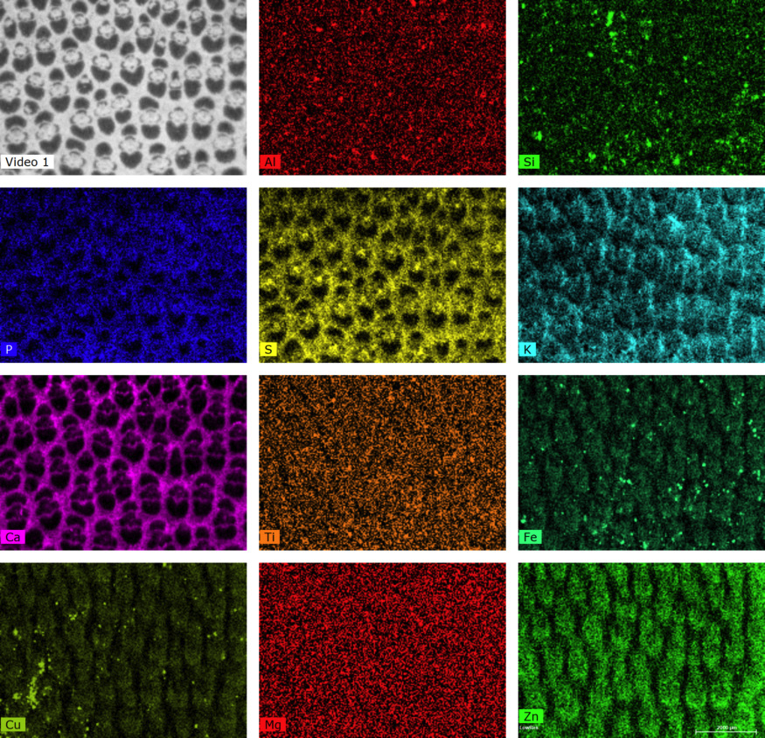
Figure S1. (Upper) Optical image of the transversal section of natural bamboo with red rectangle indicating the analysis area. In the optical image, the brighter part represents the parenchymatic tissue, while the brown part is the sclerenchymatic tissue with lignocellulose fiber. (Lower) XRF mapping of pristine bamboo and B-800 Bamboo bulk samples.
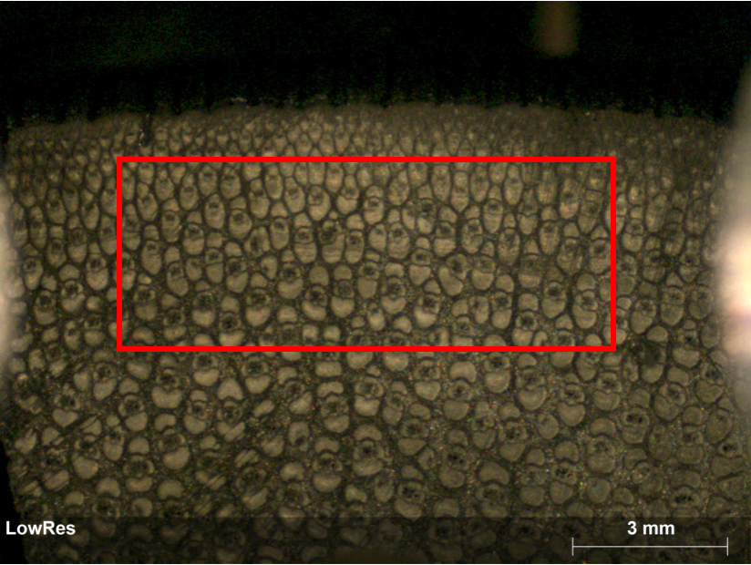
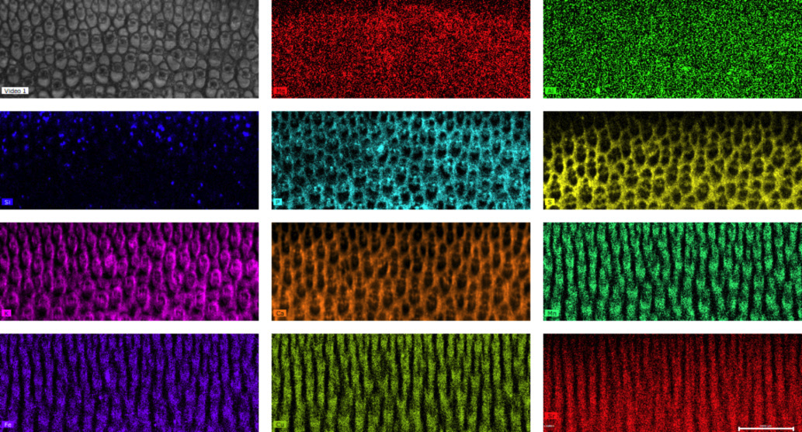
Figure S2. (Upper) Optical Image of the transversal section of B800 with a red rectangle indicating the analysis area. (Lower) XRF mapping (10 x 6 mm) of the external part of B-800 bamboo bulk sample.

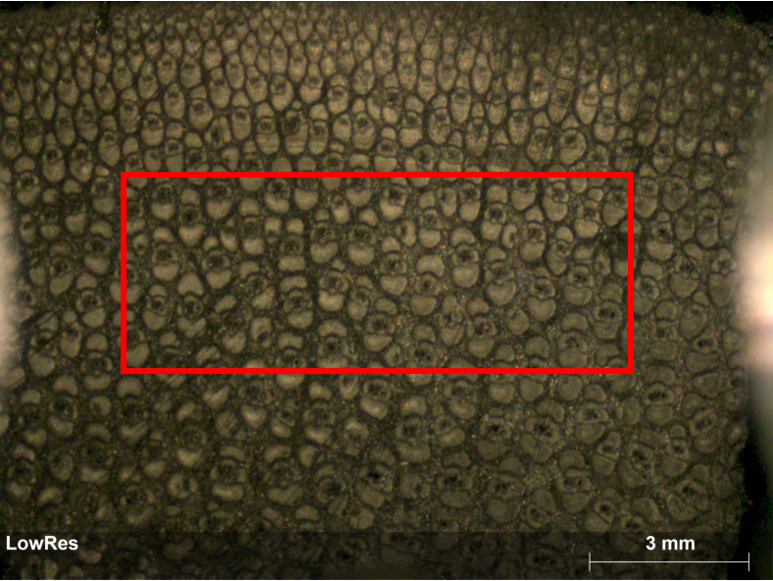
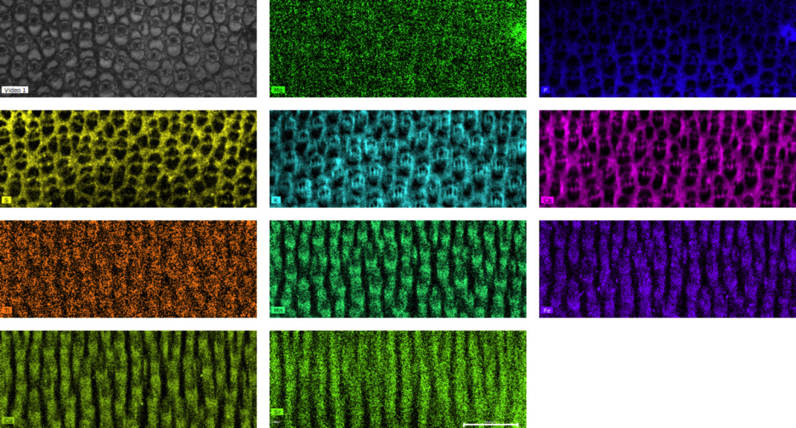
Figure S3. (Upper) Optical Image of the transversal section of B800 with a red rectangle indicating the analysis area. (Lower) XRF mapping (10 x 6 mm) of the middle part of B-800 bamboo bulk sample.

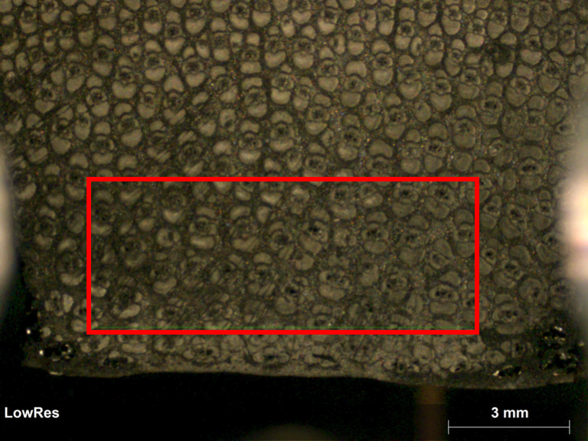
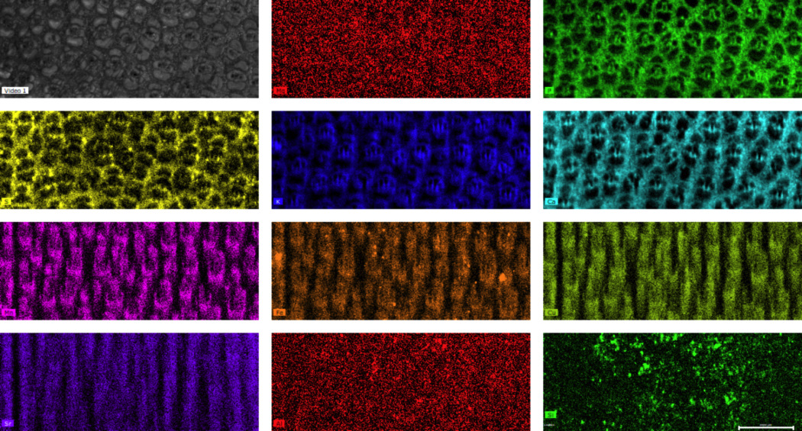
Figure S4. (Upper) Optical Image of the transversal section of B800 with a red rectangle indicating the analysis area. (Lower). XRF mapping (10 x 6 mm) of the internal part of B-800 bamboo bulk sample.

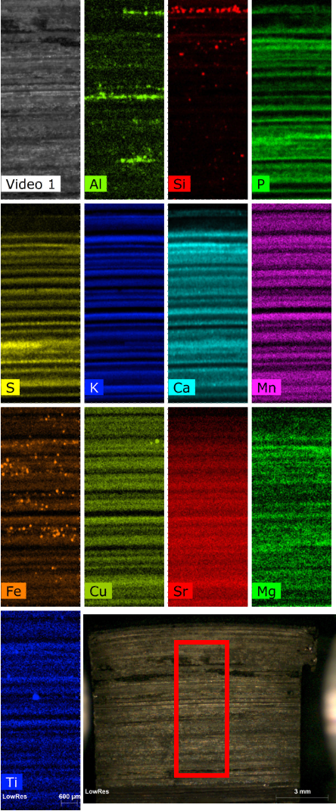

Figure S5. XRF mapping (10 x 6 mm) orthogonal to the fibers. (Down right) Optical image of the longitudinal section of B800 with a red rectangle of the analysis area.

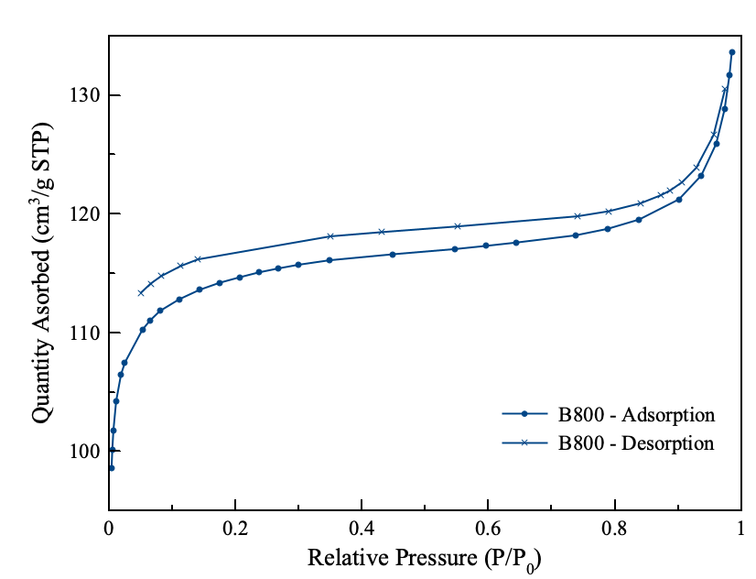

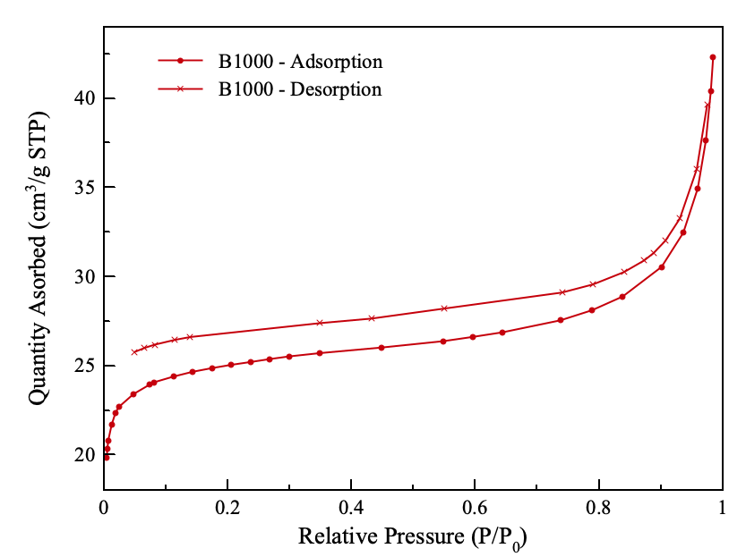

Figure S6. isotherm absorption of N₂ into B800 (upper) and B1000 (down).

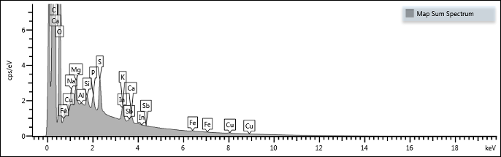

Element | Wt% | Wt% Sigma
Mg | 16.43 | 0.16
P | 11.37 | 0.14
S | 29.58 | 0.25
K | 21.58 | 0.23
Ca | 12.64 | 0.19
Fe | 3.63 | 0.25
In | 2.76 | 0.48
Sb | 2.01 | 0.46
Total: | 100.00

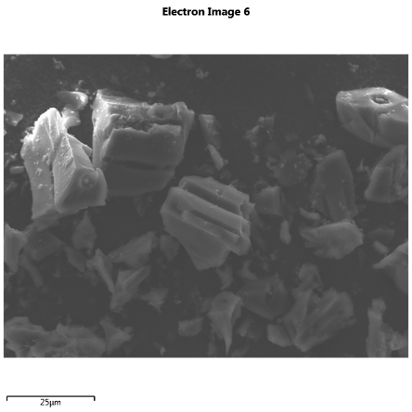

Figure S7. EDS analysis and SEM image of the bamboo powder B800.

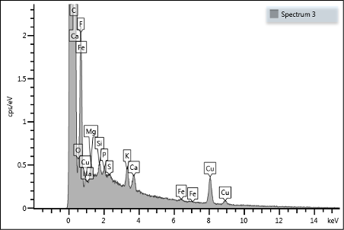

Spectrum | Line Type | Wt% | Wt% Sigma
F | K series | 56.00 | 1.04
Na | K series | 1.23 | 0.58
Mg | K series | 5.48 | 0.38
P | K series | 1.72 | 0.24
K | K series | 4.53 | 0.21
Ca | K series | 3.60 | 0.19
Fe | K series | 0.87 | 0.22
Cu | K series | 26.56 | 0.70
Total |  | 100.00

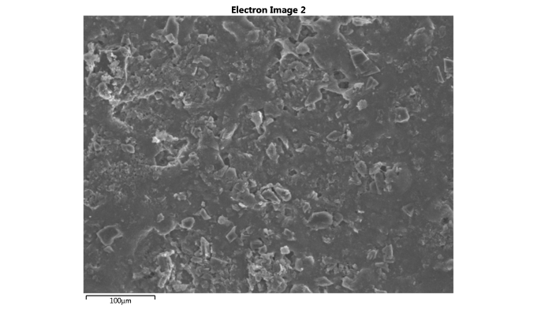
Figure S8. EDS analysis and SEM image of slurry bamboo B800 treated with the fluorinated binder.

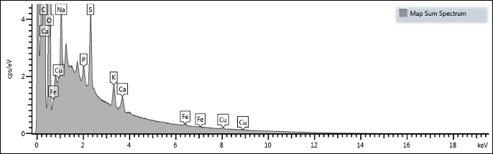

Element | Wt% | Wt% Sigma
P | 8.84 | 0.31
S | 45.36 | 0.53
K | 23.08 | 0.42
Ca | 17.50 | 0.44
Fe | 5.23 | 0.74
Total: | 100.00
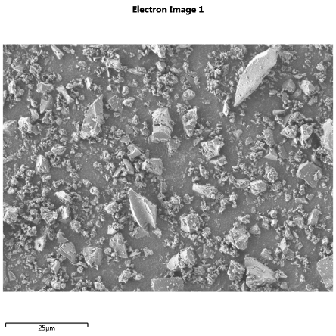
Figure S9. EDS analysis and SEM image of the bamboo powder, B1000.

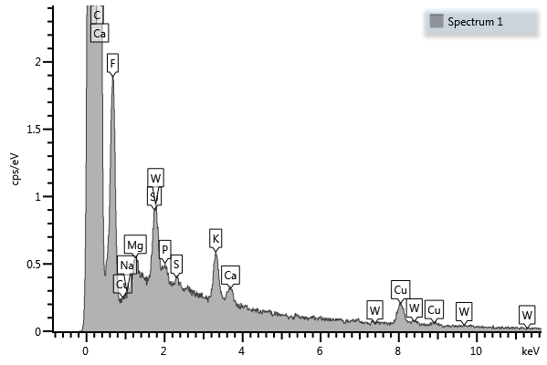

Spectrum | Line Type | Wt% | Wt% Sigma
F | K series | 55.20 | 1.53
Na | K series | 0.00 | 0.00
Mg | K series | 4.31 | 0.50
P | K series | 2.65 | 0.48
S | K series | 2.53 | 1.67
K | K series | 7.02 | 0.38
Ca | K series | 2.40 | 0.31
Cu | K series | 13.47 | 0.74
W | M series | 12.43 | 1.35
Total |  | 100.0

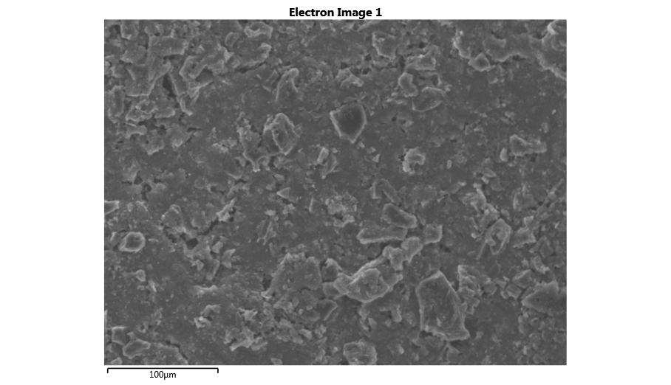
Figure S10. SEM image and EDS analysis of the slurry bamboo B1000 treated with he fluorinated binder.

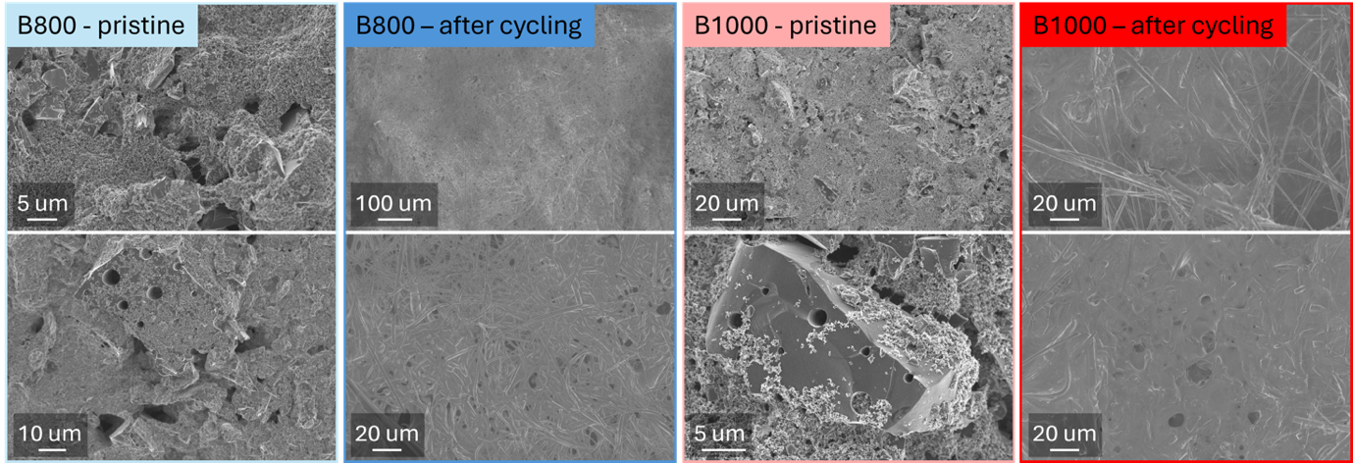
Figure S11. SEM images from the B800 and B1000 samples before and after electrochemical testing.

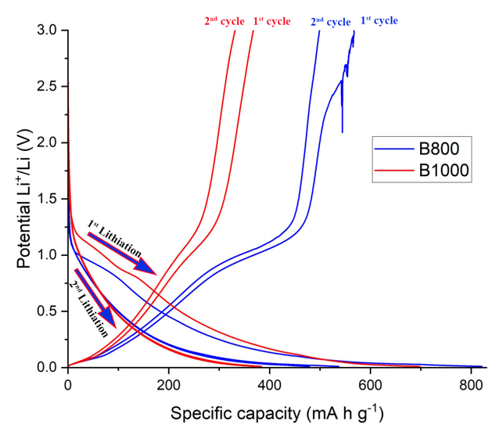

Figure S12. Voltage profile for the first 2 cycles at C/5.

