Supporting Information

Comprehensive Modelling Strategy for Gas Transport in Polymers: Analysis of Swelling and Non-Swelling Agents at High Pressures
Roberta Di Carlo¹, Eleonora Ricci², Matteo Minelli^{1,*}
¹ Department of Civil, Chemical, Environmental and Materials Engineering, Alma Mater Studiorum - University of Bologna, via Terracini 28, Bologna, Italy
² Institute for Materials and Processes, University of Edinburgh, Robert Stevenson Road, EH9 3FB, Edinburgh, UK

EoS/NELF main model parameters
$M_{i}$ | Molar mass of species i
$v_{i}$ | Molar volume of a lattice cell of component i
$r_{i}^{0}$ | Number of lattice cells occupied by a molecule of pure component i
$ω_{i}$ | Mass fraction of component i
$ρ_{i}^{*}$ | Characteristic density of component i | $ρ_{i}^{*}=\frac{M_{i}}{r_{i}v_{i}^{*}}$
$p_{i}^{*}$ | Characteristic pressure of component i | $p_{i}^{*}=\frac{ε_{i}}{v_{i}}$
$T_{i}^{*}$ | Characteristic temperature of component i | $T_{i}^{*}=\frac{ε_{i}}{k}$
$ϕ_{i}$ | Volume fraction of species i | $ϕ_{i}=\frac{ω_{i}/ρ_{i}^{*}}{\sum_{i}{ω_{i}}/ρ_{i}^{*}}$
$$r_{i}$$ | Number of lattice cells occupied by a molecule in the mixture | $r_{i}=\frac{r_{i}^{0}v_{i}^{*}}{v^{*}}$
$$r$$ | Molar average number of lattice sites occupied by a molecule in the mixture | $r=\sum_{i}{r_{i}}$
$$ρ^{*}$$ | Mixture characteristic density | $ρ^{*}=\sum_{i}{\frac{ω_{i}}{ρ_{i}}}$
$$p^{*}$$ | Mixture characteristic pressure | $$p^{*}=\sum_{i}{ϕ_{i}p_{i}^{*}}-\frac{1}{2}\sum_{i}{ϕ_{i}}\sum_{i}{ϕ_{j}Δp_{i,j}^{*}}$$
$$T^{*}$$ | Mixture characteristic temperature | $T^{*}=\frac{p^{*}v^{*}}{R}$
$$v^{*}$$ | Average close-packed per molar volume in the mixture | $v^{*}=\frac{RT^{*}}{p^{*}}$
$$\tilde{ρ}$$ | Reduced density | $\frac{ρ}{ρ^{*}}$
$$\tilde{P}$$ | Reduced pressure | $\frac{P}{P^{*}}$
$$\tilde{T}$$ | Reduced temperature | $\frac{T}{T^{*}}$
Table S1. Parameters and symbols used in the LF and NELF models [1,2].

Gas solubility isotherms in glassy P84 polyimide
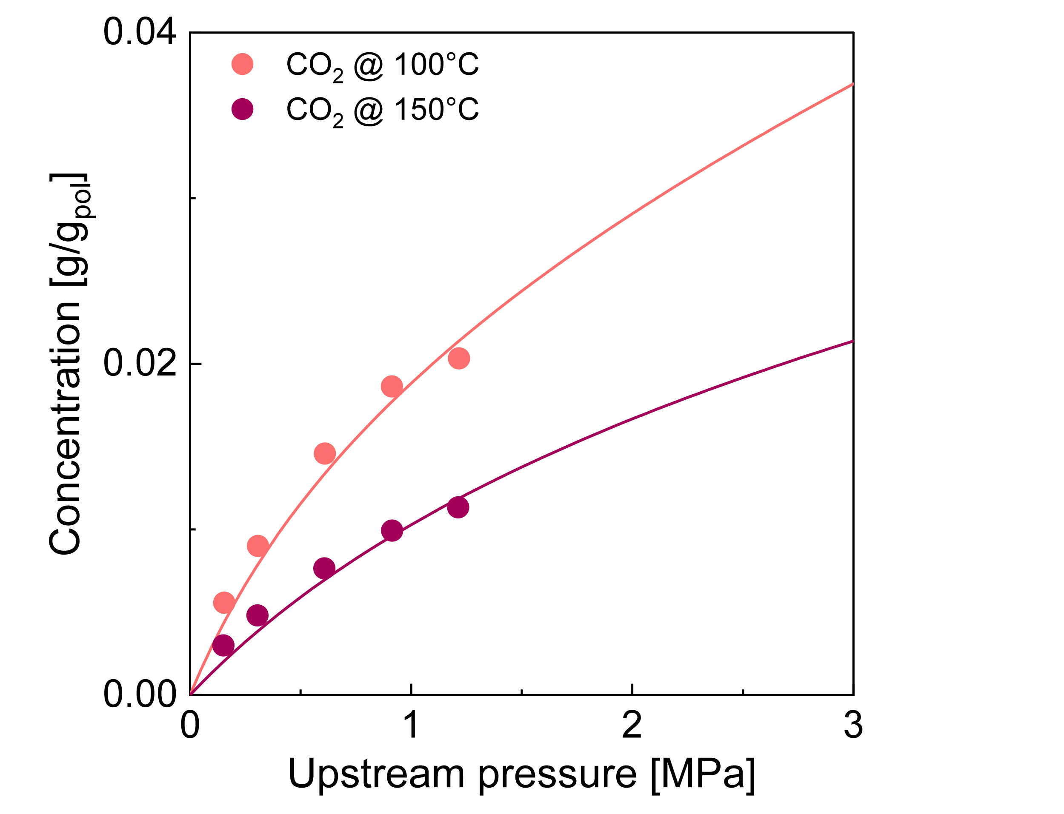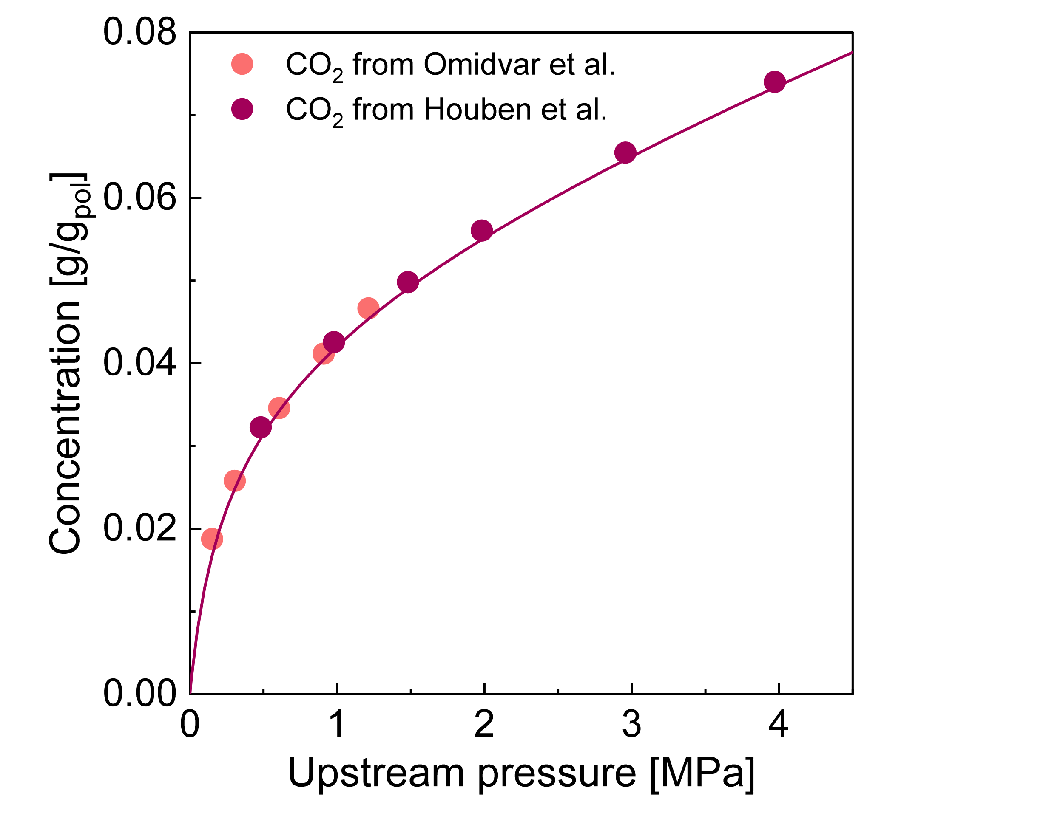
b
a
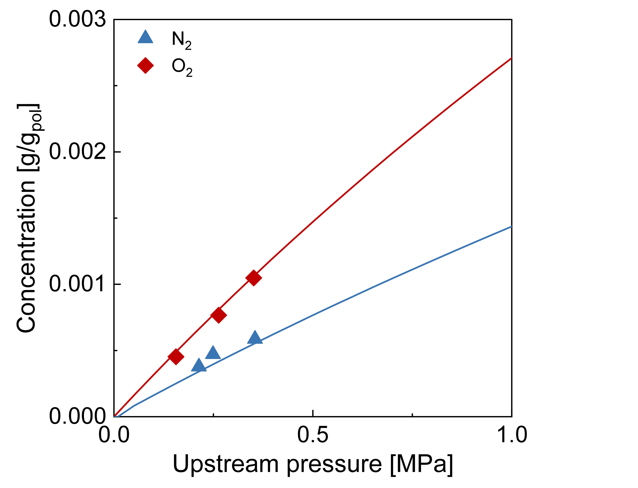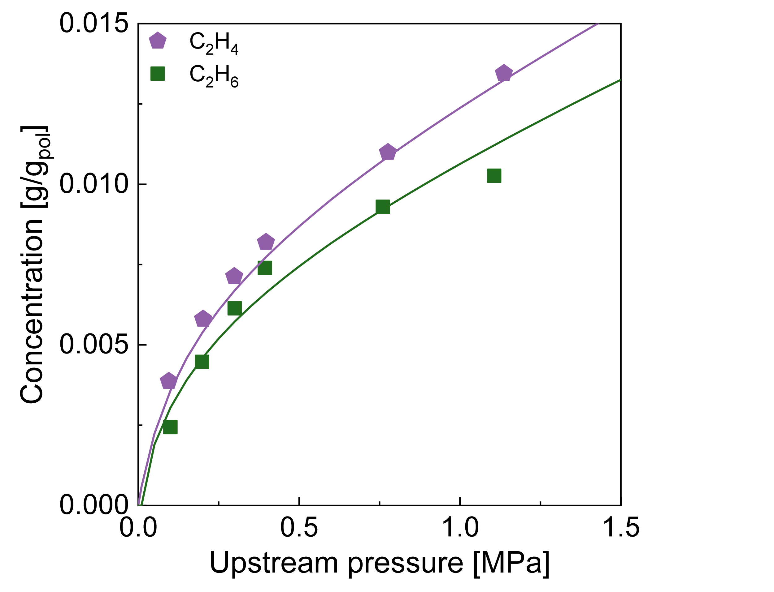
d
c
Figure S1. Solubility isotherms used to estimate the characteristic parameters of P84. Experimental data from: (a) [3], (b) [3,4], (c) [5], (d) [6]. Curves are from NELF calculations.

Gas solubility isotherms in glassy P84/Matrimid polyimide blends
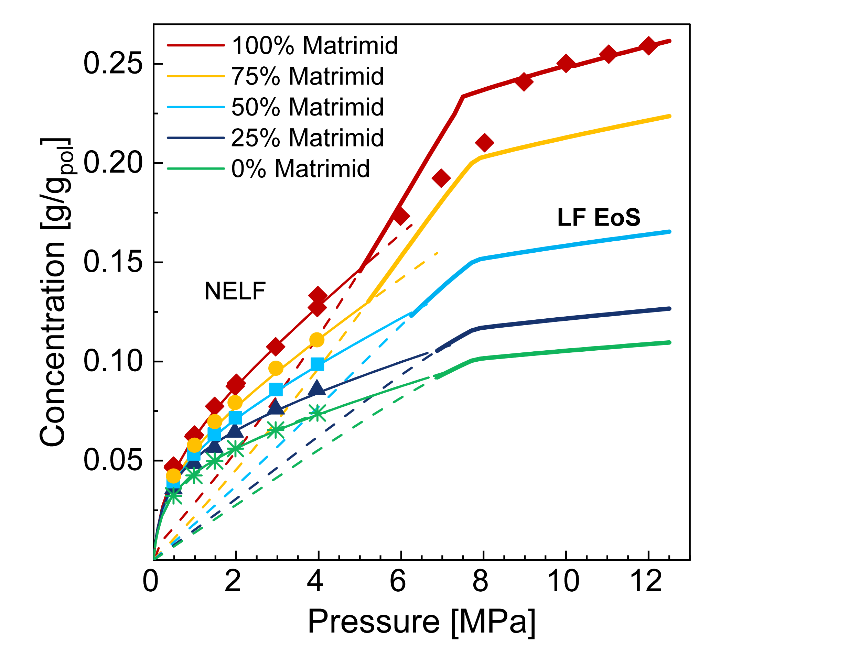
Figure S2. Solubility predictions up to 12 MPa for P84/Matrimid blend at different content of the two components. Curves are from model calculations: thin lines are from NELF, bold lines from LF EoS. Experimental data are from [4,7]

Gas solubility isotherms in Nafion
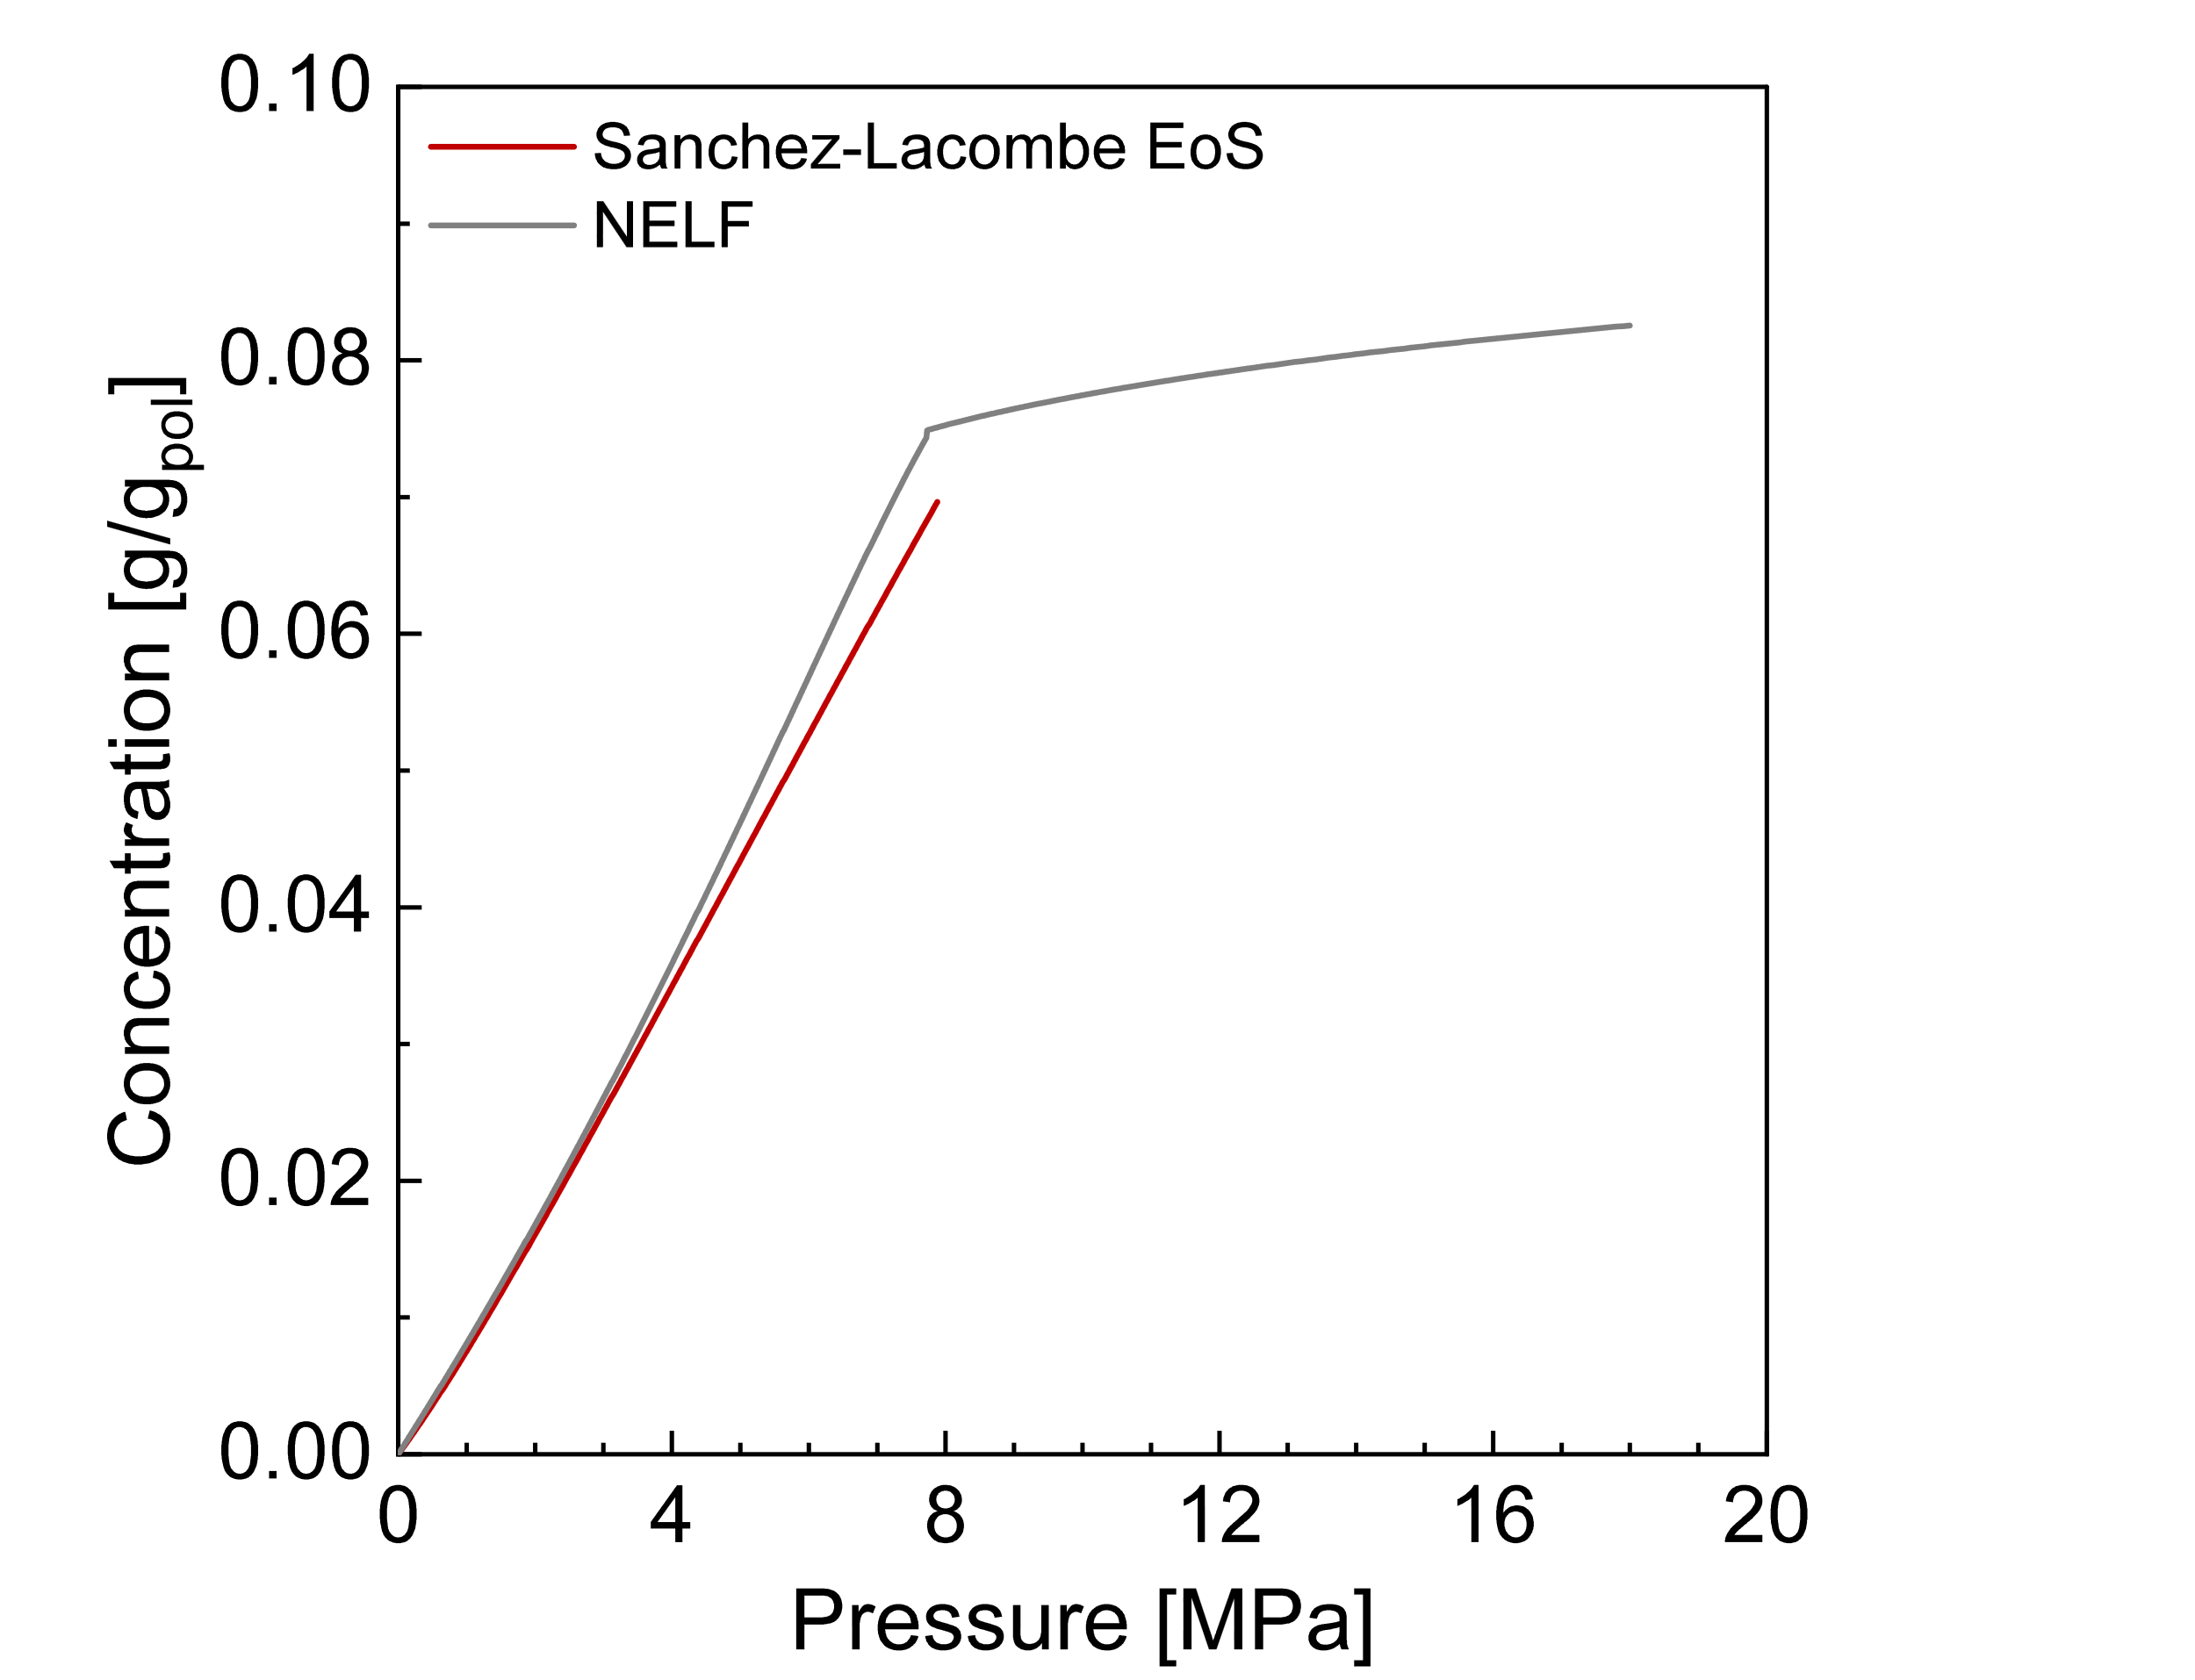
Figure S3. Comparison between the equation of state and NELF for Nafion solubility prediction
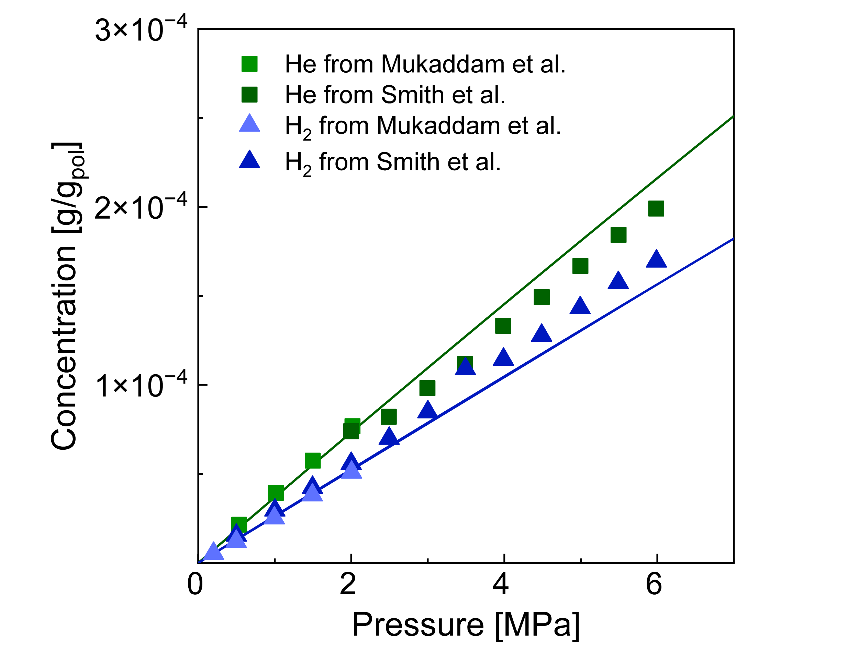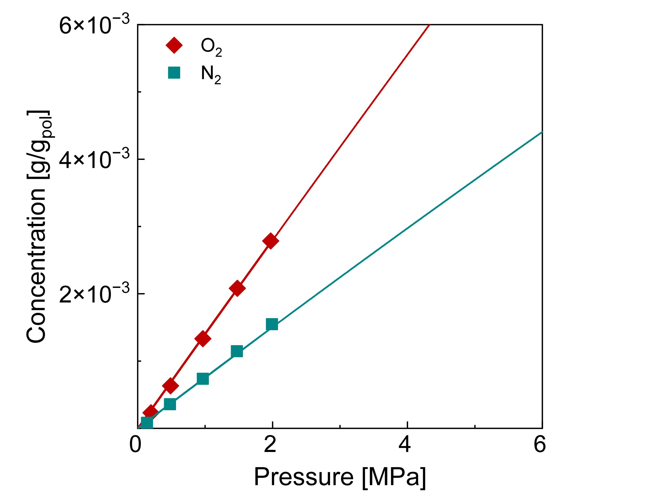
Figure S4. Solubility isotherms of different penetrants in Nafion. The experimental data are from [8,9]. Curves are from SL EoS calculations.

Nitrogen in FKM
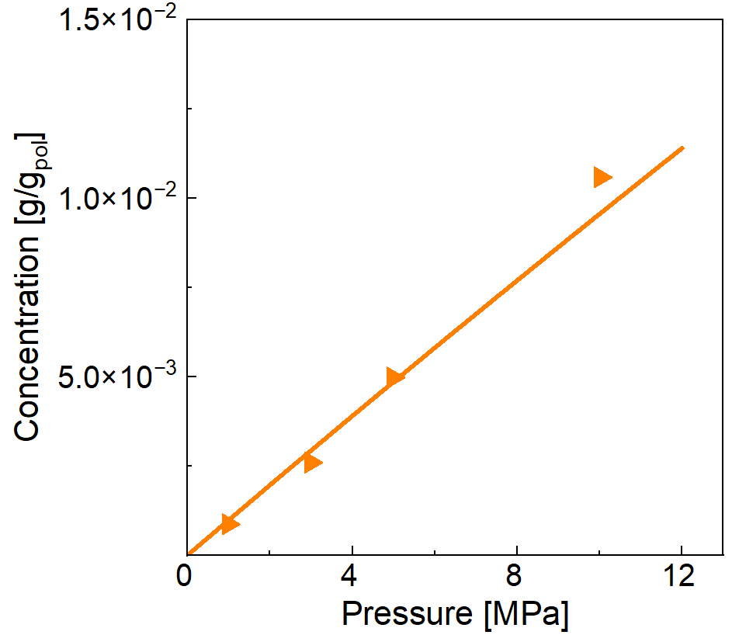
a
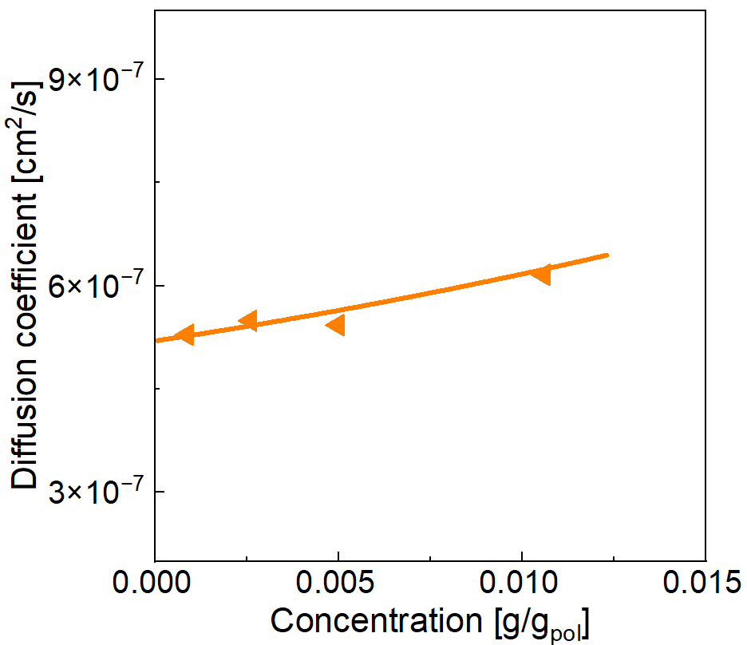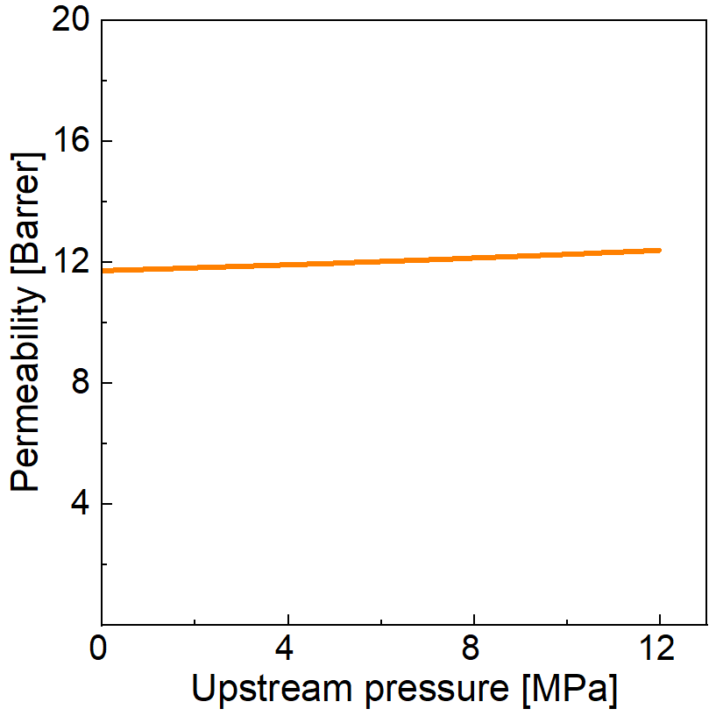
c
b
Figure S5, Results of modelling N2 in FKM (a) solubility, (b) diffusivity and (c) permeability prediction, at 323 K. Experimental data are from [10], lines are from modelling: Sanchez- Lacombe EoS (a) and ST Model (b) and (c).

Modelling coefficients results
Polymer | Penetrant | T  [K] | $$k_{ij}$$ | $$k_{sw}$$  $$[1/MPa]$$ | sMAPE | $$β$$ | $$L_{0}$$  $$\left[cm^{2}/s\right]$$ | sMAPE | Notes
P84 | CO₂ | 308.15 | 1.70·10⁻² | 6.3·10⁻³ | 1.1% | 75 | 1.5·10⁻¹⁰ | 10.4%
75%P84-25%Matrimid | CO₂ | 308.15 | 1.60·10⁻² | 6.60·10⁻³ | 3% | 65 | 2.1·10⁻¹⁰ | 10.5%
50%P84-50%Matrimid | CO₂ | 308.15 | 5.00·10⁻³ | 1.10·10⁻² | 2% | 46 | 1·10⁻⁹ | 9.6%
25%P84-75%Matrimid | CO₂ | 308.15 | -1.10·10⁻² | 1.47·10⁻² | 3.8% | 37 | 1.9·10⁻⁹ | 13%
Matrimid | CO₂ | 308.15 | -2.20·10⁻² | 1.75·10⁻² | 2.5% | 36 | 2.2·10⁻⁹ | 11%
Nafion | CO₂ | 308.15 | 1.80·10⁻² | 1.86·10^{-2*} | 2% | - | - |  | *Calculated from EoS in the range  0-7 MPa
Nafion | CO₂ | 318.15 | 1.80·10⁻² | 1.54·10^{-2*} | 2% | 42 | 2.4·10⁻⁷ | 13% | *Calculated from EoS in the range  0-7 MPa
NR | CO₂ | 303.15 | 9.24·10⁻² | 1.52·10⁻²* | 7.6% | - | - |  | *Calculated from EoS in the range 0-7 MPa
NR | CO₂ | 313.15 | 9.24·10⁻² | 1.28·10⁻²* | 8.4% | - | - |  | *Calculated from EoS in the range 0-7 MPa
NR | CO₂ | 318.15 | 9.24·10⁻² | 1.25·10⁻² |  | 23 | 2.7·10⁻⁶ | 2.6% | *Calculated from EoS in the range 0-7 MPa
NR | CO₂ | 323.15 | 9.24·10⁻² | 1.10·10⁻²* | 3.6% | - | - |  | *Calculated from EoS in the range 0-7 MPa
NR | CO₂ | 333.15 | 9.24·10⁻² | 9.65·10⁻³* | 4% | - | - |  | *Calculated from EoS in the range 0-7 MPa
PDMS | Ar | 308.15 | -1.40·10⁻² | 5.58·10⁻³* | 11% | - | - |  | *Calculated from EoS in the range 0-18 MPa
PDMS | Ar | 318.15 | -1.40·10⁻² | 5.36·10⁻³* |  | 2 | 1.8·10⁻⁵ | 1% | *Calculated from EoS in the range 0-18 MPa
PDMS | N₂ | 298.15 | 7.00·10⁻² | 1.25·10⁻³ | 6.2% | -17 | 2.2·10⁻⁵ | 1.5% | *Calculated from EoS in the range 0-15 MPa
PDMS | N₂ | 308.15 | 7.00·10⁻² | 1.22·10⁻³ | 6.2% | -17 | 2.5·10⁻⁵ | 1% | *Calculated from EoS in the range 0-15 MPa
PDMS | N₂ | 318.15 | 7.00·10⁻² | 1.19·10⁻³* | 6.2% | -17 | 2.9·10⁻⁵ | 2.9% | *Calculated from EoS in the range 0-15 MPa
PDMS | N₂ | 328.15 | 7.00·10⁻² | 1.16·10⁻³ | 6.2% | -17 | 3.3·10⁻⁵ | 2.6% | *Calculated from EoS in the range 0-15 MPa
FKM | CO₂ | 323.15 | -2.90·10⁻² | 3.45·10^{-2*} | 6.2% | 19 | 5.5·10⁻⁷ | 5.9% | *Calculated from EoS in the range 0-7 MPa
FKM | CO₂ | 348.15 | -5.50·10⁻² | 3.13·10^{-2*} | 6.8% | 20 | 7.3·10⁻⁷ | 5.5% | *Calculated from EoS in the range 0-7 MPa
FKM | CO₂ | 373.15 | -8.00·10⁻² | 2.69·10^{-2*} | 4.4% | 21 | 9.8·10⁻⁷ | 5.5% | *Calculated from EoS in the range 0-7 MPa
FKM | CO₂ | 398.15 | -1.00·10⁻¹ | 2.34·10^{-2*} | 5.3% | 22 | 1.2·10⁻⁶ | 5.7% | *Calculated from EoS in the range 0-7 MPa
FKM | N₂ | 323.15 | -1.36·10⁻¹ | 2.22·10^{-3*} | 9% | 12 | 5.2·10⁻⁷ | 1.7% | *Calculated from EoS in the range 0-7 MPa
Table S2. Summary of all the modelling parameters and coefficients results
Error analysis – 50% P84 / 50% Matrimid blend

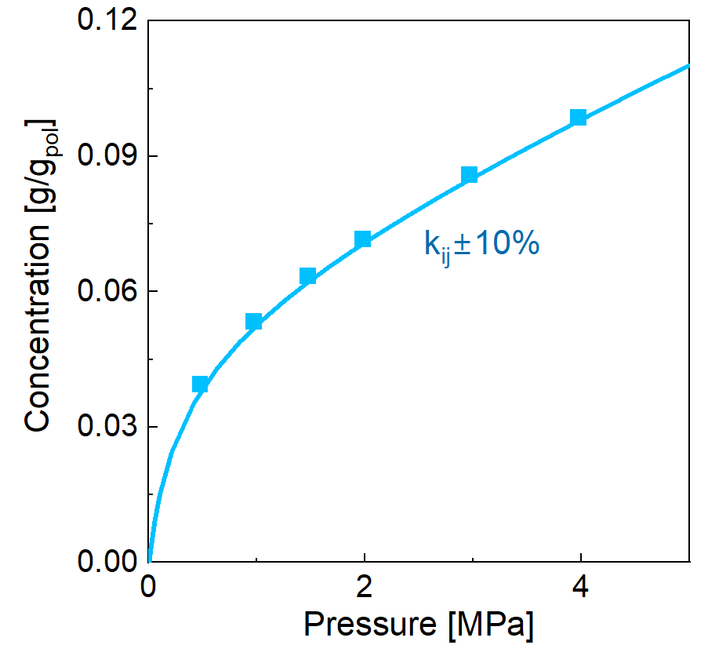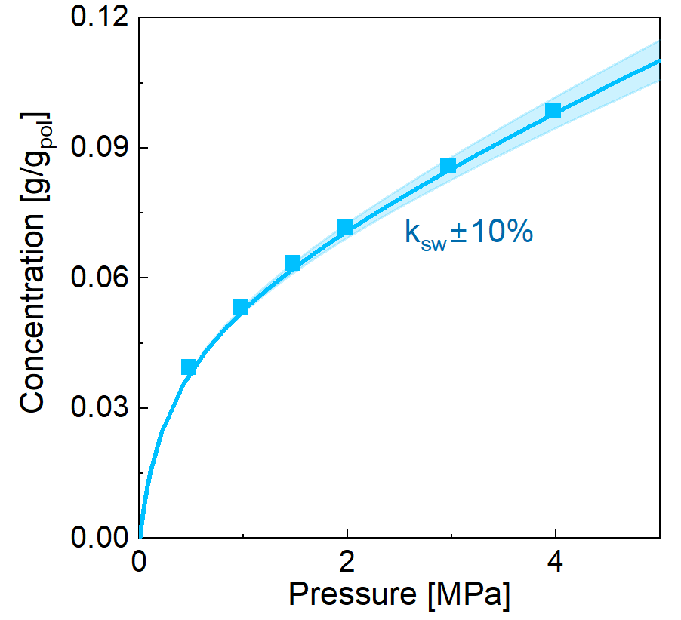
b
a
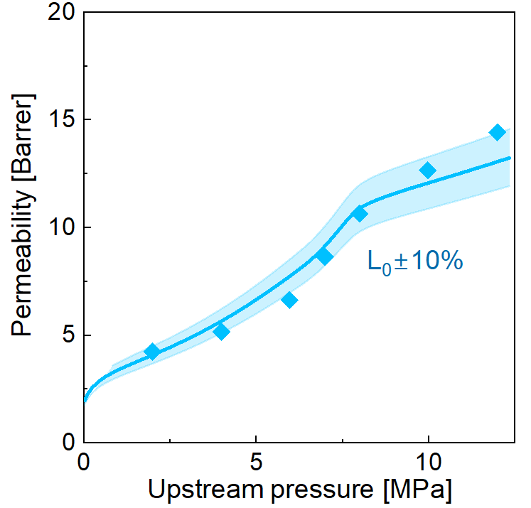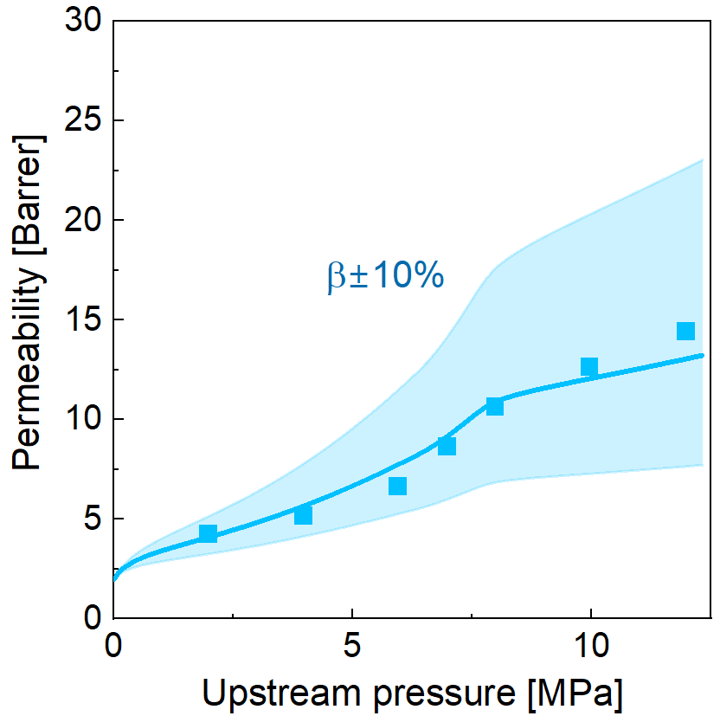
d
c
Figure S6, Contour plot of ±10% variation in (a) kij, (b) k_{sw}, (c) L₀, (d) β around the reference line, representing the reference optimal case, in 50% P84 - 50% Matrimid blend at 35°C. Experimental data are from [4], lines from (a) SL EoS, (b) NELF, (c) and (d) ST Model.

Error analysis – Nafion
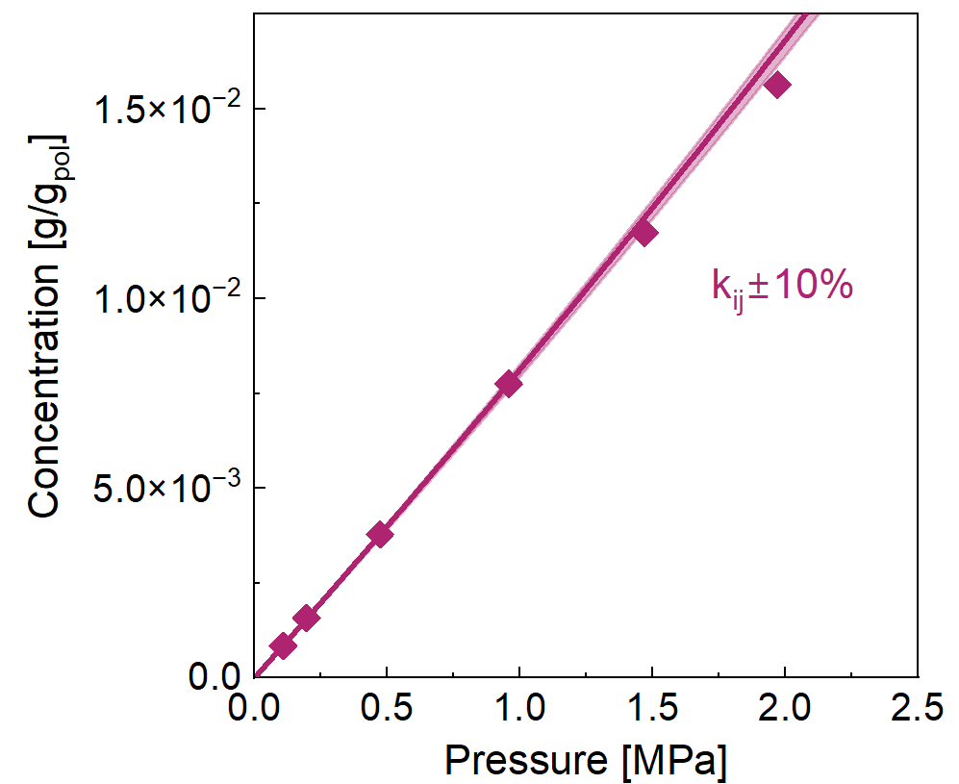
a
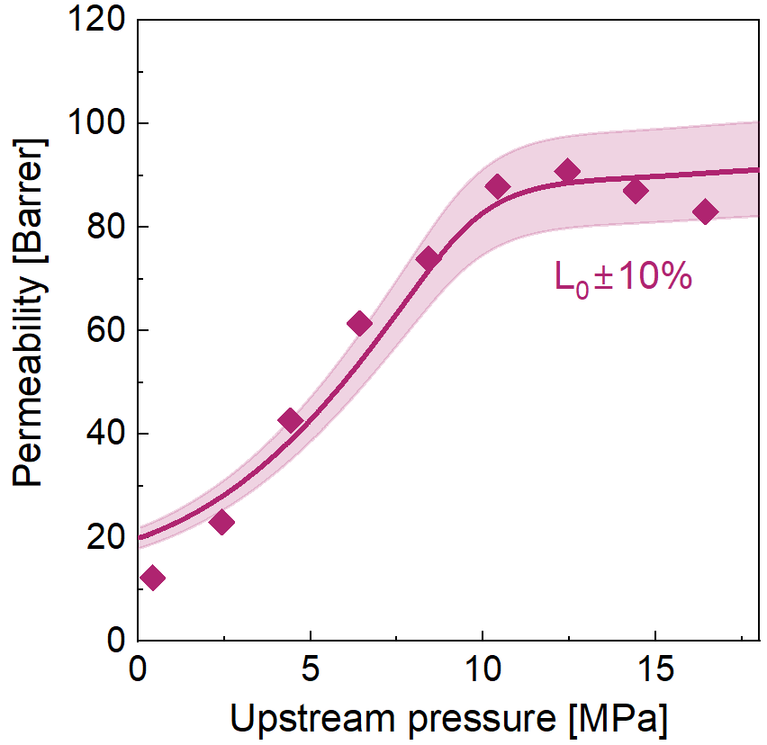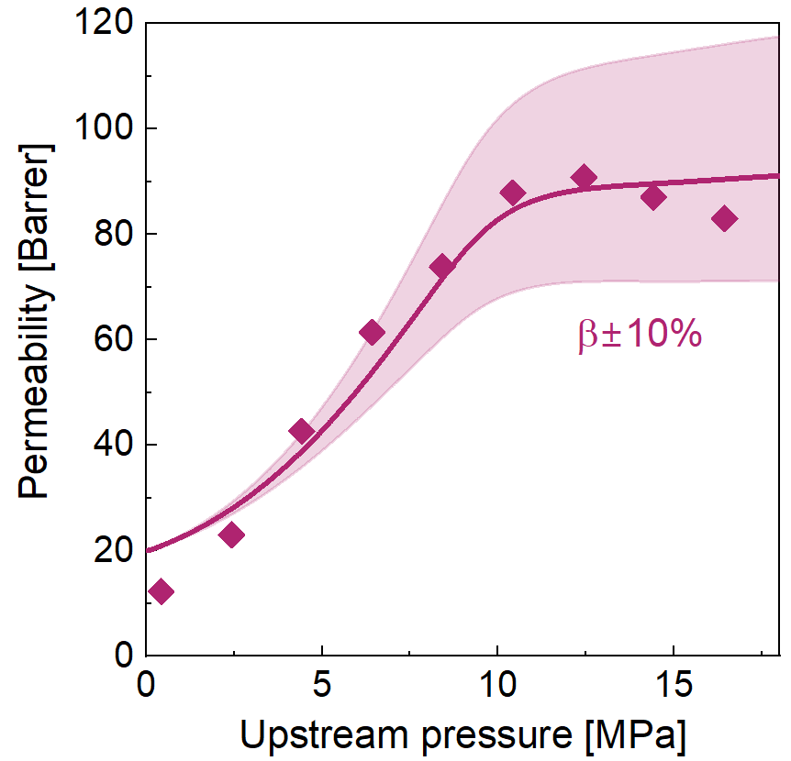
b
ca
Figure S7, Contour plot of ±10% variation in (a) k_{ij}, (b) L₀, (c) β around the reference line, representing the reference optimal case, in Nafion at 45°C. Experimental data from (a) [8] , (b) and (c) [11]. Curves are from (a) EoS, (b) and (c) ST model calculations.

Error analysis – Natural Rubber
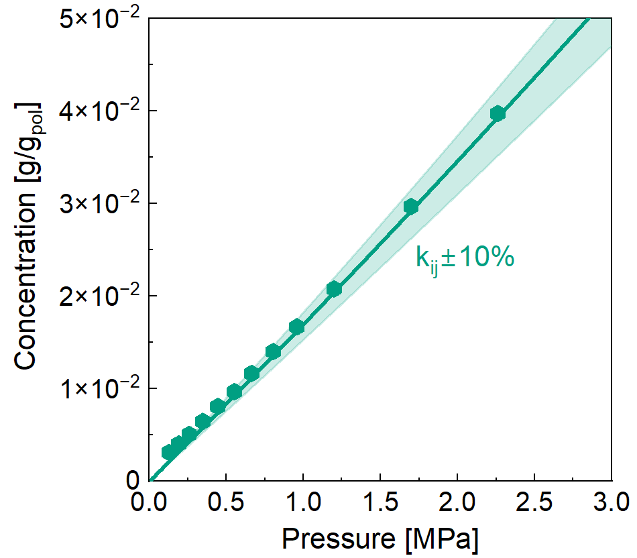
a
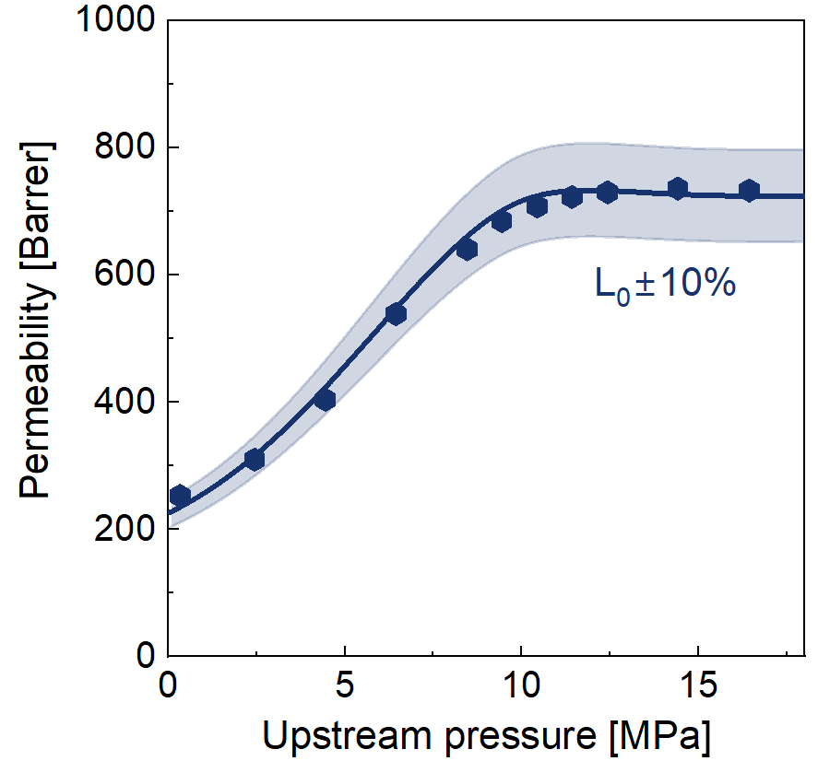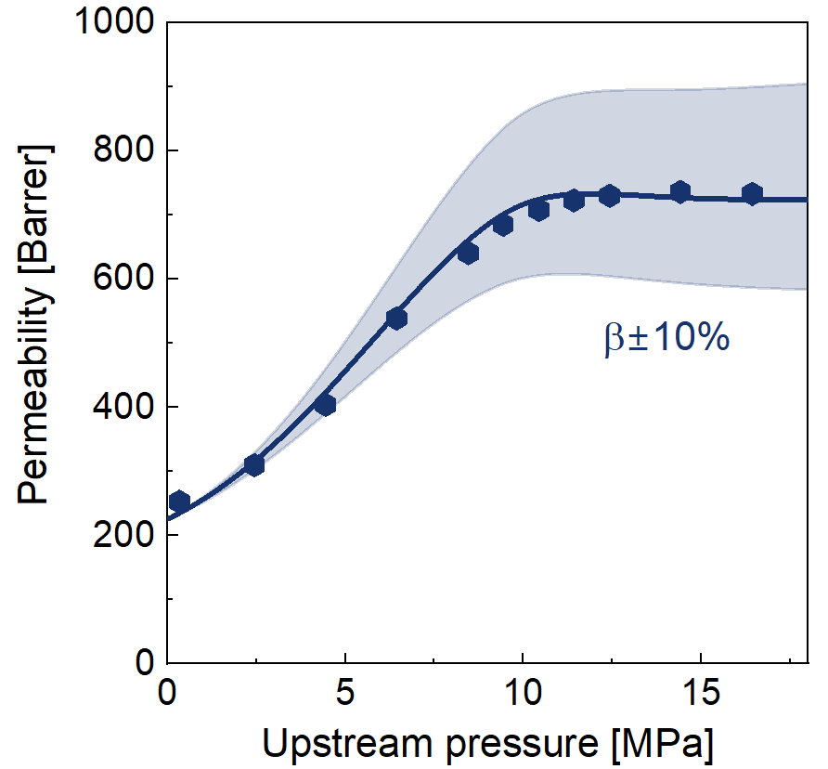
c
b
Figure S8, Contour plot of ±10% variation in (a) k_{ij}, (b) L₀, (c) β around the reference line, representing the reference optimal case, in Natural rubber at 30°C (a), and 45°C (b) and (c). Experimental data from (a) [12], (b) and (c) [11]; curves are from (a) EoS, (b) and (c) STM calculations.

Error analysis – PDMS
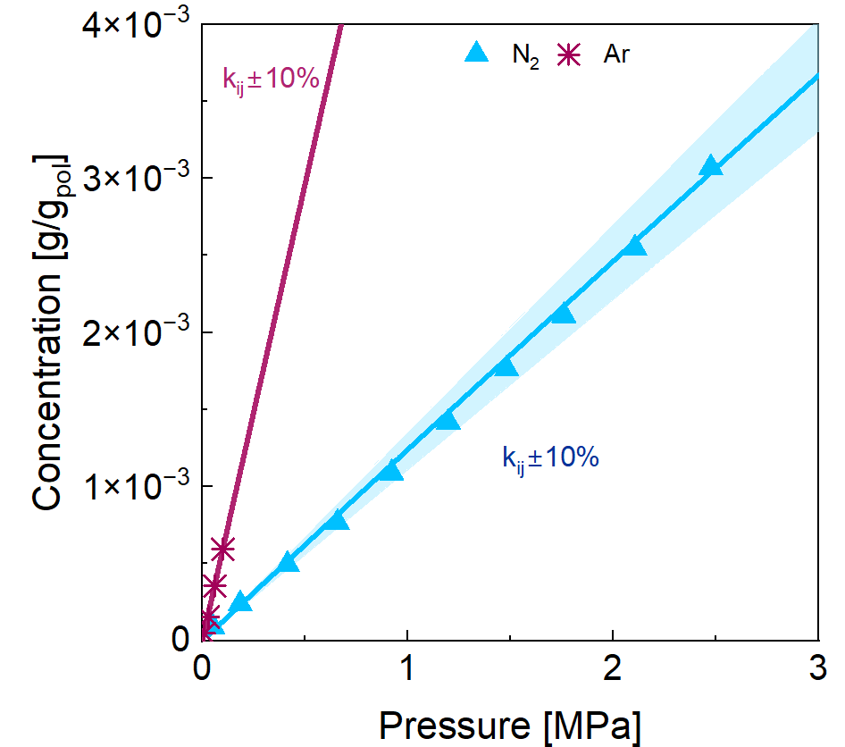
a
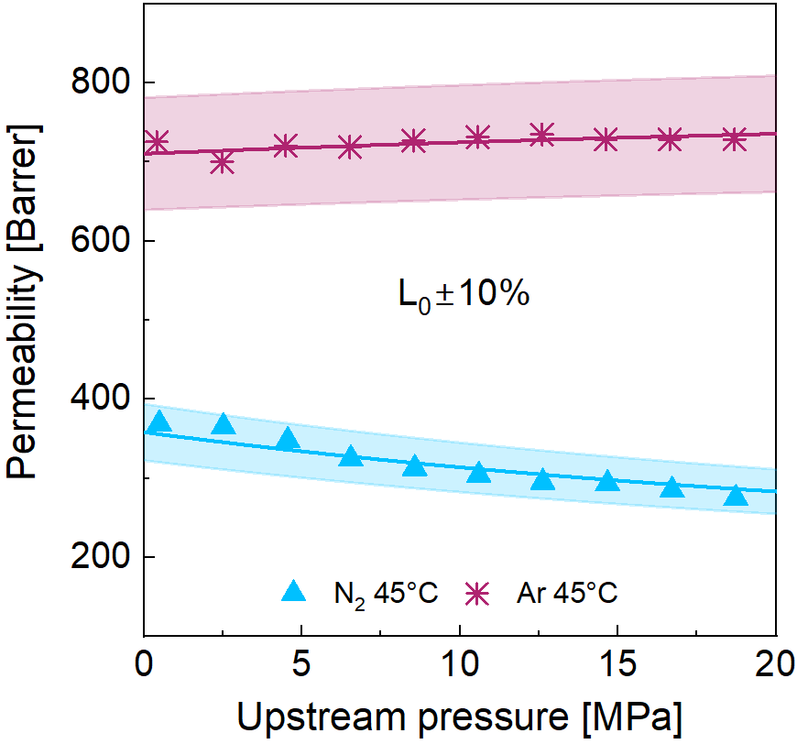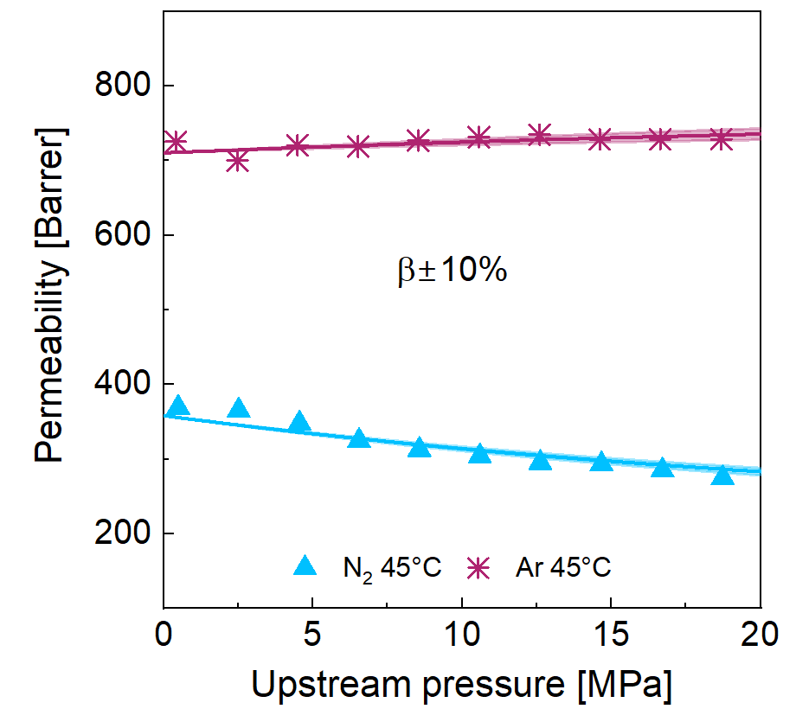
b
c
Figure S9, Contour plot of ±10% variation in (a) k_{ij}, (b) L₀, (c) β around the reference line, representing the reference optimal case, in PDMS at 35 °C (a), and 45°C (b) and (c). Experimental data from (a)[13,14], (b) and (c) [11,15]; curves are from (a) EoS, (b) and (c) STM calculations.

Error analysis – FKM
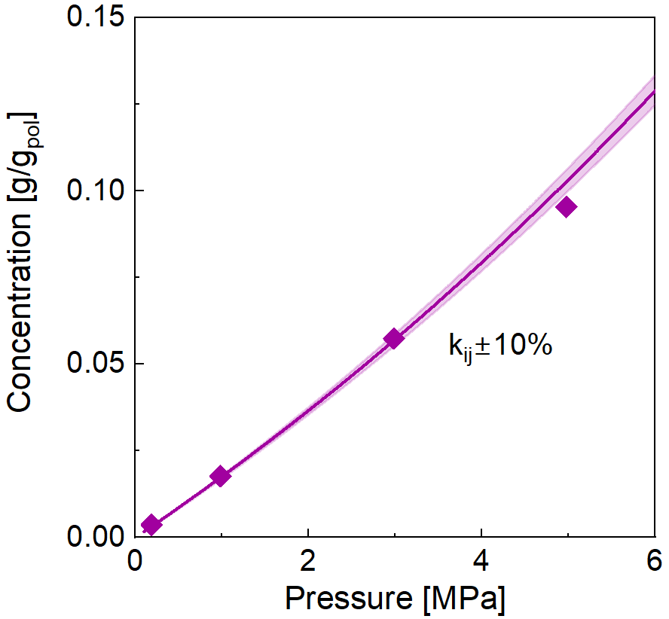
a
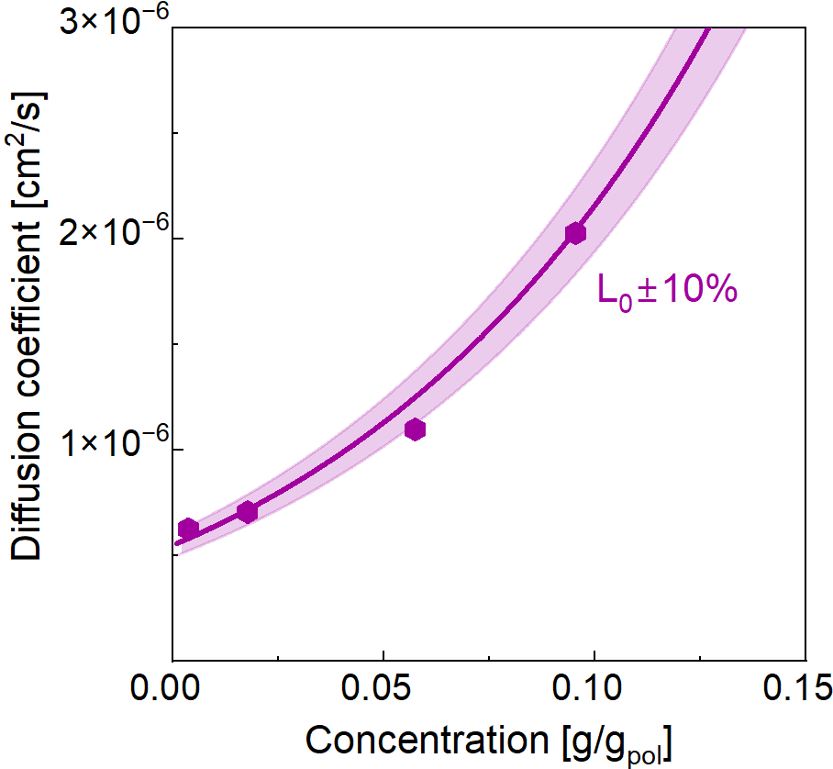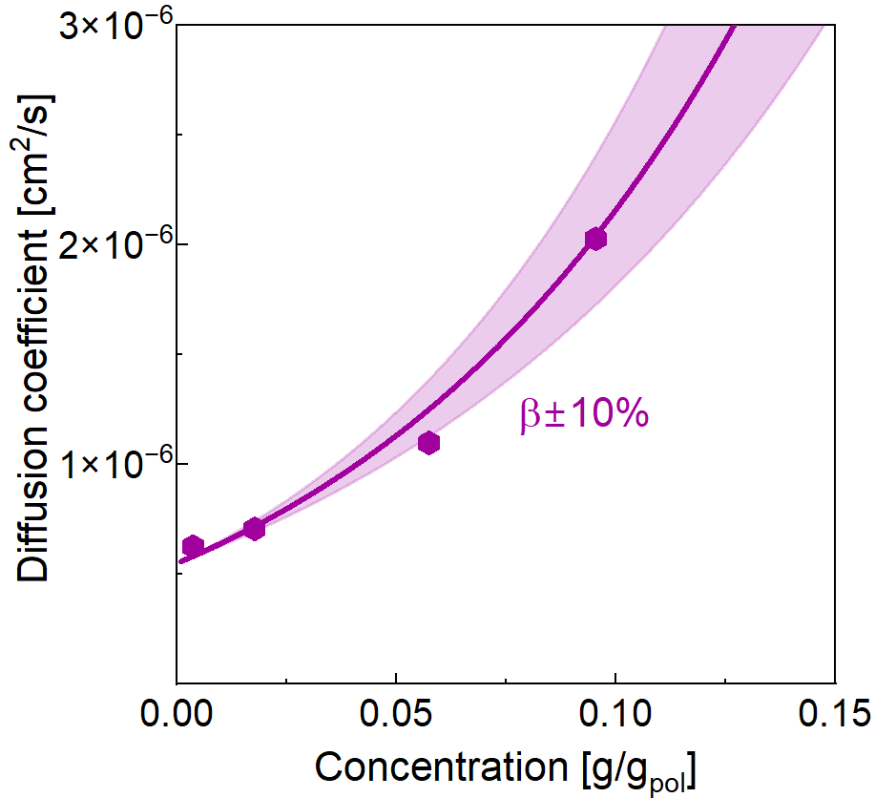
c
b
Figure S10, Contour plot of ±10% variation in (a) k_{ij}, (b) L₀, (c) β around the reference line, representing the reference optimal case, in FKM at 50°C. Experimental data from [10]; curves are from (a) EoS, (b) and (c) STM calculations.

References

[1] I.C. Sanchez, R.H. Lacombe, Statistical Thermodynamics of Polymer Solutions, Macromolecules 11 (1978) 1145–1156. https://doi.org/10.1021/ma60066a017.
[2] M. Minelli, M.G. De Angelis, An equation of state (EoS) based model for the fluid solubility in semicrystalline polymers, Fluid Phase Equilibria 367 (2014) 173–181. https://doi.org/10.1016/j.fluid.2014.01.024.
[3] M. Omidvar, C.M. Stafford, H. Lin, Thermally stable cross-linked P84 with superior membrane H2/CO2 separation properties at 100 °C, Journal of Membrane Science 575 (2019) 118–125. https://doi.org/10.1016/j.memsci.2019.01.003.
[4] M. Houben, J. Kloos, M. Van Essen, K. Nijmeijer, Z. Borneman, Systematic investigation of methods to suppress membrane plasticization during CO2 permeation at supercritical conditions, Journal of Membrane Science 647 (2022) 120292. https://doi.org/10.1016/j.memsci.2022.120292.
[5] D.M. Sterescu, D.F. Stamatialis, M. Wessling, Boltorn-modified polyimide gas separation membranes, Journal of Membrane Science 310 (2008) 512–521. https://doi.org/10.1016/j.memsci.2007.11.028.
[6] J. Ploegmakers, S. Japip, K. Nijmeijer, Mixed matrix membranes containing MOFs for ethylene/ethane separation—Part B: Effect of Cu₃BTC₂ on membrane transport properties, Journal of Membrane Science 428 (2013) 331–340. https://doi.org/10.1016/j.memsci.2012.11.013.
[7] M. Houben, R. Van Geijn, M. Van Essen, Z. Borneman, K. Nijmeijer, Supercritical CO₂ permeation in glassy polyimide membranes, Journal of Membrane Science 620 (2021) 118922. https://doi.org/10.1016/j.memsci.2020.118922.
[8] M. Mukaddam, E. Litwiller, I. Pinnau, Gas Sorption, Diffusion, and Permeation in Nafion, Macromolecules 49 (2016) 280–286. https://doi.org/10.1021/acs.macromol.5b02578.
[9] Z.P. Smith, R.R. Tiwari, M.E. Dose, K.L. Gleason, T.M. Murphy, D.F. Sanders, G. Gunawan, L.M. Robeson, D.R. Paul, B.D. Freeman, Influence of Diffusivity and Sorption on Helium and Hydrogen Separations in Hydrocarbon, Silicon, and Fluorocarbon-Based Polymers, Macromolecules 47 (2014) 3170–3184. https://doi.org/10.1021/ma402521h.
[10] L.M. Cai, K. Surve, J. Yun, A. Zolfaghari, X. Chen, A.K. Bhowmick, R. Krishnamoorti, Effect of Pressure and Temperature on the Sorption of Gases by Fluoroelastomers, Ind. Eng. Chem. Res. 61 (2022) 16721–16732. https://doi.org/10.1021/acs.iecr.2c02981.
[11] A. Shamu, M. Dunnewold, H. Miedema, Z. Borneman, K. Nijmeijer, Permeation of supercritical CO₂ through dense polymeric membranes, The Journal of Supercritical Fluids 144 (2019) 63–70. https://doi.org/10.1016/j.supflu.2018.10.009.
[12] R.C. Reis Nunes, M. López‐González, E. Riande, Basic studies on gas solubility in natural rubber–cellulose composites, J Polym Sci B Polym Phys 43 (2005) 2131–2140. https://doi.org/10.1002/polb.20507.
[13] L. Brandão, L.M. Madeira, A.M. Mendes, Mass transport on composite dense PDMS membranes with palladium nanoclusters, Journal of Membrane Science 288 (2007) 112–122. https://doi.org/10.1016/j.memsci.2006.10.052.
[14] T.C. Merkel, V.I. Bondar, K. Nagai, B.D. Freeman, I. Pinnau, Gas sorption, diffusion, and permeation in poly(dimethylsiloxane), Journal of Polymer Science Part B: Polymer Physics 38 (2000) 415–434. https://doi.org/10.1002/(SICI)1099-0488(20000201)38:3<415::AID-POLB8>3.0.CO;2-Z.
[15] A. Shamu, H. Miedema, K. Nijmeijer, Z. Borneman, The effect of supercritical CO2 on the permeation of dissolved water through PDMS membranes, Journal of CO2 Utilization 35 (2020) 145–152. https://doi.org/10.1016/j.jcou.2019.09.011.

