Supplementary Materials

Lipidomics reveals the reshaping of the mitochondrial phospholipid profile in cells lacking OPA1 and Mitofusins

Andrea Castellaneta¹, Ilario Losito^{1,2,*}, Vito Porcelli³, Serena Barile³, Alessandra Maresca⁴, Valentina Del Dotto⁵, Valentina Losacco¹, Ludovica Sofia Guadalupi¹, Cosima Damiana Calvano^{1,2}, David C. Chan⁶, Valerio Carelli^{4,5}, Luigi Palmieri^{3,7}, Tommaso R.I. Cataldi^{1,2}

¹Dipartimento di Chimica, ²Centro Interdipartimentale SMART and ³Dipartimento di Bioscienze, Biotecnologie e Ambiente - Università degli Studi di Bari Aldo Moro, via Orabona 4, 70126 Bari, Italy;
⁴IRCCS Istituto delle Scienze Neurologiche di Bologna, Programma di Neurogenetica, via Altura 3, 40139 Bologna, Italy;
⁵Dipartimento di Scienze Biomediche e Neuromotorie, Università degli Studi di Bologna, via Altura 3, 40139 Bologna, Italy;
⁶Division of Biology and Biological Engineering, California Institute of Technology, 1200 East California Boulevard, 91125 Pasadena, CA, USA.
⁷CNR-Istituto di Biomembrane, Bioenergetica e Biotecnologie Molecolari, Via Giovanni Amendola, 122/O, 70126 Bari, Italy

Figure S1. Graphical representation of the confidence intervals (α=0.05) obtained for the slopes of the calibration lines referred to several PL species in a concentration range from 0.01 to 10 µM, after the HILIC-ESI-FTMS analysis of their mixtures under the same conditions adopted for mitochondrial lipid extracts. Once subjected to Type-I correction, the intensities of the MS signals in the FTMS spectra averaged under the HILIC peaks pertaining to each lipid class were exploited as the analytical response. CL 14:0/14:0/14:0/14:0 (CL 56:0), CL 16:0/18:1/16:0/18:1 (CL 68:2), and CL 18:1/18:1/18:1/18:1 (CL 72:4) were considered as representative for CLs. PC 14:0/16:0 (PC 30:0), PC 16:1/16:1 (PC 32:2), PC P-18:0/18:1 (PC O-36:2), and PC 18:1/18:1 (PC 36:2) were considered as representative for PCs. PE 14:0/14:0 (PE 28:0) and PE P-18:0/18:1 (PE O-36:2) were considered as representative for PEs. PI 15:0/18:1 (PI 33:1) and PI 18:0/18:0 (PI 36:0) were considered as representative for PIs.

Figure S2. Details on the procedure adopted to obtain cropped gel images reported in panel A of Figure 1. The gels, loaded with mitochondrial fractions and cellular lysates separately, were transferred onto nitrocellulose membranes and stained with Ponceau S (A and B respectively). Afterwards, the membranes were cut where indicated. Sections 3 and 2 were incubated with an antibody against citrate synthase whereas sections 1 and 4 with an antibody against β-actin, as described in the main manuscript.

Figure S3. FTMS spectra averaged under chromatographic bands referred to PC and PC O (upper panel), and PE and PE O (lower panel), obtained by HILIC-ESI-FTMS analysis, in positive and negative polarity, respectively. The sample was a lipid extract of mitochondria isolated from wild-type MEFs. For the sake of clarity, peak signals referred to more abundant monoisotopic ions were labelled with the sum composition of the corresponding PL. In the case of alk(en)yl/acyl PL the sum composition label is reported as O-C:D, with C and D representing the total number of carbon atoms and C=C bonds of the side chains.

Figure S4. FTMS spectra averaged under chromatographic bands referred to PIs (upper panels) and CLs (lower panel) obtained by HILIC-ESI-FTMS analysis in negative polarity. The sample was a lipid extract of mitochondria isolated from wild-type MEFs. The m/z interval shown for CL is referred to the corresponding [M-2H]²⁻ ions. For the sake of clarity, peak signals referred to more abundant monoisotopic ions were labelled with the sum composition of the corresponding PLs.

Figure S5. Typical FTMS spectrum obtained for non-esterified fatty acids (NEFA) after spectral averaging under the corresponding band detected in the HILIC-ESI(-)-FTMS chromatogram referred to the mitochondrial lipid extract of wild-type MEF. A 5-fold vertical magnification was performed for the m/z interval 290-430, to facilitate the observation of peak signals referred to longer side chain NEFA (20 to 28 carbon atoms).

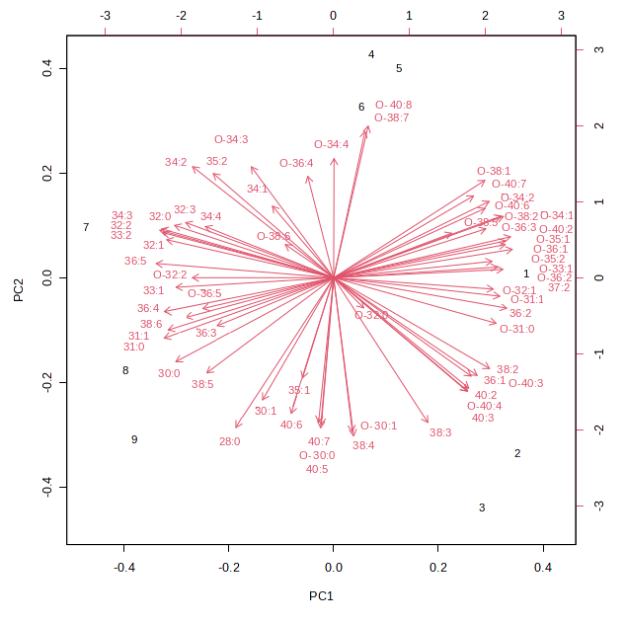
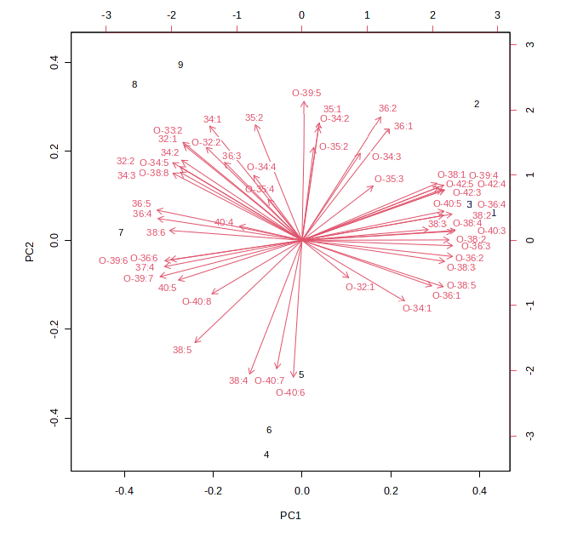
PC
PE

Figure S6. Biplots obtained for the first two principal components after the PCA based on intra-class relative abundances of PC and PE species, estimated after the HILIC-ESI-FTMS analysis of mitochondrial lipid extracts for wild-type (indicated as samples #1, 2, and 3 in the figure), OPA1^{-/-} (samples #4, 5 and 6) and Mfn1/2^{-/-} (samples #7, 8 and 9) MEF.
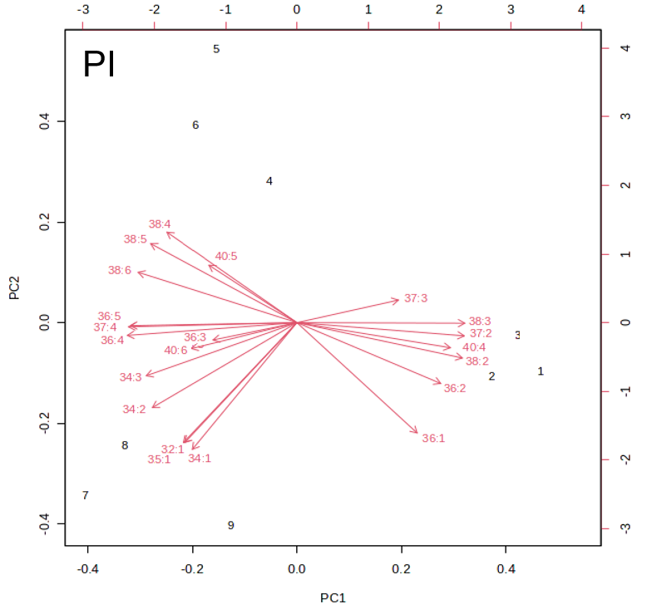

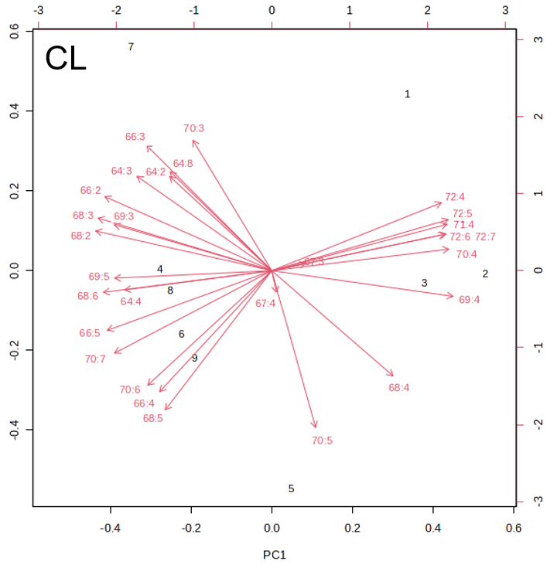

Figure S7. Biplots obtained for the first two principal components after the PCA based on intra-class relative abundances of PI and CL species, estimated after the HILIC-ESI-FTMS analysis of mitochondrial lipid extracts for wild-type (indicated as samples #1, 2, and 3 in the figure), OPA1^{-/-} (samples #4, 5 and 6) and Mfn1/2^{-/-} (samples #7, 8 and 9) MEF.

