SUPPORTING INFORMATION
Tunable Dye Adsorbing Materials from Crab and Shrimp Waste Shells for Water Remediation
C. Triunfo,^{1,2} K. Tsirtsidou,³ K. Vanhoutte,³ A. Mucaria,¹ D. Montroni,¹ S. Fermani,¹ G. Falini,^{1,*} and J. Robbens³

¹ Department of Chemistry “Giacomo Ciamician”, University of Bologna, via F. Selmi 2, 40126 Bologna, Italy. ² Fano Marine Center, viale Adriatico 1/N 61032 Fano, Italy. ³Aquatic Environment and Quality, Cell Blue Biotech and Food Integrity, Flanders Research Institute for Agriculture, Fisheries and Food (ILVO), Jacobsenstraat 1, 8400 Ostend, Belgium.

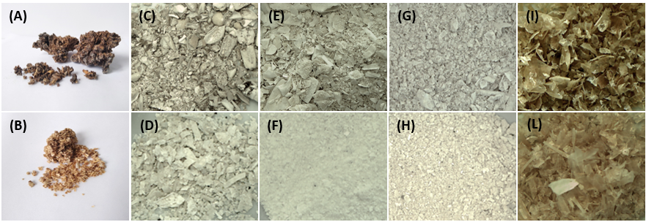
Figure S1. Camera images of CMC and BS raw material (A, B) and deproteinized (C, D), bleached (E, F), bleached/heated (G, H) ones, and chitin (I, L).

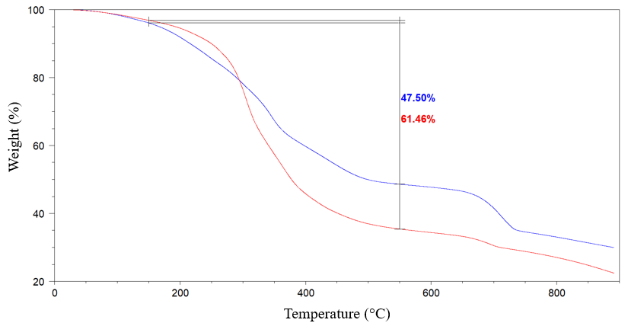
Figure S2. Thermogravimetrical analysis (TGA) profiles of CMC (blue) and BS (red) raw material. The temperature range considered to estimate the organic material content was between 150°C and 550°C.

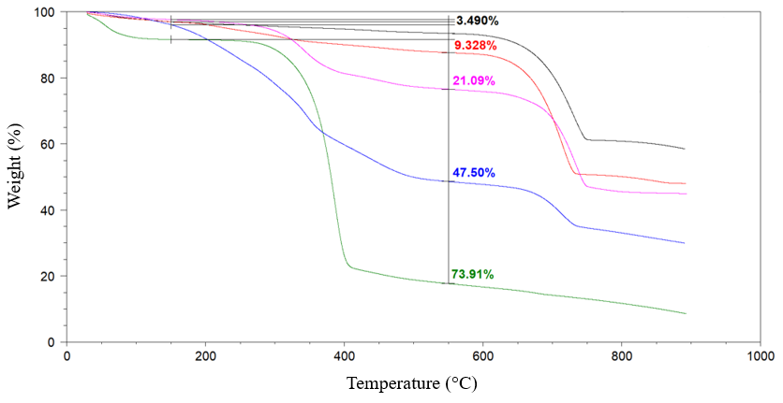
Figure S3. Thermogravimetrical analysis (TGA) profiles of CMC raw material (blue) and deproteinized (pink), bleached (red), bleached/heated (black) ones, and chitin (green). The temperature range considered to estimate the organic material content was between 150°C and 550°C.

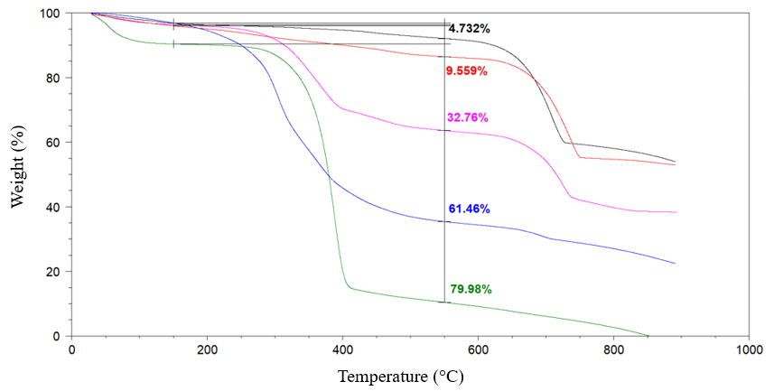
Figure S4. Thermogravimetrical analysis (TGA) profiles of BS raw material (blue) and deproteinized (pink), bleached (red), bleached/heated (black) ones, and chitin (green). The temperature range considered to estimate the organic material content was between 150 °C and 550 °C.
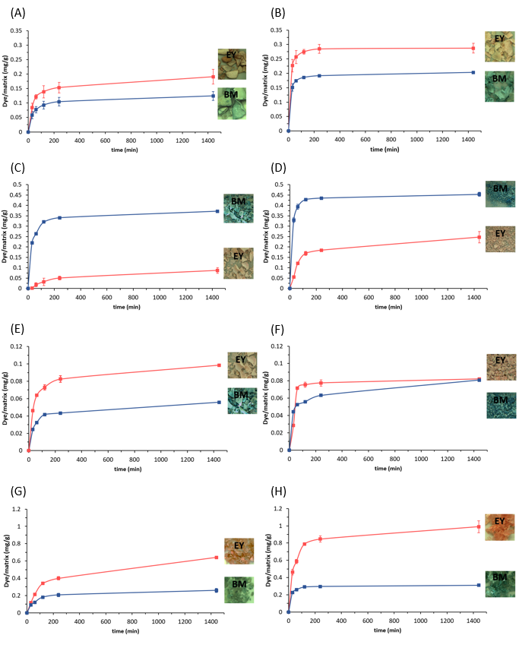
Figure S5. Adsorption kinetics and camera images of BM (blue dots) and EY (red dots) solutions at pH 7.2 on CMC and BS deproteinized (A, B), bleached (C, D), bleached/heated (E, F) shells, and chitin (G, H). The dye adsorbed is reported as the mass of dye (mg), normalized over the mass of substrate (g).

