Supplementary data

Quality Control (DNA-methylation)

Phenotype:
Overall sample at baseline: N=119
Phenotype data: N=119
DNA methylation available (Illumina EPIC-idat): N=116

Following QC, three additional samples were removed: N=113
- Technical issues and issues and bisulfite conversion controls: 3 samples
- Ethnicity outliers: none excluded.
Ancestry was estimated using available SNP data. Data-preparation and principal component composition were performed using PLINK¹ and R according to the protocol by Anderson et al.² Both principal confounders were considered for the statistical analyses performed.

Fig. S1: Ancestry comparison (based on SNP information); PC1 and PC2.

Epigenomic QC
QC: bisulfite conversion and ancestry: 3 samples excluded
Settings for preprocessing:
Normalisation method: wm.dasen normalisation (WateRmelon)
Greedycut: detection p-value cut-off 0.05
Removal of: SNP-related CGs, Sex-related CGs, cross-reactive probes

Table S1: Epigenomic QC
 | Probes at start | Samples at start
Total at start preprocessing | 866.895 | 113

Step (Filtering I) | Probes removed | Samples removed
Removal of SNP-enriched Probes | 139.721 | 0
Removal of Cross-reactive Probes | 34.264 | 0
Greedycut | 8.587 | 0
Total removed | 182.572 | 0

 | Probes retained | Samples retained
Total retained | 684.323 | 113

Step (Filtering II) | Probes removed | Samples removed
Context-specific Probes | 1.052 | 0
Removal of Probes on Sex Chromosomes | 16.223 | 0
Probes with Missing values > 90% | 153 | 0
Total removed | 17.428 | 0

 | Probes retained | Samples retained
Total retained | 666.895 | 113

Preparation of hierarchical clustering analysis 1

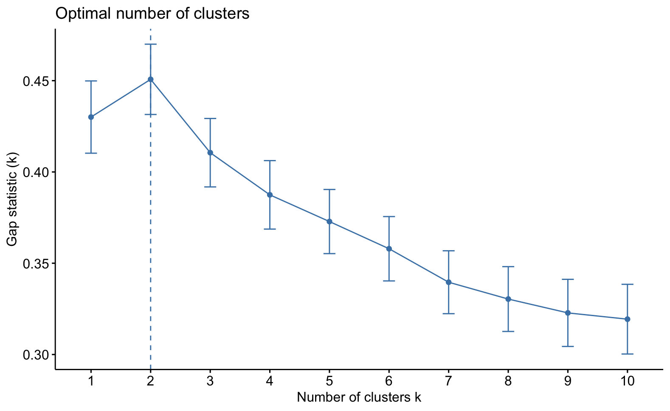
Fig. S2: Estimation of the optimal number of clusters (analysis 1): visual representation of GAP-statistic. The 2-cluster solution is considered optimal for this analysis.

Cytokines
A) Cluster analysis 1: immunomethylomics only. 1= CD4+/NK, 2=CD8+/B
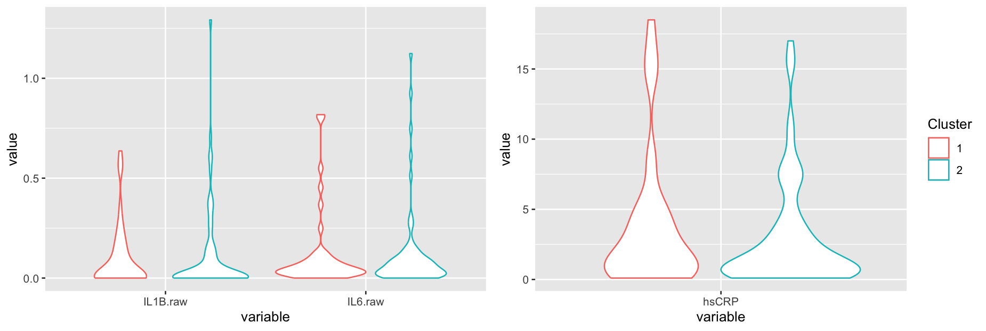
B) Cluster analysis 2: immunomethylomics + cytokines + hsCRP. 1= CD4+/NK’, 2= CD8+/B/IL-1β
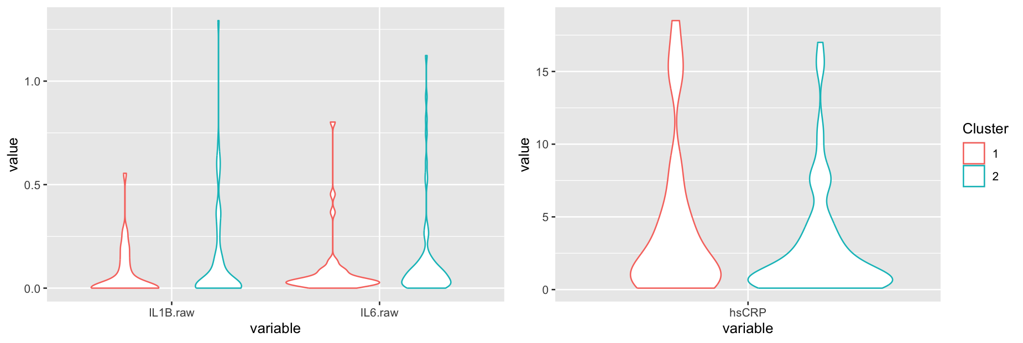
Fig. S3: Distribution of raw cytokines and hsCRP per Cluster. Value = concentration in pg/mL for both cytokines and mg/L for hsCRP.

Table S2: ANCOVA Clusters and cytokines; full model and model for each cytokine separately. Models were stratified per sex as well.

All | Full model; F(8,104) |  | hsCRP; F(6,106) |  | IL-1β; F(6,106) |  | IL-6; F(6,106)
 | F-value | p-value | F-value | p-value | F-value | p-value | F-value | p-value
hsCRP | 0.282 | 0.281 | 1.193 | 0.277 | - | - | - | -
IL-1β | 0.004 | 0.950 | - | - | 0.013 | 0.909 | - | -
IL-6 | 0.382 | 0.538 | - | - | - | - | 0.319 | 0.574
Sex | 1.700 | 0.195 | 1.899 | 0.171 | 2.441 | 0.121 | 2.264 | 0.135
BMI | 0.000 | 0.999 | 0.000 | 0.984 | 0.096 | 0.757 | 0.083 | 0.774
Education | 2.053 | 0.155 | 2.222 | 0.139 | 2.442 | 0.121 | 2.341 | 0.129
Comorbidity | 0.106 | 0.746 | 0.109 | 0.742 | 0.095 | 0.759 | 0.102 | 0.750
age | 1.200 | 0.276 | 1.181 | 0.280 | 1.298 | 0.257 | 1.315 | 0.254

Women | Full model; F(7,55) |  | hsCRP; F(5,57) |  | IL-1β; F(5,57) |  | IL-6; F(5,57)
 | F-value | p-value | F-value | p-value | F-value | p-value | F-value | p-value
hsCRP | 0.002 | 0.963 | 0.002 | 0.963 | - | - | - | -
IL-1β | 0.007 | 0.932 | - | - | 0.008 | 0.930 | - | -
IL-6 | 0.192 | 0.663 | - | - | - | - | 0.109 | 0.742
BMI | 0.172 | 0.680 | 0.145 | 0.705 | 0.100 | 0.753 | 0.111 | 0.740
Education | 1.324 | 0.255 | 1.509 | 0.224 | 1.574 | 0.215 | 1.425 | 0.237
Comorbidity | 0.334 | 0.566 | 0.384 | 0.538 | 0.362 | 0.550 | 0.343 | 0.560
age | 1.092 | 0.301 | 0.974 | 0.328 | 1.190 | 0.280 | 1.089 | 0.301

Men | Full model; F(7,42) |  | hsCRP; F(5,44) |  | IL-1β; F(5,44) |  | IL-6; F(5,44)
 | F-value | p-value | F-value | p-value | F-value | p-value | F-value | p-value
hsCRP | 2.342 | 0.133 | 2.452 | 0.125 | - | - | - | -
IL-1β | 0.023 | 0.880 | - | - | 0.004 | 0.947 | - | -
IL-6 | 0.004 | 0.953 | - | - | - | - | 0.030 | 0.864
BMI | 0.253 | 0.618 | 0.207 | 0.651 | 0.913 | 0.344 | 0.857 | 0.360
Education | 0.525 | 0.473 | 0.578 | 0.451 | 0.947 | 0.336 | 0.964 | 0.332
Comorbidity | 0.202 | 0.655 | 0.153 | 0.697 | 0.039 | 0.844 | 0.020 | 0.887
age | 1.019 | 0.319 | 1.161 | 0.287 | 0.765 | 0.387 | 0.853 | 0.361

Depression severity at baseline

Table S3: ANCOVA Clusters and depression severity at baseline

 | Full model; F(6,106) |  | Women; F(5,57) |  | Men; F(5,44)
 | F-value | p-value | F-value | p-value | F-value | p-value
MADRS at baseline | 1.536 | 0.218 | 0.379 | 0.541 | 1.282 | 0.264
Sex | 2.449 | 0.121 | - | - | - | -
BMI | 0.067 | 0.796 | 0.132 | 0.717 | 0.916 | 0.344
Education | 2.350 | 0.128 | 1.529 | 0.221 | 0.892 | 0.350
Comorbidity | 0.250 | 0.618 | 0.449 | 0.505 | 0.002 | 0.967
age | 1.555 | 0.215 | 0.859 | 0.358 | 1.900 | 0.175

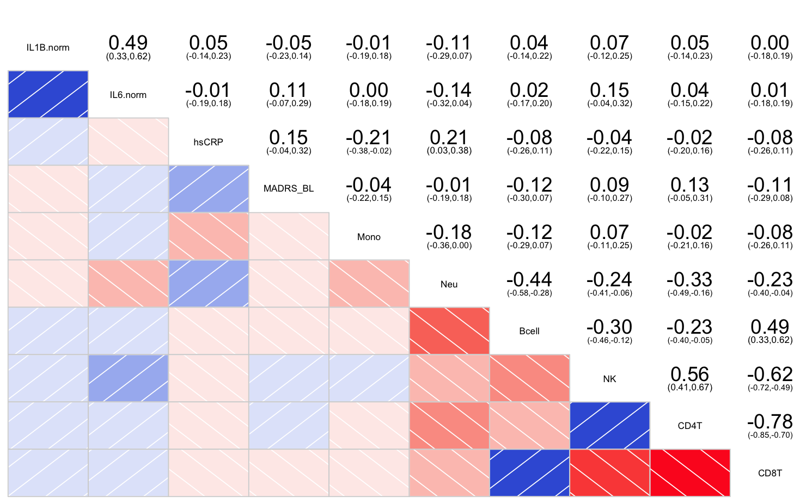
Fig. S4: corrgram of estimated cell-types, cytokines, and depression severity at baseline.

Depression severity at 6 weeks

Table S4: ANCOVA Clusters and depression severity after 6 weeks. Full model, full model + intervention, restricted model with depression severity and sex only. Also a stratified analysis is presented.

 | Full model; F(7,105) |  | Full + Intervention; F(8,104) |  | Restricted Model; F(3,109)
 | F-value | p-value | F-value | p-value | F-value | p-value
MADRS at baseline | 0.209 | 0.6484 | 0.213 | 0.6457 | 0.205 | 0.6513
MADRS at 6 weeks | 7.988 | 0.0056 | 8.119 | 0.0053 | 7.848 | 0.0060
Sex | 3.401 | 0.0680 | 3.457 | 0.0658 | 3.341 | 0.0703
BMI | 0.529 | 0.4686 | 0.538 | 0.4650 | - | -
Education | 2.085 | 0.1517 | 2.120 | 0.1484 | - | -
Comorbidity | 0.464 | 0.4975 | 0.471 | 0.4940 | - | -
age | 2.866 | 0.0934 | 2.949 | 0.0889 | - | -
Intervention | - | - | 2.689 | 0.1041 | - | -

 | Women; F(6,56) |  | Men; F(6,43)
 | F-value | p-value | F-value | p-value
MADRS at baseline | 0.778 | 0.3815 | 0.075 | 0.786
MADRS at 6 weeks | 6.953 | 0.0108 | 2.063 | 0.158
BMI | 0.001 | 0.9724 | 1.402 | 0.243
Education | 0.792 | 0.3772 | 1.120 | 0.296
Comorbidity | 0.710 | 0.4030 | 0.008 | 0.929
age | 2.607 | 0.1120 | 1.786 | 0.189

hsCRP and cytokine regression analyses

Overall analysis
lm(formula = MADRS Baseline ~ IL-1β + hsCRP + IL-6)
Residuals: Min 1Q Median 3Q Max
-16.5831 -4.3083 -0.4588 4.2893 14.9466

Estimate Std. Error t-value p
(Intercept) 26.9426 0.7625 35.336 <2e-16 ***
IL-1β -0.2600 0.1943 -1.338 0.1837
hsCRP 0.2322 0.1394 1.665 0.0987 .
IL-6 0.5413 0.3137 1.726 0.0873 .

Residual standard error: 6.399 on 109 degrees of freedom
Multiple R-squared: 0.05042, Adjusted R-squared: 0.02429
F-statistic: 1.929 on 3 and 109 DF, p-value: 0.1291

Sex-stratified (men)
lm(formula = MADRS Baseline ~ IL-1β + hsCRP + IL-6)
Residuals: Min 1Q Median 3Q Max
-15.2208 -4.4467 -0.8506 2.8623 13.4203

Estimate Std. Error t-value p
(Intercept) 27.88849 1.21675 22.921 <2e-16 ***
IL-1β -0.53956 0.30797 -1.752 0.0864 .
hsCRP -0.06782 0.30095 -0.225 0.8227
IL-6 0.97602 0.45439 2.148 0.0370 *

Residual standard error: 6.683 on 46 degrees of freedom
Multiple R-squared: 0.104, Adjusted R-squared: 0.04557
F-statistic: 1.78 on 3 and 46 DF, p-value: 0.1642

Sex-stratified (women)
lm(formula = MADRS Baseline ~ IL-1β + hsCRP + IL-6)

Residuals: Min 1Q Median 3Q Max
-15.5540 -4.4632 -0.5939 4.8896 12.3909

Estimate Std. Error t-value p
(Intercept) 26.44682 1.03932 25.446 <2e-16 ***
IL-1β -0.02391 0.25092 -0.095 0.9244
hsCRP 0.32102 0.16194 1.982 0.0521 .
IL-6 0.21587 0.45671 0.473 0.6382

Residual standard error: 6.182 on 59 degrees of freedom
Multiple R-squared: 0.06273, Adjusted R-squared: 0.01507
F-statistic: 1.316 on 3 and 59 DF, p-value: 0.2776

Preparation of hierarchical clustering analysis 2

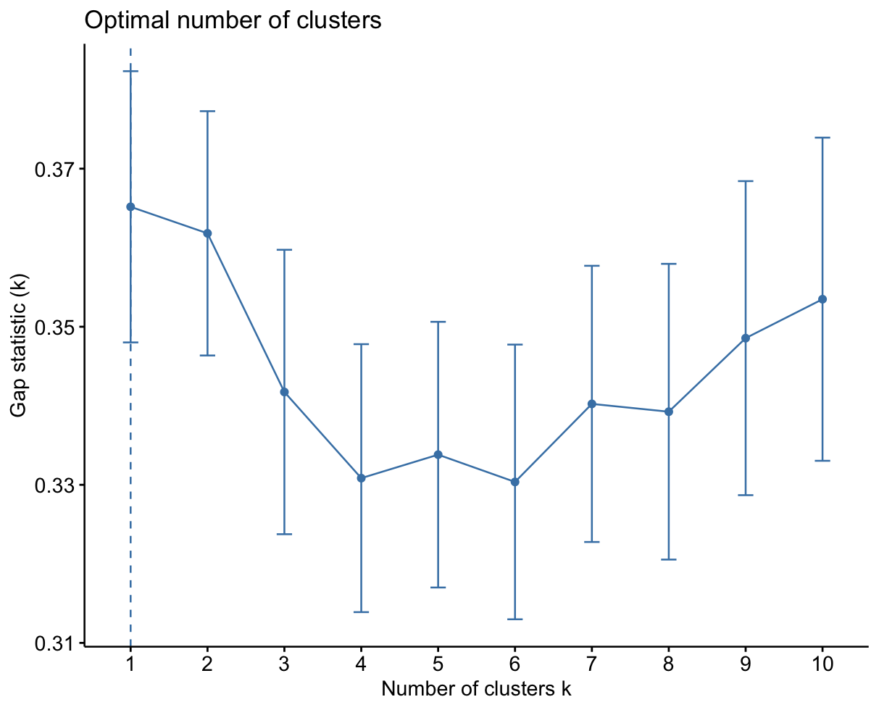
Fig. S5: Estimation of optimal number of Clusters for the second cluster analysis.
Table S4: Characteristics of clusters 1’ and 2’
 | Cluster 1’ | Cluster 2’
Sample
N | N=38 | N=75
% women (N) | 61% (23) | N=53% (40) | p=0.55
Age (M; SD) | 41.4 (15.0) | 46.0 (13.7) | F(1,111)=2.69, p=0.10
BMI (M; SD) | 30.5 (8.0) | 29.5 (6.7) | F(1,111)=0.51, p=0.48
Years of education (M; SD) | 13.5 (2.5) | 14.4 (2.0) | F(1,111)=3.95, p=0.049
Presence of medical  Comorbidity (yes/no) | 33/5 | 66/9 | p=1
(*) Intervention group (celecoxib(%)) | 22 (58%) | 30 (44%) | p=0.077
Estimated cell-type proportions, hsCRP, and cytokines
B-cells (M; SD) | 0.07 (0.02) | 0.08 (0.02) | F(1,111)= 7.61, p=0.0068
Monocytes (M; SD) | 0.10 (0.03) | 0.10 (0.02) | F(1,111)=0.14, p=0.71
Neutrophils (M; SD) | 0.59 (0.09) | 0.62 (0.08) | F(1,111)= 2.74, p=0.10
Natural Killer-cells (M; SD) | 0.00 (0.03) | -0.04 (0.03) | F(1,111)= 58.31, p<0.001
CD4-T (M; SD) | 0.10 (0.07) | -0.05 (0.08) | F(1,111)= 95.16, p<0.001
CD8-T (M; SD) | 0.20 (0.05) | 0.37 (0.11) | F(1,111)= 82.38, p<0.001
hsCRP (median; SD) | 1.90 (5.21 | 1.20 (3.79) | IC:[-0.20, 1.40], p=0.15
IL-1β (median; SD) | 0.00 (0.12) | 0.023 (0.23) | IC:[-2.55x10⁻², 5.40x10⁻⁶], p=0.069
IL-6 (median; SD) | 0.034 (0.15) | 0.062 (0.22) | IC:[-0.038, 0.0042], p=0.16
Cell-type proportions, hsCRP (mg/L), and cytokines (pg/mL) are described as non-scaled, raw coefficients and standardized concentrations, respectively.

