Supplementary Material

Movement ecology of a coastal foundation seagrass species: insights from genetic data and oceanographic modelling

Table S1. List of 16 microsatellites used in this analysis with related motif, concentration, label and sequences.

Primer Name | Primer Motif | Primer  concentration  added [pmol] | Label | Sequences
1st multiplex
Poc-45*** | (TCC)8 (TTC)4 | 5 | PET | F:AAATTGCCAGATTCTGGTGTCA  R:AACCACGTGAGTAAGGGAGGG
Po-5-10** | (GA)13 | 10 | PET | F:ATGAGACTCCCACAATAACA  R:CATGGGAAGGTATAGAAGC
Po-4-3** | (GA)10 | 10 | 6-FAM | F:ACAGAAACTACGAACCATCAG  R:TAAGGAGAAGGAGAAGGAAA
Pooc-361*** | (TC)17 | 3 | NED | F:GTGTTTTGGGCTTGACTAAGAGAT  R:AGGCAACAATTAAGATAGCCCAAAC
Po-5-39** | (GA)13 | 5 | VIC | F:CATTTGGCTGAGTCCCTTTC  R:GTCCAAGGCTTCCGTGATGG
Poc-35* | (TCC)11 | 2 | 6-FAM | F:TGGCAAAGTCAATGGCAATAGTAG  R:GTACGTCGTCTCGGATGGGAGA
Poc-42*** | (TGC)6 | 5 | 6-FAM | F:CTCCTTCCTGTACATTCCCCTC  R:TGGTCTCTCCCCTTCTCTCACT
2nd multiplex
Po-15** | (GA)20 | 5 | NED | F:AAGCACGCCGCTTAAACCATA  R:CATGTTAGTAGGCAATATACTAGGC
Pooc-229*** | (ACG)10 | 5 | PET | F:CTCAGGGGAAGGTAGAAGAGATG  R:CTGCTTTGTTTCCTCAAAAAGTG
Po-5** | (GA)20 | 5 | VIC | F:CACAATGGCCCGGTAGCA  R:GTGGTTGCGTGCCTTCGGTTG
Poc-5* | (TGG)10 | 3 | NED | F:TCTTCGGCTTGTGCTCGTCCTTGA  R:GCCTCTCCTGCCCACCACCGCT
Pooc-PC045G11*** | (GA)18 | 10 | NED | F:CTCCACCATCCGCCCCCATTTG  R:CTTCGACAACCTTGCAGGCCCT
Pooc-153*** | (AG)16 | 10 | PET | F:TCCTCCCAATCTAATTTGCTG  R:AAGAACAGTGAGCGCCAGAC
Pooc-330*** | (GAT)4 | 8 | VIC | F:GGAAAACAGCAGCAATCAATC  R:ACGTCTACATCCTCGACCAC
Pooc-044B02*** | (CA)5 | 5 | NED | F:GCTGCAACTAATACACCTCG  R:AGGGACGTGATATGCGAGAC
Pooc-333*** | (TCT)10 | 10 | VIC | F:AAAAGTGTTTGAGAGAAACAACTCG  R:ACCTTTGACTTCTCCTTCTGAATCT
*Procaccini and Waycott, 1998; **Alberto et al., 2003; ***Arranz et al., 2013

Table S2. LOSITAN analysis of P. oceanica individuals from established meadows and seed cohorts. Candidate outlier loci are highlighted in bold.

Established Meadows
Locus | Het | Fst | P (Simul Fst<sample Fst) | FDR
Po-15 | 0.838 | 0.058 | 0.020
Poc-229 | 0.430 | 0.044 | 0.107
Po-5 | 0.562 | 0.202 | 0.891
Poc-5 | 0.081 | 0.024 | 0.170
Pooc-PC045G11 | 0.843 | 0.066 | 0.045
Pooc-153 | 0.269 | 0.089 | 0.410
Pooc-330 | 0.496 | 0.008 | 0.016
Pooc-044B02 | 0.491 | -0.035 | 0.000 | Outlier
Pooc-333 | 0.556 | -0.003 | 0.001 | Outlier
Poc-45 | 0.325 | 0.117 | 0.536
Po-5-10 | 0.644 | 0.145 | 0.666
Po-4-3 | 0.598 | 0.395 | 1.000 | Outlier
Po-5-39 | 0.530 | 0.064 | 0.171
Pooc-361 | 0.729 | 0.216 | 0.957
Poc-35 | 0.671 | 0.074 | 0.185
Poc-42 | 0.510 | 0.181 | 0.775
Seed Cohorts
Locus | Het | Fst | P(Simul Fst<sample Fst) | FDR
Po-15 | 0.848 | 0.027 | 0.450
Poc-229 | 0.489 | -0.003 | 0.057
Po-5 | 0.617 | 0.031 | 0.549
Poc-5 | 0.050 | -0.006 | 0.047
Pooc-PC045G11 | 0.869 | 0.048 | 0.935
Pooc-153 | 0.181 | 0.023 | 0.477
Pooc-330 | 0.503 | 0.032 | 0.557
Pooc-044B02 | 0.489 | -0.008 | 0.023
Pooc-333 | 0.639 | 0.070 | 0.964
Poc-45 | 0.391 | 0.004 | 0.108
Po-5-10 | 0.635 | 0.046 | 0.811
Po-4-3 | 0.423 | 0.043 | 0.735
Po-5-39 | 0.518 | 0.040 | 0.704
Pooc-361 | 0.738 | 0.038 | 0.687
Poc-35 | 0.606 | 0.052 | 0.879
Poc-42 | 0.504 | 0.041 | 0.687

Table S3. Detailed output of BayeScan analysis of P. oceanica individuals from established meadows and seed cohorts. Putative outlier loci (FDR ≤0.05) are highlighted in bold.

Established Meadows
Locus | prob | log10(PO) | alpha | F_{ST}
Po-15 | 0.300 | -0.368 | -0.224 | 0.115
Poc-229 | 0.797 | 0.595 | -1.256 | 0.060
Po-5 | 0.067 | -1.145 | 0.028 | 0.138
Poc-5 | 0.081 | -1.055 | -0.033 | 0.133
Pooc-PC045G11 | 0.251 | -0.474 | -0.181 | 0.119
Pooc-153 | 0.092 | -0.994 | -0.053 | 0.131
Pooc-330 | 0.083 | -1.042 | -0.054 | 0.131
Pooc-044B02 | 0.663 | 0.293 | -1.066 | 0.071
Pooc-333 | 0.598 | 0.173 | -0.756 | 0.084
Poc-45 | 0.063 | -1.171 | 0.004 | 0.135
Po-5-10 | 0.075 | -1.092 | -0.036 | 0.132
Po-4-3 | 0.986 | 1.854 | 1.240 | 0.314
Po-5-39 | 0.059 | -1.206 | 0.015 | 0.136
Pooc-361 | 0.043 | -1.343 | 0.010 | 0.136
Poc-35 | 0.067 | -1.147 | 0.027 | 0.138
Poc-42 | 0.058 | -1.207 | -0.013 | 0.134
Seed Cohorts
Locus | prob | log10(PO) | alpha | F_{ST}
Po-15 | 0.370 | -0.232 | -0.223 | 0.052
Poc-229 | 0.760 | 0.501 | -1.009 | 0.030
Po-5 | 0.049 | -1.290 | -0.013 | 0.062
Poc-5 | 0.090 | -1.007 | -0.046 | 0.061
Pooc-PC045G11 | 0.024 | -1.602 | -0.005 | 0.062
Pooc-153 | 0.069 | -1.129 | -0.019 | 0.062
Pooc-330 | 0.071 | -1.115 | -0.031 | 0.061
Pooc-044B02 | 0.465 | -0.061 | -0.658 | 0.042
Pooc-333 | 0.046 | -1.317 | 0.011 | 0.063
Poc-45 | 0.188 | -0.635 | -0.204 | 0.055
Po-5-10 | 0.046 | -1.317 | -0.003 | 0.062
Po-4-3 | 0.046 | -1.321 | 0.002 | 0.062
Po-5-39 | 0.048 | -1.297 | -0.004 | 0.062
Pooc-361 | 0.169 | -0.693 | -0.108 | 0.057
Poc-35 | 0.040 | -1.380 | -0.009 | 0.062
Poc-42 | 0.065 | -1.159 | -0.023 | 0.061

Table S4. Pairwise F_{ST} matrix (below the diagonal) and significance level (above the diagonal) based on 1023 permutations between 8 established meadows of P. oceanica calculated in Arlequin 3.5.2.2 considering only neutral loci. *p <0.05; **p <0.01; ***p <0.001

 | NI | IF | MAC | CO | MA | SI | FO | SM
NI |  | *** | ** | ** | *** | *** | *** | ***
IF | 0.091 |  | ns | ** | *** | *** | *** | ***
MAC | 0.124 | 0.145 |  | * | * | ** | ** | ns
CO | 0.023 | 0.045 | 0.053 |  | *** | *** | *** | *
MA | 0.107 | 0.096 | 0.088 | 0.061 |  | *** | *** | *
SI | 0.067 | 0.067 | 0.173 | 0.049 | 0.045 |  | ** | ***
FO | 0.053 | 0.081 | 0.182 | 0.053 | 0.119 | 0.046 |  | ***
SM | 0.067 | 0.068 | 0.091 | 0.026 | 0.020 | 0.042 | 0.056

Table S5. Pairwise F_{ST} matrix (below the diagonal) and significance level (above the diagonal) based on 1023 permutations between 9 seed cohorts of P. oceanica calculated in Arlequin 3.5.2.2 considering all loci. *p <0.05; **p <0.01; ***p <0.001

 | NI_s | IF_s | MAC_s | CO_s | VA_s | MA_s | SI_s | FO_s | SM_s
NI_s |  | *** | *** | *** | *** | *** | *** | *** | ***
IF_s | 0.087 |  | *** | *** | *** | *** | ** | *** | ***
MAC_s | 0.062 | 0.033 |  | * | *** | *** | ns | ** | ***
CO_s | 0.050 | 0.047 | 0.011 |  | ns | ** | ns | * | ***
VA_s | 0.041 | 0.064 | 0.026 | -0.003 |  | *** | ns | *** | ***
MA_s | 0.047 | 0.056 | 0.024 | 0.021 | 0.037 |  | ** | *** | ***
SI_s | 0.029 | 0.024 | 0.008 | 0.000 | 0.004 | 0.027 |  | * | ***
FO_s | 0.064 | 0.041 | 0.017 | 0.018 | 0.032 | 0.023 | 0.013 |  | ***
SM_s | 0.073 | 0.050 | 0.026 | 0.027 | 0.038 | 0.040 | 0.033 | 0.024

Table S6. Pairwise G'_{ST} (Nei) matrix (below the diagonal) and significance level (above the diagonal) based on 9999 permutations between 8 established meadows of P. oceanica calculated in GenAlEx 6.5 considering only neutral loci. *p <0.05; **p <0.01; ***p <0.001

 | NI | IF | MAC | CO | MA | SI | FO | SM
NI |  | *** | * | ** | *** | *** | *** | ***
IF | 0.097 |  | * | ** | *** | *** | *** | **
MAC | 0.172 | 0.232 |  | ** | * | * | ** | *
CO | 0.032 | 0.043 | 0.143 |  | *** | *** | *** | **
MA | 0.102 | 0.106 | 0.131 | 0.074 |  | ** | *** | **
SI | 0.065 | 0.072 | 0.216 | 0.054 | 0.036 |  | ** | **
FO | 0.061 | 0.079 | 0.232 | 0.057 | 0.101 | 0.040 |  | **
SM | 0.081 | 0.075 | 0.179 | 0.041 | 0.035 | 0.052 | 0.053

Table S7. Pairwise G'_{ST} (Nei) matrix (below the diagonal) and significance level (above the diagonal) based on 9999 permutations between 9 seed cohorts of P. oceanica calculated in GenAlEx 6.5 considering all loci. *p <0.05; **p <0.01; ***p <0.001

 | NI_s | IF_s | MAC_s | CO_s | VA_s | MA_s | SI_s | FO_s | SM_s
NI_s |  | *** | *** | *** | *** | *** | ** | *** | ***
IF_s | 0.083 |  | *** | *** | *** | *** | ** | *** | ***
MAC_s | 0.072 | 0.034 |  | ** | ** | *** | ns | ** | ***
CO_s | 0.056 | 0.042 | 0.020 |  | ns | ** | ns | ** | ***
VA_s | 0.046 | 0.059 | 0.023 | 0.003 |  | *** | ns | ** | ***
MA_s | 0.043 | 0.051 | 0.039 | 0.021 | 0.042 |  | ** | *** | ***
SI_s | 0.033 | 0.019 | 0.011 | -0.004 | 0.003 | 0.022 |  | * | ***
FO_s | 0.064 | 0.042 | 0.018 | 0.025 | 0.027 | 0.031 | 0.015 |  | **
SM_s | 0.078 | 0.060 | 0.030 | 0.036 | 0.037 | 0.054 | 0.038 | 0.023

Table S8. Pairwise D_{est} matrix (below the diagonal) and significance level (above the diagonal) based on 9999 permutations between 8 established meadows of P. oceanica calculated in GenAlEx 6.5 considering only neutral loci. *p <0.05; **p <0.01; ***p <0.001

 | NI | IF | MAC | CO | MA | SI | FO | SM
NI |  | *** | * | ** | *** | *** | *** | ***
IF | 0.110 |  | * | ** | *** | *** | *** | **
MAC | 0.152 | 0.215 |  | * | * | * | ** | *
CO | 0.036 | 0.048 | 0.127 |  | *** | *** | *** | **
MA | 0.112 | 0.114 | 0.101 | 0.081 |  | ** | *** | **
SI | 0.073 | 0.079 | 0.203 | 0.063 | 0.037 |  | ** | **
FO | 0.076 | 0.097 | 0.256 | 0.075 | 0.122 | 0.049 |  | **
SM | 0.090 | 0.081 | 0.153 | 0.046 | 0.034 | 0.056 | 0.063

Table S9. Pairwise D_{est} matrix (below the diagonal) and significance level (above the diagonal) based on 9999 permutations between 9 seed cohorts of P. oceanica calculated in GenAlEx 6.5 considering all loci. *p <0.05; **p <0.01; ***p <0.001

 | NI_s | IF_s | MAC_s | CO_s | VA_s | MA_s | SI_s | FO_s | SM_s
NI_s |  | *** | *** | *** | *** | *** | ** | *** | ***
IF_s | 0.095 |  | *** | *** | *** | *** | ** | *** | ***
MAC_s | 0.082 | 0.038 |  | ** | ** | *** | ns | ** | ***
CO_s | 0.065 | 0.047 | 0.022 |  | ns | ** | ns | ** | ***
VA_s | 0.050 | 0.065 | 0.025 | 0.003 |  | *** | ns | ** | ***
MA_s | 0.048 | 0.057 | 0.044 | 0.023 | 0.045 |  | ** | *** | ***
SI_s | 0.038 | 0.022 | 0.013 | -0.005 | 0.004 | 0.026 |  | * | ***
FO_s | 0.076 | 0.049 | 0.020 | 0.030 | 0.031 | 0.036 | 0.018 |  | **
SM_s | 0.103 | 0.078 | 0.039 | 0.048 | 0.047 | 0.070 | 0.052 | 0.031

Table S10. Pairwise G'_{ST} (Nei) matrix (below the diagonal) and significance level (above the diagonal) based on 9999 permutations between 8 established meadows and 9 seed cohorts of P. oceanica calculated in GenAlEx 6.5 considering only neutral loci. *p <0.05; **p <0.01; ***p <0.001

 | NI | IF | MAC | CO | MA | SI | FO | SM | NI_s | IF_s | MAC_s | CO_s | VA_s | MA_s | SI_s | FO_s | SM_s
NI |  | *** | * | ** | *** | *** | *** | *** | ** | *** | *** | *** | *** | *** | ** | *** | ***
IF | 0.097 |  | * | ** | *** | *** | *** | ** | *** | *** | ** | ** | ** | ** | *** | ** | ***
MAC | 0.172 | 0.232 |  | ** | * | * | ** | * | ** | ** | ** | ** | ** | * | ** | ** | **
CO | 0.032 | 0.043 | 0.143 |  | *** | *** | *** | ** | *** | *** | ** | *** | ** | *** | * | ** | ***
MA | 0.102 | 0.106 | 0.131 | 0.074 |  | * | *** | ** | *** | *** | *** | *** | *** | * | ** | *** | ***
SI | 0.065 | 0.072 | 0.216 | 0.054 | 0.036 |  | ** | ** | *** | *** | * | ns | ** | * | * | ** | ***
FO | 0.061 | 0.079 | 0.232 | 0.057 | 0.101 | 0.040 |  | ** | *** | *** | ** | ** | ** | *** | ** | ** | ns
SM | 0.081 | 0.075 | 0.179 | 0.041 | 0.035 | 0.052 | 0.053 |  | *** | *** | ** | *** | ** | *** | ** | * | **
NI_s | 0.030 | 0.094 | 0.107 | 0.049 | 0.046 | 0.059 | 0.095 | 0.059 |  | *** | *** | *** | *** | *** | ** | *** | ***
IF_s | 0.063 | 0.096 | 0.161 | 0.051 | 0.057 | 0.067 | 0.074 | 0.041 | 0.080 |  | *** | *** | *** | *** | * | *** | ***
MAC_s | 0.060 | 0.047 | 0.225 | 0.026 | 0.055 | 0.017 | 0.045 | 0.034 | 0.073 | 0.035 |  | ** | ** | *** | * | ** | ***
CO_s | 0.045 | 0.048 | 0.174 | 0.041 | 0.055 | 0.012 | 0.023 | 0.048 | 0.054 | 0.044 | 0.021 |  | ns | ** | ns | ** | ***
VA_s | 0.035 | 0.045 | 0.184 | 0.029 | 0.060 | 0.030 | 0.040 | 0.036 | 0.037 | 0.060 | 0.023 | 0.003 |  | *** | ns | ** | ***
MA_s | 0.071 | 0.053 | 0.132 | 0.042 | 0.021 | 0.020 | 0.056 | 0.046 | 0.037 | 0.054 | 0.039 | 0.022 | 0.043 |  | ** | *** | ***
SI_s | 0.024 | 0.054 | 0.136 | 0.021 | 0.027 | 0.020 | 0.033 | 0.028 | 0.033 | 0.018 | 0.014 | -0.004 | 0.002 | 0.021 |  | * | ***
FO_s | 0.070 | 0.048 | 0.164 | 0.036 | 0.053 | 0.030 | 0.024 | 0.021 | 0.067 | 0.042 | 0.018 | 0.026 | 0.024 | 0.030 | 0.016 |  | **
SM_s | 0.064 | 0.073 | 0.184 | 0.044 | 0.078 | 0.046 | 0.013 | 0.030 | 0.079 | 0.060 | 0.031 | 0.038 | 0.035 | 0.053 | 0.040 | 0.022

Table S11. Pairwise D_{est} matrix (below the diagonal) and significance level (above the diagonal) based on 9999 permutations between 8 established meadows and 9 seed cohorts of P. oceanica calculated in GenAlEx 6.5 considering only neutral loci. *p <0.05; **p <0.01; ***p <0.001

 | NI | IF | MAC | CO | MA | SI | FO | SM | NI_s | IF_s | MAC_s | CO_s | VA_s | MA_s | SI_s | FO_s | SM_s
NI |  | *** | * | ** | *** | *** | *** | *** | ** | *** | *** | *** | *** | *** | ** | *** | ***
IF | 0.110 |  | * | ** | *** | ** | *** | ** | *** | *** | ** | ** | ** | ** | *** | ** | ***
MAC | 0.152 | 0.215 |  | * | * | * | ** | * | * | ** | ** | ** | ** | * | * | ** | **
CO | 0.036 | 0.048 | 0.127 |  | *** | *** | *** | ** | *** | *** | ** | *** | ** | *** | * | ** | ***
MA | 0.112 | 0.114 | 0.101 | 0.081 |  | ** | *** | ** | *** | *** | *** | *** | *** | * | ** | *** | ***
SI | 0.073 | 0.079 | 0.203 | 0.063 | 0.037 |  | ** | ** | *** | *** | * | ns | ** | * | * | ** | ***
FO | 0.076 | 0.097 | 0.256 | 0.075 | 0.122 | 0.049 |  | ** | *** | *** | ** | ** | ** | *** | *** | ** | ns
SM | 0.090 | 0.081 | 0.153 | 0.046 | 0.034 | 0.056 | 0.063 |  | *** | *** | ** | *** | ** | *** | ** | * | **
NI_s | 0.032 | 0.106 | 0.088 | 0.056 | 0.046 | 0.066 | 0.121 | 0.064 |  | *** | *** | *** | *** | *** | ** | *** | ***
IF_s | 0.074 | 0.113 | 0.150 | 0.061 | 0.061 | 0.079 | 0.097 | 0.045 | 0.094 |  | *** | *** | *** | *** | * | *** | ***
MAC_s | 0.069 | 0.052 | 0.215 | 0.030 | 0.058 | 0.018 | 0.056 | 0.037 | 0.084 | 0.040 |  | ** | ** | *** | * | ** | ***
CO_s | 0.053 | 0.055 | 0.171 | 0.050 | 0.061 | 0.013 | 0.029 | 0.055 | 0.064 | 0.053 | 0.024 |  | ns | ** | ns | ** | ***
VA_s | 0.039 | 0.050 | 0.171 | 0.033 | 0.064 | 0.033 | 0.049 | 0.039 | 0.041 | 0.071 | 0.026 | 0.004 |  | *** | ns | ** | ***
MA_s | 0.083 | 0.060 | 0.120 | 0.050 | 0.022 | 0.023 | 0.072 | 0.051 | 0.042 | 0.064 | 0.046 | 0.026 | 0.050 |  | ** | *** | ***
SI_s | 0.028 | 0.063 | 0.128 | 0.025 | 0.029 | 0.023 | 0.042 | 0.032 | 0.038 | 0.022 | 0.016 | -0.005 | 0.002 | 0.025 |  | * | ***
FO_s | 0.085 | 0.056 | 0.159 | 0.044 | 0.059 | 0.035 | 0.032 | 0.024 | 0.080 | 0.052 | 0.022 | 0.032 | 0.029 | 0.037 | 0.020 |  | **
SM_s | 0.086 | 0.096 | 0.204 | 0.060 | 0.097 | 0.059 | 0.018 | 0.037 | 0.106 | 0.082 | 0.040 | 0.051 | 0.047 | 0.073 | 0.055 | 0.030

Table S12. Hierarchical Analysis of Molecular Variance (AMOVA) based on 9999 permutations of P. oceanica considering only neutral loci. Individual samples were pooled into two groups: (i) established meadows (8), (ii) seed cohorts (9)

Source | df | SS | MS | Est. Var. | %
Among Groups | 1 | 6.107 | 6.107 | 0.000 | 0%
Among ‘Pops’ within groups | 15 | 159.041 | 10.603 | 0.199 | 5%
Among Individuals | 270 | 1054.689 | 3.906 | 0.000 | 0%
Within Individuals | 287 | 1158.500 | 4.037 | 4.037 | 95%
Total | 573 | 2378.336 |  | 4.236 | 100%

Figure S1. Spatial population structure performed in STRUCTURE among 8 established meadows of P. oceanica (K = 2 to K = 7) considering only neutral loci. Each individual sample is represented on the x-axis, while the y-axis denotes the probability of identity to each genetic cluster.
K = 6 is the most likely number of clusters (*). Acronyms as in Table 1.

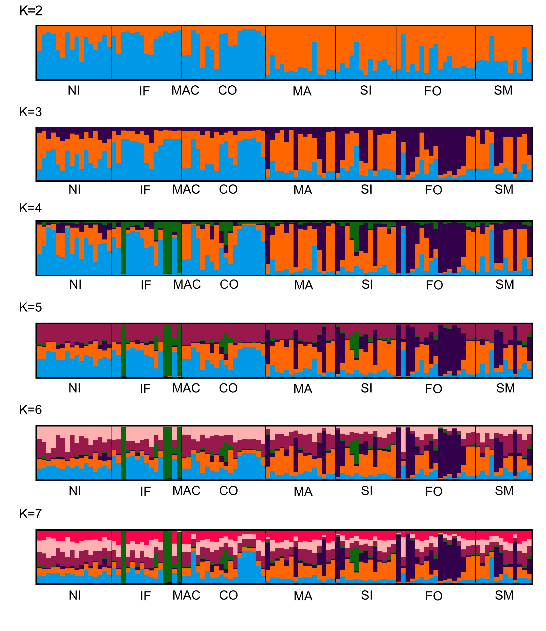
*

Figure S2. Spatial population structure performed in STRUCTURE among 9 seed cohorts of P. oceanica (K = 2 to K = 7) considering only neutral loci. Each individual sample is represented on the x-axis, while the y-axis denotes the probability of identity to each genetic cluster. K = 2 is the most likely number of clusters (*). Acronyms as in Table 1.

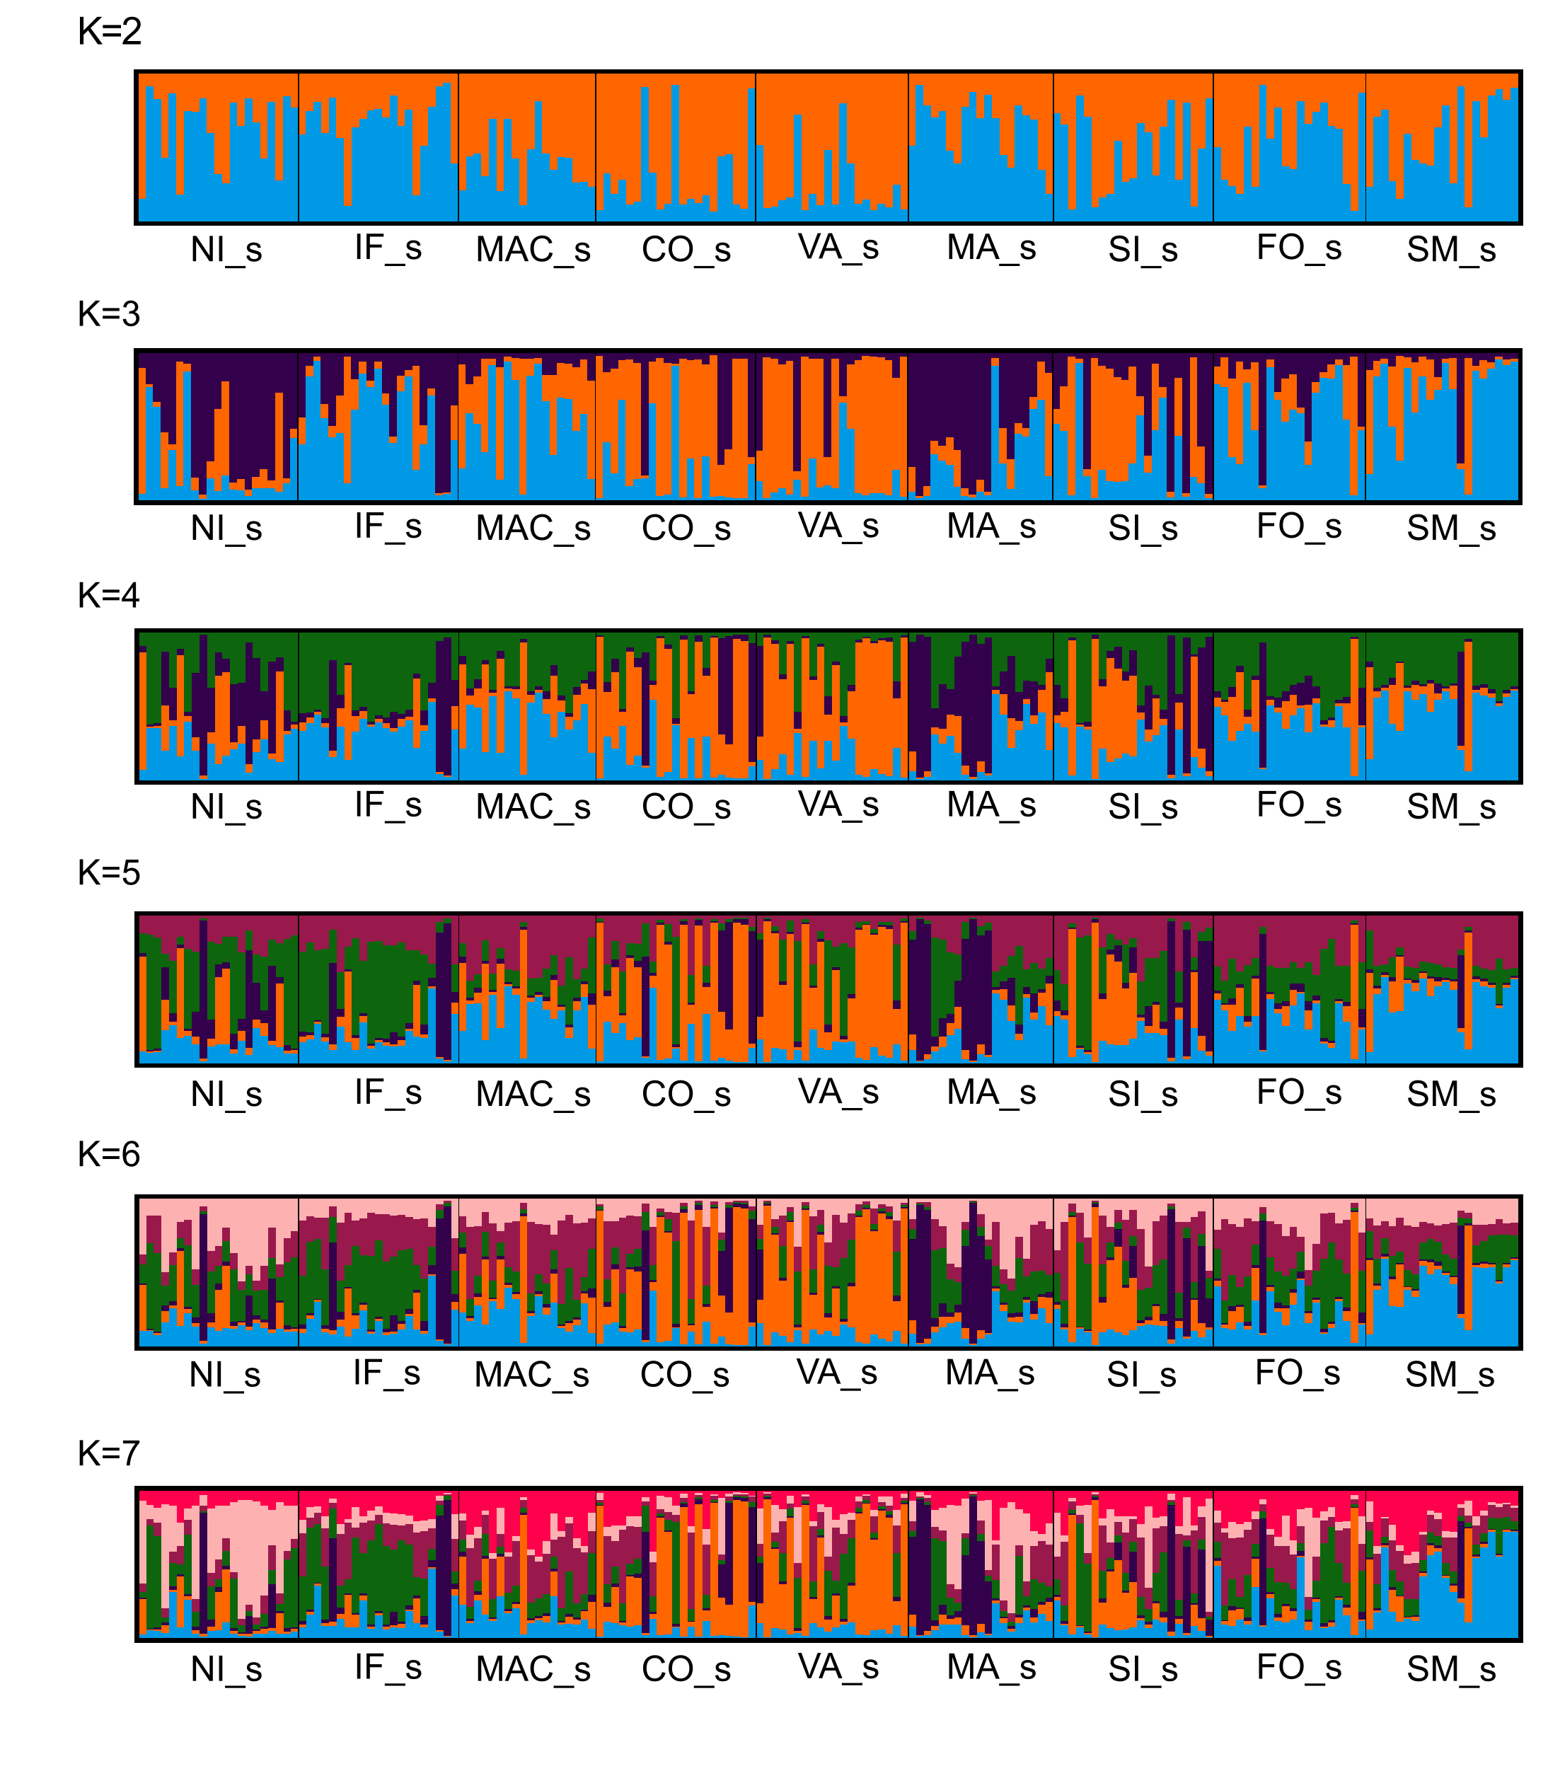
*

Figure S3. Forward-in-time Lagrangian simulations. Sets of numerical trajectories starting from all meadow sites and evolving forward in time for 21 days. The number of trajectories is 8000 per site. The ending points (yellow) represent potential target sites. San Nicola l’Arena — NI, Isola delle Femmine — IF, Macari — MAC, Cornino — CO, Marsala — MA, Torre Sibiliana — SI, Tre Fontane — FO, San Marco — SM.
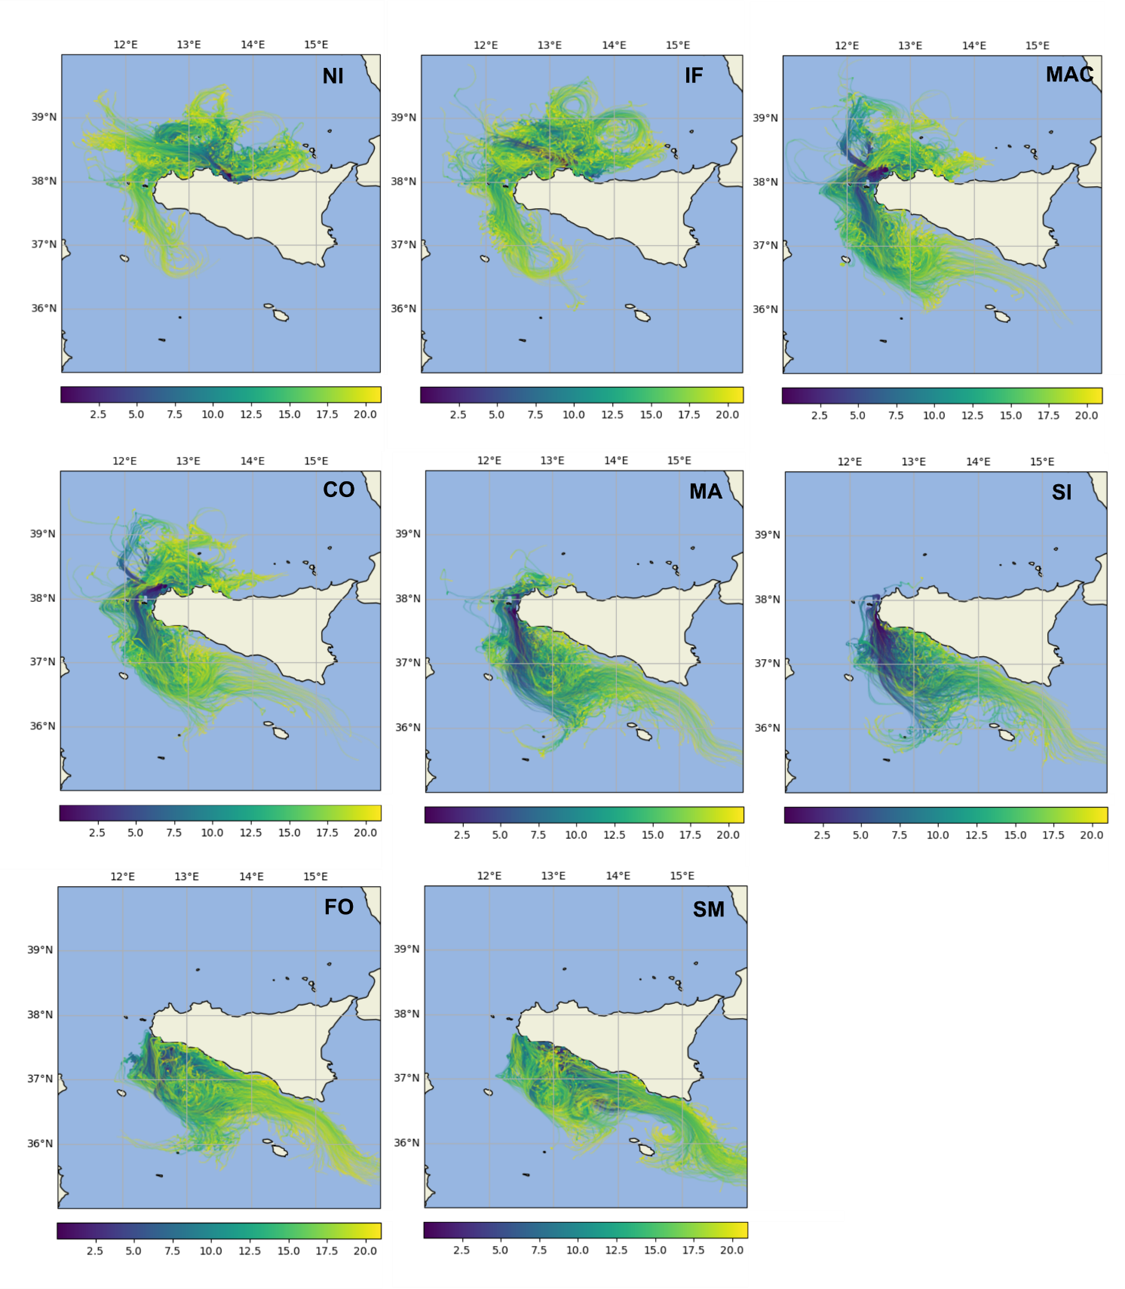

Figure S4. Backward-in-time Lagrangian simulations. Sets of numerical trajectories starting from all sampling sites and evolving backward in time for 21 days. The number of trajectories is 8000 per site. The ending points (dark violet) represent potential sources dynamically connected to the target site. San Nicola l’Arena — NI, Isola delle Femmine — IF, Macari — MAC, Cornino — CO, Marsala — MA, Torre Sibiliana — SI, Tre Fontane — FO, San Marco — SM.

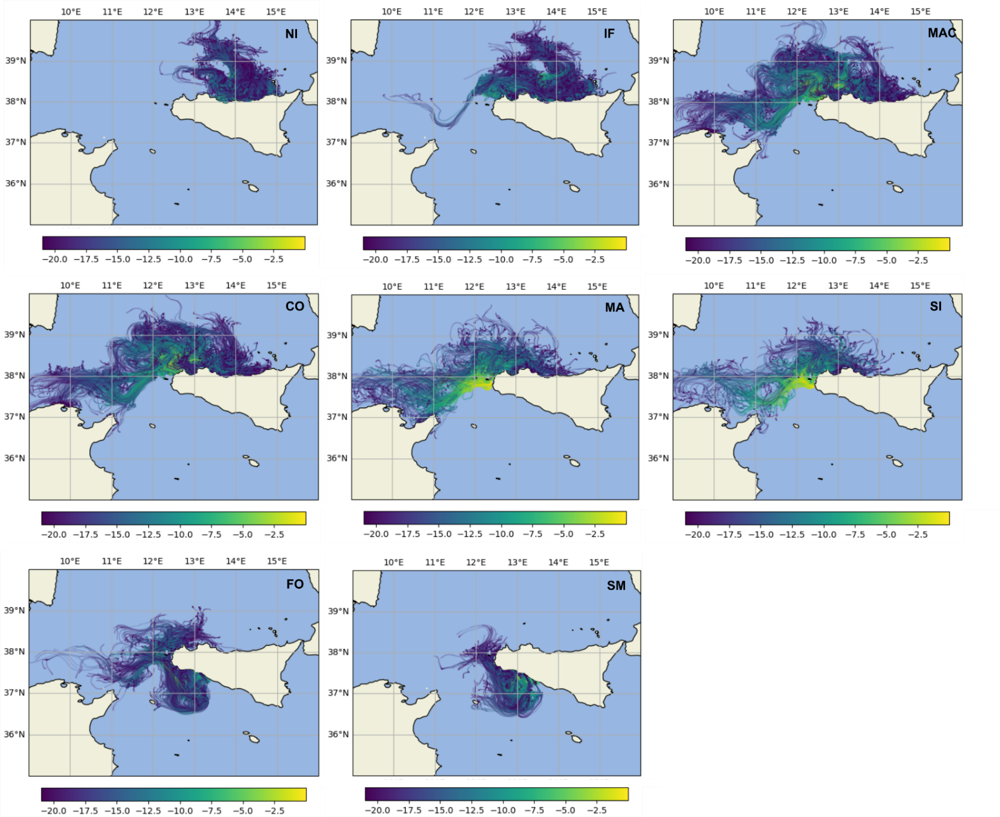

Figure S5. Forward-in-time Lagrangian simulations. Sets of numerical trajectories starting from northern Tunisian coast and evolving forward in time for 21 days. The number of trajectories is 8000 per site. The ending points (yellow) represent potential target sites.

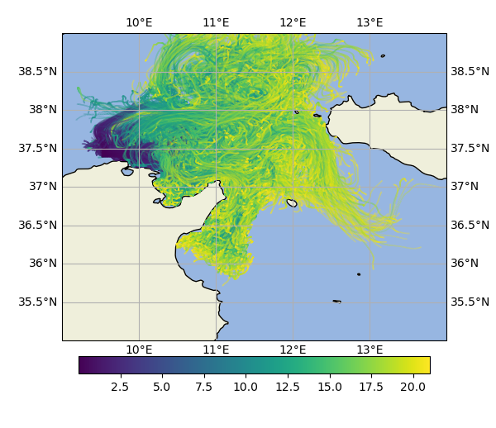

APPENDIX

Methods

Lagrangian modelling

The present modelling apparatus, even though not specifically conceived to simulate small-scale coastal flows with great accuracy, overall guarantees an optimal description of the tracer dispersion process occurring in the Mediterranean Sea surface layer (Lacorata et al., 2014). The multi-scale, chaotic and turbulent characteristics of the ocean dynamics, in general, demand for a statistical approach to the study of the transport and diffusion process: this has the non-trivial, and perhaps counterintuitive, consequence that increasing the resolution of a model does not correspond necessarily to an improvement of the accuracy. The definition of site-to-site connection probabilities is a key point for the characterization of the oceanographic (or potential) connectivity. It is worth stressing that these model-based probabilities, necessarily, have a relative, rather than absolute, meaning: the actual beaching probability is indeed unknown, even though it can be reasonably assumed, as first approximation, to be the same for all sites, provided the particles (seeds) come sufficiently close to the coast. On this basis, if the percentage of particles connecting site “A” to site “B” is, for example, twice the percentage of particles connecting “A” to “C”, we assume that the probabilistic weight of the oceanographic connectivity between “A” and “B” is twice the probabilistic weight of the oceanographic connectivity between “A” and “C”. The computation of the site-to-site model-based oceanographic connectivity, both forward and backward in time, was carried out as follows. The study area, i.e., the north-western coastal region of Sicily containing the seed collection sites (Table 1) plus the surrounding seawaters, was supposed to be divided into 8 elements, having approximately the same spatial extension. All elements of this ideal partition were identified with the same label of the corresponding geographical site. A set of Np randomly distributed particles were released inside each of these elements, and all trajectories were followed for a total time T. The position of each trajectory was checked at regular time intervals Δt=1 hour and the number of times Nij(T), for i,j={1,2,…}, that a particle starting from “i” was found in “j” was recorded. The ratio between this number and the total number of interrogations, Ntot(T), occurred in the time interval [0,T] gives the connection probability between the departure site (“i”) and the arrival site (“j”), Wij(T)= Nij(T)/ Ntot(T). This holds for both forward and backward simulations.

