Supplementary material for:
Broth microdilution protocol for determining antimicrobial susceptibility of Legionella pneumophila to clinically relevant antibiotics.

Max Sewell¹, Caitlin Farley¹, Edward AR Portal^{1,2}, Diane Lindsay³, Maria Luisa Ricci⁴, Sophie Jarraud⁵, Maria Scaturro⁴, Ghislaine Descours⁵, Anne Vatland Krøvel⁶, Rachael Barton¹, Ian Boostom¹, Roisin Ure³, Darja Kese⁷, Valeria Gaia⁸, Matej Golob⁷, Susanne Paukner⁹, Christophe Ginevra⁵, Baharak Afshar¹⁰, Sendurann Nadarajah¹¹, Ingrid Wybo¹¹, Charlotte Michel¹¹, Fedoua Echahdi¹¹, Juana María González-Rubio¹², Fernando González-Camacho¹², Massimo Mentasti¹³, Anastasia S. Flountzi¹⁴, Markus Petzold¹⁵, Jacob Moran-Gilad¹⁶, Søren Uldum¹⁷, Jonas Winchell¹⁸, Mandy Wooton^{13,19}, Kathryn Bernard²⁰, Lucy C. Jones,¹ Victoria J. Chalker²¹ , Owen B. Spiller*^{1,10}, on behalf of the ESCMID Study Group Legionella Infections†

Supplementary Instructional video: Full protocol Youtube tutorial link: https://youtu.be/ALva0i9HBsY
Supplementary Figure 1. Antibiotic preparation
Antibiotics stocks were prepared daily at 4 times the highest required concentration in the 96-well plate.
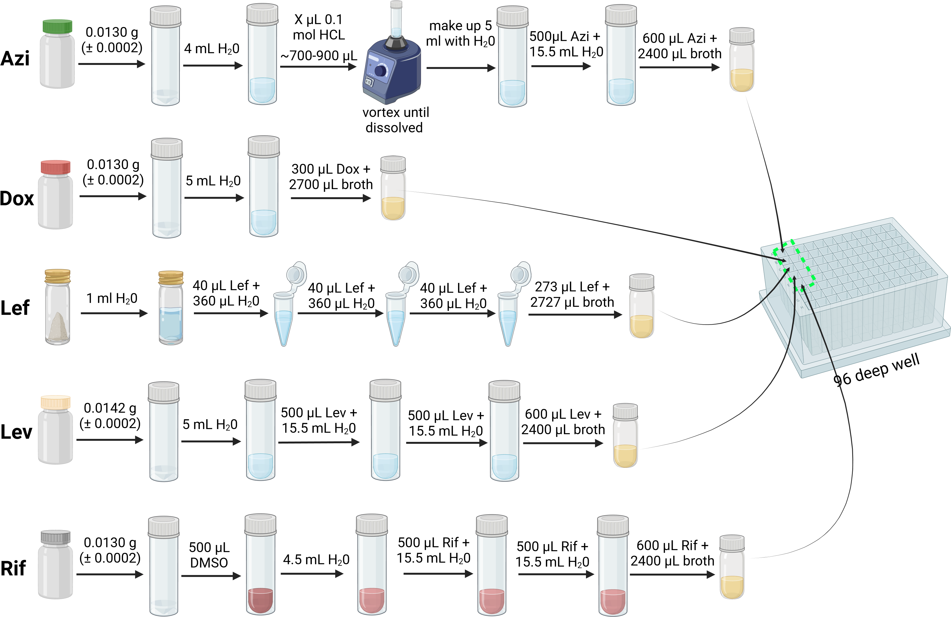
Supplementary Figure 1. Antibiotic dilutions prepared daily for all five clinically relevant antibiotic are shown taking into account the specific catalogue numbers and suppliers listed in the materials and methods. Azi- azithromycin; Dox-doxycycline; Lef-lefamulin; Lev-levofloxacin; Rif-rifampicin. For Azithromycin acidification is required to solubilise the powder, where X µL is indicated add 100 µL aliquots with vortexing until solubilised (max volume 1 ml). Please note initial solubilisation of rifampicin is in DMSO prior to addition of water. Biorender agreement number DL26ZG0D5I

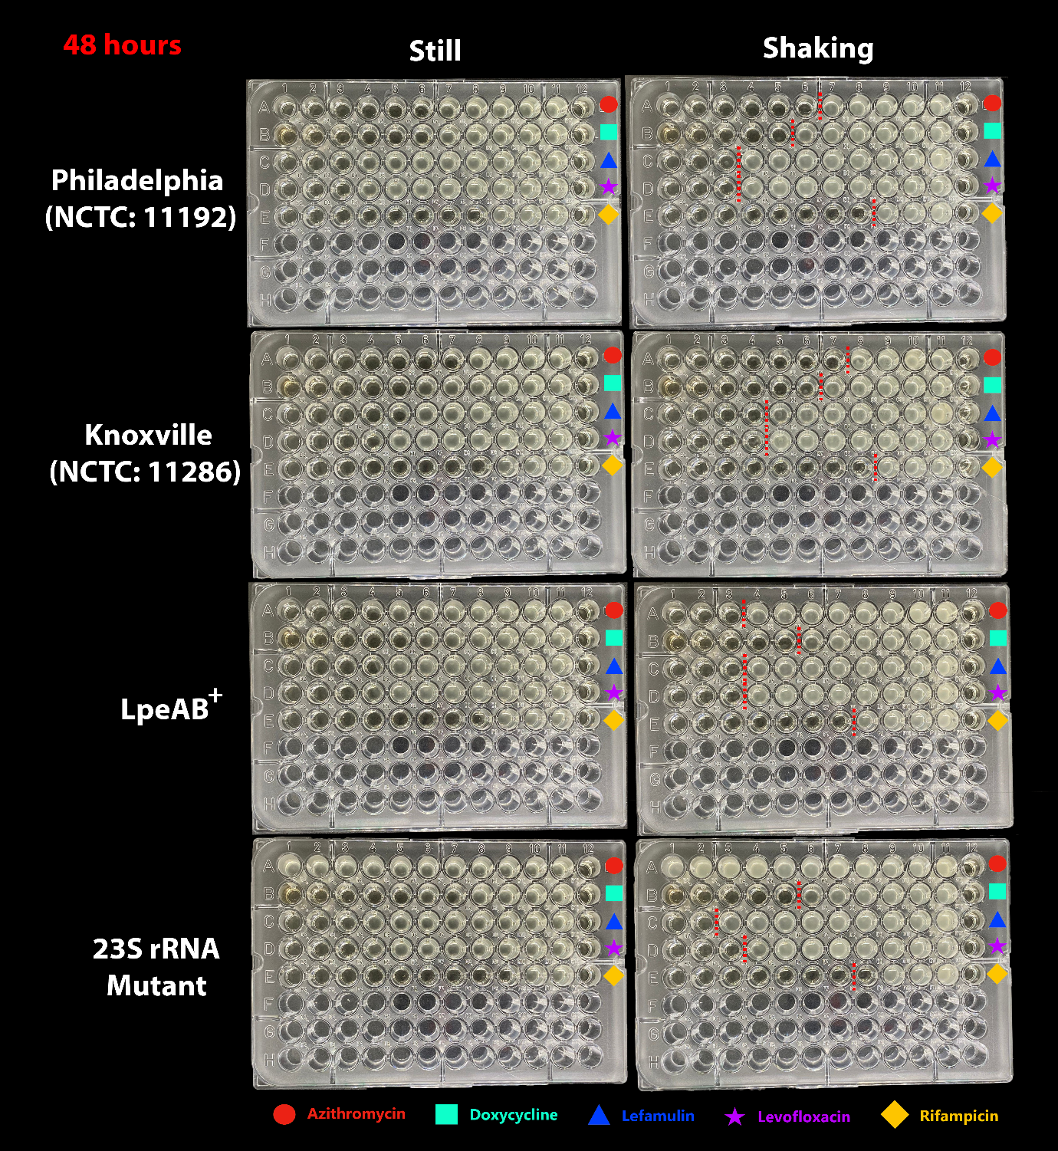
Supplementary Figure 2. Effects of agitation on MIC value clarity using four L. pneumophila strains and five clinically relevant antibiotics post 48-hour incubation. Left column: No agitation. Right column: shaking incubation at 160 rpm. Rows within 96-well plates represent antibiotics (azithromycin, doxycycline, lefamulin, levofloxacin, rifampicin). Red dotted lines represent the distinction between growth and no growth. The MIC is defined as the highest concentration of antibiotic that completely inhibits visible growth of L. pneumophila and is represented as the well left of the red dotted line.

Supplementary Table 1: Antibiotic MIC ranges across bacterial strains:
 | Antibiotic
Bacteria | Azithromycin | Doxycycline | Lefamulin | Levofloxacin | Rifampicin
Philadelphia  (NCTC: 11192) | 0.008 -0.125 mg/L | 0.5-16 mg/L | 0.064-1 mg/L | 0.008-0.032 mg/L | 0.00025-0.001 mg/L
Knoxville  (NCTC: 11286) | 0.008 -0.125 mg/L | 1-16 mg/L | 0.125-0.5 mg/L | 0.016-0.032 mg/L | 0.00025-0.001 mg/L
PHELPN45-24 (lpeAB-positive; NCTC: pending) | 0.064-0.5 mg/L | 1-16 mg/L | 0.25-2 mg/L | 0.008-0.32 mg/L | 0.00025-0.0005 mg/L
23S rRNA mutant (highly macrolide resistant NCTC: pending) | >4 mg/L mg/L | 2-16 mg/L | 1-4 mg/L | 0.016-0.032 mg/L | 0.00025-0.0005 mg/L

Supplementary table 2: MIC₅₀ and MIC₉₀ of antibiotics across bacterial strains:
Antibiotics | MIC₅₀ (Philadelphia) | MIC₉₀ (Philadelphia) | MIC₅₀ (Knoxville) | MIC₉₀ (Knoxville) | MIC₅₀ (LpeAB⁺) | MIC₉₀ (LpeAB⁺) | MIC₅₀  (23S rRNA mutant) | MIC₉₀  (23S rRNA mutant)
Azithromycin | 0.032 | 0.0625 | 0.016 | 0.032 | 0.125 | 0.25 | N/A* | N/A
Doxycycline | 2 | 8 | 3 | 16 | 4 | 16 | 8 | 16
Lefamulin | 0.5 | 1 | 0.25 | 0.5 | 0.5 | 1 | 1 | 2
Levofloxacin | 0.016 | 0.016 | 0.016 | 0.016 | 0.016 | 0.032 | 0.016 | 0.016
Rifampicin | 0.00025 | 0.0005 | 0.00025 | 0.0005 | 0.00025 | 0.0005 | 0.00025 | 0.0005
Legend: * N/A as the maximum in this assay is 4 mg/L, and MIC is above this consistently, but would always flag this isolate as requiring further investigation with an extended range.

