Vulnerability of Process and Air Supply Utilities to Volcanic Ash

Matteo VALENTE, Federica RICCI*, Valerio COZZANI

LISES – Department of Civil, Chemical, Environmental and Material Engineering
Alma Mater Studiorum – University of Bologna
via Terracini 28, 40131 Bologna (Italy)

* Corresponding author:
e-mail: federica.ricci18@unibo.it

SUPPLEMENTARY MATERIAL

Revised version – December 2025

Submitted to:
RELIABILITY ENGINEERING AND SYSTEM SAFETY

Validation of the surrogate model
A validation dataset of 2500 entries of input parameters was considered to compare the results of the detailed and surrogate model. The dataset was built from the combination of 50 equally distributed values of d_{p} and u in the variability range defined in Table 3 of the main text:
- d_{p}: 50 µm –1000 µm
- u: 1.78 m/s – 4.46 m/s, based on commercially available filtration systems
Besides the parity plot provided in Figure 8 of the main text, some additional indicators were calculated to evaluate the performance of the correlations developed for the surrogate model. Specifically, the average absolute relative error AARE, the error standard deviation of the correlation SD_{c}, the maximum relative error RE_{max}, and the minimum relative error RE_{min}. These parameters are evaluated respectively with Eqs. 1, 2, 3, and 4:
Eq. 1
Eq. 2
Eq. 3
Eq. 4
where k is the number of sets of input parameters considered in the analysis, θ_{c,i} is the value of θ calculated through the surrogate model for the i-th set of input parameters, and θ_{m,i} is the value of θ calculated with the detailed model for the i-th set of input parameters. The results of the analysis are reported in Table S1.
Table S1. Values of the indicators selected to evaluate the correlations developed for the surrogate model.
Fitting parameter | Loosely | Tapped
Average absolute relative error AARE | 0.0209 | 0.0218
Error standard deviation of the correlation SD_{C} | 0.0252 | 0.1476
Maximum relative error RE_{max} | 0.0590 | 0.0551
Minimum relative error RE_{min} | -0.1772 | -0.2616

Similar values can be observed for the AARE of both the developed correlations, showing an excellent agreement with the source data under the studied conditions (i.e., < 2.5%). On the contrary, large values in absolute terms can be observed for the RE. However, in both cases, it is worth noting that RE_{min} is significantly larger than the RE_{max}, meaning that the developed correlations tend to guarantee a conservative approach on the safe side. Consequently, high values of RE_{min} and RE_{max} indicate a larger distribution of the data as confirmed by the error standard deviation, especially in the case of the tapped correlation.

Additional results of Test bed 1
Results of the Test bed 1 are reported in Table S2 (loosely packing) and Table S3 (tapped packing) for all the combinations of filtration systems, particle diameters, and concentrations as defined in Section 2 of the main text. A comparison is performed between the time to clogging obtained with the surrogate model (SM) and the detailed model (DM), defining the deviation as Δttc:
Eq. 5
As can be seen from the results in the tables, the greatest deviation occurs when the surrogate model underestimates the time to clogging, with maximum variations of approximately 24 hours. However, this still provides a conservative assessment from the safety perspective.
Table S2. Time to clogging considering the loosely packing for the scenarios defined for Test bed 1 in Section 2 of the main text, calculated with the detailed model (DM) and surrogate model (SM).
Filter | d_{p}  [µm] | C [µg/m³] | ttc_{DM}  [d] | ttc_{SM}  [d] | Δttc  [h] | Filter | d_{p}  [µm] | C [µg/m³] | ttc_{DM}  [d] | ttc_{SM}  [d] | Δttc  [h]
F1 | 100 | 1000 | 11.47 | 11.68 | 5.23 | F5 | 100 | 1000 | 13.08 | 13.35 | 6.45
F1 | 100 | 2500 | 4.59 | 4.67 | 2.09 | F5 | 100 | 2500 | 5.23 | 5.34 | 2.58
F1 | 100 | 4000 | 2.87 | 2.92 | 1.31 | F5 | 100 | 4000 | 3.27 | 3.34 | 1.61
F1 | 300 | 1000 | 46.9 | 46.8 | -2.39 | F5 | 300 | 1000 | 50.2 | 50.7 | 11.87
F1 | 300 | 2500 | 18.76 | 18.72 | -0.95 | F5 | 300 | 2500 | 20.08 | 20.28 | 4.75
F1 | 300 | 4000 | 11.73 | 11.7 | -0.6 | F5 | 300 | 4000 | 12.55 | 12.67 | 2.97
F1 | 800 | 1000 | 103.61 | 102.6 | -24.23 | F5 | 800 | 1000 | 106.03 | 105.51 | -12.53
F1 | 800 | 2500 | 41.44 | 41.04 | -9.69 | F5 | 800 | 2500 | 42.41 | 42.2 | -5.01
F1 | 800 | 4000 | 25.9 | 25.65 | -6.06 | F5 | 800 | 4000 | 26.51 | 26.38 | -3.13
F2 | 100 | 1000 | 2.36 | 2.43 | 1.73 | F6 | 100 | 1000 | 18.86 | 19.25 | 9.29
F2 | 100 | 2500 | 0.94 | 0.97 | 0.69 | F6 | 100 | 2500 | 7.54 | 7.7 | 3.72
F2 | 100 | 4000 | 0.59 | 0.61 | 0.43 | F6 | 100 | 4000 | 4.72 | 4.81 | 2.32
F2 | 300 | 1000 | 8.67 | 8.9 | 5.49 | F6 | 300 | 1000 | 72.37 | 73.09 | 17.12
F2 | 300 | 2500 | 3.47 | 3.56 | 2.2 | F6 | 300 | 2500 | 28.95 | 29.23 | 6.85
F2 | 300 | 4000 | 2.17 | 2.23 | 1.37 | F6 | 300 | 4000 | 18.09 | 18.27 | 4.28
F2 | 800 | 1000 | 17.81 | 17.86 | 1.35 | F6 | 800 | 1000 | 152.85 | 152.1 | -18.07
F2 | 800 | 2500 | 7.12 | 7.15 | 0.54 | F6 | 800 | 2500 | 61.14 | 60.84 | -7.23
F2 | 800 | 4000 | 4.45 | 4.47 | 0.34 | F6 | 800 | 4000 | 38.21 | 38.02 | -4.52
F3 | 100 | 1000 | 10.22 | 10.4 | 4.39 | F7 | 100 | 1000 | 17.84 | 18.21 | 8.79
F3 | 100 | 2500 | 4.09 | 4.16 | 1.76 | F7 | 100 | 2500 | 7.14 | 7.28 | 3.52
F3 | 100 | 4000 | 2.55 | 2.6 | 1.1 | F7 | 100 | 4000 | 4.46 | 4.55 | 2.2
F3 | 300 | 1000 | 40.97 | 40.98 | 0.1 | F7 | 300 | 1000 | 68.46 | 69.14 | 16.19
F3 | 300 | 2500 | 16.39 | 16.39 | 0.04 | F7 | 300 | 2500 | 27.38 | 27.65 | 6.48
F3 | 300 | 4000 | 10.24 | 10.24 | 0.03 | F7 | 300 | 4000 | 17.12 | 17.28 | 4.05
F3 | 800 | 1000 | 89.2 | 88.38 | -19.61 | F7 | 800 | 1000 | 144.59 | 143.88 | -17.09
F3 | 800 | 2500 | 35.68 | 35.35 | -7.84 | F7 | 800 | 2500 | 57.84 | 57.55 | -6.84
F3 | 800 | 4000 | 22.3 | 22.1 | -4.9 | F7 | 800 | 4000 | 36.15 | 35.97 | -4.27
F4 | 100 | 1000 | 9.06 | 9.25 | 4.46 | F8 | 100 | 1000 | 15.8 | 16.13 | 7.79
F4 | 100 | 2500 | 3.62 | 3.7 | 1.79 | F8 | 100 | 2500 | 6.32 | 6.45 | 3.11
F4 | 100 | 4000 | 2.27 | 2.31 | 1.12 | F8 | 100 | 4000 | 3.95 | 4.03 | 1.95
F4 | 300 | 1000 | 34.77 | 35.12 | 8.22 | F8 | 300 | 1000 | 60.64 | 61.23 | 14.34
F4 | 300 | 2500 | 13.91 | 14.05 | 3.29 | F8 | 300 | 2500 | 24.25 | 24.49 | 5.74
F4 | 300 | 4000 | 8.69 | 8.78 | 2.06 | F8 | 300 | 4000 | 15.16 | 15.31 | 3.59
F4 | 800 | 1000 | 73.44 | 73.08 | -8.68 | F8 | 800 | 1000 | 128.07 | 127.43 | -15.14
F4 | 800 | 2500 | 29.38 | 29.23 | -3.47 | F8 | 800 | 2500 | 51.23 | 50.97 | -6.05
F4 | 800 | 4000 | 18.36 | 18.27 | -2.17 | F8 | 800 | 4000 | 32.02 | 31.86 | -3.78
Table S3. Time to clogging considering the tapped packing for the scenarios defined for Test bed 1 in Section 2 of the main text, calculated with the detailed model (DM) and surrogate model (SM).
Filter | d_{p}  [µm] | C [µg/m³] | ttc_{DM}  [d] | ttc_{SM}  [d] | Δttc  [h] | Filter | d_{p}  [µm] | C [µg/m³] | ttc_{DM}  [d] | ttc_{SM}  [d] | Δttc  [h]
F1 | 100 | 1000 | 5.21 | 5.34 | 3.08 | F5 | 100 | 1000 | 6.02 | 6.18 | 3.83
F1 | 100 | 2500 | 2.09 | 2.14 | 1.23 | F5 | 100 | 2500 | 2.41 | 2.47 | 1.53
F1 | 100 | 4000 | 1.3 | 1.34 | 0.77 | F5 | 100 | 4000 | 1.5 | 1.54 | 0.96
F1 | 300 | 1000 | 25 | 24.97 | -0.77 | F5 | 300 | 1000 | 27.01 | 27.3 | 6.85
F1 | 300 | 2500 | 10 | 9.99 | -0.31 | F5 | 300 | 2500 | 10.81 | 10.92 | 2.74
F1 | 300 | 4000 | 6.25 | 6.24 | -0.19 | F5 | 300 | 4000 | 6.75 | 6.82 | 1.71
F1 | 800 | 1000 | 57.08 | 56.53 | -13.15 | F5 | 800 | 1000 | 58.76 | 58.52 | -5.85
F1 | 800 | 2500 | 22.83 | 22.61 | -5.26 | F5 | 800 | 2500 | 23.5 | 23.41 | -2.34
F1 | 800 | 4000 | 14.27 | 14.13 | -3.29 | F5 | 800 | 4000 | 14.69 | 14.63 | -1.46
F2 | 100 | 1000 | 1.09 | 1.13 | 0.96 | F6 | 100 | 1000 | 8.67 | 8.9 | 5.53
F2 | 100 | 2500 | 0.44 | 0.45 | 0.38 | F6 | 100 | 2500 | 3.47 | 3.56 | 2.21
F2 | 100 | 4000 | 0.27 | 0.28 | 0.24 | F6 | 100 | 4000 | 2.17 | 2.23 | 1.38
F2 | 300 | 1000 | 4.69 | 4.82 | 3.09 | F6 | 300 | 1000 | 38.94 | 39.35 | 9.87
F2 | 300 | 2500 | 1.88 | 1.93 | 1.24 | F6 | 300 | 2500 | 15.58 | 15.74 | 3.95
F2 | 300 | 4000 | 1.17 | 1.21 | 0.77 | F6 | 300 | 4000 | 9.74 | 9.84 | 2.47
F2 | 800 | 1000 | 9.9 | 9.95 | 1.17 | F6 | 800 | 1000 | 84.71 | 84.35 | -8.44
F2 | 800 | 2500 | 3.96 | 3.98 | 0.47 | F6 | 800 | 2500 | 33.88 | 33.74 | -3.38
F2 | 800 | 4000 | 2.48 | 2.49 | 0.29 | F6 | 800 | 4000 | 21.18 | 21.09 | -2.11
F3 | 100 | 1000 | 4.66 | 4.77 | 2.65 | F7 | 100 | 1000 | 8.2 | 8.42 | 5.23
F3 | 100 | 2500 | 1.86 | 1.91 | 1.06 | F7 | 100 | 2500 | 3.28 | 3.37 | 2.09
F3 | 100 | 4000 | 1.17 | 1.19 | 0.66 | F7 | 100 | 4000 | 2.05 | 2.11 | 1.31
F3 | 300 | 1000 | 21.91 | 21.92 | 0.44 | F7 | 300 | 1000 | 36.84 | 37.23 | 9.34
F3 | 300 | 2500 | 8.76 | 8.77 | 0.18 | F7 | 300 | 2500 | 14.73 | 14.89 | 3.74
F3 | 300 | 4000 | 5.48 | 5.48 | 0.11 | F7 | 300 | 4000 | 9.21 | 9.31 | 2.33
F3 | 800 | 1000 | 49.24 | 48.8 | -10.54 | F7 | 800 | 1000 | 80.13 | 79.79 | -7.98
F3 | 800 | 2500 | 19.69 | 19.52 | -4.22 | F7 | 800 | 2500 | 32.05 | 31.92 | -3.19
F3 | 800 | 4000 | 12.31 | 12.2 | -2.63 | F7 | 800 | 4000 | 20.03 | 19.95 | -2
F4 | 100 | 1000 | 4.17 | 4.28 | 2.66 | F8 | 100 | 1000 | 7.27 | 7.46 | 4.63
F4 | 100 | 2500 | 1.67 | 1.71 | 1.06 | F8 | 100 | 2500 | 2.91 | 2.98 | 1.85
F4 | 100 | 4000 | 1.04 | 1.07 | 0.66 | F8 | 100 | 4000 | 1.82 | 1.86 | 1.16
F4 | 300 | 1000 | 18.71 | 18.91 | 4.74 | F8 | 300 | 1000 | 32.63 | 32.97 | 8.27
F4 | 300 | 2500 | 7.48 | 7.56 | 1.9 | F8 | 300 | 2500 | 13.05 | 13.19 | 3.31
F4 | 300 | 4000 | 4.68 | 4.73 | 1.19 | F8 | 300 | 4000 | 8.16 | 8.24 | 2.07
F4 | 800 | 1000 | 40.7 | 40.53 | -4.05 | F8 | 800 | 1000 | 70.97 | 70.67 | -7.07
F4 | 800 | 2500 | 16.28 | 16.21 | -1.62 | F8 | 800 | 2500 | 28.39 | 28.27 | -2.83
F4 | 800 | 4000 | 10.17 | 10.13 | -1.01 | F8 | 800 | 4000 | 17.74 | 17.67 | -1.77

Figure S1 presents the Δttc results, grouping them into four categories: (i) less than or equal to 0 hours, (ii) between 0 and 1 hour, (iii) between 1 and 5 hours, and (iv) greater than 5 hours. In more than 33% of cases, correlations of the surrogate model underestimate the ttc obtained with the detailed model when considering both loosely and tapped packing conditions. Moreover, the overestimation by the surrogate model remains limited and does not exceed 5 hours in about half of all investigated cases. Regarding larger deviations, where the difference between the surrogate and the detailed model exceeds 5 hours, the percentage decreases significantly, settling at 19% for loosely packing and 8% for tapped packing conditions. It is worth noting that errors greater than 5 hours (with maximum deviations of 17 hours and 10 hours for loosely and tapped packing conditions, respectively) occur only when the time to clogging is very high and never below 13 days. Consequently, the relative error introduced by the correlation remains very limited, slightly exceeding 2%.

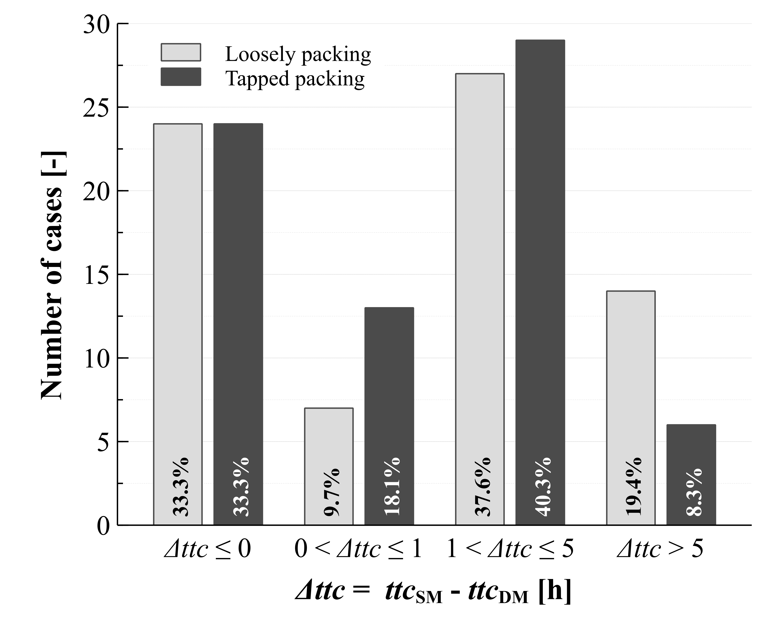
Figure S1. Differences in the time to clogging (Δttc) calculated with the surrogated model (SM) and the detailed model (DM) for Test bed 1 considering both loosely and tapped packing.

Additional results of Test bed 2
Figure S2 shows the results of the Test bed 2 for Scenario 5 and 6, which are described in Section 3.2 of the main text. As shown in the figure, the time to clogging is shorter than the duration of the scenario regardless of the packing conditions for Scenario 5 and Scenario 6 (panels a and b in Figure S2), indicating that the filtration system cannot withstand the ash load, leading to possible severe consequences on site.

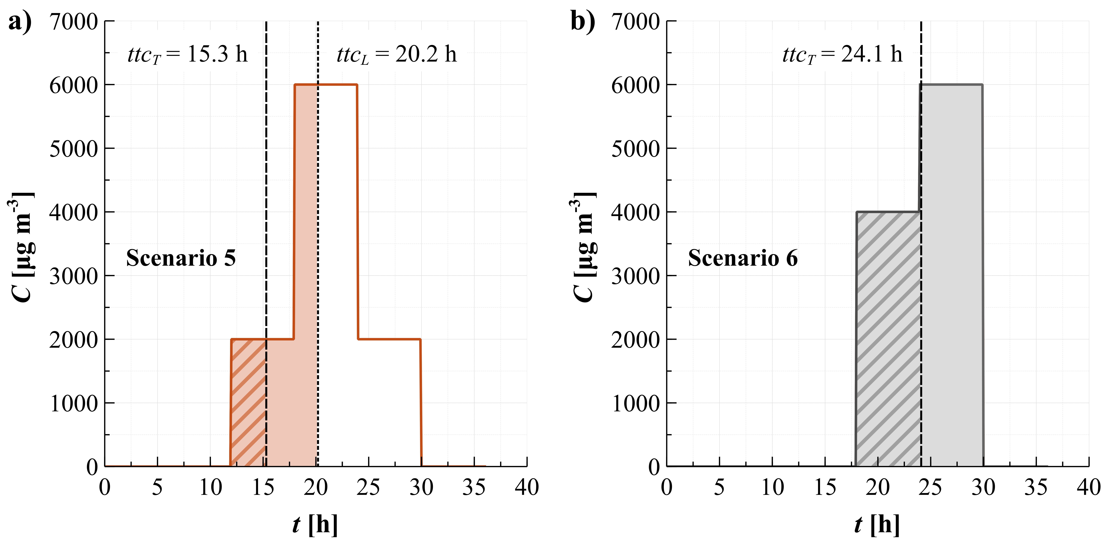
Figure S2. Concentration vs. time of the eruption scenarios and exposure time of filtration system to the ash scenario before clogging for Scenario 5 (a) and Scenario 6 (b) defined in Test bed 2 (see Section 3.2 of the main text for more details). Solid filling corresponds to the loosely packed case. Striped filling represents the tapped packed case. The ttc_{L} and ttc_{T} are also reported, when available.

