Supporting Information
Continuous fluorescence-based quantitative antioxidant assay using vegetable oil as an oxidizable substrate
Rajat Suhagª, Zongxin Jin^{b}, Giovanna Ferrentinoª, Riccardo Amorati^{b}*, Matteo Scampicchioª
ªFaculty of Agricultural, Environmental and Food Sciences, Free University of Bolzano, Piazza Università, 1, Bolzano 39100, Italy
^{b}Department of Chemistry “G. Ciamician”, University of Bologna, Via P. Gobetti 85, 40129 Bologna, Italy
*Corresponding author: riccardo.amorati@unibo.it

Synthesis of STY-BODIPY

Synthesis of compound
Both compounds were synthesized by literature procedures (De Cremer et al., 2010). Briefly, a solid mixture of pyrrole-2-carboxaldehyde (1.0 g, 10.5 mmol), zinc dust (0.69 g, 10.5 mmol), and benzyl triphenylphosphonium bromide (4.3 or 4.5 g, 10.5 mmol) was heated to 100 °C under an inert atmosphere and stirred overnight. The mixture was allowed to cool before it was diluted with CHCl₃ (25 mL) and filtered. The filtrate was washed once with water and once with brine before drying with MgSO₄. Following filtration and concentration under reduced pressure, the product was purified by column chromatography on silica gel using a gradient of 20–30% CHCl₃ in hexanes.

Synthesis of STY-BODIPY
The product styryl-substituted pyrrole (0.53 or 0.46 g, 2.7 mmol) was then combined with 3,5-dimethylpyrrole-2-carboxaldehyde (0.34 g, 2.7 mmol) in dry CH₂Cl₂ (135 mL) under an inert atmosphere. POCl₃ (0.27 mL, 2.9 mmol) was then added dropwise over several minutes, and the reaction was stirred overnight in the dark at room temperature. Diisopropylethylamine (2.0 mL, 11.5 mmol) was then added slowly, and the reaction was stirred for another 10 min, followed by dropwise addition of BF₃–OEt₂ (1.4 mL, 11.2 mmol). The reaction was stirred at room temperature until complete (∼1 h, as judged by TLC), poured into a separatory funnel, and washed twice with water and then a small amount of brine. The organic phase was dried with MgSO₄ and filtered and the solvent evaporated. Column chromatography (100% CH₂Cl₂) removed the major impurities. A second column (60% CH₂Cl₂ in hexanes) afforded pure product. ¹H NMR (600 MHz, DMSO-d₆) δ = 7.69 (s, 1H), 7.62 – 7.56 (m, 3H), 7.45 (d, J = 17.5 Hz, 3H), 7.40 – 7.34 (m, 1H), 7.21 (d, J = 4.3 Hz, 1H), 7.15 (d, J = 4.3 Hz, 1H), 6.34 (s, 1H), 2.52 (d, J = 1.8 Hz, 3H), 2.28 (s, 3H). ¹³C NMR (151 MHz, DMSO-d6) δ = 159.3, 152.7, 144.1, 136.6, 136.2, 135.3, 135.1, 129.6, 129.5, 127.4, 124.3, 120.8, 118.8, 116.2, 15.1, 11.5.
Due to the oxidizability of STY-BODIPY, 2.0 mM stock solutions of each compound were prepared in DMSO (depending on whether they are for use in organic or aqueous solutions) and stored under nitrogen, frozen at −20°C. When stored in this manner, there was minimal background oxidation of the either compound over several months.
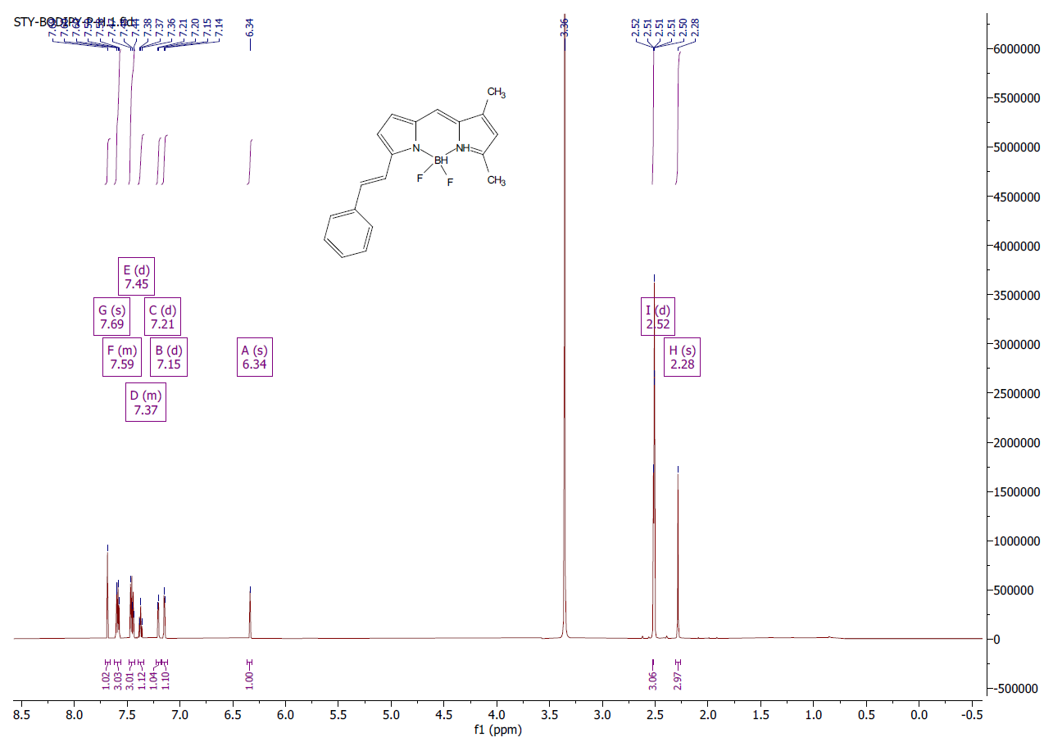
Figure S1: ¹ H NMR (600MHz) of STY-BODIPY in DMSO-d6.
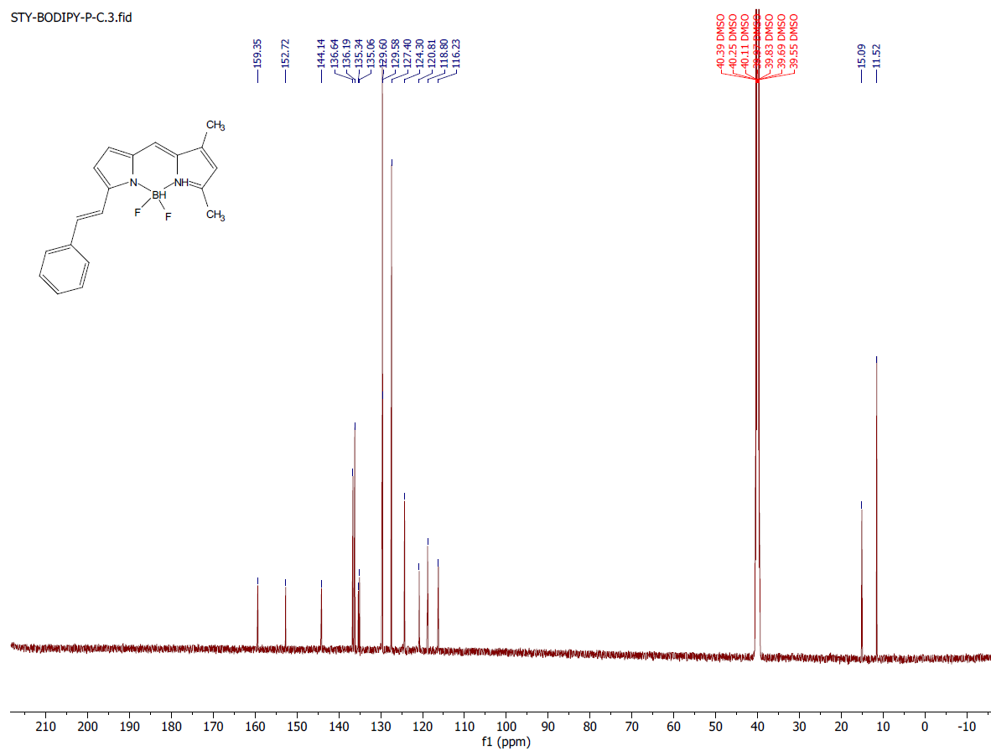
Figure S2: ¹³C NMR (151MHz) of STY-BODIPY in DMSO-d6

De Cremer, G., Roeffaers, M. B. J., Bartholomeeusen, E., Lin, K., Dedecker, P., Pescarmona, P. P., Jacobs, P. A., De Vos, D. E., Hofkens, J., & Sels, B. F. (2010). High-resolution single-turnover mapping reveals intraparticle diffusion limitation in Ti-MCM-41-Catalyzed epoxidation. Angewandte Chemie - International Edition. https://doi.org/10.1002/anie.200905039

Figure S3: Isothermal calorimetric traces showing synergistic interactions of (A) PMC + γ-terpinene and (B) PMC + caffeic acid. (1) no antioxidants, (2) PMC (3 μM), (3) PMC (3 μM) + γ-terpinene (6.3 mM), (4) PMC (3 μM) + γ-terpinene (15.4 mM), (5) PMC (3 μM) + γ-terpinene (29.4 mM), (6) PMC (3 μM) + caffeic acid (10 μM), (7) PMC (3 μM) + caffeic acid (20 μM), and (8) PMC (3 μM)+ caffeic acid (30 μM),

