Supplementary Figure 1 Ultrastructure of skeletal muscle of non-microinjected embryos at 4 dpf. (a) Regular sarcomeres (magnification 10500X) and (b) well-preserved myofibrils are wholly seen (magnification 25000X).
a
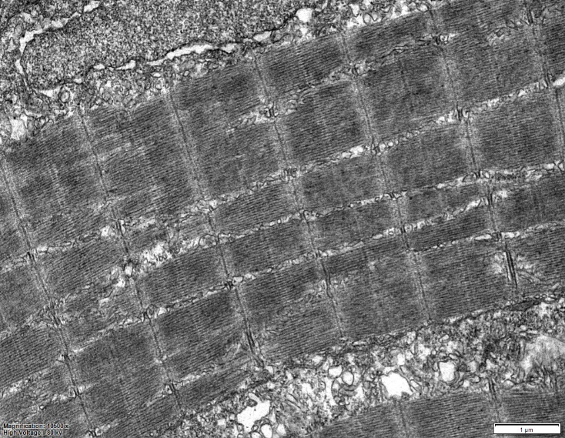
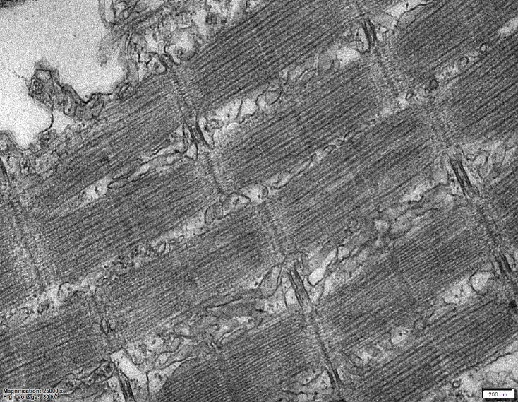
b

