Supplement 1

- eMethods1, p.2

- eMethods2, pp.3-4

- eMethods3, p.5

- Table S4, p.6

- Table S5, p.6

eMethods1
Search strategies
MEDLINE (PubMed)
(("head impulse test"[MeSH Terms] OR "head impulse test"[Title/Abstract] OR "HINTS"[Title/Abstract]) AND ("stroke"[MeSH Terms] OR "stroke"[Title/Abstract] OR "infarction"[Title/Abstract])) AND (2009:2024[pdat])
CENTRAL
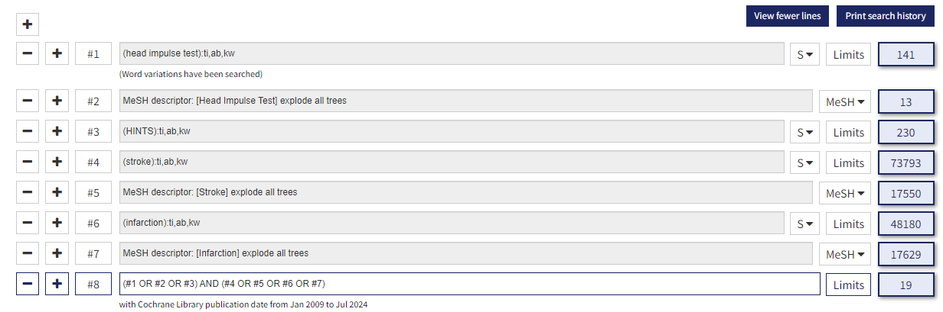
CINAHL
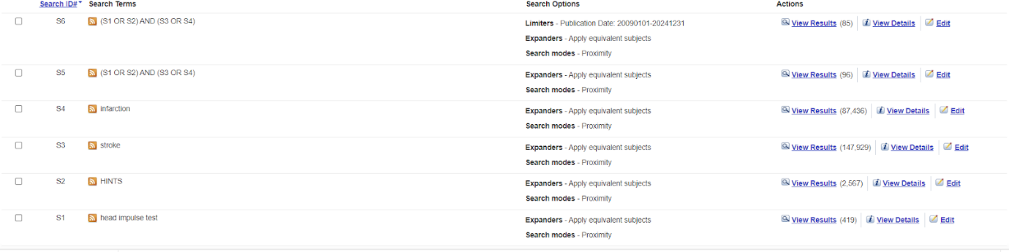
SCOPUS
( ( TITLE-ABS-KEY ( head AND impulse AND test ) ) OR ( title-abs-key {HINTS} ) ) AND ( ( TITLE-ABS-KEY ( stroke ) ) OR ( TITLE-ABS-KEY ( infarction ) ) ) AND PUBYEAR > 2008 AND PUBYEAR < 2025

eMethods2
List of excluded studies
Wrong index test
- Tamás, T. L., Garai, T., Király, I., Mike, A., Nagy, C., Paukovics, Á., Schmidt, P., Szatmári, F., Tompos, T., Vadvári, Á., & Szirmai, Á. (2017). Az akut vestibularis szindróma sürgősségi diagnosztikájával szerzett tapasztalatok [Emergency diagnosis of the acute vestibular syndrome]. Orvosi hetilap, 158(51), 2029–2040. https://doi.org/10.1556/650.2017.30886
- Nouini, A., Mat, Q., Van Nechel, C., Bostan, A., Dachy, B., & Ourtani, A. (2023). Diagnosis of dizziness in the emergency department: A 1-year prospective single-center study. Journal of vestibular research : equilibrium & orientation, 33(3), 195–202. https://doi.org/10.3233/VES-220109
- Bery, A. K., & Chang, T. P. (2022). Positive horizontal-canal head impulse test is not a benign sign for acute vestibular syndrome with hearing loss. Frontiers in neurology, 13, 941909. https://doi.org/10.3389/fneur.2022.941909
- Pudszuhn, A., Heinzelmann, A., Schönfeld, U., Niehues, S. M., & Hofmann, V. M. (2020). Akutes vestibuläres Syndrom in der Notaufnahme : Klinische Differenzierung von peripherer vs. zentraler Vestibulopathie [Acute vestibular syndrome in emergency departments : Clinical differentiation of peripheral and central vestibulopathy]. HNO, 68(5), 367–378. https://doi.org/10.1007/s00106-019-0721-8
Wrong population
- Pogson, J. M., Taylor, R. L., Young, A. S., McGarvie, L. A., Flanagan, S., Halmagyi, G. M., & Welgampola, M. S. (2016). Vertigo with sudden hearing loss: audio-vestibular characteristics. Journal of neurology, 263(10), 2086–2096. https://doi.org/10.1007/s00415-016-8214-0
- Ha, S. H., Lee, D. K., Park, G., Kim, B. J., Chang, J. Y., Kang, D. W., Kwon, S. U., Kim, J. S., Park, H. J., & Lee, E. J. (2023). Prospective analysis of video head impulse tests in patients with acute posterior circulation stroke. Frontiers in neurology, 14, 1256826. https://doi.org/10.3389/fneur.2023.1256826
- Calic, Z., Nham, B., Bradshaw, A. P., Young, A. S., Bhaskar, S., D'Souza, M., Anderson, C. S., Cappelen-Smith, C., Cordato, D., & Welgampola, M. S. (2020). Separating posterior-circulation stroke from vestibular neuritis with quantitative vestibular testing. Clinical neurophysiology : official journal of the International Federation of Clinical Neurophysiology, 131(8), 2047–2055. https://doi.org/10.1016/j.clinph.2020.04.173
Wrong study design
- Saro-Buendía, Miguel & Mas-Estelles, Fernando & Armengot, Miguel & Perez Guillen, Vanesa. (2024). Vertebral artery dissection presenting as isolated acute vestibular syndrome. Medicina Clínica Práctica. 7. 100418. 10.1016/j.mcpsp.2023.100418.
- Pavičić, T., Ruška, B., Pavlović, I., Crnošija, L., Krbot Skorić, M., Adamec,, I. & Habek, M. (2017). VIDEO HEAD IMPULSE TEST – EYE ECG. Liječnički vjesnik, 139 (9-10), 0-0. Retrieved from https://hrcak.srce.hr/193281
Wrong publication type
- Tischer, C, Pallesen, LP, Puetz, V, Barlinn, J, Timo, S, Barlinn, K. (2017). Diagnostic value of videooculography-based hints plus exam in acute vestibular syndrome: an ongoing study. European stroke journal, 2(1), 337. https://doi.org/10.1177/2396987317705242
- Siepmann, T, Gruener, C, Simon, E, Winzer, S, Sedghi, A, Pallesen, L-P, Barlinn, J, Puetz, V, Barlinn, K. (2021). Caloric testing combined with assessment of nystagmus, skew and hearing loss outperforms conventional and videooculography supported hints-plus. European stroke journal, 6(1), 177-178. https://doi.org/10.1177/23969873211034932
Wrong reference test
- Olivecrona, E., Zborayova, K., Barrenäs, M. L., & Salzer, J. (2022). Comparison Between the Video Head Impulse Test and Caloric Irrigation During Acute Vertigo. Indian journal of otolaryngology and head and neck surgery : official publication of the Association of Otolaryngologists of India, 74(Suppl 3), 4475–4482. https://doi.org/10.1007/s12070-022-03123-z
- Machner, B., Erber, K., Choi, J. H., Sprenger, A., Helmchen, C., & Trillenberg, P. (2021). A Simple Gain-Based Evaluation of the Video Head Impulse Test Reliably Detects Normal Vestibulo-Ocular Reflex Indicative of Stroke in Patients With Acute Vestibular Syndrome. Frontiers in neurology, 12, 741859. https://doi.org/10.3389/fneur.2021.741859

eMethods3
Sensitivity analyses
All studies included (n = 13)
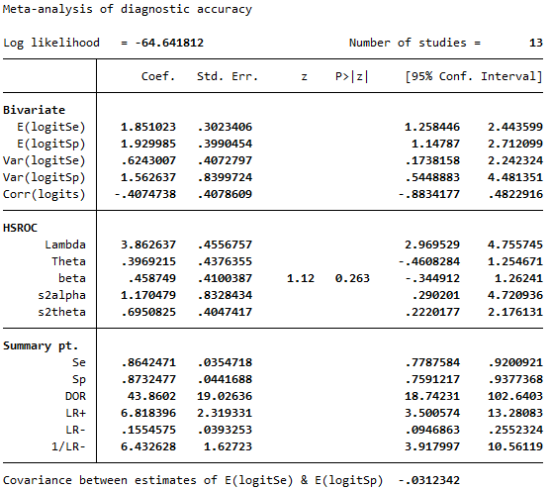
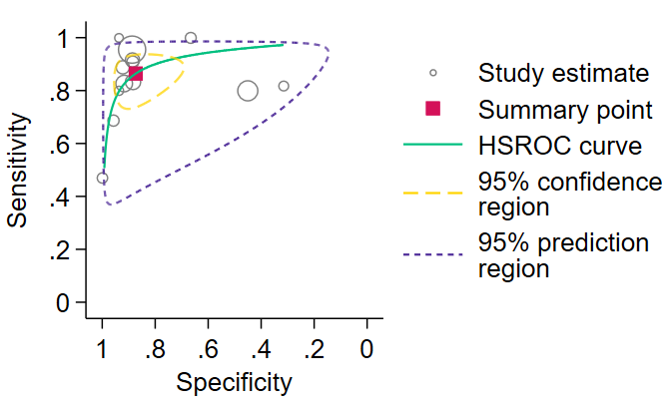

Table S4
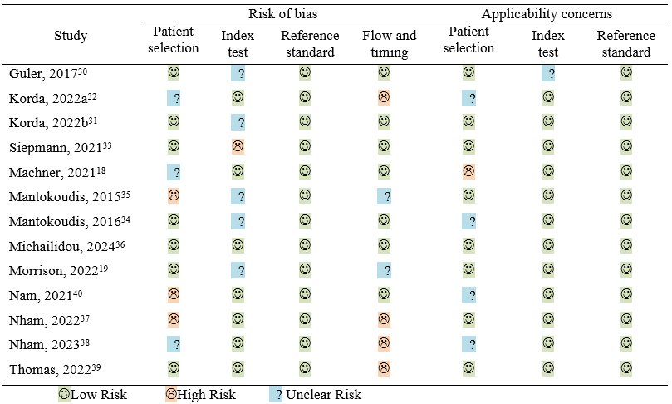
Table S5
Overlap matrix
 | Michailidou, 2024³⁶ | Mantokoudis, 2015³⁵ | Nham, 2023³⁸
Mantokoudis, 2016³⁴ |  | X
Korda, 2022a³² | X
Korda, 2022b³¹ | X
Morrison, 2022¹⁹ | X
Nham, 2022³⁷ |  |  | X
The matrix reports the studies with partial overlap. The top row represents the studies selected for analysis since they include the largest sample.

