Electronic Supporting Information
Methanol to Polypropylene: Life Cycle Assessment and a Preliminary Social Impact Analysis
Alice Vardaro¹^{,a}, Francesco Arfelli¹^{,a}*, Fabrizio Passarini¹,² , Daniele Cespi¹,²
¹Department of Industrial Chemistry “Toso Montanari”, University of Bologna, via Piero Gobetti 85, 40129 Bologna, Italy.
²Interdepartmental Centre of Industrial Research “Renewable Resources, Environment, Sea and Energy”, University of Bologna, via Angherà 22, 47922 Rimini, Italy.
ªThe authors equally contributed to the article
Corresponding author: francesco.arfelli3@unibo.it

METHODOLOGICAL CHOICES
- The choice of adopting the “avoided products” approach to deal with the multifunctionality of the system is supported by ISO 14040 (International Organization for Standardization (ISO) 2006). The ISO suggests to rely on a “system expansion” approach when, in multifunctional systems, it is not possible to directly allocate inputs and outputs involved in a unit process to a specific product. In addition, the ISO ranks this option as preferable with respect to physical and economic allocation.
- The literature lacks representative and comprehensive data to account for the material and energy flows associated with membrane gas separation phase in LCA. In the absence of complete data, assumptions are often necessary (Cellura et al. 2011).When input data are not fully supported by reliable references, the impact of such assumptions can be evaluated through sensitivity analysis, which helps quantify the uncertainty and assess its influence on the results (De Souza et al. 2016). Accordingly, the authors adopted a conservative yet arbitrary separation efficiency of 95% to ensure the separation stage was not entirely omitted. This assumption was subsequently tested through a dedicated sensitivity analysis (see Sensitivity and uncertainty analysis section).
- The biomass gasification process (latter one) specific to China is not available in the ecoinvent database and the available alternatives were between "CH" and "RoW". The choice of "CH" was motivated by the fact that, although "RoW" represents the same sequence of processes as "CH", it includes a series of geographically specific variables that are more complex to control and interpret. The use of "CH" allowed us to keep the focus on the technological stages characterising the biomass-to-methanol conversion, rather than on the geographic assumptions behind the background data. However, it is important to specify that the CC impact between the RoW version is 2.67 times higher. Such a difference is not due to the technology, since the material flow remains identical between the two options, but to the type of electricity consumed. In particular, the RoW version shows a 45.5% contribution of electricity, against the 3.67% in the case of CH. The discrepancy is accordingly attributable to the geographical variability intrinsically included in the two proxies.
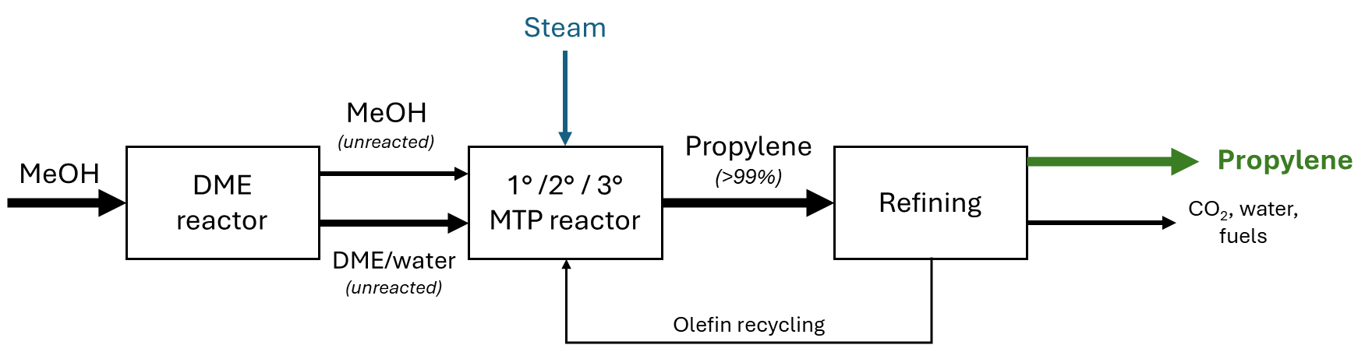
Figure S1: Flowsheet of the MTP synthesis according to Lurgi’s technology, adapted from (Gogate 2019).

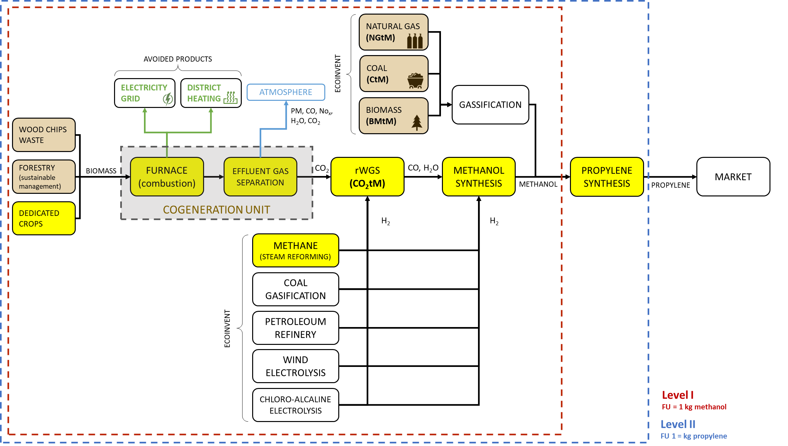
Figure S2: Product system representing the synthesis of methanol (Level I) and propylene (Level II) starting from biomass from dedicated crops as raw material and involving the employment of hydrogen derived by methane steam reforming (CO₂tM-dmCO₂ methane H₂)
Table S1: Inventory of methanol (FU = 1 kg of propylene) starting from biomass from dedicated crops as raw material and involving the employment of hydrogen derived by methane steam reforming (CO₂tM-dmCO₂ methane H₂)
Process | Required amount | Unit
MeOH synthesis | 7.28E-01 | kg
Hydrogen production, steam methane reforming | hydrogen, gaseous, low pressure | APOS, U - RER | 9.16E-02 | kg
Market group for natural gas, high pressure | natural gas, high pressure | APOS, U - Europe without Switzerland | 3.87E-01 | m³
Chemical factory construction, organics | chemical factory, organics | APOS, U - RER | 4.57E-11 | Item(s)
Market for natural gas, high pressure | natural gas, high pressure | APOS, U - CH | 2.70E-03 | m³
Market for zeolite, powder | zeolite, powder | APOS, U - GLO | 7.54E-05 | kg
Market for nickel, class 1 | nickel, class 1 | APOS, U - GLO | 1.73E-05 | kg
Market for copper oxide | copper oxide | APOS, U - GLO | 3.09E-05 | kg
Market for water, deionised | water, deionised | APOS, U - Europe without Switzerland | 3.77E-01 | kg
Market for aluminium oxide, metallurgical | aluminium oxide, metallurgical | APOS, U - IAI Area, EU27 & EFTA | 4.55E-05 | kg
Market for zinc oxide | zinc oxide | APOS, U - GLO | 3.17E-05 | kg
Market for chromium trioxide, flakes | chromium trioxide, flakes | APOS, U - GLO | 3.07E-06 | kg
Market for molybdenum trioxide | molybdenum trioxide | APOS, U - GLO | 1.43E-06 | kg
Market for magnesium oxide | magnesium oxide | APOS, U - GLO | 2.39E-06 | kg
Market for quicklime, milled, packed | quicklime, milled, packed | APOS, U - RER | 4.10E-06 | kg
Market for portafer | portafer | APOS, U - GLO | 2.67E-05 | kg
Market for water, deionised | water, deionised | APOS, U - CH | 1.36E-03 | kg
Market for silica sand | silica sand | APOS, U - GLO | 9.90E-07 | kg
RWGS | 6.36E-01 | kg
Hydrogen production, steam methane reforming | hydrogen, gaseous, low pressure | APOS, U - RER | 4.58E-02 | kg
Treatment of wastewater, unpolluted, wastewater treatment | wastewater, unpolluted | APOS, U - RoW | 4.09E-04 | m³
Purified CO₂ | 1.00E+00 | kg
Cogeneration of dedicated biomass | 1.05E+00 | kg
_heat production, hardwood chips from forest, at furnace 50kW | heat, central or small-scale, other than natural gas | APOS, U - CH | 9.78E-01 | MJ
Heat production, natural gas, at boiler modulating <100kW | heat, central or small-scale, natural gas | APOS, U - Europe without Switzerland | -3.52E+00 | MJ
Electricity, high voltage, production mix | electricity, high voltage | APOS, U - IT | -2.56E+00 | MJ
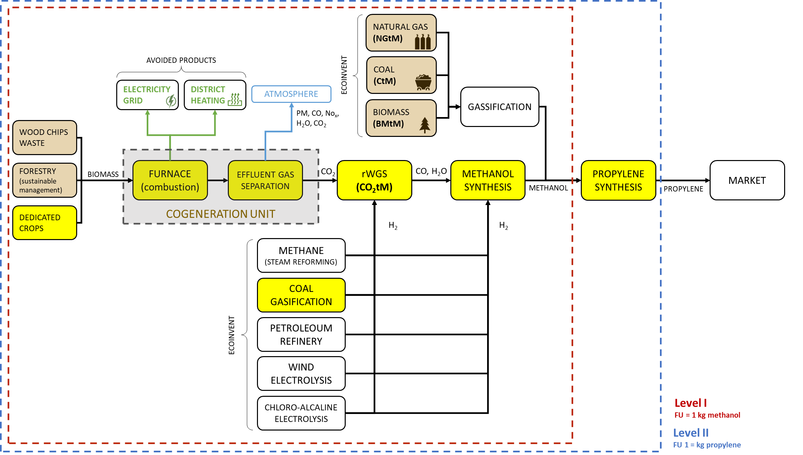
Figure S3: Product system representing the synthesis of methanol (Level I) and propylene (Level II) starting from biomass from dedicated crops as raw material and involving the employment of hydrogen derived by coal gasification (CO₂tM- dmCO₂ coal H₂
Table S2: Inventory of methanol (FU = 1 kg of propylene) starting from biomass from dedicated crops as raw material and involving the employment of hydrogen derived by coal gasification (CO₂tM- dmCO₂ coal H₂)
Process | Required amount | Unit
Meoh synthesis | 7.28E-01 | kg
Hydrogen production, coal gasification | hydrogen, gaseous, low pressure | APOS, U - CN | 9.16E-02 | kg
Market group for electricity, medium voltage | electricity, medium voltage | APOS, U - CN | 1.32E+00 | MJ
Market for hard coal | hard coal | APOS, U - CN | 5.66E-01 | kg
Market for chemical factory, organics | chemical factory, organics | APOS, U - GLO | 4.11E-11 | Item(s)
Market for methanol | methanol | APOS, U - CN | 3.71E-04 | kg
Market for non-ionic surfactant | non-ionic surfactant | APOS, U - GLO | 2.84E-04 | kg
Market for hard coal ash | hard coal ash | APOS, U - row | 6.22E-02 | kg
Market for cobalt | cobalt | APOS, U - GLO | 1.51E-05 | kg
Market for waste gypsum | waste gypsum | APOS, U - row | 2.30E-02 | kg
Market for molybdenum trioxide | molybdenum trioxide | APOS, U - GLO | 4.09E-05 | kg
Market for aluminium oxide, metallurgical | aluminium oxide, metallurgical | APOS, U - row | 8.19E-05 | kg
Market for water, deionised | water, deionised | APOS, U - row | 5.00E-01 | kg
Market for wastewater, average | wastewater, average | APOS, U - row | 5.00E-04 | m³
Market for limestone, crushed, washed | limestone, crushed, washed | APOS, U - row | 1.34E-02 | kg
Market for hazardous waste, for underground deposit | hazardous waste, for underground deposit | APOS, U - row | 5.60E-05 | kg
RWGS | 6.36E-01 | kg
Hydrogen production, coal gasification | hydrogen, gaseous, low pressure | APOS, U - row | 4.58E-02 | kg
Treatment of wastewater, unpolluted, wastewater treatment | wastewater, unpolluted | APOS, U - row | 4.09E-04 | m³
Purified CO₂ | 1.00E+00 | kg
Cogeneration of dedicated biomass (1) | 1.05E+00 | kg
_heat production, hardwood chips from forest, at furnace 50kw | heat, central or small-scale, other than natural gas | APOS, U - CH | 9.78E-01 | MJ
Heat production, natural gas, at boiler modulating <100kw | heat, central or small-scale, natural gas | APOS, U - Europe without Switzerland | -3.52E+00 | MJ
Electricity, high voltage, production mix | electricity, high voltage | APOS, U - IT | -2.56E+00 | MJ

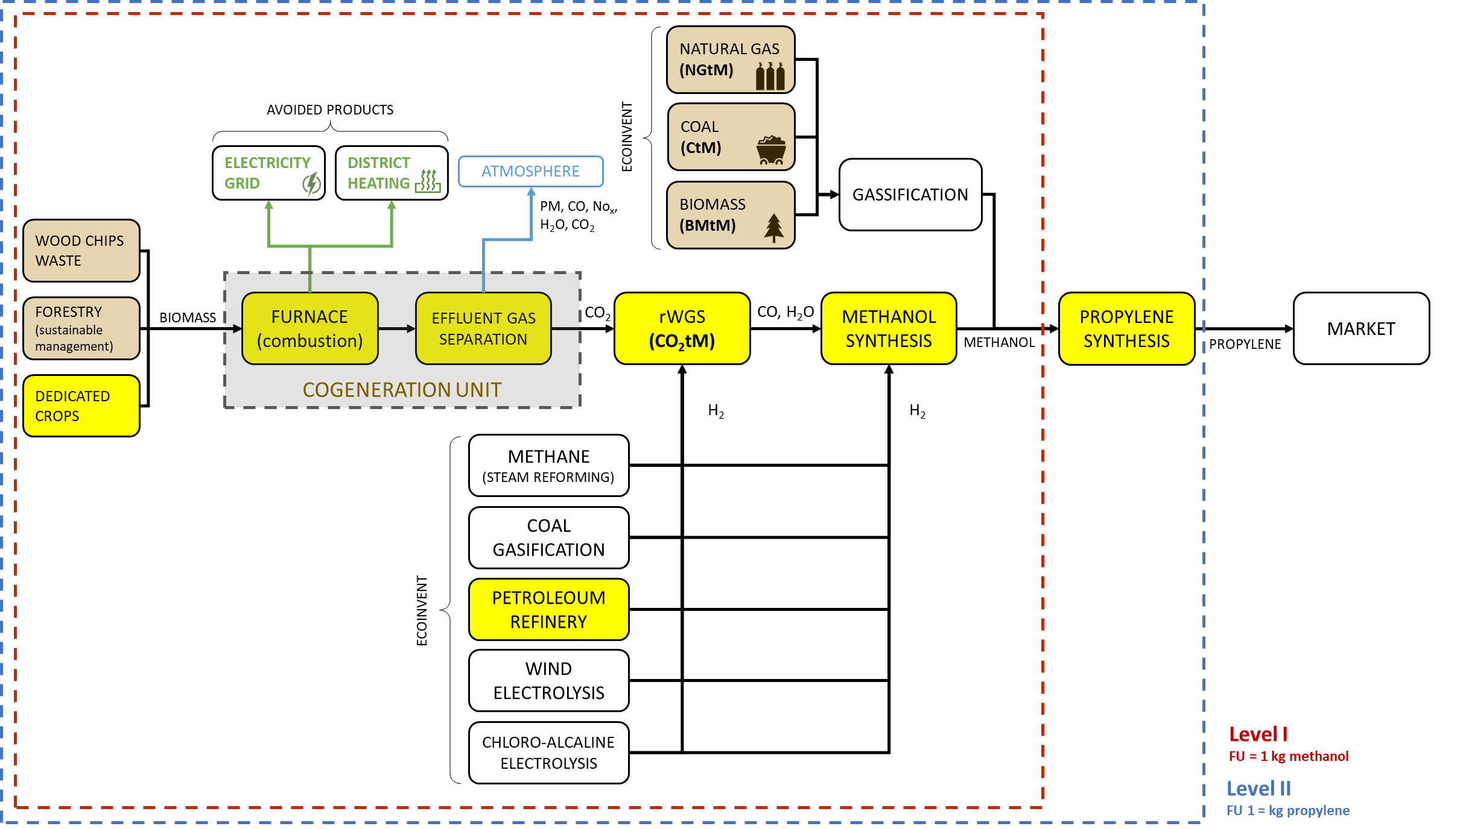
Figure S4: Product system representing the synthesis of methanol (Level I) and propylene (Level II) starting from biomass from dedicated crops as raw material and involving the employment of hydrogen derived by petroleum refinery (CO₂tM- dmCO₂ petroleum H₂)
Table S3: Inventory of methanol (1 kg of propylene) starting from biomass from dedicated crops as raw material and involving the employment of hydrogen derived by petroleoum refinery (CO₂tM- dmCO₂ petroleum H₂)
Process | Required amount | Unit
MeOH synthesis | 7.28E-01 | kg
Hydrogen production, gaseous, petroleum refinery operation | hydrogen, gaseous | APOS, U - Europe without Switzerland | 9.16E-02 | kg
Market for petroleum | petroleum | APOS, U - GLO | 2.78E-01 | kg
Market for lime, hydrated, packed | lime, hydrated, packed | APOS, U - RER | 3.53E-04 | kg
Market for refinery sludge | refinery sludge | APOS, U - Europe without Switzerland | 1.38E-04 | kg
Market for hazardous waste, for incineration | hazardous waste, for incineration | APOS, U - Europe without Switzerland | 7.75E-05 | kg
Market for quicklime, milled, packed | quicklime, milled, packed | APOS, U - RER | 7.89E-05 | kg
Market for platinum | platinum | APOS, U - GLO | 1.28E-09 | kg
Petroleum refinery construction | petroleum refinery | APOS, U - RER | 1.52E-12 | Item(s)
Market for sodium hydroxide, without water, in 50% solution state | sodium hydroxide, without water, in 50% solution state | APOS, U - GLO | 1.09E-05 | kg
Market for hydrochloric acid, without water, in 30% solution state | hydrochloric acid, without water, in 30% solution state | APOS, U - RER | 2.17E-05 | kg
Market for zeolite, powder | zeolite, powder | APOS, U - GLO | 2.39E-06 | kg
Market for aluminium oxide, non-metallurgical | aluminium oxide, non-metallurgical | APOS, U - IAI Area, EU27 & EFTA | 4.09E-06 | kg
Market for waste gypsum | waste gypsum | APOS, U - Europe without Switzerland | 2.85E-04 | kg
Market for cobalt | cobalt | APOS, U - GLO | 8.53E-08 | kg
Market for lanthanum oxide | lanthanum oxide | APOS, U - GLO | 8.53E-08 | kg
Market for silicone product | silicone product | APOS, U - RER | 8.53E-07 | kg
Market for hazardous waste, for underground deposit | hazardous waste, for underground deposit | APOS, U - RER | 8.50E-06 | kg
Market for nickel, class 1 | nickel, class 1 | APOS, U - GLO | 8.53E-08 | kg
Market for molybdenum trioxide | molybdenum trioxide | APOS, U - GLO | 8.53E-08 | kg
Market for kaolin | kaolin | APOS, U - GLO | 8.53E-07 | kg
RWGS | 6.36E-01 | kg
Hydrogen production, gaseous, petroleum refinery operation | hydrogen, gaseous, low pressure | APOS, U - Europe without Switzerland | 4.58E-02 | kg
Treatment of wastewater, unpolluted, wastewater treatment | wastewater, unpolluted | APOS, U - row | 4.09E-04 | m³
Purified CO₂ | 1.00E+00 | kg
Cogeneration of dedicated biomass | 1.05E+00 | kg
_heat production, hardwood chips from forest, at furnace 50kw | heat, central or small-scale, other than natural gas | APOS, U - CH | 9.78E-01 | MJ
Heat production, natural gas, at boiler modulating <100kw | heat, central or small-scale, natural gas | APOS, U - Europe without Switzerland | -3.52E+00 | MJ
Electricity, high voltage, production mix | electricity, high voltage | APOS, U - IT | -2.56E+00 | MJ

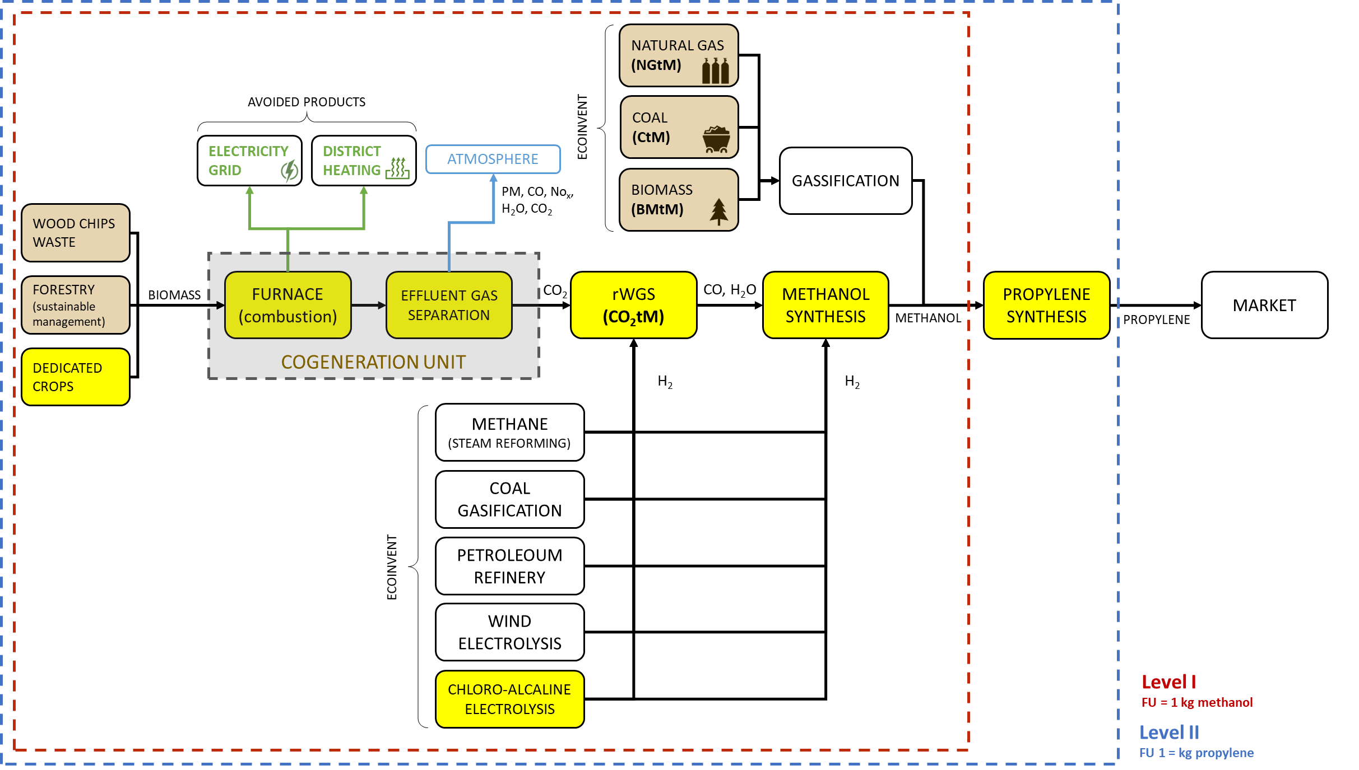
Figure S5: Product system representing the synthesis of methanol (Level I) and propylene (Level II) starting from biomass from dedicated crops as raw material and involving the employment of hydrogen derived by chloro-alcaline electrolysis (CO₂tM- dmCO₂ electrolysis H₂)
Table S4: Inventory of methanol (FU = 1 kg of propylene) starting from biomass from dedicated crops as raw material and involving the employment of hydrogen derived by chloro-alcaline electrolysis (CO₂tM- dmCO₂ electrolysis H₂)
Process | Required amount |  | Unit
MeOH synthesis | 7.28E-01 | kg
Chlor-alkali electrolysis, membrane cell | hydrogen, gaseous, low pressure | APOS, U - RER | 9.16E-02 | kg
Market for electricity, medium voltage | electricity, medium voltage | APOS, U - DE | 1.60E+00 | MJ
Market for sodium chloride, powder | sodium chloride, powder | APOS, U - GLO | 7.25E-01 | kg
Market for heat, from steam, in chemical industry | heat, from steam, in chemical industry | APOS, U - RER | 8.90E-01 | MJ
Market for electricity, medium voltage | electricity, medium voltage | APOS, U - PL | 1.94E-01 | MJ
Market for electricity, medium voltage | electricity, medium voltage | APOS, U - NL | 3.50E-01 | MJ
Market for electricity, medium voltage | electricity, medium voltage | APOS, U - BE | 5.06E-01 | MJ
Chemical factory construction, organics | chemical factory, organics | APOS, U - RER | 1.55E-10 | Item(s)
Market for electricity, medium voltage | electricity, medium voltage | APOS, U - HU | 1.78E-01 | MJ
Market for electricity, medium voltage | electricity, medium voltage | APOS, U - GB | 2.44E-01 | MJ
Market for electricity, medium voltage | electricity, medium voltage | APOS, U - ES | 1.49E-01 | MJ
Market for hydrochloric acid, without water, in 30% solution state | hydrochloric acid, without water, in 30% solution state | APOS, U - RER | 1.28E-02 | kg
Market for electricity, medium voltage | electricity, medium voltage | APOS, U - CZ | 3.55E-02 | MJ
Market for electricity, medium voltage | electricity, medium voltage | APOS, U - FR | 2.09E-01 | MJ
Market for electricity, medium voltage | electricity, medium voltage | APOS, U - PT | 5.82E-02 | MJ
Market for soda ash, dense | soda ash, dense | APOS, U - GLO | 3.23E-03 | kg
Market for potassium chloride | potassium chloride | APOS, U - RER | 2.20E-03 | kg
Market for electricity, medium voltage | electricity, medium voltage | APOS, U - FI | 3.50E-02 | MJ
Market for electricity, medium voltage | electricity, medium voltage | APOS, U - IT | 9.72E-03 | MJ
Market for nitrogen, liquid | nitrogen, liquid | APOS, U - RER | 5.03E-03 | kg
Market for electricity, medium voltage | electricity, medium voltage | APOS, U - SE | 6.68E-02 | MJ
Market for electricity, medium voltage | electricity, medium voltage | APOS, U - NO | 1.70E-01 | MJ
Market for sodium hydrogen sulfite | sodium hydrogen sulfite | APOS, U - GLO | 6.34E-04 | kg
Market for sulfuric acid | sulfuric acid | APOS, U - RER | 6.37E-03 | kg
Market for compressed air, 600 kpa gauge | compressed air, 600 kpa gauge | APOS, U - RER | 1.35E-02 | m³
Market for chemical, inorganic | chemical, inorganic | APOS, U - GLO | 2.22E-04 | kg
Market for wastewater, average | wastewater, average | APOS, U - Europe without Switzerland | 9.92E-04 | m³
Market for hazardous waste, for incineration | hazardous waste, for incineration | APOS, U - Europe without Switzerland | 1.36E-04 | kg
Market for carbon dioxide, liquid | carbon dioxide, liquid | APOS, U - RER | 3.71E-04 | kg
Market for hazardous waste, for underground deposit | hazardous waste, for underground deposit | APOS, U - RER | 1.03E-03 | kg
Market for chemical, organic | chemical, organic | APOS, U - GLO | 7.72E-05 | kg
Market group for natural gas, high pressure | natural gas, high pressure | APOS, U - Europe without Switzerland | 3.56E-04 | m³
Market for hydrogen peroxide, without water, in 50% solution state | hydrogen peroxide, without water, in 50% solution state | APOS, U - RER | 1.15E-04 | kg
Market for water, deionised | water, deionised | APOS, U - Europe without Switzerland | 7.20E-01 | kg
Market for platinum | platinum | APOS, U - GLO | 2.02E-09 | kg
Market for calcium chloride | calcium chloride | APOS, U - RER | 2.46E-04 | kg
Market for hydrogen, gaseous, low pressure | hydrogen, gaseous, low pressure | APOS, U - RER | 1.16E-05 | kg
Market for sodium sulfite | sodium sulfite | APOS, U - RER | 1.72E-04 | kg
Market for sodium sulfide | sodium sulfide | APOS, U - GLO | 2.10E-05 | kg
Market for potassium carbonate | potassium carbonate | APOS, U - GLO | 1.30E-05 | kg
Market for disodium disulphite | disodium disulphite | APOS, U - GLO | 3.27E-05 | kg
Market for refrigerant R134a | refrigerant R134a | APOS, U - GLO | 1.95E-06 | kg
Market for barium carbonate | barium carbonate | APOS, U - GLO | 1.92E-05 | kg
Market for inert waste | inert waste | APOS, U - RER | 1.16E-03 | kg
Market for anionic resin | anionic resin | APOS, U - RER | 4.10E-06 | kg
Market for titanium dioxide | titanium dioxide | APOS, U - RER | 2.02E-06 | kg
Market for hazardous waste, for incineration | hazardous waste, for incineration | APOS, U - CH | 3.55E-06 | kg
Market for activated carbon, granular | activated carbon, granular | APOS, U - GLO | 2.32E-06 | kg
Market for wastewater, average | wastewater, average | APOS, U - CH | 2.49E-05 | m³
Market for cationic resin | cationic resin | APOS, U - RER | 4.10E-06 | kg
Market for natural gas, high pressure | natural gas, high pressure | APOS, U - CH | 2.49E-06 | m³
Market for perfluoropentane | perfluoropentane | APOS, U - GLO | 4.65E-08 | kg
Market for water, deionised | water, deionised | APOS, U - CH | 2.59E-03 | kg
Market for ammonia, anhydrous, liquid | ammonia, anhydrous, liquid | APOS, U - RER | 9.32E-08 | kg
Market for oxygen, liquid | oxygen, liquid | APOS, U - RER | 3.67E-07 | kg
Market for ethylene glycol | ethylene glycol | APOS, U - RER | 6.52E-08 | kg
RWGS | 6.36E-01 | kg
Chlor-alkali electrolysis, membrane cell | hydrogen, gaseous, low pressure | APOS, U - RER | 4.58E-02 | kg
Treatment of wastewater, unpolluted, wastewater treatment | wastewater, unpolluted | APOS, U - row | 4.09E-04 | m³
Purified CO₂ | 1.00E+00 | kg
Cogeneration of dedicated biomass | 1.05E+00 | kg
_heat production, hardwood chips from forest, at furnace 50kw | heat, central or small-scale, other than natural gas | APOS, U (3) - CH | 9.78E-01 | MJ
Heat production, natural gas, at boiler modulating <100kw | heat, central or small-scale, natural gas | APOS, U - Europe without Switzerland | -3.52E+00 | MJ
Electricity, high voltage, production mix | electricity, high voltage | APOS, U - IT | -2.56E+00 | MJ

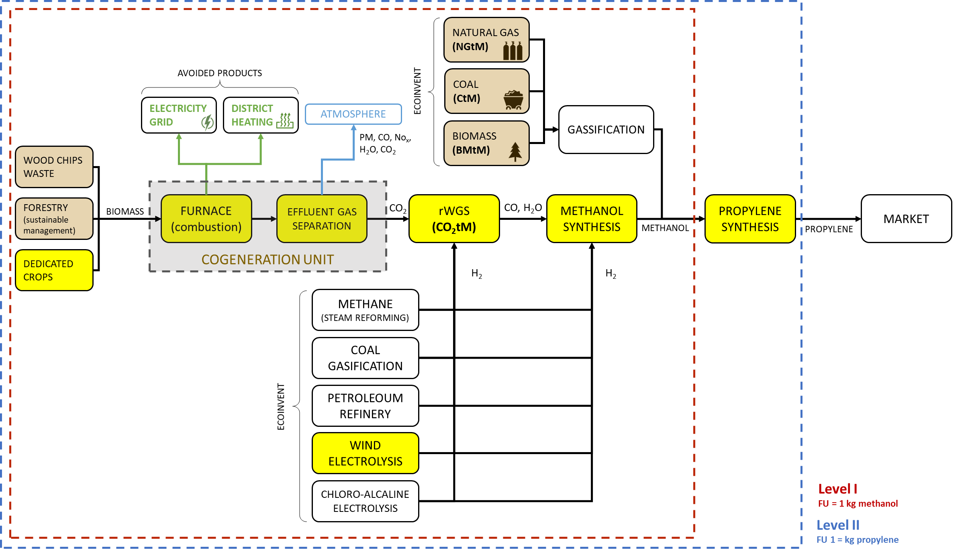
Figure S6: Product system representing the synthesis of methanol (Level I) and propylene (Level II) starting from biomass from dedicated crops as raw material and involving the employment of hydrogen derived by wind electrolysis (CO₂tM- dmCO₂ wind electrolysis H₂)
Table S5: Inventory of methanol (FU = 1 kg of propylene) starting from biomass from dedicated crops as raw material and involving the employment of hydrogen derived by wind electrolysis (CO₂tM- dmCO₂ wind electrolysis H₂)
Process | Required amount | Unit
MeOH synthesis | 7.28E-01 | kg
r-H₂ production | 9.16E-02 | kg
Electricity production, wind, >3MW turbine, onshore | electricity, high voltage | APOS, U - IT | 9.09E-01 | MJ
RWGS | 6.36E-01 | kg
R-H₂ production | 4.58E-02 | kg
Treatment of wastewater, unpolluted, wastewater treatment | wastewater, unpolluted | APOS, U - row | 4.09E-04 | m³
Purified CO₂ | 1.00E+00 | kg
Cogeneration of dedicated biomass | 1.05E+00 | kg
_heat production, hardwood chips from forest, at furnace 50kw | heat, central or small-scale, other than natural gas | APOS, U - CH | 9.78E-01 | MJ
Heat production, natural gas, at boiler modulating <100kw | heat, central or small-scale, natural gas | APOS, U - Europe without Switzerland | -3.52E+00 | MJ
Electricity, high voltage, production mix | electricity, high voltage | APOS, U - IT | -2.56E+00 | MJ

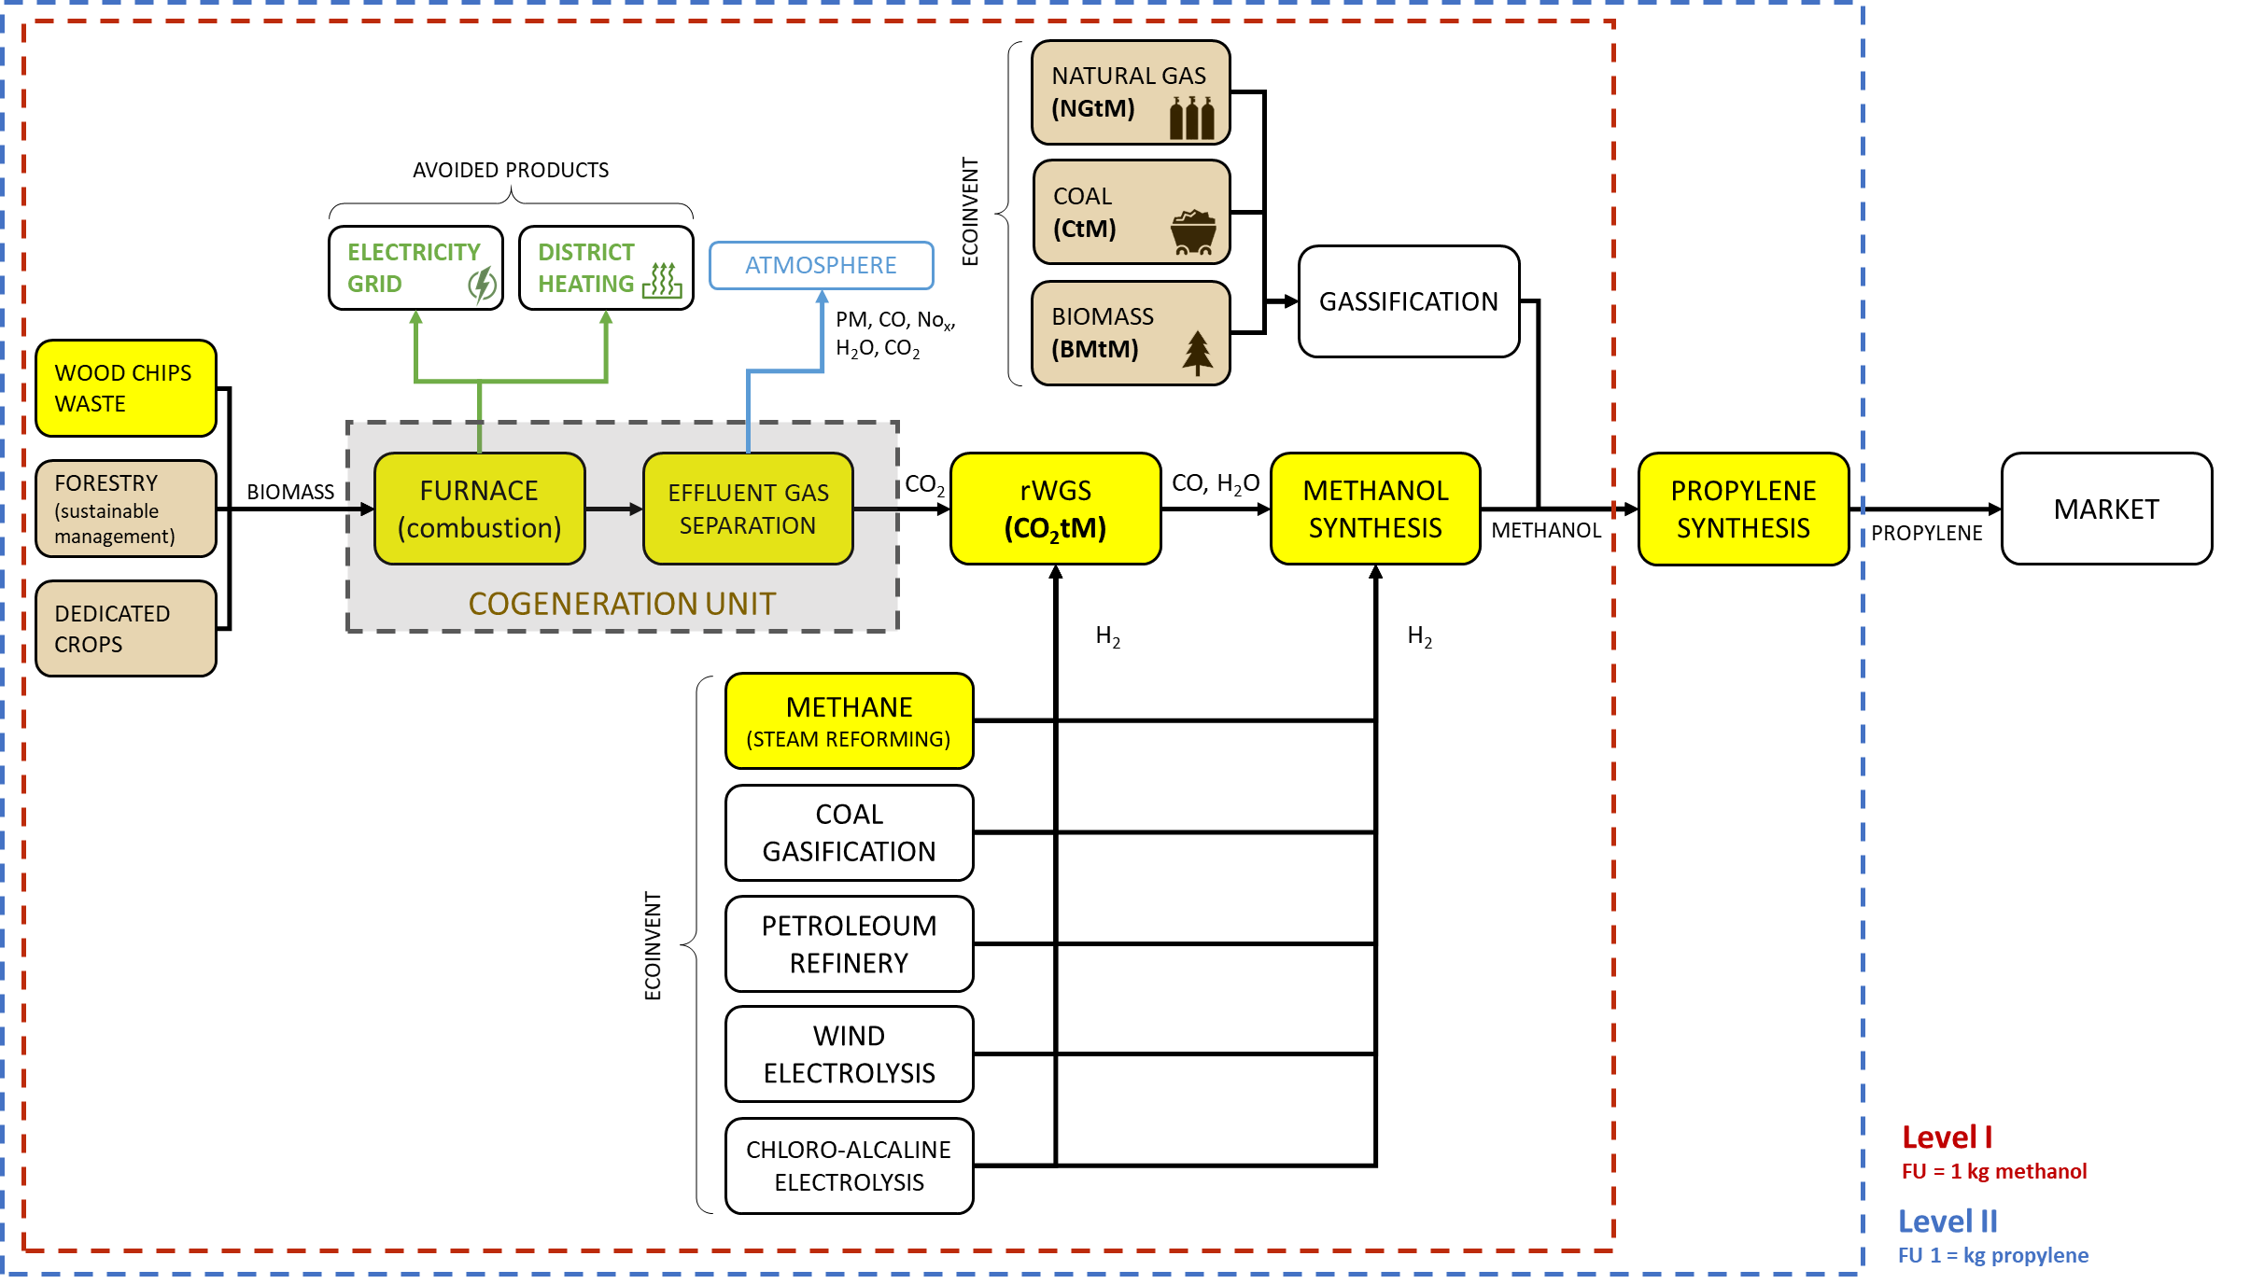
Figure S7: Product system representing the synthesis of methanol (Level I) and propylene (Level II) starting from waste biomass raw material and involving the employment of hydrogen derived by methane steam reforming (CO₂tM- wcwCO2 methane H₂)
Table S6: Inventory of methanol (FU = 1 kg of propylene) starting from biomass from waste biomass raw material and involving the employment of hydrogen derived by methane steam reforming (CO₂tM- wcwCO2 methane H₂)
Process | Required amount | Unit
MeOH synthesis | 7.28E-01 | kg
Hydrogen production, steam methane reforming | hydrogen, gaseous, low pressure | APOS, U - RER | 9.16E-02 | kg
Market group for natural gas, high pressure | natural gas, high pressure | APOS, U - Europe without Switzerland | 3.87E-01 | m³
Chemical factory construction, organics | chemical factory, organics | APOS, U - RER | 4.57E-11 | Item(s)
Market for natural gas, high pressure | natural gas, high pressure | APOS, U - CH | 2.70E-03 | m³
Market for zeolite, powder | zeolite, powder | APOS, U - GLO | 7.54E-05 | kg
Market for nickel, class 1 | nickel, class 1 | APOS, U - GLO | 1.73E-05 | kg
Market for copper oxide | copper oxide | APOS, U - GLO | 3.09E-05 | kg
Market for water, deionised | water, deionised | APOS, U - Europe without Switzerland | 3.77E-01 | kg
Market for aluminium oxide, metallurgical | aluminium oxide, metallurgical | APOS, U - IAI Area, EU27 & EFTA | 4.55E-05 | kg
Market for zinc oxide | zinc oxide | APOS, U - GLO | 3.17E-05 | kg
Market for chromium trioxide, flakes | chromium trioxide, flakes | APOS, U - GLO | 3.07E-06 | kg
Market for molybdenum trioxide | molybdenum trioxide | APOS, U - GLO | 1.43E-06 | kg
Market for magnesium oxide | magnesium oxide | APOS, U - GLO | 2.39E-06 | kg
Market for quicklime, milled, packed | quicklime, milled, packed | APOS, U - RER | 4.10E-06 | kg
Market for portafer | portafer | APOS, U - GLO | 2.67E-05 | kg
Market for water, deionised | water, deionised | APOS, U - CH | 1.36E-03 | kg
Market for silica sand | silica sand | APOS, U - GLO | 9.90E-07 | kg
RWGS | 6.36E-01 | kg
Hydrogen production, steam methane reforming | hydrogen, gaseous, low pressure | APOS, U - RER | 4.58E-02 | kg
Treatment of wastewater, unpolluted, wastewater treatment | wastewater, unpolluted | APOS, U - row | 4.09E-04 | m³
Purified CO₂ | 1.00E+00 | kg
Cogeneration of dedicated biomass | 1.05E+00 | kg
_heat production, hardwood chips from forest, at furnace 50kw | heat, central or small-scale, other than natural gas | APOS, U (5) - CH | 9.78E-01 | MJ
Heat production, natural gas, at boiler modulating <100kw | heat, central or small-scale, natural gas | APOS, U - Europe without Switzerland | -3.52E+00 | MJ
Electricity, high voltage, production mix | electricity, high voltage | APOS, U - IT | -2.56E+00 | MJ

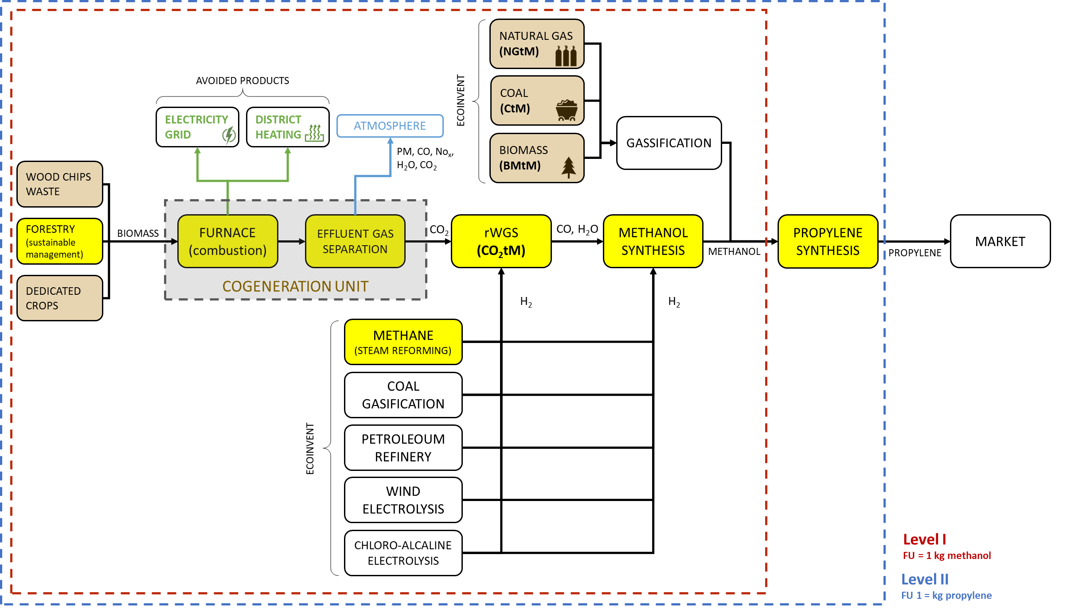
Figure S8: Product system representing the synthesis of methanol (Level I) and propylene (Level II) starting from biomass obtained by a sustainably managed forest as raw material and involving the employment of hydrogen derived by methane steam reforming (CO₂tM- smCO₂ methane H₂)
Table S7: Inventory of methanol (FU = 1 kg of propylene) starting from biomass obtained by a sustainably managed forest as raw material and involving the employment of hydrogen derived by methane steam reforming (CO₂tM- smCO₂ methane H₂)
Process | Required amount | Unit
MeOH synthesis | 7.28E-01 | kg
Hydrogen production, steam methane reforming | hydrogen, gaseous, low pressure | APOS, U - RER | 9.16E-02 | kg
Market group for natural gas, high pressure | natural gas, high pressure | APOS, U - Europe without Switzerland | 3.87E-01 | m3
Chemical factory construction, organics | chemical factory, organics | APOS, U - RER | 4.57E-11 | Item(s)
Market for natural gas, high pressure | natural gas, high pressure | APOS, U - CH | 2.70E-03 | m³
Market for zeolite, powder | zeolite, powder | APOS, U - GLO | 7.54E-05 | kg
Market for nickel, class 1 | nickel, class 1 | APOS, U - GLO | 1.73E-05 | kg
Market for copper oxide | copper oxide | APOS, U - GLO | 3.09E-05 | kg
Market for water, deionised | water, deionised | APOS, U - Europe without Switzerland | 3.77E-01 | kg
Market for aluminium oxide, metallurgical | aluminium oxide, metallurgical | APOS, U - IAI Area, EU27 & EFTA | 4.55E-05 | kg
Market for zinc oxide | zinc oxide | APOS, U - GLO | 3.17E-05 | kg
Market for chromium trioxide, flakes | chromium trioxide, flakes | APOS, U - GLO | 3.07E-06 | kg
Market for molybdenum trioxide | molybdenum trioxide | APOS, U - GLO | 1.43E-06 | kg
Market for magnesium oxide | magnesium oxide | APOS, U - GLO | 2.39E-06 | kg
Market for quicklime, milled, packed | quicklime, milled, packed | APOS, U - RER | 4.10E-06 | kg
Market for portafer | portafer | APOS, U - GLO | 2.67E-05 | kg
Market for water, deionised | water, deionised | APOS, U - CH | 1.36E-03 | kg
Market for silica sand | silica sand | APOS, U - GLO | 9.90E-07 | kg
RWGS | 6.36E-01 | kg
Hydrogen production, steam methane reforming | hydrogen, gaseous, low pressure | APOS, U - RER | 4.58E-02 | kg
Treatment of wastewater, unpolluted, wastewater treatment | wastewater, unpolluted | APOS, U - row | 4.09E-04 | m³
Purified CO₂ | 1.00E+00 | kg
Cogeneration of dedicated biomass | 1.05E+00 | kg
_heat production, hardwood chips from forest, at furnace 50kw | heat, central or small-scale, other than natural gas | APOS, U - CH | 9.78E-01 | MJ
Heat production, natural gas, at boiler modulating <100kw | heat, central or small-scale, natural gas | APOS, U - Europe without Switzerland | -3.52E+00 | MJ
Electricity, high voltage, production mix | electricity, high voltage | APOS, U - IT | -2.56E+00 | MJ
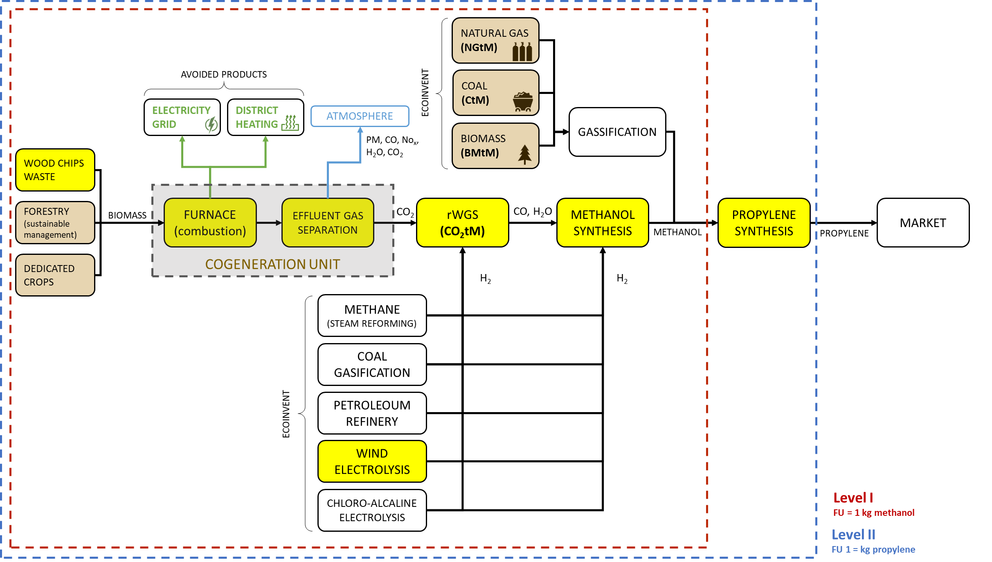
Figure S9: Product system representing the synthesis of methanol (Level I) and propylene (Level II) starting from waste biomass raw material and involving the employment of hydrogen derived by wind electrolysis (CO₂tM- wcwCO₂ wind electrolysis H₂)
Table S8: Inventory of methanol (FU = 1 kg of propylene) starting from waste biomass raw material and involving the employment of hydrogen derived by wind electrolysis (CO₂tM- wcwCO₂ wind electrolysis H₂)
Process | Required amount | Unit
MeOH synthesis | 7.28E-01 | kg
r-H₂ production | 9.16E-02 | kg
Electricity production, wind, >3MW turbine, onshore | electricity, high voltage | APOS, U - IT | 9.09E-01 | MJ
RWGS | 6.36E-01 | kg
R-H₂ production | 4.58E-02 | kg
Treatment of wastewater, unpolluted, wastewater treatment | wastewater, unpolluted | APOS, U - row | 4.09E-04 | m³
Purified CO₂ | 1.00E+00 | kg
Cogeneration of dedicated biomass | 1.05E+00 | kg
_heat production, hardwood chips from forest, at furnace 50kw | heat, central or small-scale, other than natural gas | APOS, U - CH | 9.78E-01 | MJ
Heat production, natural gas, at boiler modulating <100kw | heat, central or small-scale, natural gas | APOS, U - Europe without Switzerland | -3.52E+00 | MJ
Electricity, high voltage, production mix | electricity, high voltage | APOS, U - IT | -2.56E+00 | MJ

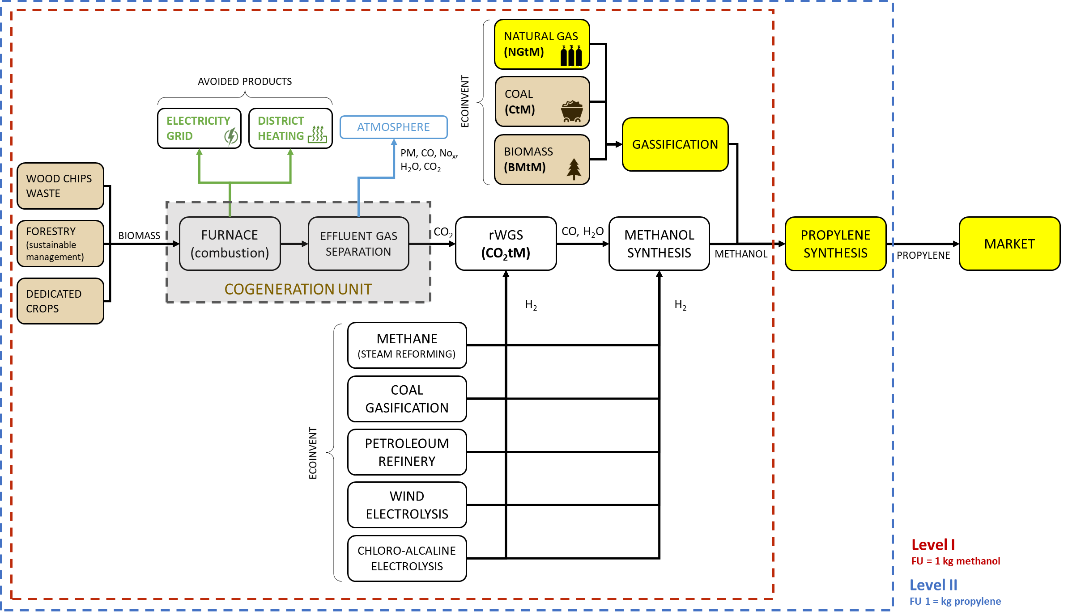
Figure S10: Product system representing the Natural Gas to Methanol (NGtM) scenario.
Table S9: Inventory of methanol (FU = 1 kg of propylene) representing the Natural Gas to Methanol (NGtM) scenario
Process | Required amount | Unit
Methanol production, natural gas reforming | methanol | APOS, U - CN | 7.28E-01 | kg
Market for natural gas, high pressure | natural gas, high pressure | APOS, U - CN | 6.47E-01 | m³
Market group for electricity, medium voltage | electricity, medium voltage | APOS, U - CN | 2.32E-01 | MJ
Market for nickel, class 1 | nickel, class 1 | APOS, U - GLO | 1.46E-05 | kg
Market for copper oxide | copper oxide | APOS, U - GLO | 6.55E-05 | kg
Market for methanol factory | methanol factory | APOS, U - GLO | 2.71E-11 | Item(s)
Market for aluminium oxide, non-metallurgical | aluminium oxide, non-metallurgical | APOS, U - row | 1.75E-04 | kg
Market for molybdenum trioxide | molybdenum trioxide | APOS, U - GLO | 7.28E-06 | kg
Market for water, deionised | water, deionised | APOS, U - row | 2.58E-01 | kg
Market for wastewater, average | wastewater, average | APOS, U - row | 2.15E-04 | m³
Market for heat, district or industrial, natural gas | heat, district or industrial, natural gas | APOS, U - row | 7.28E-03 | MJ
Market for zinc oxide | zinc oxide | APOS, U - GLO | 2.18E-05 | kg

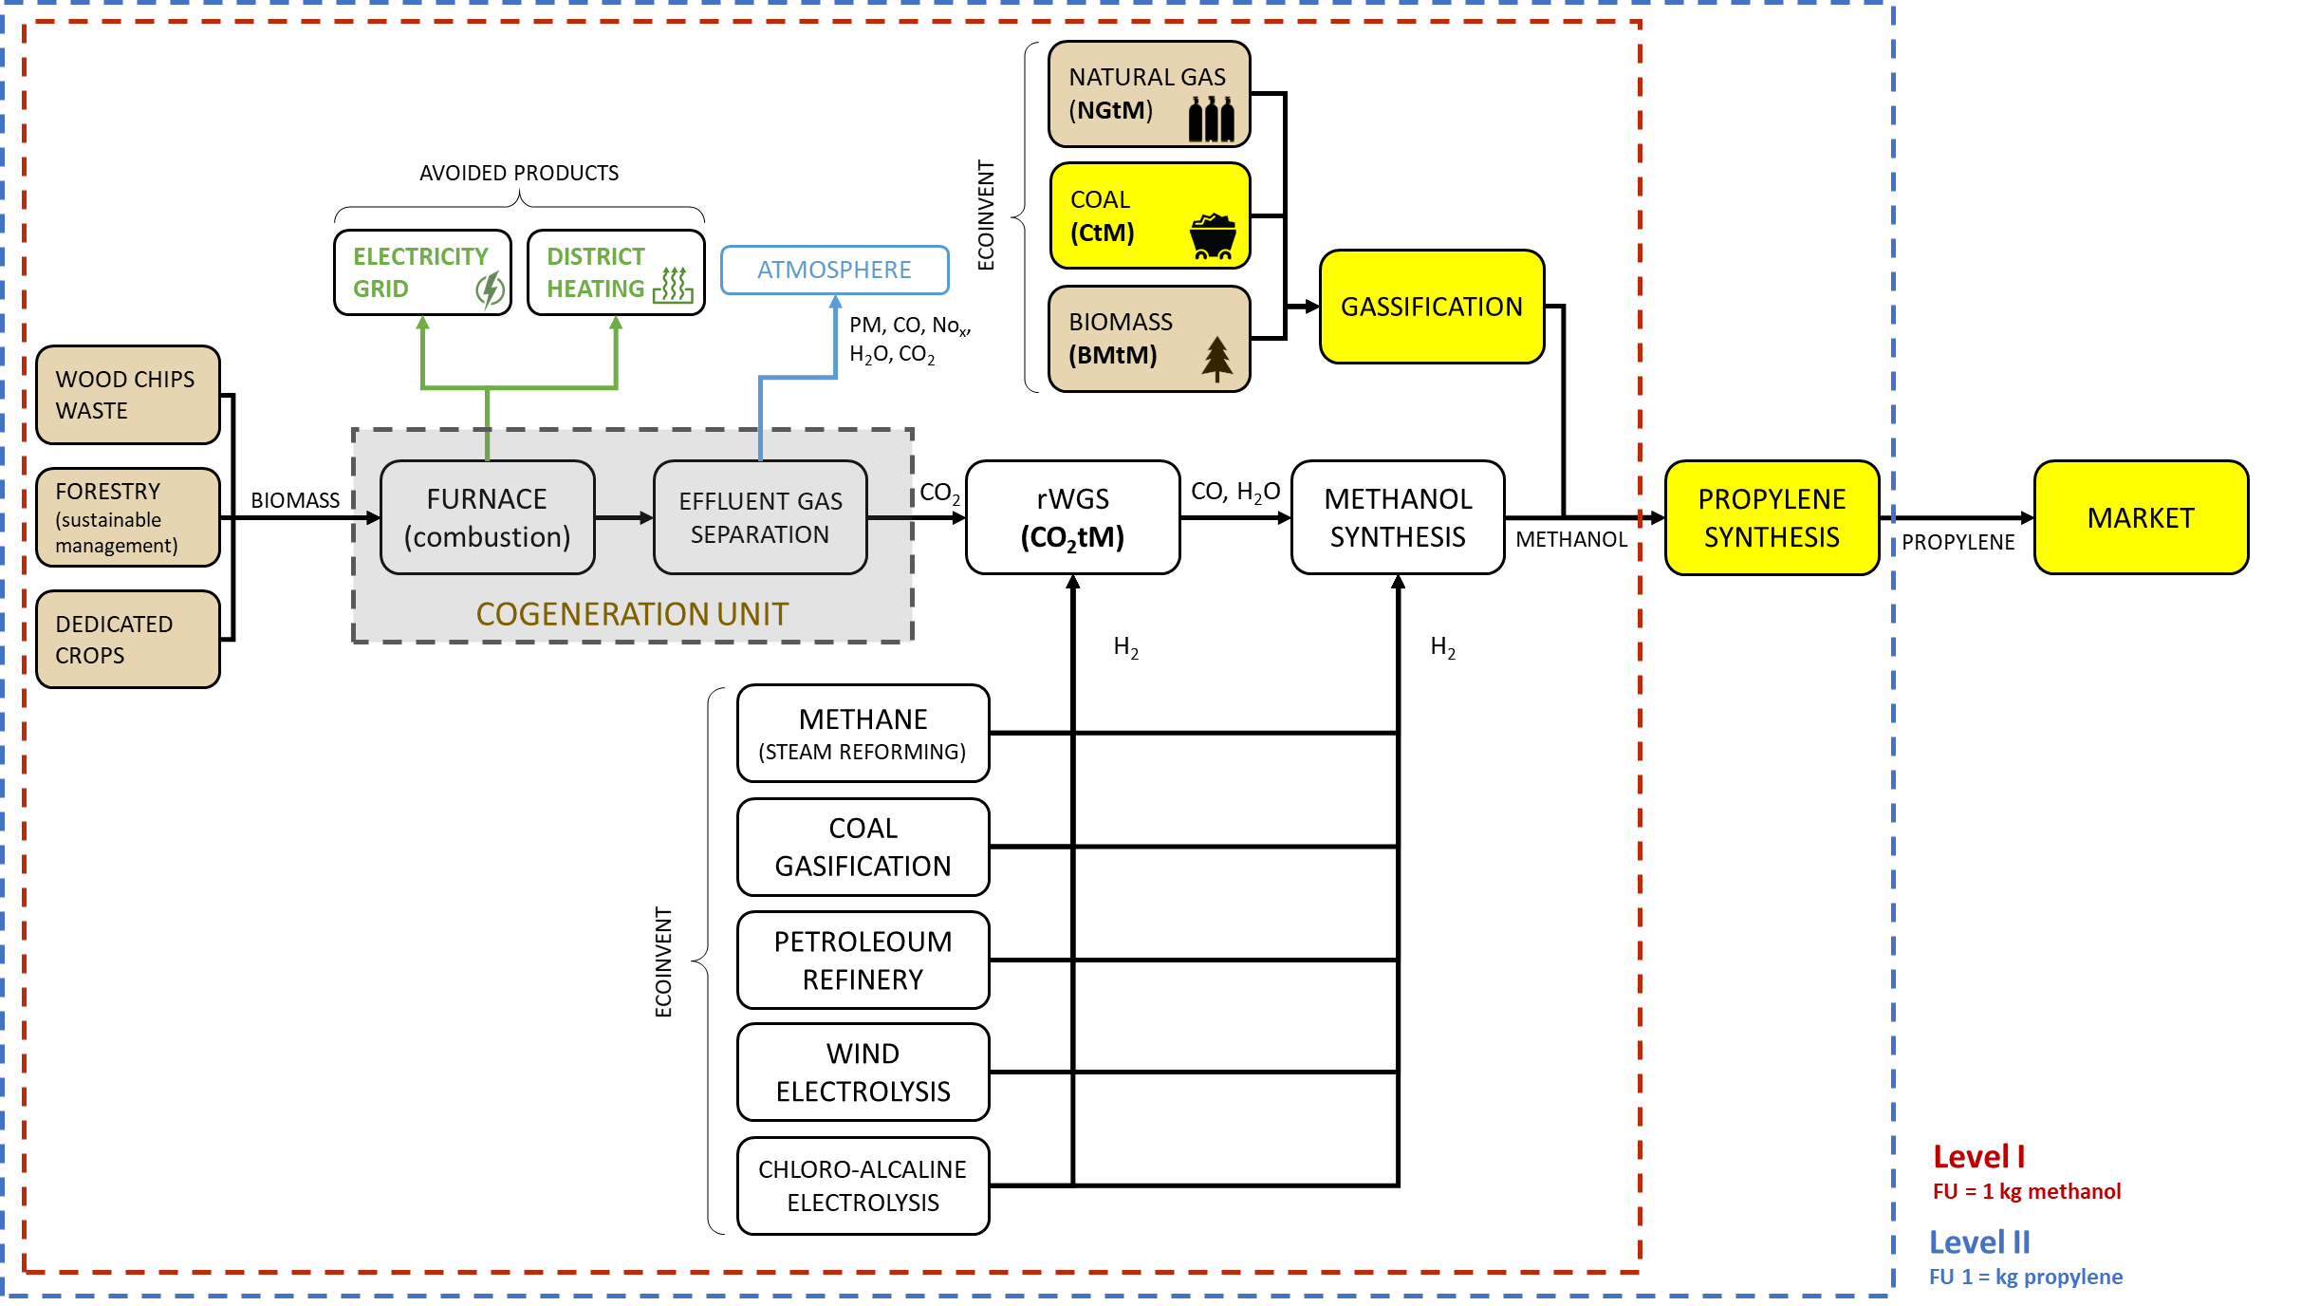Figure S11: Product system representing the Coal to Methanol (CtM) scenario
Table S10: Inventory of methanol (Level I, FU = 1 kg of propylene) representing the Coal to Methanol (CtM) scenario
Process | Required amount | Unit
Methanol production, coal gasification | methanol | APOS, U (copy) - CN | 7.28E-01 | kg
Market for oxygen, liquid | oxygen, liquid | APOS, U - row | 9.76E-01 | kg
Market for hard coal | hard coal | APOS, U - CN | 1.11E+00 | kg
Market for nitrogen, liquid | nitrogen, liquid | APOS, U - row | 4.15E-01 | kg
Market for heat, from steam, in chemical industry | heat, from steam, in chemical industry | APOS, U - row | 1.32E+00 | MJ
Market group for electricity, medium voltage | electricity, medium voltage | APOS, U - CN | 2.88E-01 | MJ
Market for chemical factory, organics | chemical factory, organics | APOS, U - GLO | 2.91E-10 | Item(s)
Market for heat, district or industrial, natural gas | heat, district or industrial, natural gas | APOS, U - row | 2.04E-01 | MJ
Market for hard coal ash | hard coal ash | APOS, U - row | 1.16E-01 | kg
Market for tap water | tap water | APOS, U - row | 1.42E-01 | kg
Market for water, deionised | water, deionised | APOS, U - row | 4.62E-02 | kg
Market for wastewater, average | wastewater, average | APOS, U - row | 4.62E-05 | m³

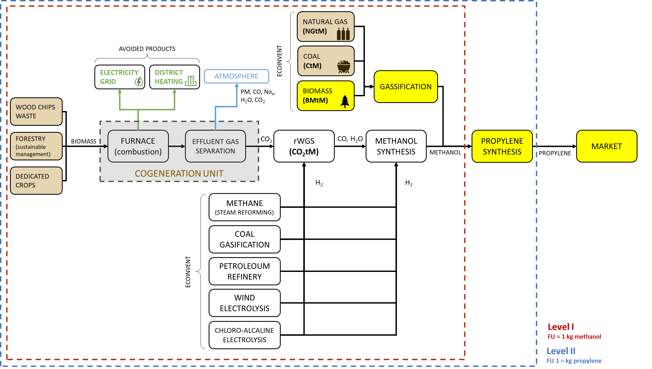
Figure S12: Product system representing the Biomass to Methanol (BMtM) scenario.
Table S11: Inventory of methanol (Level I, FU = 1 kg of propylene) representing the Biomass to Methanol (BMtM) scenario
Process | Required amount | Unit
Methanol production, biomass gasification | methanol, from biomass | APOS, U (copy) - CH | 7.28E-01 | kg
Market for synthetic gas | synthetic gas | APOS, U - CH | 5.19E+00 | m3
Market for electricity, medium voltage | electricity, medium voltage | APOS, U - CH | 7.25E-01 | MJ
Market for methanol factory | methanol factory | APOS, U - GLO | 2.70E-11 | Item(s)
Market for wastewater, average | wastewater, average | APOS, U - CH | 3.87E-03 | m3
Market for copper oxide | copper oxide | APOS, U - GLO | 6.55E-05 | kg
Market for aluminium oxide, non-metallurgical | aluminium oxide, non-metallurgical | APOS, U - row | 1.75E-04 | kg
Market for nickel, class 1 | nickel, class 1 | APOS, U - GLO | 1.46E-05 | kg
Market for molybdenum | molybdenum | APOS, U - GLO | 7.28E-06 | kg
Market for water, deionised | water, deionised | APOS, U - CH | 6.19E-01 | kg
Market for zinc | zinc | APOS, U - GLO | 2.18E-05 | kg
Table S12: Inventory of Methanol to Propylene synthesis (Propylene production, from methanol-to-propylene conversion | propylene | APOS, U -CN)
Process | Required amount | Unit
Propylene production, from methanol-to-propylene conversion | propylene | APOS, U (copy) - CN | 1.00E+00 | kg
Market for heat, from steam, in chemical industry | heat, from steam, in chemical industry | APOS, U - row | 1.67E+00 | MJ
Steam production, as energy carrier, in chemical industry | heat, from steam, in chemical industry | APOS, U - row | 1.67E+00 | MJ
Market for chemical factory, organics | chemical factory, organics | APOS, U - GLO | 3.92E-10 | Item(s)
Chemical factory construction, organics | chemical factory, organics | APOS, U - row | 2.63E-10 | Item(s)
Chemical factory construction, organics | chemical factory, organics | APOS, U - RER | 1.30E-10 | Item(s)
Market for cooling energy, at -25 °C | cooling energy, at -25 °C | APOS, U - GLO | 2.66E-02 | MJ
Cooling energy production, at -25 °C, propylene compression refrigeration system 1 MW | cooling energy, at -25 °C | APOS, U - GLO | 1.33E-02 | MJ
Cooling energy production, at -25 °C, ammonia compression refrigeration system 1 MW | cooling energy, at -25 °C | APOS, U - GLO | 1.33E-02 | MJ
Market for wastewater, average | wastewater, average | APOS, U - row | 1.26E-03 | m³
Treatment of wastewater, average, wastewater treatment | wastewater, average | APOS, U - row | 5.19E-04 | m³
Sewer grid construction, urban | sewer grid, urban | APOS, U - GLO | 1.04E-03 | m³
Sewer grid construction, rural | sewer grid, rural | APOS, U - GLO | 2.17E-04 | m³
Table S13: Pedigree Matrix
 | Amount of methanol produced | Energy (credit) | CO₂ purified (to rWGS) | Hydrogen and CO₂ input in rWGS | CO in output in rWGS
Reliability | 2 | 3 | 2 | 3 | 3
Completeness | 1 | 1 | 2 | 1 | 1
Temporal correlation | 1 | 1 | 3 | 1 | 1
Geographical correlation | 1 | 1 | 1 | 1 | 1
Technological correlation | 1 | 1 | 4 | 1 | 1
Ub | 1.05 | 1.05 | 1.05 | 1.05 | 1.05

Table S14: Contribution analysis of the investigated scenarios of the CO₂tM reaction in terms of kg CO₂eq, Level I.
GWP100 [kgCO₂eq]
 | CO₂tM-wcCO₂mH₂ | CO₂tM-wcCO₂cH₂ | CO₂tM-wcCO₂pH₂ | CO₂tM-wcCO₂eH₂ | CO₂tM-wcCO₂weH₂ | CO₂tM-wc0CO₂mH₂ | CO₂tM-sCO₂mH₂ | CO₂tM-wc0CO₂weH₂
CO₂ source | -4.10E-01 | -4.10E-01 | -4.10E-01 | -4.10E-01 | -4.10E-01 | -4.11E-01 | -4.09E-01 | -4.11E-01
rWGS | 3.68E-01 | 6.89E-01 | 9.53E-02 | 2.64E-01 | 2.82E-03 | 3.68E-01 | 3.68E-01 | 2.82E-03
H₂ source | 7.35E-01 | 1.58E+00 | 1.05E-01 | 5.28E-01 | 5.56E-03 | 7.35E-01 | 7.35E-01 | 5.56E-03
net | 6.93E-01 | 1.86E+00 | -2.10E-01 | 3.82E-01 | -4.02E-01 | 6.92E-01 | 6.93E-01 | -4.02E-01

Table S15: Standard Deviation associated with the midpoint categories of the ReCiPe 2016 method, Level I.
 | IR  (kBq Co-60-Eq) | LO  (m²*a crop-Eq) | MET  (kg 1,4-DCB-Eq) | WC  (m³) | OD  (kg CFC-11-Eq) | ME  (kg N-Eq) | SO  (kg Cu-Eq) | HOF  (kg NOx-Eq) | FF  (kg oil-Eq)
CO₂tM-wcCO₂mH₂ | 1.82E-03 | 1.94E-02 | 6.34E-03 | 1.07E-03 | -2.11E-08 | 4.61E-06 | 2.27E-03 | 3.27E-04 | 2.71E-01
CO₂tM-wcCO₂cH₂ | 2.43E-02 | 4.08E-02 | 4.33E-02 | 2.92E-04 | 3.79E-08 | 3.41E-05 | 1.34E-03 | 1.46E-03 | 2.73E-01
CO₂tM-wcCO₂pH₂ | 5.35E-03 | 1.93E-02 | -6.46E-03 | -2.27E-03 | 9.36E-08 | -5.82E-06 | -6.87E-04 | 2.75E-04 | 1.86E-01
CO₂tM-wcCO₂eH₂ | 2.19E-01 | 5.69E-02 | 9.90E-02 | 5.51E-03 | 2.77E-07 | 8.69E-05 | 8.23E-03 | 1.23E-03 | 7.06E-02
CO₂tM-wcCO₂weH₂ | -1.40E-03 | 1.90E-02 | -7.00E-03 | -2.59E-03 | -1.03E-07 | -9.02E-06 | -1.10E-03 | -3.21E-04 | -1.40E-01
CO₂tM-wc0CO₂mH₂ | 1.52E-03 | -7.08E-03 | 6.32E-03 | 1.05E-03 | -2.17E-08 | 4.55E-06 | 2.26E-03 | 3.23E-04 | 2.70E-01
CO₂tM-sCO₂mH₂ | 1.55E-03 | 2.40E-02 | 6.34E-03 | 1.06E-03 | -2.06E-08 | 4.67E-06 | 2.27E-03 | 3.30E-04 | 2.71E-01
CO₂tM-wc0CO₂weH₂ | -1.70E-03 | -7.49E-03 | -7.02E-03 | -2.60E-03 | -1.03E-07 | -9.08E-06 | -1.10E-03 | -3.25E-04 | -1.40E-01
NGtM | 3.89E-03 | 2.07E-03 | 1.34E-02 | 1.00E-03 | 6.49E-08 | 1.70E-05 | 3.74E-03 | 1.00E-03 | 4.61E-01
CtM | 8.39E-02 | 4.36E-02 | 9.39E-02 | 2.50E-02 | 3.57E-07 | 5.76E-05 | 5.97E-03 | 4.12E-03 | 7.11E-01
BMtM | 4.42E-02 | 8.52E-01 | 2.23E-02 | 5.98E-03 | 9.34E-08 | 2.53E-05 | 2.47E-03 | 7.42E-04 | 3.87E-02
 | FE  (kg P-Eq) | FET  (kg 1,4-DCB-Eq) | TET  (kg 1,4-DCB-Eq) | HTc  (kg 1,4-DCB-Eq) | HTnc  (kg 1,4-DCB-Eq) | EOF  (kg NOx-Eq) | TA  kg SO₂-Eq | PMF  (kg PM2.5-Eq)
CO₂tM-wcCO₂mH₂ | -1.97E-05 | 3.38E-03 | 2.00E+00 | 3.88E-02 | 4.11E-02 | 4.12E-04 | -2.72E-05 | 1.02E-04
CO₂tM-wcCO₂cH₂ | 5.63E-04 | 3.14E-02 | 1.05E+00 | 1.58E-01 | 1.44E+00 | 1.43E-03 | 2.22E-03 | 1.33E-03
CO₂tM-wcCO₂pH₂ | -3.20E-05 | -4.01E-03 | -8.38E-01 | -1.54E-02 | -5.09E-02 | 3.18E-04 | 7.66E-04 | 3.43E-04
CO₂tM-wcCO₂eH₂ | 5.40E-04 | 7.02E-02 | 8.27E+00 | 1.92E-01 | 1.46E+00 | 1.24E-03 | 2.03E-03 | 9.53E-04
CO₂tM-wcCO₂weH₂ | -3.30E-05 | -3.72E-03 | -1.82E+0 | -2.42E-02 | -2.18E-02 | -3.67E-04 | -4.20E-04 | -5.46E-05
CO₂tM-wc0CO₂mH₂ | -2.00E-05 | 3.37E-03 | 1.99E+00 | 3.86E-02 | 4.06E-02 | 4.07E-04 | -3.00E-05 | 1.01E-04
CO₂tM-sCO₂mH₂ | -1.95E-05 | 3.38E-03 | 2.00E+00 | 3.88E-02 | 4.10E-02 | 4.16E-04 | -2.60E-05 | 1.03E-04
CO₂tM-wc0CO₂weH₂ | -3.33E-05 | -3.73E-03 | -1.83E+0 | -2.43E-02 | -2.24E-02 | -3.72E-04 | -4.23E-04 | -5.58E-05
NGtM | 2.77E-05 | 6.85E-03 | 3.97E+00 | 6.93E-02 | 1.38E-01 | 1.21E-03 | 6.54E-04 | 2.75E-04
CtM | 8.16E-04 | 6.41E-02 | 7.92E+00 | 3.37E-01 | 2.38E+00 | 4.58E-03 | 5.03E-03 | 3.19E-03
BMtM | 6.65E-05 | 1.51E-02 | 2.87E+00 | 6.30E-02 | 6.68E-01 | 8.10E-04 | 6.13E-04 | 2.54E-04

Table S16: Impacts associated with the midpoint categories of the ReCiPe 2016 method, Level I.
 | IR  (kBq Co-60-Eq) | LO  (m²*a crop-Eq) | MET  (kg 1,4-DCB-Eq) | WC  (m³) | OD  (kg CFC-11-Eq) | ME  (kg N-Eq) | MRD  (kg Cu-Eq) | HOF  (kg NOx-Eq) | FD  (kg oil-Eq)
NGtM | 1.5E-01 | 6.6E-03 | 2.7E-02 | 1.8E-03 | 9.7E-08 | 1.3E-05 | 3.2E-03 | 3.4E-04 | 6.6E-02
CtM | 2.7E+00 | 8.7E-02 | 4.2E-01 | 2.1E-02 | 8.7E-07 | 1.3E-04 | 8.1E-03 | 2.6E-03 | 3.7E-01
BMtM | 3.2E-01 | 6.1E-01 | 4.1E-02 | 4.4E-03 | 1.9E-07 | 2.8E-05 | 1.8E-03 | 6.0E-04 | 7.8E-02
CO₂tM-wcCO₂mH₂ | 3.5E-01 | 2.0E-02 | 3.3E-02 | 4.2E-03 | 2.5E-07 | 2.4E-05 | 2.4E-03 | 5.1E-04 | 7.6E-02
CO₂tM-wcCO₂cH₂ | 3.1E-01 | 3.5E-02 | 2.0E-01 | 4.6E-03 | 3.4E-07 | 3.1E-05 | 1.9E-03 | 6.3E-04 | 9.9E-02
CO₂tM-wcCO₂pH₂ | 5.1E-01 | 2.3E-02 | 4.9E-02 | 4.8E-03 | 3.8E-07 | 3.2E-05 | 1.8E-03 | 9.4E-04 | 9.4E-02
CO₂tM-wcCO₂eH₂ | 1.6E+00 | 7.1E-02 | 2.6E-01 | 1.8E-02 | 7.7E-07 | 1.1E-04 | 9.7E-03 | 2.2E-03 | 3.2E-01
CO₂tM-wcCO₂weH₂ | 5.0E-01 | 3.0E-02 | 7.2E-02 | 7.1E-03 | 3.8E-07 | 4.8E-05 | 2.6E-03 | 9.3E-04 | 1.4E-01
CO₂tM-wc0CO₂mH₂ | 9.1E-02 | 7.2E-03 | 3.1E-02 | 2.3E-03 | 1.8E-07 | 1.2E-05 | 1.8E-03 | 2.5E-04 | 3.9E-02
CO₂tM-sCO₂mH₂ | 2.0E-01 | 3.8E-02 | 5.4E-02 | 5.8E-03 | 3.3E-07 | 3.9E-05 | 2.7E-03 | 7.3E-04 | 1.1E-01
CO₂tM-wc0CO₂weH₂ | 6.6E-01 | 2.8E-02 | 7.9E-02 | 9.7E-03 | 4.4E-07 | 5.6E-05 | 3.1E-03 | 1.1E-03 | 1.6E-01
MtP | 2.0E+00 | 1.7E-01 | 1.0E+00 | 4.3E-02 | 1.6E-06 | 2.8E-04 | 1.7E-02 | 5.0E-03 | 7.7E-01
 | FE  (kg P-Eq) | CC  (kg CO₂-Eq) | FET  (kg 1,4-DCB-Eq) | TET  (kg 1,4-DCB-Eq) | HTc  (kg 1,4-DCB-Eq) | HTnc  (kg 1,4-DCB-Eq) | EOF  (kg NOx-Eq) | TA  kg SO₂-Eq | PMF  (kg PM2.5-Eq)
NGtM | 2.0E-04 | 1.6E-01 | 1.9E-02 | 8.2E+00 | 8.7E-02 | 2.0E+00 | 4.3E-04 | 4.7E-04 | 2.0E-04
CtM | 2.1E-03 | 1.4E+00 | 2.9E-01 | 2.1E+01 | 9.2E-01 | 2.8E+01 | 2.7E-03 | 4.7E-03 | 2.4E-03
BMtM | 7.5E-04 | 2.9E-01 | 2.8E-02 | 5.7E+00 | 1.2E-01 | 2.3E+00 | 6.3E-04 | 1.0E-03 | 4.1E-04
CO₂tM-wcCO₂mH₂ | 6.7E-04 | 2.7E-01 | 2.3E-02 | 6.3E+00 | 1.5E-01 | 2.4E+00 | 5.4E-04 | 9.3E-04 | 4.1E-04
CO₂tM-wcCO₂cH₂ | 1.8E-03 | 5.9E-01 | 1.4E-01 | 3.6E+00 | 8.7E-01 | 8.4E+01 | 6.5E-04 | 1.2E-03 | 8.1E-04
CO₂tM-wcCO₂pH₂ | 6.0E-04 | 3.6E-01 | 3.3E-02 | 5.5E+00 | 1.1E-01 | 5.1E+00 | 9.6E-04 | 1.2E-03 | 5.3E-04
CO₂tM-wcCO₂eH₂ | 1.7E-03 | 1.2E+00 | 1.8E-01 | 2.2E+01 | 3.7E+00 | 9.0E+00 | 2.3E-03 | 4.3E-03 | 1.8E-03
CO₂tM-wcCO₂weH₂ | 7.0E-04 | 5.0E-01 | 5.0E-02 | 5.7E+00 | 1.8E-01 | 3.3E+00 | 9.5E-04 | 1.8E-03 | 7.4E-04
CO₂tM-wc0CO₂mH₂ | 3.1E-04 | 1.5E-01 | 2.2E-02 | 4.4E+00 | 7.5E-02 | 1.0E+00 | 2.8E-04 | 4.3E-04 | 1.8E-04
CO₂tM-sCO₂mH₂ | 2.3E-03 | 4.1E-01 | 3.7E-02 | 6.1E+00 | 1.6E-01 | 1.8E+00 | 7.6E-04 | 1.4E-03 | 5.9E-04
CO₂tM-wc0CO₂weH₂ | 7.5E-04 | 5.9E-01 | 5.5E-02 | 5.8E+00 | 1.6E-01 | 5.0E+00 | 1.1E-03 | 2.1E-03 | 8.5E-04
MtP | 4.0E-03 | 2.8E+00 | 7.3E-01 | 4.2E+01 | 2.4E+00 | 1.3E+02 | 5.2E-03 | 9.5E-03 | 4.5E-03

Table S17: Social impact of the category Labor right. Dark red: very high risk, red: high risk, yellow: medium risk, green: low risk, blue: no evidence, white: no data.
LABOR RIGHT
subcategory | issue | China | Italy | Germany
Wage assessments | Overall country-sector risk that average wage is below the benchmarks
Wage assessments | Risk that Sector average wage is below Living Wage
Wage assessments | Risk that Sector average wage is below Sweatfree Wage
Wage assessments | Risk that Sector average wage is below country Minimum Wage
Workers in poverty | Overall risk employed population is living below international poverty line
child labor | Overall country-sector risk child labor
child labor | Risk of children missing out of childhood (Save the Children)
child labor | Risk related to children's rights in the workplace (index)
child labor | Overall country risk of child labor
Forced labor | Overall country-sector risk forced labor
Forced labor | Risk of trafficking in persons (US DoL)
Forced labor | Forced labor risk (Global Slavery Index)
Forced labor | Overall country risk of forced labor
Excessive working time | Overall risk excessive working time
Excessive working time | Risk of working >48 hrs per week (ILO)
Excessive working time | Lack of regulatory framework for working hours and its implementation (US DoS)
Freedom of association, collective bargaining, right to strike | Overall risk related to freedom of association, collective bargaining, right to strike
 | Lack of association & collective bargaining rights & right to strike (ITUC)
 | Collective bargaining coverage (ILO)
Migrant labor | Overall risk migrant workers
Migrant labor | Net migration rate
Migrant labor | Immigrants as a percentage of the population
Migrant labor | Workers’ remittances and compensation paid per immigrant
Migrant labor | Ratified international conventions or set up policies for immigrants
Migrant labor | Evidence of risk to migrant Workers - qualitative
Migrant labor | People of concern
Social benefits | Overall risk social benefits
Social benefits | Paid annual leave available to workers
Social benefits | Sick leave (pay, start, duration)
Social benefits | Other types of leave (child, adult, educational and health)
Social benefits | Maternal leave (pay & duration)
Social benefits | Parental leave (pay & duration)
Social benefits | Paternal leave (pay & duration)
Social benefits | Proportion of population covered by social assistance programs
Labor laws & conventions | Overall risk labor laws & conventions
Labor laws & conventions | Year minimum wage was last updated
Labor laws & conventions | Number of labor laws in country
Labor laws & conventions | Ratification of ILO Conventions
Labor laws & conventions | Number of labor laws by sector
Labor laws & conventions | Ratification of conventions by sector
Discrimination, equal opportunity | Overall prevalence of discrimination in the workplace (qualitative)
Unemployment | Overall (un)employment risk
 | Unemployment level
 | Vulnerable employment
 | Unemployment programs in place (ISSA)

Table S18: Social impact of the category Health and safety. Dark red: very high risk, red: high risk, yellow: medium risk, green: low risk, blue: no evidence, white: no data.
HEALTH AND SAFETY
subcategory | issue | China | Italy | Germany
Occupational toxics & hazards | Overall risk occupational toxics & hazards
Occupational toxics & hazards | Occupational noise related risk
Occupational toxics & hazards | Occupational cancer related risk
Occupational toxics & hazards | Occupational asthma related risk
Occupational toxics & hazards | Occupational COPD related risk
Occupational toxics & hazards | Occupational Pneuma related risk
Occupational toxics & hazards | Occupational infectious disease related risk
Occupational injuries & fatalities | Overall risk occupational injuries & fatalities
Occupational injuries & fatalities | Occupational road injuries & fatalities related risk
Occupational injuries & fatalities | Occupational poison related injuries & fatalities
Occupational injuries & fatalities | Occupational related fall injuries & fatalities
Occupational injuries & fatalities | Occupational related fire/heat injuries & fatalities
Occupational injuries & fatalities | Occupational related drowning injuries & fatalities
Occupational injuries & fatalities | Occupational related exposure to mechanical forces injuries & fatalities

Table S19: Social impact of the category Society. Dark red: very high risk, red: high risk, yellow: medium risk, green: low risk, blue: no evidence, white: no data.
SOCIETY
subcategory | issue | China | Italy | Germany
Indigenous rights | Overall country-sector risk related to indigenous rights infringement
Indigenous rights | Overall country risk of indigenous rights being infringed
Indigenous rights | Percent of population that is indigenous
Indigenous rights | Ratification conventions to protect indigenous rights
Indigenous rights | Number of laws to protect indigenous rights (ILO)
Gender Equality | Overall gender equality risk
Gender Equality | Social Institutions and Gender Index (SIGI)
Gender Equality | The Global Gender Gap Index (World Economic Forum)
Gender Equality | Gender Inequality Index (GII) (UNDP)
Gender Equality | Woman, Business and Law Index (World Bank)
High conflict zones | Overall risk high conflict
High conflict zones | High conflict (Heidelberg Institute)
High conflict zones | State Fragility Index (Center for Systemic Peace)
High conflict zones | People under Threat (Minority Rights Group)
High conflict zones | Global Peace Index
Human health issues - Non-Communicable Diseases (NCD) and other health risk | Overall risk non-communicable diseases and other health risk
 | Life expectancy at birth (years)
 | Under-five mortality rate
 | Age-standardized mortality rates for non-communicable diseases
 | Age-standardized mortality rates for injuries
 | Proportion of undernourished in population
 | Age-standardized mortality for cardiovascular diseases
 | Mortality rate attributed to household and ambient air pollution and exposure to unsafe WASH services
 | Population affected by natural disaster
Human health issues - Communicable diseases | Overall risk Human health issues - Communicable diseases Age standardized mortality rates from communicable diseases.
Human health issues - Communicable diseases | Cases of HIV
Human health issues - Communicable diseases | Cases of Tuberculosis
Human health issues - Communicable diseases | Notified cases of Malaria
Human health issues - Communicable diseases | Dengue Fever, incidence rate

Table S20: Social impact of the category Governance. Dark red: very high risk, red: high risk, yellow: medium risk, green: low risk, blue: no evidence, white: no data.
GOVERNANCE
subcategory | issue | China | Italy | Germany
Legal system | Overall risk fragility in legal system
Legal system | Worldwide Governance Rule of Law Indicator (World Bank)
Legal system | Rule of Law - Independent Judiciary (Bertelsmann Transformation Index)
Legal system | Rule of Law Index (World Justice Project)
Legal system | Rule of Law (African Integrity Indicators)
Corruption | Overall risk corruption
Corruption | Worldwide Governance Indicators Corruption Index (World Bank)
Corruption | Corruption (Competitiveness report WEF)
Corruption | Corruption Perception Index (CPI) (Transparency International)
Corruption | CPI 3 year trend (2017-2020) (Transparency International)
Democracy & freedom of speech | Overall risk related to democracy & freedom of speechc
Democracy & freedom of speech | Democracy Index (EUI)
Democracy & freedom of speech | Freedom of speech (Freedom House)
Democracy & freedom of speech | Global State of Democracy indices (IDEA)
Table S21: Social impact of the category Community. Dark red: very high risk, red: high risk, yellow: medium risk, green: low risk, blue: no evidence, white: no data.
COMMUNITY
subcategory | issue | China | Italy | Germany
Access to improved source of drinking water | Overall access to improved source of drinking water
Access to improved source of drinking water | Urban access to improved source of drinking water
Access to improved source of drinking water | Rural access to improved source of drinking water
Access to improved source of sanitation | Overall access to improved source of sanitation
Access to improved source of sanitation | Urban access to improved source of sanitation
Children out of school | Overall risk children out of school
Children out of school | Children out of primary school, male
Children out of school | Children out of primary school, female
Access to health care | Overall risk related to access to health care
Access to health care | Hospital beds
Access to health care | Nurses/Midwives
Smallholders versus commercial farms (only agriculture sectors) | Overall risk related to (agri) smallholders
 | Percentage of family-owned farms in country
 | Percentage of commercially-owned farms in country
 | Smallholdings Land % < x hectares
 | Smallholdings Land % > x hectares
Access to electricity | Overall access to electricity
Property rights | Overall property rights (citizen's perceptions)

REFERENCES
International Organization for Standardization (ISO). 2006. ISO 14040:2006/Amd 1:2020 Environmental management - Life cycle assessment - Requirements and guidelines. https://www.iso.org/standard/37456.html
Cellura M, Longo S, Mistretta M. 2011. Sensitivity analysis to quantify uncertainty in Life Cycle Assessment: The case study of an Italian tile. Renewable and Sustainable Energy Reviews. 15(9):4697–4705 [accessed 2025 Jul 26]. https://linkinghub.elsevier.com/retrieve/pii/S1364032111003273. https://doi.org/10.1016/j.rser.2011.07.082
De Souza RJ, Eisen RB, Perera S, Bantoto B, Bawor M, Dennis BB, Samaan Z, Thabane L. 2016. Best (but oft-forgotten) practices: sensitivity analyses in randomized controlled trials. The American Journal of Clinical Nutrition. 103(1):5–17 [accessed 2025 Jul 26]. https://linkinghub.elsevier.com/retrieve/pii/S0002916523120958. https://doi.org/10.3945/ajcn.115.121848
Gogate MR. 2019. Methanol-to-olefins process technology: current status and future prospects. Petroleum Science and Technology. 37(5):559–565 [accessed 2024 Aug 7]. https://www.tandfonline.com/doi/full/10.1080/10916466.2018.1555589. https://doi.org/10.1080/10916466.2018.1555589

