SUPPLEMENTARY MATERIALS

HIV INFECTION AMONG ADOLESCENTS AND YOUNG ADULTS IN ITALY: EPIDEMIOLOGY, VIRO-IMMUNOLOGICAL AND TREATMENT OUTCOMES
Authors
Francesco Maria Fusco, Ilaria Mastrorosa*, Francesca Vichi, Adriana Cervo, Annalisa Saracino, Leonardo Calza, Eugenia Quiros-Roldan, Maria Elisabetta Teti, Andrea Costantini, Antonella Cingolani, Enrico Girardi, Andrea Antinori, Antonella d'Arminio Monforte, Alessandro Tavelli for the ICONA Foundation Study Group

*Corresponding author:
Ilaria Mastrorosa, MD
Via Portuense 292, 00149 Rome, Italy
Tel.: +39 06 55170546
E-mail: ilaria.mastrorosa@inmi.it

Supplementary methods
Study Participants
Study Setting
The ICONA Foundation cohort is an Italian, open-ended, multicenter, prospective observational study, set up in 1997, enrolling HIV-1 positive and antiretroviral-naïve subjects at the time of enrolment, aged > 18 years. More than 21,500 people with HIV (PWH) were enrolled and prospectively followed in 62 adults’ Italian infectious diseases centres. The study provides continuous yearly enrolment and covers around 35-40% of all the new HIV diagnoses in Italy every year, with a good representativeness of Italian HIV population [Vourli G, et al. AIDS. 2019]. ICONA cohort has been used as a reference data to evaluate the HIV cascade of care in Italy in recent year also by the Istituto Superiore di Sanità [Not Ist Super Sanità 2024;37(11):3-59]. PWH with vertical HIV infection are not included in the Icona study. All the individuals with a new HIV diagnosis, entering in HIV care in the Infectious Disease center of the ICONA cohort, receive informative material and details of the ICONA cohort study by their treating physician, after which they can sign a written informed consent for study participation and processing of personal data or opt-out. Following a standardized protocol, every 6 months viro-immunological data with other laboratory parameters (e.g. complete blood test, biochemical test, co-infections and other sexually transmitted diseases serology, etc) as well as clinical, comorbidities, hospitalization, antiretroviral therapy and co-medications data are measured and recorded in ICONA. Data are prospectively collected in an online electronic case report form (eCRF, www.icona.org), by dedicated staff in each center. A proportion of the ICONA centers have implemented an electronic data import from medical records to the ICONA dataset. Reasons for ART-drug discontinuation are recorded as reported by the treating physicians in the medical record. On-site monitoring visits are conducted annually at each center, along with continuous review of selected queries to resolve discrepancies and errors in collaboration with site personnel. The electronic case report form (eCRF) also includes built-in validation checks to minimize inconsistencies and data entry error.

Ethics Statement
All the enrolled subjects provided a written informed consent for study participation and processing of personal data. The ICONA Foundation study protocol and the informed consent were approved by the Institutional Review Board (IRB) of each participating centre. The latest amendment of the ICONA Foundation Study was approved centrally by the Lazio Area 4 Territorial Ethics Committee on 01 July 2024 (approval no. 83-2024). All procedures of the study were performed in accordance with the 1964 Helsinki declaration and its later amendments.

Supplementary results
figure S1. Causes of treatment discontinuation (TD) among adolescents and young adults (AYAs) and adults enrolled in ICONA cohort in 2014-2023.
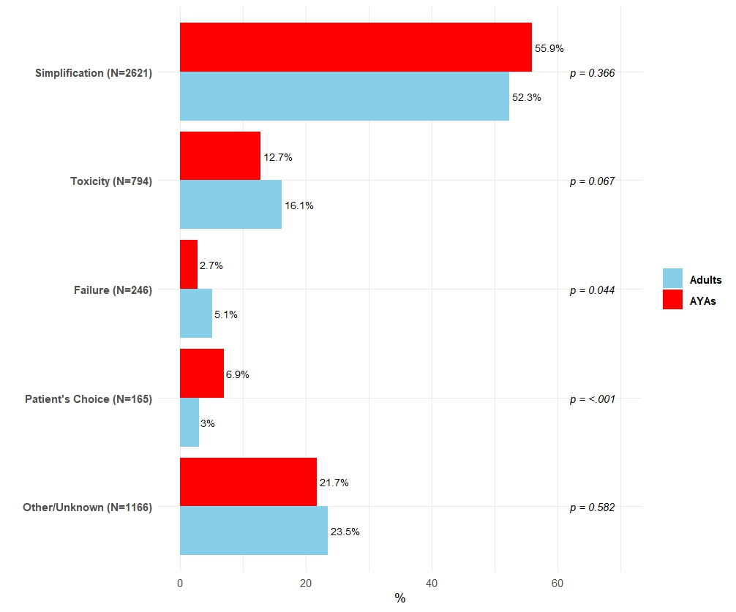

Supplementary figure S2. Kaplan-Meier curves showing the cumulative probabilities of each endpoint (see the main text for detailed definitions) among adolescents and young adults (AYA) vs Adults: (A) ART initiation in participants enrolled after 2015; (B) Virological Failure (VF); (C) Treatment Discontinuation (TD) for any cause; (D) TD for failure; (E) TD for patient’s choice/non-adherence; (F) TD for toxicity/intolerance; (G) lost to follow-up (LTFU) for at least 12 months; (H) definitive LTFU.
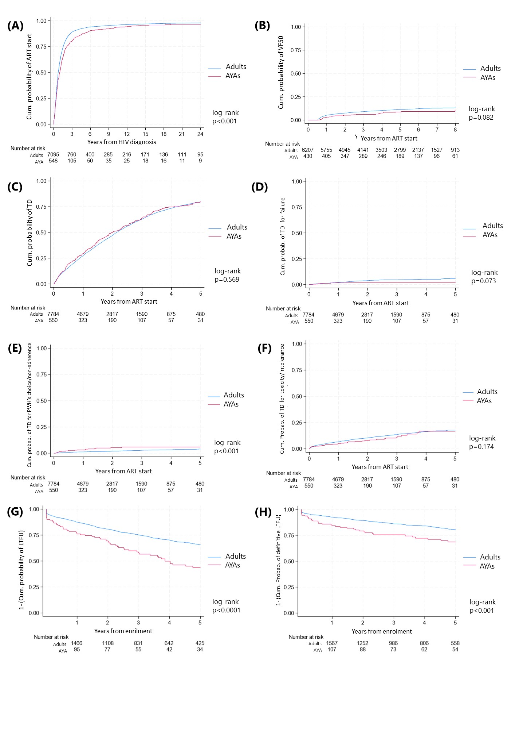
Supplementary figure S3. Distribution of participants lost to follow-up among adolescents and young adults (AYAs) and adults enrolled in ICONA cohort in 2014-2023 according to year of last visit (p=0.490).
