Supporting information:
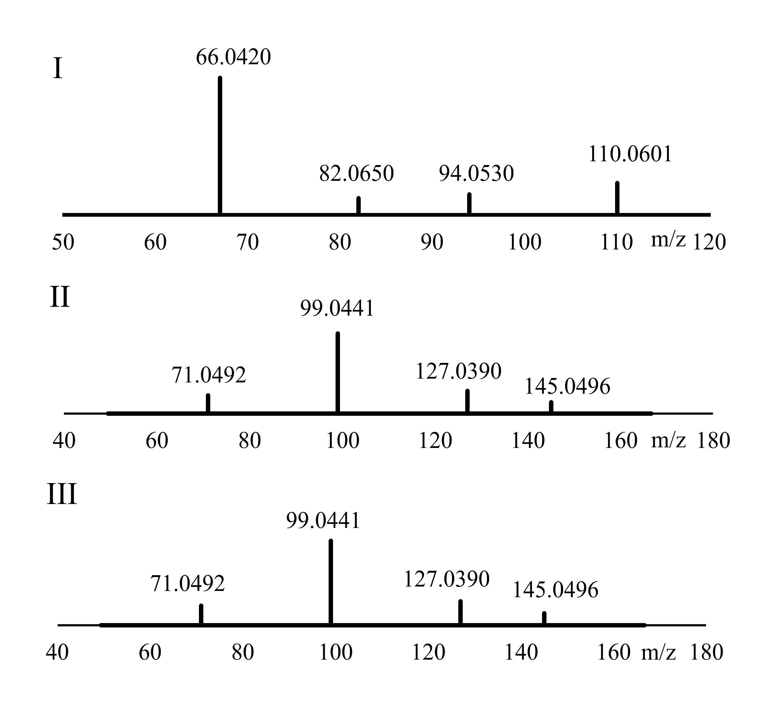

S1. MS/MS fragmentation spectra of peak I (m/z parent ion = 110.0601), peak II and peak III (m/z parent ions = 145.0496)

S 2. Fragmentation pathways of compounds II and III in the HRMS analyzer. The proposed scheme elucidates the fragmentation mechanisms of Peaks II and III, tentatively identified as dihydro-dihydroxymethylpyrone (DDMP) and its furanone isomer. Both compounds exhibit protonated molecular ions [M+H]+ at m/z 145.0495. The fragmentation process involves the loss of water (m/z 127.0390), followed by the sequential loss of carbon monoxide molecules (m/z 99.0441 and m/z 71.0492).

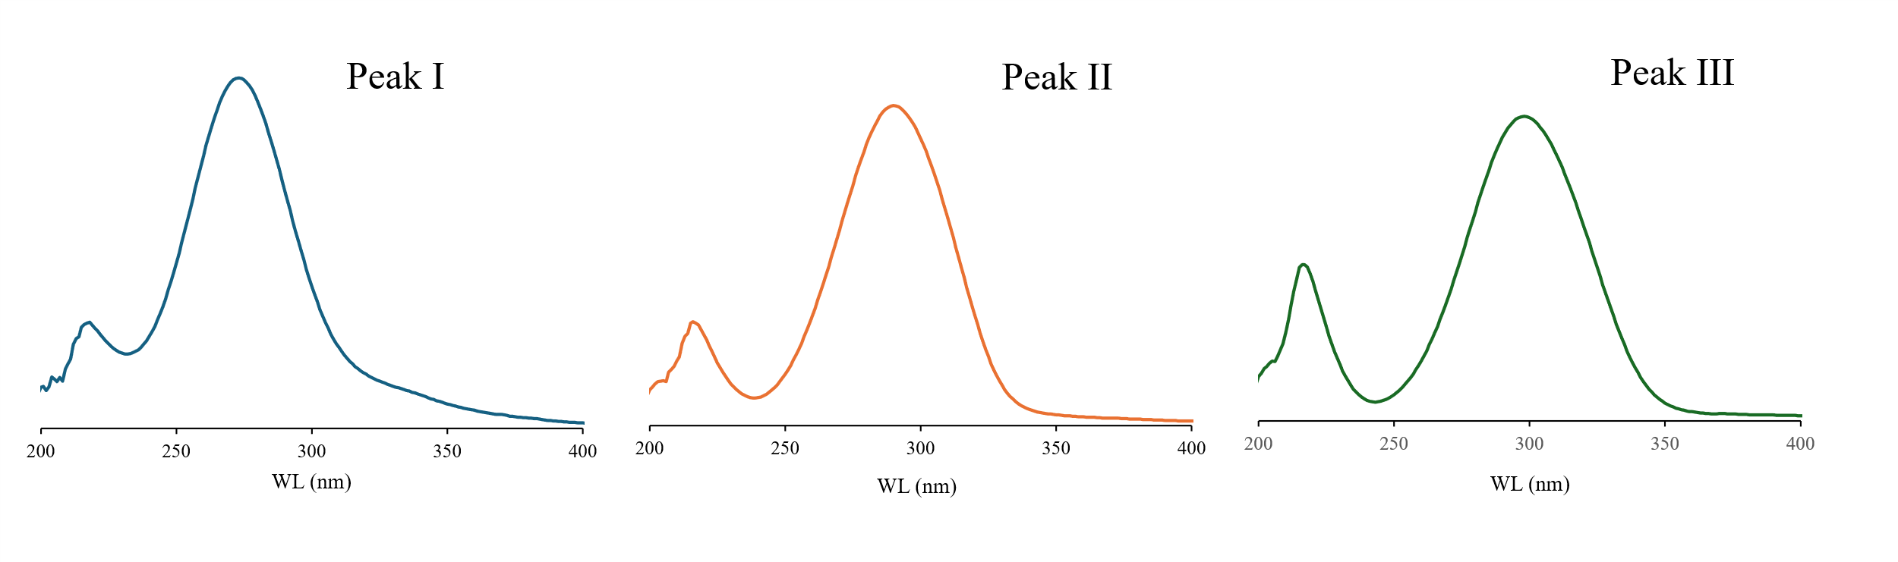
S 3. UV spectra recorded by HPLC coupled with diode array detector for peak I, peak II and peak III.

