SUPPLEMENTAL FIGURES
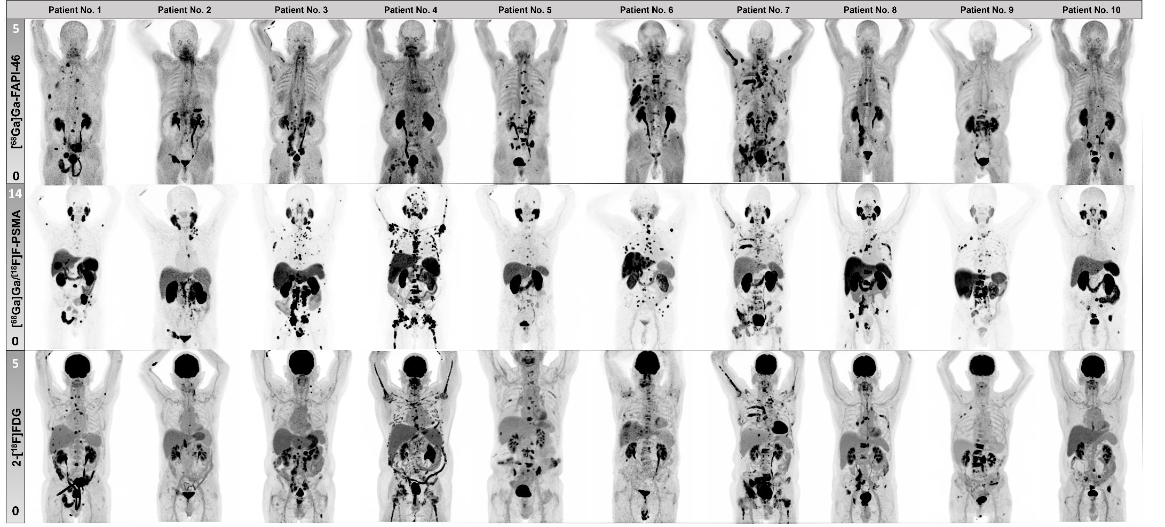 Supplemental Figure 1: Overview of Imaging Results in all Patients. Maximum intensity projections of all patients, including [⁶⁸Ga]Ga-/[¹⁸F]F-PSMA-11/-1007, 2-[¹⁸F]FDG and [⁶⁸Ga]Ga-FAPI-46 PET images.

GRAPHICAL ABSTRACT
