Supplementary material of the scientific paper “Landslide susceptibility methodology for railway planning: A comparative analysis of statistical and machine learning methods in a case study of Marche region, Italy”
Authors: Rodolfo Rani^{a,}*, Marco Sciarra^{b}, Stefano Rodani^{b}, Gianluca Benedetti^{b}, Matteo Bertiª
ªDepartment of Biological, Geological, and Environmental Sciences (BiGea), University of Bologna, Via Zamboni 67, 40126, Bologna, Italy
^{b}ITALFERR S.p.A., Gruppo Ferrovie dello Stato Italiane - Architecture, Environment & Territory Department - Geology Division, Via Galati 87, 00155, Roma Italy
* Corresponding author
Email address: rodolfo.rani2@unibo.it (R. Rani), m.sciarra@italferr.it (M. Sciarra), s.rodani@italferr.it (S. Rodani), g.benedetti@italferr.it (G. Benedetti), matteo.berti@unibo.it (M. Berti)

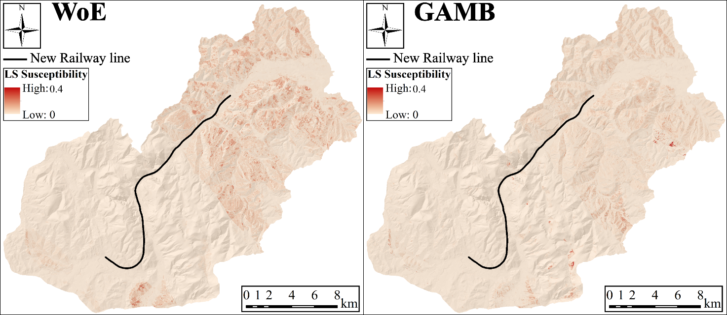
S 1. Not determinate (ND) landslide type susceptibility with both models (WoE and GAMB). Colors stretched from 0 to 0.4.
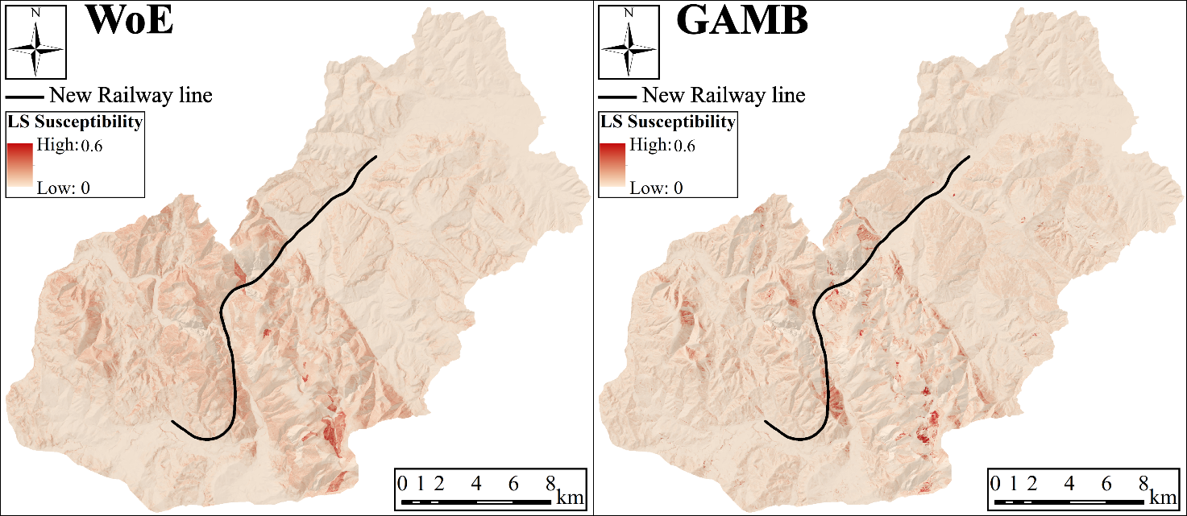
S 2. Slide (S) landslide type susceptibility with both models (WoE and GAMB). Colors stretched from 0 to 0.6.
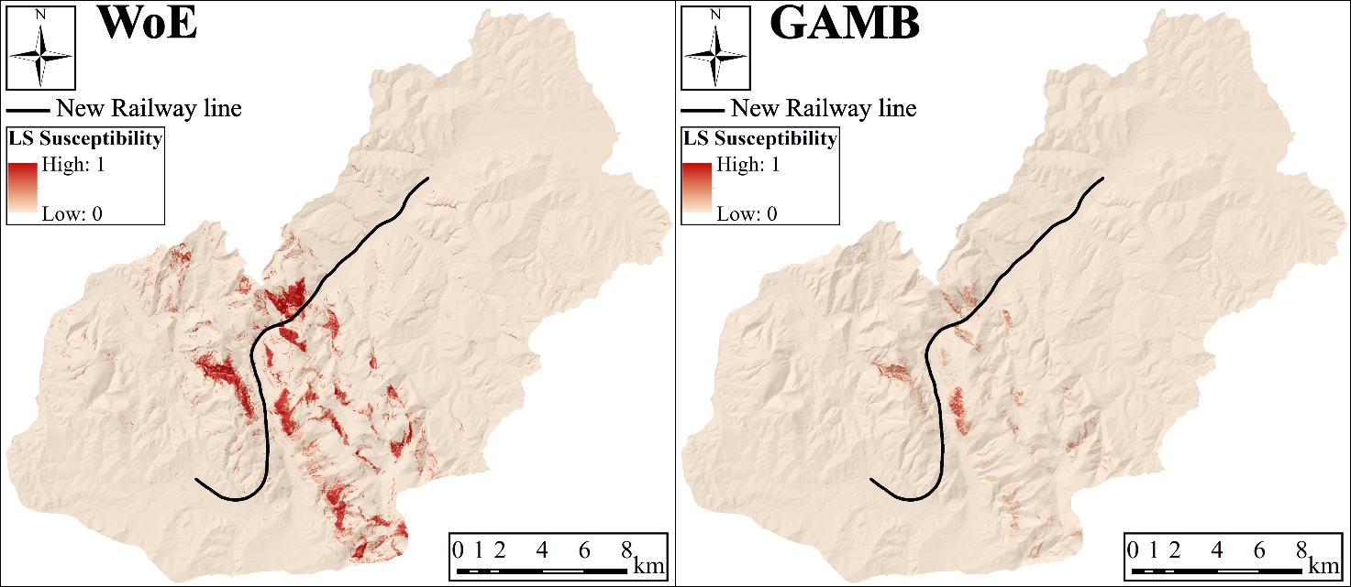
S 3. Fall/Topple (FT) landslide type susceptibility with both models (WoE and GAMB). Colors stretched from 0 to 1.
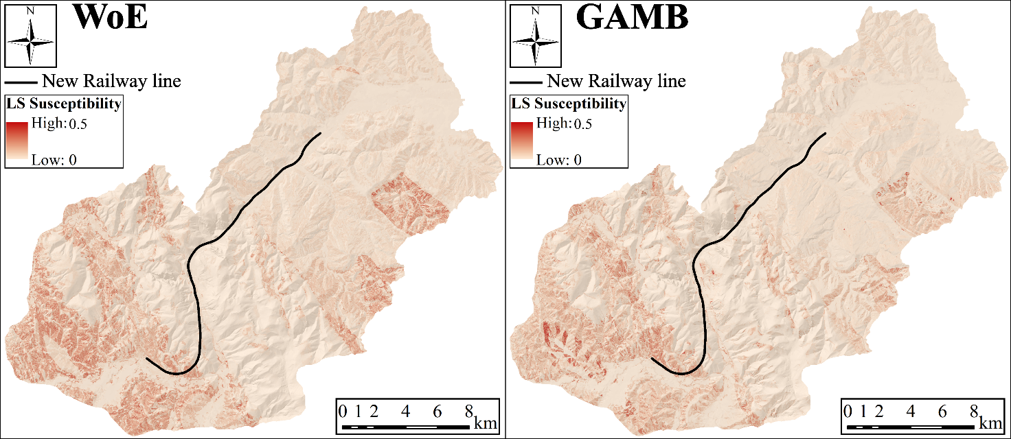
S 4. Slow flow (SF) landslide type susceptibility with both models (WoE and GAMB). Colors stretched from 0 to 0.5.
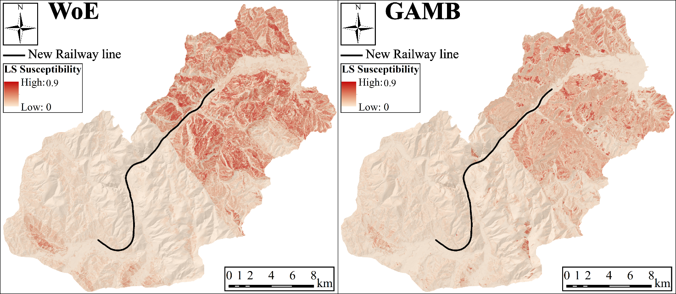
S 5. Complex (C) landslide type susceptibility with both models (WoE and GAMB). Colors stretched from 0 to 0.9.
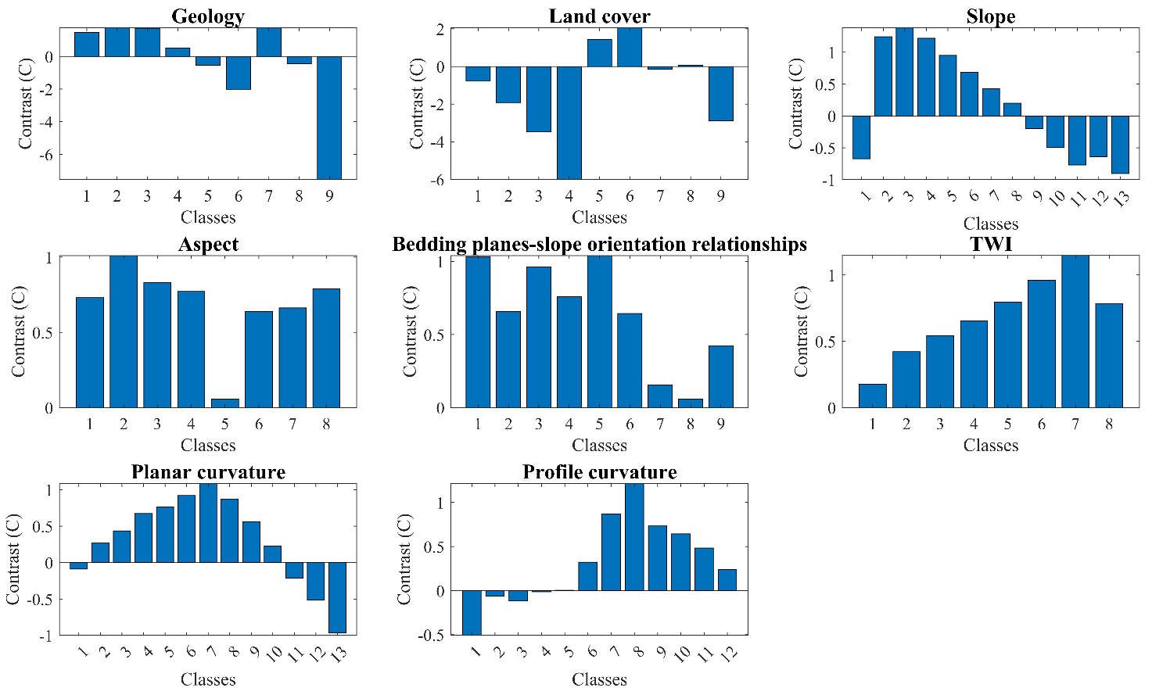
S 6. WoE Contrast (CS) of Not Determinate (ND) Landslide

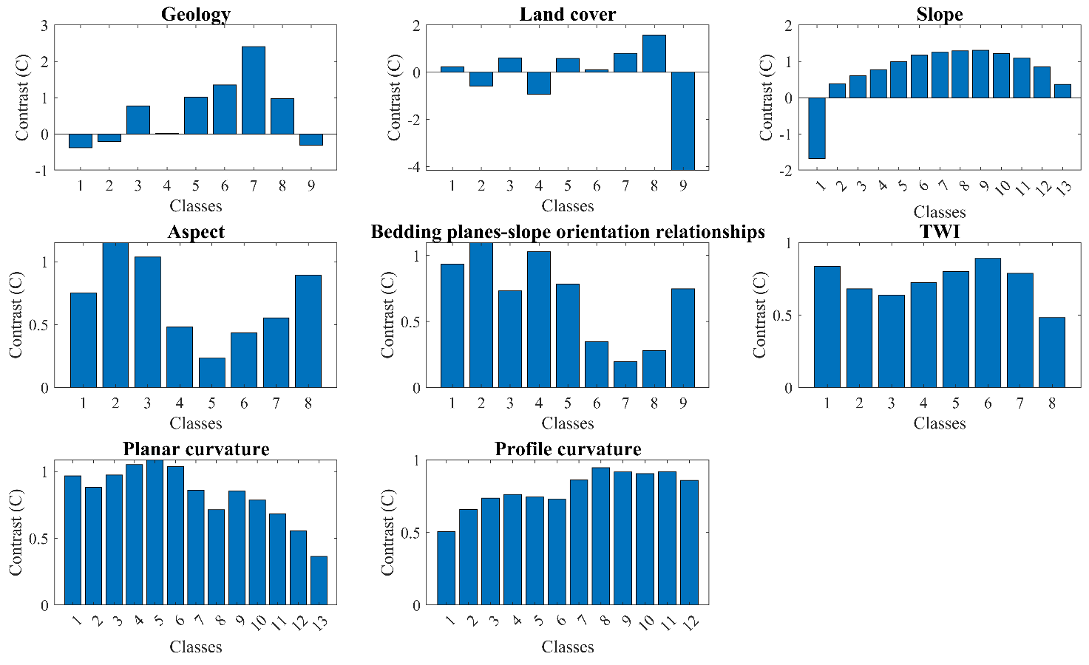
S 7. WoE Contrast (CS) of Slide (S) Landslide
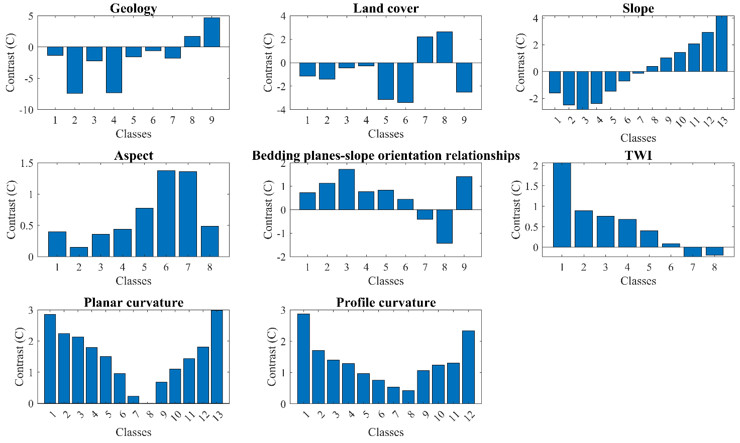
S 8. WoE Contrast (CS) of Fall/Topple (FT) Landslide
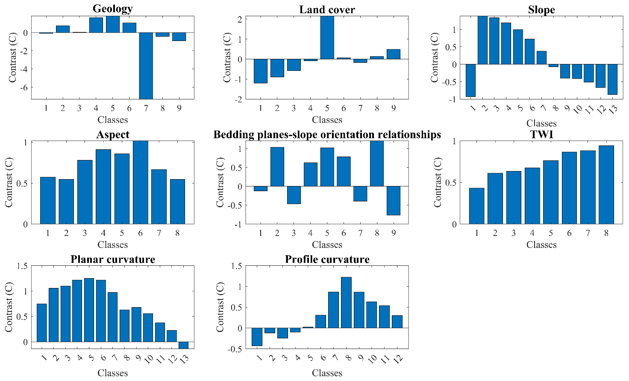
S 9. WoE Contrast (CS) of Slow Flow (SF) Landslide
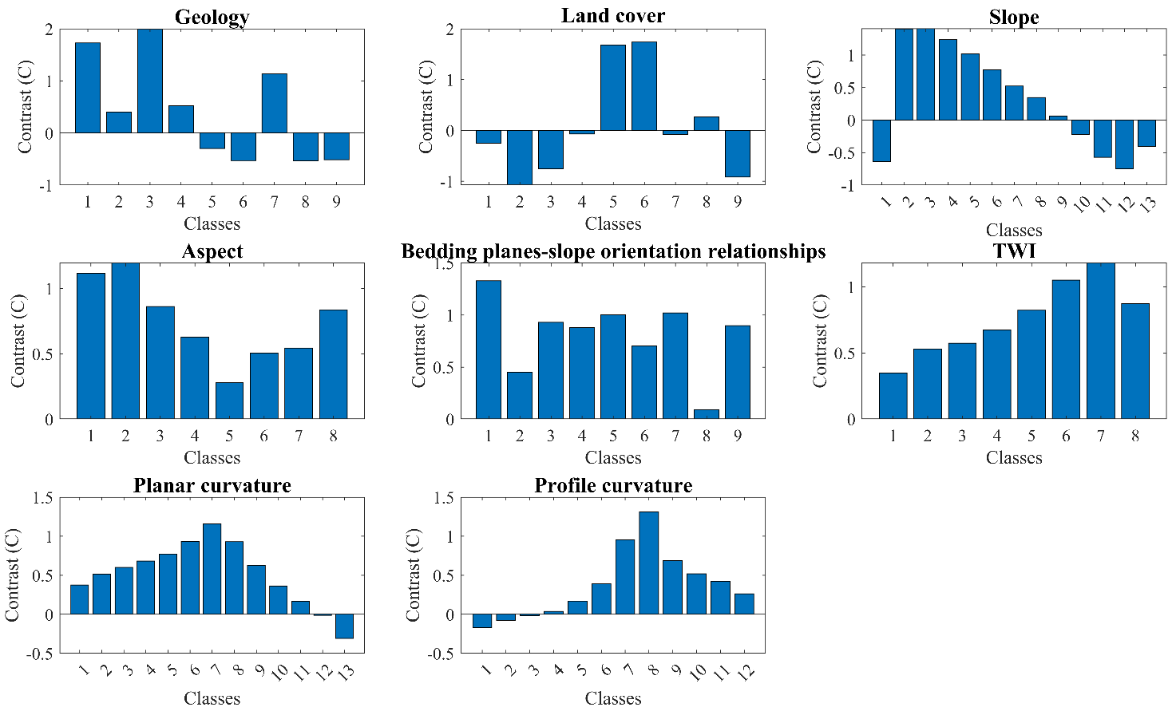
S 10. WoE Contrast (CS) of Complex (C) Landslide
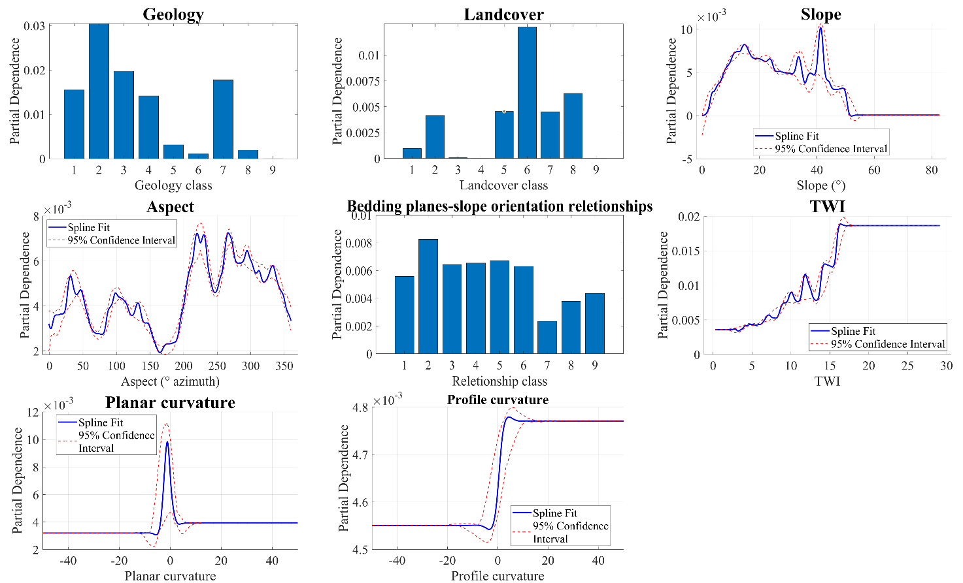
S 11. GAMB partial dependences (PD) of Not Determinate (ND) Landslide
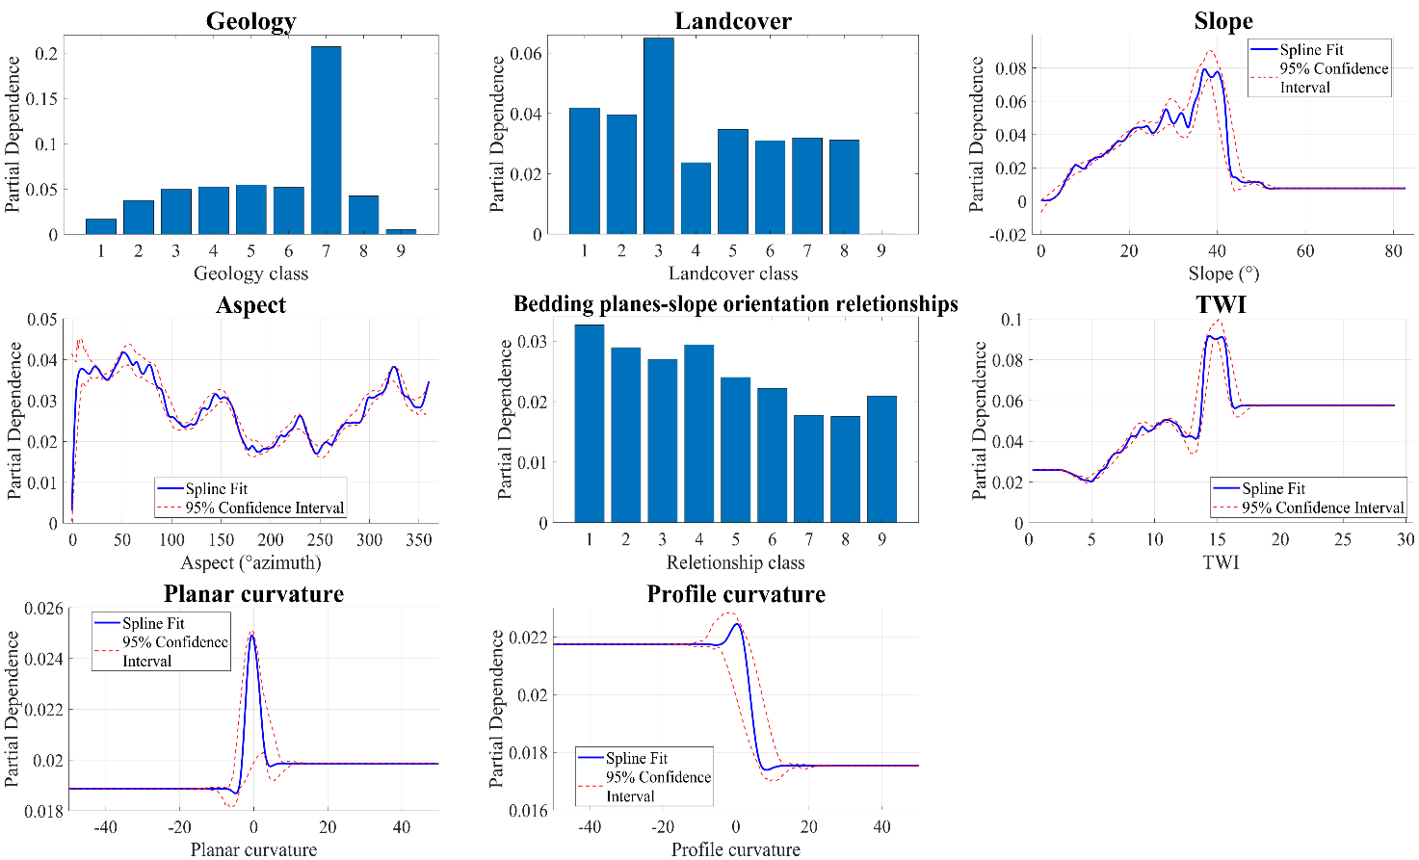
S 12
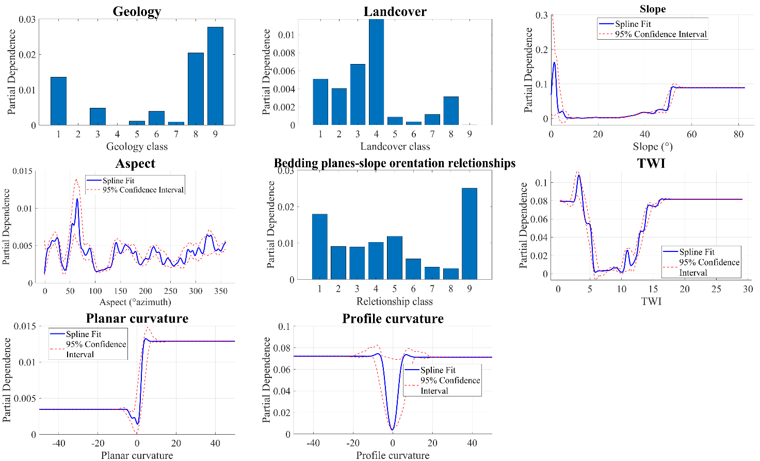
S 13. GAMB partial dependences (PD) of Fall/Topple (FT) Landslide
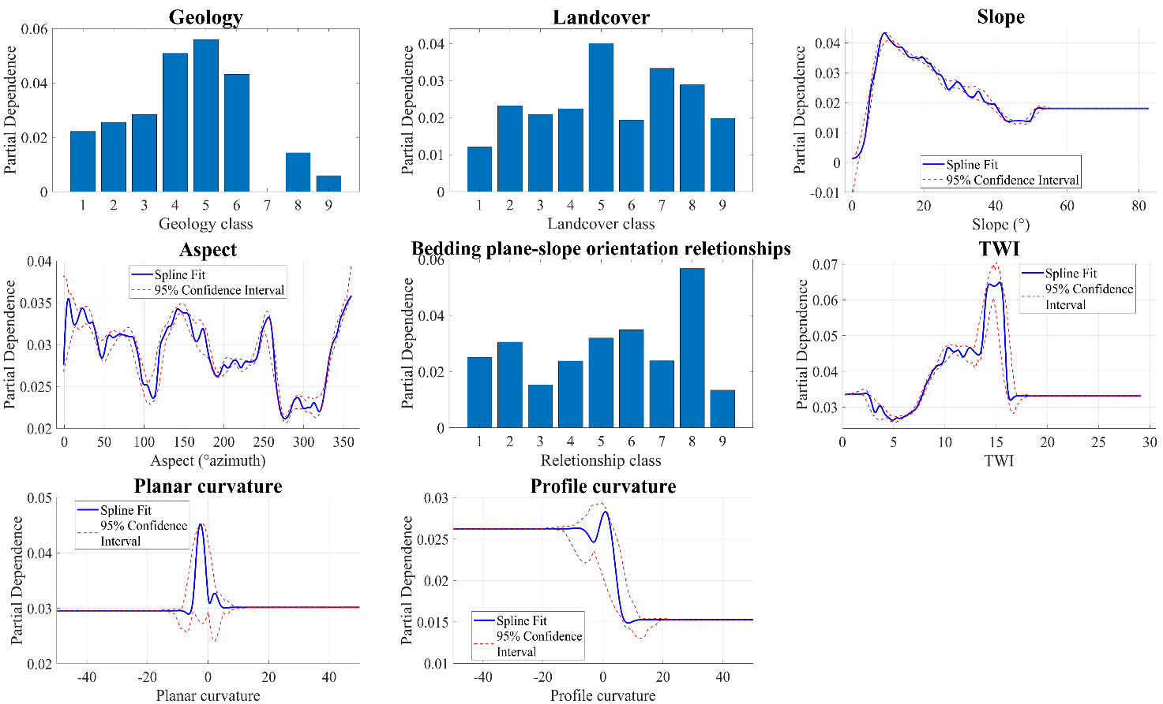
S 14. GAMB partial dependences (PD) of Slow Flow (SF) Landslide
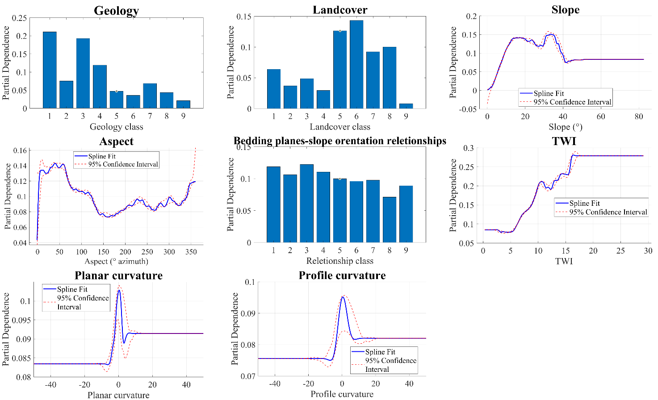
S 15. GAMB partial dependences (PD) of Complex (C) Landslide

