When the Last Branch Closes:
The Impact of Bank Desertification on Local Firm Growth

Carmelo Algeri, Paola Brighi, Claudia Girardone, Valeria Venturelli

Supplementary material
Online Appendix 1: Event-study design
We implement an event-study specification to examine how outcomes evolve in treated municipalities. The model includes leads and lags around the treatment date, enabling us to assess both pre-treatment trends and post-treatment dynamics. The year t-1 serves as the reference year and excluded from the estimation. The results are presented in Table A1 and Figure A1.
< Table A1 about here>
< Figure A1 about here>
The pre-treatment estimate for t-2 is both small and statistically insignificant, providing no evidence of differential pre-trends and supporting the validity of the parallel trends assumption. At the time of treatment (t = 0), we observe a statistically significant decline in firm growth (−0.583, p < 0.01), consistent with an immediate negative effect of branch closure. Post-treatment estimates remain insignificant, suggesting no persistent dynamic effects.
To address concerns related to staggered treatment timing and heterogeneous treatment effects, we supplement our baseline two-way fixed effects estimates with the estimator proposed by Callaway and Sant’Anna (2021), which allows for treatment effect heterogeneity across cohorts and over time. The model is also well suited to settings with imbalanced treated and control groups. The corresponding event-study results are reported in Table A2 and Figure A2. The estimates confirm the absence of differential pre-trends: both the average pre-treatment effect (Pre_avg = −0.101, p = 0.523) and the individual lead coefficients (t−2 = −0.058, p = 0.855; t−1 = −0.144, p = 0.546) are statistically different from zero.
< Table A2 about here>
< Figure A2 about here>

By contrast, the effect emerges at the time of treatment, with a statistically significant decline in firm growth (t = 0: −0.557, p = 0.012) and remains negative thereafter. The average treatment effect on the treated (ATT) is also negative and statistically significant (=−0.516, p = 0.018). Importantly, these estimates are very similar in magnitude to those obtained using the baseline two-way fixed effects specification (see Table A1 above), suggesting that our results are not driven by biases associated with treatment effect heterogeneity in staggered DiD settings. Overall, these findings further support our identification strategy by showing no evidence of pre-existing differential trends and by confirming that our results are robust to recent advances in DiD methods.

Online Appendix 2: Economic magnitude of estimates

To better contextualise the economic magnitude of the estimates reported in Table 4 of our manuscript, we benchmark the estimated effect against the pre-treatment distribution of the outcome variable. Table A3 presents descriptive statistics for all municipality-year observations in the pre-treatment period. The mean firm growth rate is close to zero (-0.092), with a standard deviation of 3.007. The estimated decline of 0.22 percentage points therefore corresponds to approximately 0.07 standard deviations, indicating a modest but non-negligible effect. Interpreting the estimates dynamically, a persistent annual decline of this magnitude would imply a cumulative reduction of approximately 1.1 percentage points in the growth rate over five years.
To provide a more intuitive interpretation, we express the effect into changes in the number of firms. Using the pre-treatment distribution of firm counts reported in Table A3 (mean 522.15; median 210), a 0.22 percentage points decline in the growth rate corresponds to a reduction of approximately 1.15 firms per year for the average municipality (0.0022 × 522.15), and about 0.46 firms per year for the median municipality (0.0022 × 210). Over five years, this corresponds to about 5.7 and 2.3 fewer firms, respectively. When aggregated across the 809 treated municipalities, the estimates imply a reduction of roughly 930 firms per year at the sample mean, or about 370 using the median. Over a five-year horizon, this yields a cumulative loss of around 4,600 (mean) to 1,800 (median) firms.
< Table A3 about here>

Online Appendix 3: Checks: Placebo Test
To validate our identification strategy, we run a placebo test (results in Table A4) using pre-treatment interactions (t = −2 to t = −4). All placebo coefficients are small and statistically insignificant. Moreover, a joint test fails to reject the null that all pre-treatment coefficients are equal to zero (p = 0.78), providing no evidence of spurious pre-treatment effects. This further support to the validity of our empirical strategy and reinforces the interpretation of our estimates as reflecting the causal impact of bank desertification on firm growth.

< Table A4 about here>

Online appendix: Tables and figures

Table A1 – Pre-Trend assumption test

Event time | Coefficient | Std. error | T-stat | p-value
t-2 | 0.059 | 0.135 | 0.43 | 0.664
t=0 | -0.583 | 0.123 | -4.76 | 0.000
t+1 | -0.193 | 0.140 | -1.38 | 0.169
t+2 | 0.154 | 0.155 | 0.99 | 0.320

Note: The dependent variable is firm growth. Standard errors are clustered at the municipality level. Coefficients are relative to the year prior to treatment (t = −1).

Figure A1 – Pre-Trend assumption Test

Note: Event-study estimates around bank desertification. Coefficients are relative to the year prior to treatment (t = −1).

Table A2 – Event-study estimates (Callaway and Sant’Anna, 2021)
Event time | Coefficient | Std. error | Z | p-value
t-2 | -0.058 | 0.314 | -0.18 | 0.855
t-1 | -0.144 | 0.239 | -0.60 | 0.546
t=0 | -0.557 | 0.221 | -2.53 | 0.012
t+1 | -0.446 | 0.262 | -1.70 | 0.088
t+2 | -0.436 | 0.320 | -1.36 | 0.173
ATT | -0.516 | 0.219 | -2.36 | 0.018
Pre_avg | -0.101 | 0.158 | -0.64 | 0.523
Post_avg | -0.480 | 0.222 | -2.16 | 0.031
Note: The table reports dynamic treatment effects estimated using the method of Callaway and Sant’Anna (2021). ATT is the Average Treatment effect on the Treated. Pre_avg and Post_avg denote the average effects in the pre- and post-treatment periods, respectively. Standard errors are clustered at the municipality level.

Figure A2 – Event study (Callaway-Sant’Anna)
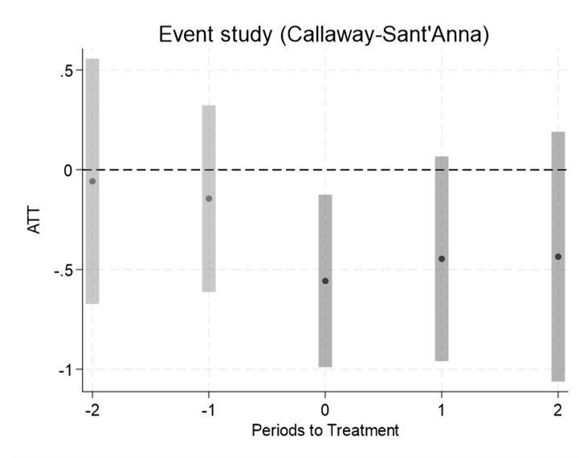
Note: Event-study estimates (Callaway-Sant’Anna) around bank desertification. ATT: Average Treatment effect on the Treated.

Table A3 – Pre-treatment descriptive statistics
Variable | N | Mean | Median | Standard Deviation | Min | Max
Firm growth rate | 8,646 | -0.092 | 0 | 3.007 | -9.194 | 9.097
Number of firms | 11,748 | 522.15 | 210 | 2,606.722 | 3 | 127,382

Table A4 – Placebo test: pre-treatment effects of bank desertification
 | Firm growth
Treated*Pre[-2] | 0.120
 | (0.130)
Treated*Pre[-3] | 0.091
 | (0.147)
Treated*Pre[-4] | 0.000
 | (0.182)
Municipality FE | Y
Year FE | Y
N | 18612
R-squared | 0.012
Joint test of placebo coefficients | p = 0.780
Notes: The table reports placebo estimates obtained by interacting treated municipalities with pre-treatment periods only. Municipality and year fixed effects are included. Standard errors in parentheses are clustered at the municipality level.

Department of Management, University of Bologna, Italy.
Department of Law “Cesare Beccaria”, University of Milan, Italy.
Corresponding Author: Essex Business School, University of Essex, Wivenhoe Park, Colchester; CO43SQ; United Kingdom. E-mail: cgirard@essex.ac.uk
Marco Biagi Department of Economics, University of Modena and Reggio Emilia, Italy.

