Suppl Figure 1 Study flow diagram
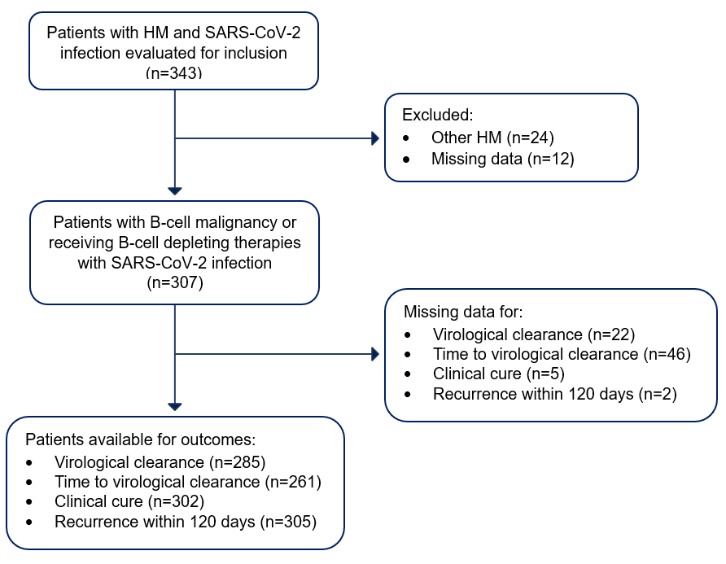

Suppl Table 1: Patients included in the analysis
Participating partner-hospital center | Total number of patients 307 (%)
UNIBO-IRCCS Azienda Ospedaliero-Universitaria of Bologna | 191 (62.2)
IRCCS Istituto Clinico Humanitas of Milan | 37 (12.1)
SAS-Hospital Virgen Macarena of Seville | 31 (10.1)
UNIVR-Azienda Ospedaliera Universitaria Integrata of Verona | 29 (9.4)
IRCCS INMI Lazzaro Spallanzani of Rome | 19 (6.2)

Suppl Table 2: Multivariable logistic regression with Bendamustine
 | Odds Ratio | 95% CI | p-value
Malignancy
Chronic Lymphocytic Leukemia | 0.614 | 0.247-1.524 | 0.293
Hodgkin Lymphoma | 0.219 | 0.032-1.478 | 0.119
Multiple Myeloma | 4.352 | 0.522-36.30 | 0.174
Non-Hodgkin Lymphoma | Ref.
Age (years) | 0.995 | 0.980-1.011 | 0.555
Male | 0.885 | 0.347-2.256 | 0.799
Tixagevimab/cilgavimab use * | 4.683 | 1.060-20.69 | 0.042
Time from HM to index episode (months) | 1.008 | 1.002-1.014 | 0.009
Hospital admission at index episode | 5.118 | 2.079-12.60 | <0.001
ICU admission at index episode | 0.976 | 0.511-1.864 | 0.941
Anti-CD20 antibody therapy | 3.156 | 2.321-4.292 | <0.001
Early antiviral treatment
Molnupiravir | 0.551 | 0.259-1.170 | 0.121
Nirmatrelvir/r | 0.324 | 0.188-0.560 | <0.001
Remdesivir | 0.256 | 0.181-0.636 | <0.001
None | Ref.
Bendamustine° | 1.144 | 0.363-3.611 | 0.818
Sotrovimab as early treatment | 0.327 | 0.152-0.700 | 0.004
Constant | 0.223 | 0.084-0.589 | 0.002
* in the last 6 months or first 10 days of index episode. ° in the previous 6 months

Suppl Table 3: Multivariable logistic regression in the NHL subgroup
 | Odds Ratio | 95% CI | p-value
Malignancy
Chronic Lymphocytic Leukemia | 0.614 | 0.247-1.524 | 0.293
Hodgkin Lymphoma | 0.219 | 0.032-1.478 | 0.119
Multiple Myeloma | 4.352 | 0.522-36.30 | 0.174
Non-Hodgkin Lymphoma | Ref.
Age (years) | 0.996 | 0.981-1.011 | 0.586
Male | 0.838 | 0.380-1.850 | 0.663
Tixagevimab/cilgavimab use * | 2.841 | 0.752-10.728 | 0.123
Time from HM to index episode (months) | 1.007 | 1.004-1.012 | 0.013
Hospital admission at index episode | 5.509 | 1.536-19.762 | 0.009
Anti-CD20 antibody therapy° | 2.956 | 2.275-3.841 | <0.001
Early antiviral treatment
Molnupiravir | 0.853 | 0.316-2.305 | 0.755
Nirmatrelvir/r | 0.327 | 0.137-0.777 | 0.011
Remdesivir | 0.302 | 0.248-0.367 | <0.001
None | Ref.
Sotrovimab as early treatment | 0.423 | 0.120-1.490 | 0.180
Constant | 0.227 | 0.070-0.741 | 0.014
* in the last 6 months or first 10 days of index episode. ° in the previous 24 months

Suppl Table 4: Comparison of patients with and w/out persistent SARS-CoV2 infection in the CLL subgroup
Characteristic | Non-persisting  N = 44 (%) | Persisting  N = 15 (%) | p-value
Age, years (median, IQR) | 70 (65.5-74.5) | 71 (59-76) | 0.89
Sex (Male) | 29 (65.9) | 10 (66.7) | 0.96
Charlson Comorbidity Index (median, IQR) | 5 (4.5-6) | 5 (4-6) | 0.64
Treatment for underlying condition
Anti-CD20 | 9 (20.9) | 6 (46.2%) | 0.072
Bendamustina | 1 (2.3) | 1 (6.7) | 0.417
BTKi | 30 (69.8) | 6 (46.2) | 0.119
Number of treatment lines (median, IQR) | 1 (1-3) | 1.5 (1-2) | 0.843
Index episode features
Immunization status
Prior infection | 2 (4.5) | 0 (0.0) | 0.401
Vaccination | 41 (93.2) | 15 (100) | 0.299
Clinical severity at diagnosis |  |  | 0.137
Mild | 1 (2.3) | 0 (0.0)
Moderate | 38 (86.4) | 10 (66.7)
Severe | 4 (9.1) | 5 (33.0)
Critical | 1 (2.3) | 0 (0.0)
Radiological findings
Bilateral pneumonia | 5 (11.4) | 9 (60.0) | <0.001
Need of hospital admission | 7 (15.9) | 9 (60.0) | <0.001
Therapeutic management of index episode
Early treatment |  |  | 0.428
None | 12 (27.3) | 7 (46.7)
Molnupiravir | 8 (18.2) | 1 (6.7)
Nirmatrelvir/r | 10 (22.7) | 2 (13.3)
Remdesivir | 14 (31.8) | 5 (33.3)
Sotrovimab | 4 (9.1) | 0 (0.0) | 0.226

