Online Supplementary Material

Chamelea gallina growth declines in a warming climate: Insights from the Northern Adriatic Sea during the Holocene Climate Optimum
Alessandro Cheli^{†1,2}, Arianna Mancuso^{†1,2}, Fiorella Prada^{1,3}, Alexis Rojas¹, Giuseppe Falini^{2,4}, Stefano Goffredo^{1,2*}, Daniele Scarponi^{5*}

Contents

Supplemental Methods 1
Supplemental Figures 4
Supplemental Table 6

Supplemental Methods
Specimens collection (from Cheli et al., 2021)
In particular, the two Holocene horizons were collected from core 205-S6 (Comacchio, 44°68’N, 12°15’E), respectively, at depths of 17.2 m (code "CO1") and 13.2 m (code "CO2"). Both horizons came from shoreface depositional environments characterized by sandy substrates and estimated water depths between 5 and 10 m.
Modern samples of C. gallina were collected in the Northern Adriatic Sea off the coast of Goro (code “MGO”; 44°75’N, 12°43’E) and Cervia (code “MCE”; 44°30’N, 12°40’E), two sites near to the extraction areas of cores used in this study and distant about fifty kilometers away from each other. Samplings were performed during scuba diving and using Van Veen Grab on the sandy bottom, ranging from 1 to 5 m water depth. Sampling operations were confined to the top-most 10 cm of the sea bottom's taphonomically active zone (TAZ). This sampling allowed us to collect a time-averaged record of shells estimated in tens of years, following the deposition rates reported by Trincardi et al. This allowed a better comparison between modern and sub-fossil horizons, consisting of shells from tens of years. No living organism was collected for this study.
Only 5–30 mm long shells (the maximum distance on the anterior-posterior axis) were considered for the analyses. The technical difficulties in obtaining reliable measurements in very small specimens defined the lower size limit. The upper size limit was due to the difficulty of collecting whole shells over 30 mm in the sub-fossil horizons with a 90 mm core diameter.
Before any measurements, each valve was cleaned with a toothbrush and soaked in distilled water for two hours to remove any external residue on the shell’s surfaces. In addition, valves from modern settings were immersed in distilled water and hydrogen peroxide (5% vol.) for 24 h to eliminate any traces of organic material (e.g., epibionts). Then, the valves were dried in an oven at 40°C for one night to remove any moisture that may influence subsequent measurements.

Environmental Parameters (from Cheli et al., 2021)
Sea surface temperature (SST) for the Adriatic Sea of modern settings was obtained from the global ocean OSTIA sea surface temperature and sea ice analysis databank (https://ghrsst-pp.metoffice.gov.uk). Mean annual SST was calculated from daily values from January 2010 to December 2019 (number of daily values = 3651 for each site). SST estimates for sub-fossil horizons were based on the Alkenones unsaturation index, a widely applied proxy for past SST and obtained from the high-resolution SST record of the past 10,000 years for the central-northern Mediterranean Sea (Gulf of Lion; Jalali et al., 2016), considered a comparable physiographic setting for the North Adriatic Sea. To evaluate possible discrepancies between Gulf of Lion and targeted area of the NAS we extracted sea surface temperature data for the Gulf of Lion from January 2010 to December 2019, which corresponds to the period used to assess modern temperatures in the Adriatic Sea. This data was sourced from the Global Ocean OSTIA database (Copernicus link: Global Ocean OSTIA Sea Surface Temperature and Sea Ice Analysis | Copernicus Marine Service ; Donlon et al., 2012; Good et al., 2020; ). We focused on two specific locations (ca. 80 km apart) within the Gulf:
1) Offshore of the Rhône Delta (longitude 4.980°E, latitude 43.271°N), which provides an environment comparable to our study area. The mean temperature for this location during the period from 2010 to 2019 was 17.3°C, with a 95% confidence interval (CI) of 17.2°C to 17.5°C.
2) The northernmost part of the Gulf (longitude 4.031°E, latitude 43.520°N), approximately 80 km northwest of the first site, recorded a mean temperature of 16.7°C, with a 95% CI of 16.6°C to 16.9°C.
In the target area of the NAS, the mean modern temperatures from January 2010 to December 2019 for the two sites (30 km apart) were 17.2°C and 17.3°C. Thus, the modern temperatures in our sample area are comparable to, or slightly lower than, those reported for the study area. This suggests that our findings are conservative and robust. We have also updated the Environmental Parameters section of the supplementary material to include this information.

Shell biometrics and skeletal parameters (from Cheli et al. 2021, slightly modified)
Shell length (the maximum distance on the anterior-posterior axis) was measured using ImageJ software after data capture of each shell shape with a scanner (Acer Acerscan Prisa 620 ST 600 dpi), and dry shell weight was measured using an analytical balance (±0.1 mg).
Shells of different sizes from each assemblage were used for the analyses. They were divided into two groups according to size: immature shells (up to 18 mm) and mature ones (over 18 mm).
Shell skeletal parameters were measured by buoyant weight (BW) analysis using a density determination kit Ohaus Explorer Pro balance (± 0.1 mg; Ohaus Corp., Pine Brook, NJ, USA) as reported in Gizzi et al. 2016.
The BW measurement was repeated three times, and the average was considered for statistical analysis. The BW technique allowed us to estimate the variable of interest:
- micro-density (mass per unit volume of the material which composes the shell, excluding the volume of pores; g·cm⁻³);
- apparent porosity: the volume of pores connected to the external surface (%);
- bulk density: shell mass/volume ratio, including the volume of pores, the volume of pores; g·cm⁻³).

At the microscale level, the shells were composed of pure aragonite with a perfectly preserved mineral phase and no relevant diagenetic alteration, except for a slight degradation of the inter-crystalline organic phase retrieved (Cheli et al., 2021).

Shell aging methods
For counting surface external rings (Ramon and Richardson, 1992), which appeared as smooth clefts on the shell surface and as strong pigmented lines across the anterior-posterior axis, shells were scanned in transmitted light to enhance the contrast of the surface’s ridge and highlight bands at different densities.
To estimate age using shell sectioning, the valves were embedded in epoxy resin under vacuum at room temperature, followed by 24-hour hardening. The shells were sectioned along the anterior-posterior axis, from the umbo to the ventral margin, using an electrodeposited diamond cutting blade for counting internal bands. Sections were ground using successive finger grits (600, 1200, 2400 μm) and polished with abrasive alumina compound (3M Perfect-it III Extrafine Paste). Finally, the sections were ultrasonically cleaned, rinsed in purified water, and dried. Shell sections were then examined and photographed under oblique light at low magnification to identify internal growth bands. In each section, the number of annual growth rings was determined by counting the alternating opaque (carbonate matrix) and translucent (carbonate-organic matrix) increments visible on the shell cross-section (Arneri et al., 1995) using a dissecting microscope under reflected light at low magnification (6.4 X). Assuming that the growth rings are laid down yearly, the age of each clam was estimated by counting all the translucent zones.
To validate the data from the two counting rings methods, oxygen isotopic measurements (δ¹⁸O) were carried out on “spot” samples collected sequentially using a handheld Dremel-type rotary tool equipped with a 0.5 mm dental diamond drill bit. The drill was operated intermittently, applying minimal pressure to avoid frictional heating and prevent damage to the shells. The samples for δ¹⁸O were taken from the umbo to the ventral edge of 3 shells of different sizes for each site. Dried homogenized powdered samples were treated with helium, and then an acidified solution consisting of 104% orthophosphoric acid was added and left to react for 1 hour at 70 °C. Each sample was analyzed using a Thermo Gasbench preparation system attached to a Thermo Delta V Advantage mass spectrometer in continuous flow mode. Each run of samples was accompanied by ten reference carbonates (Carrara Z) and two control samples (Fletton Clay). Carrara Z has been calibrated to VPDB using the international standard NBS19.

References
Arneri, E., Giannetti, G., Polenta, R. & Antolini, B. Age and growth of Chamelea gallina (Bivalvia: Veneridae) in the Central Adriatic Sea obtained by thin sections. Rapp. Comm. int. Mer Médit 34, 17 (1995)
Cheli, A. et al. Climate variation during the Holocene influenced the skeletal properties of Chamelea gallina shells in the North Adriatic Sea (Italy). PLoS One 16, e0247590 (2021).
Donlon, C.J. et al. The Operational Sea Surface Temperature and Sea Ice Analysis (OSTIA) system. Remote Sensing of the Environment. 116, 140-158 (2012).
Gizzi, F. et al. Shell properties of commercial clam Chamelea gallina are influenced by temperature and solar radiation along a wide latitudinal gradient. Sci Rep. 6: 36420 (2016)
Good, S. et al. The Current Configuration of the OSTIA System for Operational Production of Foundation Sea Surface Temperature and Ice Concentration Analyses. Remote Sens. 12, 720 (2020)
Jalali B, Sicre M.A., Bassetti M.A. & Kallel N. Holocene climate variability in the North-Western Mediterranean Sea (Gulf of Lions). Clim Past. 12, 91–101 (2016)
John D. et al. OSTIA : An operational, high resolution, real time, global sea surface temperature analysis system., Oceans 07 IEEE Aberdeen, conference proceedings. Marine challenges: coastline to deep sea. Aberdeen, Scotland.IEEE (2007)
Ramón, Montserrat, and C. A. Richardson. "Age determination and shell growth of Chamelea gallina (Bivalvia: Veneridae) in the western Mediterranean." Marine ecology progress series 15-23 (1992).

Supplemental Figures

Figure. S1. Study area map and stratigraphic framework of the latest Quaternary Po coastal plain-sedimentary succession (revised by Cheli et al., 2021). In the left panel, black dots mark HCO assemblages (CO1, CO2), black triangles mark sampled thanatocoenosis from present-day shoreface environments (MCE, MCO), square marks the location of Marina di Ravenna, and the black solid line represents the along-dip cross-section of the Po coastal plain (right panel). The right panel shows sketched climate-driven environmental changes within the study area during the Holocene; the dashed line indicates the wave ravinement surface, and green-filled symbols represent projected samples on the cross-section. Acronyms: MFS = maximum flooding surface; TST = transgressive systems tract; HST = highstand systems tract.

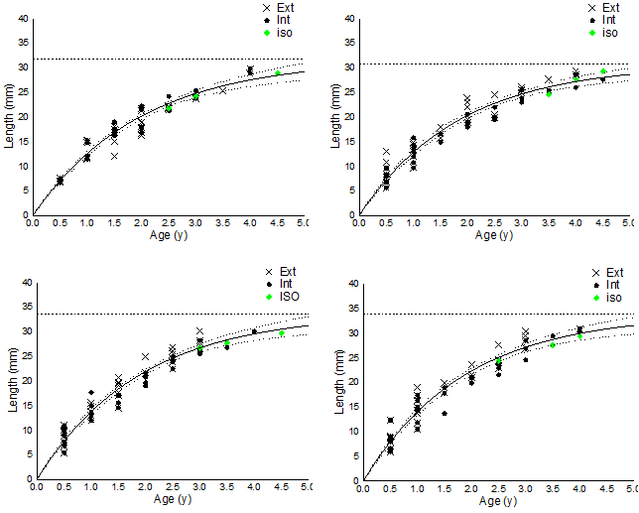
Figure S2. Von Bertalanffy growth curves. The generalized age-length von Bertalanffy growth curve for each assemblage was obtained by merging data from the two aging methods (counting external and internal rings). Green diamonds represent the ages obtained from the δ18O profiles along the shell growth axis and serve as validation of the counting aging methods by fitting the curves.

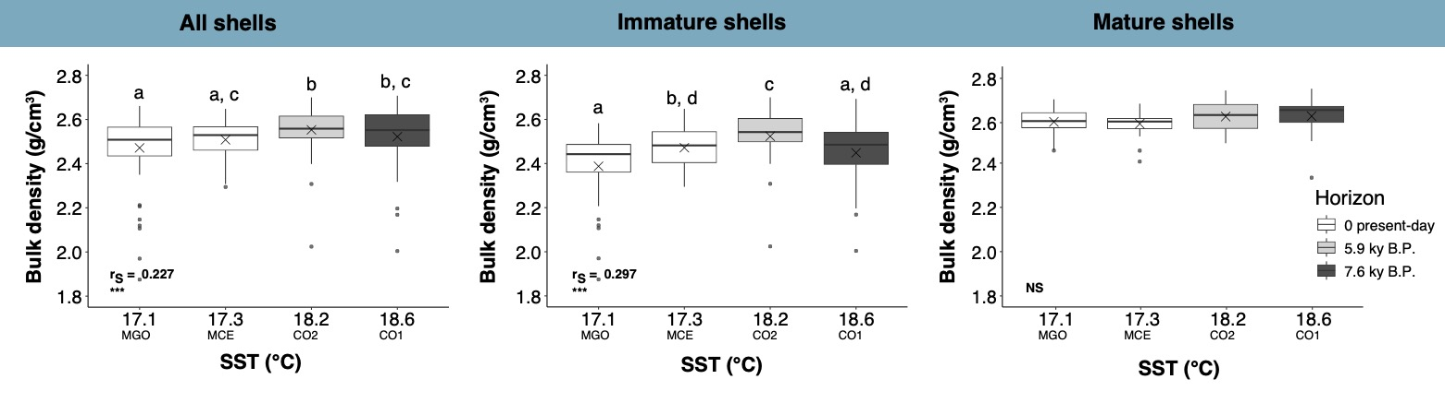
Figure S3. Variation of bulk density in relation to different SST (Sea Surface Temperature). Three groups were considered: correlations in all shells, correlations in immature shells (<18 mm), and correlations in mature shells (>18 mm). The box colors represent the age of the assemblages, ranging from the oldest fossil horizon (dark grey boxes) to the present-day horizon (white boxes). The boxes indicate the 25th and 75th percentiles, the lines within the boxes mark the medians, and the crosses mark the mean values. Black points represent outliers. Different letters indicate statistical differences among assemblages (p < 0.05; the number of clams measured for each assemblage is reported in Table 1). r_{S}, Spearman’s rho coefficient. ***p < 0.001, NS, not significant.

Supplemental Table

Table S1. Radiocarbon data for individual specimens of Chamalea gallina from core 205-S6 sampled at 17.10 m core depth and used to estimate time-averaging of sample CO1 (i.e., interquartile range).
Sample descriptors |  |  |  | 14C descriptors and radiometric age |  |  |  |  |  | Calibrated age (y.B.P.)
Core ID | Sample ID | depth (m) | Facies | Fraction modern | error | D 14C | error | Age 14C | error | median | 2s old | 2s yng
205-S6 | CO1-1 | 17.10 | shoreface | 0.400426571 | 0.003118 | -599.573 | 3.117556 | 7350 | 70 | 7679 | 7829 | 7556
205-S6 | CO1-2 | 17.10 | shoreface | 0.41499394 | 0.003169 | -585.006 | 3.168601 | 7060 | 70 | 7435 | 7559 | 7304
205-S6 | CO1-3 | 17.10 | shoreface | 0.402457845 | 0.00322 | -597.542 | 3.219648 | 7310 | 70 | 7640 | 7789 | 7507
205-S6 | CO1-4 | 17.10 | shoreface | 0.40290253 | 0.002906 | -597.097 | 2.905615 | 7300 | 60 | 7632 | 7771 | 7510
205-S6 | CO1-5 | 17.10 | shoreface | 0.404109428 | 0.003101 | -595.891 | 3.100696 | 7280 | 70 | 7612 | 7754 | 7481
205-S6 | CO1-6 | 17.10 | shoreface | 0.408723272 | 0.002965 | -591.277 | 2.964883 | 7190 | 60 | 7532 | 7647 | 7421
205-S6 | CO1-7 | 17.10 | shoreface | 0.403931637 | 0.003427 | -596.068 | 3.426882 | 7280 | 70 | 7616 | 7770 | 7478
205-S6 | CO1-8 | 17.10 | shoreface | 0.405556803 | 0.003716 | -594.443 | 3.71624 | 7250 | 80 | 7586 | 7736 | 7437
205-S6 | CO1-9 | 17.10 | shoreface | 0.415306016 | 0.003745 | -584.694 | 3.745432 | 7060 | 80 | 7429 | 7563 | 7282
205-S6 | CO1-10 | 17.10 | shoreface | 0.406444916 | 0.003029 | -593.555 | 3.02942 | 7230 | 60 | 7571 | 7688 | 7443
205-S6 | CO1-11 | 17.10 | shoreface | 0.40195615 | 0.001067 | -601.4 | 1.067254 | 7320 | 25 | 7641 | 7726 | 7568

