SUPPLEMENTARY MATERIALS

Appendix to the paper:

Effect of Femoral Component Design and Quadriceps Load on Patellofemoral Kinematics After Total Knee Arthroplasty: An In Vitro Cadaveric Study

SUPPLEMENTARY MATERIAL #2

Influence of the quadriceps muscle
for all degrees of freedom of the tibiofemoral joint after TKA
This section mirrors the analysis presented for the patellofemoral joint but focuses on the tibiofemoral articulation following TKA. The same graphical structure is adopted, reporting:
- Median ± SD of all six tibiofemoral kinematic parameters across the flexion-extension cycle, grouped by QVML, QVAP, and QVload.
- Median ± SD of the variation relative to the baseline condition.
- P-values from the Kruskal-Wallis test with Bonferroni correction for each parameter, identifying which quadriceps factors significantly influenced tibiofemoral motion.
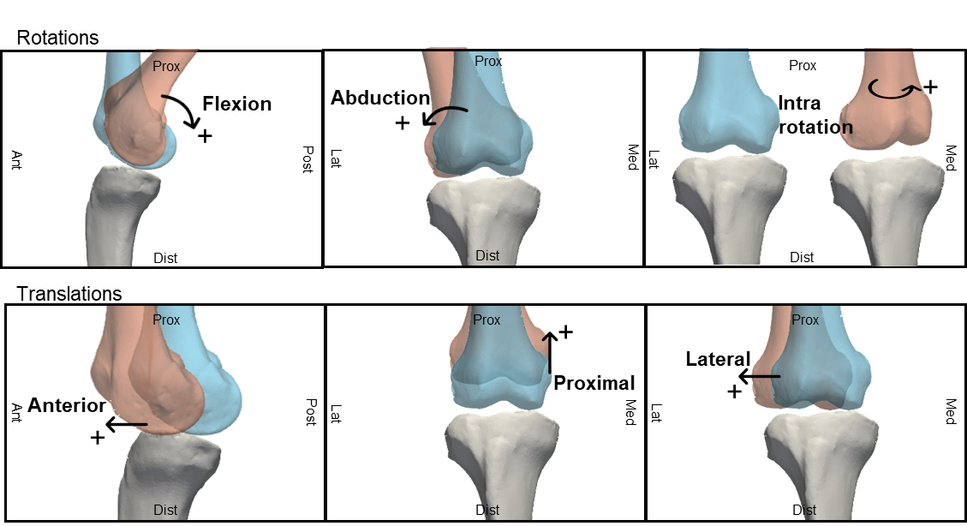 Figure S2_1 Degrees of freedom of the tibiofemoral joint. Figshare repository (https://doi.org/10.6084/m9.figshare.29278721).
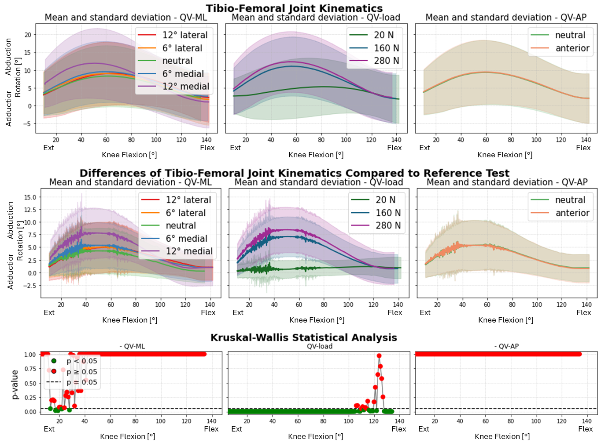
Figure S2_2: Abduction-Adduction rotation of the femur after TKA. TOP: absolute values as a function of knee flexion angle (the median and standard deviation between 12 specimens are plotted). CENTER: differences of all tests compared with the reference test (QVload = 20 N, QVML = neutral, QVAP = posterior). Left shows the difference as a function of QVML, middle QVload, right QVAP. BOTTOM: significance of the differences plotted at the center. The p-value trend is plotted for the three parameters (left QVML, middle QVload, right QVAP); the significant values are highlighted in green (p<0.05), the non significant ones in red (p≥0.05).
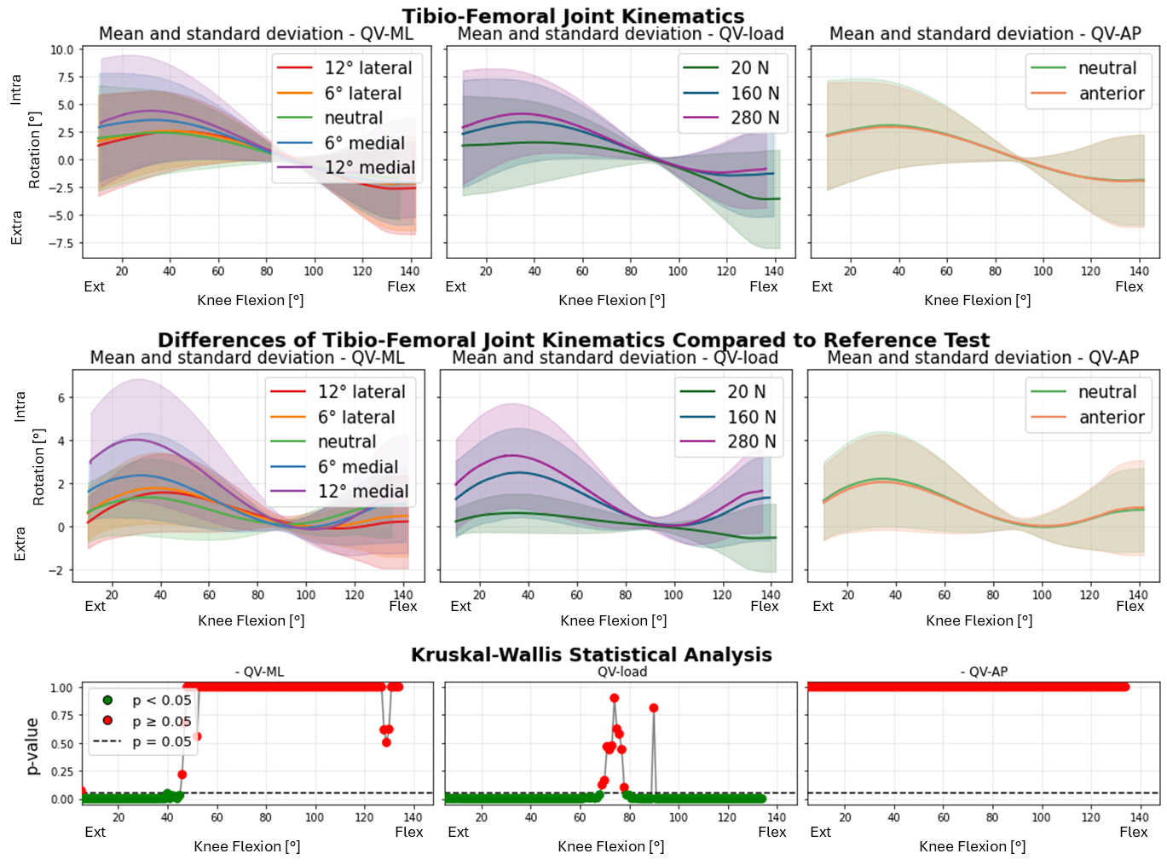
Figure S2_3: Intra-Extra rotation of the femur after TKA. TOP: absolute values as a function of knee flexion angle (the median and standard deviation between 12 specimens are plotted). CENTER: differences of all tests compared with the reference test (QVload = 20 N, QVML = neutral, QVAP = posterior). Left shows the difference as a function of QVML, middle QVload, right QVAP. BOTTOM: significance of the differences plotted at the center. The p-value trend is plotted for the three parameters (left QVML, middle QVload, right QVAP); the significant values are highlighted in green (p<0.05), the non significant ones in red (p≥0.05).
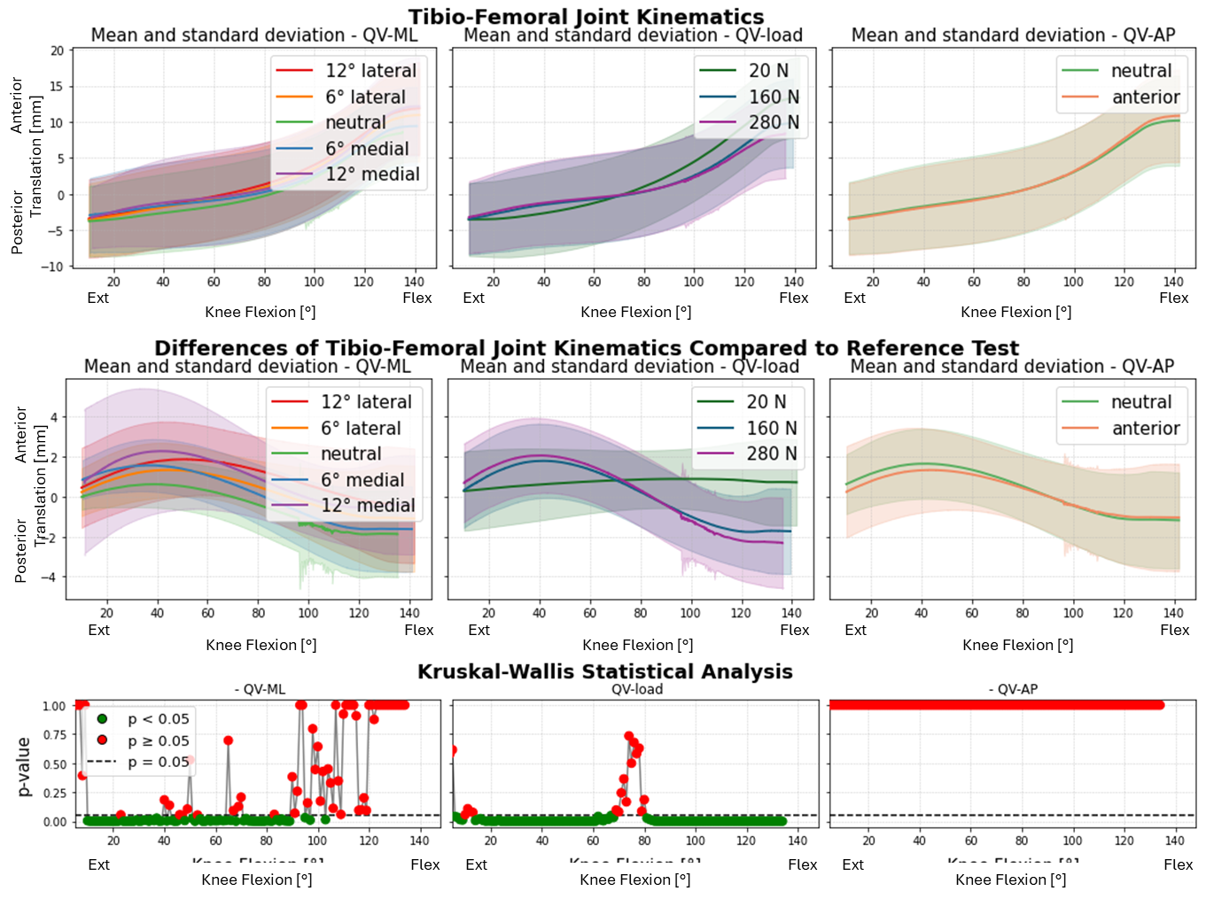
Figure S2_4: Anterior-Posterior translation of the femur after TKA. TOP: absolute values as a function of knee flexion angle (the median and standard deviation between 12 specimens are plotted). CENTER: differences of all tests compared with the reference test (QVload = 20 N, QVML = neutral, QVAP = posterior). Left shows the difference as a function of QVML, middle QVload, right QVAP. BOTTOM: significance of the differences plotted at the center. The p-value trend is plotted for the three parameters (left QVML, middle QVload, right QVAP); the significant values are highlighted in green (p<0.05), the non significant ones in red (p≥0.05).
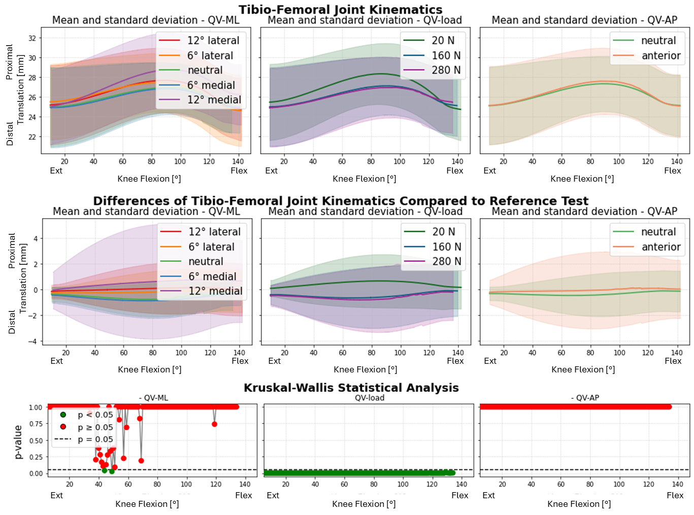
Figure S2_5: Proximal-Distal translation of the femur after TKA. TOP: absolute values as a function of knee flexion angle (the median and standard deviation between 12 specimens are plotted). CENTER: differences of all tests compared with the reference test (QVload = 20 N, QVML = neutral, QVAP = posterior). Left shows the difference as a function of QVML, middle QVload, right QVAP. BOTTOM: significance of the differences plotted at the center. The p-value trend is plotted for the three parameters (left QVML, middle QVload, right QVAP); the significant values are highlighted in green (p<0.05), the non significant ones in red (p≥0.05).green line.
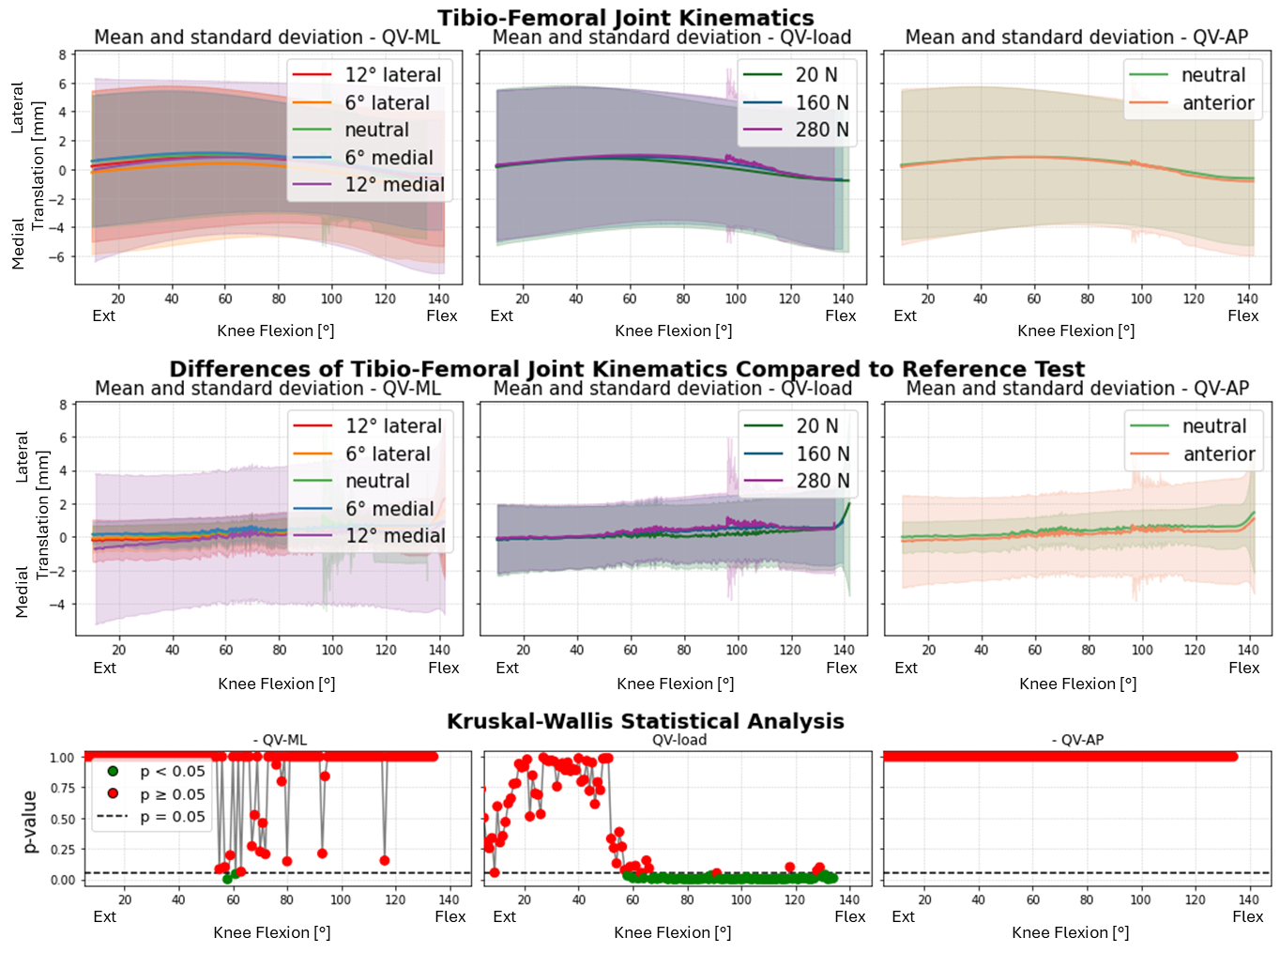
Figure S2_6: Medial-Lateral translation of the femur after TKA. TOP: absolute values as a function of knee flexion angle (the median and standard deviation between 12 specimens are plotted). CENTER: differences of all tests compared with the reference test (QVload = 20 N, QVML = neutral, QVAP = posterior). Left shows the difference as a function of QVML, middle QVload, right QVAP. BOTTOM: significance of the differences plotted at the center. The p-value trend is plotted for the three parameters (left QVML, middle QVload, right QVAP); the significant values are highlighted in green (p<0.05), the non significant ones in red (p≥0.05).

