Supplementary materials

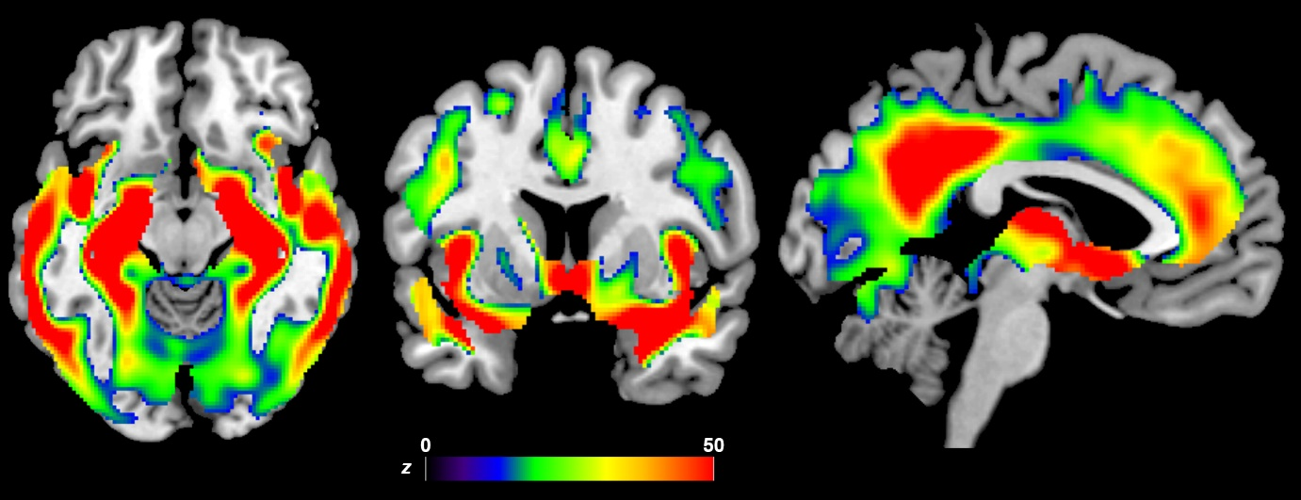
Supplementary Figure 1. Results of the VBM ANOVA model comparing GM volume across CU, MCI and AD groups (n = 800; p < 0.05 FWE-corrected for multiple comparisons).

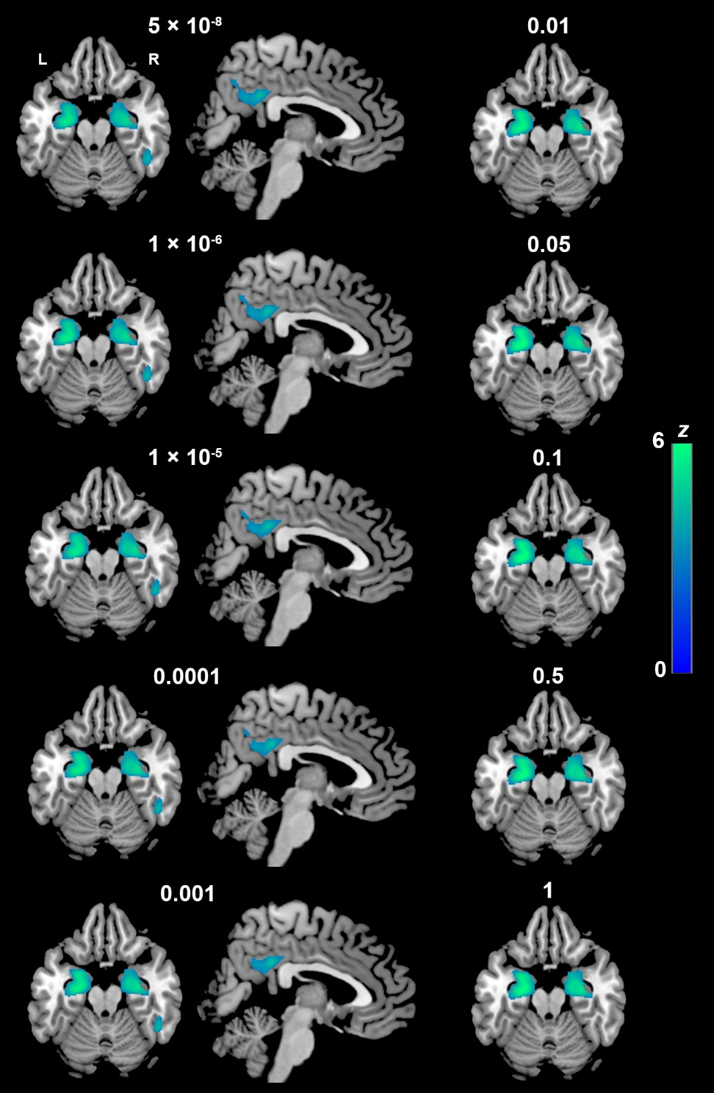
Supplementary Figure 2. Voxel-based negative associations between AD-PRS (calculated using 10 thresholds) and GM volume in the whole sample (n = 800; p < 0.05 FWE-corrected for multiple comparisons).
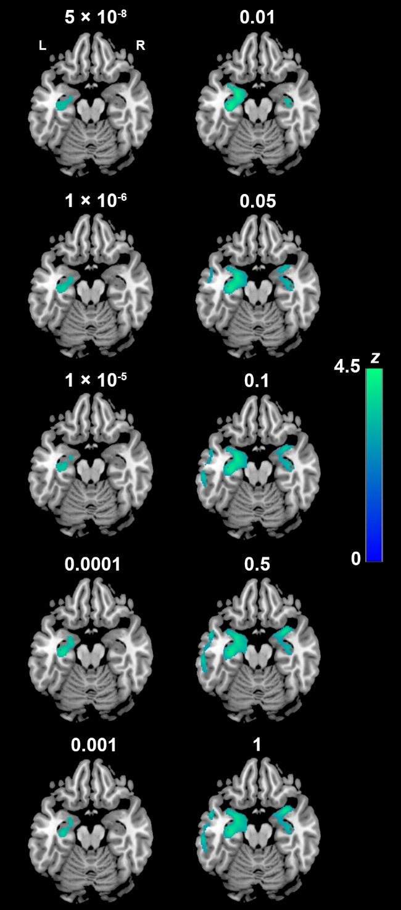
Supplementary Figure 3. Voxel-based negative associations between AD-PRS_{noAPOE} (calculated using 10 thresholds) and GM volume in the whole sample (n = 800; p < 0.05 FWE-corrected for multiple comparisons).

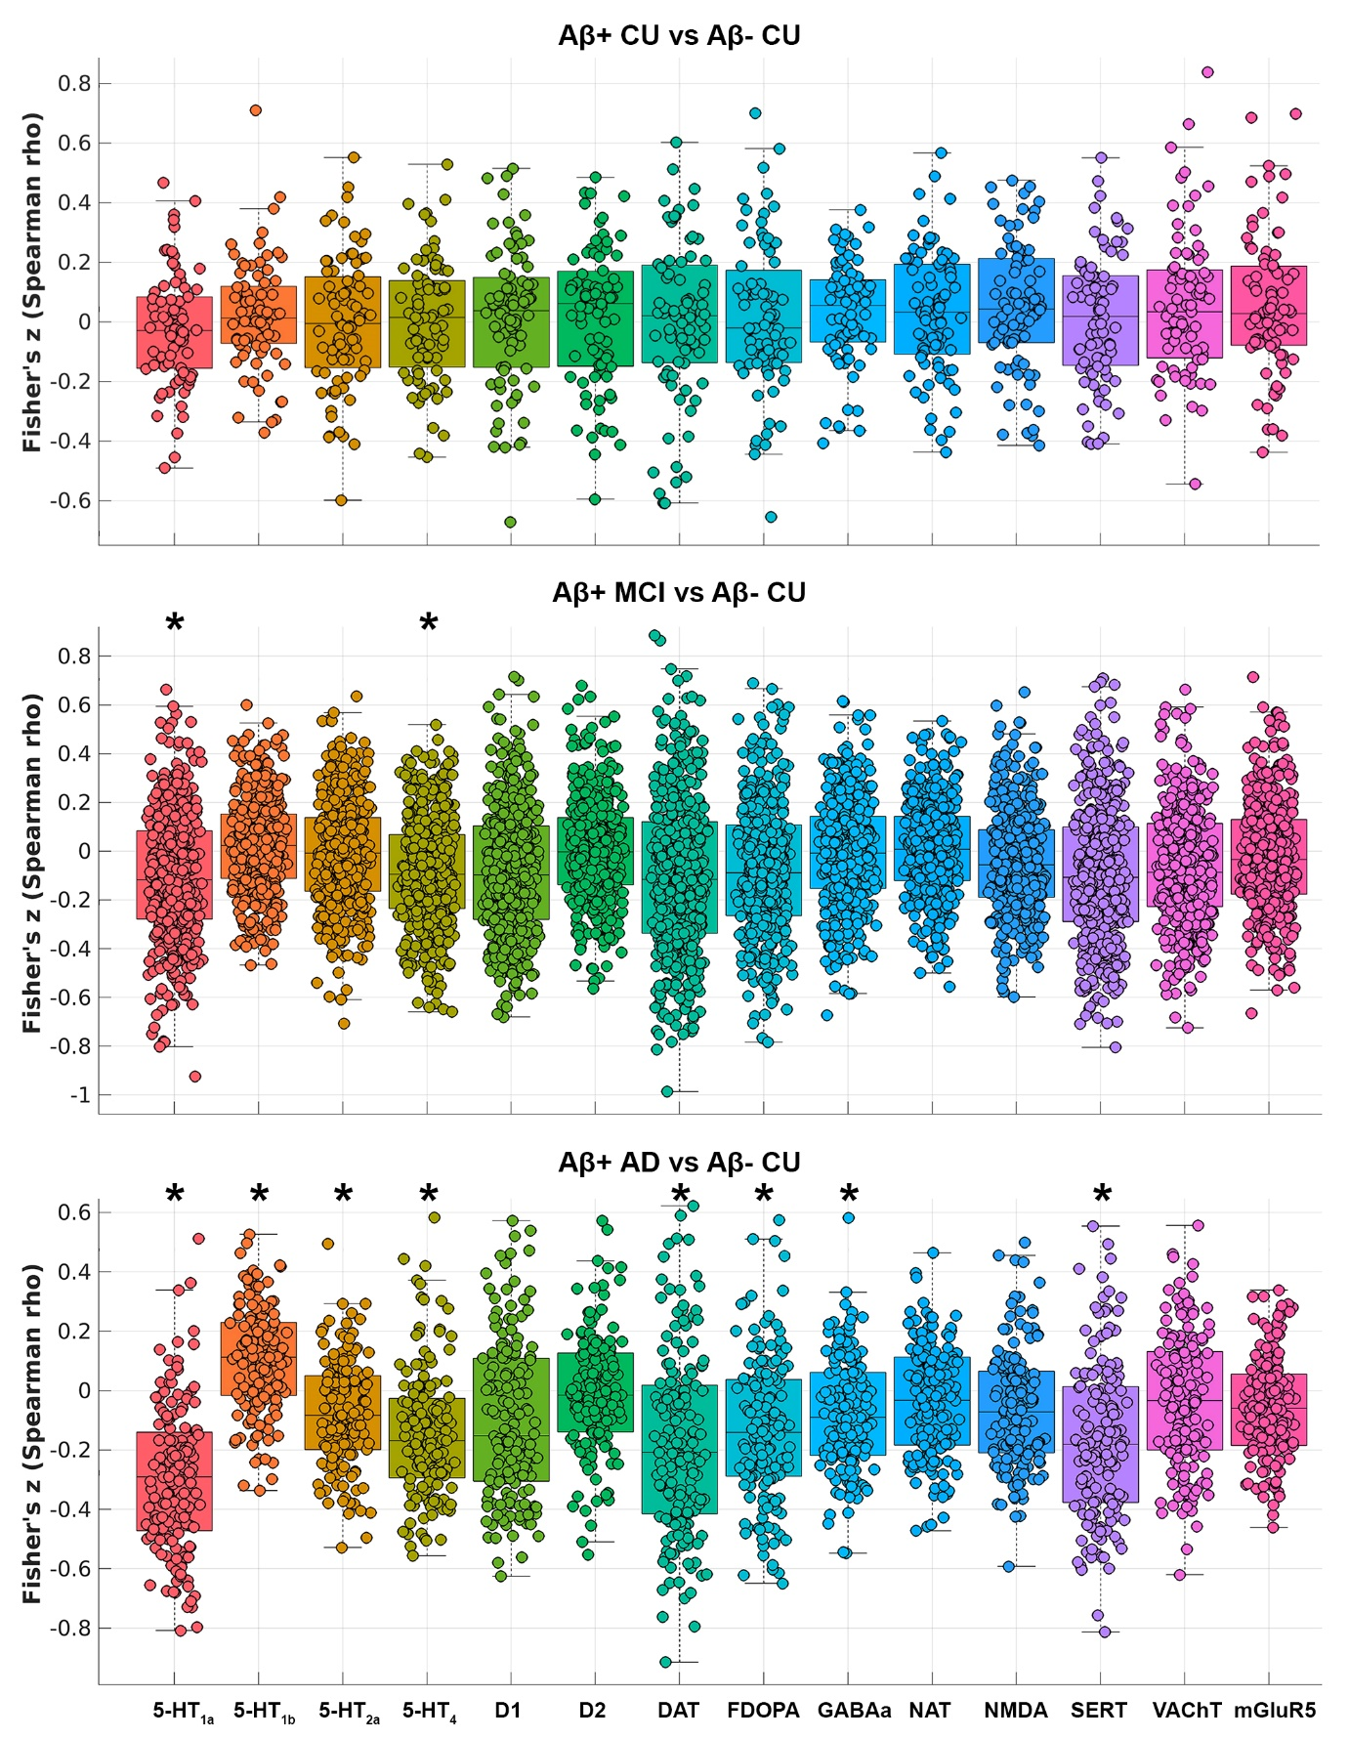
Supplementary Figure 4. Associations between grey matter atrophy in Aβ+ CU, Aβ+ MCI and Aβ+ AD groups and a priori density values of neurotransmitters compared with Aβ- CU participants (significant results are indicated by an asterisk).

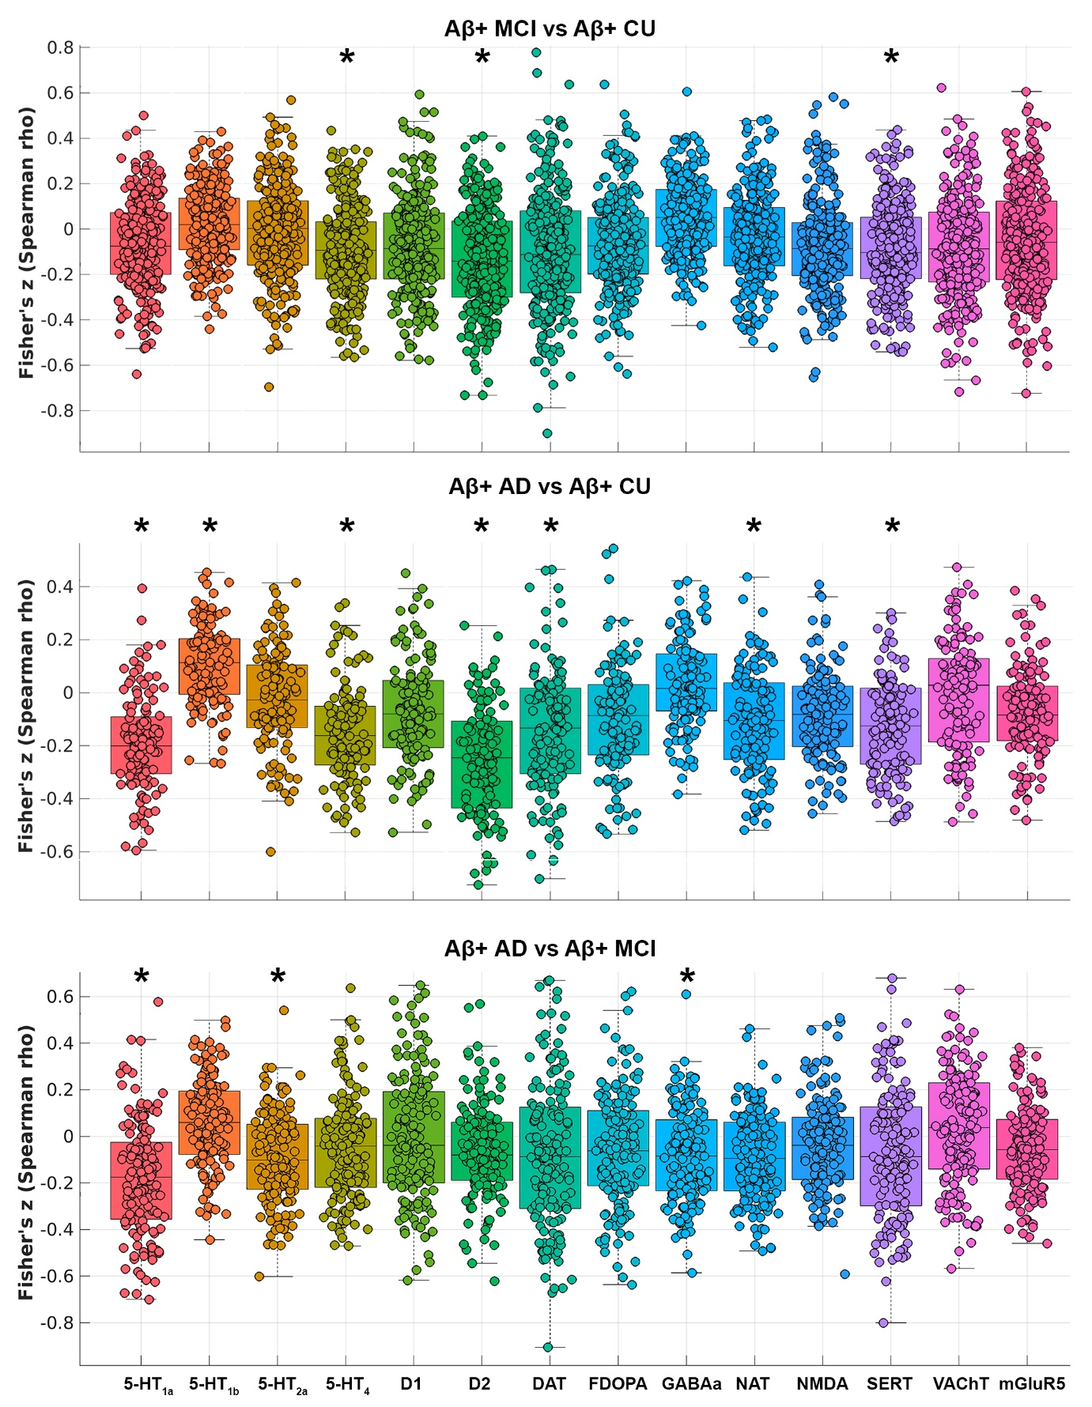
Supplementary Figure 5. Associations between grey matter atrophy in Aβ+ groups and a priori density values of neurotransmitters (significant results are indicated by an asterisk).

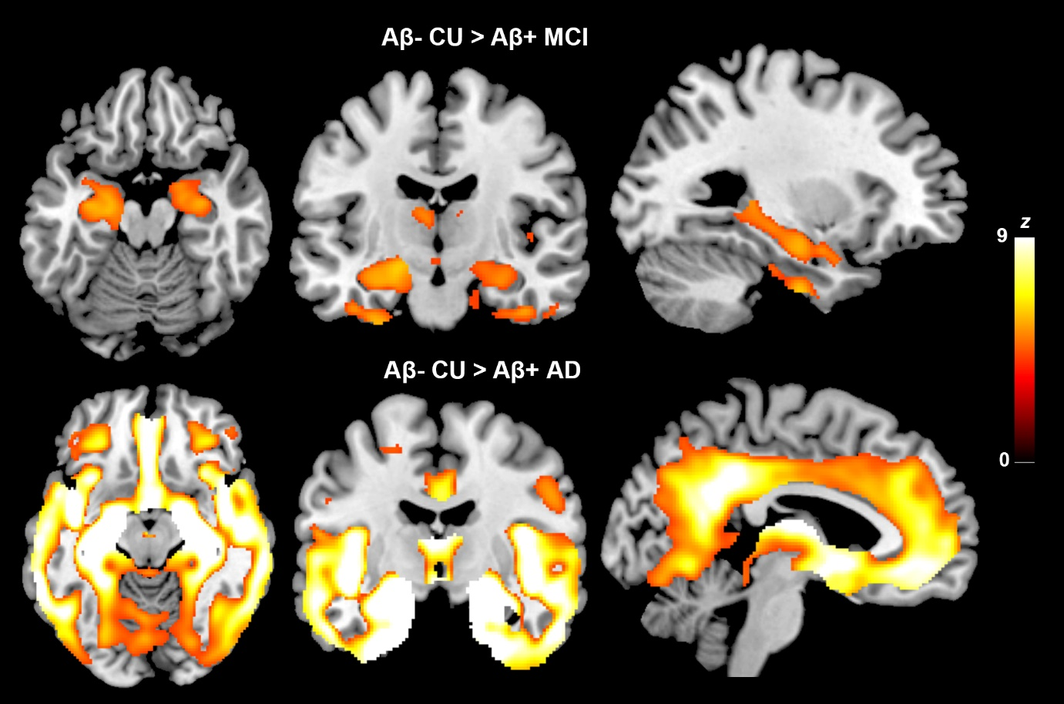
Supplementary Figure 6. Results of the VBM analyses comparing Aβ+ patients with Aβ- CU participants (p < 0.05 FWE-corrected for multiple comparisons).

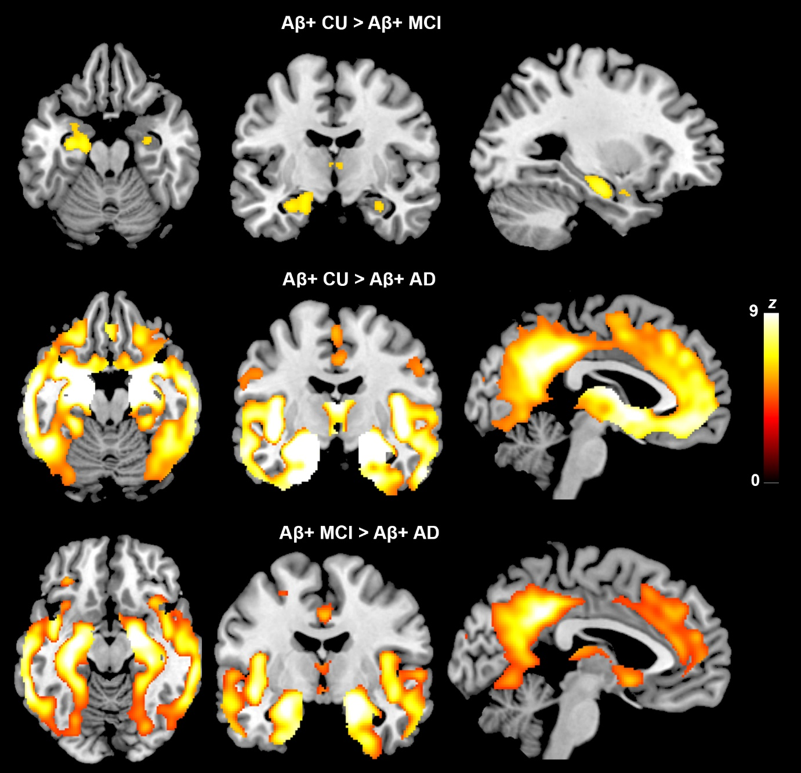
Supplementary Figure 7. Results of the VBM analyses comparing all Aβ+ groups (p < 0.05 FWE-corrected for multiple comparisons).

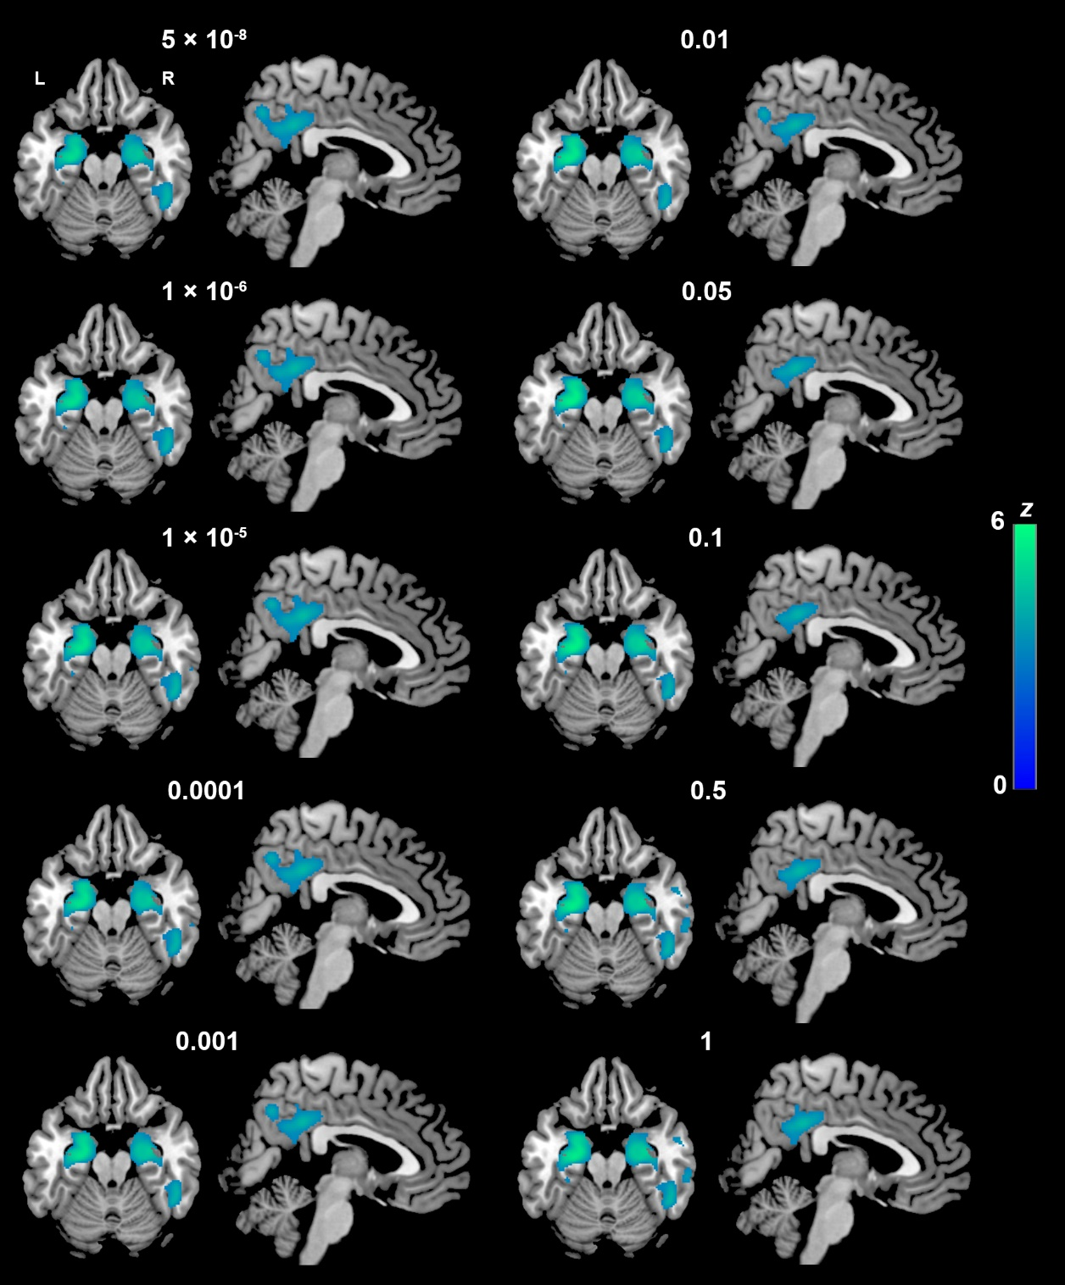
Supplementary Figure 8. Voxel-based negative associations between AD-PRS (calculated using 10 thresholds) and GM volume in the Aβ+ sample (n = 481; p < 0.05 FWE-corrected for multiple comparisons).

Supplementary Table 1. Demographic and clinical profile of Aβ+ and Aβ- CU participants. All summary statistics are mean (standard deviation) unless otherwise specified (Bonferroni-corrected p = 0.0042).
Variables | Aβ- CU (n = 105) | Aβ+ CU (n = 79) | Aβ+ MCI (n = 274) | Aβ+ AD (n = 128) | F | p
Demographic
Age | 73.8 (5.9) | 73.6 (5.8) | 74.4 (7.9) | 76.1 (7.9) | 10.8ª | 0.012
Education | 16.6 (2.8) | 16.3 (2.4) | 16.1 (2.8) | 15.9 (2.9) | 4.4ª | 0.220
Sex (%, F/M) | 51.4/48.6 | 53.2/46.8 | 39.8/60.2 | 45.3/54.7 | 6.9^{b} | 0.075
Cognitive
MMSE (total score) | 29.1 (1.1)^{c,d} | 29.1 (1.3)^{c,d} | 27.7 (2.0)^{d} | 21.2 (5.1) | 280.4ª | <0.001
CDT (Drawing) | 4.7 (0.5)^{c,d} | 4.7 (0.5)^{d} | 4.6 (0.8)^{d} | 3.2 (1.5) | 111.8ª | <0.001
CDT (Copy) | 4.9 (0.4)^{d} | 4.9 (0.3)^{d} | 4.7 (0.5)^{d} | 4.0 (1.3) | 70.8ª | <0.001
LMT (Immediate recall) | 14.7 (3.0)^{c,d} | 14.8 (2.9)^{c,d} | 9.6 (3.9)^{d} | 4.0 (3.1) | 331.2ª | <0.001
LMT (Delayed recall) | 13.8 (3.3)^{c,d} | 13.6 (3.1)^{c,d} | 7.3 (4.0)^{d} | 1.6 (2.8) | 374.5ª | <0.001
CFT (Animals) | 20.7 (5.5)^{c,d} | 21.9 (5.6)^{c,d} | 17.8 (5.0)^{d} | 10.7 (5.2) | 198.4ª | <0.001
TMT-A (seconds) | 32.6 (9.8)^{c,d} | 34.0 (10.5)^{c,d} | 40.1 (16.9)^{d} | 69.6 (45.6) | 97.7ª | <0.001
Imaging and biomarkers
TIV | 1444.6 (140.1) | 1417.4 (129.3) | 1469.0 (143.1) | 1449.5 (162.0) | 7.3 | 0.063
APOE (%) |  |  |  |  | 108.9^{b} | <0.001
ε4ε4 | 0.0^{c,d,e} | 3.8^{d} | 9.1^{d} | 20.3
ε3ε4 | 15.2^{c,d,e} | 30.4^{d} | 39.4^{d} | 51.5
ε3ε3 | 65.7^{c,d} | 57.0^{c,d} | 42.3^{d} | 23.4
ε2ε4 | 1.0 | 0.0 | 3.6 | 3.1
ε2ε3 | 18.1^{c,d} | 8.9^{d} | 5.1 | 1.6
ε2ε2 | 0.0 | 0.0 | 0.4 | 0.0
Aβ: Amyloid beta, AD: Alzheimer’s disease, APOE: Apolipoprotein E, CDT: Clock Drawing test, CFT: Category Fluency test, CU: Cognitively unimpaired, F: Female, LMT: Logical Memory test, M: Males, MCI: Mild cognitive impairment, MMSE: Mini Mental State Examination, TMT-A: Trail Making Test – part A
ª Kruskal-Wallis test
^{b} χ² test
^{c} Significant difference compared with Aβ+ MCI group
^{d} Significant difference compared with Aβ+ AD group
^{e} Significant difference compared with Aβ+ CU group

Supplementary Table 2. Comparisons (Kruskall-Wallis test) of demographic and clinical profiles across MCI groups stratified by amyloid status. All summary statistics are mean (standard deviation) unless otherwise specified (Bonferroni-corrected p = 0.05/12 = 0.0042).
Variables | Aβ− MCI (n = 148) | Aβ+ MCI (n = 274) | Aβ Unknown MCI (n = 20) | χ² | p
Demographic
Age | 71.3 (8.3) | 74.4 (7.6)ª | 73.6 (7.5) | 14.86 | <0.001
Education | 15.8 (2.6) | 16.1 (2.8) | 15.6 (3.6) | 1.15 | 0.563
Sex (%, F/M) | 45.9/54.1 | 39.8/60.2 | 30.0/70.0 | 2.62^{b} | 0.269
Cognitive
MMSE (total score) | 28.4 (1.5) | 27.7 (2.0) | 27.9 (1.6) | 9.77 | 0.008
CDT (Drawing) | 4.6 (0.6) | 4.5 (0.8) | 4.6 (0.6) | 3.16 | 0.206
CDT (Copy) | 4.8 (0.4) | 4.7 (0.5) | 4.9 (0.3) | 4.07 | 0.131
LMT (Immediate recall) | 10.6 (3.2) | 9.6 (3.9) | 10.2 (4.3) | 7.98 | 0.018
LMT (Delayed recall) | 8.4 (2.9) | 7.3 (4.0)ª | 6.9 (4.8) | 12.51 | 0.002
CFT (Animals) | 18.8 (4.9) | 17.8 (5.0) | 18.9 (5.7) | 4.46 | 0.108
TMT-A (seconds) | 32.3 (11.9) | 40.1 (16.9) | 36.8 (12.7) | 8.24 | 0.016
Biomarkers and imaging
TIV | 1440.4 (129.0) | 1469.0 (143.1) | 1468.0 (124.6) | 3.34 | 0.188
APOE ε4 (%, C/NC) | 17.6/82.4 | 52.2/47.8ª | 30.0/70.0 | 49.00 | <0.001
Aβ: Amyloid beta, AD: Alzheimer’s disease, APOE: Apolipoprotein E, C: Carriers, CDT: Clock Drawing test, CFT: Category Fluency test, CU: Cognitively unimpaired, F: Female, LMT: Logical Memory test, M: Males, MCI: Mild cognitive impairment, MMSE: Mini Mental State Examination, NC: Non-carriers, TMT-A: Trail Making Test – part A
ª Significantly different from the Aβ− MCI group
^{b} Chi-square test

Supplementary Table 3. Comparisons (Kruskall-Wallis test) of demographic and clinical profiles across AD groups stratified by amyloid status. All summary statistics are mean (standard deviation) unless otherwise specified (Bonferroni-corrected p = 0.05/12 = 0.0042).
Variables | Aβ− AD (n = 13) | Aβ+ AD (n = 128) | Aβ Unknown AD (n = 14) | χ² | p
Demographic
Age | 80.8 (8.3) | 76.1 (7.9) | 80.5 (6.4) | 7.65 | 0.022
Education | 16.5 (2.5) | 15.9 (2.9) | 16.3 (3.0) | 0.67 | 0.714
Sex (%, F/M) | 69.2/30.8 | 54.7/45.3 | 50.0/50.0 | 1.20 | 0.549
Cognitive
MMSE (total score) | 24.9 (2.5) | 21.2 (5.1) | 19.9 (5.0) | 10.24 | 0.006
CDT (Drawing) | 4.0 (1.2) | 3.2 (1.5) | 2.9 (1.6) | 4.06 | 0.131
CDT (Copy) | 4.5 (0.9) | 4.0 (1.3) | 3.9 (1.2) | 2.76 | 0.252
LMT (Immediate recall) | 7.1 (5.1) | 4.0 (3.1) | 3.7 (2.8) | 4.92 | 0.086
LMT (Delayed recall) | 4.9 (5.3) | 1.6 (2.8) | 1.5 (2.0) | 5.60 | 0.061
CFT (Animals) | 13.5 (4.4) | 10.7 (5.2) | 11.2 (5.2) | 3.59 | 0.166
TMT-A (seconds) | 45.9 (18.5) | 69.9 (45.6) | 73.6 (40.0) | 3.74 | 0.154
Biomarkers and imaging
TIV | 1545.2 (214.6) | 1449.5 (162.0) | 1412.7 (126.0) | 3.02 | 0.221
APOE ε4 (%, C/NC) | 7.7/92.3 | 75.0/25.0ª | 78.6/21.4ª | 25.88^{b} | <0.001
Aβ: Amyloid beta, AD: Alzheimer’s disease, APOE: Apolipoprotein E, C: Carriers, CDT: Clock Drawing test, CFT: Category Fluency test, CU: Cognitively unimpaired, F: Female, LMT: Logical Memory test, M: Males, MCI: Mild cognitive impairment, MMSE: Mini Mental State Examination, NC: Non-carriers, TMT-A: Trail Making Test – part A
ª Significantly different from the Aβ− AD group
^{b} Chi-square test

