Supplementary Material
Breaking the Temperature Barrier: Unveiling the Potential of Ceria Nanorods for Low Temperature Thermochemical Water Splitting
Dhanaji R.Naikwadi¹, Vaishnavi Ganesh¹, Hesham Sharaf¹, Michele Offidani^{2,3}, Stefania^{2,3} Albonetti, Nikolaos Dimitratos^{2,3} and Atul Bansode^{1*}
¹Department of Chemical Engineering, Delft University of Technology, Van der Massweg 9, 2629 HZ Delft, The Netherlands
²Department of Industrial Chemistry “Toso Montanari”, University of Bologna, Viale Risorgimento 4, 40136 Bologna, Italy
³Center for Chemical Catalysis—C3, Alma Mater Studiorum Università di Bologna, Viale Risorgimento 4, 40136 Bologna, Italy
*Correspondence: a.b.bansode@tudelft.nl ; Tel.: +31-1527-81060

Experimental
Materials and Methods
All the chemicals were purchased from Sigma-Aldrich (CeCl₃.7H₂O, (99.9%) CeNO₃.6H₂O (99%), NaOH (≥98 %)) and used without any purification. The ultrapure Argon gas was used as an inert carrier for thermochemical water splitting (TCWS) reactions. The commercial ceria was kindly supplied by Daiichi Kigenso Kagaku Kogyo Co. Ltd., Japan and used without any further treatment
Synthesis of ceria nanorods (CeNR):
All CeNRs were synthesized by simple template-free coprecipitation method. The procedure was optimised considering the effects of calcination, mixing sequence and ageing time to produce well-defined nanorods for enhanced catalytic performance. CeNR-1: Typically, in a 50 mL of autoclave the stoichiometric amount of CeCl₃.7H₂O added dropwise (15 min) to a highly alkaline (14 M, NaOH) solution, which results into a precipitate. The precipitate solution was vigorously stirred 15 min. The resulting precipitate was aged for four days at 100ºC. After that the obtained material was washed with deionised water until the filtrate attained a neutral pH. The final wash was done with ethanol to aid the drying process. The washed precipitate was dried in an oven at 100ºC for 24 hours, and the obtained powder was crushed into fine particles using a mortar and pestle. The synthesis yield was in the range of 70-80%. CeNR-2: Similar procedure used for synthesis of CeNR-2 although using CeNO₃.6H₂O as a precursor. CeNPs: CeNR-1 was calcined at 500ºC 5 deg/min for 4 h to obtain the CeNPs.
TCWS in fixed bed reactor
The thermochemical water splitting reactions were conducted using a fixed bed reactor system (Figure S1). In a typical experiment 210 mg (particle size 355- 100 µm) of redox material was placed in a 50 cm long quartz reactor (ID 4 mm) with quartz wool as a boundary material. The bed length of redox material was ca. 1 cm. For the reduction stage 21.3 mL/min of argon was used whereas for the oxidation stage 5 ml/min argon gas was mixed with 0.01 mL/min of liquid H₂O in a heated zone at 110ºC to evaporate the water. The water was pumped using a syringe pump from New Era Syringe pump (NE-4000-ES). The reactor tube was heated using Nabertherm GmbH (Maximum heat capacity 1300ºC) tubular furnace. At the outlet of the reactor a water condenser was placed followed by the silica gel trap acting as desiccant to prevent water going on the GC column. The outlet gases are continuously analysed and quantified using the Thermo Trace-GC equipped with TCD detector and ShinCarbon chromatography column.
Hydrogen Yield calculation.

The hydrogen yield for each cycle was calculated using GC runs, with each injection having a runtime of 3 minutes. The hydrogen peak area (A) from each injection was used to determine the amount of hydrogen produced. Using the GC calibration curve, the peak area was converted into the percentage of hydrogen produced. Since the Argon flow is constant, the hydrogen percentage was then converted into the hydrogen production rate (mL/min) using Argon as an internal standard. The total hydrogen produced was determined by integrating the hydrogen production rate over time for each cycle. This process was repeated for three cycles, and the total hydrogen amount was obtained by summing the integrated values from all cycles. Finally, to allow for comparison across different experiments, the total hydrogen produced was normalized by the amount of redox material used.
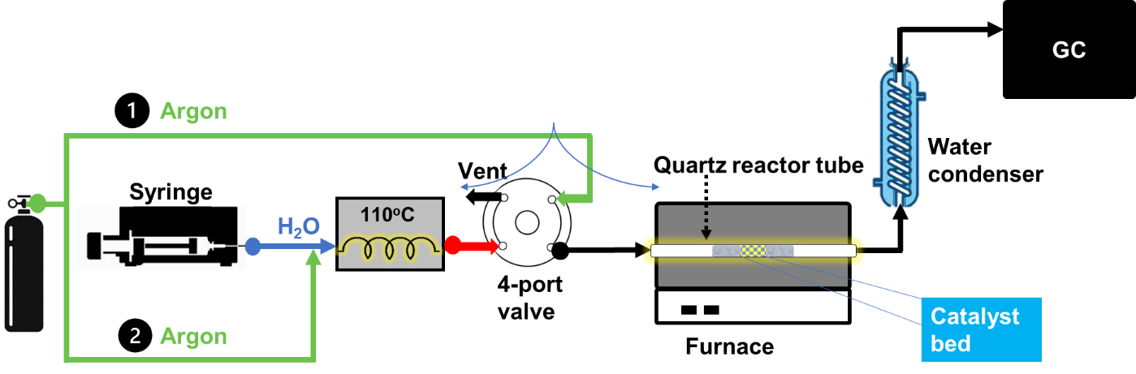
Figure S1. TCWS Reactor system
Material characterization techniques
Transmission Electron Microscope (TEM) imaging was carried out on a JEOL1400 Plus. For image collection, samples were prepared by crushing a small amount of material and mixing it with iso-propanol to ensure thorough dispersion for improved image quality. X-Ray Powder Diffraction (XRD) patterns were recorded in the 2θ range of 10–80° using CuKα radiation on a Bruker D8 Advance Eco machine. H₂-Temperature-Programmed Reduction (H₂-TPR) experiments were conducted in a fixed-bed reactor equipped with a thermal conductivity detector (TCD). The TPR setup consisted of a tubular furnace housing a quartz tube with a 6 mm internal diameter, which held the material samples. Prior to reduction, the reactor was loaded with approximately 300 mg of SiC, followed by the addition of about 100 mg of the sample placed on top. The samples were reduced in a 10% H₂/Ar (hydrogen/argon) atmosphere, with the temperature ramping from 25 °C to 1000°C at a rate of 10°C/min. BET surface area of the samples was determined from N₂ adsorption isotherms at 77 K using a Micromeritics TriStar II 3020 instrument. For N₂ adsorption-desorption experiments, the sample was degassed using a Micromeritics SmartPrep Degasser, where the temperature was increased from room temperature to 200°C at a heating rate of 5°C/min and maintained for 15 hours. X-ray photoelectron spectroscopy (XPS) data was obtained using a ThermoFisher K-alpha machine equipped with an X-ray gun generating monochromatic energy of 1500 eV. Sample preparation involved applying a stroke of the sample onto carbon tape and attaching it to the sample holder. The sample holder was then transitioned from the entry chamber to the analysis chamber onto a stage once the pressure dropped below 2×10⁻⁷ Pa. The analyzer selected electrons based on their kinetic energies, measuring counts within a fixed range of binding energies. Raman spectroscopy was performed using a red laser with a wavelength of 729 nm as the incident light source, and an external BWtek detector. Measurements were carried out on the samples at room temperature.
Table S1. Literature table high temperature swing solar TCWS for hydrogen production (Reused from reference 30, permission is requested at the Publisher)
Number on the Multi-Criteria Analysis | Redox Material | Reduction Temperature  (°C) | Oxidation Temperature  (°C) | Maximum H₂ Production Rate  (mL·g⁻¹·min⁻¹) | Ref.
1 | Ce_{0.75}Zr_{0.25}O₂ | 1450 | 1045 | 0.47 | [12,23]
2 | Ce_{1−x}Sm_{x}O₂ | 1500 | 900 | 4.1 | [12,50]
3 | Rh/CeO₂ | 1500 | 1500 | 1.5 | [51]
4 | Rh/CeO₂/γ-Al₂O₃ | 1050 | 1200 | n.a. | [51]
5 | CeO₂/SnO₂ core-shell nanowires | Reduced material obtained after CeO₂ pulse laser deposition | 800 | 2.14 | [52]
6 | cork-templated CeO₂ | 1450 | 1050 | 1.6 | [53]
7 | Ni_{x}Fe_{3−x}O₄ | 1400 | 1000 | n.a. | [12,53]
7 | Ni_{x}Fe_{3−x}O₄ | 1450 | 1000 | 0.314 | [12, 56]
8 | Fe₃O₄ on yttrium-stabilized, cubic zirconia (YSZ) | 1400 | 1000 | 0.5 | [55]
9 | Ni_{x}Fe_{3−x}O₄ supported on ZrO₂ | 1400 | 1000 | 0.65 | [54]
10 | NiFe₂O₄/Y₂O₃ core-shell nanoparticles | 1100 | 900 | 0.162 | [57]
11 | CeO₂-NiO | 1400 |  | 1.4 | [48]
12 | CeO₂ | 1500 |  | 3.37 | [60]
13 | CeO₂-Fe₂O₃ | 1350 | 1000 | 2.26 | [60]

Table S2. BET Surface area of all ceria materials
Commercial Ceria  CeNR-1 | 101 m²/g  108 m²/g
CeNR-2 | 98 m²/g
CeNPs | 90 m²/g

Ce(OH)₃
Figure S2. XRD of intermediate CeOH₃ (CeCl₃ precursor)
Figure S3. XRD studies of CeNR-1, CeNR-2, and CeNPs

Figure S4. TEM images using CeCl₃ precursor. (A),(B) TEM images of Ce(OH)₃ at different magnification levels and (C) upon aging after precipitation and filtration
Figure S5. TEM image of spent CeNR-1 (After TCWS reaction 400 °C)

Figure S6. XPS analysis of CeNR-1, CeNR-2, and CeNPs
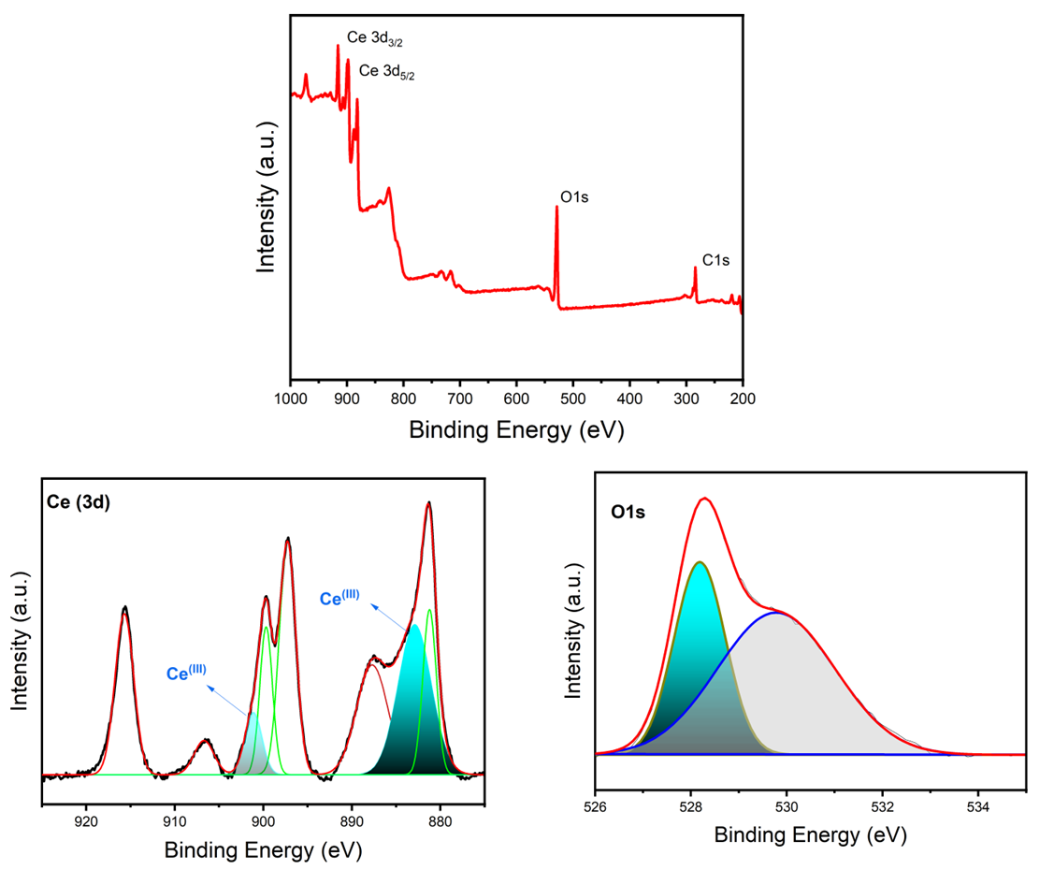
Figure S7. XPS studies CeNR-1 Fresh (Chemical composition and oxidation state)

Figure S8. The XPS analysis of the spent CeNR-1 material shows that after sintering, the intensity of Ce³⁺ decreases significantly.

Figure S9. Hydrogen yield in three cycles using temperature swing approach over commercial ceria (H₂O flow 0.01 mL/min, Reduction phase-Argon 90 min 1000 ºC, 1100 ºC, 1200 ºC and oxidation at 900 °C Argon/H₂O 90 min, amount of sample is 0.2 g)

