Exploring the relationship between humoral and adaptive T cellular responses against SARS-CoV-2 in exposed individuals from Emilia Romagna region and COVID-19 severity
SUPPLEMENTARY

Supplementary Table 1

ID samples | SARS-CoV-2 serology date | Index value | Positive SARS-CoV2 swab test date | delta_time
2001 | 25/07/2020 | 2,72 | NA | NA
2002 | 25/07/2020 | 2,34 | 20/04/2020 | 96
2003 | 25/07/2020 | 2,06 | NA | NA
2004 | 25/07/2020 | 5,53 | NA | NA
2005 | 25/07/2020 | 7,09 | 31/03/2020 | 116
2006 | 25/07/2020 | 6,36 | 26/03/2020 | 121
2007 | 25/07/2020 | 4,41 | 02/04/2020 | 114
2008 | 25/07/2020 | 6,08 | NA | NA
2009 | 25/07/2020 | 3,68 | NA | NA
2010 | 25/07/2020 | 5,94 | 21/03/2020 | 126
2011 | 25/07/2020 | 3,63 | 26/03/2020 | 121
2012 | 25/07/2020 | 4,79 | NA | NA
2013 | 24/07/2020 | 3,21 | NA | NA
2014 | 24/07/2020 | 3,35 | 06/04/2020 | 109
2015 | 24/07/2020 | 2,27 | 16/03/2020 | 130
2016 | 24/07/2020 | 1,54 | 12/03/2020 | 134
2017 | 24/07/2020 | 3,01 | 30/03/2020 | 116
2018 | 24/07/2020 | 6,26 | 24/03/2020 | 122
2019 | 24/07/2020 | 2,67 | NA | NA
2020 | 24/07/2020 | 1,9 | NA | NA
2021 | 27/07/2020 | 2,81 | 02/05/2020 | 86
2022 | 27/07/2020 | 4,25 | 17/04/2020 | 101
2023 | 27/07/2020 | 4,65 | 10/03/2020 | 139
2024 | 27/07/2020 | 1,46 | NA | NA
2025 | 27/07/2020 | 1,41 | NA | NA
2026 | 27/07/2020 | 3,3 | 18/03/2020 | 131
2027 | 27/07/2020 | 5,74 | 08/03/2020 | 141
2028 | 27/07/2020 | 2,03 | 20/03/2020 | 129
2029 | 27/07/2020 | 3,91 | NA | NA
2030 | 27/07/2020 | 4,48 | 22/03/2020 | 127
2031 | 27/07/2020 | 4,36 | 14/03/2020 | 135
2032 | 27/07/2020 | 4,32 | 17/03/2020 | 132
2033 | 27/07/2020 | 2,67 | NA | NA
2034 | 27/07/2020 | 1,53 | 11/03/2020 | 138
2035 | 27/07/2020 | 4,02 | NA | NA
2036 | 27/07/2020 | 1,56 | NA | NA
2037 | 27/07/2020 | 5,28 | 06/03/2020 | 143
2038 | 27/07/2020 | 4,14 | 31/03/2020 | 118
2039 | 23/07/2020 | 3,41 | 07/04/2020 | 107
2040 | 23/07/2020 | 3,75 | 08/04/2020 | 106
2041 | 23/07/2020 | 4,9 | 16/04/2020 | 98
2042 | 23/07/2020 | 2,34 | NA | NA
2043 | 23/07/2020 | 5,96 | NA | NA
2044 | 23/07/2020 | 1,61 | NA | NA
2045 | 23/07/2020 | 7,22 | 18/03/2020 | 127
2046 | 23/07/2020 | 3,32 | 12/03/2020 | 133
2047 | 23/07/2020 | 5,84 | 12/03/2020 | 133
2048 | 23/07/2020 | 4,94 | 06/03/2020 | 139
2049 | 22/07/2020 | 2,95 | 14/04/2020 | 99
2050 | 22/07/2020 | 7,8 | 13/03/2020 | 131
2051 | 22/07/2020 | 2,34 | NA | NA
2052 | 22/07/2020 | 5,35 | 15/03/2020 | 129
2053 | 22/07/2020 | 4,5 | 18/03/2020 | 126
2054 | 22/07/2020 | 2,6 | NA | NA
2055 | 22/07/2020 | 4,53 | 13/03/2020 | 131
2056 | 22/07/2020 | 1,55 | NA | NA
2057 | 22/07/2020 | 2,57 | 25/03/2020 | 119
2058 | 22/07/2020 | 3,73 | 29/03/2020 | 115
2059 | 22/07/2020 | 2,2 | 27/03/2020 | 117
2060 | 22/07/2020 | 3,12 | NA | NA
2061 | 22/07/2020 | 4,01 | 08/04/2020 | 105
2062 | 22/07/2020 | 4,48 | 17/04/2020 | 96
2063 | 22/07/2020 | 2,66 | 19/03/2020 | 125
2064 | 22/07/2020 | 2,84 | NA | NA
2065 | 22/07/2020 | 2,96 | NA | NA
2066 | 22/07/2020 | 6,73 | 29/03/2020 | 115
2067 | 22/07/2020 | 1,42 | NA | NA
2068 | 21/07/2020 | 2,62 | 23/03/2020 | 120
2069 | 21/07/2020 | 4,52 | NA | NA
2070 | 21/07/2020 | 4,84 | 27/03/2020 | 116
2071 | 21/07/2020 | 6,67 | 28/02/2020 | 144
2072 | 21/07/2020 | 4,85 | 24/03/2020 | 119
2073 | 21/07/2020 | 2,89 | 15/03/2020 | 128
2074 | 21/07/2020 | 4,51 | 29/03/2020 | 114
2075 | 21/07/2020 | 2,21 | NA | NA
2076 | 21/07/2020 | 7,35 | 18/03/2020 | 125
2077 | 21/07/2020 | 6,94 | NA | NA
2078 | 21/07/2020 | 2,97 | NA | NA
2079 | 21/07/2020 | 3,79 | 12/03/2020 | 131
2080 | 21/07/2020 | 4,02 | 09/03/2020 | 134
2081 | 21/07/2020 | 5,51 | 31/03/2020 | 112
2082 | 21/07/2020 | 2,37 | NA | NA
2083 | 21/07/2020 | 5,87 | 20/03/2020 | 123
2084 | 21/07/2020 | 4,96 | 23/03/2020 | 120
2085 | 21/07/2020 | 3,26 | 13/03/2020 | 130
2086 | 20/07/2020 | 6,27 | NA | NA
2087 | 20/07/2020 | 5,63 | 19/03/2020 | 123
2088 | 20/07/2020 | 6,9 | 15/03/2020 | 127
2089 | 20/07/2020 | 1,67 | 08/03/2020 | 134
2090 | 20/07/2020 | 5,23 | 11/03/2020 | 131
2091 | 20/07/2020 | 3,2 | 26/03/2020 | 116
2092 | 20/07/2020 | 4,88 | 25/03/2020 | 117
2093 | 20/07/2020 | 5,58 | 14/03/2020 | 128
2094 | 20/07/2020 | 2,8 | 09/04/2020 | 102
2095 | 20/07/2020 | 5,2 | 21/03/2020 | 121
2096 | 20/07/2020 | 6,68 | 20/03/2020 | 122
2097 | 20/07/2020 | 7,77 | NA | NA
2098 | 20/07/2020 | 2,01 | 04/03/2020 | 138
2099 | 20/07/2020 | 2,65 | 31/03/2020 | 111
2100 | 20/07/2020 | 3,3 | 28/04/2020 | 83
2101 | 20/07/2020 | 1,42 | NA | NA
2102 | 20/07/2020 | 2,93 | NA | NA
2103 | 20/07/2020 | 1,44 | 08/04/2020 | 103
2104 | 20/07/2020 | 3,06 | 25/03/2020 | 117
2105 | 20/07/2020 | 1,78 | NA | NA
2106 | 20/07/2020 | 6,56 | 04/03/2020 | 138
2107 | 20/07/2020 | 5,19 | 11/03/2020 | 131
2108 | 20/07/2020 | 4,01 | 23/03/2020 | 119
2109 | 28/07/2020 | 3,86 | NA | NA
2110 | 28/07/2020 | 5,8 | 24/03/2020 | 126
2111 | 28/07/2020 | 5,73 | 09/03/2020 | 141
2112 | 28/07/2020 | 3,31 | 18/04/2020 | 101
2113 | 28/07/2020 | 3,67 | 23/03/2020 | 127
2114 | 28/07/2020 | 8,6 | 23/03/2020 | 127
2115 | 28/07/2020 | 2,27 | NA | NA
2116 | 28/07/2020 | 7,77 | 01/05/2020 | 88
2117 | 28/07/2020 | 2,24 | 13/03/2020 | 137
2118 | 28/07/2020 | 7,85 | 25/03/2020 | 125
2119 | 28/07/2020 | 1,73 | 14/03/2020 | 136
2120 | 28/07/2020 | 2,84 | 16/03/2020 | 134
2121 | 28/07/2020 | 6,75 | NA | NA
2122 | 28/07/2020 | 3,93 | 06/04/2020 | 113
2123 | 28/07/2020 | 2,73 | 20/03/2020 | 130
2124 | 28/07/2020 | 3,37 | 18/03/2020 | 132
2125 | 28/07/2020 | 1,72 | 01/04/2020 | 118
2126 | 29/07/2020 | 6,56 | 13/03/2020 | 138
2127 | 29/07/2020 | 5,56 | 24/03/2020 | 127
2128 | 29/07/2020 | 3,39 | NA | NA
2129 | 29/07/2020 | 4,18 | NA | NA
2130 | 29/07/2020 | 5,62 | 30/03/2020 | 121
2131 | 29/07/2020 | 1,7 | NA | NA
2132 | 29/07/2020 | 2,53 | 21/03/2020 | 130
2133 | 29/07/2020 | 3,66 | 01/05/2020 | 89
2134 | 29/07/2020 | 5,16 | 11/05/2020 | 79
2135 | 29/07/2020 | 4,72 | 17/03/2020 | 134
2136 | 29/07/2020 | 6,18 | 03/04/2020 | 117
2137 | 29/07/2020 | 2,6 | 09/03/2020 | 142
2138 | 29/07/2020 | 2,49 | NA | NA
2139 | 29/07/2020 | 5,86 | NA | NA
2140 | 29/07/2020 | 4,21 | 18/03/2020 | 133
2141 | 16/07/2020 | 4,79 | 21/03/2020 | 117
2142 | 16/07/2020 | 3,28 | 11/03/2020 | 127
2143 | 16/07/2020 | 1,55 | 22/04/2020 | 85
2144 | 16/07/2020 | 3,94 | NA | NA
2145 | 16/07/2020 | 7,3 | 08/04/2020 | 99
2146 | 16/07/2020 | 4,32 | 21/03/2020 | 117
2147 | 16/07/2020 | 2,17 | 09/04/2020 | 98
2148 | 16/07/2020 | 4,47 | 14/03/2020 | 124
2149 | 16/07/2020 | 4,21 | 26/03/2020 | 112
2150 | 16/07/2020 | 5,76 | NA | NA
2151 | 16/07/2020 | 3,66 | 22/04/2020 | 85
2152 | 16/07/2020 | 7,87 | 08/04/2020 | 99
2153 | 16/07/2020 | 3,54 | NA | NA
2154 | 16/07/2020 | 1,94 | 12/03/2020 | 126
2155 | 16/07/2020 | 1,77 | NA | NA
2156 | 16/07/2020 | 7,43 | 13/03/2020 | 125
2157 | 16/07/2020 | 2,57 | 20/03/2020 | 118
2158 | 16/07/2020 | 3,43 | 20/03/2020 | 118
2159 | 16/07/2020 | 9,39 | 22/04/2020 | 85
2160 | 16/07/2020 | 4,99 | 28/03/2020 | 110
2161 | 16/07/2020 | 4,67 | 03/05/2020 | 74
2162 | 16/07/2020 | 5,51 | 20/04/2020 | 87
2163 | 16/07/2020 | 2,2 | 19/03/2020 | 119
2164 | 16/07/2020 | 3,66 | 07/04/2020 | 100
2165 | 16/07/2020 | 5,2 | 08/04/2020 | 99
2166 | 16/07/2020 | 1,44 | NA | NA
2167 | 16/07/2020 | 3,55 | 27/03/2020 | 111
2168 | 16/07/2020 | 4,37 | 06/04/2020 | 101
2169 | 16/07/2020 | 3,81 | 30/03/2020 | 108
2170 | 16/07/2020 | 2,04 | 24/03/2020 | 114
2171 | 16/07/2020 | 3,6 | 26/03/2020 | 112
2172 | 16/07/2020 | 3,68 | 20/03/2020 | 118
2173 | 16/07/2020 | 6,36 | 22/03/2020 | 116
2174 | 16/07/2020 | 8,17 | 18/03/2020 | 120
2175 | 16/07/2020 | 7,75 | NA | NA
2176 | 16/07/2020 | 2,35 | 17/03/2020 | 121
2177 | 16/07/2020 | 3,01 | 26/02/2020 | 141
2178 | 16/07/2020 | 4,46 | 31/03/2020 | 107
2179 | 16/07/2020 | 6,94 | 28/04/2020 | 79
2180 | 16/07/2020 | 5,38 | 08/04/2020 | 99
2181 | 17/07/2020 | 2,92 | NA | NA
2182 | 17/07/2020 | 2,79 | 11/04/2020 | 97
2183 | 17/07/2020 | 3,24 | 26/04/2020 | 82
2184 | 17/07/2020 | 4,86 | 13/03/2020 | 126
2185 | 17/07/2020 | 6,75 | 18/04/2020 | 90
2186 | 17/07/2020 | 3,98 | 11/03/2020 | 128
2187 | 17/07/2020 | 3,17 | NA | NA
2188 | 17/07/2020 | 3,33 | NA | NA
2189 | 17/07/2020 | 2,09 | 02/04/2020 | 106
2190 | 17/07/2020 | 1,93 | NA | NA
2191 | 17/07/2020 | 4,2 | 19/03/2020 | 120
2192 | 17/07/2020 | 6,38 | 11/03/2020 | 128
2193 | 17/07/2020 | 3,52 | 18/03/2020 | 121
2194 | 17/07/2020 | 3,34 | 14/03/2020 | 125
2195 | 17/07/2020 | 2,15 | 12/03/2020 | 127
2196 | 17/07/2020 | 2,51 | 09/05/2020 | 69
2197 | 17/07/2020 | 4,53 | 17/03/2020 | 122
2198 | 17/07/2020 | 4,87 | 06/03/2020 | 133
2199 | 17/07/2020 | 4,17 | 11/03/2020 | 128
2200 | 17/07/2020 | 3,74 | 18/04/2020 | 90
2201 | 17/07/2020 | 5,82 | 04/03/2020 | 135
2202 | 17/07/2020 | 5,85 | 10/03/2020 | 129
2203 | 17/07/2020 | 6,49 | 20/03/2020 | 119
2204 | 17/07/2020 | 5,86 | NA | NA
2205 | 17/07/2020 | 1,46 | 23/03/2020 | 116
2206 | 17/07/2020 | 7,65 | 05/03/2020 | 134
2207 | 17/07/2020 | 2,52 | 13/03/2020 | 126
2208 | 17/07/2020 | 2,99 | 22/03/2020 | 117
2209 | 18/07/2020 | 3,04 | NA | NA
2210 | 18/07/2020 | 1,55 | 19/03/2020 | 121
2211 | 18/07/2020 | 3,92 | NA | NA
2212 | 18/07/2020 | 2,55 | 13/03/2020 | 127
2213 | 18/07/2020 | 4,62 | NA | NA
2214 | 18/07/2020 | 3,41 | 26/03/2020 | 114
2215 | 18/07/2020 | 4,09 | 15/03/2020 | 125
2216 | 18/07/2020 | 3,39 | 08/04/2020 | 101
2217 | 18/07/2020 | 1,91 | 14/04/2020 | 95
2218 | 18/07/2020 | 2,5 | NA | NA
2219 | 18/07/2020 | 2,45 | 10/04/2020 | 99
2220 | 18/07/2020 | 3,13 | NA | NA
2221 | 18/07/2020 | 3,17 | 11/03/2020 | 129
2222 | 18/07/2020 | 6,62 | 16/03/2020 | 124
2223 | 18/07/2020 | 3,78 | 28/02/2020 | 141
2224 | 18/07/2020 | 1,47 | 21/03/2020 | 119
2225 | 18/07/2020 | 1,67 | 07/03/2020 | 133
2226 | 18/07/2020 | 1,53 | 14/03/2020 | 126
2227 | 18/07/2020 | 1,93 | 20/03/2020 | 120
2228 | 18/07/2020 | 1,7 | 30/03/2020 | 110
2229 | 18/07/2020 | 6,12 | 27/03/2020 | 113
2230 | 18/07/2020 | 4,48 | 20/03/2020 | 120
2231 | 18/07/2020 | 3,58 | 02/03/2020 | 138
2232 | 18/07/2020 | 6,58 | 09/03/2020 | 131
2233 | 18/07/2020 | 3,31 | 26/03/2020 | 114
2234 | 18/07/2020 | 4,69 | 25/03/2020 | 115
2235 | 18/07/2020 | 7,19 | 02/03/2020 | 138
2236 | 18/07/2020 | 3,47 | NA | NA
2237 | 18/07/2020 | 4,01 | NA | NA
2238 | 30/07/2020 | 5,16 | 02/03/2020 | 150
2239 | 30/07/2020 | 4,21 | NA | NA
2240 | 30/07/2020 | 2,24 | NA | NA
2241 | 30/07/2020 | 4,18 | 29/03/2020 | 123
2242 | 30/07/2020 | 1,9 | 13/03/2020 | 139
2243 | 30/07/2020 | 2,78 | NA | NA
2244 | 30/07/2020 | 7,93 | 16/03/2020 | 136
2245 | 30/07/2020 | 4,74 | NA | NA
2246 | 30/07/2020 | 4,04 | 27/03/2020 | 125
2247 | 30/07/2020 | 2,51 | 15/04/2020 | 106
2248 | 30/07/2020 | 6,43 | NA | NA
2249 | 30/07/2020 | 3,91 | 10/03/2020 | 142
2250 | 30/07/2020 | 4,73 | 12/03/2020 | 140
2251 | 30/07/2020 | 2,16 | 16/03/2020 | 136
2252 | 30/07/2020 | 4,75 | 24/05/2020 | 67
2253 | 30/07/2020 | 7,67 | 23/03/2020 | 129
2254 | 30/07/2020 | 2,76 | NA | NA
2255 | 30/07/2020 | 2,54 | 26/03/2020 | 126
2256 | 30/07/2020 | 5,61 | NA | NA
2257 | 31/07/2020 | 2,26 | 24/03/2020 | 129
2258 | 31/07/2020 | 5,52 | 10/03/2020 | 143
2259 | 31/07/2020 | 5,28 | 12/04/2020 | 110
2260 | 31/07/2020 | 5,13 | 26/03/2020 | 127
2261 | 31/07/2020 | 1,4 | 28/04/2020 | 94
2262 | 31/07/2020 | 5,89 | NA | NA
2263 | 31/07/2020 | 2,32 | NA | NA
2264 | 31/07/2020 | 6,16 | 19/03/2020 | 134
2265 | 31/07/2020 | 4,96 | NA | NA
2266 | 31/07/2020 | 6,38 | 28/04/2020 | 94
2267 | 31/07/2020 | 5,08 | NA | NA
2268 | 31/07/2020 | 2,99 | 16/03/2020 | 137
2269 | 31/07/2020 | 6,01 | 15/03/2020 | 138
2270 | 01/08/2020 | 5,67 | 27/03/2020 | 127
2271 | 01/08/2020 | 5,94 | 03/03/2020 | 151
2272 | 01/08/2020 | 8,13 | 23/03/2020 | 131
2273 | 01/08/2020 | 5,85 | 11/03/2020 | 143
2274 | 01/08/2020 | 8,27 | 23/03/2020 | 131
2275 | 01/08/2020 | 4,42 | 31/03/2020 | 123
2276 | 01/08/2020 | 5,14 | NA | NA
2277 | 01/08/2020 | 2,17 | NA | NA
2278 | 01/08/2020 | 1,93 | NA | NA
2279 | 01/08/2020 | 2,96 | 03/04/2020 | 120
2280 | 01/08/2020 | 5,15 | NA | NA
2281 | 03/08/2020 | 2,57 | 03/03/2020 | 153
2282 | 03/08/2020 | 3,65 | 02/05/2020 | 93
2283 | 03/08/2020 | 7,74 | NA | NA
2284 | 03/08/2020 | 2,31 | 21/03/2020 | 135
2285 | 03/08/2020 | 2,62 | 04/04/2020 | 121
2286 | 03/08/2020 | 2,45 | 09/03/2020 | 147
2287 | 03/08/2020 | 2,76 | 05/04/2020 | 120
2288 | 03/08/2020 | 4,21 | NA | NA
2289 | 03/08/2020 | 1,79 | NA | NA
2290 | 03/08/2020 | 3,2 | NA | NA
2291 | 03/08/2020 | 7,58 | 18/04/2020 | 107
2292 | 03/08/2020 | 6,45 | 16/04/2020 | 109
2293 | 03/08/2020 | 3,66 | 08/03/2020 | 148
2294 | 03/08/2020 | 5,24 | 11/03/2020 | 145
2295 | 03/08/2020 | 3,38 | 14/04/2020 | 111
2296 | 03/08/2020 | 7,06 | NA | NA
2297 | 03/08/2020 | 3,07 | 03/04/2020 | 122
2298 | 03/08/2020 | 6,79 | 14/04/2020 | 111
2299 | 03/08/2020 | 4,22 | 23/03/2020 | 133
2300 | 03/08/2020 | 8,78 | 26/03/2020 | 130
2301 | 03/08/2020 | 4,76 | 01/04/2020 | 124
2302 | 03/08/2020 | 5,29 | NA | NA
2303 | 03/08/2020 | 5,9 | 20/03/2020 | 136
2304 | 03/08/2020 | 2,97 | 16/03/2020 | 140
2305 | 03/08/2020 | 4,12 | 07/04/2020 | 118
2306 | 04/08/2020 | 1,8 | 26/03/2020 | 131
2307 | 04/08/2020 | 3,04 | NA | NA
2308 | 04/08/2020 | 7,81 | 23/03/2020 | 134
2309 | 04/08/2020 | 3,31 | 18/03/2020 | 139
2310 | 04/08/2020 | 3,87 | 16/03/2020 | 141
2311 | 04/08/2020 | 3,35 | NA | NA
2312 | 04/08/2020 | 4,28 | NA | NA
2313 | 04/08/2020 | 5,98 | 17/03/2020 | 140
2314 | 04/08/2020 | 6,5 | 14/03/2020 | 143
2315 | 04/08/2020 | 2,99 | 09/03/2020 | 148
2316 | 04/08/2020 | 2,79 | 11/03/2020 | 146
2317 | 04/08/2020 | 3,31 | 21/03/2020 | 136
2318 | 04/08/2020 | 1,86 | 15/03/2020 | 142
2319 | 04/08/2020 | 4,43 | 14/03/2020 | 143
2320 | 04/08/2020 | 3,69 | 30/03/2020 | 127
2321 | 04/08/2020 | 2,17 | 03/03/2020 | 154
2322 | 04/08/2020 | 2,74 | NA | NA
2323 | 04/08/2020 | 3,93 | 15/03/2020 | 142
2324 | 04/08/2020 | 5,03 | 20/03/2020 | 137
2325 | 04/08/2020 | 6,69 | 05/04/2020 | 121
2326 | 04/08/2020 | 3,42 | 31/03/2020 | 126
2327 | 04/08/2020 | 6,08 | 18/03/2020 | 139
2328 | 04/08/2020 | 7,25 | 14/03/2020 | 143
2329 | 04/08/2020 | 2,62 | 19/03/2020 | 138
2330 | 04/08/2020 | 5,11 | 26/03/2020 | 131
2331 | 04/08/2020 | 4,8 | 26/03/2020 | 131
2332 | 04/08/2020 | 1,74 | 07/04/2020 | 119
2333 | 04/08/2020 | 1,69 | 13/03/2020 | 144
2334 | 03/08/2020 | 5,18 | 29/03/2020 | 127
2335 | 03/08/2020 | 9,14 | 15/03/2020 | 141
2336 | 03/08/2020 | >10 | 09/03/2020 | 147
2337 | 01/08/2020 | >10 | 15/04/2020 | 108
2338 | 04/08/2020 | >10 | NA | NA
2339 | 04/08/2020 | >10 | 12/03/2020 | 145
2340 | 04/08/2020 | >10 | 12/03/2020 | 145
2341 | 04/08/2020 | >10 | 17/03/2020 | 140
2342 | 05/08/2020 | 6,85 | 26/03/2020 | 132
2343 | 05/08/2020 | 4,71 | 26/03/2020 | 132
2344 | 05/08/2020 | 2,29 | NA | NA
2345 | 05/08/2020 | 2,66 | 17/03/2020 | 141
2346 | 05/08/2020 | 3,13 | NA | NA
2347 | 05/08/2020 | 5,71 | NA | NA
2348 | 05/08/2020 | 7,12 | 20/03/2020 | 138
2349 | 05/08/2020 | 2,57 | 18/03/2020 | 140
2350 | 05/08/2020 | 3,39 | 10/04/2020 | 117
2351 | 05/08/2020 | 5,34 | NA | NA
2352 | 05/08/2020 | 3,87 | 26/03/2020 | 132
2353 | 05/08/2020 | 5,82 | 26/03/2020 | 132
2354 | 05/08/2020 | 4,3 | 20/03/2020 | 138
2355 | 05/08/2020 | 4,95 | 31/03/2020 | 127
2356 | 05/08/2020 | 7,98 | 03/04/2020 | 124
2357 | 05/08/2020 | 6,54 | 18/04/2020 | 109
2358 | 05/08/2020 | 1,64 | NA | NA
2359 | 05/08/2020 | 1,82 | 24/03/2020 | 134
2360 | 05/08/2020 | 4,65 | NA | NA
2361 | 05/08/2020 | 2,28 | 08/03/2020 | 150
2362 | 05/08/2020 | 6,06 | NA | NA
2363 | 05/08/2020 | 3,53 | 18/03/2020 | 140
2364 | 05/08/2020 | 3,77 | 15/03/2020 | 143
2365 | 05/08/2020 | 7,17 | 23/03/2020 | 135
2366 | 05/08/2020 | 5,16 | 21/03/2020 | 137
2367 | 05/08/2020 | >10 | 21/03/2020 | 137
2368 | 05/08/2020 | 6,99 | 24/03/2020 | 134
2369 | 05/08/2020 | 1,79 | 22/04/2020 | 105
2370 | 06/08/2020 | 6,38 | 11/03/2020 | 148
2371 | 06/08/2020 | 4,93 | NA | NA
2372 | 06/08/2020 | 1,86 | NA | NA
2373 | 06/08/2020 | 4,87 | 14/03/2020 | 145
2374 | 06/08/2020 | 2,4 | 31/03/2020 | 128
2375 | 06/08/2020 | 6,34 | 26/03/2020 | 133
2376 | 06/08/2020 | 6,38 | 20/03/2020 | 139
2377 | 06/08/2020 | 2,73 | 07/05/2020 | 91
2378 | 06/08/2020 | 4,27 | NA | NA
2379 | 07/08/2020 | 1,86 | NA | NA
2380 | 07/08/2020 | 1,97 | NA | NA
2381 | 07/08/2020 | 3,59 | 24/03/2020 | 136
2382 | 07/08/2020 | 5,98 | NA | NA
2383 | 07/08/2020 | 3,65 | 06/03/2020 | 154
2384 | 07/08/2020 | 3,33 | NA | NA
2385 | 07/08/2020 | 6,36 | NA | NA
2386 | 08/08/2020 | 1,46 | NA | NA
2387 | 08/08/2020 | 2,47 | 09/03/2020 | 152
2388 | 08/08/2020 | 3,97 | 09/03/2020 | 152
2389 | 08/08/2020 | 3,92 | NA | NA
2390 | 08/08/2020 | 8,99 | 14/04/2020 | 116
2391 | 08/08/2020 | 5,13 | NA | NA
2392 | 08/08/2020 | 5,97 | 23/03/2020 | 138
2393 | 08/08/2020 | 3,58 | NA | NA
2394 | 08/08/2020 | 2,56 | 16/03/2020 | 145
2395 | 08/08/2020 | 2,71 | NA | NA
2396 | 08/08/2020 | 4,83 | NA | NA
2397 | 10/08/2020 | 4,91 | 28/03/2020 | 135
2398 | 10/08/2020 | 4,88 | NA | NA
2399 | 10/08/2020 | 2,09 | NA | NA
2400 | 10/08/2020 | 9,52 | NA | NA
2401 | 10/08/2020 | 8,34 | 22/04/2020 | 110
2402 | 10/08/2020 | 4,25 | NA | NA
2403 | 10/08/2020 | 4,83 | 22/03/2020 | 141
2404 | 10/08/2020 | 5,78 | NA | NA
2405 | 10/08/2020 | 4,43 | 18/03/2020 | 145
2406 | 10/08/2020 | >10 | 17/03/2020 | 146
2407 | 10/08/2020 | >10 | 08/03/2020 | 155
2408 | 11/08/2020 | 1,41 | NA | NA
2409 | 11/08/2020 | 1,65 | NA | NA
2410 | 11/08/2020 | 6,3 | 27/03/2020 | 137
2411 | 12/08/2020 | 7,88 | NA | NA
2412 | 12/08/2020 | 4,67 | 12/03/2020 | 153
2413 | 12/08/2020 | 2,96 | 16/03/2020 | 149
2414 | 12/08/2020 | 1,91 | NA | NA
2415 | 20/08/2020 | 5 | 19/03/2020 | 154
2416 | 23/07/2020 | 9,79 | 19/03/2020 | 126
2417 | 31/07/2020 | >10 | 10/03/2020 | 143
2418 | 24/07/2020 | 9,33 | 15/04/2020 | 100
2419 | 20/07/2020 | 8,23 | 02/03/2020 | 140
2420 | 27/07/2020 | >10 | 03/03/2020 | 146
2421 | 31/07/2020 | 3,05 | 08/04/2020 | 114
2422 | 28/07/2020 | 2,75 | 02/03/2020 | 148
2423 | 27/07/2020 | >10 | 16/03/2020 | 133
2424 | 23/07/2020 | 1,34 | 19/03/2020 | 126
2425 | 28/07/2020 | >10 | 18/03/2020 | 132
2426 | 24/07/2020 | 5,69 | 06/03/2020 | 140
2427 | 24/07/2020 | >10 | 28/04/2020 | 87
2428 | 20/07/2020 | 4,16 | 10/03/2020 | 132
2429 | 18/07/2020 | 7,43 | 23/03/2020 | 117
2430 | 21/07/2020 | 2,65 | 02/04/2020 | 110
2431 | 24/07/2020 | >10 | 02/04/2020 | 113
2432 | 18/07/2020 | >10 | 08/04/2020 | 101
3001 | 04/08/2020 | 0,17 | 15/03/2020 | 142
3002 | 24/07/2020 | 0,09 | 13/03/2020 | 133
3003 | 18/07/2020 | 0,92 | 12/03/2020 | 128
3004 | 28/07/2020 | 0,79 | 12/03/2020 | 138
3005 | 03/08/2020 | 0,83 | 03/04/2020 | 122
3006 | 11/08/2020 | 0,15 | 14/04/2020 | 119
3007 | 05/08/2020 | 0,46 | 12/03/2020 | 146
3008 | 24/07/2020 | 0,87 | 28/03/2020 | 118
3009 | 30/07/2020 | 0,75 | 15/03/2020 | 137
3010 | 22/07/2020 | 0,25 | 11/03/2020 | 133
3011 | 23/07/2020 | 0,81 | 30/03/2020 | 115
3012 | 16/07/2020 | 0 | 18/04/2020 | 89
3013 | 31/07/2020 | 0,73 | 13/03/2020 | 140
3014 | 17/07/2020 | 0,8 | 29/03/2020 | 110
3015 | 07/08/2020 | 0,32 | 12/03/2020 | 148
3016 | 20/07/2020 | 0,36 | 12/03/2020 | 130
3017 | 20/07/2020 | 0,34 | 12/03/2020 | 130
3018 | 16/07/2020 | 0,44 | 12/03/2020 | 126
3019 | 18/07/2020 | 0,73 | 03/04/2020 | 106
3020 | 21/07/2020 | 0,35 | 01/05/2020 | 81
3021 | 17/07/2020 | 0,02 | 28/04/2020 | 80
3022 | 16/07/2020 | 0,42 | 02/03/2020 | 136
3023 | 18/07/2020 | 0,28 | 31/03/2020 | 109
3024 | 25/07/2020 | 0,05 | 18/03/2020 | 129
3025 | 25/07/2020 | 0,66 | 15/03/2020 | 132
3026 | 03/08/2020 | 0,15 | 22/04/2020 | 103
3027 | 24/07/2020 | 0,75 | 30/03/2020 | 116
3028 | 20/07/2020 | 0,89 | 15/04/2020 | 96

Supplementary Figure 1
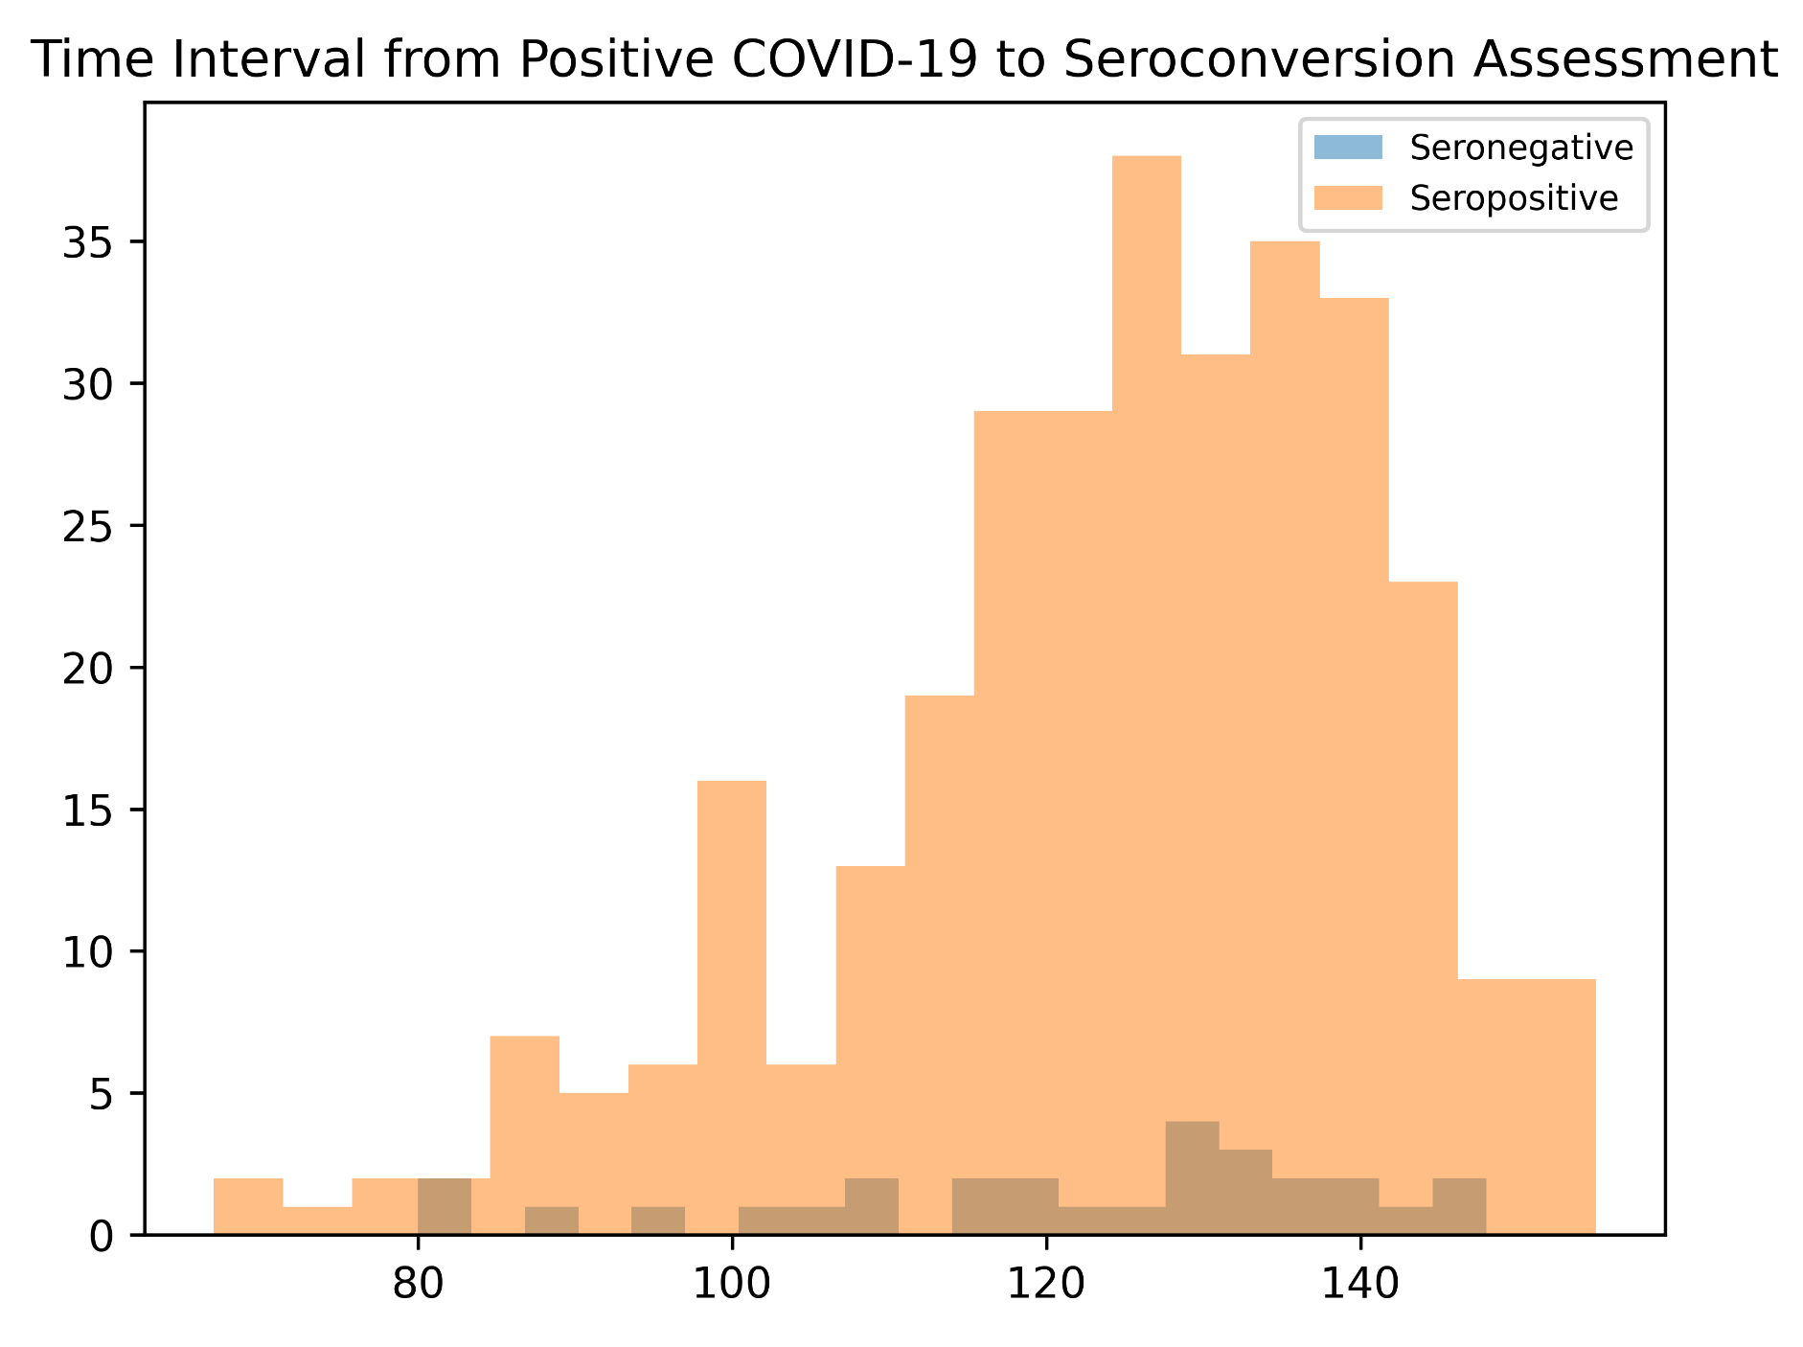
Note. Time interval distribution (delta-time) between COVID-19 positive swab test and blood collection for seroconversion analysis in seropositive and seronegative cohorts. The delta-time in both cohorts is not normally distributed and is not significantly different from each other (p= 0.5).

Supplementary Figure 2
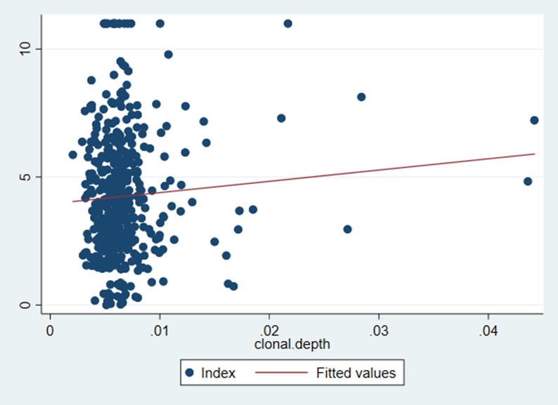
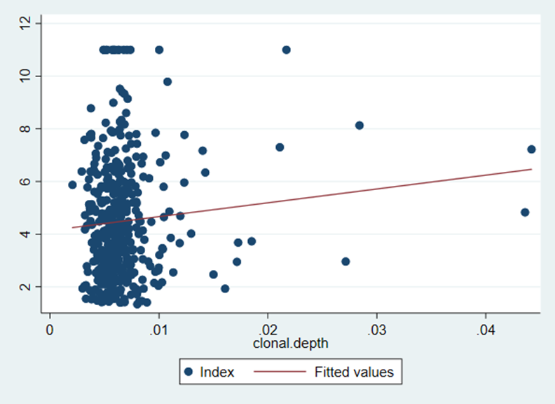
Note. A) correlation Index – clonal depth. Spearman’s rho = 0.01, p= 0.75. B) correlation Index – clonal depth in seropositive (sp). Spearman’s rho = 0.05, p= 0.34.

Supplementary Table 2
A | Median (range) | p-value
Sex
Female | 0.0060746 (0.0020637-0.0436012)
Male | 0.0059753 (0.0029082 – 0.0441973) | 0.87
Hosp
Sì | 0.0060008 (0.0020637 - 0.028407)
No | 0.0060107 (0.0029846 - 0.0441973 ) | 0.45

B | Median (range) | p-value
Sex
Female | 0.0061652 (0.0045662 – 0.0081128)
Male | 0.0062689 (0 – 0.0081904) | 0.52
Hosp
Sì | 0.006278 (0.0041249 – 0.0081904 )
No | 0.0061911 (0 – 0.0081128) | 0.38

C | Median (range) | p-value
FEMALE
Hosp
Sì | 0.0059154 (0.0020637 - 0.014252)
No | 0.0061093 (0.0031602 - 0.0436012) | 0.63
MALE
Hosp
Sì | 0.0062087 (0.0029082 - 0.028407)
No | 0.0059067 (0.0029846 - 0.0441973) | 0.11

D | Median (range) | p-value
FEMALE
Hosp
Sì | .0061269 (.0045662 - .0076072)
No | .0061963 (.0048378 - .0081128) | 0.97
MALE
Hosp
Sì | 0.0063568 (0.0041249 - 0.0081904)
No | 0.006176 (0 - 0.0077566) | 0.32

Note. Association of clonal depth (A) and clonal breadth (B) with hospitalization and sex. Subanalyses of association of clonal depth (C) and breadth (D) with hospitalization categorized by gender.

Supplementary Figure 3
A)
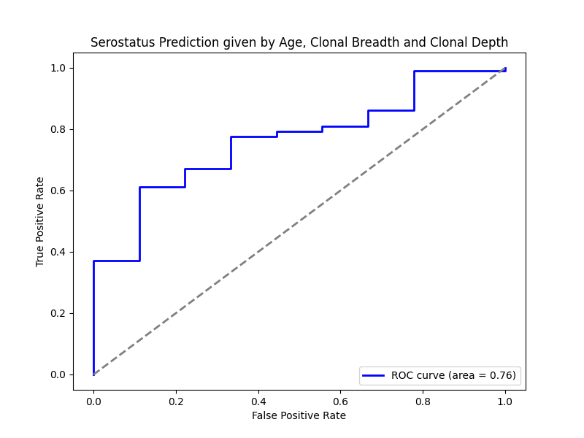

B)
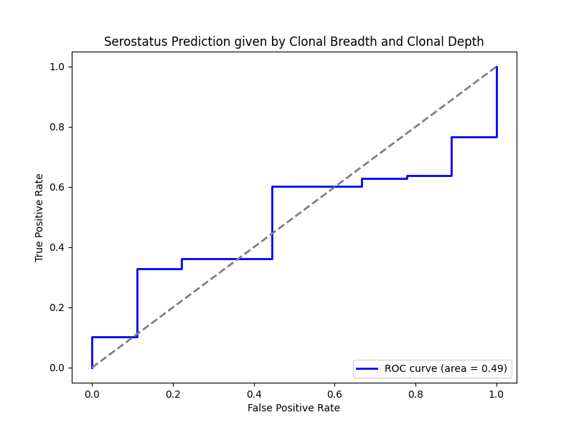

C)
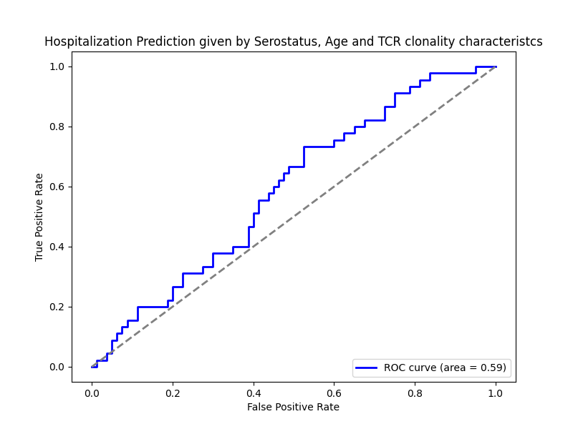

D)
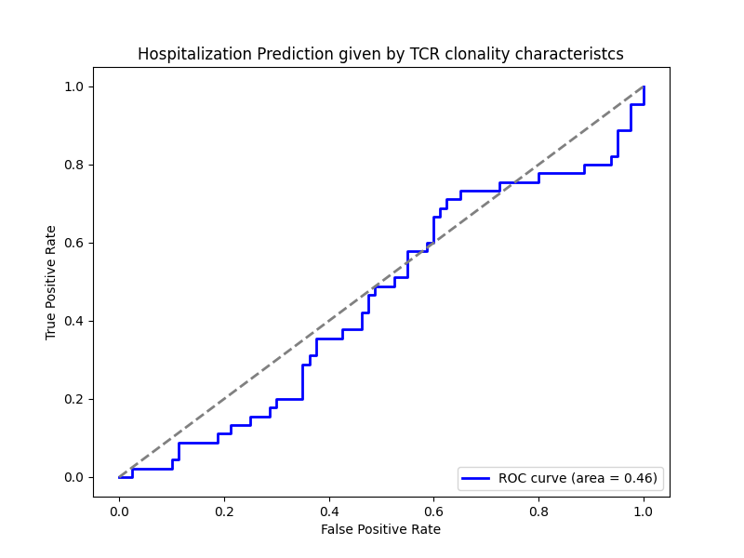
Note. A) Age predictive accuracy for seropositivity given by the variables age, clonal breadth, and clonal depth. B) Predictive accuracy for seropositivity given by only clonal breadth and clonal depth. C) Predictive accuracy of multiple variables (age, clonal breadth, depth, serostatus) for hospitalization. D) Predictive accuracy of clonal breadth and depth for hospitalization.

Supplementary Figure 4
VDJ family and gene usage among seropositive, seronegative, and individuals with acute COVID-19 infection.
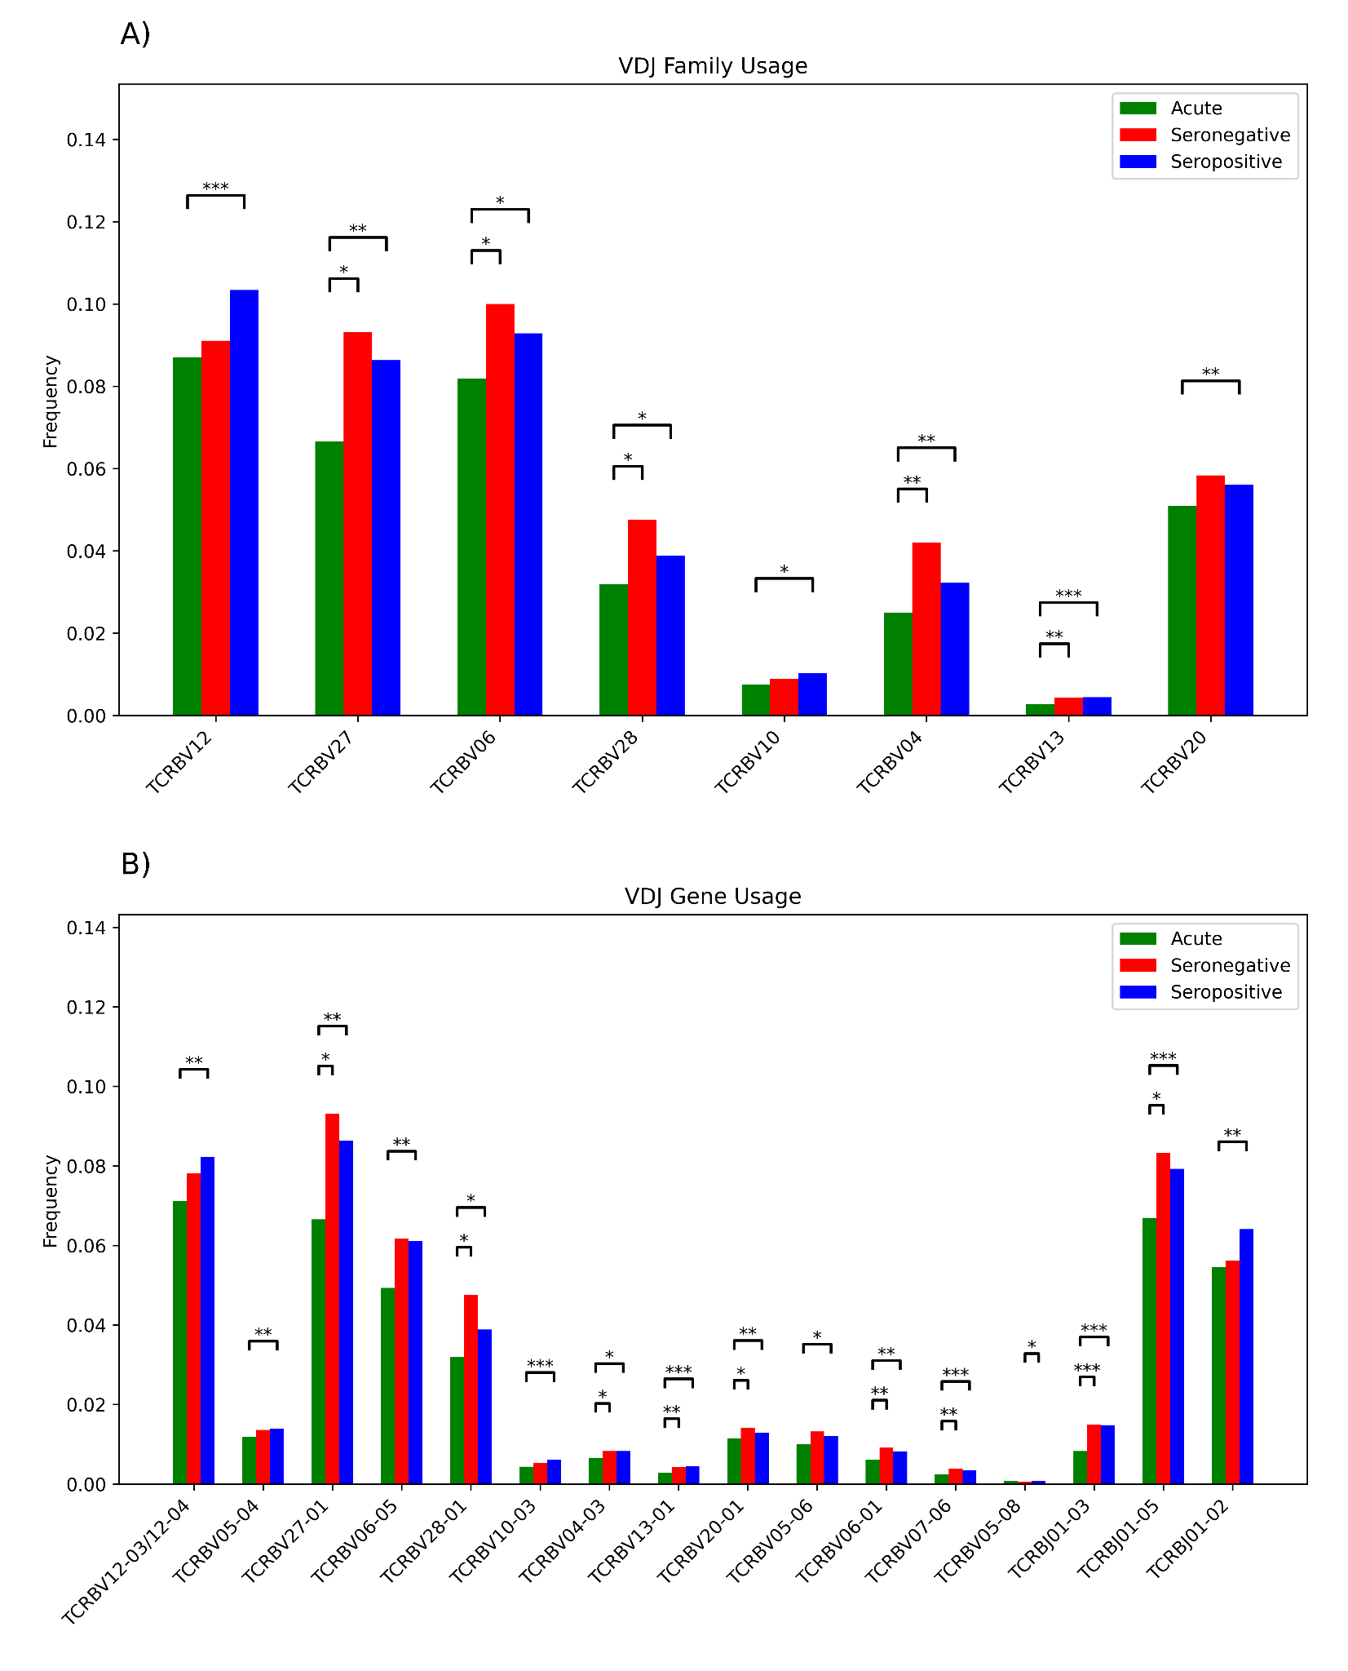
Note. Panel A shows VDJ family usage among cohorts; frequency comparison for VDJ family p-value <0.05. Panel B shows VDJ gene usage among cohorts; frequency comparison for VDJ gene p-value <0.05. Color code acute=green, seronegative=red, seropositive=blue. This analysis showed a statistically significant reduction in the frequency for many VDJ families in the acute group compared to the seropositive or convalescent populations. In particular, TRBV27-01, TRBV28-01, TRBV04-03, TRBV13-01, TRBV20-01, TRBV06-01, TRBV07-06, TRBV27, TRBV06, TRBV28, TRBV04, TRBV13, TRBJ01-03 were found to be underrepresented in the acute cohort compared to the convalescent one. The significance level of p-value * p<0.05. ** p<0.01. *** p<0.001.

Supplementary Table 3
Clonal depth comparison for each Open Reading Frame among cohorts.
ORFs | Seronegative vs. seropositive | Seronegative vs. acute | Seropositive vs. acute
envelope | 0.687 | 0.403 | 0.231
membrane glycoprotein | 0.421 | 0.0433 | 0.024
nucleocapsid phosphoprotein | 0.564 | 0.09 | 0.001
ORF10 | 0.1 | 0.071 | 0.0908
ORF1ab | 0.216 | 0.964 | 0.373
ORF3a | 0.49 | 0.055 | 0.009
ORF6 | 0.806 | 0.038 | 0.001
ORF7a | 0.021 | 0.0001 | 0.0002
ORF7b | 0.083 | 0.018 | 0.036
ORF8 | 0.595 | 0.044 | 0.006
surface glycoprotein | 0.295 | 0.035 | 0.05
Note. Clonal depth in the acute cohort was significantly lower for several associated SARS-CoV-2 peptides than in convalescents. P-values from Wilcoxon test comparison of clonal depth for each ORF among cohorts. The cohort reported first in the comparison has a higher median of clone frequencies related to that ORF. In bold significant p-value (p<0.05). In italic borderline significance.

Supplementary Figure 5
Clonal depth analysis for each SARS-CoV-2 associated ORF in the three cohorts.
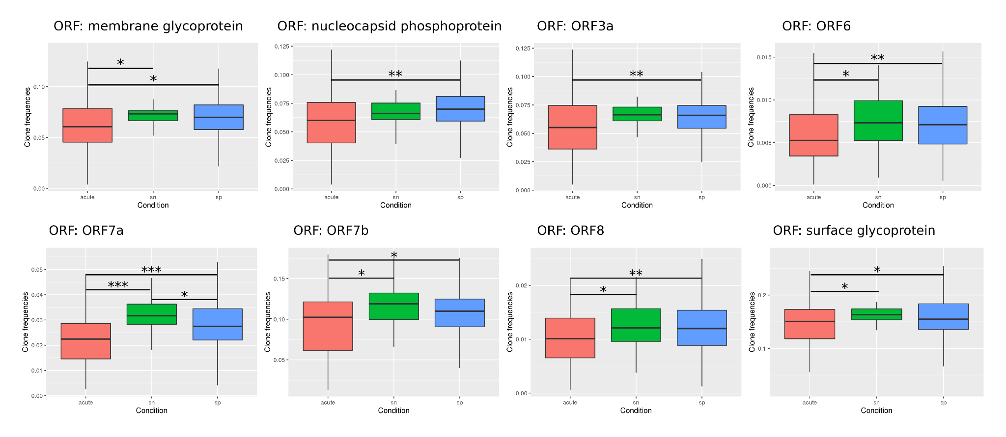
Note. ORF=open reading frame. Significance level of p-value * p<0.05, ** p<0.01, *** p<0.001.

Supplementary Figure 6
HLA inference from TCR repertoire.
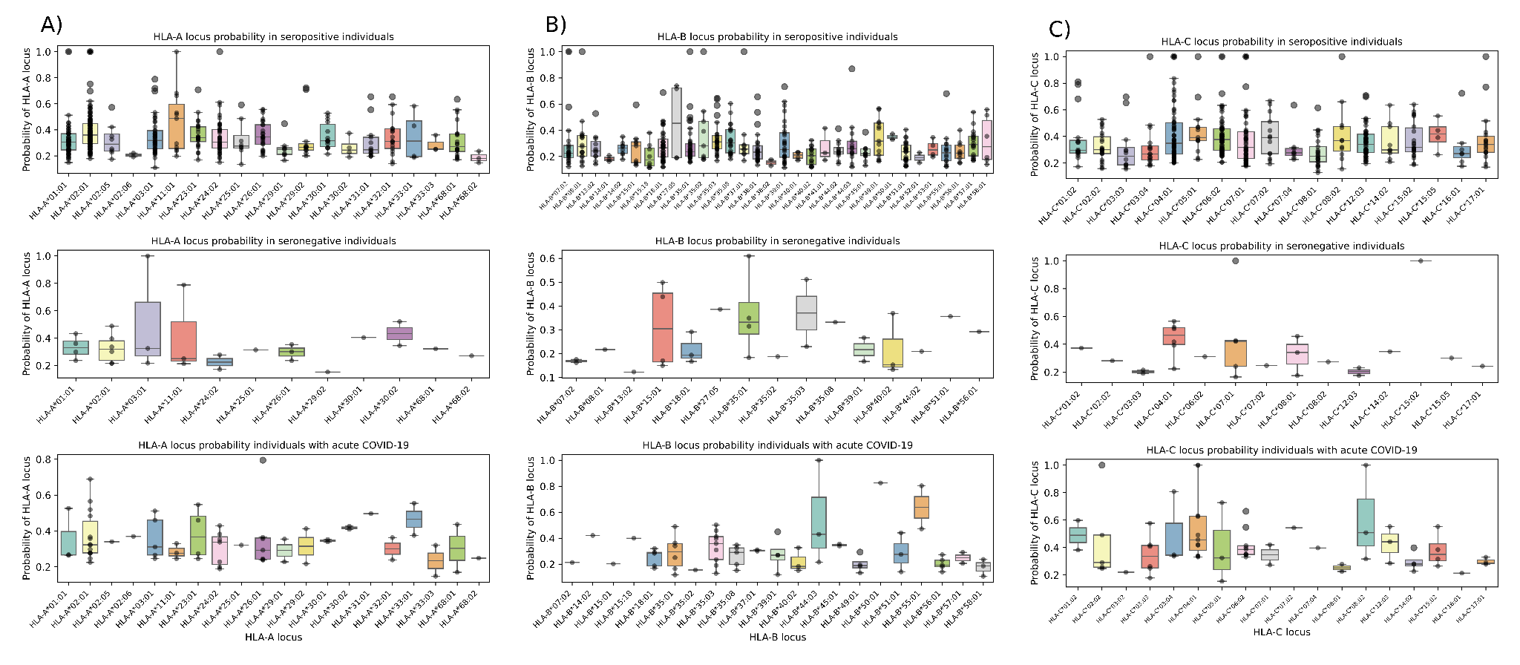
Note. HLA-A (A), HLA-B (B), and HLA-C (C) alleles were inferred by using the in silico HLA3 tool following the developer’s guidelines in seropositive, seronegative, and patients individuals with acute COVID-19 infection (from top to bottom, respectively).

Supplementary Table 4
HLA frequency and comparison
 | Seropositive (sp) |  | Seronegative (sn) |  | Acute |  | sp vs. sn  p-value | sp vs. acute  p-value | sn vs. acute  p-value | Bonferroni correction for multiple comparisons
HLA-A | Count | Freq (%) | Count | Freq (%) | Count | Freq (%) | sp vs. sn  p-value | sp vs. acute  p-value | sn vs. acute  p-value | sp vs. sn  adj-p-value | sp vs. acute  adj-p-value | sn vs. acute  adj-p-value
*02:01 | 101 | 25.77 | 5 | 21.74 | 12 | 22.64 | 0.81 | 0.74 | 1.00 | 1.00 | 1.00 | 1.00
*01:01 | 46 | 11.73 | 4 | 17.39 | 2 | 3.77 | 0.50 | 0.10 | 0.06 | 1.00 | 0.29 | 0.19
*24:02 | 43 | 10.97 | 2 | 8.7 | 6 | 11.32 | 1.00 | 1.00 | 1.00 | 1.00 | 1.00 | 1.00
*03:01 | 39 | 9.95 | 3 | 13.04 | 3 | 5.66 | 0.72 | 0.45 | 0.36 | 1.00 | 1.00 | 1.00
*23:01 | 24 | 6.12 | 0 | 0 | 3 | 5.66 | 0.38 | 1.00 | 0.55 | 1.00 | 1.00 | 1.00
*26:01 | 23 | 5.87 | 2 | 8.7 | 5 | 9.43 | 0.64 | 0.36 | 1.00 | 1.00 | 1.00 | 1.00
*68:01 | 20 | 5.1 | 1 | 4.35 | 2 | 3.77 | 1.00 | 1.00 | 1.00 | 1.00 | 1.00 | 1.00
*32:01 | 16 | 4.08 | 0 | 0 | 2 | 3.77 | 1.00 | 1.00 | 1.00 | 1.00 | 1.00 | 1.00
*30:01 | 13 | 3.32 | 0 | 0 | 2 | 3.77 | 1.00 | 0.70 | 1.00 | 1.00 | 1.00 | 1.00
*31:01 | 11 | 2.81 | 0 | 0 | 0 | 0 | 1.00 | 0.38 | 1.00 | 1.00 | 1.00 | 1.00
*11:01 | 9 | 2.3 | 2 | 8.7 | 3 | 5.66 | 0.12 | 0.16 | 0.64 | 0.36 | 0.49 | 1.00
*29:01 | 9 | 2.3 | 0 | 0 | 2 | 3.77 | 1.00 | 0.63 | 1.00 | 1.00 | 1.00 | 1.00
*29:02 | 9 | 2.3 | 1 | 4.35 | 2 | 3.77 | 0.44 | 0.63 | 1.00 | 1.00 | 1.00 | 1.00
*02:05 | 8 | 2.04 | 0 | 0 | 1 | 1.89 | 1.00 | 1.00 | 1.00 | 1.00 | 1.00 | 1.00
*25:01 | 6 | 1.53 | 1 | 4.35 | 1 | 1.89 | 0.33 | 0.59 | 0.52 | 0.99 | 1.00 | 1.00
*33:01 | 4 | 1.02 | 0 | 0 | 2 | 3.77 | 1.00 | 0.15 | 1.00 | 1.00 | 0.46 | 1.00
*30:02 | 4 | 1.02 | 1 | 4.35 | 1 | 1.89 | 0.25 | 0.47 | 0.52 | 0.75 | 1.00 | 1.00
*68:02 | 3 | 0.77 | 1 | 4.35 | 1 | 1.89 | 0.20 | 0.40 | 0.52 | 0.61 | 1.00 | 1.00
*02:06 | 2 | 0.51 | 0 | 0 | 1 | 1.89 | 1.00 | 0.32 | 1.00 | 1.00 | 0.95 | 1.00
*33:03 | 2 | 0.51 | 0 | 0 | 2 | 3.77 | 1.00 | 0.07 | 1.00 | 1.00 | 0.21 | 1.00
 | Seropositive (sp) |  | Seronegative (sn) |  | Acute |  | sp vs. sn  p-value | sp vs. acute  p-value | sn vs. acute  p-value | sp vs. sn  adj-p-value | sp vs. acute  adj-p-value | sn vs. acute  adj-p-value
HLA-B | Count | Freq (%) | Count | Freq (%) | Count | Freq (%)
*18:01 | 35 | 8.93 | 3 | 13.04 | 4 | 7.547 | 0.46 | 1.00 | 0.43 | 1.00 | 1.00 | 1.00
*35:01 | 35 | 8.93 | 3 | 13.04 | 5 | 9.434 | 0.46 | 0.80 | 0.69 | 1.00 | 1.00 | 1.00
*35:03 | 27 | 6.89 | 0 | 0 | 8 | 15.094 | 0.39 | 0.05 | 0.10 | 1.00 | 0.16 | 0.29
*38:01 | 24 | 6.12 | 0 | 0 | 0 | 0 | 0.38 | 0.10 | 1.00 | 1.00 | 0.29 | 1.00
*39:01 | 23 | 5.87 | 2 | 8.7 | 3 | 5.66 | 0.64 | 1.00 | 0.64 | 1.00 | 1.00 | 1.00
*51:01 | 22 | 5.61 | 1 | 4.35 | 3 | 5.66 | 1.00 | 1.00 | 1.00 | 1.00 | 1.00 | 1.00
*35:08 | 20 | 5.1 | 1 | 4.35 | 3 | 5.66 | 1.00 | 0.75 | 1.00 | 1.00 | 1.00 | 1.00
*07:02 | 18 | 4.59 | 2 | 8.7 | 1 | 1.887 | 0.31 | 0.71 | 0.22 | 0.92 | 1.00 | 0.65
*08:01 | 17 | 4.34 | 1 | 4.35 | 0 | 0 | 1.00 | 0.24 | 0.30 | 1.00 | 0.73 | 0.91
*57:01 | 15 | 3.83 | 0 | 0 | 2 | 3.774 | 1.00 | 1.00 | 1.00 | 1.00 | 1.00 | 1.00
*55:01 | 14 | 3.57 | 0 | 0 | 1 | 1.887 | 1.00 | 1.00 | 1.00 | 1.00 | 1.00 | 1.00
*40:02 | 13 | 3.32 | 3 | 13.04 | 3 | 5.66 | 0.05 | 0.42 | 0.36 | 0.16 | 1.00 | 1.00
*49:01 | 12 | 3.06 | 0 | 0 | 4 | 7.547 | 1.00 | 0.11 | 0.31 | 1.00 | 0.33 | 0.92
*45:01 | 12 | 3.06 | 0 | 0 | 1 | 1.887 | 1.00 | 1.00 | 1.00 | 1.00 | 1.00 | 1.00
*44:03 | 11 | 2.81 | 0 | 0 | 3 | 5.66 | 1.00 | 0.23 | 0.55 | 1.00 | 0.68 | 1.00
*44:02 | 10 | 2.55 | 1 | 4.35 | 0 | 0 | 0.47 | 0.62 | 0.30 | 1.00 | 1.00 | 0.91
*13:02 | 10 | 2.55 | 0 | 0 | 0 | 0 | 1.00 | 0.62 | 1.00 | 1.00 | 1.00 | 1.00
*35:02 | 8 | 2.04 | 1 | 4.35 | 0 | 0 | 0.40 | 0.60 | 0.30 | 1.00 | 1.00 | 0.91
*56:01 | 8 | 2.04 | 1 | 4.35 | 5 | 9.434 | 0.40 | 0.01 | 0.66 | 1.00 | 0.04 | 1.00
*15:18 | 8 | 2.04 | 0 | 0 | 0 | 0 | 1.00 | 0.60 | 1.00 | 1.00 | 1.00 | 1.00
*15:01 | 8 | 2.04 | 3 | 13.04 | 1 | 1.887 | 0.02 | 1.00 | 0.08 | 0.06 | 1.00 | 0.24
*37:01 | 7 | 1.79 | 0 | 0 | 1 | 1.887 | 1.00 | 1.00 | 1.00 | 1.00 | 1.00 | 1.00
*14:02 | 7 | 1.79 | 0 | 0 | 1 | 1.887 | 1.00 | 1.00 | 1.00 | 1.00 | 1.00 | 1.00
*58:01 | 6 | 1.53 | 0 | 0 | 3 | 5.66 | 1.00 | 0.08 | 0.55 | 1.00 | 0.24 | 1.00
*53:01 | 4 | 1.02 | 0 | 0 | 0 | 0 | 1.00 | 1.00 | 1.00 | 1.00 | 1.00 | 1.00
*40:01 | 4 | 1.02 | 0 | 0 | 0 | 0 | 1.00 | 1.00 | 1.00 | 1.00 | 1.00 | 1.00
*14:01 | 3 | 0.77 | 0 | 0 | 0 | 0 | 1.00 | 1.00 | 1.00 | 1.00 | 1.00 | 1.00
*27:05 | 3 | 0.77 | 1 | 4.35 | 0 | 0 | 0.20 | 1.00 | 0.30 | 0.61 | 1.00 | 0.91
*52:01 | 2 | 0.51 | 0 | 0 | 0 | 0 | 1.00 | 1.00 | 1.00 | 1.00 | 1.00 | 1.00
*38:02 | 2 | 0.51 | 0 | 0 | 0 | 0 | 1.00 | 1.00 | 1.00 | 1.00 | 1.00 | 1.00
*41:01 | 2 | 0.51 | 0 | 0 | 0 | 0 | 1.00 | 1.00 | 1.00 | 1.00 | 1.00 | 1.00
*50:01 | 2 | 0.51 | 0 | 0 | 1 | 1.887 | 1.00 | 0.32 | 1.00 | 1.00 | 0.95 | 1.00
 | Seropositive (sp) |  | Seronegative (sn) |  | Acute |  | sp vs. sn  p-value | sp vs. acute  p-value | sn vs. acute  p-value | sp vs. sn  adj-p-value | sp vs. acute  adj-p-value | sn vs. acute  adj-p-value
HLA-C | Count | Freq (%) | Count | Freq (%) | Count | Freq (%)
*04:01 | 62 | 15.82 | 5 | 21.74 | 11 | 20.75 | 0.40 | 0.43 | 1.00 | 1.00 | 1.00 | 1.00
*06:02 | 55 | 14.03 | 1 | 4.35 | 8 | 15.09 | 0.34 | 0.83 | 0.26 | 1.00 | 1.00 | 0.26
*07:01 | 47 | 11.99 | 4 | 17.39 | 2 | 3.77 | 0.51 | 0.10 | 0.06 | 0.30 | 0.79 | 0.19
*12:03 | 46 | 11.73 | 2 | 8.7 | 2 | 3.77 | 1.00 | 0.10 | 0.58 | 0.29 | 0.19 | 0.58
*08:01 | 25 | 6.38 | 3 | 13.04 | 2 | 3.77 | 0.20 | 0.76 | 0.16 | 1.00 | 1.00 | 0.16
*15:02 | 21 | 5.36 | 0 | 0 | 3 | 5.66 | 0.62 | 1.00 | 0.55 | 1.00 | 0.48 | 0.55
*02:02 | 19 | 4.85 | 1 | 4.35 | 3 | 5.66 | 1.00 | 0.74 | 1.00 | 1.00 | 1.00 | 1.00
*17:01 | 17 | 4.34 | 0 | 0 | 2 | 3.77 | 0.61 | 1.00 | 1.00 | 1.00 | 1.00 | 1.00
*03:04 | 16 | 4.08 | 0 | 0 | 3 | 5.66 | 1.00 | 0.48 | 0.55 | 1.00 | 1.00 | 0.55
*01:02 | 15 | 3,83 | 1 | 4.35 | 2 | 3.77 | 0.61 | 1.00 | 1.00 | 1.00 | 1.00 | 1.00
*05:01 | 12 | 3,06 | 0 | 0 | 2 | 3.77 | 1.00 | 0.68 | 1.00 | 1.00 | 1.00 | 1.00
*08:02 | 11 | 2.81 | 1 | 4.35 | 3 | 5.66 | 0.50 | 0.23 | 1.00 | 0.68 | 1.00 | 1.00
*03:03 | 10 | 2.55 | 2 | 8.7 | 4 | 7.55 | 0.14 | 0.07 | 1.00 | 0.22 | 1.00 | 1.00
*07:02 | 10 | 2.55 | 1 | 4.35 | 0 | 0 | 0.47 | 0.62 | 0.30 | 1.00 | 1.00 | 0.30
*14:02 | 9 | 2.3 | 1 | 4.35 | 3 | 5.66 | 0.44 | 0.16 | 1.00 | 0.49 | 0.91 | 1.00
*07:04 | 7 | 1.79 | 0 | 0 | 1 | 1.89 | 1.00 | 1.00 | 1.00 | 1.00 | 1.00 | 1.00
*16:01 | 6 | 1.53 | 0 | 0 | 1 | 1.89 | 1.00 | 0.59 | 1.00 | 1.00 | 1.00 | 1.00
*15:05 | 4 | 1.02 | 1 | 4.35 | 0 | 0 | 0.25 | 1.00 | 0.30 | 1.00 | 1.00 | 0.30
*03:02 | 0 | 0 | 0 | 0 | 1 | 1.89 | 1.00 | 0.12 | 1.00 | 0.36 | 0.91 | 1.00
Total | 392 | 100 | 23 | 100 | 53 | 100

Note. The statistical significance of the comparison between groups was calculated using chi-square test 2x2. The resulting p-values of multiple comparisons adjusted (adj-p-value) after Bonferroni correction are reported. Significant adj-p-value<0.05 are highlighted in bold font, borderline significance in italic font. sp=seropositive. sn=seronegative. adj=adjusted. Freq=frequency.

Supplementary Table 5
Summary of HLA associations with COVID-19 outcomes and comparison with our results.
Allele | Country | Association with | Reference | Our results
HLA-A*01 | Arabia | Infection susceptibility | Naemi et al. [50] | -
HLA-A*01:01 | Russia | Infection susceptibility | Shkurnikov et al. [51]  Pisanti et al. [52] | -
HLA-A*24 | Iran | Infection susceptibility | Hamidi Farahani et al. [53] | -
HLA-A*24:02 | China | Infection susceptibility | Warren et al. [53,54] | -
HLA-A*25:01 | - | Infection susceptibility | Nguyen et al. [11] | -
HLA-A*26 | UK | Infection susceptibility | Poulton et al. [10] | -
HLA-A*30:02 | Africa/USA | Infection susceptibility | Schindler et al. [55] | -
HLA-A*68 | Iran | Infection susceptibility | Hamidi Farahani et al. [53] | HLA-A*68:01 is associated with increased CB (p=0.037).
HLA-B*08:01 | Italy | Infection susceptibility | Pisanti et al. [52] | Associated with severity (OR=2.8, CI=1.1-7.2), need for hospitalization due to COVID-19 infection.
HLA-B*15:27 | China | Infection susceptibility | Wang et al. [56] | -
HLA-B*22 | Hong Kong | Infection susceptibility | Yung YL al. [57] | -
HLA-B*38 | Iran | Infection susceptibility | Hamidi Farahani et al. [53] | -
HLA-B*39 | Spain | Infection susceptibility | Lorente et al. [58] | HLA-B*39:01 affects negatively the CB (borderline significance p=0.07).
HLA-B*44 | Italy | Infection susceptibility | Correale et al. [59] | -
HLA-B*46:01 | - | Infection susceptibility | Nguyen et al. [11] | -
HLA-B*51 | South Asia | Infection susceptibility | Naemi et al. [60] | -
HLA-B*54:01 | China | Infection susceptibility | Yung et al. [57] | -
HLA-B*56 | Arabia | Infection susceptibility | Naemi et al. [50] | Associated with severity (OR=4.4, CI=1.1-17.8) need for hospitalization due to COVID-19 infection.
HLA-B*56:01 | China | Infection susceptibility | Yung et al.[57]
HLA-B*56:04 | China | Infection susceptibility | Yung et al. [57] | -
HLA-C*01 | Italy | Infection susceptibility | Correale et al. [59] | -
HLA-C*01:02 | - | Infection susceptibility | Nguyen et al. [11] | -
HLA-C*04:01 | Italy | Infection susceptibility | Littera et al. [61] | -
HLA-C*07:01 | Italy | Infection susceptibility | Pisanti et al. [52] | -
HLA-C*07:29 | China | Infection susceptibility | Wang et al. [56] | -
HLA-C*16 | Spain | Infection susceptibility | Lorente et al. [58] | -
HLA-B*15:01 | USA | Asymptomatic infection | Augusto et al. [62] | Associated with seronegativity (OR=0.1, CI=0.03-0.56, p=0.005).
HLA-A*11 | Spain | Severity | Lorente et al. [58] | -
HLA-A*11:01 | China Japan | Severity | Wang et al. [63]  Khor et al. [64] | -
 |  |  |  | -
HLA-A*30:02 | Italy | Severity | Littera et al. [61] | -
HLA-B*14:02 | Italy | Severity | Littera et al. [61] | Borderline significance of association with increased CD (p=0.067) and sp patients carriers have increased median CD (p=0.03) vs. overall sp CD median.
HLA-B*27 | Italy | Severity | Novelli et al. [65] | -
HLA-B*27:07 | Italy | Severity | Novelli et al. [65] | -
HLA-B*51:01 | China | Severity | Wang et al. [63] | -
HLA-B*52:01 | Japan | Severity | Khor et al. [64] | -
HLA-C*01 | Spain | Severity | Lorente et al. [58] | -
HLA-C*04:01 | Germany New York | Severity | Weiner et al. [66]  Warren et al. [67] | -
HLA-C*05:01 | Various countries | Severity | Sakuraba et al. [68] | -
HLA-C-06:02 | Italy. Romagna | Severity | - | Borderline significance for the association with severity (OR=1.7. CI=0.97-3.06, p=0.06), need for hospitalization due to COVID-19 infection.
HLA-C*07:02 | Italy. Romagna | Severity | - | Borderline significance for the association with severity (OR=3.9. CI= 1.1- 13.4, p=0.03), need of hospitalization due to COVID-19 infection. Also associated with increased CB (p=0.02).
HLA-C*08:02 | Italy | Severity | Littera et al. [61] | -
HLA-C*12:02 | Japan | Severity | Khor et al. [64] | -
HLA-C*14:02 | China | Severity | Wang et al. [63] | -
HLA-A*02:01 | Russia  Italy | Protection | Shkurnikov et al. [51]  Pisanti et al. [52] | Seropositive carriers of this allele show increased CB (p=0.008) and CD (p=0.059).
HLA-A*02:02 | - | Protection | Nguyen et al. [11] | -
HLA-A*02:05 | Italy | Protection | Littera et al. [61] | Seropositive carriers show decreased mean CB (p=0.008) and median CD (p=0.055) vs. overall sp mean and median. It also associated with increased CD in acute vs. sp individuals (p=0.01).
HLA-A*02:06 | Various countries | Protection | Toyoshima et al. [69] | -
HLA-A*03:01 | Russia | Protection | Shkurnikov et al. [51] | Seronegative carriers show decreased mean CD vs. overall sn CD mean (p=0.01).
HLA-A*11:01 | Various countries | Protection | Toyoshima et al. [69] | -
HLA-A*24:02 | Various countries | Protection | Tomita et al. [70] | -
HLA-A*32 | Spain | Protection | Lorente et al. [58] | -
HLA-B*15 | Egypt | Protection | Abdelhafiz et al. [71] | -
HLA-B*15:03 | - | Protection | Nguyen et al. [11] | -
HLA-B*18:01 | Italy | Protection | Pisanti et al. [52] | Seropositive carriers show increased mean CB (p=0.04) and decreased CD in acute individuals vs. sp (p=0.04).
HLA-B*27 | Northern Italy | Protection | Guerini et al. [72] | -
HLA-B*35 | South Asia | Protection | Naemi et al. [60] | -
HLA-B*35:01 | Germany | Protection | Fisher et al. [73] | Significant association with increased CB (p<0.0001).  Borderline significance for the association with increased CB in sn vs. sp (p=0.065).
HLA-B*54:01 | Various countries | Protection | Toyoshima et al. [69] | -
HLA-B*58:01 | Italy | Protection | Littera et al. [61] | -
HLA-C*07:01 | Italy | Protection | Pisanti et al. [52]  Littera et al. [61] | -
HLA-C*12:02 | Northern Italy | Protection | Guerini et al. [72] | -
HLA-C*12:03 | - | Protection | Nguyen et al. [11] | Associated with decreased CB (p=0.007).
HLA-A*40:02 | Italy. Romagna | Serostatus | - | Associated with seronegativity (OR= 0.2, CI=0.06-0.87, p=0.03).
Note. CB=clonal breadth. CD=clonal depth. sp=seropositive. sn=seronegative. OR=odds ratio. CI=confidence interval. Significant p-value<0.05. Borderline significance in italic font.

Supplementary Figure 7
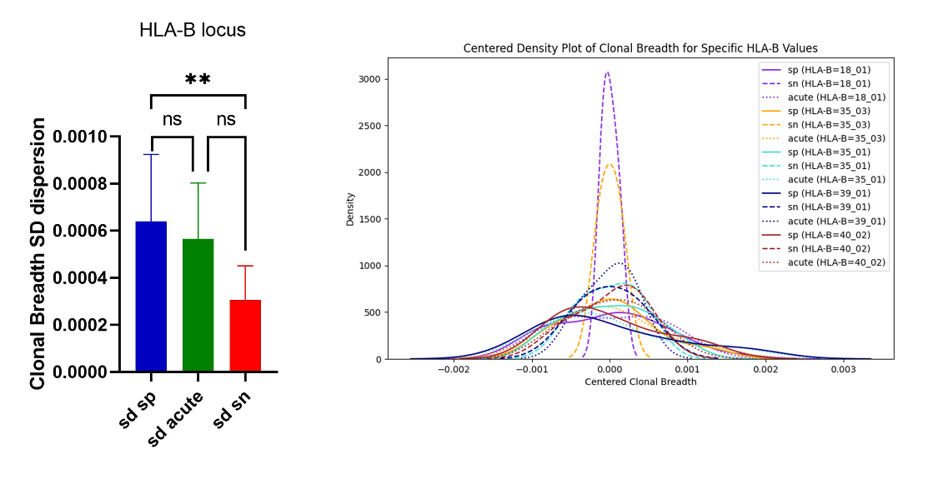
Note. Clonal breadth secondo-order standard deviation (left panel) and density plots (right panel) for specific HLA-B loci. Different subcohorts are represented with different lines whereas HLA-B loci are represented with different colors. The significance level of p-value ** p<0.01, ns for not significant.

