Supplementary Material to
A BEE Indicator for Monitoring Wild Bee Diversity
in Agricultural Systems.
Biologia Futura
d’Agostino Mª, Zenga EL^{a,b}, Giovanetti Mª, Bitonto FF^{c}, Galloni M^{c}, Quaranta Mª, Bortolotti Lª
ªCREA Research Centre for Agriculture and Environment, Bologna, Italy
^{b}Present Affiliation: Department of Agricultural, Forest, and Food Sciences, University of Turin, Italy
^{c}Department of Biological, Geological and Environmental Sciences, University of Bologna, Bologna, Italy
Contact: Manuela Giovanetti
email: manuela.giovanetti@gmail.com

Field Procedures for BEE Indicator Implementation
Introduction
The term bioindicators refers to living organisms used to assess the state of the environment and its changes over time, whether due to natural processes or human interventions. Using certain organisms as indicators makes it possible to evaluate the effects of human activities on ecosystems. These evaluations can be conducted independently or in conjunction with physico-chemical analyses of environmental elements.
Wild bees can serve as valuable bioindicators because they are directly and strongly affected by agricultural practices such as pesticide use, soil cultivation, and monoculture. The diversity of wild bees is largely influenced by the availability of food resources and nesting sites. The highest bee diversity in Europe is found in the Mediterranean region, making it especially important to monitor the impact of agriculture on these insects in this biogeographical area.
The BEE Indicator is intended for use in plain or hilly agroecosystems in warm temperate and Mediterranean areas of Europe. Farms suitable for its application must meet the following criteria: a) be located in Southern Europe, and b) lie below 500 meters above sea level. The indicator was designed with the understanding that bee monitoring on farms should involve a balanced sampling effort that also takes into account the natural features within farm boundaries, in relation to the agronomic practices in place. It is intended to be user-friendly for samplers with basic taxonomic knowledge, and the results can be obtained through simple automatic calculations.
The BEE Indicator was developed by CREA Agriculture and Environment as a tool to evaluate agri-environmental measures at the farm scale. It was created within the framework of the Life 4 Pollinators project (LIFE18 GIE/IT/000755), which aims to protect pollinators in the Mediterranean region.
The application of the BEE Indicator involves three main stages:
1. Location: selection of the monitoring area and sampling transects, based on the cartography.
2. Naturality: analysis of the landscape composition; in the field and on the map.
3. Sampling: capture, identification and counting of Apoidea morphogenera in the field.

1. Location
In this phase, the sampler identifies a monitoring area composed of four transects within the farm. This process can be carried out using physical maps and/or GIS software such as QGIS, ArcGIS, or similar tools. With the aid of maps and in consultation with the farmer, the monitoring area is selected near the center of the farm.
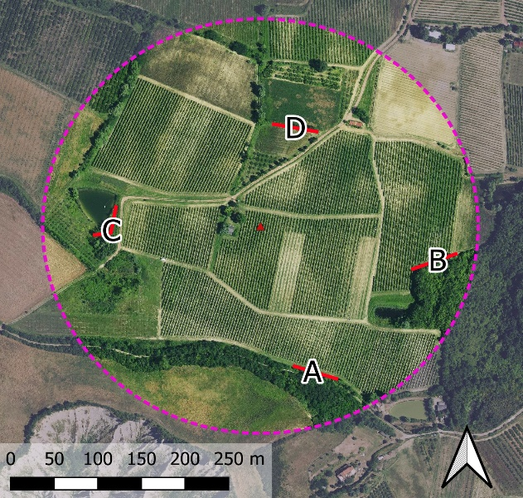
The monitoring area:
A circular area is selected within the farm boundaries, within which four walking transects (A, B, C, and D) are established.
• it is made up of a circle with a radius of 250 m (as in the figure on the right)
• it is located in the central part of the farm (to minimize the influence of nearby crops)
• must include the most representative crops and habitats of the farm
The four transects (A, B, C, D) must:
• 50 m long and 2 m wide each (not necessarily in a straight line)
• placed within the circular monitoring area
• at least 100 m away from each other
• located outside cultivated fields.

Where to place the transect. Field edges are optimal, as are other similar locations where agricultural habitat diversity is maximized: ditches, roadsides, forest edges, and pond edges. Shaded locations should be avoided. Identification of landscape elements can be done using aerial photos, verified with field observations. The position of the transect must remain unchanged during the entire monitoring period.
2. Naturality
In the second phase, the natural value of the landscape surrounding the farm is assessed. This is done by estimating the percentage of land covered by natural areas, which serves as an indicator of the overall naturality of the environment. Areas that are minimally influenced by human activity are generally more suitable for supporting a diverse bee fauna. These "natural" areas tend to provide food resources throughout the entire bee activity season. In addition to food, features such as uncultivated land, shrublands, and forest edges offer rich nesting habitats for bees.
Natural areas are defined as all surfaces that are free of buildings, cultivated crops, or water bodies. Two key criteria distinguish natural from cultivated areas: the absence of tillage and the absence of pesticide use. Examples of natural areas include forests, shrublands, meadows, wastelands, and urban parks. In contrast, agricultural areas such as wheat fields, olive groves, and vineyards are not considered natural.
To accurately determine which areas should be included in the naturality assessment, please refer to the following table:
Landscape element | Natural | Criterion
Woods / Forest | yes | considered part of the natural environment of the farm
Shrub, bush | yes | considered part of the natural environment of the farm
Hedges, row of trees | yes | considered part of the natural environment of the farm
Trees or shrubs in a garden or park | yes | considered part of the natural environment of the farm
Bare ground, rock, gullies, river banks | yes | considered part of the natural environment of the farm
Building, asphalt road | No | buildings or impervious surfaces
River, pond, lakes, sea | No | water
Cultivated area - land, vegetable garden | No | cultivated lands
Orchard, vineyard, olive grove (permanent cultivation) | No | orchards
Arboriculture for wood, forestry plantation | No | cultivated lands
Edge of field, cart track | No | areas subject to mowing or weeding
Prairie / Grassland / Pastures / Meadows | No | areas subject to mowing or weeding
Lawn in a garden or park | No | areas subject to mowing or weeding

How to proceed with the naturality assessment. Naturality is assessed within a 500-meter radius area centered on the monitoring site (see figure in the next page). All natural surfaces within this area can be manually digitized using aerial imagery in GIS software or marked directly on paper maps. The extent of natural areas is then expressed as a percentage of the total landscape area considered.
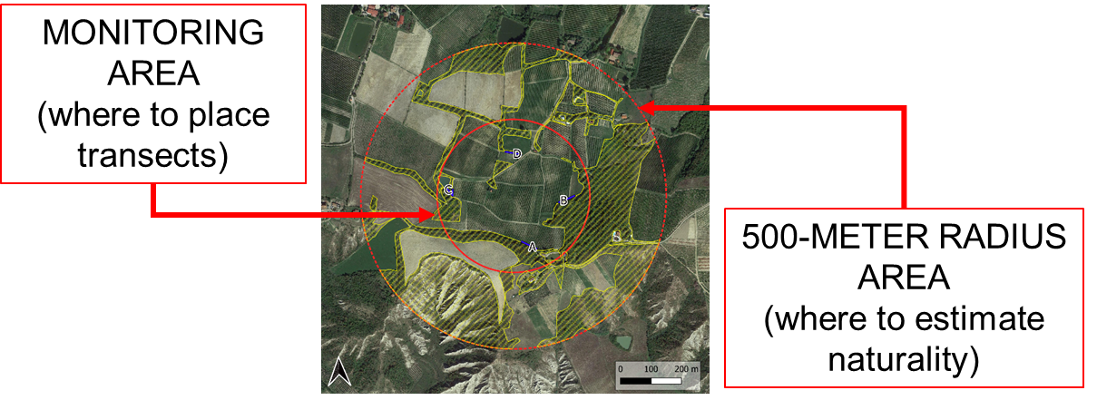
3. Sampling
The third phase is the most critical part of the process and spans a three-month monitoring period. Sampling is conducted using a “catch-and-release” method with an entomological net, and bees are identified in the field at the morphogenera level. Sampling must be repeated over three consecutive months between spring and summer, aligning with the main flowering season and adjusted for local climatic conditions. In warm-temperate climates, the most suitable months are typically May, June, and July, when bee diversity peaks. In Mediterranean climates, monitoring should be advanced by one or two months to avoid periods of severe drought.
Sampling must only be conducted under suitable weather conditions:
- temperature between 15°C and 35°C,
- cloud cover below 50%,
- no rain
- wind speed below 15 km/h (Beaufort scale < 4)
Sampling is carried out once per month, with two sessions per day:
- morning: between 08:00 and 12:00
- afternoon: between 12:00 and 17:00
Each of the four transects must be walked for exactly 15 minutes. During sampling, time must be paused during each bee capture: the use of a stopwatch is strongly recommended to ensure timing accuracy. The sampler should choose the most appropriate time slots based on daily weather conditions.
At the end of each transect, bees must be identified to the morphogenus level and data recorded on the field sheet. A diagnostic guide for morphogenera identification is freely available for reference. After identification, all specimens should be released. If field identification is not possible, bees may be collected, stored in ethyl acetate, and labeled with date, location, and transect. These specimens can later be prepared and identified using a stereomicroscope and specialized literature—or with the assistance of a taxonomic expert.

How to carry out the sampling. The objective of the monitoring is to collect all the individuals encountered along the transect within the established time, using an entomological net. Transects are walked once, in a single direction (the direction must be kept constant during replications) and the transect must be done within a 15-minutes period. Therefore, the sampler must be equipped with a stopwatch to stop the timer during sample collection and handling. Insects are collected both while feeding on flowers and while in flight. Honey bees are not included in the sampling. The path along the transect should maintain at constant - regular pace, paying equal attention to all flowering plants along the transect. Once captured, the bees are placed in a transparent tube and stored in a portable refrigerator until the end of the transect. After identification in the field, they will be released.

