Supplementary material

Supplementary Table 1
GNSS pole network at Dome C: locations of the poles and their annual horizontal movements derived from measurements taken between 1996 and 2014. Measurements from 2014 are indicated in bold.

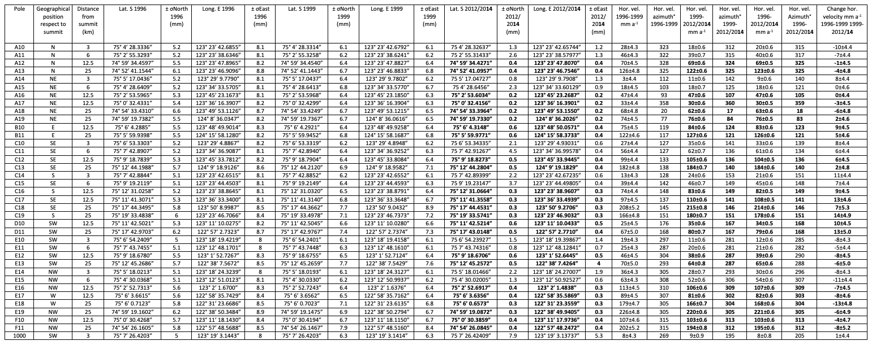

Supplementary Table 2
GNSS pole network at Dome C: surface elevation, elevation of the pole, and their annual vertical movements derived from measurements taken between 1996 and 2014. Surface Mass Balance (SMB) is presented in water equivalent (we) per year. Measurements from 2014 are indicated in bold.

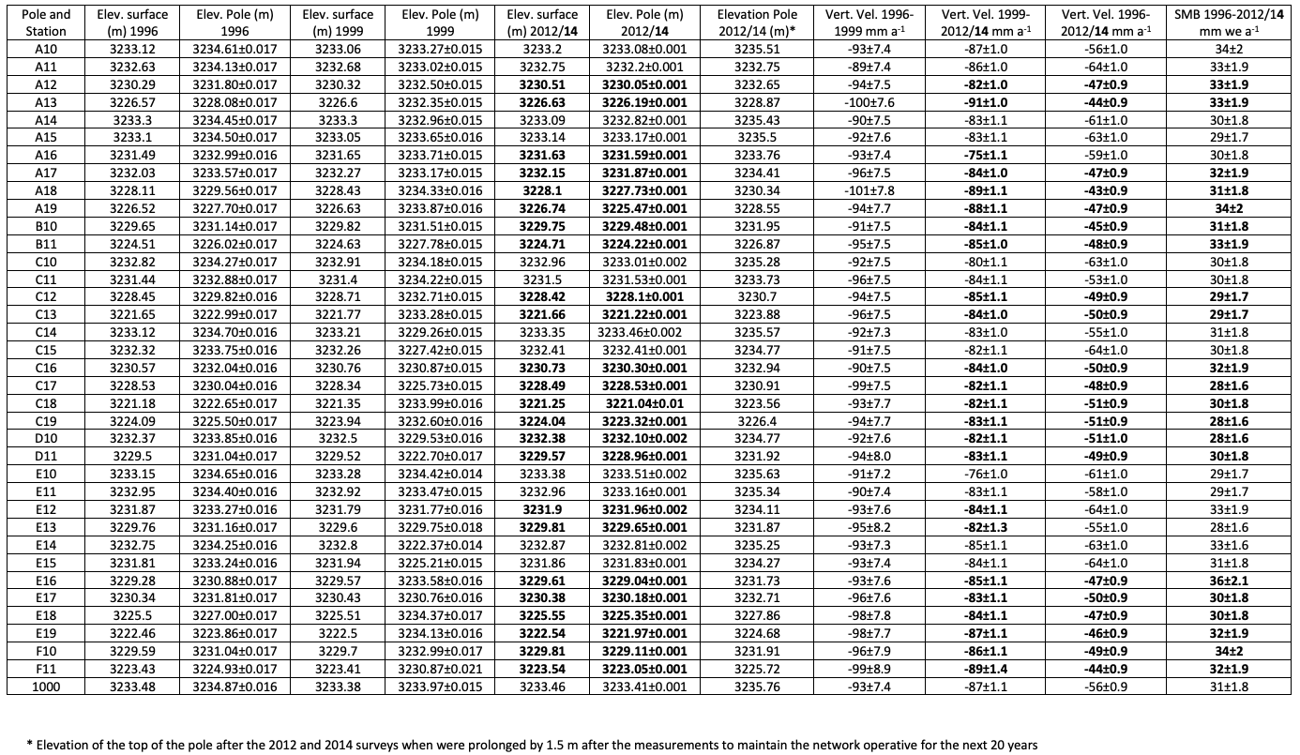

Supplementary Table 3
ITASE GNSS poles: locations of the poles, their GNSS annual movements, and MEaSUREs movements at nearby sites (Rignot and others, 2017). *Vittuari and others, 2004; °Urbini and others, 2008; ^Frezzotti and others, 2007; Frezzotti and others 1998.

Site | Longitude East° | Latitude South ° | GNSS Horizontal  velocity m a⁻¹ | Horizontal velocity  MeASUREs m a⁻¹
31Dpt* | 155°57’21” | 74°01’26” | 7.90±0.07 | 5.15
Aws7350” | 163°18'43" | 74°47'50" | 143.60±0.16 | 113.13
Aws7352” | 163°09'52” | 74°15'18" | 128.30±0.16 | 133.48
Charcot | 139°00’53” | 69°22’29” | 4.90±0.01 | 3.42
D2* | 140°37’47” | 75°37’18” | 3.60±0.07 | 4.17
D4* | 135°49’56” | 75°35’48” | 4.30±0.07 | 5.72
D6* | 129°48’39” | 75°26’53” | 1.46±0.07 | 2.15
D66 | 136°56’07” | 68°56’23” | 26.10±0.02 | 24.57
DA10 | 158°07’03” | 75°07’48” | 88.60±0.16 | 74.79
DA11 | 158°10’44” | 75°04’31” | 56.10±0.16 | 56.60
DA2” | 162°06’31” | 75°21’38” | 553.38±0.16 | 546.00
DA3” | 160°48’55” | 75°15’52” | 262.75±0.16 | 276.00
DA4” | 161°03’20” | 75°18’20” | 508.90±0.16 | 516.00
Da5” | 161°27’15” | 75°10’14” | 113.20±0.16 | 114.55
Da6” | 161°42’29” | 75°12’25” | 68.43±0.16 | 74.18
DA9” | 158°11’45” | 75°15’45” | 102.90±0.16 | 106.00
DRY1” | 162°58’21” | 75°23’33” | 680.30±0.16 | 651.03
Dry7” | 165°18’54” | 75°30’49” | 714.50±0.16 | 699.58
Dry8” | 164°13’41” | 75°27’19” | 714.20±0.16 | 692.56
GPS1 | 160°39’29” | 74°48’54” | 19.11±0.07 | 14.40
GPS2* | 157°30’19” | 74°38’44” | 28.40±0.07 | 29.87
GV1 | 141°23’00” | 70°52’16” | 7.70±0.01 | 8.36
GV2 | 145°15’47” | 71°42’42” | 10.50±0.01 | 10.43
GV3 | 150°10’26” | 72°37’42” | 7.90±0.01 | 5.99
GV4 | 154°29’03” | 72°23’19” | 4.10±0.01 | 1.78
GV5^ | 158°32’13” | 71°53’13” | 0.30±0.01 | 1.74
GV7^ | 158°51’45” | 70°41’03” | 0.30±0.01 | 1.88
GVP1 | 137°15’01” | 69°12’12” | 4.20±0.04 | 3.10
GVP3 | 141°04’30” | 70°23’15 | 6.40±0.13 | 6.11
GVP4 | 141°59’39” | 71°08’58” | 28.00±0.10 | 28.58
GVP7 | 148°29’25” | 72°26’37” | 7.10±0.05 | 8.24
M2 | 151°16’10” | 74°48’16” | 6.99±0.07 | 12.15
M3^ | 157°39’42” | 73°22’55” | 1.90±0.01 | 4.57
MdPta* | 145°51’32” | 75°32’10” | 4.90±0.07 | 5.30
Ree1” | 162°42’08” | 74°45’30” | 251.80±0.16 | 245.59
Ree2” | 162°25’58” | 74°44’45” | 150.80±0.16 | 134.78
St553 | 156°22’06” | 72°16’40” | 2.90±0.03 | 0.58
TD01° | 159°05’46’’ | 72°48’03’’ | 0.04±0.01 | 0.62
TD02° | 159°06’45’’ | 72°43’41’’ | 0.10±0.01 | 1.60
TD03° | 159°16’19’’ | 72° 44’55’’ | 0.32±0.01 | 0.58
TD04° | 159°20’28’’ | 72°48’04’’ | 0.31±0.01 | 0.58
TD05° | 159°16’21’’ | 72°51’01’’ | 0.14±0.01 | 0.96
TD06° | 159°05’58” | 72°52’19” | 0.30±0.01 | 1.81
TD07° | 158°55’38’’ | 72°51’03’’ | 0.28±0.01 | 1.60
TD08° | 158°51’24’’ | 72°47’59’’ | 0.12±0.01 | 0.35
TD09° | 158°55’44’’ | 72°44’56’’ | 0.15±0.01 | 1.64
TP6S | 143°04’55” | 71°24’30” | 9.00±0.04 | 7.98
TP7S | 147°17’15” | 72°18’07” | 8.3±0.01 | 7.46
TP8S | 152°21’26” | 72°31’15” | 3.3±0.01 | 1.84

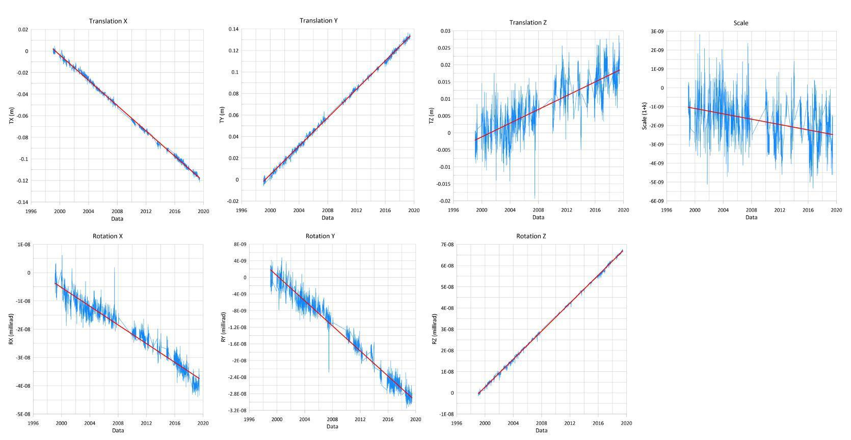

Supplementary Fig. 1
Time series of the seven transformation parameters calculated epoch by epoch using a Precise Point Positioning Ambiguity Resolution (PPP-AR) approach, based on 20 years of GNSS signal acquisitions from permanent stations (CAS1, MAW1, MCM4, SYOG, TNB1, VESL). The graphs demonstrate a strong correspondence with the hypothesis of linearity in the movements expected from plate motion in the area of interest.

