Supplementary Information
Investigating Coupling and Intensification Mechanisms in Multi-Shaft Digesting Stirring Reactors Using POD
Tong Meng^{1,2,3}·Alessandro Paglianti²·Federico Alberini²·Giuseppina Montante²·Yu Wang^{1,3}·Zuohua Liu^{1,3*}
¹School of Chemistry and Chemical Engineering, Chongqing University, Chongqing 400044, China
²Department of Industrial Chemistry “Toso Montanari”, University of Bologna, Bologna 40131, Italy
³State Key Laboratory of Coal Mine Disaster Dynamics and Control, Chongqing 400044, China

Correspondence
*Zuohua Liu, School of Chemistry and Chemical Engineering, Chongqing University, Chongqing 400044, China; State Key Laboratory of Coal Mine Disaster Dynamics and Control, Chongqing 400044, China
Email: liuzuohua@cqu.edu.cn

Content
Supplementary Figure S1: Energy contribution of the POD modes in the stationary zone.
Supplementary Figure S2: Energy contribution of the POD modes in the rotating zone.
Supplementary Figure S3: The Lissajous curve between first and other modal coefficients in the stationary zone: (a) 112 rpm; (b) 163 rpm; (c) 366 rpm.
Supplementary Figure S4: The Lissajous curve between first and other modal coefficients in the rotating zone: (a) 112 rpm; (b) 163 rpm; (c) 366 rpm.
Supplementary Figure S5: Shear rate cloud diagram under various rotational speeds: (a) 112 rpm; (b) 163 rpm; (c) 366 rpm.

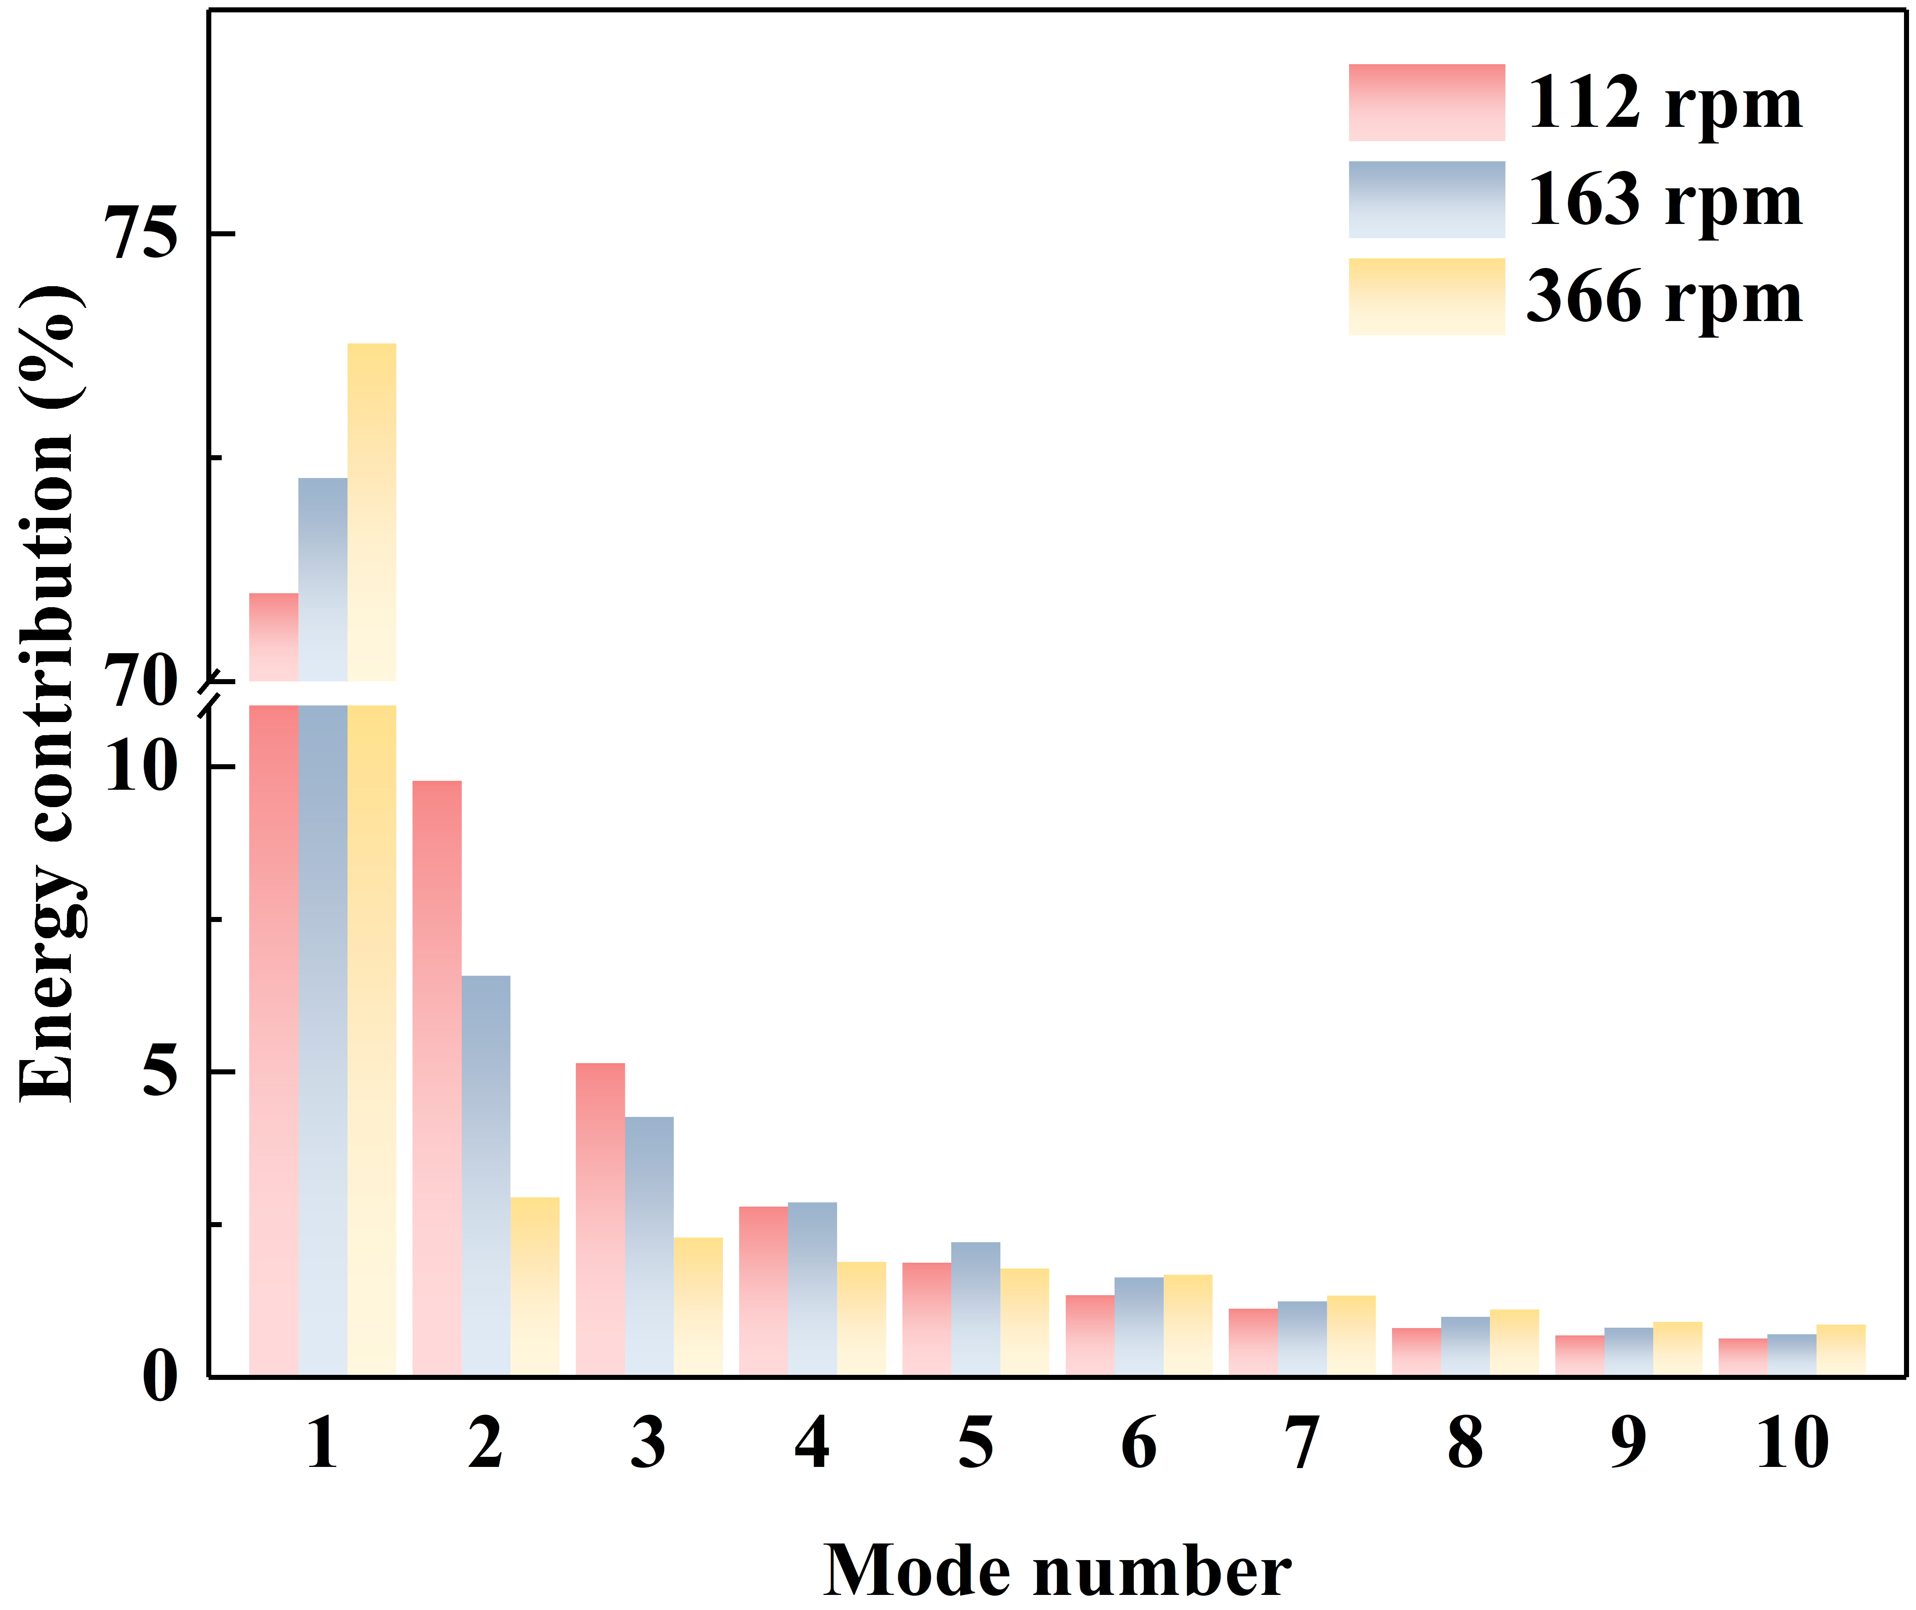
F I G U R E S1 Energy contribution of the POD modes in the stationary zone.

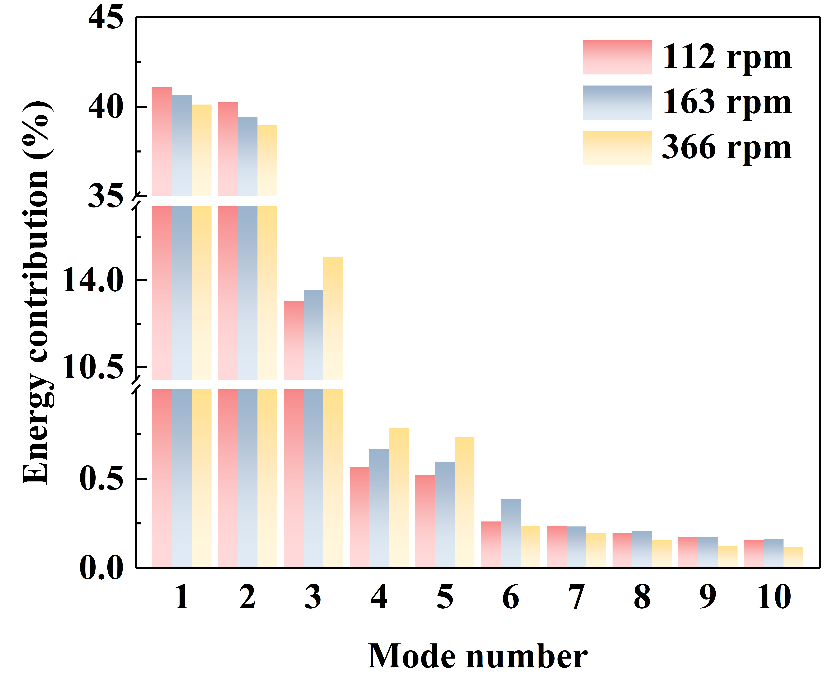
F I G U R E S2 Energy contribution of the POD modes in the rotating zone.

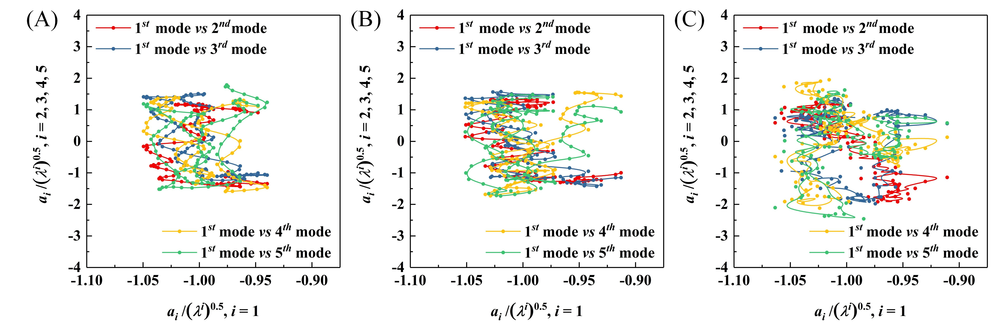
F I G U R E S3 The Lissajous curve between first and other modal coefficients in the stationary zone: (A) 112 rpm; (B) 163 rpm; (C) 366 rpm.

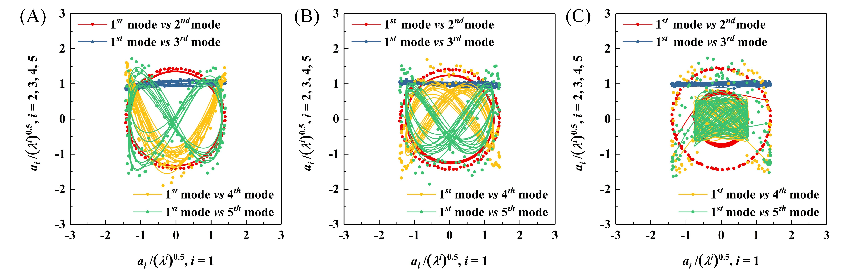
F I G U R E S4 The Lissajous curve between first and other modal coefficients in the rotating zone: (A) 112 rpm; (B) 163 rpm; (C) 366 rpm.

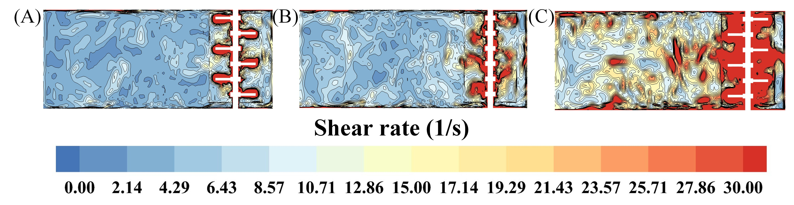
F I G U R E S5 Shear rate cloud diagram under various rotational speeds: (A) 112 rpm; (B) 163 rpm; (C) 366 rpm.

