Appendix

A. Theory and previous findings
  - Table A1. Schematic presentation of literature of wealth effects in education. + sign indicates a positive and significant relation; – sign indicates a negative and significant relation; NS indicates a non-significant relation.
Study | Country | Wealth measurement | Educational performance | Tertiary Enrolment | Educational attainment | Horizontal stratification
Conley (2001) | USA | Log net worth |  | + | +
Orr (2003) | USA | Log value of income-producing assets | +
 |  | Log value of non-income-producing assets | NS
Zhan (2006) | USA | Log net worth | +
Haveman and Wilson (2007) | USA | Log net worth |  | + | +
Williams and Shanks (2007) | USA | Net worth (categorical | +
Nam and Huang (2009) | USA | Log net worth |  | NS | NS
 |  | Log financial assets |  | + | NS
 |  | Homeownership (dummy) |  | NS | –
 |  | Liquid assets (categorical) |  | + | NS
Lovenheim (2011) | USA | Home equity value |  | +
Zhan and Sherraden (2011) | USA | Log financial assets |  |  | +
 |  | Log non-financial assets |  |  | +
 |  | Log secured debt |  | NS | NS
 |  | Log unsecured debt |  |  | –
Pfeffer (2018) | USA | Net worth quintiles |  | + | +
 |  | Home equity quintiles |  | + | +
Karagiannaki (2017) | UK | Net worth |  |  | +
 |  | Financial assets |  |  | NS
 |  | Home equity |  |  | +
Henseke et al. (2021) | UK | Home equity |  |  |  | +
Hällsten and Pfeffer (2017) | Sweden | Net worth ranks | + | +
Hällsten and Thaning (2018) | Sweden | Net worth ranks |  |  | + | +
Wiborg (2017) | Norway | Log gross wealth |  | +
Dräger and Müller (2020) | Germany | IHS net worth | + | +
Müller, Pforr and Hochmann (2020) | Germany | Log gross worth |  |  |  | +
Dräger (2021) | Germany | IHS net worth |  | +
Pietrolucci and Albertini (2023) | Italy | IHS net worth, financial, and real wealth |  | +
Torche and Spilerman (2009) | Mexico | Weighted parental asset index |  | + | +
Torche and Costa-Ribeiro (2012) | Brazil | Gross wealth categories |  |  | +
Comparative works
Pfeffer (2011) | Germany  USA | Log net worth |  | Germany +  USA +
Pfeffer & Hällstein (2012) | Germany  USA  Sweden | Log net worth |  | Germany +  USA +  Sweden +
Grätz & Wiborg (2020) | USA  Germany  Norway | Percentile rank | USA +  Germany +  Norway +

Table A2. Association between parental education and educational attainment.
Study | Jerrim and MacMillan 2013 | Jerrim and MacMillan 2013 | Pfeffer 2008 | Hertz et al. 2007 | Hertz et al. 2007 | Anderson et al. 2024 | Chevalier et al. 2009 | Liu and Ding 2020 | Liu and Ding 2020
Method | University Access Difference | Effect size | Unidiff parameter | Regression Coefficient | Correlation | Sibling correlation | Regression Coefficient | Regression Coefficient | Correlation
Austria | 29.4 | 0.99 |  |  |  |  |  | 0.144 | 0.159
Belgium | 32.7 | 0.99 | 0.20 | 0.41 | 0.40 |  | 0.394 | 0.273 | 0.261
Estonia | 33.9 | 0.85 |  | 0.54 | 0.40
France | 43.0 | 0.98 |  |  |  | 0.54 |  | 0.333 | 0.273
Germany | 34.0 | 1.00 | 0.27 |  |  | 0.47 | 0.542 | 0.142 | 0.136
Hungary |  |  | 0.15 | 0.61 | 0.49 | 0.42 | 0.374
Italy | 51.5 | 1.43 | 0.14 | 0.67 | 0.54 |  | 0.477 | 0.343 | 0.248
Netherlands | 36.1 | 0.78 |  | 0.58 | 0.36 | 0.47 | 0.406 | 0.221 | 0.201
Poland | 55.2 | 1.34 | -0.08 | 0.48 | 0.43 | 0.45 | 0.495 | 0.326 | 0.257
Slovakia | 57.0 | 1.48 |  | 0.61 | 0.37 |  |  | 0.376 | 0.302
Slovenia |  |  | 0.34 | 0.54 | 0.52 |  | 0.459
Spain | 45.6 | 1.02 |  |  |  | 0.60 |  | 0.263 | 0.190
Portugal, Greece, and Luxembourg have not been included in these studies.
Chevalier et al. (2009), Table 12.3, Country specific regression.
Hertz et al. (2007), Table 2, Coefficient and Correlation.
Liu and Ding (2020), Table 10.3, average of regression coefficient and correlation for women and men.
Jerrim and MacMillan (2013), Table 3, Percentage-point difference in university access and effect size for years of education.
Pfeffer (2008), Table 4, UniDiff Parameter.
Anderson et al. (2024), Figure 2.

Table A3: Country contextual characteristics
Country | Share of first-cycle students paying fees (%)ª | Average fees for students who pay fees (in EUR) ª | Share of first-cycle students with a need-based grant (%) | Min and max amount of need-based grant per year (in EUR) | Private spending / total spending on tertiary education^{b} | Differentiation of secondary-level curricula Index ^{c} | Centralization  Index ^{c} | Welfare
AT | 32 | 0 | 16 | 3900/  10000 | 10.5 | 25.9 | 66.2 | Continental
BE | Depending on region | 100-947 | 20 | 2500 + tax benefits | 13.2 | 14.9 | 45.6 | Continental
DE | Depending on region | 50-75 | 12 | 5900 | 14.8 | 41.4 | 52 | Continental
EE | 0 | 0 | 25 | 1500 | 17.6 | 56.8 | 36.7 | Continental/Eastern
ES | 77 | 1022 | 30.6 | 2900/6900 | 33.7 | 63.7 | 54.5 | South European
FR | 66 | 262 | 34 | 1000/5700 | 21.7 | 76.9 | 66.9 | Continental
GR | 0 | 0 | 1 | 1800/  3400 | 13.9 | 53.2 | 72.8 | South European
HU | 31 | 1689 | 24 | 600/3300 | 30.5 | 40.3 | 62.3 | Continental/Eastern
IT | 71 | 1473 | 14 | 1900/5200 | 35.9 | 63.5 | 72.9 | South European
LU | 100 | 400-800 | 64 | 2100/7000 | 5.6 | 59.4 | 56.4 | Continental
NL | 100 | 2143 | 31 | 4800 |  |  |  | Continental
PL | 100 | 57 | 14 | 1500 | 19.9 | 55.9 | 55.5 | Continental/Eastern
PT | 100 | 495-697 | 22 | 870/5500 | 31.8 | 66.8 | 68.8 | South European
SI | 9 | 21-36 | ND | 860/4400 | 11.1 | 49.2 | 61.1 | Continental
SK | 18 | 1-100 | 9.3 | 100/3600 | 29.3 | 59.6 | 56.6 | Continental/Eastern
ª = European Commission/EACEA/Eurydice (2020). National Student Fee and Support Systems in European Higher Education – 2020/21. Eurydice – Facts and Figures. Luxembourg: Publications Office of the European Union.
^{b} = OECD (2020) Spending on Tertiary education. https://data.oecd.org/eduresource/spending-on-tertiary-education.htm#indicator-chart
^{c} = Traini (2019)

B. Analytical sample description

B1. Definition of the analytical sample
The Household Finance and Consumption Survey (HFCS) covers 23 European countries, including 19 Euro area countries (Austria, Belgium, Cyprus, Czech Republic, Germany, Estonia, Finland, France, Greece, Hungary, Ireland, Italy, Latvia, Lithuania, Luxembourg, Malta, Netherlands, Poland, Portugal, Slovenia, Slovakia, Spain), as well as Croatia, Hungary, and Poland. Due to data limitations in some countries, we selected 15 countries for our analysis. Specifically, we excluded:
Ireland, Malta, and Cyprus: The variable age is operationalized as a categorical variable with age brackets (16-19/20-24) which do not fit our analytical sample age boundaries (19-21/20-22).
Finland: The share of individuals who established an independent household – for whom it is not possible to retrieve any information about their parents – is remarkably high (46%).
Countries with very low sample sizes: Croatia (n=203), Czech Republic (n=141), Latvia (n=150), Lithuania (n=103).
The resulting analytical sample consists of 15 countries with sample sizes ranging between 417 (NL) and 4,124 (FR). We define observations in analytical sample as the combination of person-year since some countries (BE, DE, EE, ES, FR, IT, PL, SK) include a small panel component. However, given that the HFCS includes a limited number of waves (from 2 to 4) and that the age boundaries for inclusion in the analytical sample are narrow (3 years range), only a minor proportion of individuals are observed more than once (1.34%). In the analytical sample, households with siblings comprise 17.35% of the total, with an average of 1.15 individuals per household.

B2. Selection in the analytical sample
In several countries (AT, DE, EE, GR, FR, HU) more than 10% of individuals in our target age groups live in household separate from their parents (Figure B1). Due to the lack of parental information for these individuals, explicit modelling of selection into the sample (e.g. through a Heckman selection model) is not feasible. To address this issue, we perform two operations. First, we compare descriptively the enrolment rates in post-secondary education between observations inside and outside the parental household in countries with a high share of individuals outside the parental household (>=10%). Second, we apply a reweighting procedure as described in the main text.
Figure B2 shows that in most countries, individuals observed outside the parental household have lower enrolment rates than those observed in the parental household, with the exception of DE. The difference in enrolment rates between in-household and out-of-household ranges between 6 percentage points in HU and 13 percentage points in EE, and GR. We interpret this result as a signal that, on average, individuals outside the parental home face higher barriers to access post-secondary education. Indeed, setting up an independent household entails a higher economic burden due to the lack of household economies of scale, which may reinforce the role of parental wealth in post-secondary enrolment. Therefore, the exclusion of individuals in independent households may lead to a partial underestimation of wealth inequalities in our results.
Comparing the kernel density distributions for net worth in the pre- and post-graduation periods reveals considerable differences in most countries (Figure B3). However, the application of counterfactual weights (Figure B4) aligns the distribution in the post-graduation period closely with the distribution in the pre-graduation period. This adjustment mitigates the bias introduced by the selection into the sample, ensuring a more accurate representation of parental wealth.

  - Figure B1. Relative distribution of observations by household type (in parental household vs out of parental household).
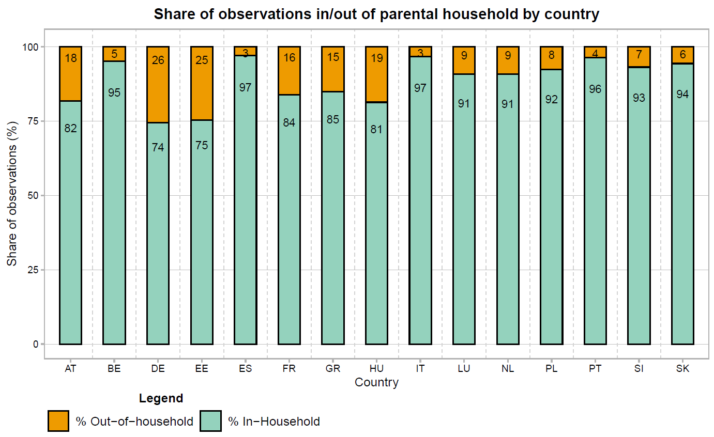

  - Figure B2. Observed enrolment in post-secondary education by household type (in parental household and out of parental household), in countries with high shares of out-of-household individuals.
  - 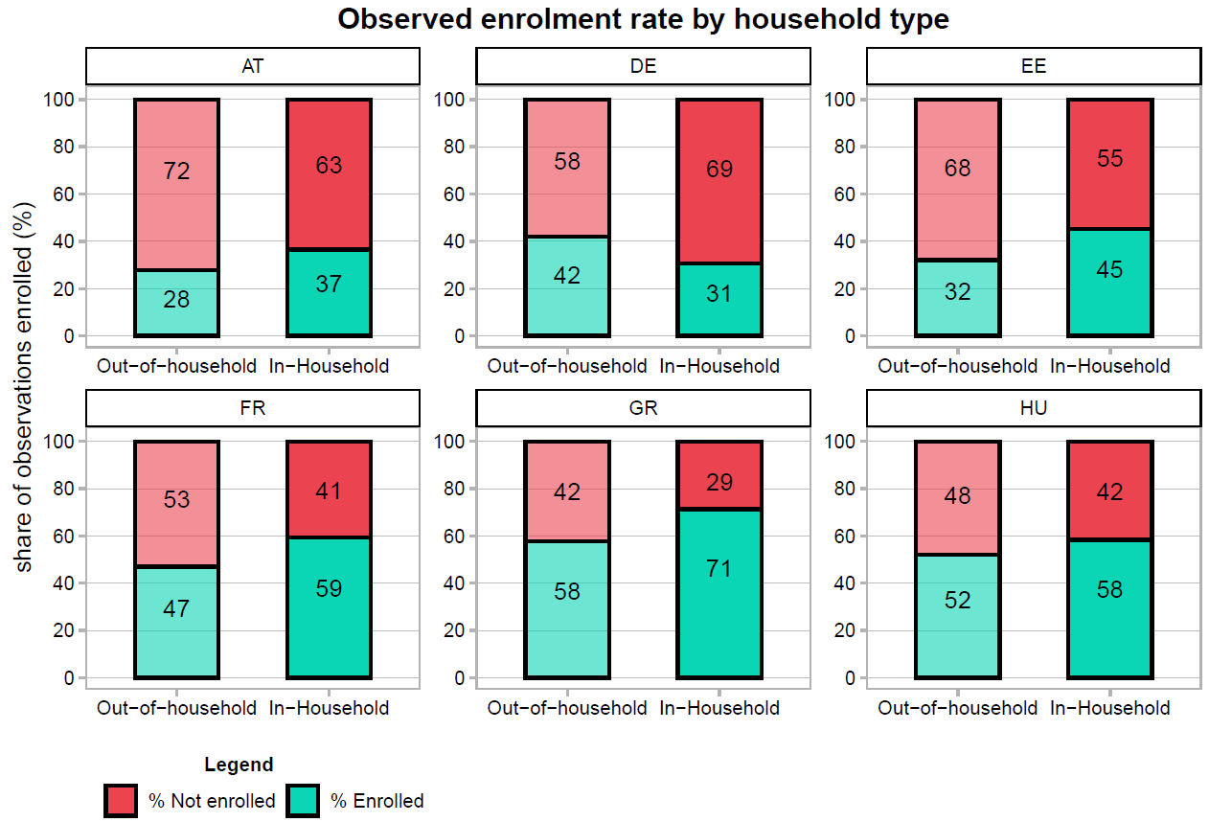

  - Figure B3. Net wealth kernel density distribution of observed pre-graduation and post-graduation samples by country.
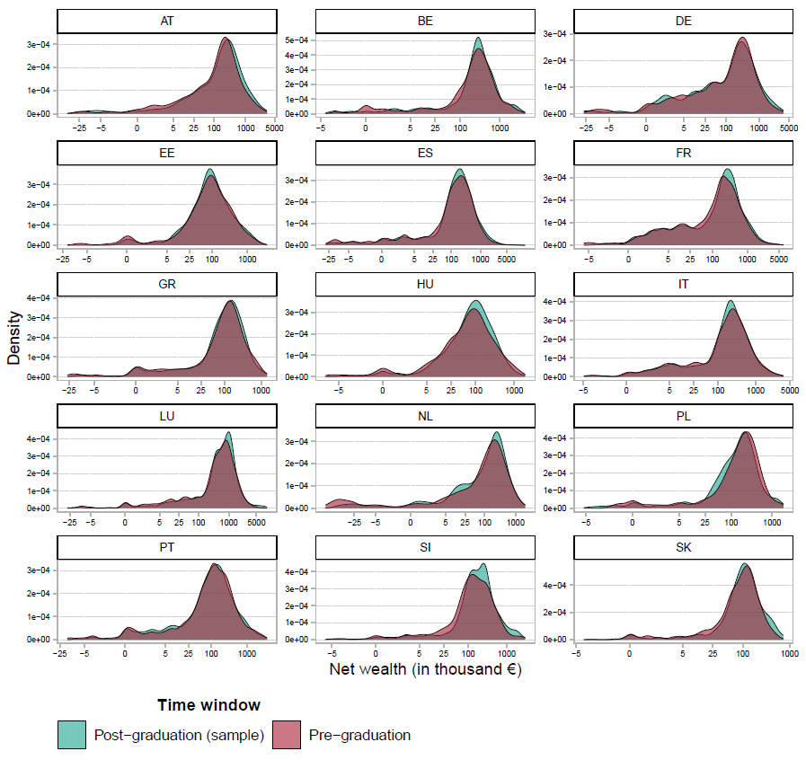
  - Figure B4. Net wealth kernel density distributions of observed pre-graduation and counterfactual post-graduation (reweighted through IPW) samples by country.
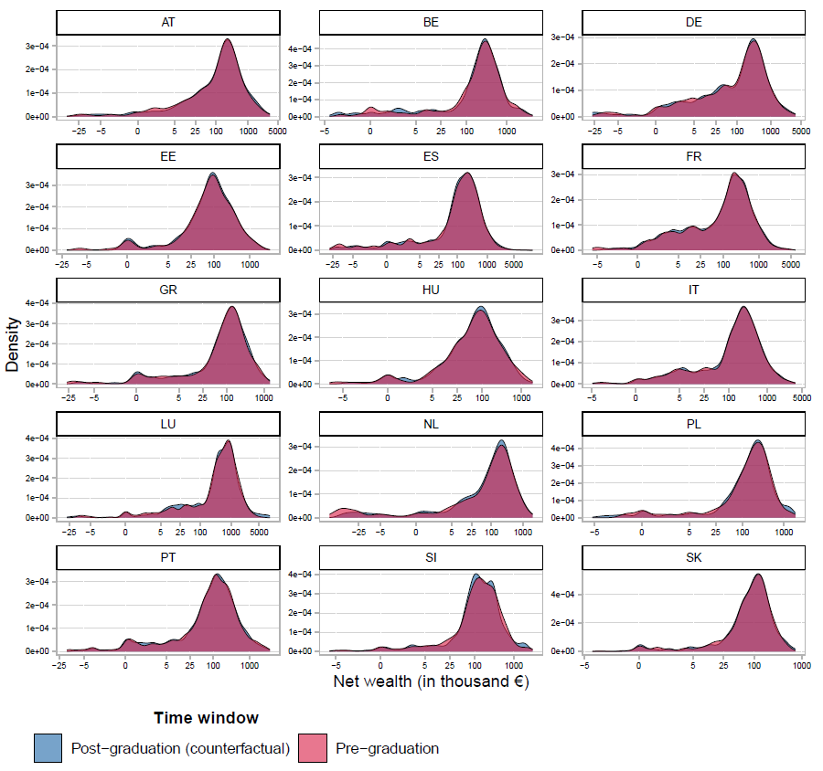

B3. Wealth operationalization and missing values
We operationalize our wealth and debt variables building on the definition elaborated by the HFCS. Financial assets are defined as the sum of the value of all liquid assets owned by a household, specifically deposits, mutual funds, bonds, shares, managed accounts, and voluntary pensions/life insurance. Real assets are defined as the sum of the value of all tangible assets, including the household main residence, other real estate properties, vehicles, valuables, and the value of (private) businesses owned. Secured debt is represented by the sum of the outstanding balance of collateralized loans, encompassing the main residence mortgage and mortgages on other properties (e.g., real estate or businesses). Unsecured debt is defined as the outstanding balance of all non-collateralized loans, including credit lines, credit card debt, non-mortgage loans, and private loans. Consequently, gross wealth is given by the sum of financial and real assets, while total debt is the result of the outstanding balance of both collateralized and non-collateralized loans. Finally, net wealth is defined as the sum of the values of all assets owned by a household (gross wealth) minus the sum of all liabilities (debt).
Figure B6. Descriptive schema of wealth and debt variables composition
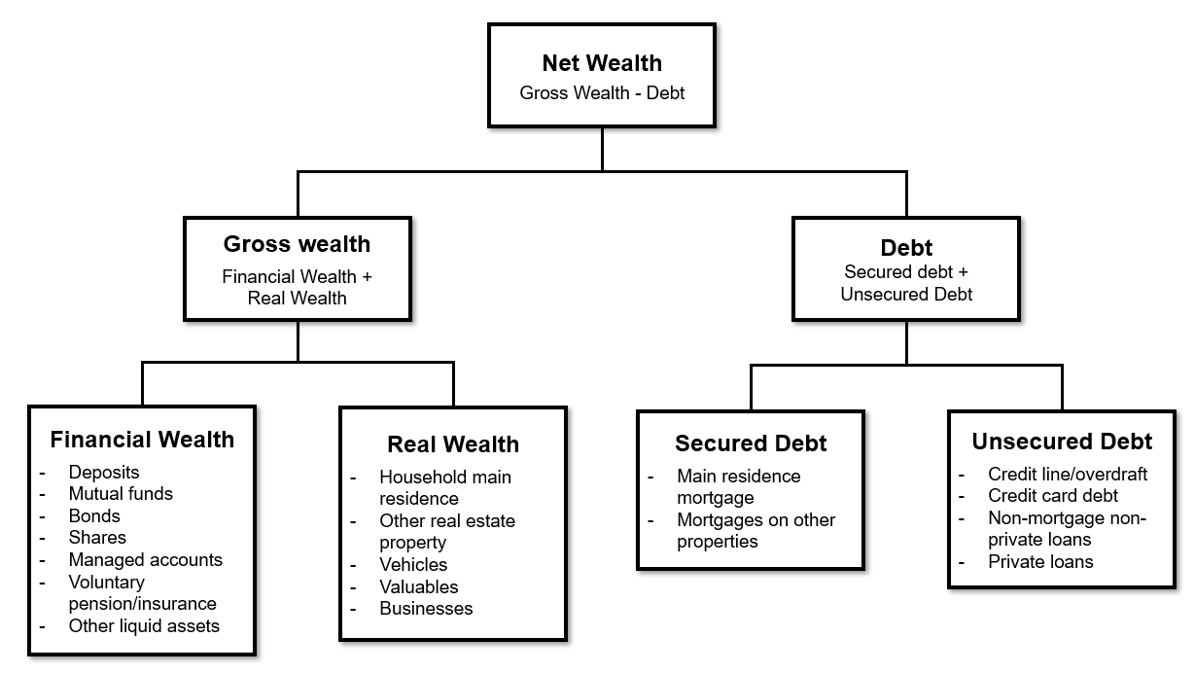
To address item non-response, the HFCS imputes missing values for households’ assets and liabilities using Multiple Imputation by Chained Equations (MICE), generating 5 imputations. This technique is applied for each country included in the survey, except for Italy (all waves) and France (2014-2017 waves) where single imputation is utilized. Table B2 displays the share of observations reporting imputed values on wealth and debt variables used in our analysis, by country. In some countries, the share of observations reporting imputed values is notably high (e.g., EE, LU, PL, and SI).
It is important to note that wealth and debt measures are marked as imputed if at least one basic variable composing the wealth/debt measure is imputed. For instance, if the variable “bonds” is imputed for a given observation, the entire variable “financial assets” is considered imputed. Consequently, gross wealth and net wealth would be considered as imputed variables as well. As a result, secured and unsecured debt – which are composed only of a few basic variables – exhibit lower shares of imputed values compared to wealth measures, which consist of more basic variables. Indeed, the average shares of the value of imputed wealth and debt components are considerably lower (Table B3). With the exception of PL and EE, the shares are below 30% in each country.
Additionally, we multiply imputed missing values (3.72%) for the parental social class variable in Italy (wave 2014). We used Multiple Imputation by Chained Equations (MICE) based on a multinomial logistic regression model, utilizing the highest educational level achieved and personal income as predictors of social class. Consistent with the HFCS’s multiple imputation procedure for wealth and debt variables, we generated 5 imputations for the parental social class variable.
Table B2. Share of observations with at least one imputed value in the variables composing wealth and debt measures. Shares are reported by wealth and debt component, and by country.
Country | Net Wealth  (%) | Gross Wealth  (%) | Financial Wealth  (%) | Real Wealth  (%) | Debt  (%) | Secured Debt  (%) | Unsecured Debt  (%) | Treatment of missing values
AT | 48.37 | 46.31 | 41.51 | 23.33 | 15.61 | 8.58 | 8.06 | Multiple imputation
BE | 54.34 | 51.15 | 45.03 | 16.84 | 14.16 | 10.97 | 4.85 | Multiple imputation
DE | 54.55 | 53.27 | 50.10 | 13.17 | 8.81 | 5.54 | 4.06 | Multiple imputation
EE | 79.79 | 76.42 | 57.47 | 38.95 | 23.58 | 0.63 | 23.16 | Multiple imputation
ES | 38.24 | 35.58 | 20.14 | 24.30 | 6.28 | 3.27 | 3.35 | Multiple imputation
FR | 27.84 | 27.84 | 24.39 | 27.84 | 4.07 | 1.38 | 3.01 | Single/ Multiple imputation
GR | 44.68 | 41.95 | 22.99 | 30.91 | 6.75 | 4.68 | 2.08 | Multiple imputation
HU | 19.75 | 18.33 | 16.62 | 4.75 | 2.37 | 0.00 | 2.37 | Multiple imputation
IT | --- | --- | --- | --- | --- | --- | --- | Single imputation
LU | 74.40 | 70.40 | 61.60 | 33.76 | 19.04 | 10.72 | 10.88 | Multiple imputation
PL | 70.98 | 68.35 | 65.23 | 23.98 | 24.94 | 19.90 | 9.35 | Multiple imputation
PT | 70.32 | 69.00 | 55.67 | 45.65 | 11.21 | 3.69 | 7.65 | Multiple imputation
SI | 61.44 | 52.21 | 39.73 | 33.94 | 27.35 | 20.50 | 9.69 | Multiple imputation
SK | 68.24 | 67.27 | 59.22 | 27.05 | 7.91 | 2.50 | 5.83 | Multiple imputation

Table B3. Average share of the value of imputed wealth and debt components. Shares are reported by wealth and debt component, and by country.
Country | Gross Wealth  (%) | Financial Wealth  (%) | Real Wealth  (%) | Debt  (%) | Secured Debt  (%) | Unsecured Debt  (%) | Treatment of missing values
AT | 26.55 | 35.23 | 18.35 | 15.35 | 9.43 | 7.42 | Multiple imputation
BE | 15.70 | 29.14 | 9.84 | 12.08 | 10.94 | 4.15 | Multiple imputation
DE | 13.19 | 25.13 | 6.88 | 7.20 | 4.86 | 3.87 | Multiple imputation
EE | 31.62 | 46.03 | 27.01 | 14.69 | 0.63 | 19.37 | Multiple imputation
ES | 13.33 | 13.20 | 12.78 | 5.22 | 3.27 | 3.11 | Multiple imputation
FR | 25.69 | 22.05 | 27.01 | 3.27 | 1.27 | 2.82 | Single/ Multiple imputation
GR | 21.39 | 22.13 | 18.91 | 7.31 | 5.58 | 1.98 | Multiple imputation
HU | 11.97 | 25.03 | 6.84 | 8.58 | 4.45 | 6.28 | Multiple imputation
IT | --- | --- | --- | --- | --- | --- | Single imputation
LU | 24.58 | 46.84 | 18.36 | 15.11 | 10.47 | 9.21 | Multiple imputation
NL | 28.83 | 47.29 | 14.52 | 22.27 | 19.32 | 8.89 | Multiple imputation
PL | 40.45 | 46.73 | 36.34 | 12.88 | 5.05 | 9.03 | Multiple imputation
PT | 24.51 | 33.26 | 21.10 | 23.98 | 20.22 | 9.11 | Multiple imputation
SI | 25.31 | 49.66 | 19.03 | 6.96 | 2.64 | 5.09 | Multiple imputation
SK | 18.03 | 34.99 | 13.26 | 11.23 | 7.75 | 4.81 | Multiple imputation

C. Additional Descriptive statistics
  - Figure C1. Observed enrolment rate in post-secondary education (HFCS) and in tertiary education (Eurostat) by country.

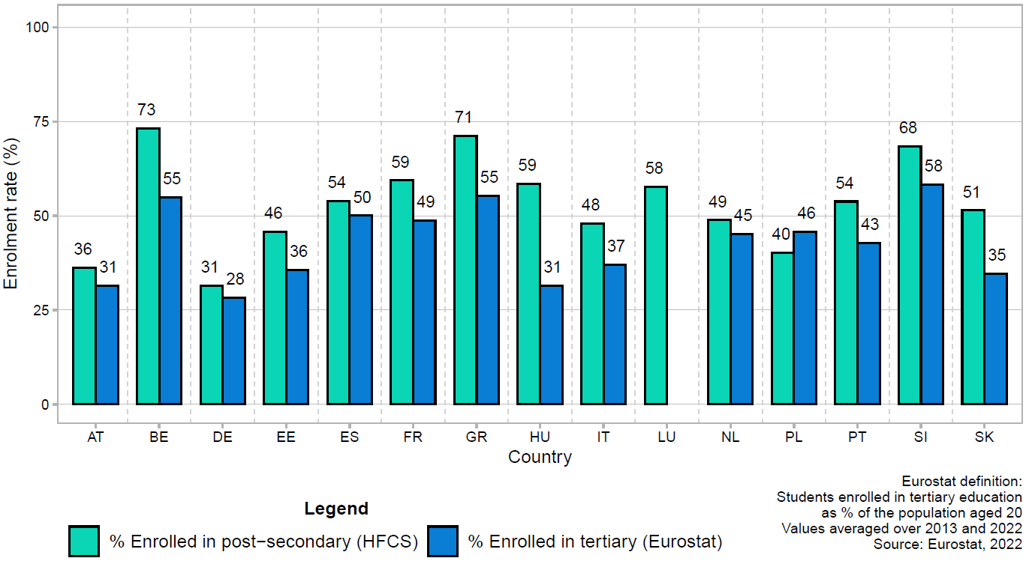

  - Figure C2. Pen’s parade of wealth components by country
  - 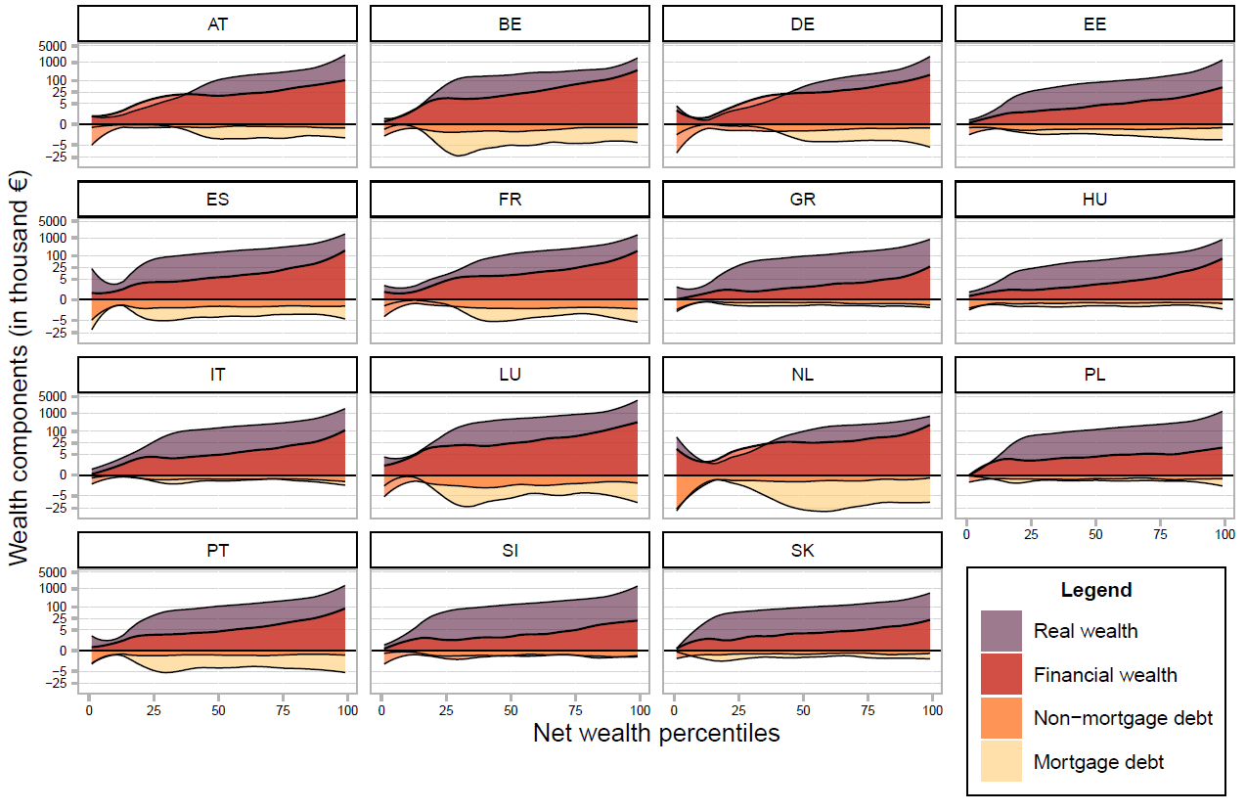
  - Figure C3. Share of students taking out publicly subsidised loans (2019/2020)
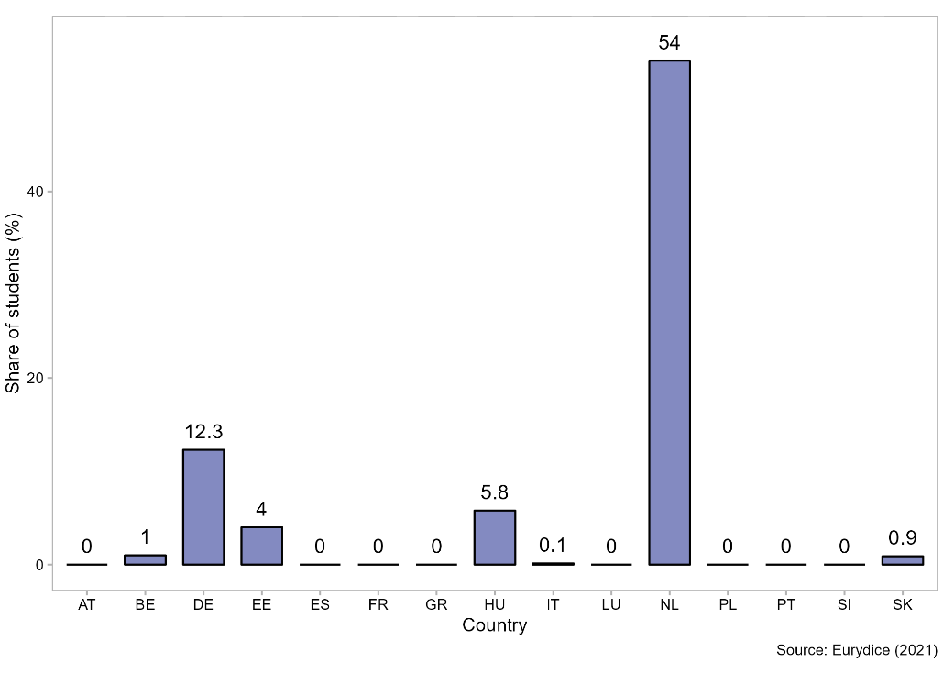

D. Predicted values
  - Figure D1. Predicted values of net wealth on post-secondary enrolment by country, full model specification. Vertical dashed lines refer to country-specific values of 10th, 50th, and 90th percentiles. Values are reported up to 99th percentile of country-specific distributions.
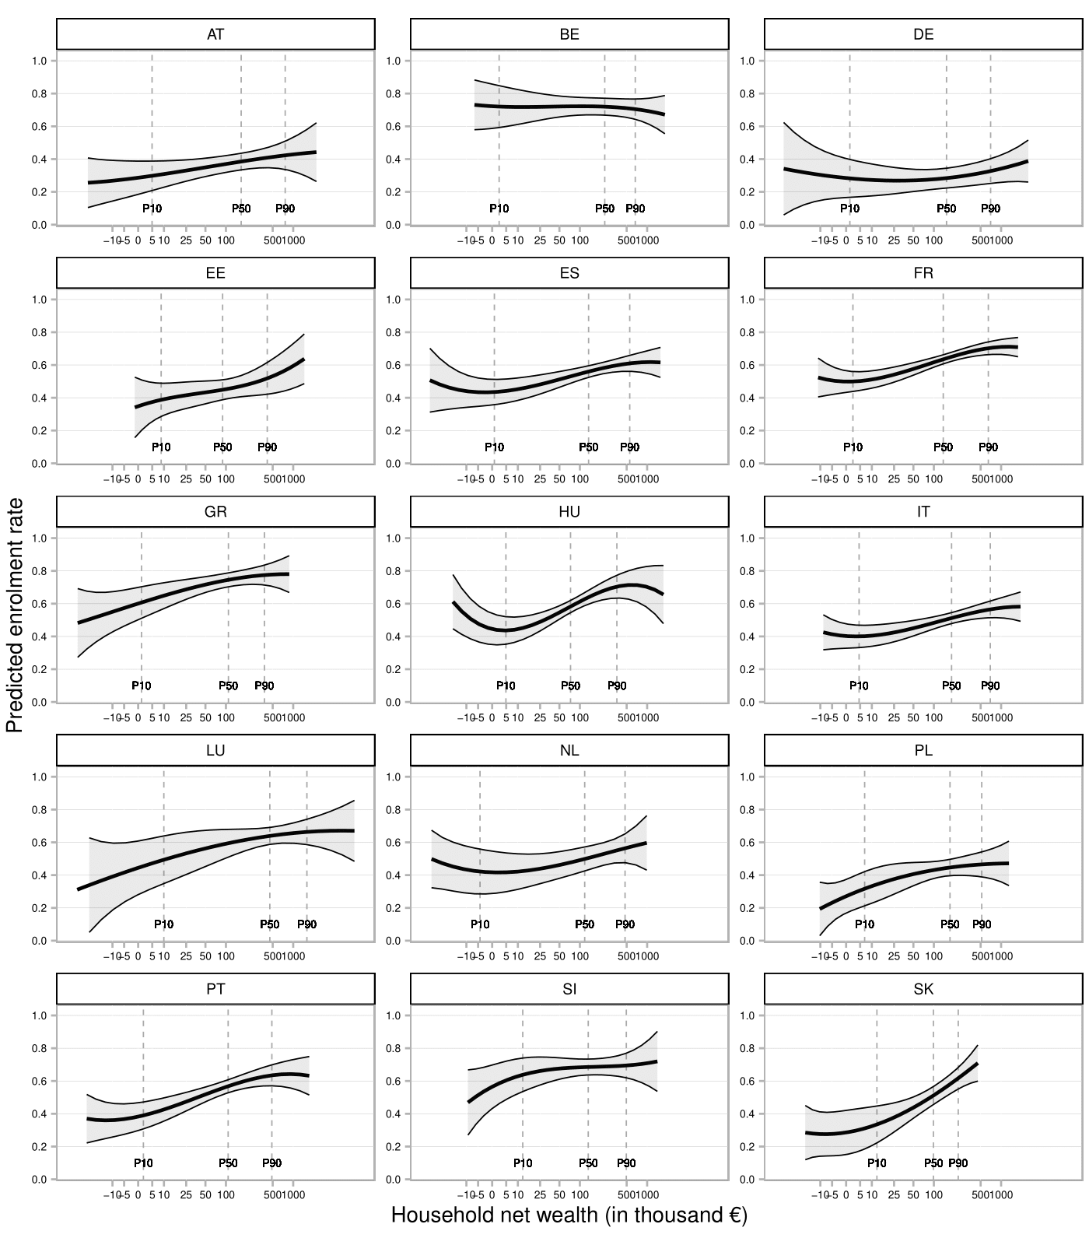

  - Figure D2. Predicted values of gross wealth on post-secondary enrolment by country, full model specification. Vertical dashed lines refer to country-specific values of 10th, 50th, and 90th percentiles. Values are reported up to 99th percentile of country-specific distributions.
  - 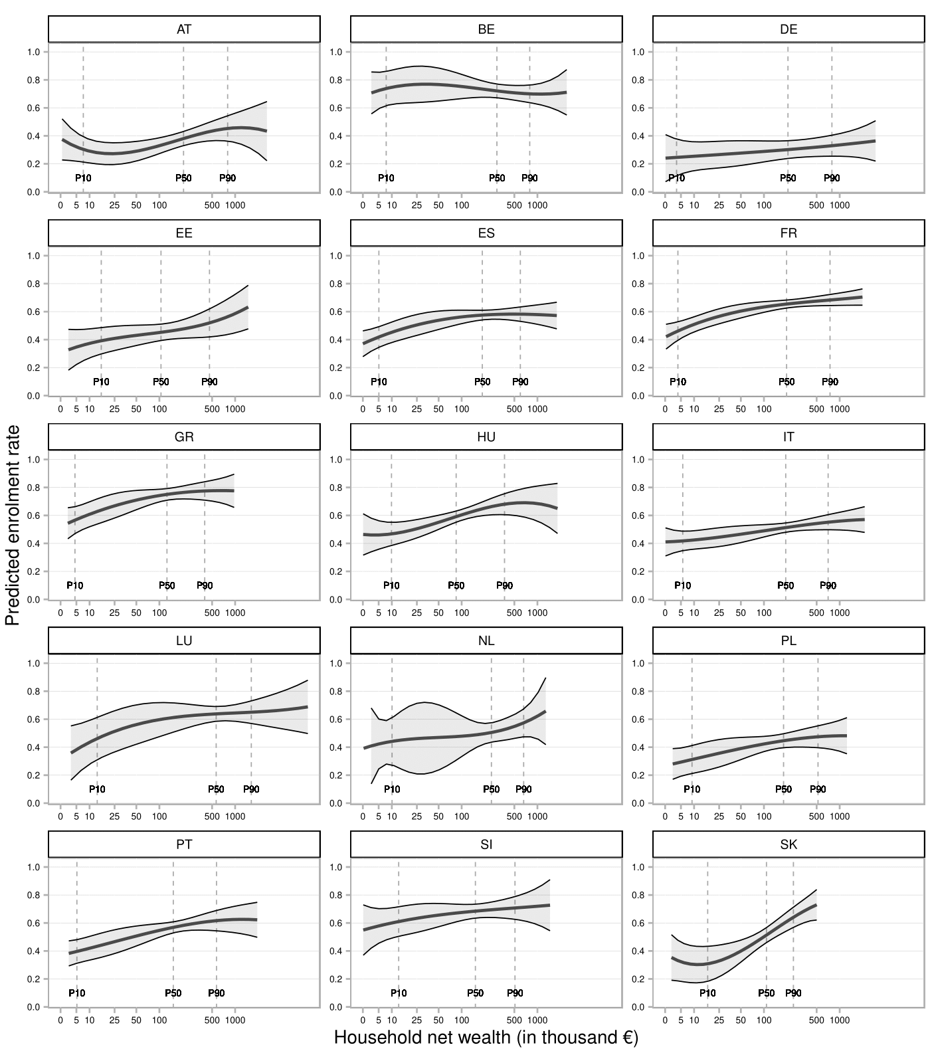

  - Figure D3. Predicted values of debt on post-secondary enrolment by country, full model specification. Vertical dashed lines refer to country-specific values of 10th, 50th, and 90th percentiles. Values are reported up to 99th percentile of country-specific distributions.
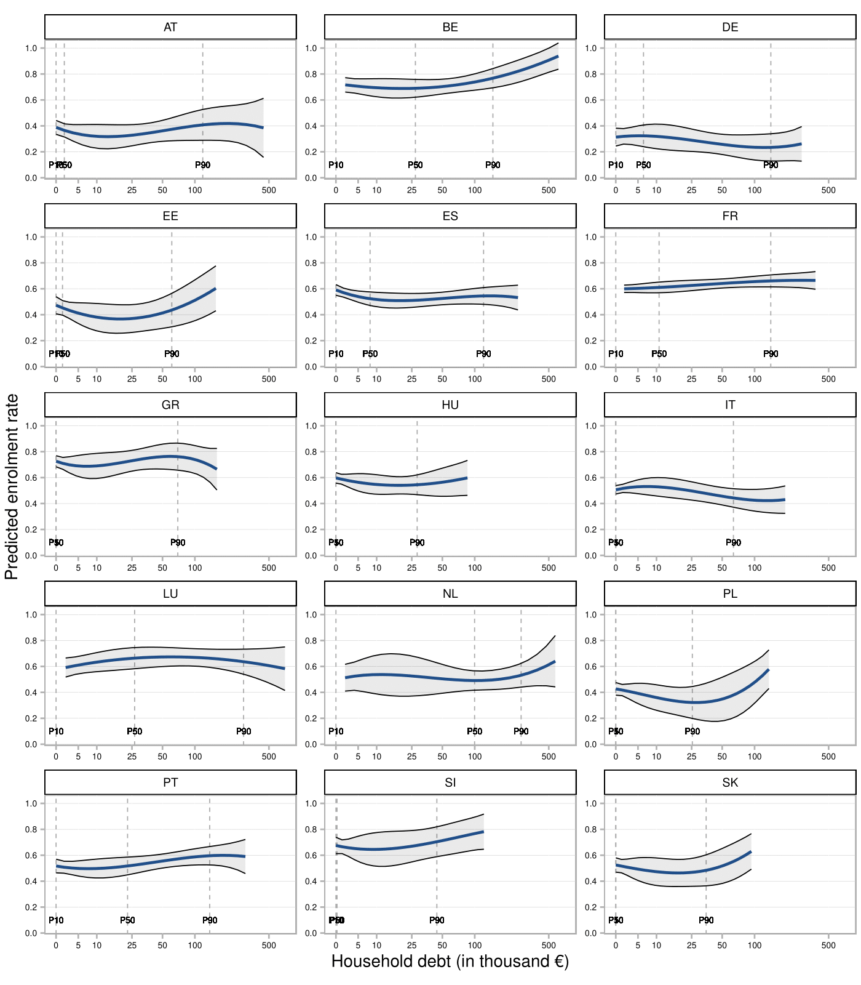

  - Figure D4. Predicted values of per capita financial wealth on post-secondary enrolment by country, full model specification. Vertical dashed lines refer to country-specific values of 10th, 50th, and 90th percentiles. Values are reported up to 99th percentile of country-specific distributions.
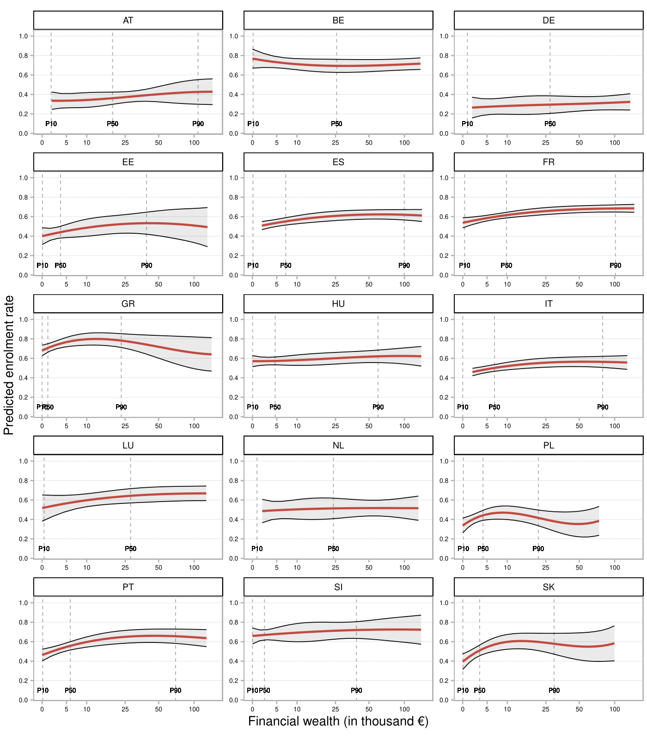

  - Figure D5. Predicted values of real wealth on post-secondary enrolment by country, full model specification. Vertical dashed lines refer to country-specific values of 10th, 50th, and 90th percentiles. Values are reported up to 99th percentile of country-specific distributions.
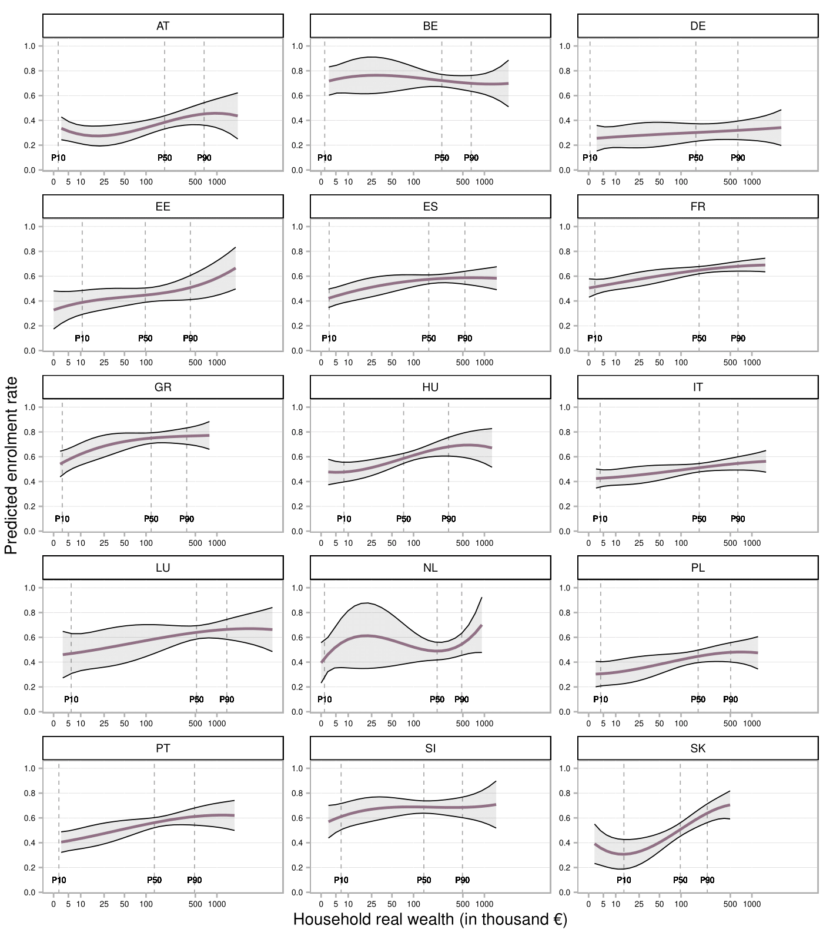

  - Figure D6. Predicted values of secured debt on post-secondary enrolment by country, full model specification. Vertical dashed lines refer to country-specific values of 10th, 50th, and 90th percentiles. Values are reported up to 99th percentile of country-specific distributions.
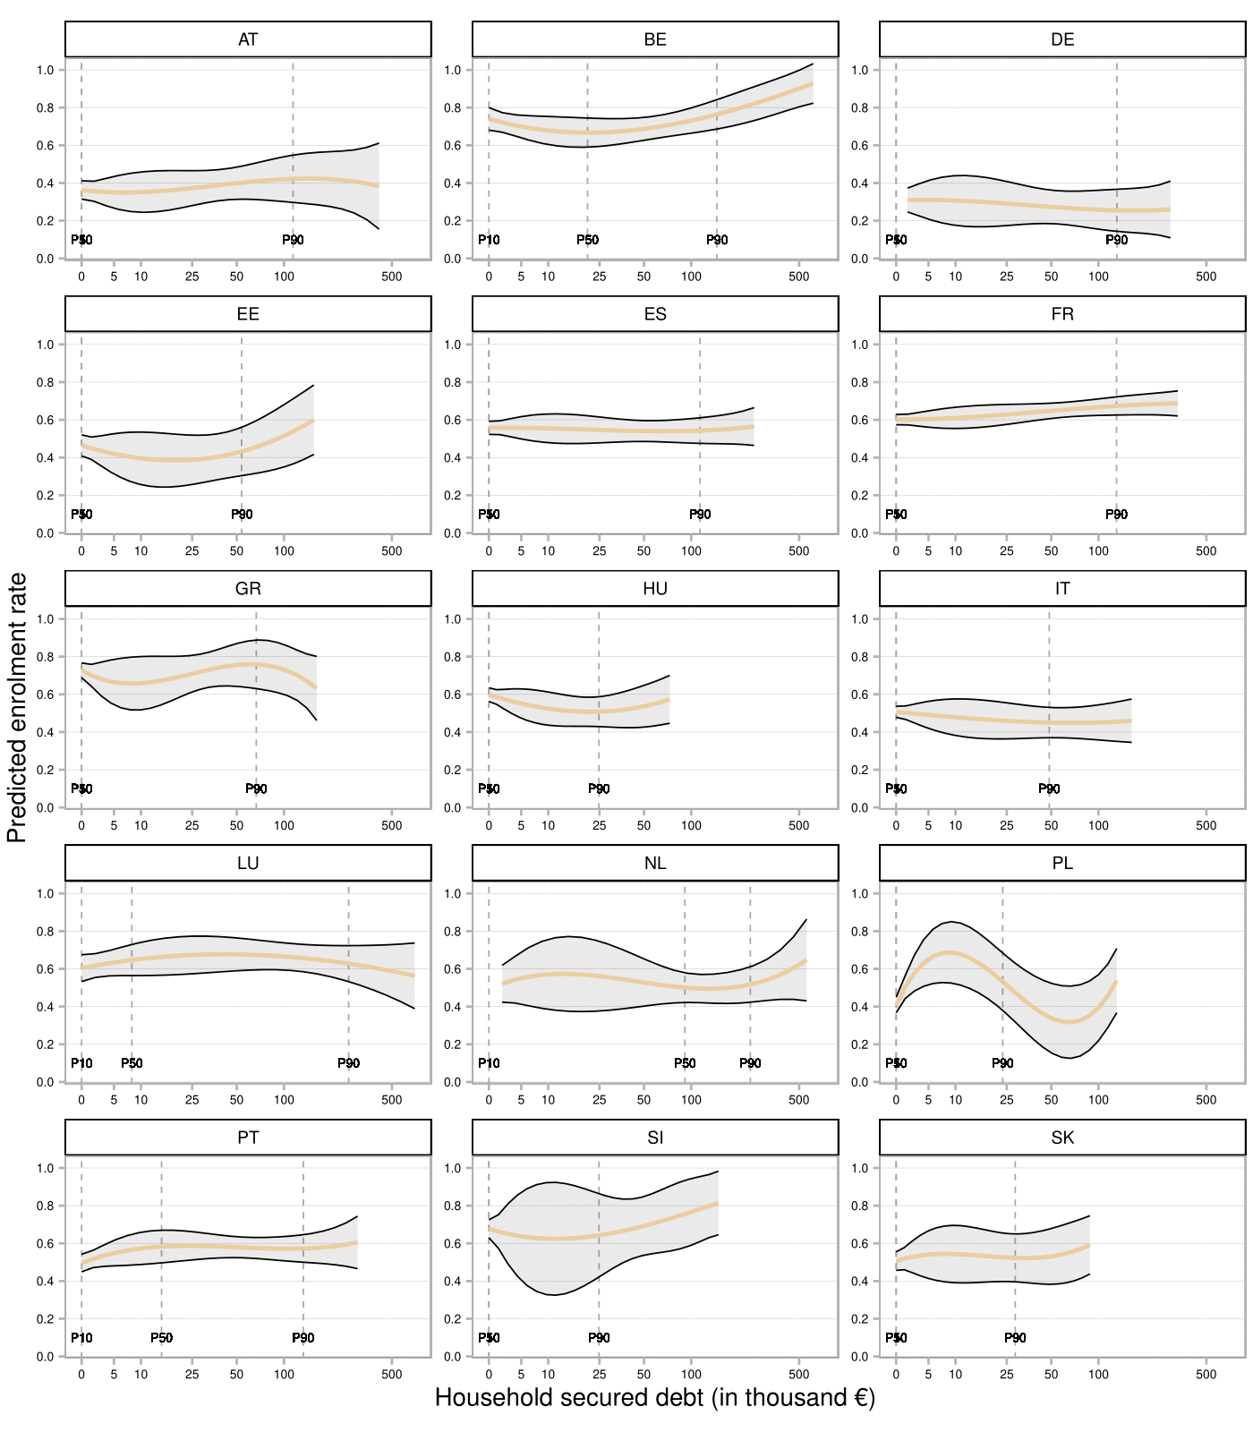

  - Figure D7. Predicted values of unsecured debt on post-secondary enrolment by country, full model specification. Vertical dashed lines refer to country-specific values of 10th, 50th, and 90th percentiles. Values are reported up to 99th percentile of country-specific distributions.
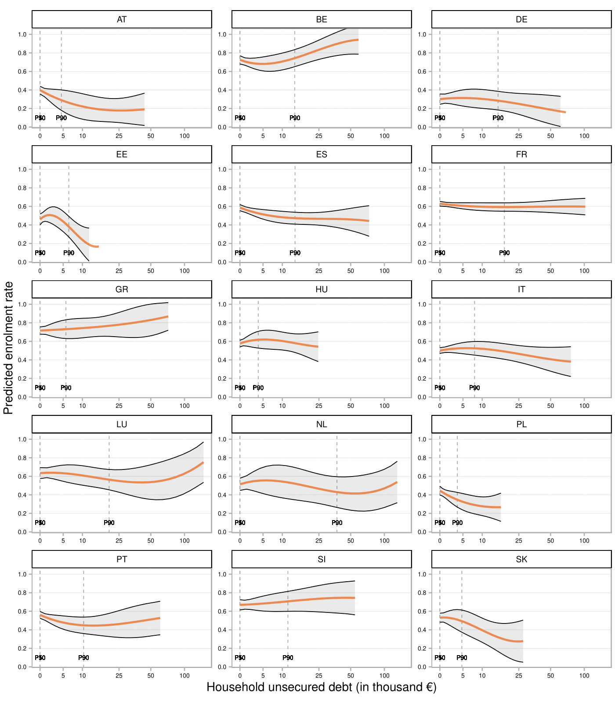

E. Robustness checks
We perform a series of robustness checks to evaluate the sensitivity of our results to the methodological choices made in the main analyses. The following graphs report on the y-axis the difference between the estimates reported in the main analyses (Full model, M3) and the estimates from the robustness analyses (same specifications as M3). We also flag whether there is a change in conventional levels of statistical significance between the two estimates. Specifically, we define a positive change if the estimates in the main analyses show a higher level of statistical significance (i.e., a lower p-value) compared to the estimates in the robustness analyses. Conversely, we define a negative change if the estimates in the main analyses show a lower level of significance (i.e., a higher p-value). The intervals for conventional levels of statistical significance are set as follows: p<0.05; 0.05>p>0.1; p>0.1.a. Counterfactual Weights vs. Observed Distributions -> to be commented
First, we assess the differences in adjusted wealth gaps between models using counterfactual weights to account for selection bias and models using the observed, unweighted distributions of variables. We expect that countries with lower levels of selection (i.e., with a lower share of individuals observed outside parental household) would show smaller differences in wealth gaps between the counterfactual and observed models compared to countries with higher levels of selection. Results from this robustness check confirmed our expectation (Figure E1), indicating that countries with low levels of selection (i.e., with a share of individuals observed outside parental household lower than 5%) exhibit a smaller average difference (1 percentage point) and only 2.4% of changes in significance levels, compared to countries with moderate (Δ=2.59 percentage points, 19% of changes) and high levels of selection (Δ=2.03 percentage points, 16.6% of changes).
b. Marginal Odds Ratios (MOR)
Second, we assess the extent to which the magnitude of differences in predicted probabilities is dependent on the country-specific average enrolment rates by computing marginal odds ratios (MOR) (Holm, Ejrnæs, and Karlson 2015; Karlson and Jann, 2023). To facilitate comparisons with differences in predicted probabilities, we express MOR on a linear scale by applying a natural logarithmic transformation to MOR (lnMOR; Karlson and Jann, 2023). The results show little difference between estimates calculated using differences in predicted probabilities and marginal odds ratios, both in terms of country rankings and relative effect sizes (Figure E2).
c. Household vs. Per Capita Wealth and Debt Measures
Third, we check whether the definition of wealth and debt variables measured as household values leads to significant differences in p10-p90 wealth gaps compared to defining these measures in per capita terms. Differences in effect sizes are generally small (Figure E2), with average changes in wealth gaps ranging from 1.4 percentage points for gross wealth to 2.02 for real wealth. Changes in significance levels are limited (7.6% of total country-component estimates), ranging from 0 to a maximum of 2 countries reporting differences in significance levels within each component. Both positive and negative changes in significance levels and effect sizes are observed, indicating that the adopted definitions do not systematically under- or overestimate wealth gaps.
d. Linear Probability Model (LPM) vs. Logit Model
Fourth, we test whether the choice of a LPM resulted in significant differences in wealth gaps compared to a Logit model (Figure E3). Differences in effect sizes are minimal, with average change ranges ranging between 0.6 and 1.3 percentage points. Changes in significance levels are limited to a few countries (8.5%) with a maximum of 3 changes for net wealth. Both positive and negative changes are observed.
e. Interval Selection for Computing Wealth Gaps
Fifth, we evaluate the sensitivity of our results to the choice of the interval selected for computing wealth gaps (p10 vs p90), by also reporting wealth gaps between p20 and p80. Figure E4 presents the change in effect sizes and significance levels between wealth gaps computed with p10 vs p90, and p20 vs p80 intervals. As expected, changes in the effect size are larger compared to previous robustness checks, since different points of the distribution are compared. The average difference in wealth gaps ranges from 1.1 percentage points for financial wealth to 7.9 for real wealth. Changes in significance levels are more pronounced (27.6% of estimates), with no change for financial wealth, and a maximum of 7 changes for real wealth. In addition to providing a robustness check, this result reports that real wealth gaps are more pronounced at the extremes of the wealth distribution, while they show a similar pattern to financial wealth when gaps are calculated between less extreme points of the distribution (P20-P80). Wealth and debt variables exhibit different patterns: for net, gross and real wealth, p20-p80 gaps are generally smaller as compared to p10-p90 gaps, whereas debt variables show both positive and negative differences.
f. Absolute vs. Relative Wealth Measures
Sixth, we assess whether our results are robust to alternative definitions of wealth variables by comparing absolute measures (using IHS transformations) with relative measures using rank transformations. Results show slight differences between the two operationalisations (Figure E5), with average differences ranging between 1.4 (financial wealth) and 4.6 (real wealth) percentage points. Changes in significance levels are limited to 10.4% of the estimates, with a maximum of 4 changes.
g. Sensitivity to θ Parameter in IHS Transformation
We also check the sensitivity of our results to the definition of the θ parameter in the IHS transformation. Different values of θ imply different distributional assumptions, with values of θ close to 1 approximating a natural logarithmic transformation and values close to 0 approximating a linear scale (Pence, 2006; Aihounton & Henningsen (2021). We compare an IHS transformation with θ=0.0001 (main analyses) to one with θ=0.001. Results (Figure E6) show minimal differences, with average differences ranging from 1.1 (debt) to 2 (financial wealth) percentage points, and changes in significance levels affecting 11.4% of estimates.
h. Controlling for mother’s and father’s SES separately
Additionally, we check whether the estimates are sensitive to the operationalisation of parental education and social class through the dominance criterion by specifying models with maternal and paternal education and social class separately. As 19.5% of individuals live in single-parent household, we treat them as having two parents with the same education and social class and add a dummy to control for this to avoid dropping them from the analytical sample. The comparison between the two model specifications (dominance in the main analyses vs separate parental SES variables in the robustness) show small differences in the variation of wealth gaps, with a maximum difference of 1.8 percentage points for real wealth (Figure E8). The variation in the levels of statistical significance affects 12.3% of country estimates, but it is mostly a consequence of the increased number of degrees of freedom in the model for countries with a small sample size.

i. Distinguishing between business and property real wealth
Finally, we perform additional analyses by decomposing real wealth into business assets and property assets (i.e., housing assets and valuables). Indeed, business assets may influence the enrolment decision through different mechanisms compared to housing assets, as business assets entail higher risks and may increase the opportunity cost of enrolling in post-secondary education by providing direct access to the labour market through the family business. Furthermore, as business assets are concentrated at the top of the wealth distribution, the adoption of an aggregate measure of real wealth may simply reflect the difference in the composition of wealth between different parts of the distribution. Results from figure E9 show that separating business assets from property assets does not change substantially the results. Indeed, gaps for business assets are small and almost not significant and gaps for real assets and property assets are fully equivalent in both models specified (M1 and M2).
These robustness checks confirm the stability of our findings and indicate that our methodological choices do not systematically bias our results.

  - Figure E1. Differences in adjusted wealth gaps between models with counterfactual weights (reference, used in the main analyses), and observed distributions.
  - 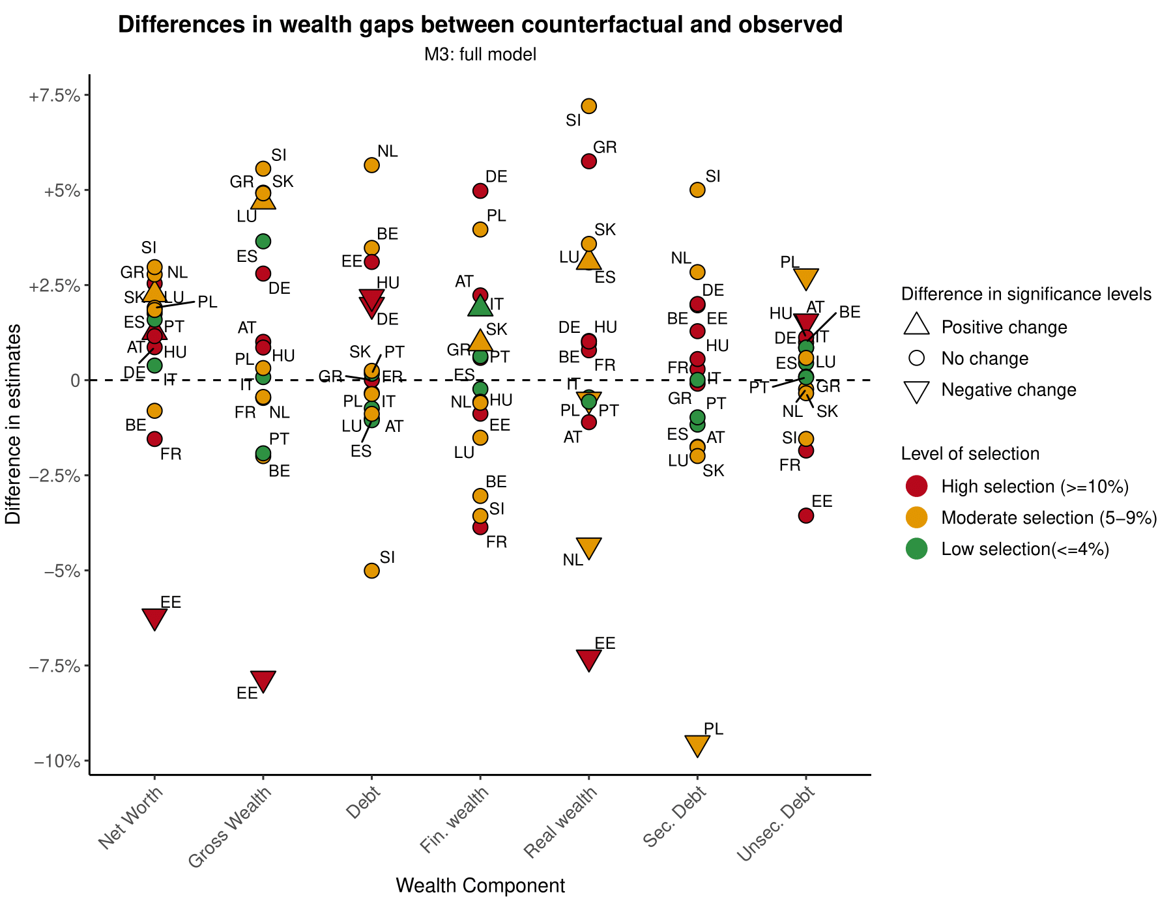
Level of selection | Low selection  (<5%) | Moderate selection (5-9%) | High selection  (>=10%)
Average absolute difference (pp %) | 1.0 | 2.59 | 2.03
% changes in significance levels | 2.4% | 19.0% | 16.6%

  - Figure E2. Adjusted wealth gaps with estimates computed as differences in P10-P90 predicted probabilities and (ln) Marginal Odds Ratio.
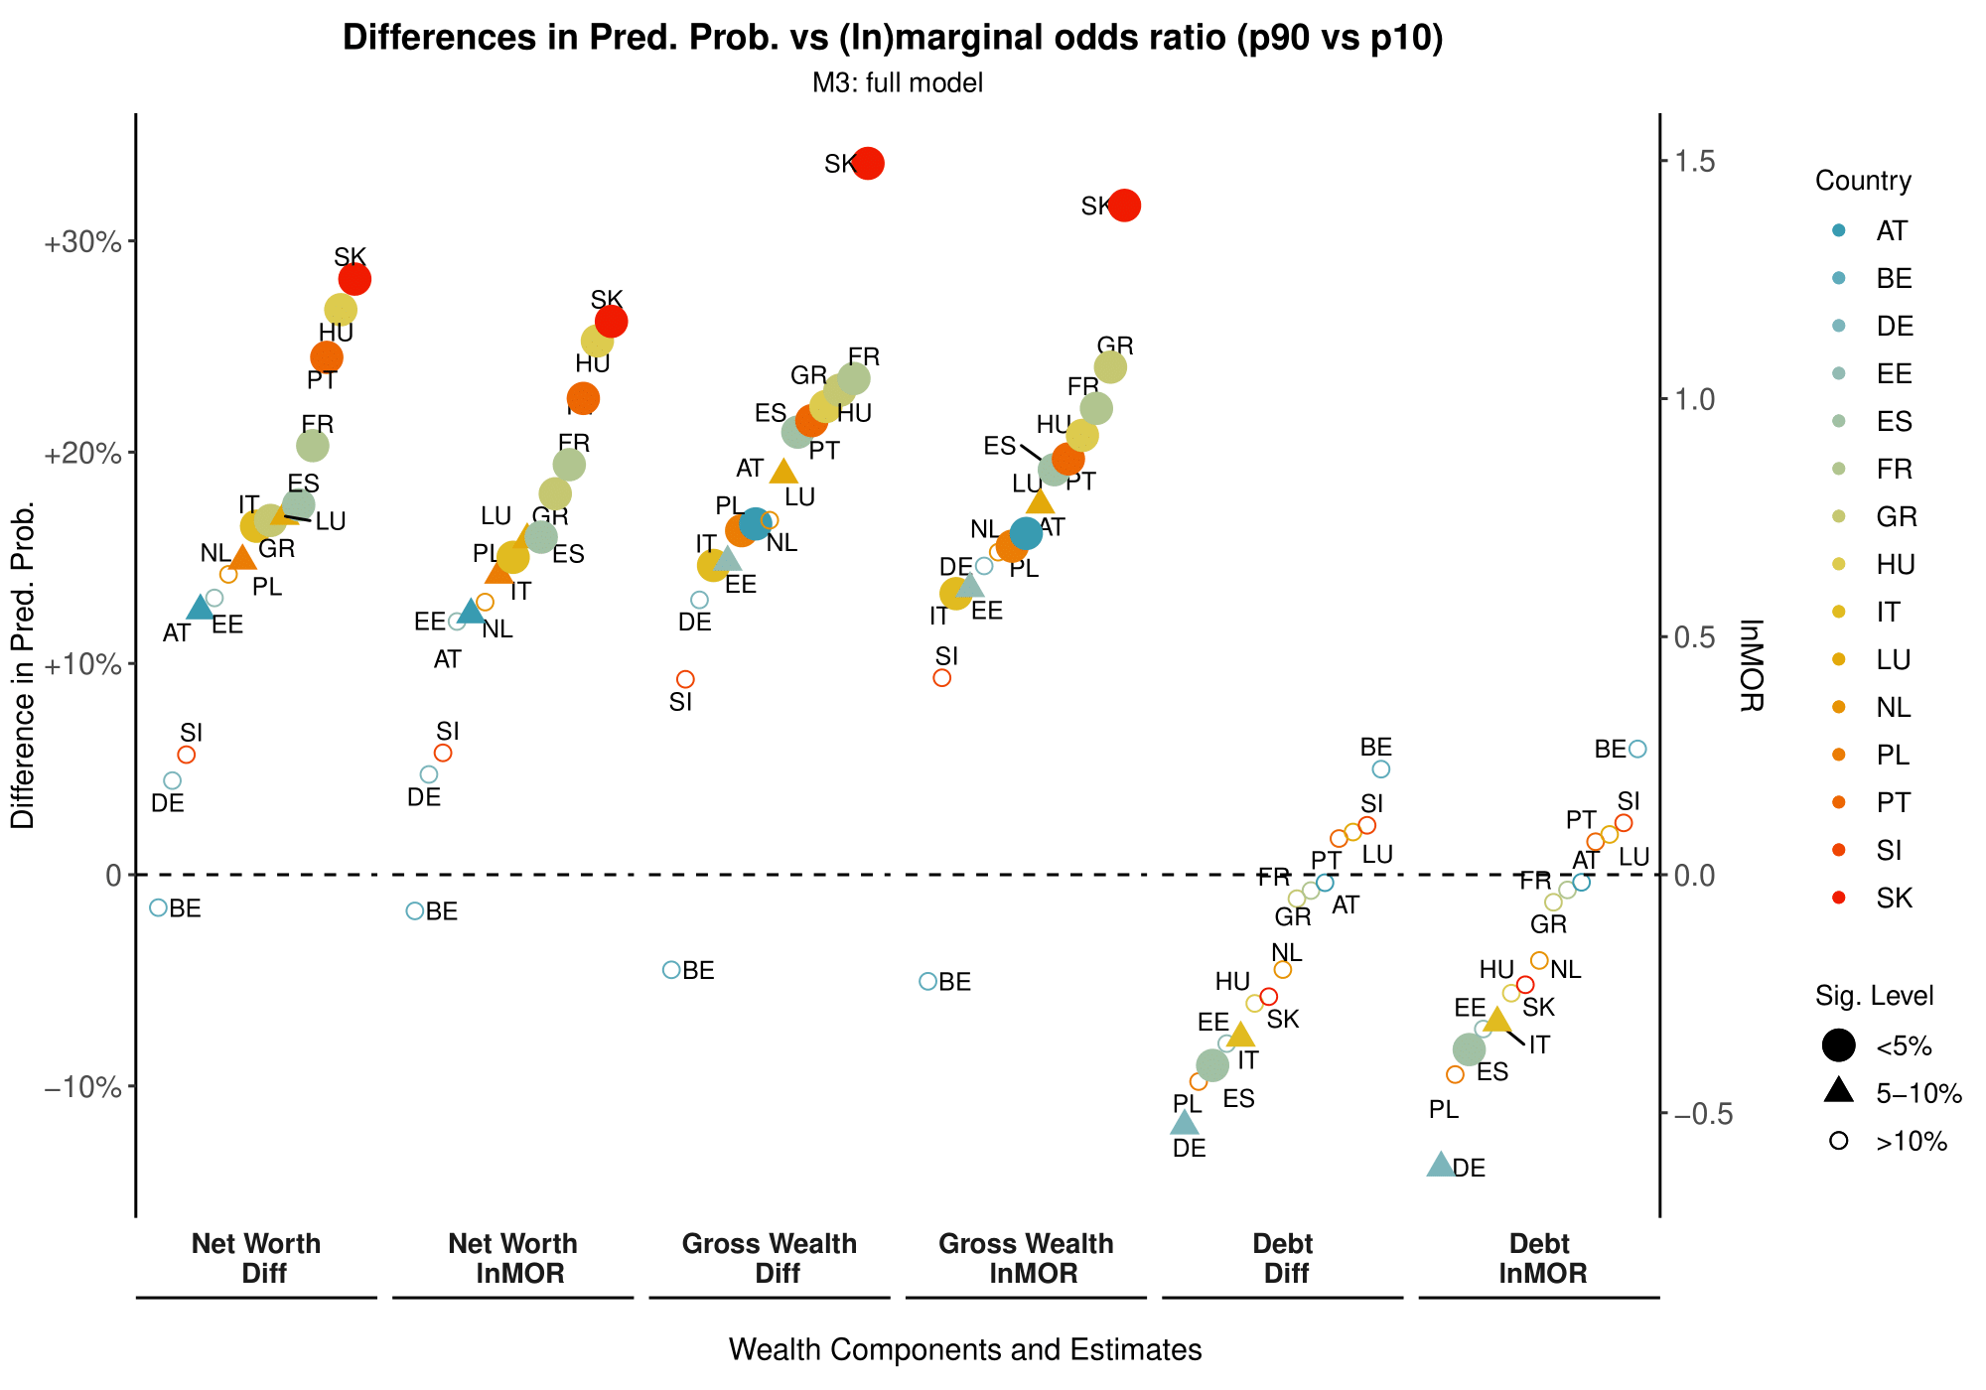
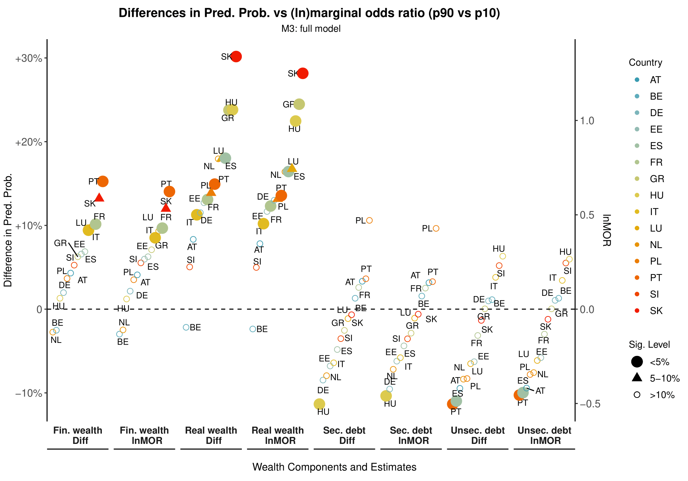

  - Figure E3. Differences in adjusted wealth gaps between models with household-level measures (reference, used in the main analyses), and per capita measures of wealth and debt components.
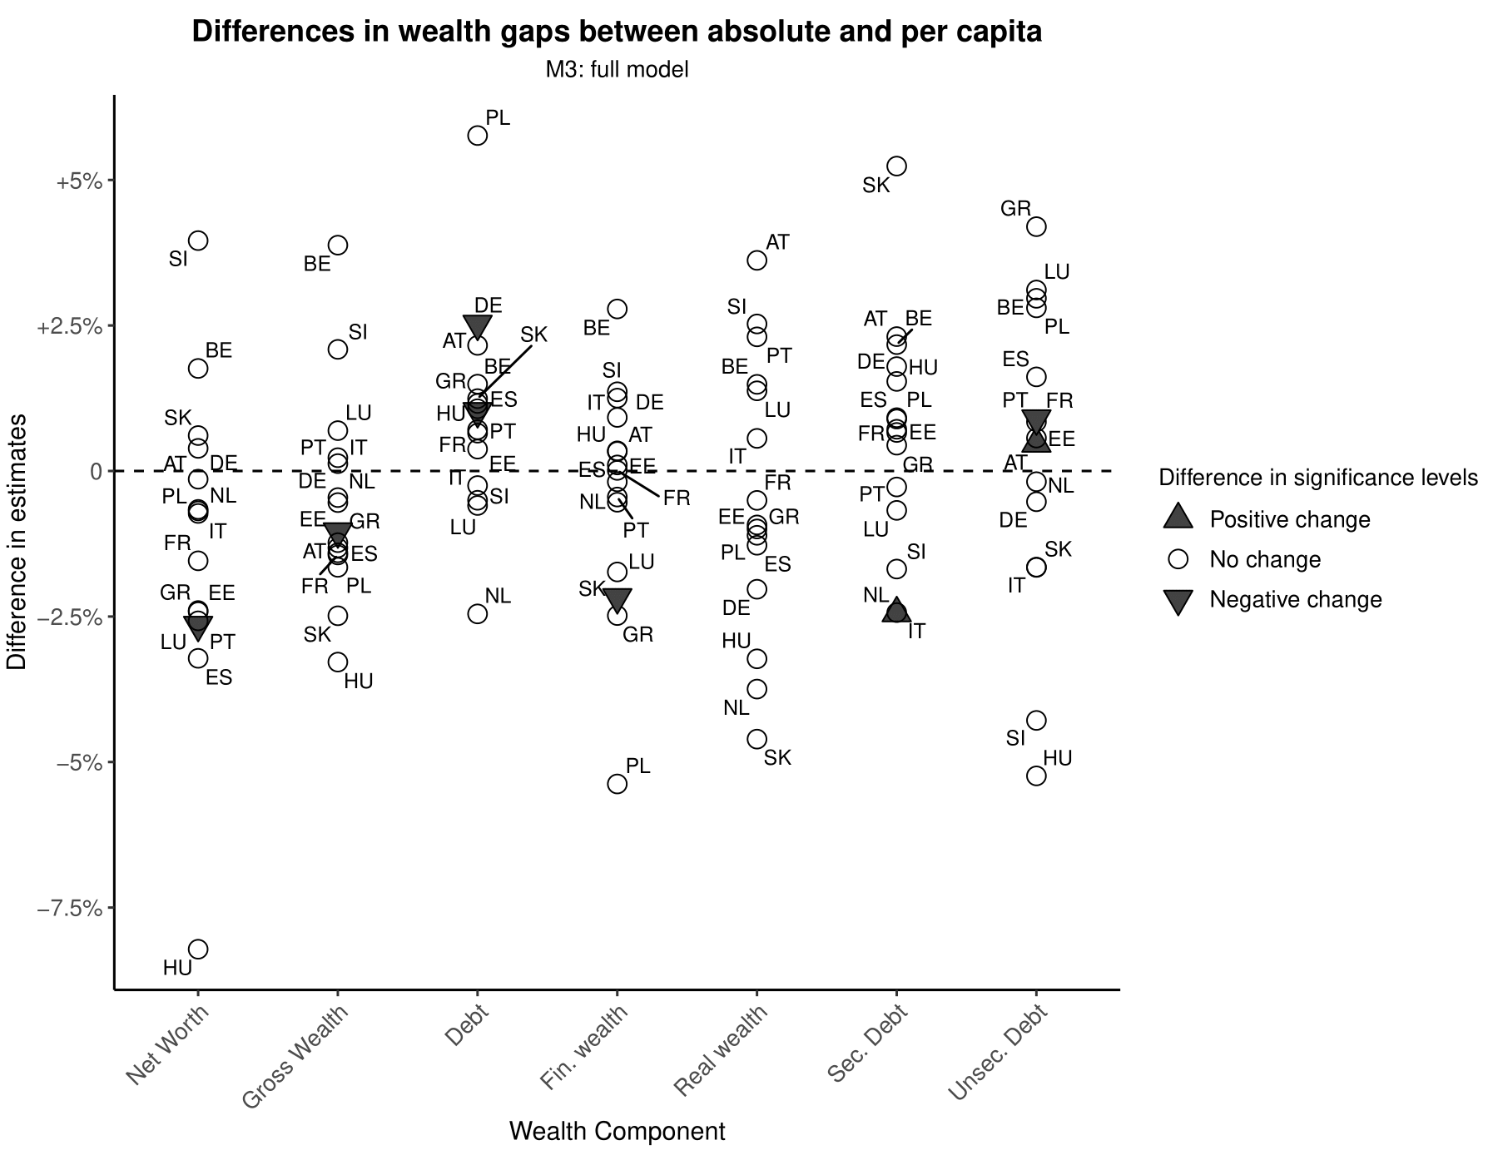
Wealth component | Net wealth | Gross wealth | Debt | Financial wealth | Real wealth | Secured debt | Unsecured debt
Average absolute difference (pp %) | 2.13 | 1.46 | 1.47 | 1.34 | 2.02 | 1.61 | 2.07
N° change in significance levels | 1 | 1 | 2 | 1 | 0 | 1 | 2

  - Figure E4. Differences in adjusted wealth gaps estimated through LPM (reference, used in the main analyses), and logistic regression models.
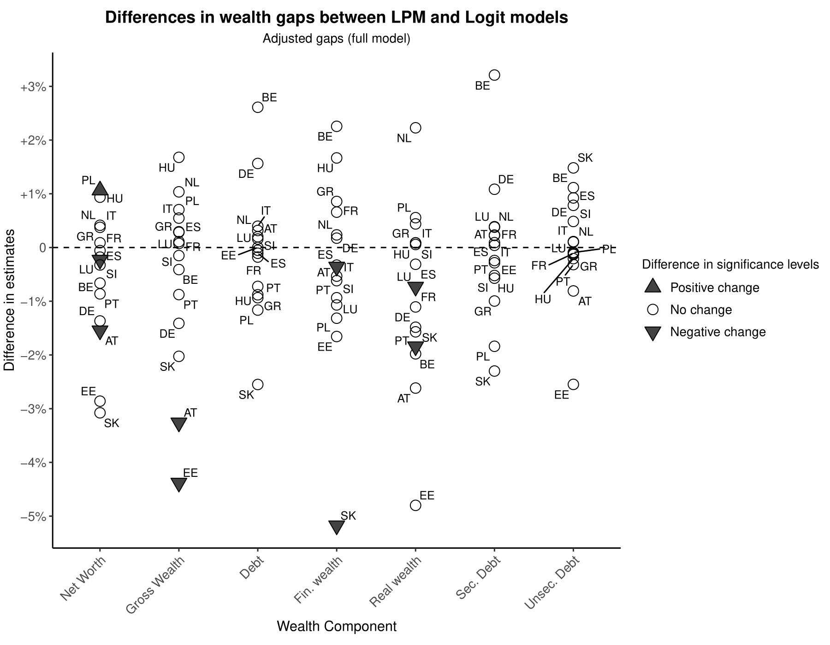
Wealth component | Net wealth | Gross wealth | Debt | Financial wealth | Real wealth | Secured debt | Unsecured debt
Average absolute difference (pp %) | 0.94 | 1.15 | 0.79 | 1.19 | 1.33 | 0.83 | 0.62
N° change in significance levels | 3 | 2 | 0 | 2 | 2 | 0 | 0

  - Figure E5. Differences in adjusted wealth gaps between p10 vs p90 (reference, used in the main analyses), and p20 vs p80.
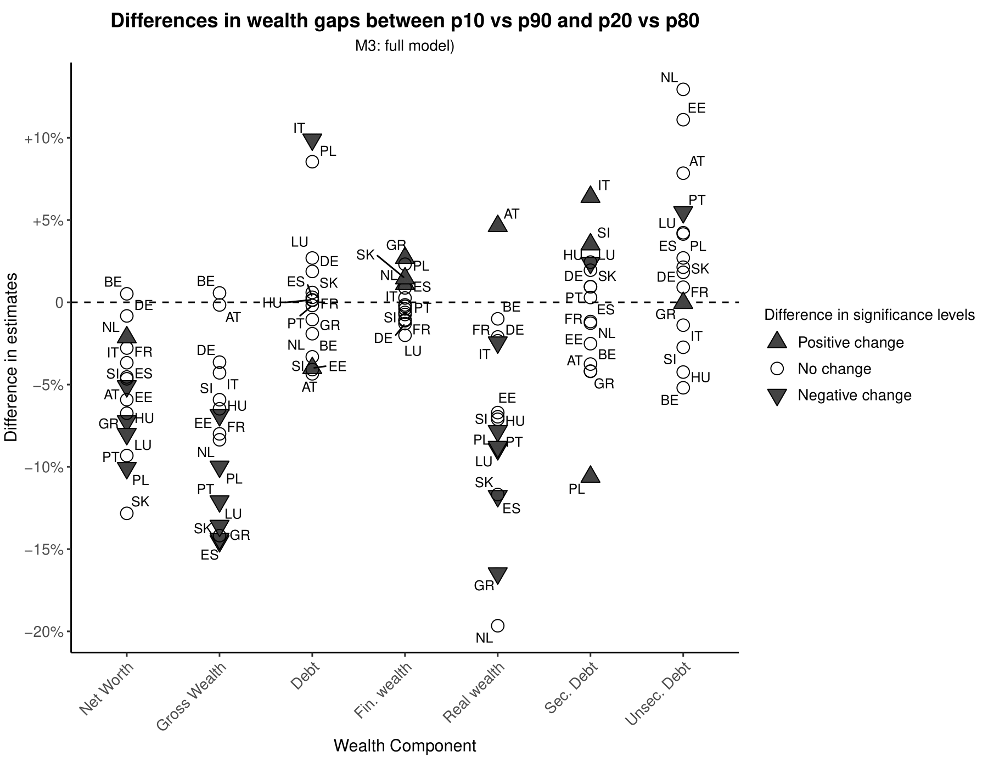
Wealth component | Net wealth | Gross wealth | Debt | Financial wealth | Real wealth | Secured debt | Unsecured debt
Average absolute difference (pp %) | 5.62 | 8.20 | 2.87 | 1.09 | 7.89 | 3.11 | 4.46
N° positive change in significance levels | 1 | 0 | 1 | 3 | 1 | 3 | 1
N° negative change in significance levels | 4 | 6 | 1 | 0 | 6 | 1 | 1

  - Figure E6. Differences in adjusted wealth gaps between IHS transformation of wealth (reference, used in the main analyses), and rank transformation.
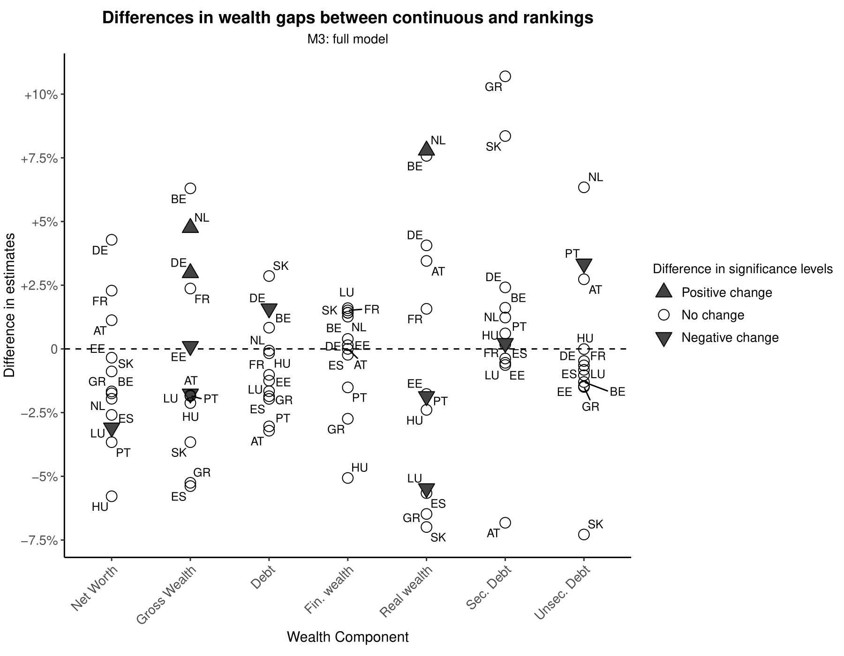
Wealth component | Net wealth | Gross wealth | Debt | Financial wealth | Real wealth | Secured debt | Unsecured debt
Average absolute difference (pp %) | 2.45 | 3.20 | 1.63 | 1.44 | 4.59 | 2.81 | 2.25
N° change in significance levels | 1 | 4 | 1 | 0 | 3 | 1 | 1

  - Figure E7. Differences in adjusted wealth gaps between IHS transformation of wealth with θ=0.0001 (reference, used in the main analyses), and θ=0.001.
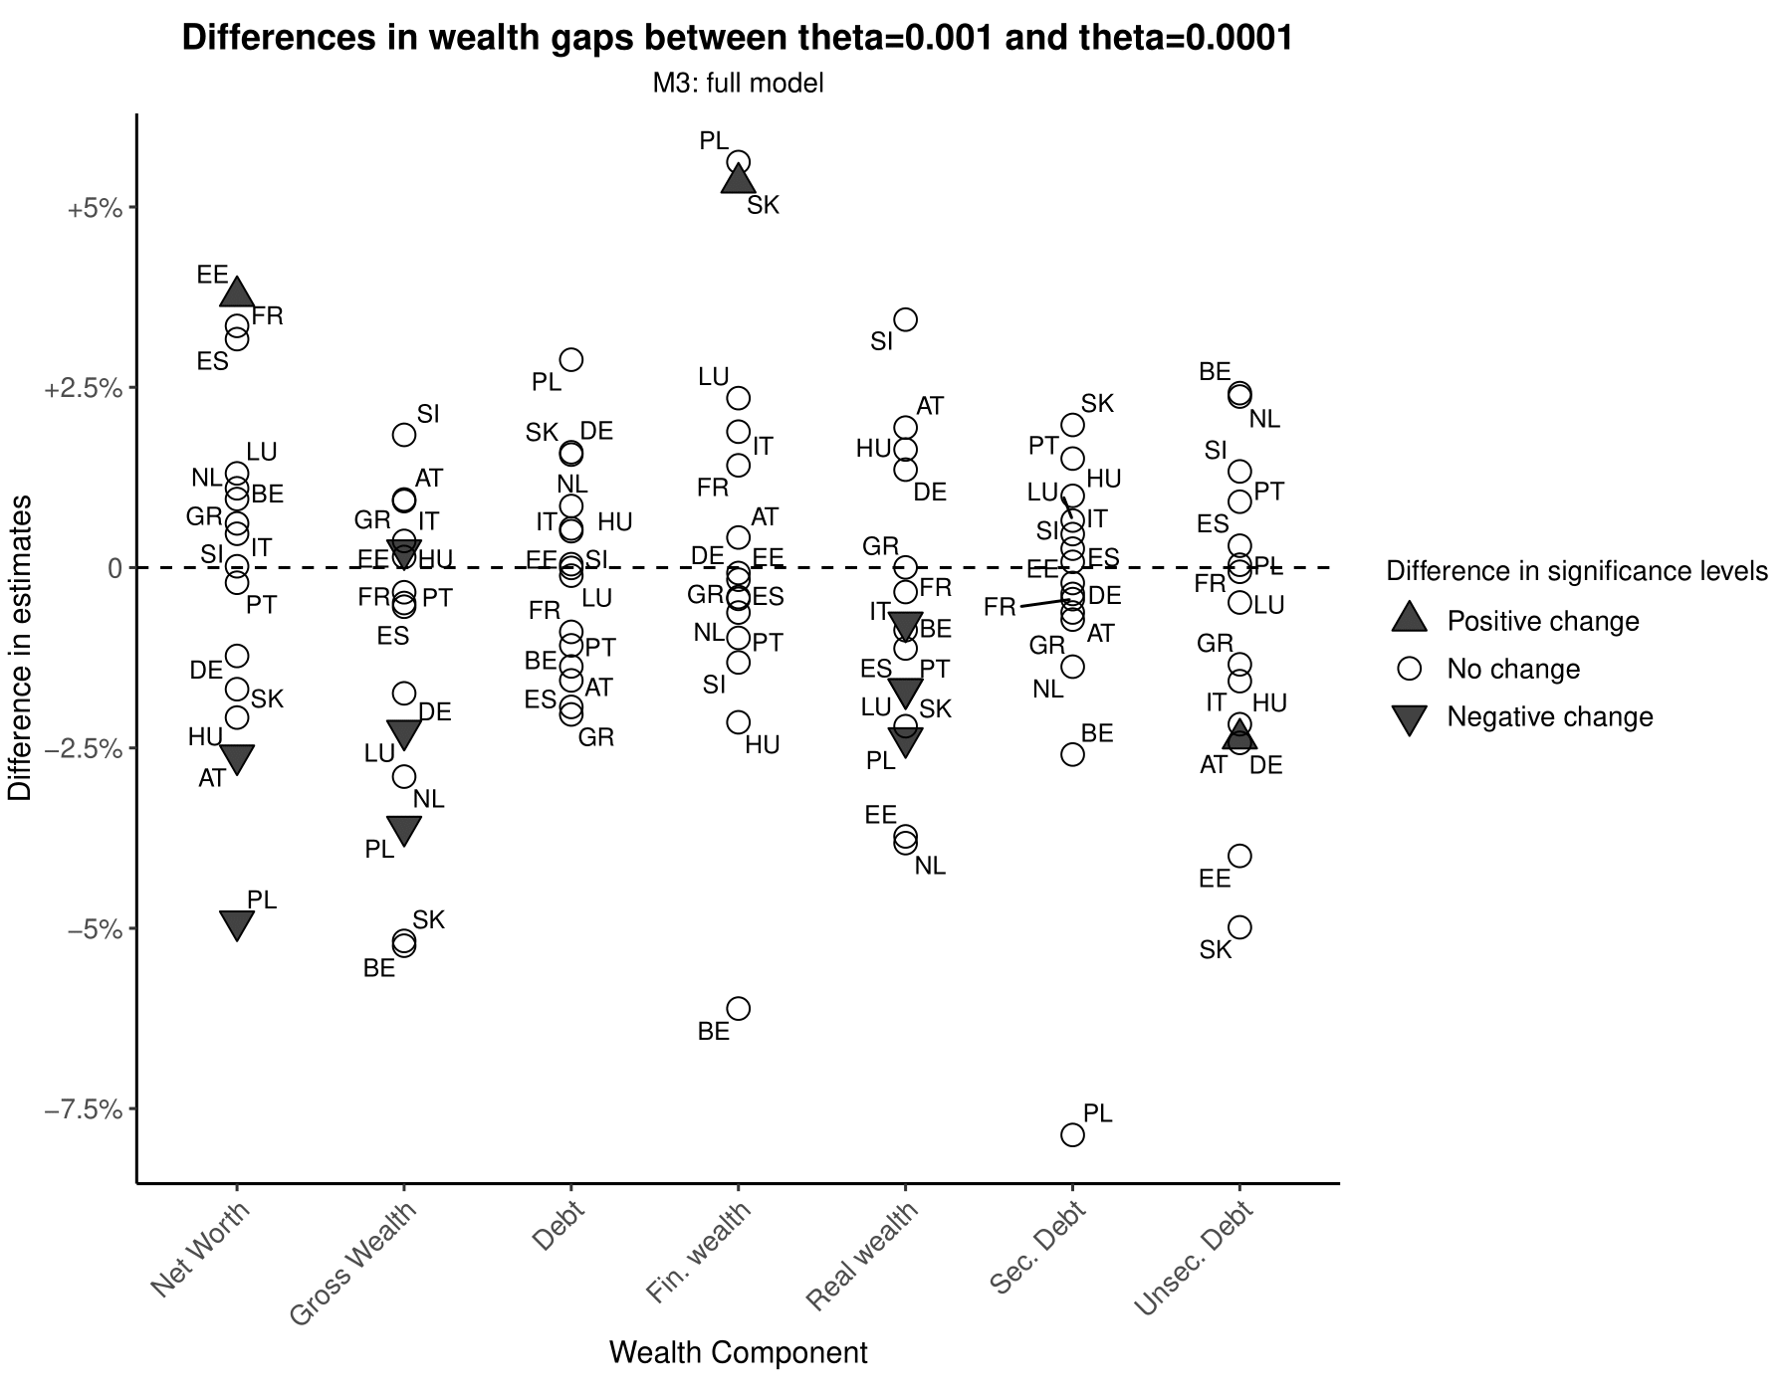
Wealth component | Net wealth | Gross wealth | Debt | Financial wealth | Real wealth | Secured debt | Unsecured debt
Average absolute difference (pp %) | 1.83 | 1.78 | 1.13 | 1.95 | 1.80 | 1.34 | 1.79
N° change in significance levels | 3 | 3 | 0 | 1 | 4 | 0 | 1

  - Figure E8. Differences in adjusted wealth gaps between model specifications with dominance criterion for parental education and social class (reference, used in the main analyses), and models with both parents’ education and social class.
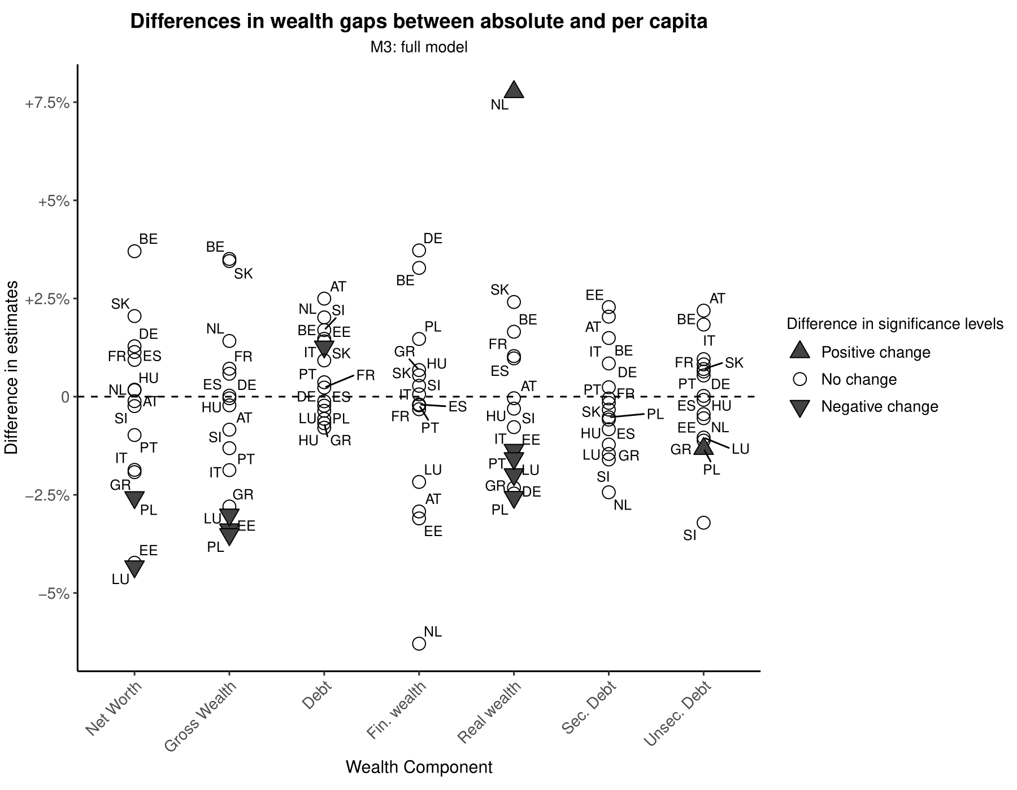
Wealth component | Net wealth | Gross wealth | Debt | Financial wealth | Real wealth | Secured debt | Unsecured debt
Average absolute difference (pp %) | 1.64 | 1.75 | 0.94 | 1.73 | 1.80 | 1.03 | 0.95
N° change in significance levels | 3 | 3 | 1 | 0 | 5 | 0 | 1

Figure E9. Adjusted wealth gaps (p90 vs p10) by country for real, business and property assets. Sampling and counterfactual weights are specified. SE are estimated through Rubin's rule. NA values are given for countries where less than 90% of observations have business assets.
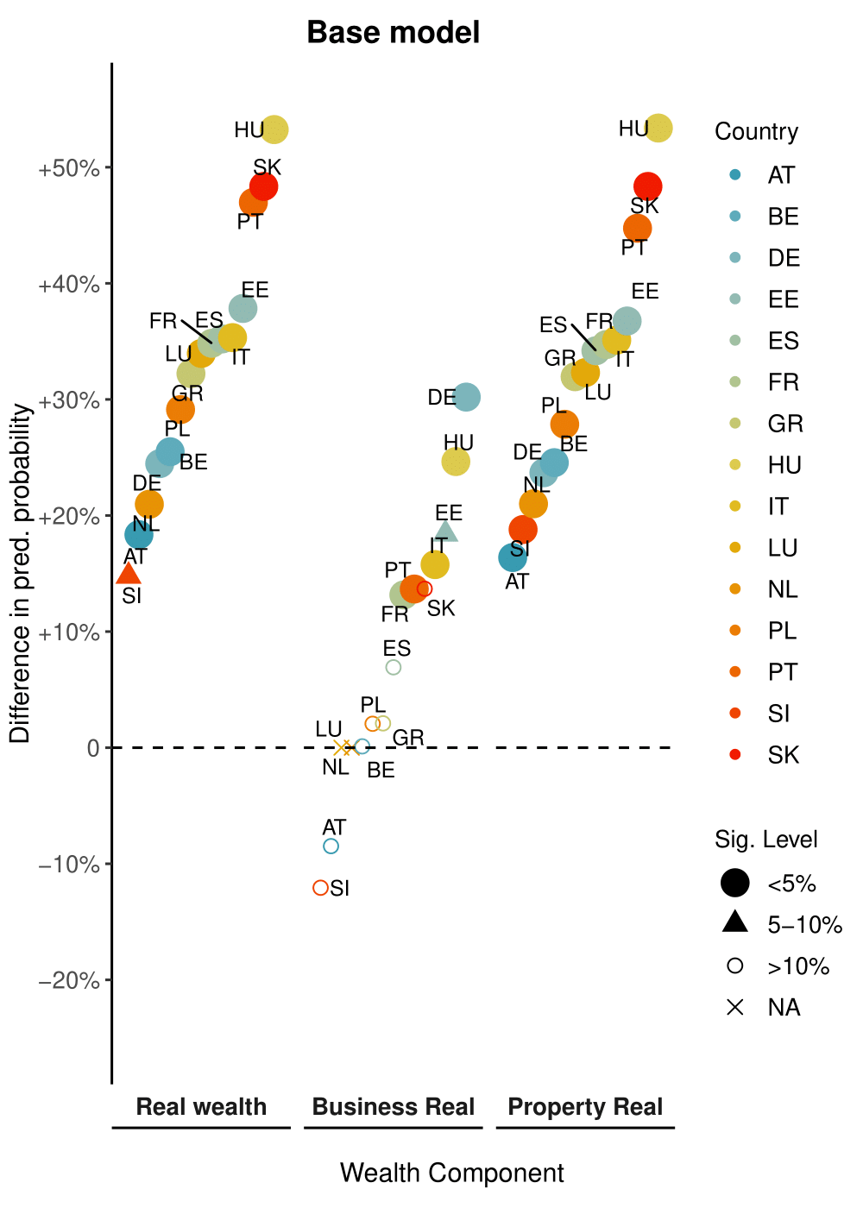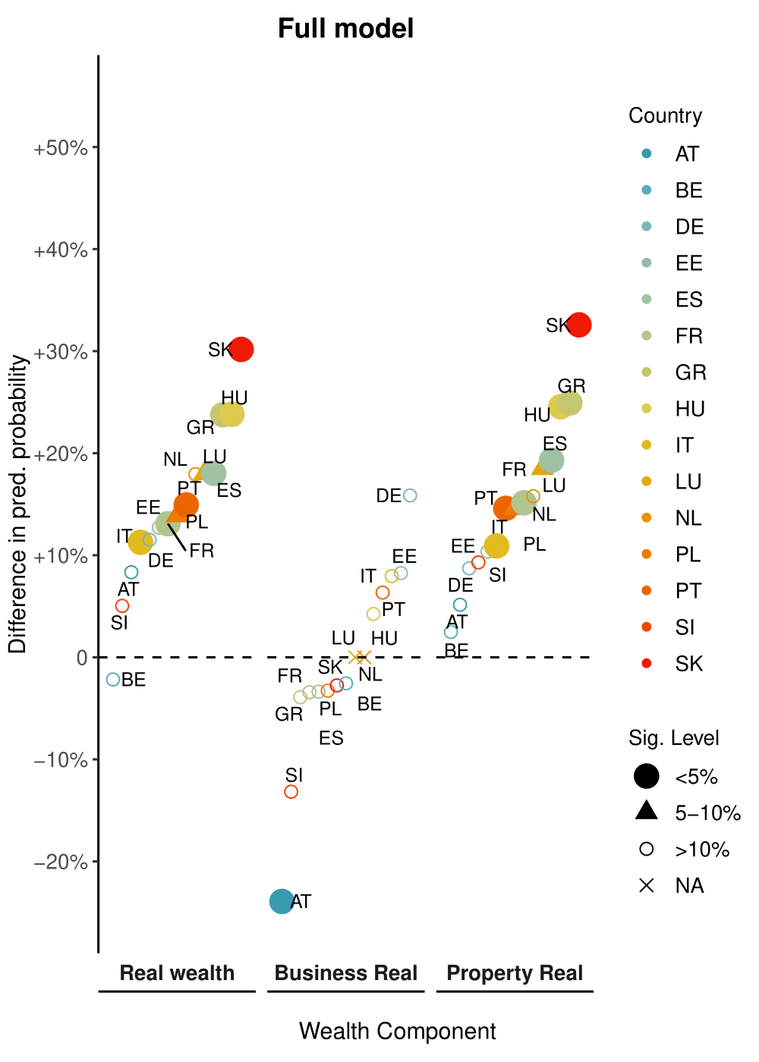

F. Alternative figures

  - Figure F1. Wealth gaps (p90 vs p10) adjusted for parental SES by country, and by wealth and debt components. Sampling and counterfactual weights are specified. SE are estimated through Rubin's rule.
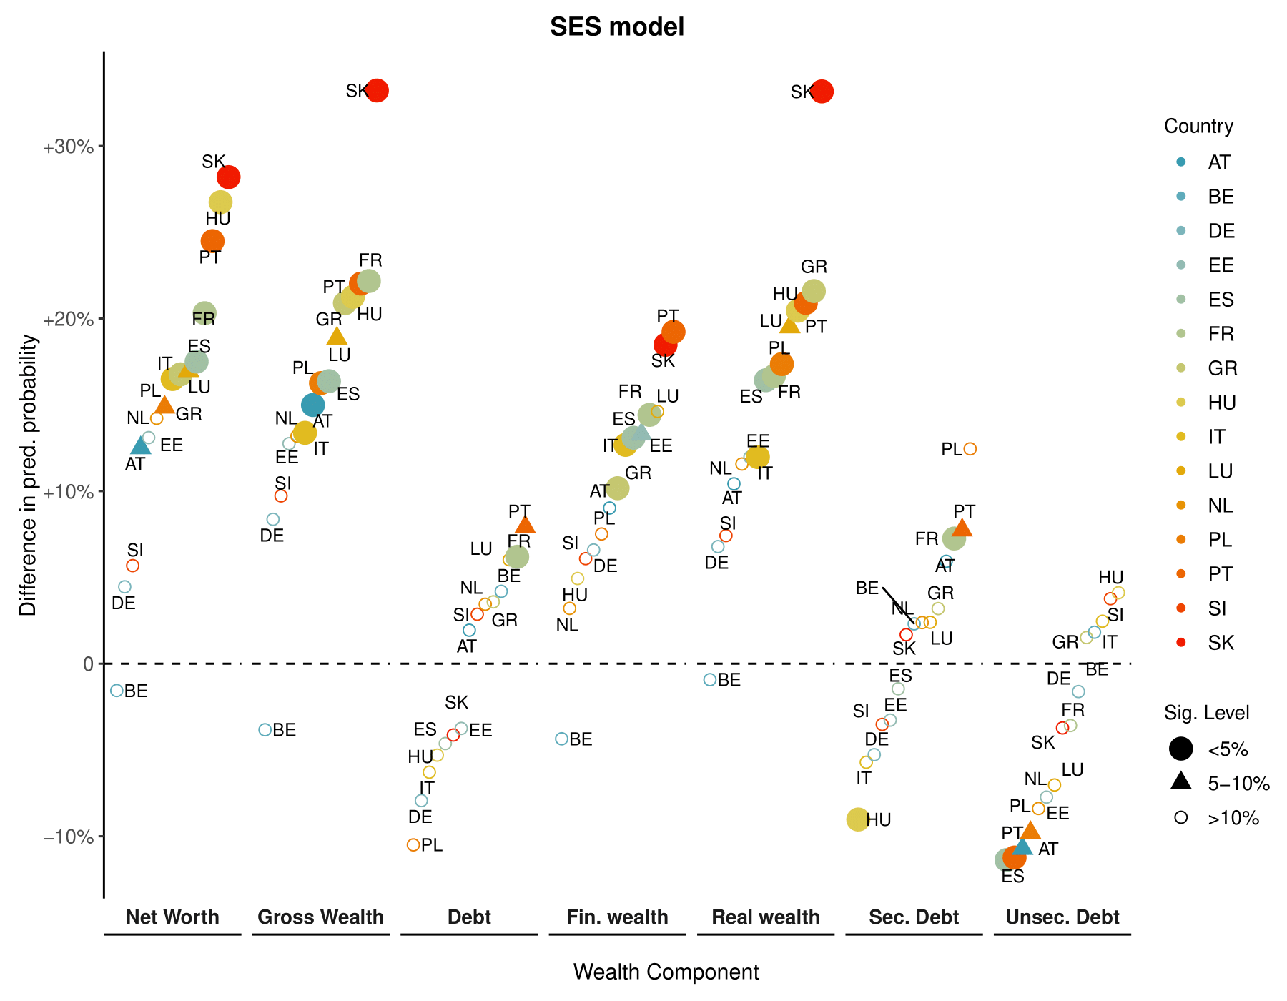
Table F1. Average absolute gaps, average gaps, and number of country estimates with significance levels with p<0.1 and p<0.05, computed from SES model by wealth component.
Wealth component | Net wealth | Gross wealth | Debt | Financial wealth | Real wealth | Secured debt | Unsecured debt
Average absolute gap (pp %) | 15.6 | 16.5 | 5.2 | 10.5 | 15.1 | 4.9 | 5.9
Average net gap (pp %) | 15.4 | 16 | -0.4 | 9.9 | 15.0 | 1.1 | -4.1
N° countries with p<0.1 | 10 | 10 | 2 | 7 | 9 | 3 | 4
N° countries with p<0.05 | 7 | 9 | 1 | 6 | 8 | 2 | 2

  - Figure F2. Wealth gaps (p90 vs p10, M1: baseline model) by country, wealth, and debt components, without counterfactual weights.
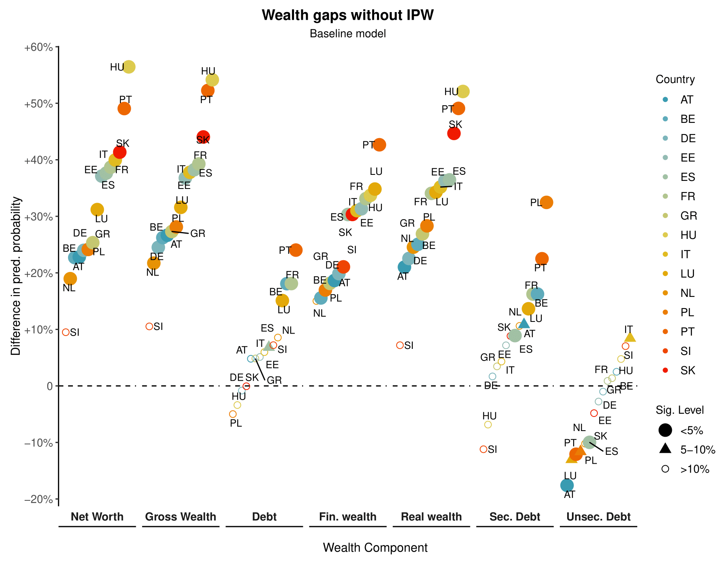
  - Figure F3. Wealth gaps (p90 vs p10, M2: full model) by country, wealth, and debt components, without counterfactual weights.
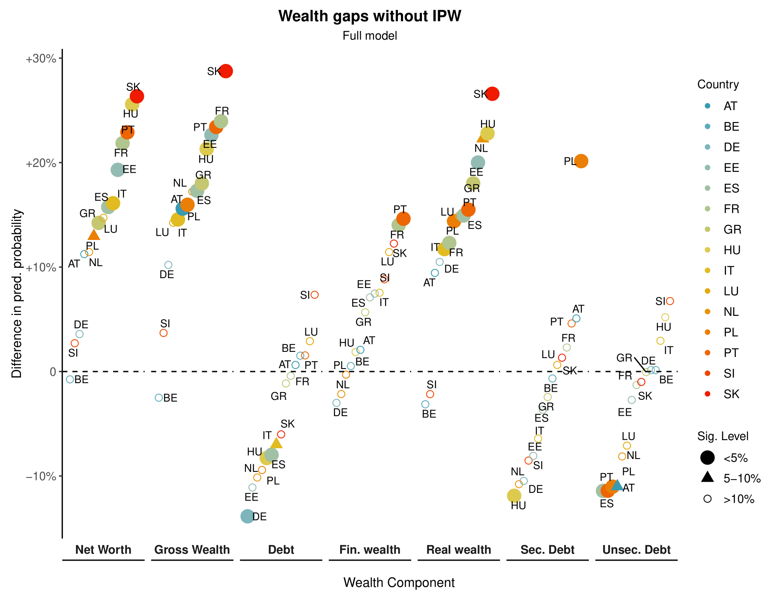

Observed and counterfactual distributions for the other wealth components are available on request.
In case of France missing values of wealth are imputed via multiple imputation in the first wave (2009), and via single imputation in the second, third, and fourth waves (2014, 2017, 2020).
In case of Italy, missing values imputed through single imputation are not reported nor flagged.
In case of France missing values of wealth are imputed via multiple imputation in the first wave (2009), and via single imputation in the second and third waves (2014, 2017).
In case of Italy, missing values imputed through single imputation are not reported nor flagged.

