Supporting Information
In this document we provide additional information about:
- The size of the operational warning areas (WAs) used by the Department of Civil Protection in Italy. For this study, the algorithm retains only WAs with an area greater than 1,000 km², without verifying whether the excluded WAs are spatially contiguous. Of the 156 WAs covering the entire Italian territory, the majority (75%) exceed this threshold. A total of 40 WAs are smaller than 1,000 km², and their spatial distribution is shown in Figure S1. Among the 1,534 extreme precipitation events (EPEs) identified during the study period (November 1984 – October 2024), only 30 exceed the 1,000 km² threshold due to the aggregation of multiple smaller WAs. Therefore, this limitation is not expected to significantly impact our results.

- Comparison of Precipitation Datasets for Extreme Precipitation Events (EPEs) over Central-Northern Italy. We compared four precipitation datasets—ArCIS, MSWEP, CERRA, and CERRA-Land—in terms of their ability to represent Extreme Precipitation Events (EPEs) over Central-Northern Italy (Figure S2, Table S1). Although CERRA-Land exhibited performance comparable to CERRA in terms of EPE detection—as indicated by similar percentages of overlapping extreme days with ArCIS—it was excluded from the final analysis due to concerns related to trend reliability. In particular, the limited spatial coverage and station density within the Italian territory were found to be insufficient to robustly support the analysis of extremes. This limitation is evident in the presence of trend patterns over Northern Italy that are inconsistent with those derived from ArCIS. Based on these considerations, we selected CERRA for the extended analysis across the entire Italian territory. Additionally, the composite map of Z500 and mean sea level pressure (mSLP) from the 2x2 self-organizing map (SOM) clustering for ArCIS over Central-Northern Italy is shown in Figure S3.

- Robustness of WTs patterns. To evaluate the robustness of the SOM algorithm in identifying coherent atmospheric patterns, we construct signal-to-noise (S2N) maps (Figure S4). These maps are generated by computing the composite anomalies of Z500 and mean sea level pressure (mSLP) for each node and dividing them by the corresponding intra-node standard deviation. Higher absolute S2N values indicate stronger agreement among the individual anomaly maps associated with a given node, thereby highlighting regions of increased pattern consistency.

- Seasonal decomposition of EPEs trend analysis. To evaluate the presence of seasonal trends, we compute the seasonal decomposition of EPE occurrences by dividing the annual number of events into the four climatological seasons (DJF, MAM, JJA, SON) and calculating linear trends over the complete study period (1985–2023). Here, we present results for WT4 (Figure S5) and WT6 (Figure S6) only, as WT4 exhibited a statistically significant annual trend, while WT6 is the only weather type displaying a statistically significant seasonal trend (p-value < 0.05).

- Trend analysis of the number of days with atmospheric flow analog to WTs. We apply the SOM, previously trained on extreme days, to the full set of daily data. This means that for each extreme WT category, we compute the maximum Euclidean distance (radius) from the SOM node across all associated EPEs. We then define the 25th percentile of these distances as a threshold, representing the maximum acceptable radius for associating a given synoptic configuration with a specific WT. The use of a relatively small threshold is motivated by the aim of selecting days that closely resemble the composite circulation structure of each WT. Only days falling within this 25th percentile radius are retained for the trend analysis. In practice, a day is considered an analogue to a given WT if the root mean square error (i.e., Euclidean distance) between the combined MSLP and Z500 anomalies of that day and those of the SOM node is smaller than a given threshold. This threshold is set as the 25th percentile of the Euclidean distances computed for all EPE days assigned to that node by the SOM. If a day is found to be similar to more than one WT, it is assigned to the one with the smallest Euclidean distance. The choice of a low percentile threshold is motivated by the aim of selecting only those days that closely resemble the average characteristics of the node. Results of the trend analysis is shown in Figure S7-S8.

Operational warning Areas
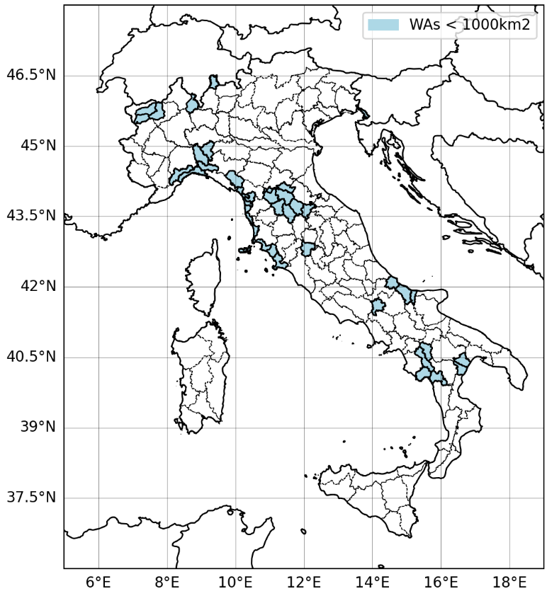
Figure S1 – The 156 operational Warning Areas (WAs) across the entire Italian territory. The areas colored in blue represent those with a surface area smaller than 1,000 km².
Comparison of Precipitation Datasets
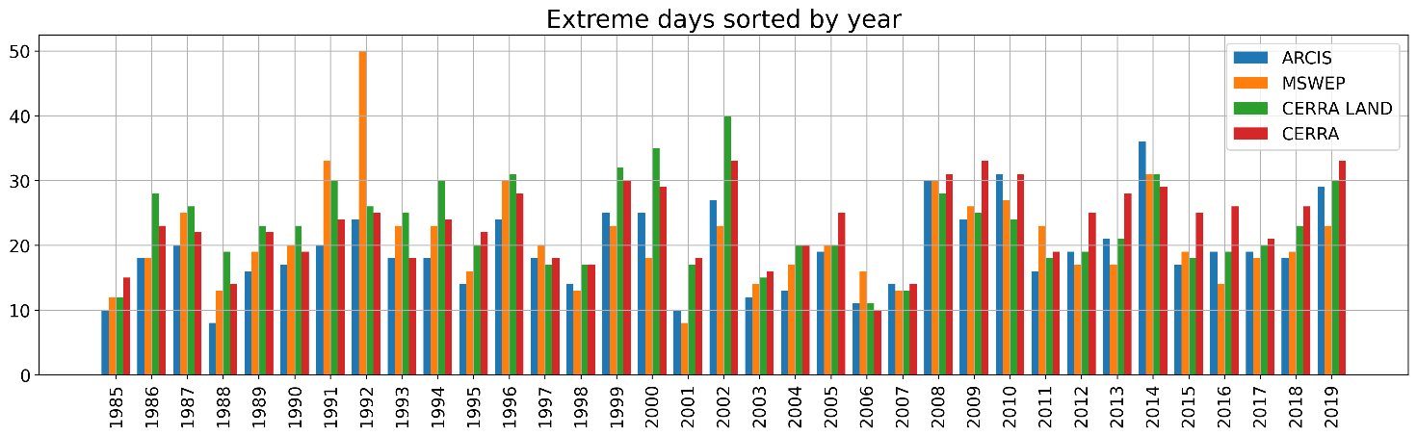
Figure S2 – Comparison of annual cumulative of EPEs in the 1985 – 2019 period for ArCIS (in blue), MSWEP (in orange), CERRA Land (in green) and CERRA (in red) for North-Central Italy domain.
Table S1 – Number of EPEs in in the 1985 – 2019 period for ArCIS, MSWEP, CERRA Land and CERRA for North-Central Italy domain. The overlap with ArCIS and the correspondent correlation coefficient is also given.
Dataset | N° Extremes | Overlap with ArCIS | Correlation (R Pearson)
ArCIS | 674
MSWEP | 731 | 391 (58%) | 0.66
CERRA LAND | 806 | 495 (73%) | 0.74
CERRA | 813 | 494 (73%) | 0.86

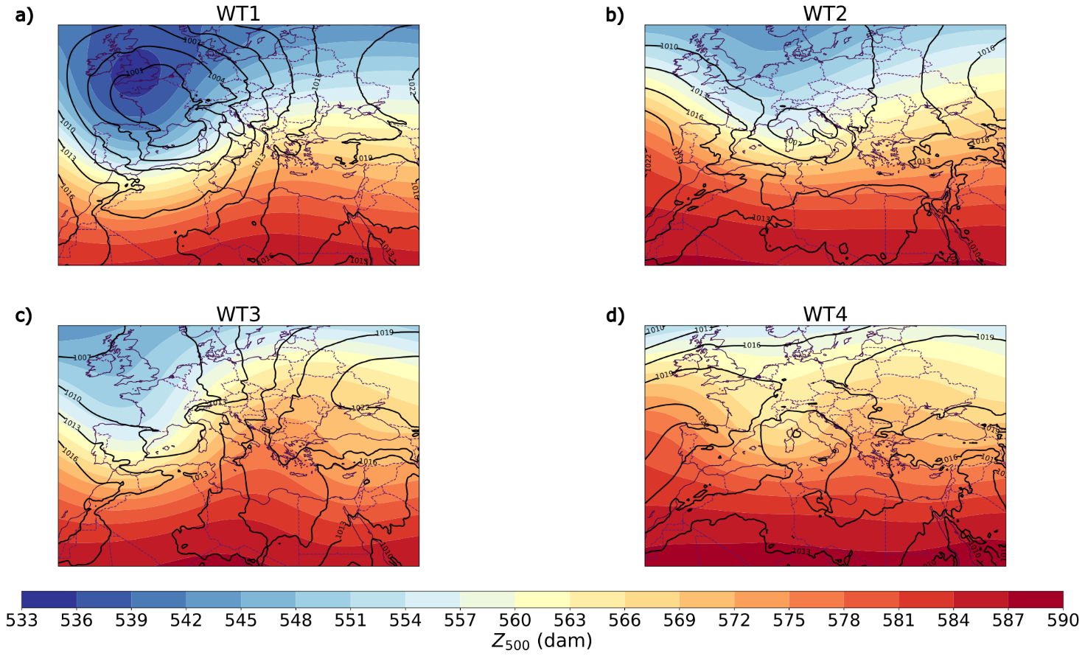
Figure S3 – Composites of geopotential height at 500 hPa (Z500) and mean sea-level pressure (mSLP) associated with the four patterns identified by the SOM applied to ArCIS over North-Central Italy.
Robustness of WTs patterns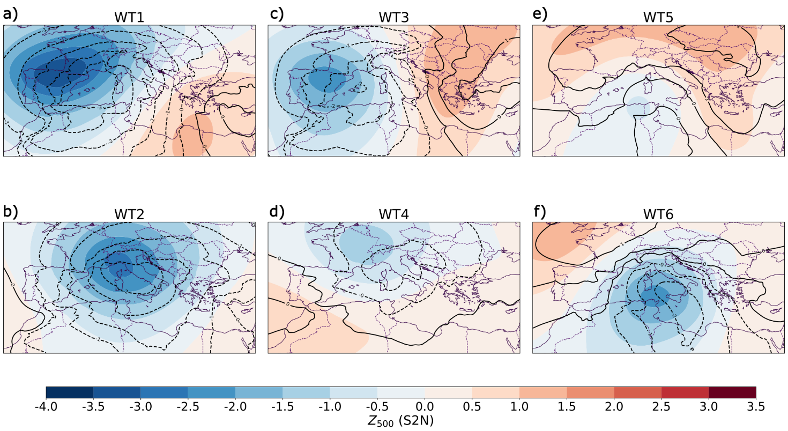
Figure S4 – Signal-to-noise (S2N) maps computed using CERRA data for Italian EPEs over the study period (November 1985 – October 2024). Higher absolute S2N values (both positive and negative) indicate greater agreement among the individual anomaly maps assigned to each SOM node, thereby highlighting regions of enhanced pattern consistency.

Seasonal decomposition of EPEs’ trend analysis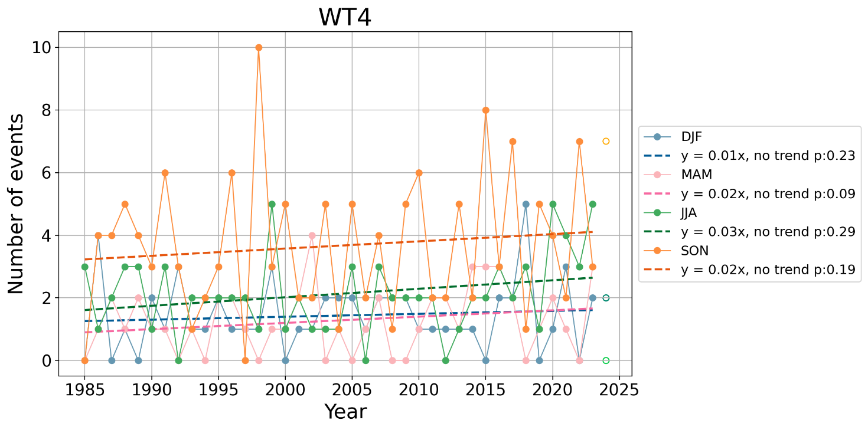
Figure S5 – Seasonal decomposition (DJF, MAM, JJA, SON) of the number of EPEs for CERRA during the study period (November 1984 – October 2024) occurring during WT4. The trend line is computed only on complete years (1985‐2023) and overplotted. The year 1984 is not displayed, while 2024 is included as a hollow circle to indicate its incompleteness. Trends' significance has been assessed through the Mann-Kandall test; no statistically significant trend was detected (dashed lines).
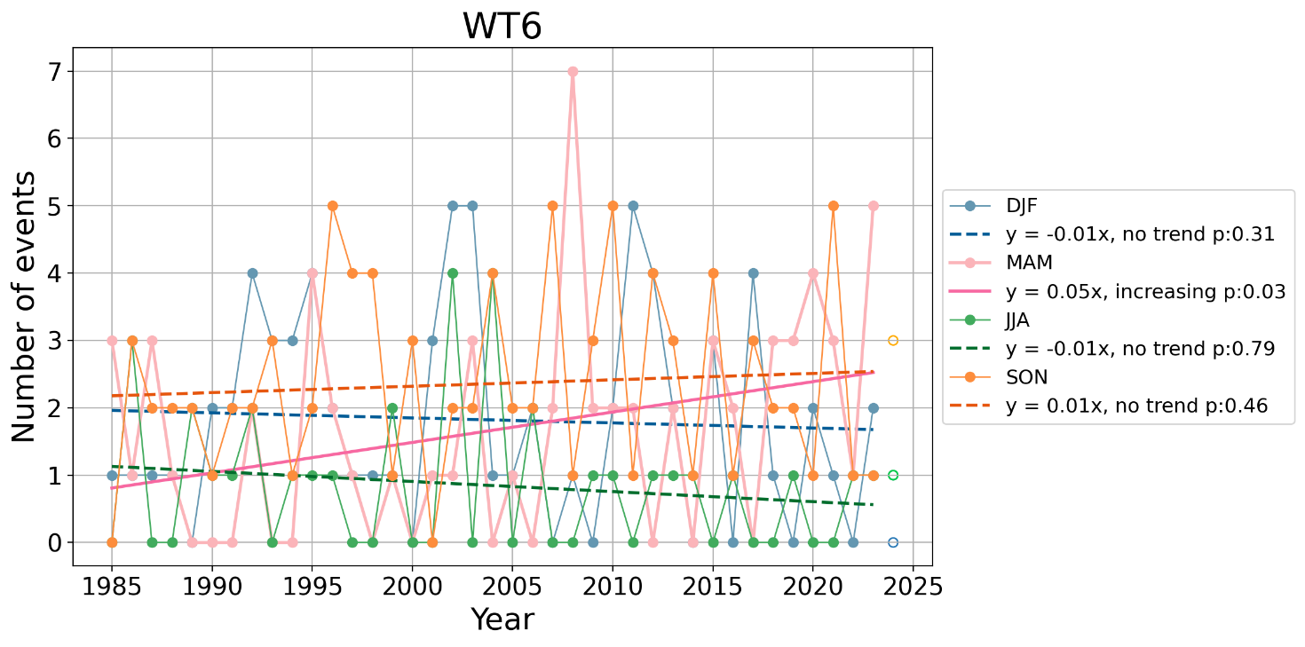
Figure S6 - Same as Figure S3 but for WT6. Only MAM annual frequencies exhibit a statistically significant increasing trend (solid line) according to the Mann‐Kendall test with p‐value < 0.05.

Trend analysis of the number of days with atmospheric flows analog to the WTs
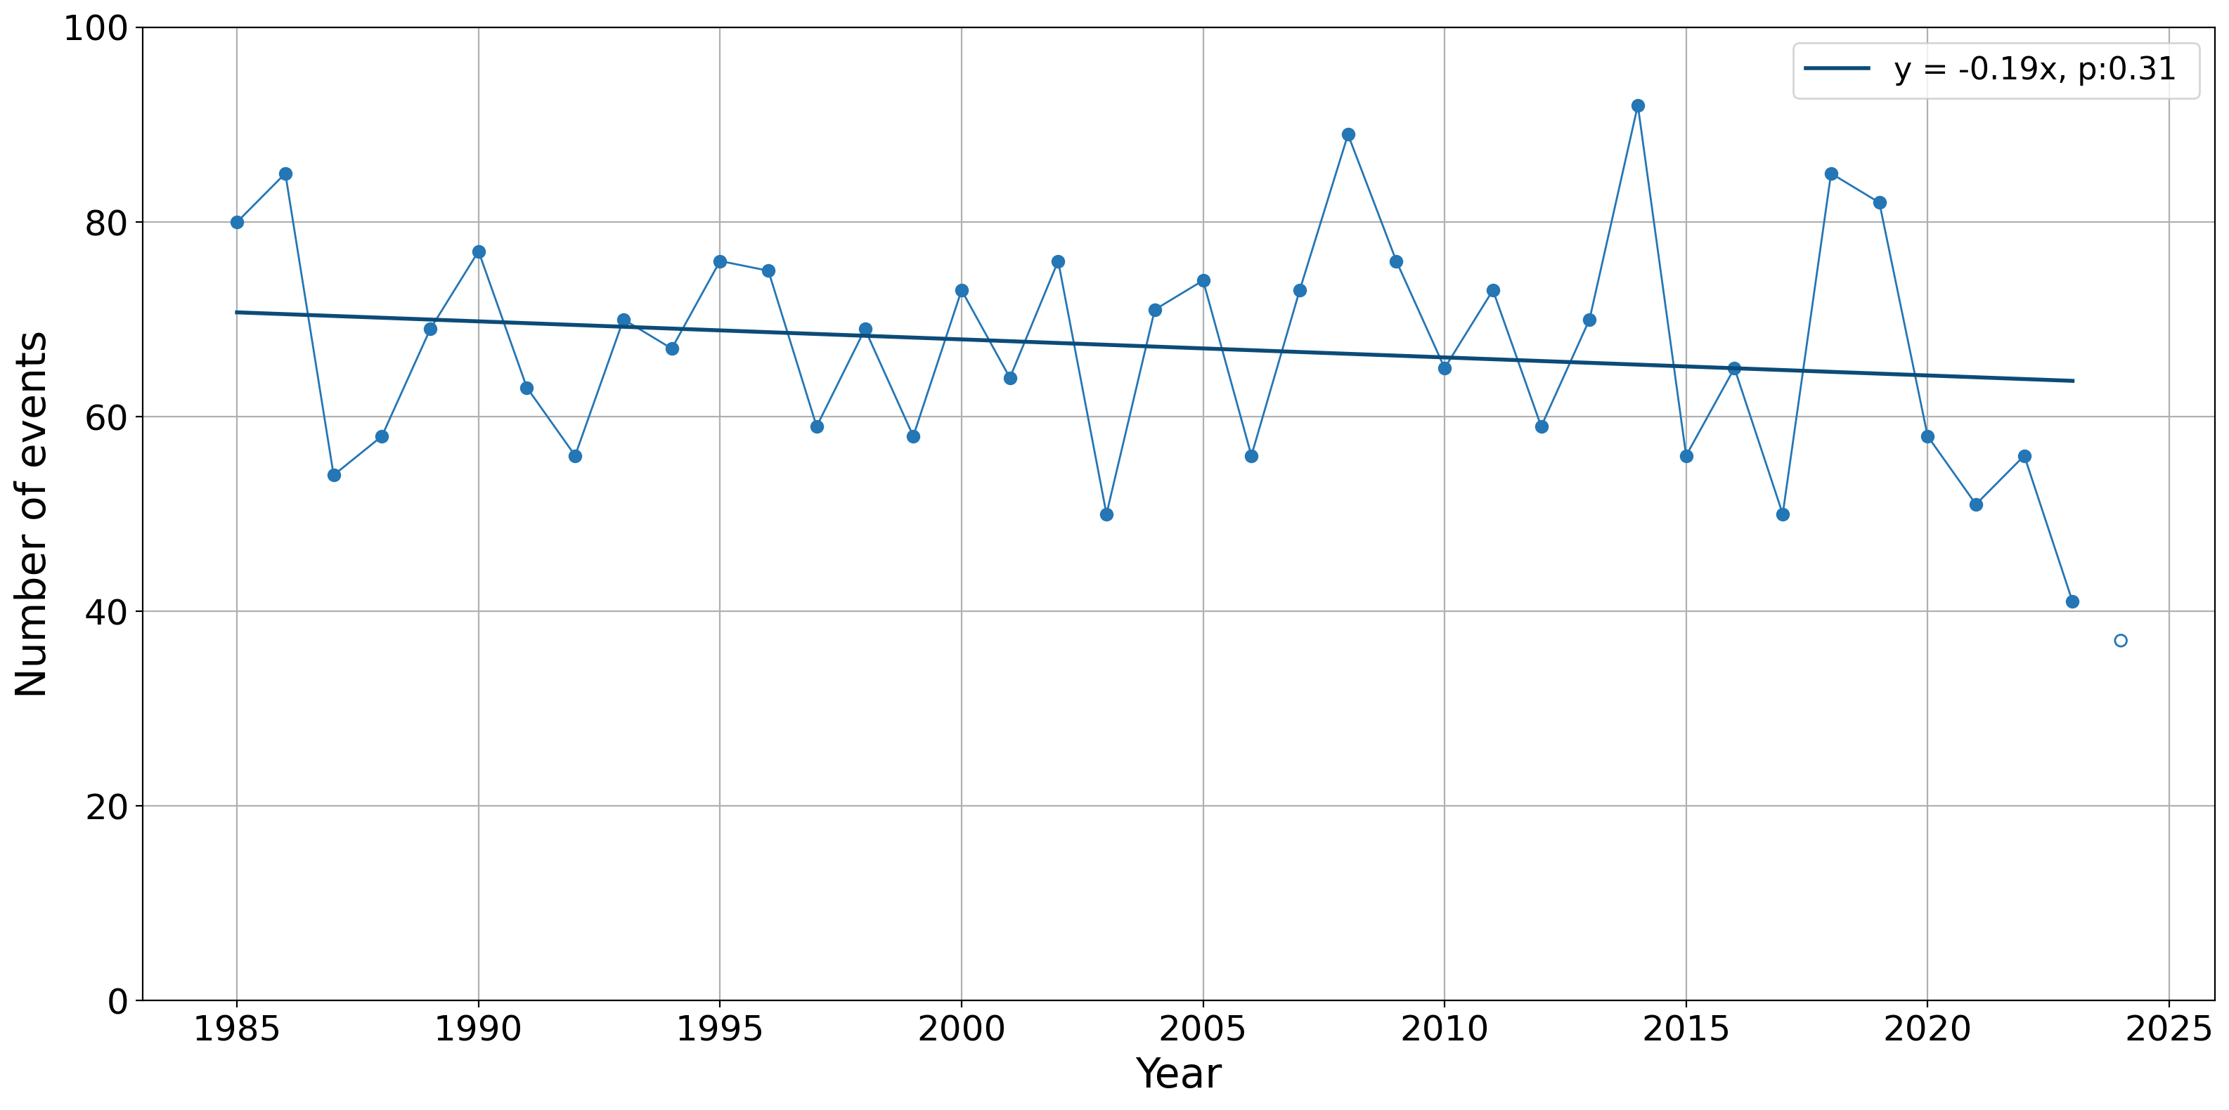
Figure S7 - Number of days in CERRA during the study period (November 1984 – October 2025) with a Z500 and MSLP anomaly pattern similar to the WTs. The trend line is computed only on complete years (1985‐2023) and overplotted. The year 1984 is not displayed, while 2024 is included as a hollow circle to indicate its incompleteness. Trends' significance has been assessed through the Mann-Kandall test; no statistically significant trends were detected.
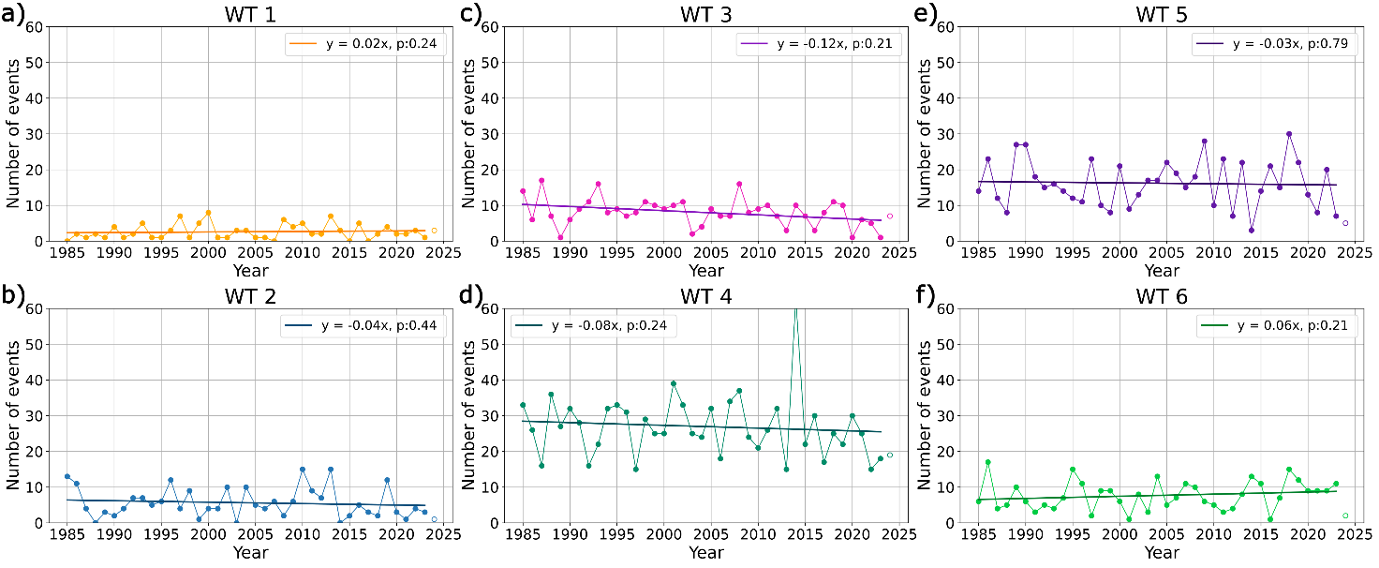
Figure S8 - Number of days in CERRA during the study period (November 1984 – October 2025) for all days similar to each weather type: (a) days similar to WT1, (b) WT2, (c) WT3, (d) WT4, (e) WT5, and (f) WT6. Trend lines, computed using only complete years (1985–2023), are overplotted. Trends' significance has been assessed through the Mann-Kandall test. None of the weather types exhibits a statistically significant trend.

