Supplementary
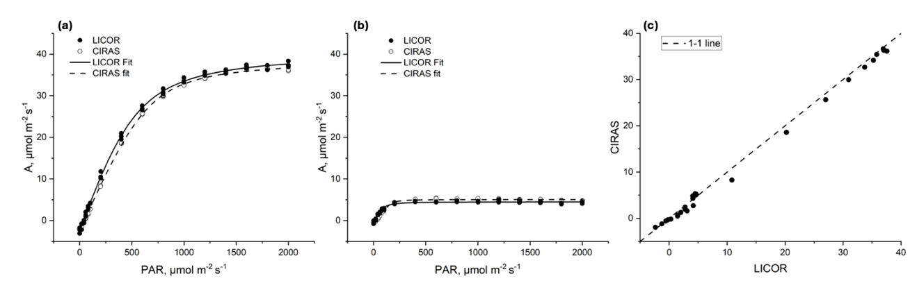
Figure S1: Comparative response curves of net photosynthetic rate (A) versus photosynthetically active radiation (PAR) measured with the Li6400XT and CIRAS systems for two different samples (a, b). Measurements were conducted on the same leaf and at the same time using both instruments. A comparison of A values obtained with the two systems is shown in panel (c), including the 1:1 reference line.

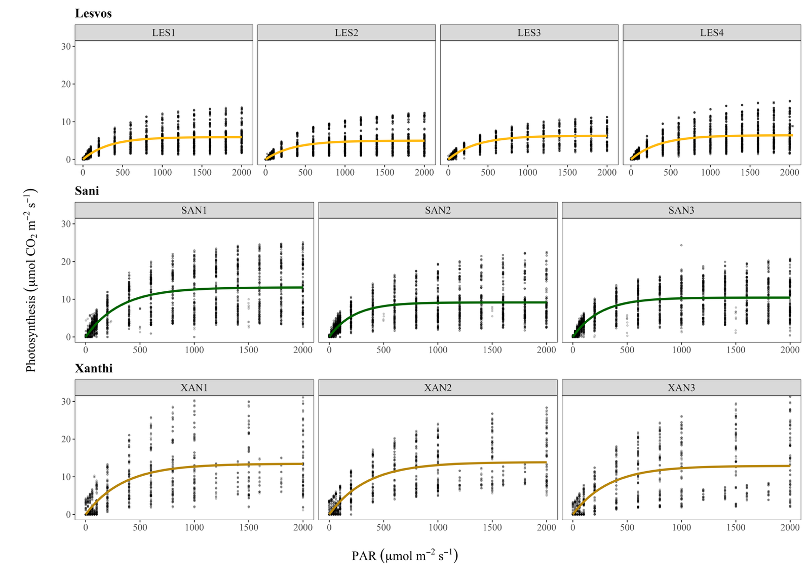
Figure S2: Average light curves per site per plot (fitted lines). Dots represent raw data of each curve taken.

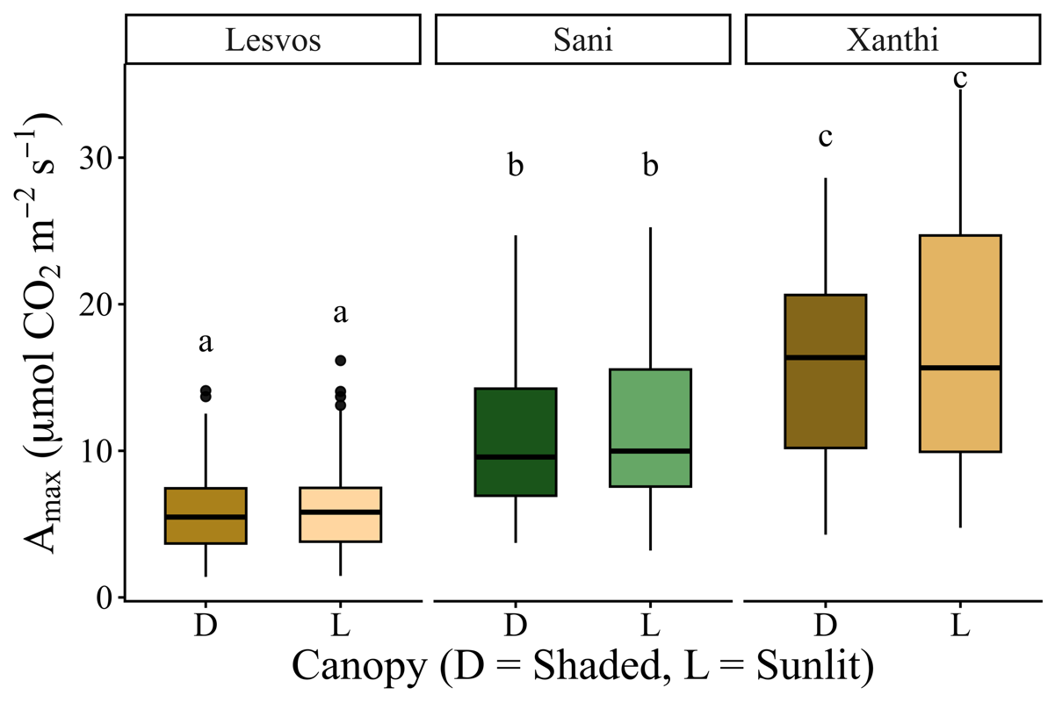
Figure S3. Photosynthetic capacity (Amax) by canopy status (D = Shaded needles, L = Sunlit needles) across the study sites (Lesvos, Sani, and Xanthi). Each box represents the interquartile range (IQR; 25th-75th percentiles), the horizontal line within each box indicates the median.

Table S1. Initial Linear Mixed Effect model for photosynthetic capacity (Amax). The model includes all the independent variables that are Vapor Pressure Deficit (VPD mean), Land Surface Water Index (LSWI), Leaf Area Index (LAI), Basal Area (BA), Nitrogen (N), Phosphorus (P). The plot was set as a random factor.
 | Amax
Predictors | Estimates |  | CI p
(Intercept) | 3.25 |  | -1.55 – 8.04 | 0.184
VPD mean | -1.02 |  | -1.68 – -0.36 | 0.003
LSWI | 17.64 |  | 5.84 – 29.44 | 0.004
Site [Sani] | 10.20 |  | 7.55 – 12.84 | <0.001
Site [Xanthi] | 6.76 |  | 0.90 – 12.61 | 0.024
Season [Spring] | 7.03 |  | 5.20 – 8.86 | <0.001
Season [Summer] | 4.50 |  | 1.12 – 7.89 | 0.009
Season [Autumn] | -0.84 |  | -2.73 – 1.05 | 0.382
LAI | -1.07 |  | -3.82 – 1.68 | 0.446
BA | 0.01 |  | -0.17 – 0.19 | 0.913
N | -0.65 |  | -1.50 – 0.20 | 0.136
P | 0.83 |  | 0.02 – 1.64 | 0.045
Site [Sani] × Season [Spring] | -0.13 |  | -2.56 – 2.30 | 0.916
Site [Xanthi] × Season [Spring] | 2.94 |  | 0.27 – 5.60 | 0.031
Site [Sani] × Season [Summer] | -2.65 |  | -6.33 – 1.02 | 0.156
Site [Xanthi] × Season [Summer] | -7.17 |  | -11.17 – -3.17 | <0.001
Site [Sani] × Season [Autumn] | -1.58 |  | -4.31 – 1.16 | 0.258
Site [Xanthi] × Season [Autumn] | 7.48 |  | 4.87 – 10.09 | <0.001
VPD mean × Site [Sani] | -2.60 |  | -4.23 – -0.97 | 0.002
VPD mean × Site [Xanthi] | 0.23 |  | -0.77 – 1.23 | 0.651
Random Effects
σ² | 9.01
τ₀₀ _{Plot} | 0.35
ICC | 0.04
N _{Plot} | 10
Observations | 401
Marginal R² / Conditional R² | 0.802 / 0.810

Table S2. Initial Linear Mixed Effect Model for stomatal conductance (gs). The model includes all the independent variables that are Vapor Pressure Deficit (VPD mean), Land Surface Water Index (LSWI), Leaf Area Index (LAI), Basal Area (BA), Nitrogen (N), Phosphorus (P). The plot was set as a random factor.
 | gs
Predictors | Estimates |  | CI p
(Intercept) | 0.08 |  | -0.10 – 0.25 | 0.380
VPD mean | -0.01 |  | -0.02 – 0.00 | 0.213
LSWI | 0.09 |  | -0.34 – 0.52 | 0.677
Site [Sani] | -0.05 |  | -0.26 – 0.17 | 0.672
Site [Xanthi] | -0.06 |  | -0.25 – 0.14 | 0.574
Site [Spring] | 0.06 |  | 0.01 – 0.10 | 0.021
Site [Summer] | -0.01 |  | -0.11 – 0.08 | 0.767
Site [Autumn] | -0.05 |  | -0.09 – -0.01 | 0.021
LAI | -0.03 |  | -0.11 – 0.05 | 0.464
BA | 0.00 |  | -0.00 – 0.01 | 0.585
N | -0.01 |  | -0.04 – 0.02 | 0.402
P | 0.02 |  | -0.01 – 0.04 | 0.141
Site [Sani] × Season [Spring] | 0.01 |  | -0.07 – 0.08 | 0.809
Site [Xanthi] × Season [Spring] | 0.11 |  | 0.05 – 0.17 | <0.001
Site [Sani] × Season [Summer] | -0.02 |  | -0.15 – 0.11 | 0.774
Site [Xanthi] × Season [Summer] | -0.02 |  | -0.13 – 0.09 | 0.690
Site [Sani] × Season [Autumn] | -0.07 |  | -0.14 – -0.00 | 0.036
Site [Xanthi] × Season [Autumn] | 0.09 |  | 0.04 – 0.15 | 0.001
VPD mean × Site [Sani] | -0.02 |  | -0.06 – 0.02 | 0.313
VPD mean × Site [Xanthi] | -0.02 |  | -0.04 – -0.00 | 0.041
LSWI × Site [Sani] | 0.69 |  | 0.11 – 1.27 | 0.021
LSWI × Site [Xanthi] | 0.45 |  | -0.16 – 1.06 | 0.148
Random Effects
σ² | 0.00
τ₀₀ _{Plot} | 0.00
ICC | 0.10
N _{Plot} | 10
Observations | 398
Marginal R² / Conditional R² | 0.733 / 0.761

Table S3. Initial Linear Mixed Effect Model for Intrinsic Water Use Efficiency (iWUE). The model includes all the independent variables that are Vapor Pressure Deficit (VPD mean), Land Surface Water Index (LSWI), Leaf Area Index (LAI), Basal Area (BA), Nitrogen (N), Phosphorus (P). The plot was set as a random factor.
 | i WUE
Predictors | Estimates |  | CI p
(Intercept) | 0.05 |  | -0.03 – 0.13 | 0.234
VPD mean | 0.01 |  | 0.00 – 0.02 | 0.004
LSWI | 0.03 |  | -0.17 – 0.23 | 0.793
Site [Sani] | 0.12 |  | 0.02 – 0.22 | 0.014
Site [Xanthi] | 0.04 |  | -0.05 – 0.12 | 0.395
Season [Spring] | 0.01 |  | -0.01 – 0.03 | 0.460
Season [Summer] | 0.06 |  | 0.01 – 0.10 | 0.013
Season [Autumn] | 0.06 |  | 0.04 – 0.08 | <0.001
LAI | 0.01 |  | -0.03 – 0.04 | 0.722
BA | -0.00 |  | -0.00 – 0.00 | 0.809
N | 0.01 |  | -0.01 – 0.02 | 0.327
P | -0.00 |  | -0.01 – 0.01 | 0.756
Site [Sani] × Season [Spring] | -0.05 |  | -0.08 – -0.01 | 0.013
Site [Xanthi] × Season [Spring] | -0.02 |  | -0.05 – 0.00 | 0.084
Site [Sani] × Season [Summer] | -0.07 |  | -0.14 – -0.01 | 0.028
Site [Xanthi] × Season [Summer] | -0.06 |  | -0.11 – -0.01 | 0.014
Site [Sani] × Season [Autumn] | -0.05 |  | -0.08 – -0.02 | 0.004
Site [Xanthi] × Season [Autumn] | -0.06 |  | -0.08 – -0.03 | <0.001
VPD mean × Site [Sani] | 0.01 |  | -0.00 – 0.03 | 0.108
VPD mean × Site [Xanthi] | 0.01 |  | 0.00 – 0.02 | 0.003
LSWI × Site [Sani] | -0.43 |  | -0.70 – -0.16 | 0.002
LSWI × Site [Xanthi] | -0.11 |  | -0.40 – 0.17 | 0.446
Random Effects
σ² | 0.00
τ₀₀ _{Plot} | 0.00
ICC | 0.08
N _{Plot} | 10
Observations | 397
Marginal R² / Conditional R² | 0.641 / 0.669

