Supplementary Material

Arthroscopic device with bendable tip for the controlled extrusion of hydrogels on cartilage defects

Daniele Guarnera^{1,2}, Francesco Restaino^{1,2}, Lorenzo Vannozzi^{1,2}, Diego Trucco^{1,2,3}, Tommaso Mazzocchi⁴, Michał Worwąg⁵, Tomasz Gapinski⁶, Gina Lisignoli³, Stefano Zaffagnini⁷, Alessandro Russo⁷, Leonardo Ricotti^{1,2,*}

- The BioRobotics Institute, Scuola Superiore Sant’Anna, Piazza Martiri della Liberta’ 33, Pisa, 56127 Italy
- Department of Excellence in Robotics & AI, Scuola Superiore Sant’Anna, Piazza Martiri della Liberta’ 33, Pisa, 56127 Italy
- IRCCS Istituto Ortopedico Rizzoli, SC Laboratorio di Immunoreumatologia e Rigenerazione Tissutale, Via di Barbiano, 1/10, Bologna 40136, Italy
- Relief s.r.l, Viale Rinaldo Piaggio 32, Pontedera, 56025, Italy
- Vimex Endoscopy, Ul. Toruńska 27, Gliwice 44-122, Poland
- Lega Medical Sp. Z o. O, ul. Majowa 11, Rybnik 44-217, Poland
- IRCCS Istituto Ortopedico Rizzoli, Orthopaedic and Traumatologic Clinic, Via di Barbiano, 1/10, Bologna 40136, Italy

* Address correspondence to Daniele Guarnera at the Biorobotics Institute, Scuola Superiore Sant’Anna, Piazza Martiri della Libertà 33, Pisa, 56127 Italy. Electronic mail: daniele.guarnera@santannapisa.it

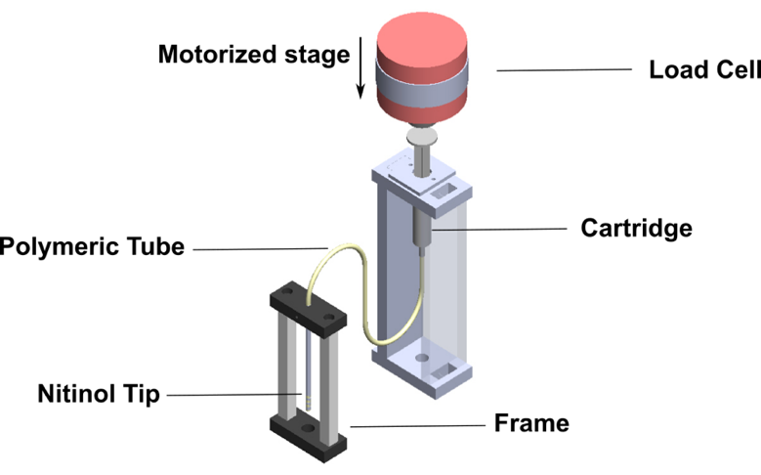

Figure S1. Experimental setup used for evaluating the extrusion force needed to flow the different hydrogels through tubes having different diameters.

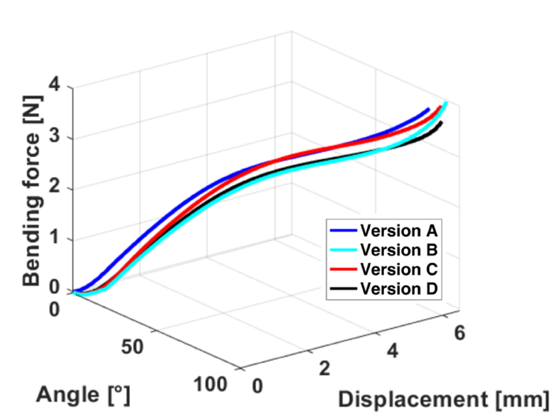

Figure S2. Mechanical characterization of the tip. Correlation between displacement, bending force and bending angle, for all the tip versions.

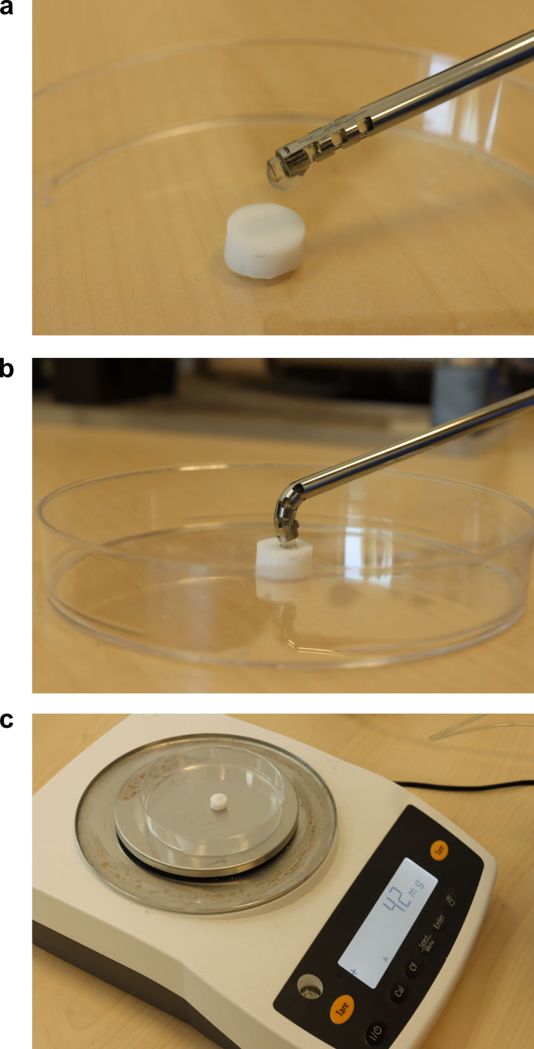

Figure S3. Examples of conditions set for the resolution tests. (a) Extrusion of GGMA with straight tip in fall condition; (b) extrusion of GMMA with bent tip in contact condition. All tests were performed by printing materials on a cylindrical teflon substrate. (c) Precision balance used to weigh the quantity of hydrogel extruded (the weight of the bare teflon was considered, through an appropriate tare).

Figure S4. Ex-vivo test on a human cadaver knee. (a) Creation of the defect on the medial condyle using a 90°-bent rasp. (b) Exposed knee tissues, allowing a check of the hydrogel retention on the cartilage defects after extrusion (the hydrogel is blue-colored).

Volumetric System - Free Comments | Pneumatic System - Free Comments
The bendable tip should better return to its original position; the control of the quantity of extruded material needs to be improved. | The tip diameter could be smaller to reach out the corners and to have more maneuverability. However, it is quite easy to use.
Apart from injectability, the device works very well. | Good relation between pedal and extrusion; good maneuverability; the tip is probably too large.
The device is good, but the quantity of material released is not so accurate. | I would reduce the tip size. In arthroscopy moving large tips is hard, and they are difficult to be clearly seen.
The device keeps on releasing even after leaving the pedal; the tip sometimes remains bent after use. | The tip should be smaller; it would be nice to have a unidirectional bending.
The tip is probably too big; it can be used inside the knee, but considering the ankle, a smaller tip would be more appropriate.
The bendable tip is not so crucial for the knee: maybe it would be more useful in other joints; the pedal-controlled extrusion is not effective: a more ‘controlled’ pedal would be more useful; the mechanism for the tip rotation is useful, but it should be easier to use.

The tool is too long and hard to drive; the tip offers not so many advantages with respect to a straight one; it should be smaller; the pedal is hard to press.
Table S1. Free comments provided by the surgeons after testing both systems on a cadaver knee.

Complete list of Supplementary Movies:

- Video S1
- Video S2
- Video S3
- Video S4
- Video S5

The Supplementary Movies are available at https://doi.org/10.5281/zenodo.8147102

