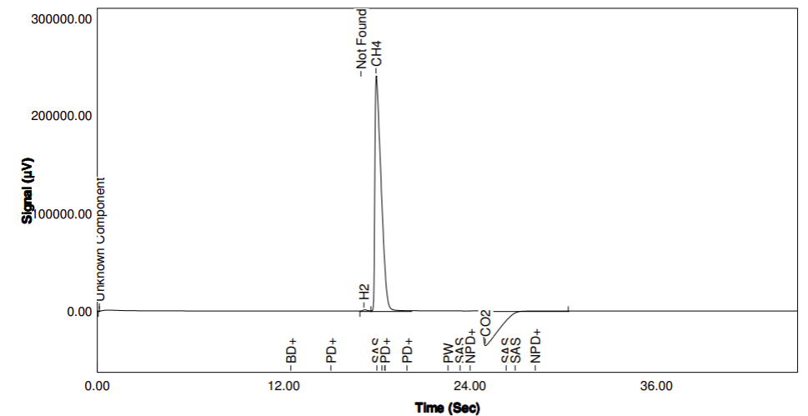
S1. Chromatogram result of the GC analysis. Example of replicate R2 of FM1

S2. Result of gas composition of the FMs three replicates (R1, R2, R3), analysed with three replicates at the microGC (a, b, c).
Samples | CH₄  (%) | CO₂  (%)
FM1
R1_a | 46.74 | 53.26
R1_b | 49.73 | 50.27
R1_c | 46.63 | 53.37
R1 mean ± s.d. | 47.70 ± 1.76 | 52.30 ± 1.76
R2_a | 52.60 | 47.40
R2_b | 52.18 | 47.82
R2_c | 52.20 | 47.80
R2 mean ± s.d. | 52.33 ± 0.24 | 47.67 ± 0.234
R3_a | 52.23 | 47.77
R3_b | 52.05 | 47.95
R3_c | 52.02 | 47.98
R3 mean ± s.d. | 52.10 ± 0.11 | 47.90 ± 0.11
Blank_a | 54.27 | 45.73
Blank_b | 54.38 | 45.62
Blank_c | 54.27 | 45.73
Blank mean ± s.d. | 54.31 ± 0.07 | 45.69 ± 0.07
 | FM2
R1_a | 53.25 | 46.75
R1_b | 53.15 | 46.85
R1_c | 53.11 | 46.89
R1 mean ± s.d. | 53.17 ± 0.07 | 46.83 ± 0.07
R2_a | 52.24 | 47.76
R2_b | 52.27 | 47.73
R2_c | 52.21 | 47.79
R2 mean ± s.d. | 52.24 ± 0.03± | 47.76 ± 0.03
R3_a | 52.37 | 47.63
R3_b | 52.39 | 47.61
R3_c | 52.39 | 47.61
R3 mean ± s.d. | 52.38 ± 0.01 | 47.62 ± 0.01
Blank_a | 53.67 | 46.33
Blank_b | 53.67 | 46.33
Blank_c | 53.69 | 46.31
Blank mean ± s.d. | 53.68 ± 0.01 | 46.32 ± 0.01

S3. Gas composition. Results of the average gas composition (%) of FM1 and FM2.
Content (%) | FM1 | FM2
CH₄ | 50.71 ± 2.43 | 52.60 ± 0.44
CO₂ | 49.29 ± 2.43 | 47.44 ± 0.44

