Mineralization of ¹³C-labeled polyethylene by marine Bacillus velezensis MT9

Kejvin Bajo^{ab}, Boris Kolvenbach^{b}, Philippe F.-X. Corvini^{b}, Fabio Favaª, Noura Raddadiª*.

ªDepartment of Civil, Chemical, Environmental and Materials Engineering (DICAM)-University of Bologna, Italy

^{b} School of Life Sciences, FHNW, Muttenz, Switzerland

* For correspondence:
Noura Raddadi. Department of Civil, Chemical, Environmental and Materials Engineering (DICAM), via Terracini 28, 40131 Bologna, Italy. E-mail: noura.raddadi@unibo.it

Supplementary material
Fig. 1S. FTIR spectra of a reference ¹²C-polyethylene film (black line) and ¹³C-polyethylene powder (orange line).

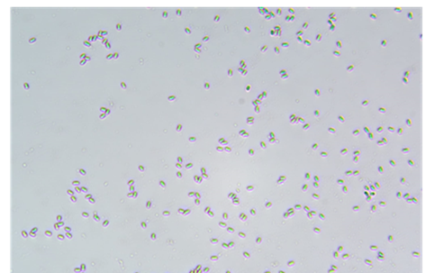
Fig. 2S. – Microscopy observation showing endospore formation by B. velezensis MT9 after 30 days incubation in mineral medium with UV-treated ¹³C-PE powder.

