Supporting information for:
Active vs passive eDNA sampling across depths at a tropical fish-aggregating device (FAD)

Section S1) Tutorial: eDNA active filtration detailed protocol

Checklist
- Vacuum Pump (“Macchinetta”)
- Filters (provided inside the filter bag)
- Vacuum Bottle (4L)
- Hoses (1x bottle to filter, 1x bottle to pump)
- Sterile Plastic bags (twirl’em for temporary water storage)
- Bucket (at least 5L)
- Gloves (sterile ones)
- Marker pen
- Ice box

Preparation: Mark the plastic bags before leaving for sampling with the names of the samples to be collected. Use the same names to label the filter bags that will be used.

Tube Connections: The long hose must be used to connect the bottle to the filter (point 2 “LIQ” on the bottle in the Figure S1). The short tube connects the bottle to the pump box, and it must be connected to point 1 (AIR) on the bottle.

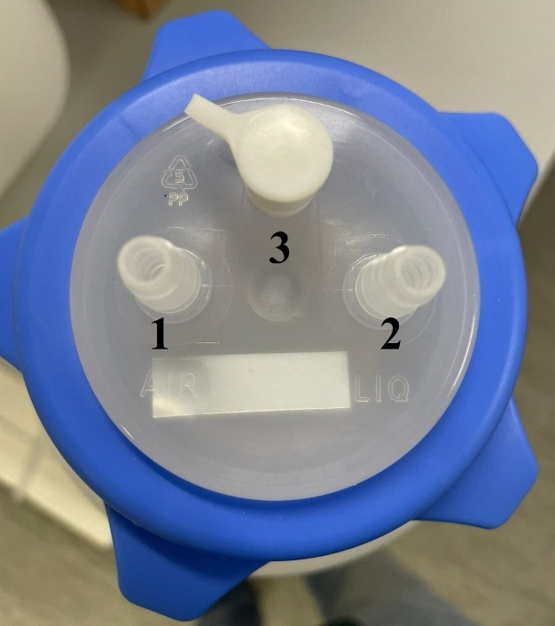
Figure S1. Connections for tubing on the vacuum trap bottle cap: (1) air inlet, (2) liquid outlet, and (3) pressure release port.

Field Procedure:
- Put on gloves.
- Rinse a clean bucket (see cleaning instructions below) with sea water collected at the sampling location, repeat three times.
- Collect a surface water sample using the bucket from at least 50 cm below the surface. Approximately 5 Lt.
- Open the sterile plastic bag, place the bottom on a flat surface, and hold it tightly with two hands. Pour the water from the bucket into the bag (try to avoid wetting the gloves, if it happens spray with 70% alcohol).
- Try to remove as much air as possible from the bag and close it by folding the top edge over three times and then twisting the ends together (to form a handle).
- Store the collected water sample in the ice box (close it and avoid contact with sunlight). Be careful not to place anything heavy on the bags as they might open.*
- Write metadata corresponding to the water sample on the metadata sheet (plastic bag number, time, weather condition, name of the sampler, etc.)
- Repeat step 2-7 to collect a total of 5 water samples. Try to sample water samples at different locations, if possible (different sides of the boat) or wait at least 2 minutes in between water samples.

For Filtration:
- Take the water sample bag and gently move it upside down to mix the inside water.
- Place the plastic bag with the water sample into a bucket, placing it on one side of the bucket to keep it stable.
- Open the bag just enough to allow the filter holder to go inside.
- Then open the filter bag. Without touching the inside, move the capsule toward the opening of the bag with the yellow part (indicated by the number 1 in Figure S2) upside.
- Attach the filter-bottle hose to the yellow part, take it out of the bag holding the extremity of the hose, add the disposable rigid pipe (number 3 in the Figure S2; while still in the bag) to the white part (number 2 in Figure S2) of the capsule.
- Insert the rigid pipe connected to the capsule into the water plastic bag (be careful not to immerse the filter-bottle hose in the water sample). Steps 5-6 are shown in the sequence of images in Figure S3.
- Turn on the pump, ensuring that the hoses are securely connected and that the bottle is properly sealed otherwise the negative pressure needed for filtration will not be generated.
- Filtration time: 20 minutes.
- If filtration reaches 3.8/3.9 liters, there is a risk that water will enter the air suction hose of the pump (which could damage the pump). At that point, remove the filter holder from the plastic bag, turning the holder vertically upwards and wait about 2 minutes to allow the filter to dry as much as possible.
- After two minutes, turn off the pump, open the white cap (n°3 in Figure S1) on the bottle to depressurize. Place the filter holder back in its packaging (remove and discard the disposable rigid pipe) and, by holding it through the bag from the outside (never touching the inside of the bag), detach it from the tube.
- Close the sample bag and use the marker to write the filtered volume on the filter bag label.
- Discard the water in the vacuum bottle.
- Write down the time of filtration on metadata sheet.
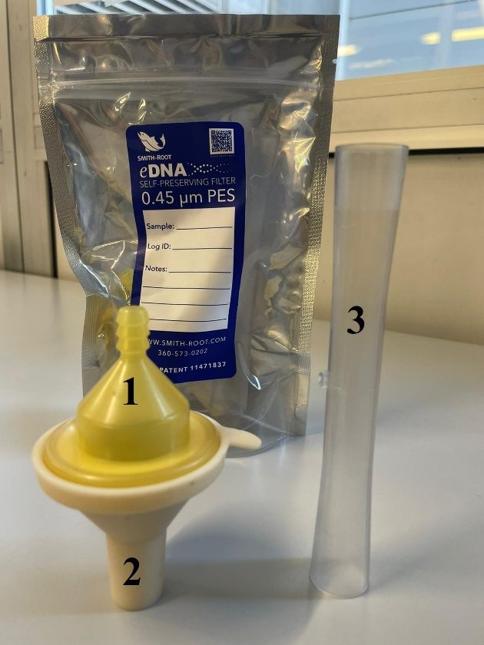
Figure S2. Components of the Smith-Root self-preserving eDNA filter (0.45 μm PES): (1) filter outlet, (2) filter inlet, and (3) the disposable rigid pipe.

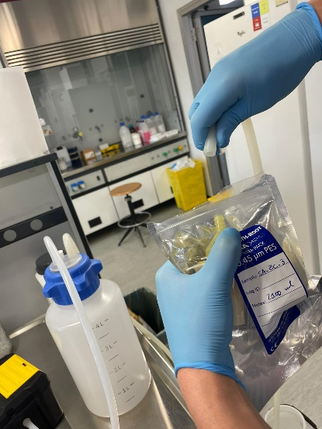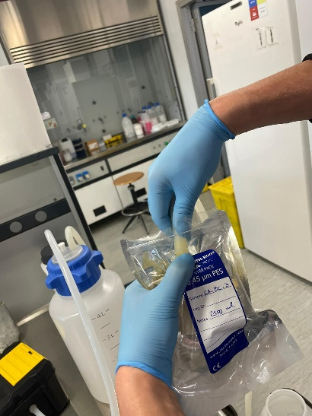
Figure S3. Attaching the extension tube to the Smith-Root eDNA filter while avoiding direct contact with the filter inlet to minimize contamination risk.

Protocol for filtration of the Field blank:
- Pour the distilled water into a sterile plastic bag that has been transported in the same manner as the bags used for water sample collection.
- Follow steps 2 to 7 of the water sample filtration protocol.
- Ensure the rigid pipe and filter holder are clean before starting the filtration of the blank.
- Filtration time: 10 minutes or until the complete passage of the 2 litres of distilled water through the filter.
- After filtration, follow steps 9 to 11 of the water sample filtration protocol.
- Follow steps 2 to 7 of the water sample filtration protocol.
- Filtration time: until the complete passage of the 2 litres of distilled water through the filter.
- After filtration, follow steps 9 to 11 of the water sample filtration protocol.

Cleaning Instructions
Clean the instruments after each sample collection to avoid cross contamination between different sampling days.
- Put on clean gloves
- Rinse the vacuum bottle, hoses, ice box and bucket thoroughly with running water to remove any residues. There is no a strict need to use 10% bleach here, just thoroughly clean everything, the bucket will be rinsed with seawater in place, just before sampling.
- Dampen absorbent paper with 70% alcohol.
- Wipe down all external surfaces of the pump, vacuum bottle and marker pen to reduce contamination.
- Ensure the hoses are dried completely after rinsing.
If possible, store all the equipment in a box, in order to facilitate the transport during the sampling process.

Section S2) Tutorial: eDNA collection with passive samplers (GenoPod and GenoCartridge)

This tutorial provides step-by-step instructions on how to use a GenoPod for collecting environmental DNA from a water column. The device consists of a tube with three internal slots that hold the Genocartridge. The Genopod and GenoCartridge systems are designed and manufactured by Acqua proget Ravenna (https://acquaprogetravenna.com/).
Each GenoCartridge unit was assembled under sterile conditions following the procedure described below (Figure S4):

GenoCartridge assembly materials
- Sterile medical-grade cotton gauze (100% cotton; single-use sterile pads)
- Sterile cotton core (approximately 1 × 2 cm)
- 3D-printed GenoCartridge (PLA material)
- Sterile forceps
- Aluminum foil for sterile workspace

Assembly procedure
Two layers of sterile gauze were placed flat on a clean aluminum surface. A small piece of sterile cotton was positioned at the center to form the inner core. The gauze sheets were then rolled tightly around the cotton core to form a cylindrical absorbent unit approximately matching the inner diameter of the GenoCartridge shell.
Using sterile forceps, the rolled gauze-cotton unit was inserted into the GenoCartridge housing, ensuring full contact with the internal lattice structure. Once inserted, the cartridge was closed with its screw cap to secure the absorbent material in place.
The assembled cartridges were individually sealed in sterile aluminum foil until deployment. During fieldwork, each cartridge was handled with sterile gloves and transferred directly into the GenoPod holder.

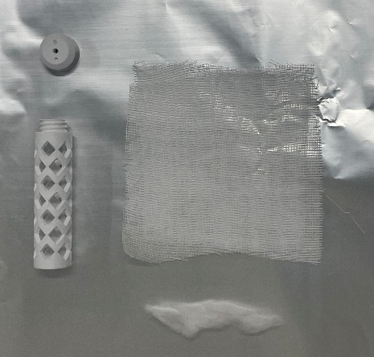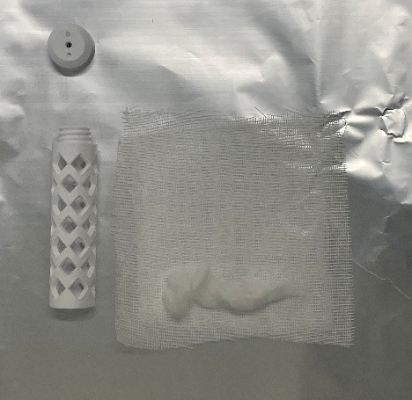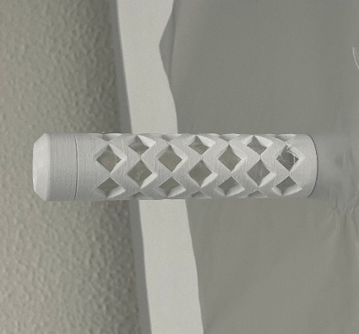
Figure S4. GenoCartridge assembly sequence.

GenoPod assembly materials
- GenoPod (Figure S5; indicated by the number 1-2)
- GenoCartridge (Figure S5; indicated by the number 3)
- Nitrile gloves
- Collection vials (volume 50ml)
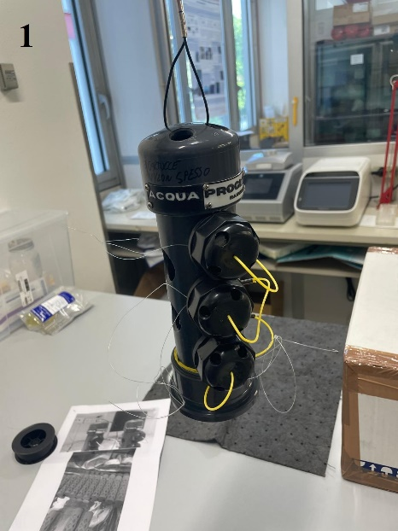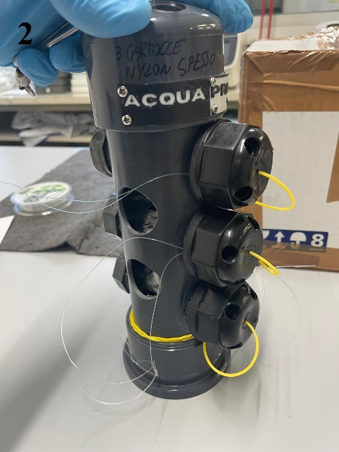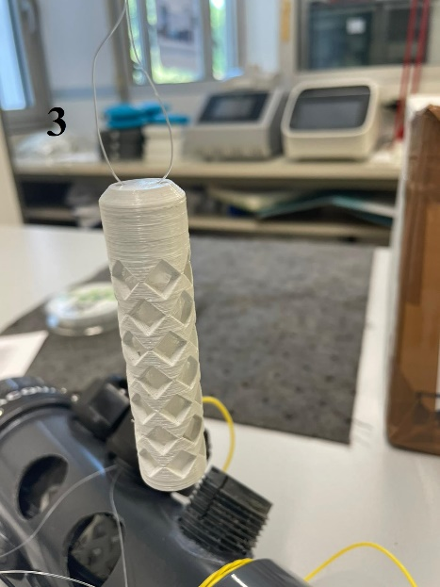
Figure S5. Figures showing the GenoPod (1-2) and a close-up of the GenoCartridge (3).

Step-by-Step Instructions
- Preparation
  - Wear nitrile gloves.
  - Ensure you have all materials ready and a clean workspace.
- Loading the GenoCartridge
  - Hold the GenoPod upright and remove the caps from the cartridge slots. (Figure S6; indicated by the number 4-5)

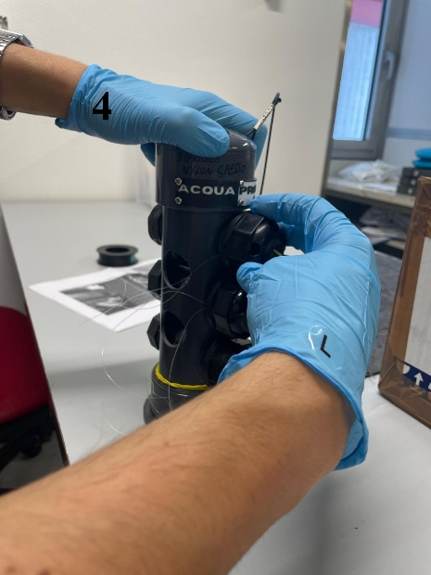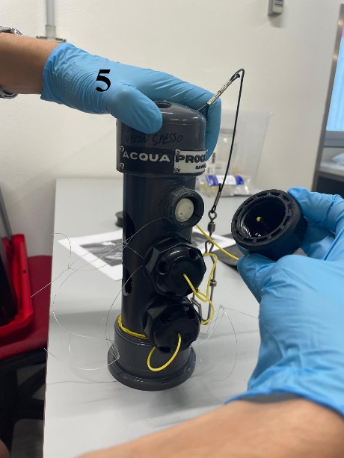
Figure S6. Loading of the GenoPod with the GenoCartridge (4-5).

  - Insert the GenoCartridge into the three slots of the sampler (GenoPod). Ensure the cartridge are securely placed inside the slot.
- Securing the Cartridges
  - Once the GenoCartridge are in place, screw the slot caps back onto the sampler tube. Ensure they are tightly secured.
- Deploying the GenoPod
  - Attach a line to the top of the sampler for easy retrieval.
  - Lower the GenoPod into the water column to the desired depth. Secure it in place and leave it submerged for approximately four hours to collect eDNA.
- Retrieving the Sampler
  - After the sampling period, retrieve the sampler from the water.
  - Unscrew the slot caps and carefully remove the GenoCartridge from the slot (Figure S7; indicated by the number 6-7) using the nylon thread.
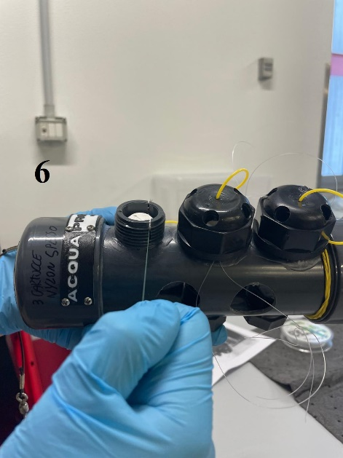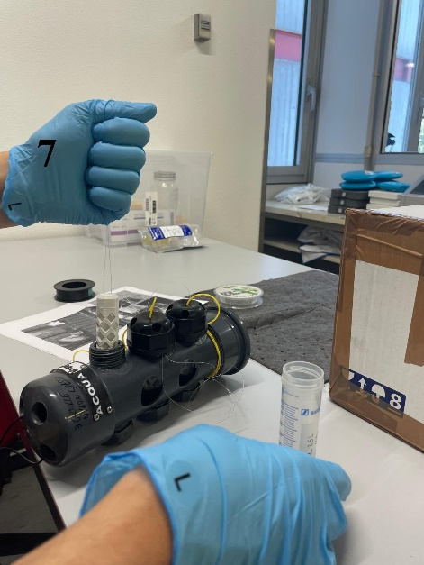
Figure S7. Safe removal of the GenoCartridge from the GenoPod. (6) Positioning the GenoPod for cartridge release. (7) Extracting the GenoCartridge while minimizing direct contact.

  - Place each cartridge into a separate collection vial. (Figure S8; indicated by the number 8)
  - Fill the vial with 100% ethanol.
  - Cut or tighten the nylon thread with scissors (Figure S8; indicated by the number 9) and seal the vial cap with parafilm (Figure S9) to prevent evaporation of the ethanol. Ensure that the nylon thread does not get caught in the cap, as this could cause all the ethanol to escape from the vial during transport.

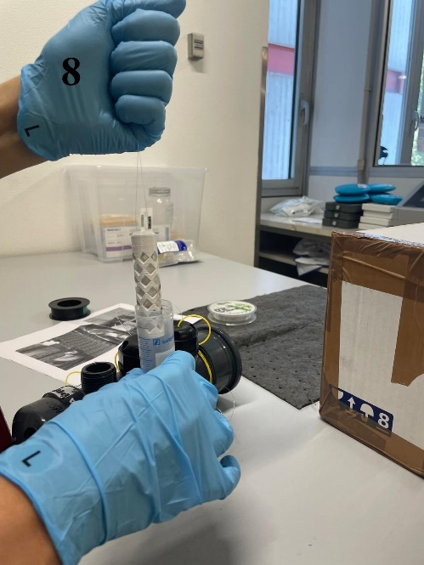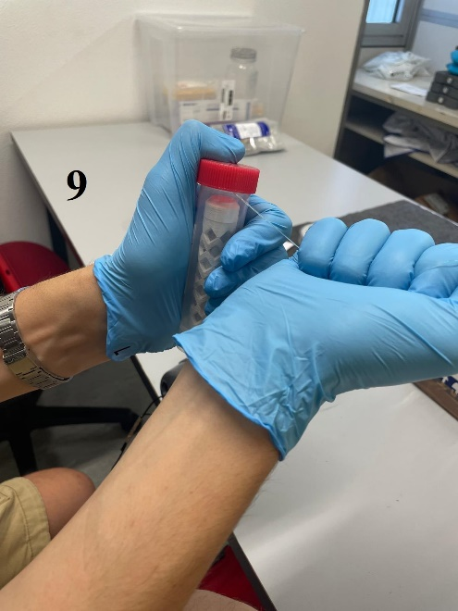
Figure S8. Placement of the GenoCartridge into a 50 mL Falcon tube using the nylon thread (8), followed by its removal either by pulling or cutting the thread (9).

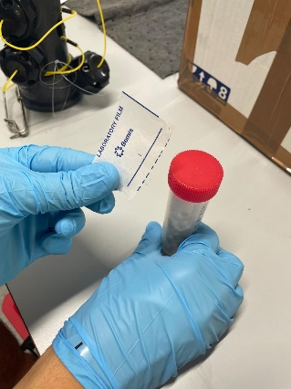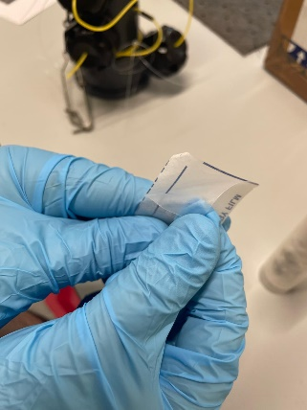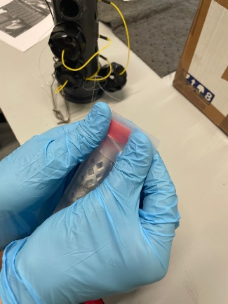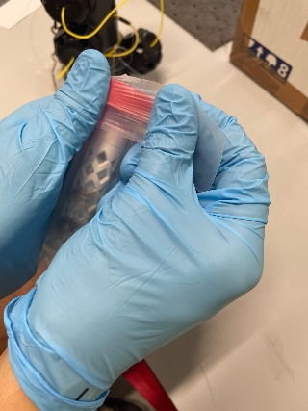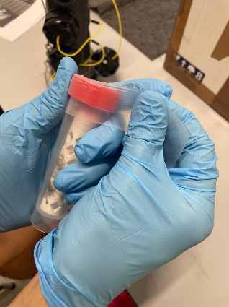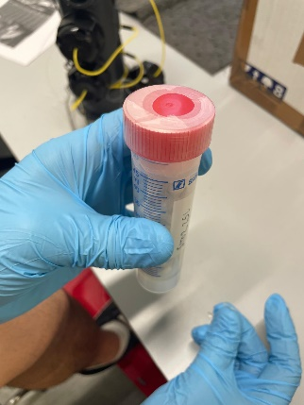
Figure S9. Sealing the 50 mL Falcon tube containing the GenoCartridge with Parafilm to ensure proper sample conservation during transport to the laboratory.

- Storing the Samples
  - Label each collection vial with the relevant information, such as date, time, and location of sampling. As ethanol can erase the ink, always use a pencil for labelling. (Write the data on a piece of paper with the pencil and cover it with tape to keep it covered and attached to the vial).
  - For long-term storage, empty the ethanol used to collect the sample and replace it with fresh ethanol.
- Cleaning and Maintenance
  - Clean the sampler carefully after use to remove any residue and prevent contamination. Use 10% bleach and rinse with freshwater.
  - Inspect the sampler for any damage and ensure it is ready for the next sampling event.

Section S3) Bioinformatic pipeline

#FISHBASE INDONESIAN SPECIES
#in R environment
#
#

library(rvest)
library(dplyr)
library(stringr)
library(openxlsx)
library(readr)

url <- "https://www.fishbase.se/Country/CountryChecklist.php?c_code=360&cpresence=reported&showAll=yes&vhabitat=saltwater"

tables <- url %>% read_html() %>% html_table(fill = TRUE)
fish_df <- tables[[which.max(sapply(tables, nrow))]]

fish_df <- fish_df %>%
mutate(across(everything(), \(x) str_squish(as.character(x)))) %>%
filter(!is.na(Species) & Species != "")
write_tsv(fish_df, "FishBase_Indonesia_marine.tsv")

#species.txt list obtained from FishBase_Indonesia_marine.tsv

tail -n +2 tax-export/taxonomy.tsv | grep -F -f species.txt > hits.tsv || true
cut -f1 hits.tsv | sort -u > ids-to-keep.txt
{ echo "feature-id"; cat ids-to-keep.txt; } > ids-to-keep.tsv

#switch to QIIME2 environment
#Database filtering

qiime feature-table filter-seqs \
--i-data Mitohelper_jan25_12S-seqs.qza \
--m-metadata-file ids-to-keep.tsv \
--o-filtered-data Mitohelper_jan25_12S-seqs-FILTERED.qza

qiime rescript filter-taxa \
--i-taxonomy Mitohelper_jan25_12S-tax.qza \
--m-ids-to-keep-file ids-to-keep.tsv \
--o-filtered-taxonomy Mitohelper_jan25_12S-tax-FILTERED.qza

#DEMULTIPLEXING RAW SEQUENCES

cutadapt \
-e 0 \
-O 12 \
--no-indels \
--action=retain \
-g file:file_barcode_Tele02_F_FAD.txt \
-G file:file_barcode_Tele02_R_FAD.txt \
-o demulti/{name1}-{name2}.run1.1.fastq.gz \
-p demulti/{name1}-{name2}.run1.2.fastq.gz \
Tele02_FAD_R1.fastq.gz \
Tele02_FAD_R2.fastq.gz \
-j 0

cd demulti

cat *unknown*.1.fastq.gz > unknown.1.fastq.gz
cat *unknown*.2.fastq.gz > unknown.2.fastq.gz

rm *unknown*.run1.*.fastq.gz

cutadapt \
-e 0 \
-O 12 \
--no-indels \
--action=retain \
-g file:file_barcode_Tele02_F_FAD.txt \
-G file:file_barcode_Tele02_R_FAD.txt\
-o {name1}-{name2}.run2.1.fastq.gz \
-p {name1}-{name2}.run2.2.fastq.gz \
unknown.2.fastq.gz \
unknown.1.fastq.gz \
-j 0

rm *unknown*.fastq.gz

while read combo; do
cat "$combo".run*.1.fastq.gz > "$combo".1.fastq.gz
cat "$combo".run*.2.fastq.gz > "$combo".2.fastq.gz
done < combo_Tele02_FAD.txt

rm *run*.fastq.gz
mmv < pattern_Tele02_FAD.txt

ls -1 "$PWD/"*.1.fastq.gz > R1.txt
ls -1 "$PWD/"*.2.fastq.gz > R2.txt

find . -type f \( -name "*.1.fastq.gz" -o -name "*.2.fastq.gz" \) | sed -E 's/\.([12])\.fastq\.gz//' | awk -F/ '{print $NF}' | sort | uniq > ids.txt

paste ids.txt R1.txt R2.txt > man.tsv
echo sample-id$'\t'forward-absolute-filepath$'\t'reverse-absolute-filepath > manifest.tsv
cat man.tsv >> manifest.tsv

#IMPORT IN QIIME2

qiime tools import \
--type 'SampleData[PairedEndSequencesWithQuality]' \
--input-path manifest.tsv \
--output-path seqs_Tele02_FAD.qza\
--input-format PairedEndFastqManifestPhred33V2

#DADA2 STEP

qiime dada2 denoise-paired \
--i-demultiplexed-seqs seqs_Tele02_FAD.qza\
--p-trim-left-f 26 \
--p-trim-left-r 28 \
--p-trunc-len-f 150 \
--p-trunc-len-r 150 \
--p-max-ee-f 2.0 \
--p-max-ee-r 2.0 \
--p-chimera-method 'consensus' \
--p-n-reads-learn 100000 \
--p-n-threads 0 \
--o-table table_Tele02_FAD.qza\ #ASV Table
--o-representative-sequences rep-seqs_Tele02_FAD.qza\
--o-denoising-stats denoising-stats_Tele02_FAD.qza \
--verbose

#TAXONOMIC IDENTIFICATION

qiime feature-classifier classify-consensus-vsearch \
--i-query rep-seqs_Tele02_FAD.qza\
--i-reference-reads Mitohelper_jan25_12S-seqs-FILTERED.qza \
--i-reference-taxonomy Mitohelper_jan25_12S-tax-FILTERED.qza \
--p-perc-identity 0.97 \
--p-threads 7 \
--o-classification Vsearch-taxonomy_Tele02_FAD.qza\
--o-search-results o-search-results_Tele02_FAD.qza\
--verbose

qiime taxa barplot \
--i-table table_Tele02_FAD.qza\
--i-taxonomy Vsearch-taxonomy_Tele02_FAD.qza\
--m-metadata-file metadata_FAD.csv \
--o-visualization Barplot_tele02_FAD.qzv

Section S4) Ancillary information for Material and Methods and Results sections of the Main text

Table S1. Sequencing summary for samples (blank controls excluded) before QC (pre) and after blank removal (post). Total reads are the reads retained at each step. Assigned reads are sequences with a taxonomic assignment (assigned to at least one OTU). Total OTUs are the distinct OTUs detected in the dataset (present in at least one sample).
Total reads pre | 37800187
Total reads post | 3681244
Assigned reads pre | 4062825
Assigned reads post | 3251421
Total OTU pre | 39
Total OTU post | 39

Table S2. Sample-level sequencing summary and metadata for all libraries, including samples and negative controls. SampleID is the unique identifier of each library. Day indicates the sampling day. Sample_type specifies the material processed. Control_type classifies each entry as a biological sample or a negative control. Depth is the sampling depth in meters for samples (set to “na” for controls). Total_reads is the total number of reads obtained for that sample, including unassgned reads. Reads_assigned is the number of reads that received a taxonomic assignment (assigned to at least one OTU).
SampleID | Day | Sample_type | Control_type | Depth | Total_reads | Reads_assigned
IDN_F_p02 | 1 | Filter | Sample | 10 | 1109224 | 7079
IDN_F_p03 | 1 | Filter | Sample | 1 | 1128153 | 4118
IDN_F_p04 | 1 | Filter | Sample | 10 | 994400 | 20105
IDN_F_p05 | 1 | Filter | Sample | 1 | 1257279 | 18490
IDN_F_p06 | 1 | Filter | Sample | 10 | 919293 | 58438
IDN_F_p07 | 1 | Filter | Sample | 1 | 1698338 | 5265
IDN_F_p08 | 1 | Filter | Sample | 10 | 1603104 | 62775
IDN_F_p09 | 1 | Filter | Sample | 1 | 264079 | 14678
IDN_F_p10 | 1 | Filter | Sample | 10 | 242059 | 1735
IDN_F_p11 | 1 | Filter | Sample | 1 | 798708 | 53408
IDN_F_p13 | 2 | Filter | Sample | 10 | 440185 | 28375
IDN_F_p14 | 2 | Filter | Sample | 1 | 1192232 | 86497
IDN_F_p15 | 2 | Filter | Sample | 10 | 411130 | 80824
IDN_F_p16 | 2 | Filter | Sample | 1 | 1641366 | 20719
IDN_F_p17 | 2 | Filter | Sample | 10 | 372879 | 30367
IDN_F_p18 | 2 | Filter | Sample | 1 | 843872 | 25623
IDN_F_p19 | 2 | Filter | Sample | 10 | 438384 | 46105
IDN_F_p20 | 2 | Filter | Sample | 1 | 437184 | 34706
IDN_F_p21 | 2 | Filter | Sample | 10 | 350364 | 18596
IDN_F_p22 | 2 | Filter | Sample | 1 | 642833 | 32653
IDN_F_p24 | 3 | Filter | Sample | 10 | 506505 | 5852
IDN_F_p25 | 3 | Filter | Sample | 1 | 1063031 | 128064
IDN_F_p26 | 3 | Filter | Sample | 10 | 336529 | 1765
IDN_F_p27 | 3 | Filter | Sample | 1 | 591862 | 38744
IDN_F_p28 | 3 | Filter | Sample | 10 | 411119 | 14125
IDN_F_p29 | 3 | Filter | Sample | 1 | 988713 | 87280
IDN_F_p30 | 3 | Filter | Sample | 10 | 954789 | 84449
IDN_F_p31 | 3 | Filter | Sample | 1 | 728580 | 8568
IDN_F_p32 | 3 | Filter | Sample | 10 | 194129 | 34507
IDN_F_p33 | 3 | Filter | Sample | 1 | 730340 | 67177
IDN_M_p02 | 1 | GenoCartridge | Sample | 1 | 194129 | 75227
IDN_M_p03 | 1 | GenoCartridge | Sample | 1 | 730340 | 71713
IDN_M_p04 | 1 | GenoCartridge | Sample | 1 | 822682 | 10767
IDN_M_p05 | 1 | GenoCartridge | Sample | 10 | 1092575 | 38440
IDN_M_p06 | 1 | GenoCartridge | Sample | 10 | 154678 | 687
IDN_M_p07 | 1 | GenoCartridge | Sample | 10 | 1698822 | 761389
IDN_M_p08 | 1 | GenoCartridge | Sample | 40 | 99036 | 156
IDN_M_p09 | 1 | GenoCartridge | Sample | 40 | 894094 | 37497
IDN_M_p10 | 1 | GenoCartridge | Sample | 40 | 314734 | 111
IDN_M_p11 | 1 | GenoCartridge | Sample | 60 | 519918 | 788
IDN_M_p12 | 1 | GenoCartridge | Sample | 60 | 58148 | 4706
IDN_M_p13 | 1 | GenoCartridge | Sample | 60 | 245677 | 609
IDN_M_p15 | 2 | GenoCartridge | Sample | 1 | 342846 | 18964
IDN_M_p16 | 2 | GenoCartridge | Sample | 1 | 70168 | 25
IDN_M_p17 | 2 | GenoCartridge | Sample | 1 | 346320 | 14304
IDN_M_p18 | 2 | GenoCartridge | Sample | 10 | 193566 | 656
IDN_M_p19 | 2 | GenoCartridge | Sample | 10 | 264616 | 143323
IDN_M_p20 | 2 | GenoCartridge | Sample | 10 | 356058 | 87744
IDN_M_p21 | 2 | GenoCartridge | Sample | 40 | 377504 | 207063
IDN_M_p22 | 2 | GenoCartridge | Sample | 40 | 472048 | 54784
IDN_M_p23 | 2 | GenoCartridge | Sample | 40 | 136665 | 28329
IDN_M_p24 | 2 | GenoCartridge | Sample | 60 | 341435 | 198
IDN_M_p25 | 2 | GenoCartridge | Sample | 60 | 355430 | 315
IDN_M_p26 | 2 | GenoCartridge | Sample | 60 | 166742 | 24480
IDN_M_p28 | 3 | GenoCartridge | Sample | 1 | 748094 | 438722
IDN_M_p29 | 3 | GenoCartridge | Sample | 1 | 182578 | 27692
IDN_M_p30 | 3 | GenoCartridge | Sample | 1 | 586136 | 157241
IDN_M_p31 | 3 | GenoCartridge | Sample | 10 | 494404 | 91794
IDN_M_p32 | 3 | GenoCartridge | Sample | 10 | 350727 | 131751
IDN_M_p33 | 3 | GenoCartridge | Sample | 40 | 523316 | 73954
IDN_M_p34 | 3 | GenoCartridge | Sample | 10 | 589997 | 269206
IDN_M_p35 | 3 | GenoCartridge | Sample | 40 | 193320 | 6867
IDN_M_p36 | 3 | GenoCartridge | Sample | 40 | 454338 | 27191
IDN_M_p37 | 3 | GenoCartridge | Sample | 60 | 550730 | 12912
IDN_M_p38 | 3 | GenoCartridge | Sample | 60 | 680686 | 87456
IDN_M_p39 | 3 | GenoCartridge | Sample | 60 | 402310 | 35855
B01 | 1 | Sequencing_blank | Sequencing_blank | na | 3924 | 17
B02 | 1 | Sequencing_blank | Sequencing_blank | na | 13851 | 85
B03 | 2 | Sequencing_blank | Sequencing_blank | na | 34702 | 2484
B04 | 2 | Sequencing_blank | Sequencing_blank | na | 7264 | 76
B05 | 3 | Sequencing_blank | Sequencing_blank | na | 2331 | 21
B06 | 3 | Sequencing_blank | Sequencing_blank | na | 2528 | 16
CN01 | 1 | PCR_blank | PCR_blank | na | 495072 | 10449
CN02 | 1 | PCR_blank | PCR_blank | na | 699256 | 68005
CN03 | 1 | PCR_blank | PCR_blank | na | 3469 | 221
CN04 | 1 | PCR_blank | PCR_blank | na | 1518026 | 12
CN05 | 2 | PCR_blank | PCR_blank | na | 70149 | 663
CN06 | 2 | PCR_blank | PCR_blank | na | 90560 | 48
CN07 | 2 | PCR_blank | PCR_blank | na | 44741 | 137
CN08 | 2 | PCR_blank | PCR_blank | na | 200052 | 195
CN09 | 3 | PCR_blank | PCR_blank | na | 48281 | 55
CN10 | 3 | PCR_blank | PCR_blank | na | 598896 | 37836
CN11 | 3 | PCR_blank | PCR_blank | na | 194400 | 309
CN12 | 3 | PCR_blank | PCR_blank | na | 143572 | 66
Ex_blank_F1 | 1 | Filter | extraction_blank | na | 413046 | 1177
Ex_blank_F2 | 2 | Filter | extraction_blank | na | 152374 | 44966
Ex_blank_F3 | 3 | Filter | extraction_blank | na | 305277 | 73
Ex_blank_M1 | 1 | GenoCartridge | extraction_blank | na | 360482 | 44
Ex_blank_M2 | 2 | GenoCartridge | extraction_blank | na | 105502 | 649
Ex_blank_M3 | 3 | GenoCartridge | extraction_blank | na | 291580 | 40
IDN_F_p01 | 1 | Filter | Field_blank | na | 1871011 | 152878
IDN_F_p12 | 2 | Filter | Field_blank | na | 1204363 | 13539
IDN_F_p23 | 3 | Filter | Field_blank | na | 1747697 | 15955
IDN_M_p01 | 1 | GenoCartridge | Field_blank | na | 728580 | 55517
IDN_M_p14 | 2 | GenoCartridge | Field_blank | na | 445339 | 264
IDN_M_p27 | 3 | GenoCartridge | Field_blank | na | 316490 | 4001

Table S3. Demultiplexing information for all the sequenced samples and controls. SampleID indicates the unique sample identifier; barcode_FW and barcode_RV report the forward and reverse barcode sequences associated with each sample and used for demultiplexing the raw sequencing data.
SampleID | barcode_FW | barcode_RV
IDN_F_p03 | tactatac | acacacac
IDN_F_p05 | tatgtcag | acacacac
IDN_F_p07 | acacacac | acacacac
IDN_F_p09 | actagatc | acagcaca
IDN_F_p11 | tagtcgca | acagcaca
IDN_M_p02 | acagcaca | acagcaca
IDN_M_p03 | acacacac | acagcaca
IDN_M_p04 | gcgtcagc | gtgtacat
IDN_F_p02 | actagatc | acacacac
IDN_F_p04 | tagtcgca | acacacac
IDN_F_p06 | acagcaca | acacacac
IDN_F_p08 | gcgtcagc | acagcaca
IDN_F_p10 | tactatac | acagcaca
IDN_M_p05 | agactatg | gtgtacat
IDN_M_p06 | tactatac | gtgtacat
IDN_M_p07 | tagtcgca | gtgtacat
IDN_M_p08 | tatgtcag | gtgtacat
IDN_M_p09 | acagcaca | gtgtacat
IDN_M_p10 | acacacac | gtgtacat
IDN_M_p11 | gcgtcagc | tatgtcag
IDN_M_p12 | agactatg | tatgtcag
IDN_M_p13 | actagatc | tatgtcag
IDN_F_p14 | actagatc | tagtcgca
IDN_F_p16 | tatgtcag | tagtcgca
IDN_F_p18 | acacacac | tagtcgca
IDN_F_p20 | agactatg | tactatac
IDN_F_p22 | tactatac | tactatac
IDN_M_p15 | acagcaca | tactatac
IDN_M_p16 | acacacac | tactatac
IDN_M_p17 | gcgtcagc | actagatc
IDN_F_p13 | agactatg | tagtcgca
IDN_F_p15 | tactatac | tagtcgca
IDN_F_p17 | acagcaca | tagtcgca
IDN_F_p19 | gcgtcagc | tactatac
IDN_F_p21 | actagatc | tactatac
IDN_M_p18 | agactatg | actagatc
IDN_M_p19 | actagatc | actagatc
IDN_M_p20 | tactatac | actagatc
IDN_M_p21 | tagtcgca | actagatc
IDN_M_p22 | tatgtcag | actagatc
IDN_M_p23 | acacacac | actagatc
IDN_M_p24 | tagtcgca | gatcgcga
IDN_M_p25 | tatgtcag | gatcgcga
IDN_M_p26 | acagcaca | gatcgcga
IDN_F_p25 | tagtcgca | cgctctcg
IDN_F_p27 | actagatc | cgctctcg
IDN_F_p29 | gcgtcagc | cgctctcg
IDN_F_p31 | agactatg | gtcgtaga
IDN_F_p33 | tactatac | gtcgtaga
IDN_M_p28 | acagcaca | gtcgtaga
IDN_M_p29 | acacacac | gtcgtaga
IDN_M_p30 | gcgtcagc | gtcacgtc
IDN_F_p24 | tatgtcag | cgctctcg
IDN_F_p26 | tactatac | cgctctcg
IDN_F_p28 | agactatg | cgctctcg
IDN_F_p30 | gcgtcagc | gtcgtaga
IDN_F_p32 | actagatc | gtcgtaga
IDN_M_p31 | agactatg | gtcacgtc
IDN_M_p32 | actagatc | gtcacgtc
IDN_M_p34 | tatgtcag | gtcacgtc
IDN_M_p33 | tactatac | gtcacgtc
IDN_M_p35 | acagcaca | gtcacgtc
IDN_M_p36 | acacacac | gtcacgtc
IDN_M_p37 | gcgtcagc | gactgatg
IDN_M_p38 | agactatg | gactgatg
IDN_M_p39 | actagatc | gactgatg
CN01 | gcgtcagc | acacacac
CN02 | agactatg | acagcaca
CN03 | actagatc | gtgtacat
CN04 | tactatac | tatgtcag
CN05 | tagtcgca | tagtcgca
CN06 | tatgtcag | tactatac
CN07 | acagcaca | actagatc
CN08 | acacacac | gatcgcga
CN09 | acagcaca | cgctctcg
CN10 | tatgtcag | gtcgtaga
CN11 | tagtcgca | gtcacgtc
CN12 | tactatac | gactgatg
IDN_F_p01 | agactatg | acacacac
IDN_M_p01 | tatgtcag | acagcaca
IDN_F_p12 | gcgtcagc | tagtcgca
IDN_M_p14 | tagtcgca | tactatac
IDN_F_p23 | acacacac | cgctctcg
IDN_M_p27 | tagtcgca | gtcgtaga
Ex_blank_F1 | tagtcgca | tatgtcag
Ex_blank_M1 | tatgtcag | tatgtcag
Ex_blank_F2 | actagatc | gatcgcga
Ex_blank_M2 | tactatac | gatcgcga
Ex_blank_F3 | tagtcgca | gactgatg
Ex_blank_M3 | tatgtcag | gactgatg
B01 | acagcaca | tatgtcag
B02 | acacacac | tatgtcag
B03 | gcgtcagc | gatcgcga
B04 | agactatg | gatcgcga
B05 | acagcaca | gactgatg
B06 | acacacac | gactgatg

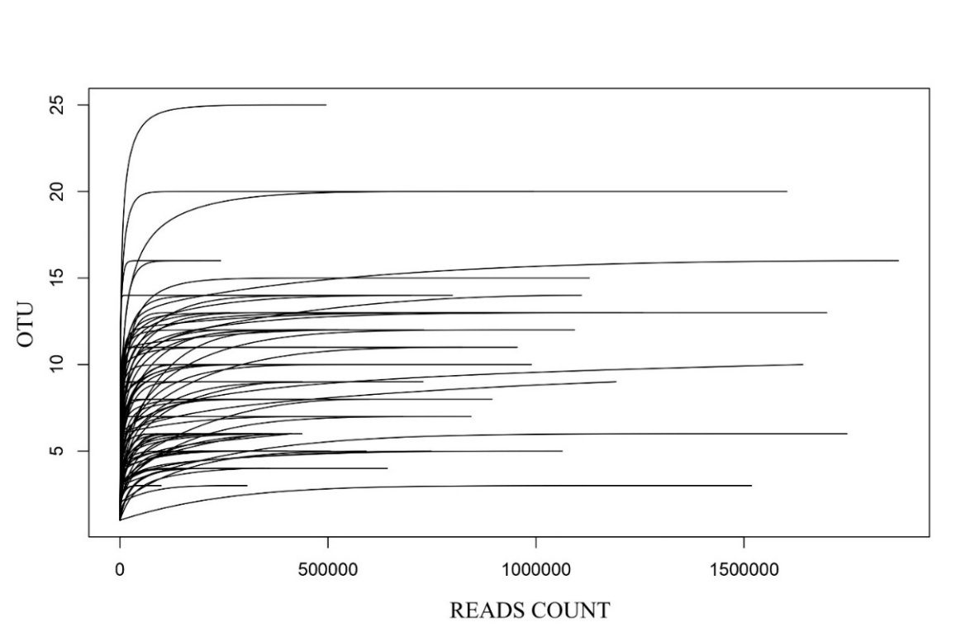
Figure S10. Rarefaction curves showing the relationship between sequencing depth (read count) and OTU richness for all samples (preQC). Sample completeness calculated with iNEXT (Hsieh et al., 2016; version 3.0.2) was 1 for all the samples.

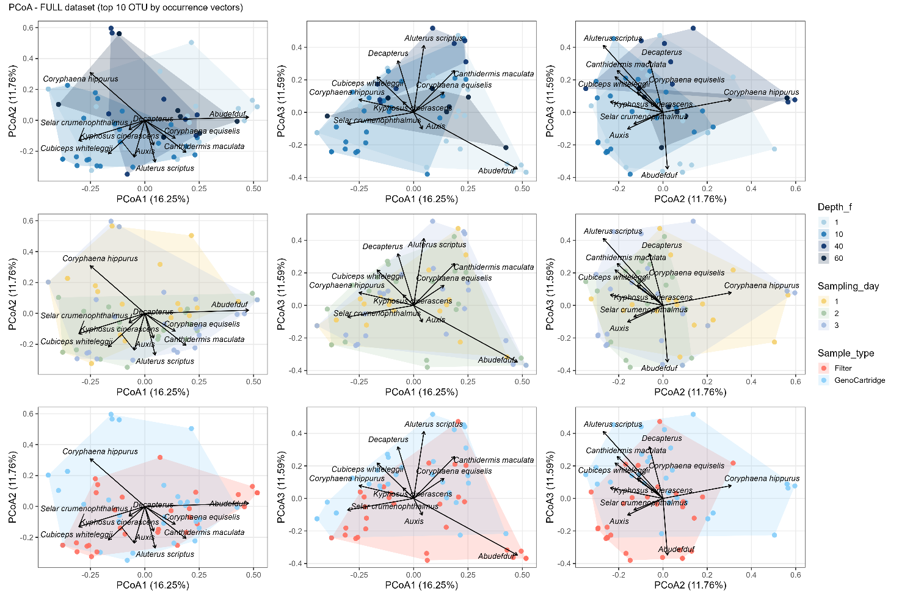
Figure S11. Multi-panel PCoA based on Dice (Sørensen) dissimilarity from presence-absence data on the entire dataset.

