Supplementary material
Figure S1. Temporal trends of nutrient water concentrations at the sampling location retrieved from the Copernicus web portal. Ridges plots are colored according to the month and show the fluctuations of the parameters for each month (lines within ridges indicate median, 25th and 75th percentiles).

Figure S2. Biometric parameters assessed in M. galloprovincialis digestive glands during the 2022 MHW in the NW Adriatic Sea. Box plots (median, upper and lower quartiles; N = 10) show variations of mussel shell and soft tissue parameters across the sampling period. Different letters indicate statistical differences between sampling months (p < 0.05, Mann-Whitney U-test; N = 10).

Table S1. Gene transcript names and functions, primer sequences and qPCR performances.
Transcript name (Acronym) |  | Function | Primers  (5’-3’) | Amplification efficiency (%) |  | GeneBank Accession number  (Reference)
Target genes assessed in digestive glands
Antioxidant response
Catalase  (CAT) |  | Antioxidant enzyme - catalyzes the decomposition of hydrogen peroxide to water and oxygen: | CGACCAGAGACAACCCACC  GCAGTAGTATGCCTGTCCATCC | 96 |  | AY743716  (Anantharaman and Craft, 2012)
Superoxide dismutase  (SOD) |  | Antioxidant enzyme - catalyses the dismutation of superoxide anion to hydrogen peroxide and triplet oxygen. | AGCCAATGCAGAGGGAAAAGCAGA  CCACAAGCCAGACGACCCCC | 97 |  | FM177867  (Koutsogiannaki et al., 2014)
Glutathione s-transferase  (GST) |  | Glutathione pathway enzyme - conjugation of reduced glutathione with various metabolites | TCCAGTTAGAGGCCGAGCTGA  CTGCACCAGTTGGAAACCGTC | 100 |  | AF527010  (Hoarau et al., 2006)
Metabolism
α-amylase  (AMYL) | Digestive enzyme – carbohydrate metabolism |  | CCTCGGGGTAGCTGGTTTTA  TCCAAAGTTACGGGCTCCTT |  | 91 |  | EU336958  (Paul-Pont et al., 2016)
Pyruvate kinase  (PK) | Glycolysis |  | AGACTTGGAGCTGCCTTCAG  GGAATGCACAGAGGGTTCAT |  | 102 |  | Locus22823a  (Paul-Pont et al., 2016)
Isocitrate dehydrogenase  (IDH) | Cell energy metabolism and biosynthesis |  | GGAGGTACTGTATTTCGTGAGGC  TGATCTCCATAAGCATGACGTCC |  | 99 |  | Locus2855a  (Paul-Pont et al., 2016)
Cytoprotection/Detoxification
P-glycoprotein  (ABCB) | ABC transporter – xenobiotic detoxification |  | CACCATAGCCGAGAACATCC  CTCCACGCTCTCCAACTAG |  | 112 |  | EF057747  (Franzellitti and Fabbri, 2013)
Lysozyme  (LYS) | Antimicrobial peptide |  | ATGTGGAATCTGAAGGACTTGT  CCAGTATCCAATGGTGTTAGGG |  | 124 |  | AF334665  (Balbi et al., 2017)
20 kDa metallothionein  (MT20) | Metal binding protein – Metal homeostasis |  | TGTGAAAGTGGCTGCGGA  GTACAGCCACATCCACACGC |  | 92 |  | AY566248  (Dondero et al., 2005)
Lysosome function
Hexosaminidase  (HEX) | Lysosomal hydrolase – marker for lysosomal membrane stabilty |  | GATACTCCAGGACACACTCAATC  CTGGTCCATAGCTACCATCAAATA |  | 101 |  | EU339934  (Capolupo et al., 2018)
ß-Glucuronidase  (GUSB) | Lysosomal hydrolase – Marker for lysosomal structural changes test |  | GCGGTCATTATCTGGTCTGTAG  CCGGTCTTGTTGGGTCTAAAT |  | 120 |  | EU339935  (Capolupo et al., 2018)
Cathepsin L  (CTSL) | Lysosomal cysteine protease |  | CCGAGGCTTCATACCCATATAC  CGACAGCGGACATCAAATCT |  | 92 |  | AY618311  (Capolupo et al., 2018)
Target genes assessed in mantles

Neuroendocrine control
Serotonin receptor  (5-HT1) | Type 1 serotonin receptor – serotoninergic signaling pathway |  | CAGCTGCAAGATCGAGGATT TGAAGCCATCTTGACTGACG |  | 117 |  | AB526218  (Cubero-Leon et al., 2010)
Estrogen receptor 1  (MeER1) | Steroid hormone related receptor |  | TTACGAGAAGGTGTGCGTTT TCACCATAGGAAGGATATGT |  | 101 |  | AB257132  (Puinean and Rotchell, 2006)
Estrogen receptor 2  (MeER2) | Steroid hormone receptor |  | GGAACACAAAGAAAAGAAAGGAAG  ACAAATGTGTTCTGGATGGTG - |  | 98 |  | AB257133  (Puinean and Rotchell, 2006)
Shell biomineralization
Chitin synthase  (CS) | Chitin polymerization and trafficking |  | AACAGAAGCCAGGCACTATATC GTCAGAACCAGCACAGTAGTC |  | 104 |  | EF535882  (Balbi et al., 2017)
Carbonic anhydrase  (CA) | CaCO₃ homeostasis |  | ACCAGATGGTCTTGCAGTTT TCATCTCTGACTGCTGCTAATG |  | 95 |  | LK934681  (Balbi et al., 2016)
Extrapallial protein  (EP) | CaCO₃ homeostasis |  | TAAACTCTGGACACGCATACC  GAGTCCCTCTTGGTGCATATT |  | 100 |  | AY364453  (Balbi et al., 2016)
Gender-specific genes
Vitelline coat lysin  (VCL) | Sperm specific - Acrosomal reaction in fertilization |  | AGAGCTGTTTTGGCCACAGT  TTGCGTTTGACATGGTTGAT |  | 100 |  | FM995162  (Anantharaman and Craft, 2012)
vitelline envelope receptor for lysin  (VERL) | Oocyte specific – fertilization |  | CCGAAGGAAATGGAACTGAAA  CCCTGCAATCGTATGGAATC |  | 100 |  | FM995161  (Anantharaman and Craft, 2012)
Reference genes assessed in digestive glands and mantles

18S rRNA  (18S) | Protein synthesis |  | TCGATGGTACGTGATATGCC  CGTTTCTCATGCTCCCTCTC |  | 95 |  | L33451  (Dondero et al., 2005)
28S rRNA  (28S) | mRNA translation |  | AGCCACTGCTTGCAGTTCTC  ACTCGCGCACATGTTAGACTC |  | 94 |  | DQ158078  (Ciocan et al., 2011)
Actin  (ACT) | structure and function of the cytoskeleton, and component of cell microfilaments |  | GTGTGATGTCATATCCGTAAGGA  GCTTGGAGCAAGTGCTGTGA |  | 114 |  | AF157491  (Banni et al., 2011)
Tubulin  (TUB) | composition and maintenance of cytoskeletal structures |  | TTGCAACCATCAAGACCAAG  TGCAGACGGCTCTCTGT |  | 102 |  | HM537081  (Cubero-Leon et al., 2012)
Elongation factor-1α  (EF1) | control of translation |  | CGTTTTGCTGTCCGAGACATG  CCACGCCTCACATCATTTCTTG |  | 99 |  | AB162021  (Ciocan et al., 2011)
Helicase  (HEL) | Maintaining RNA structures during transcription, splicing, and translation |  | GCACTCATCAGAAGAAGGTGGC  GCTCTCACTTGTGAAGGGTGAC |  | 132 |  | DQ158075  (Cubero-Leon et al., 2012)

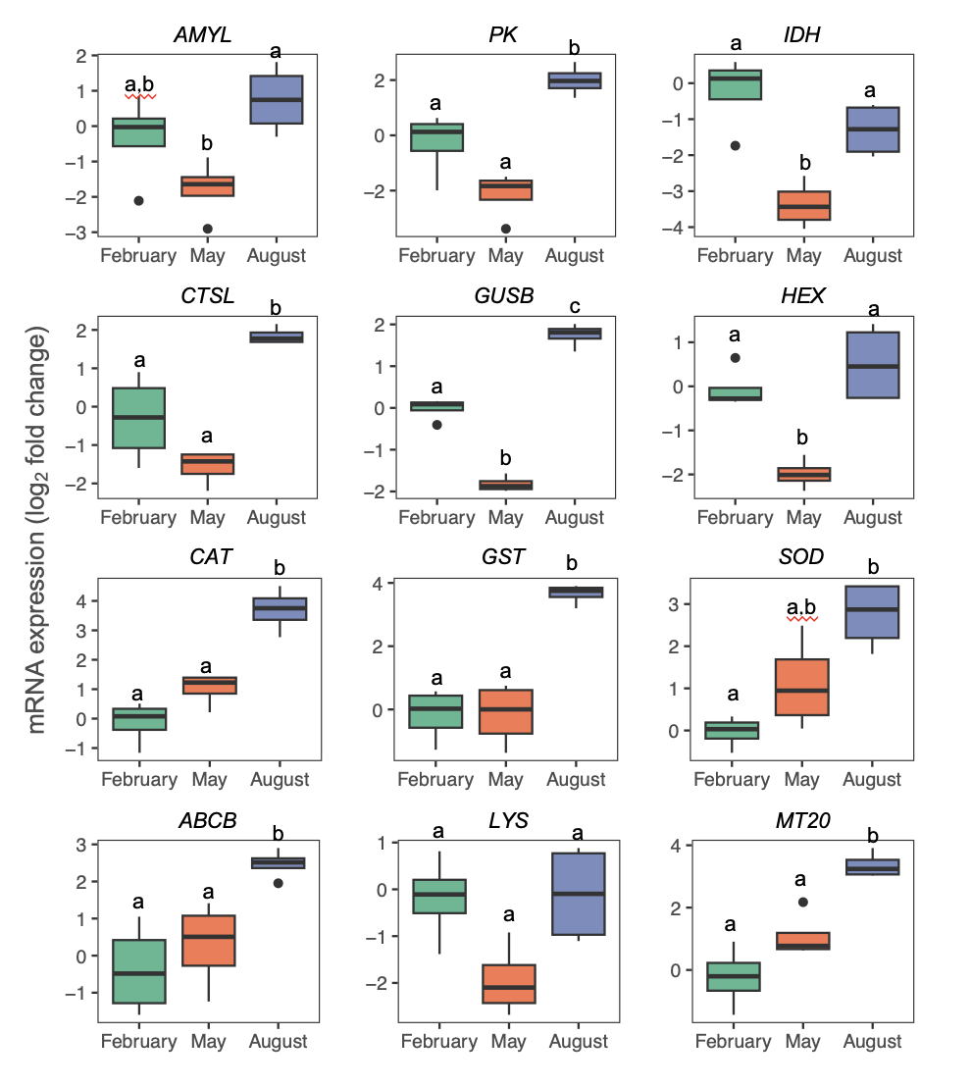

Figure S3. Transcriptional profiles of metabolic (AMYL, PK, IDH), lysosomal (CTSL, GUSB, HEX), antioxidant (CAT, GST, SOD) and cytoprotective/detoxification (ABCB, LYS, H; MT20) gene products assessed in digestive glands of M. galloprovincialis digestive glands during the 2022 MHW in the NW Adriatic Sea. Box plots (median, upper and lower quartiles; N = 10) show the expression levels across sampling timepoints. Different letters indicate statistical differences between Different letters indicate statistical differences between sampling months (p < 0.05, Mann-Whitney U-test; N = 10). Full gene transcripts names are reported in Table S1.

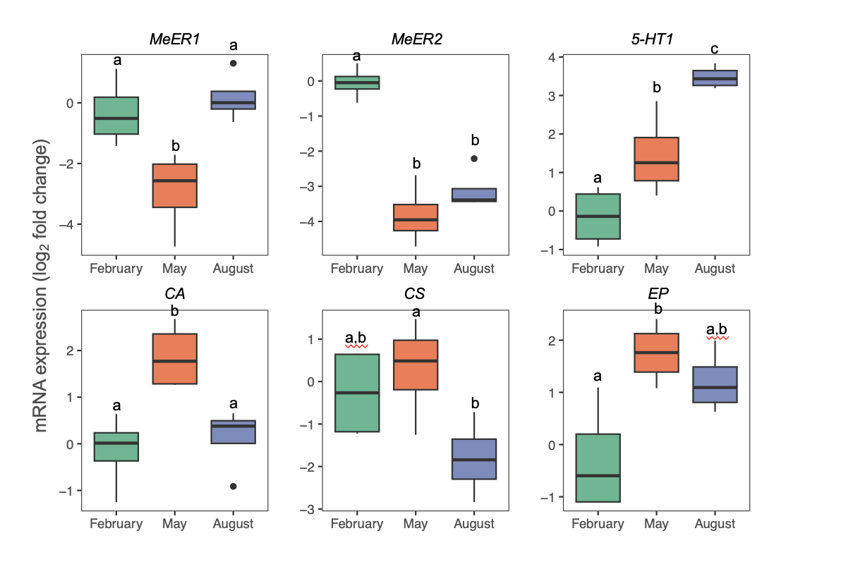

Figure S4. Transcriptional profiles of neuroendocrine (MeER1, MeER2, 5-HT1), and shell biomineralization (CA, CS, EP) related gene products assessed in mantle/gonad complexes of M. galloprovincialis digestive glands during the 2022 MHW in the NW Adriatic Sea. Box plots (median, upper and lower quartiles; N = 10) show the expression levels across sampling timepoints. Different letters indicate statistical differences between Different letters indicate statistical differences between sampling months (p < 0.05, Mann-Whitney U-test; N = 10). Full gene transcripts names are reported in Table S1.

Figure S5. Comparative analyses of timeseries transcriptional data in digestive glands of M. galloprovincialis in the NW Adriatic Sea (Italy). Data gathered in the present study (Rimini 2022) were compared with transcriptional data from digestive glands of mussels collected from nearby farms in previous years (not affected by MHWs): Cesenatico 2018 (Wathsala et al., 2021) and Cattolica 2019 (Palladino et al., 2023). (A) Map of location of the sampling sites; (B) Comparisons of relevant environmental variables sea surface temperature (SST) and chlorophyll-a concentration retrieved from the EU Copernicus web portal. (C) Heatmaps comparing changes in mRNA levels in mussel digestive glands across the sampling periods of each sampling site/year. Colors represent relative expression levels (fold change) with respect to Winter. Light grey color represents unavailable data for IDH expression in the Cattolica 2019 sampling survey. (D) Nonmetric multidimensional scaling (nMDS) analysis showing the relationships between the transcriptional datasets (2D-stress: 0.05).

References
Anantharaman, S., Craft, J.A., 2012. Annual Variation in the Levels of Transcripts of Sex-Specific Genes in the Mantle of the Common Mussel, Mytilus edulis. PLoS ONE 7, e50861. https://doi.org/10.1371/journal.pone.0050861
Balbi, T., Camisassi, G., Montagna, M., Fabbri, R., Franzellitti, S., Carbone, C., Dawson, K., Canesi, L., 2017. Impact of cationic polystyrene nanoparticles (PS-NH2) on early embryo development of Mytilus galloprovincialis: Effects on shell formation. Chemosphere 186, 1–9. https://doi.org/10.1016/j.chemosphere.2017.07.120
Balbi, T., Franzellitti, S., Fabbri, R., Montagna, M., Fabbri, E., Canesi, L., 2016. Impact of bisphenol A (BPA) on early embryo development in the marine mussel Mytilus galloprovincialis: Effects on gene transcription. Environ. Pollut. 218, 996–1004. https://doi.org/10.1016/j.envpol.2016.08.050
Banni, M., Negri, A., Mignone, F., Boussetta, H., Viarengo, A., Dondero, F., 2011. Gene Expression Rhythms in the Mussel Mytilus galloprovincialis (Lam.) across an Annual Cycle. PLoS ONE 6, e18904. https://doi.org/10.1371/journal.pone.0018904
Capolupo, M., Franzellitti, S., Valbonesi, P., Lanzas, C.S., Fabbri, E., 2018. Uptake and transcriptional effects of polystyrene microplastics in larval stages of the Mediterranean mussel Mytilus galloprovincialis. Environ. Pollut. 241, 1038–1047. https://doi.org/10.1016/j.envpol.2018.06.035
Ciocan, C.M., Cubero-Leon, E., Minier, C., Rotchell, J.M., 2011. Identification of Reproduction-Specific Genes Associated with Maturation and Estrogen Exposure in a Marine Bivalve Mytilus edulis. PLoS ONE 6, e22326. https://doi.org/10.1371/journal.pone.0022326
Cubero-Leon, E., Ciocan, C.M., Hill, E.M., Osada, M., Kishida, M., Itoh, N., Kondo, R., Minier, C., Rotchell, J.M., 2010. Estrogens disrupt serotonin receptor and cyclooxygenase mRNA expression in the gonads of mussels (Mytilus edulis). Aquat. Toxicol. 98, 178–187. https://doi.org/10.1016/j.aquatox.2010.02.007
Cubero-Leon, E., Ciocan, C.M., Minier, C., Rotchell, J.M., 2012. Reference gene selection for qPCR in mussel, Mytilus edulis, during gametogenesis and exogenous estrogen exposure. Environ. Sci. Pollut. Res. 19, 2728–2733. https://doi.org/10.1007/s11356-012-0772-9
Dondero, F., Piacentini, L., Banni, M., Rebelo, M., Burlando, B., Viarengo, A., 2005. Quantitative PCR analysis of two molluscan metallothionein genes unveils differential expression and regulation. Gene 345, 259–270. https://doi.org/10.1016/j.gene.2004.11.031
Franzellitti, S., Fabbri, E., 2013. Cyclic-AMP Mediated Regulation of ABCB mRNA Expression in Mussel Haemocytes. PLoS ONE 8, e61634. https://doi.org/10.1371/journal.pone.0061634
Hoarau, P., Damiens, G., Roméo, M., Gnassia-Barelli, M., Bebianno, M.J., 2006. Cloning and expression of a GST-pi gene in Mytilus galloprovincialis. Attempt to use the GST-pi transcript as a biomarker of pollution. Comp. Biochem. Physiol. Part C Toxicol. Pharmacol. 143, 196–203. https://doi.org/10.1016/j.cbpc.2006.02.007
Koutsogiannaki, S., Franzellitti, S., Fabbri, E., Kaloyianni, M., 2014. Oxidative stress parameters induced by exposure to either cadmium or 17β-estradiol on Mytilus galloprovincialis hemocytes. The role of signaling molecules. Aquat. Toxicol. 146, 186–195. https://doi.org/10.1016/j.aquatox.2013.11.005
Palladino, G., Rampelli, S., Scicchitano, D., Nanetti, E., Iuffrida, L., Wathsala, R.H.G.R., Interino, N., Marini, M., Porru, E., Turroni, S., Fiori, J., Franzellitti, S., Candela, M., 2023. Seasonal dynamics of the microbiome-host response to pharmaceuticals a nd pesticides in Mytilus galloprovincialis farmed in the Northwestern Adriatic Sea. Sci. Total Environ. 163948. https://doi.org/10.1016/j.scitotenv.2023.163948
Paul-Pont, I., Lacroix, C., González Fernández, C., Hégaret, H., Lambert, C., Le Goïc, N., Frère, L., Cassone, A.-L., Sussarellu, R., Fabioux, C., Guyomarch, J., Albentosa, M., Huvet, A., Soudant, P., 2016. Exposure of marine mussels Mytilus spp. to polystyrene microplastics: Toxicity and influence on fluoranthene bioaccumulation. Environ. Pollut. 216, 724–737. https://doi.org/10.1016/j.envpol.2016.06.039
Puinean, A.-M., Rotchell, J.M., 2006. Vitellogenin gene expression as a biomarker of endocrine disruption in the invertebrate, Mytilus edulis. Mar. Environ. Res. 62, S211–S214. https://doi.org/10.1016/j.marenvres.2006.04.035
Wathsala, R.H.G.R., Musella, M., Valbonesi, P., Candela, M., Franzellitti, S., 2021. Variability of metabolic, protective, antioxidant, and lysosomal gene transcriptional profiles and microbiota composition of Mytilus gallopr ovincialis farmed in the North Adriatic Sea (Italy). Mar. Pollut. Bull. 172, 112847. https://doi.org/10.1016/j.marpolbul.2021.112847

