Supplemental Materials for “Understanding workability of low carbon cements through advanced water detection techniques”
Lucia Ferrari^{a,*}, Villiam Bortolottiª, Nikola Mikanovic^{b}, Mohsen Ben-Haha^{b}, Elisa Franzoniª
ªUniversity of Bologna, Department of Civil, Chemical, Environmental, and Materials Engineering, via Terracini 28, 40131 Bologna, Italy
^{b}Global R&D, HeidelbergCement AG, Oberklamweg 2-4, 69181 Leimen, Germany
*corresponding author: lucia.ferrari9@unibo.it, ORCID ID 0000-0001-6785-9977
Cement nomenclature

Cement nomenclature: C = CaO, S = SiO₂, A = Al₂O₃, and F = Fe₂O₃; C₃S refers to 3CaO·SiO₂, namely, tricalcium silicate

Supplementary Figures and Tables

Supplementary Table 1 – Chemical composition of materials used to formulate low-carbon cement blends. CEM I (Ordinary Portland Cement CEM I 52.5 R), CEM II (CEM II/A-LL with 12% limestone and the same clinker as CEM I), calcined clay (CC), limestone (LS) determined by X-ray Fluorescence (LOI: Loss on Ignition). The two cements show a relatively similar composition. The main difference is observable in the Loss on Ignition, where CEM II has higher mass loss due to decarbonation of limestone.
Constituents | CEM I (%) | CEM II (%) | Calcined Clay (%)
LOI 1050 °C | 2.49 | 5.74 | 2.36
SiO₂ | 19.2 | 18.1 | 60.2
Al₂O₃ | 5.12 | 4.80 | 25.8
TiO₂ | 0.29 | 0.28 | 1.26
MnO | 0.04 | 0.03 | 0.00
Fe₂O₃ | 3.22 | 3.02 | 8.87
CaO | 62.7 | 61.5 | 0.98
MgO | 1.89 | 1.67 | 0.24
K₂O | 1.02 | 1.04 | 0.17
Na₂O | 0.07 | 0.06 | 0.00
SO₃ | 3.32 | 3.24 | 0.05
P₂O₅ | 0.14 | 0.16 | 0.02
Total | 99.5 | 99.6 | 100
Supplementary Table 2 – Mineralogical composition of CEM I, CEM II, LS and CC by X-ray diffraction according to DIN EN 13925‑2 procedure and Rietveld refinement. The two cements are characterized by a high C₃S and C₃A content.
Cement notation/mineralogical name | Chemical Formula | CEM I  (%) | CEM II  (%) | LS  (%) | CC  (%)
C₃S | Ca₃SiO₅ | 61.80 | 56.20 | - | -
C₂S | Ca₂SiO₄ | 8.19 | 7.69 | - | -
C₃A | Ca₃Al2O₆ | 6.00 | 5.41 | - | -
C₄AF | Ca₂(Al. Fe)₂O₅ | 11.10 | 9.31 | - | -
Portlandite | Ca(OH)₂ | 1.19 | 1.55 | - | -
Periclase | MgO | 0.72 | 0.64 | - | -
Arcanite | K₂SO₄ | 1.40 | 1.55 | - | -
Syngenite | K₂Ca(SO₄)₂ · H₂O | 0.96 | - | - | -
Anhydrite | CaSO₄ | 1.71 | 1.75 | - | -
Dihydrate calcium sulfate | CaSO₄ · 2H₂O | 0.45 | 0.28 | - | -
Hemihydrate calcium sulfate | CaSO₄ · 1/2H₂O | 2.45 | 2.08 | - | -
Quartz | SiO₂ | 0.25 | 0.71 | - | 22.8
Calcite | CaCO₃ | 3.21 | 12.40 | 99.39 | -
Dolomite | CaMg(CO₃)₂ | 0.64 | 0.49 | 0.61 | -
Hematite | Fe₂O₃ | - | - | - | 3.9
Anatase + Rutile | TiO₂ | - | - | - | 1.3
Amorphous | - | - | - | - | 72.1

Supplementary Table 3 – Densities of cements and supplementary cementitious materials measured by pycnometer method in different liquid media according to standard EN 1097-6 [1]. The measured materials’ densities are consistent with what usually expected for these kinds of materials.
Material | Medium | Density  (g cm⁻³)
CEM I | ethanol | 3.1
CEM II | ethanol | 3.1
Limestone | water | 2.7
Calcined clay | water | 2.8

Supplementary Table 4 – Specific Surface Area (SSA) measured by BET method using N₂-sorption.
Material | SSA  (m² g⁻¹)
CEM I | 0.60
CEM II | 0.04
Limestone | 0.06
Calcined clay | 48.1

Supplementary Figure 1– Particle size distribution of cements and powders used to formulate binders, measured by laser diffraction. CEM I and CEM II were investigated by Malvern Mastersizer 3000, in isopropanol, while limestone (LS) and calcined clay (CC) were tested in water by a Malvern Hydro 2000MU. In terms of grain size distribution curves, the powders are similar and typical of cementitious materials, except for limestone that is slightly coarser. The comparable granulometry of the binders is an advantage in the formulation of LC³ because substitutions of clinker with calcined clay and limestone is not going to play a major role in affecting particle size distribution, especially in relation to workability, as both CC and LS are slightly coarser than the two cements.

Supplementary Figure 2- Cumulative percentage passing by mass of the crushed manufactured sand. The sand used for mortar preparation was manufactured by crushing natural stones and was provided by Italcementi (Bergamo, Italy). Tests to characterize sand were conducted according to EN 197-6 [2] by pycnometer method. Particle size distribution was measured by quartering and sieving, after drying the sand for 24h at 110°C. The measured sand density is (2.67 ± 0.02) g/cm³, while measured water absorption is (0.44 ± 0.02) % of the dry mass of sand.
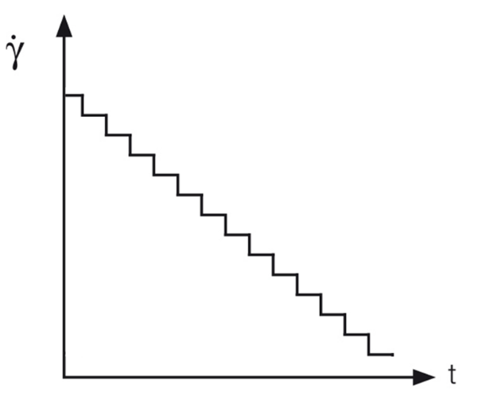
Supplementary Figure 3 – Illustration of the downward flow curve with a decreasing shear rate ($\dot{γ}$) and a defined measurement point duration for each point (t).

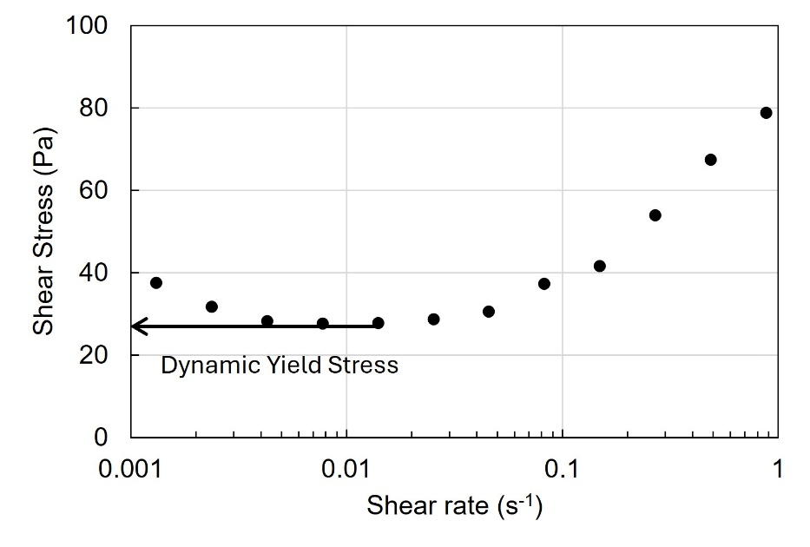

Supplementary Figure 4 – Detailed view of a downward flow curve with a decreasing shear rate and a measured shear stress. The estimation of the Dynamic Yield Stress is extracted as the minimum of the flow curve.

References
[1] British Standards Institution, “EN 1097-6:2022 - Tests for mechanical and physical properties of aggregates. Part 6, Determination of particle density and water absorption,” British Standards Institution, 2022.
[2] British Standards Institution, EN 197-6, Tests for Mechanical and Physical Properties of Aggregates. Part 6: Determination of Particle Density and Water Absorption. London, 2000.

