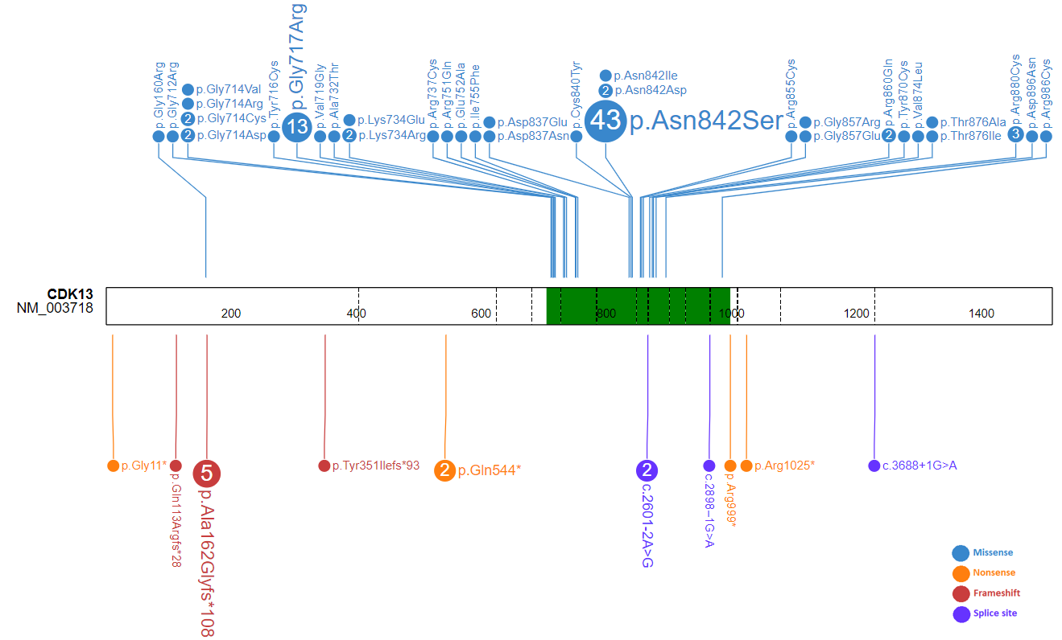
Supplementary Figure 1. Schematic representation of the variants in CDK13 reported in the literature. The green area identifies the kinase domain (residues 705-998). The different variant classes are indicated by red dots (frameshift variants), orange dots (nonsense variants), blue dots (missense variants) and violet dots (splicing variants). Numbers inside the dot correspond to the number of participants carrying the same variant (single cases, if not specified). The cartoon was created using ProteinPaint.

