Supporting Information to

Highly active Ag/C nanoparticles containing ultra-low quantities of Platinum for the electrooxidation of glycerol in alkaline media

Carlos C. Limaª. Marta V. F. Rodriguesª. Antonio F. M. Netoª. Cinthia. R. Zanata^{b}. Cléo T. G. V. M. T. Piresª. Luelc S. Costa^{a.d}. José Solla- Gullón^{c}. Pablo S. Fernández^{a.d}.

ª Institute of Chemistry. States University of Campinas (UNICAMP). Campinas-SP. 13083-970. Brazil.
^{b} Institute of Chemistry. Federal University of Mato Grosso do Sul (UFMS). Campo Grande-MS. 79074-460. Brazil
^{c} Institute of Electrochemistry. University of Alicante. Apdo. 99. E-03080 Alicante. Spain
^{d} Center for Innovation on New Energies (CINE). Campinas-SP. 13083-841. Brazil

ICP results
The composition of Pt(1%)Ag/C was measured using ICP-AES (Inductively Coupled Plasma - Atomic Emission Spectrometry). ICP results shown below indicate that the Pt/Ag atomic ratio of the Pt(1%)Ag/C is 0.0074:1.
Metal | Average mass (μg) | Deviation
Ag | 2.4794 | 0.083
Pt | 0.0184 | 0.00095
Platinum content in Pt (1%) Ag / C calculated from ICP data:
Pt(%) = 0.0184/(2.4794+0.0184)*100 = 0.74%

Measure 1
Peak | BE / eV | %Pt/(PtO_{x}+Pt) | %Pt/Ag
Pt4f_{7/2} (Pt⁰) | 71.03 | 54 | 7.3
Pt4f_{7/2} (PtO_{x}) | 72.74
Pt4f_{5/2} (Pt⁰) | 74.33
Pt4f_{5/2} (PtO_{x}) | 76.04
Ag3d_{5/2} (Ag⁰) | 368.7
Ag3d3^{/2} (Ag⁰) | 374.7
Measure
Peak | BE / eV | %Pt/(PtO_{x}+Pt) | %Pt/Ag
Pt4f_{7/2} (Pt⁰) | 70.98 | 62 | 7.7
Pt4f_{7/2} (PtO_{x}) | 72.69
Pt4f_{5/2} (Pt⁰) | 74.18
Pt4f_{5/2} (PtO_{x}) | 75.86
Ag3d_{5/2} (Ag⁰) | 368.6
Ag3d_{3/2} (Ag⁰) | 374.6
Measure 3
Peak | BE / eV | %Pt/(PtO_{x}+Pt) | %Pt/Ag
Pt4f_{7/2} (Pt⁰) | 70.96 | 47 | 6.5
Pt4f_{7/2} (PtO_{x}) | 72.73
Pt4f_{5/2} (Pt⁰) | 74.16
Pt4f_{5/2} (PtO_{x}) | 75.83
Ag3d_{5/2} (Ag⁰) | 368.6
Ag3d_{3/2} (Ag⁰) | 374.6
XPS results

Normalization factor calculation
2 mg of the catalyst were mixed with 700 µl of water. 200 µl of 2-propanol and 50 µl of Nafion®. Thus. the catalyst concentration is 2.105 x 10⁻³ mg/µl. The product of this mixture formed a homogeneous ink. 20 uL of this ink was used to form the film on the electrode surface. 20 uL of the ink contains 0.042 mg of Pt(1%)Ag/C and the ICP analysis showed that the metallic composition of the catalytic powder is in the proportion of 0.737% Pt and 99.263% Ag. Therefore. for 0.042 mg of Pt(1%)Ag/C - 20%. we have 3.093x10⁻⁴ mg of Pt. or even 309.4 ug of Pt. This value was used to normalize the current generated in the glycerol electrooxidation reaction (EOG).

Transmission electronic microscopy (TEM)
Element | Weight % | Atomic % | Uncert. % | Correction | k-Factor
O(K) | 21.92 | 52.61 | 0.82 | 0.49 | 1.974
Si(K) | 18.73 | 25.61 | 0.49 | 0.92 | 1.000
S(K) | 3.34 | 4.00 | 0.22 | 0.93 | 1.021
Ag(K) | 42.37 | 15.08 | 1.12 | 0.98 | 6.491
Pt(L) | 13.62 | 2.68 | 0.76 | 0.75 | 5.547
Fig. S1. STEM images and EDS elemental mapping: Pt(1%)Ag/C. Image in a STEM mode (below) with a HAADF detector showing the individual signal of Ag. C and Pt.

EOG on Pt(1%)Ag/C, Ag/C and Pt/C
Fig. S2 shows the profile of the glycerol electrooxidation for the Ag/C. Pt/C and Pt(1%)Ag/C catalysts. The onset potential of reaction is 0.4 V for the Pt/C and Pt(1%)Ag/C catalysts. and 0.8 V for Ag/C. In this case the currents were not normalized. then this figure will be similar (in relative terms) to one where the current is normalized by the total amount of the catalyst.
Fig. S2 Electrooxidation of glycerol on Pt/C (red). Pt(1%)Ag/C (black) and Ag/C (blue).

Fig. S3 shows the faradaic efficiency (FE) for the different products formed during 30 minutes of electrolysis. The calculation of faradaic efficiency was performed according to eq. 1.
$FE= \frac{z_{i}n_{i}F}{Q}$ x 100 eq. 1
where. z_{i} is the quantity of electrons transferred for the formation of a molecule of a given product (for example. 2 for glyceraldehyde and DHA. 4 for glyceric acid. etc.). n_{i} is the molar amount of product formed in the electrolysis. F is Faraday’s constant and $Q$ is the total charged measured in the experiment. In the acid eluent. the CO₃⁻² ion is converted to CO₂. which is not detected in our method. It explains the fact that the sum of the FE is lower than 100% for both catalysts and is in line with the FTIR results. The sum of the FE is closer to 100% for Pt(1%)Ag/C. the catalyst that generated lower CO₃⁻² in agreement with the FTIR results discussed in the text.
Table S1. Faradaic Efficiency for the GEOR after 30 min of electrolysis for Pt(1%)Ag/C and Pt/C. Two independent experiment where performed with each material.
Faradaic Efficiency (30 minutes)
 | Pt(1%)Ag/C |  | Pt/C
Molecule | Electrolysis 1 | Electrolysis 2 | Electrolysis 3 | Electrolysis 4
Glycerate | 27.49 | 36.97 | 36.23 | 26.91
Glycolate | 28.37 | 26.78 | 7.33 | 5.44
Lactate | 11.95 | 26.74 | 15.34 | 11.39
Formate | 15.38 | 0 | 0 | 0
Total | 83.19 | 90.49 | 58.90 | 43.74

In order to understand the intrinsic activity of the Pt atoms (and discard the possibility that the improvement in activity be exclusively due to a better Pt utilization) current were normalized by the Pt atoms that are at the surface of Pt(1%)Ag/C and Pt/C. To do this. it is necessary to know how the percentage of atoms at the surface of the nanoparticles changes with their size and shape. Fig. S4 shows the percentage of atoms at the surface of a spherical nanoparticle of Pt as a function of its diameter. The nanoparticle was constructed using the software Vesta considering a lattice parameter of 3.9231 angstroms and a face-centered cubic structure.[1]
Fig. S3. Relation between the particle diameter and the percentage of atoms at the surface of a spherical Pt nanoparticle.

Table S2 shows the data used in figure S4.
Diameter of NPs/nm | Total atoms | Atoms at the surface | atoms at the surface (%)
0.28 | 1 | 1 | 100.0%
0.83 | 27 | 22 | 81.5%
1.39 | 103 | 76 | 73.8%
1.94 | 282 | 179 | 63.5%
2.77 | 584 | 302 | 51.7%
3.33 | 1000 | 416 | 41.6%
3.61 | 1534 | 534 | 34.8%
4.16 | 2171 | 637 | 29.3%
4.44 | 2899 | 729 | 25.1%
4.99 | 3805 | 907 | 23.8%
5.27 | 4897 | 1093 | 22.3%
5.83 | 6051 | 1155 | 19.1%
6.10 | 7419 | 1369 | 18.5%
6.38 | 9189 | 1483 | 16.1%
7.21 | 12887 | 1999 | 15.5%
8.05 | 17789 | 2491 | 14.0%
9.16 | 25267 | 3355 | 13.3%
9.99 | 34521 | 3757 | 10.9%
10.54 | 39015 | 3583 | 9.2%
10.82 | 43659 | 3397 | 7.8%

Fig. S4. Cyclic voltammograms of ethanol electrooxidation on Pt(1%)Ag/C (black). Pt/C (red) and Ag/C (blue). without normalization (a) and after normalizing by the Pt mass (b). Electrolyte of NaOH 0.5 mol.L⁻¹ and 1.0 M EtOH solution.

XAFS (X-ray absorption fine structure)
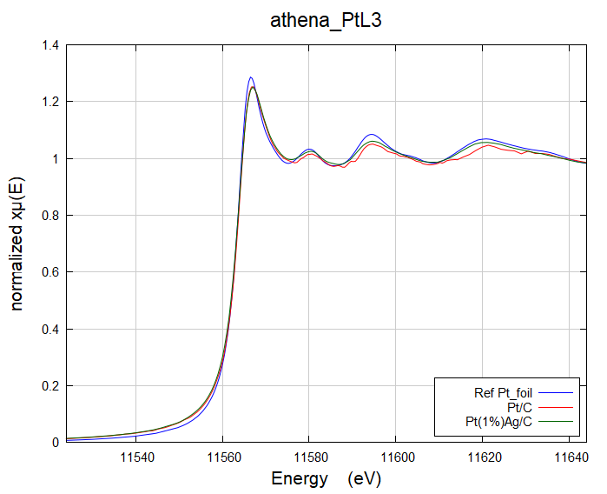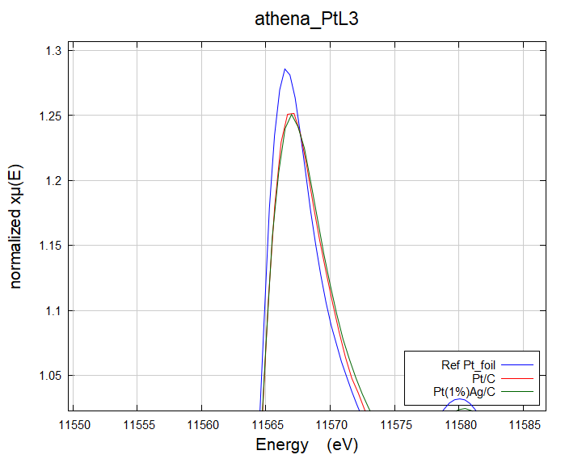

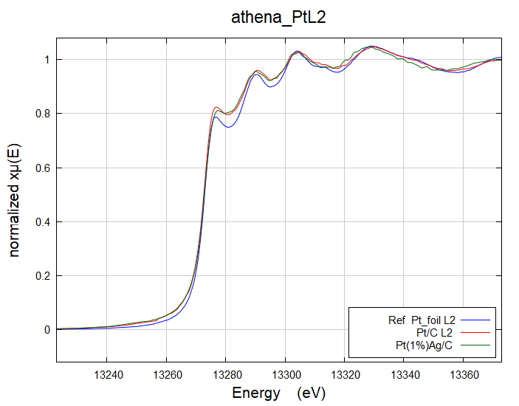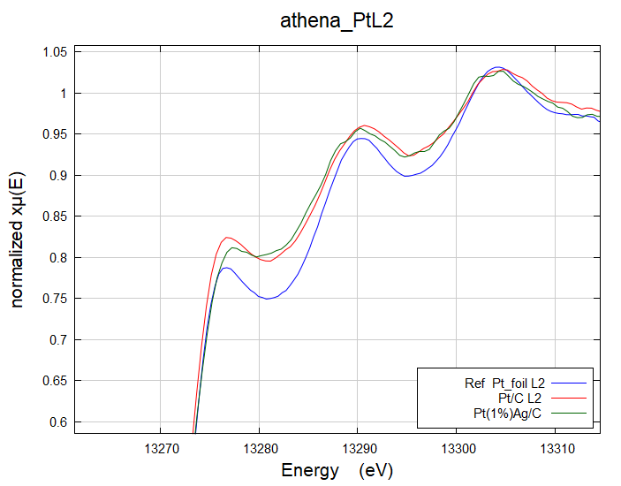

Fig. S5. In situ XAFS measurement where performed in 0.1 M NaOH for Pt(1%)Ag/C (green), Pt/C (red) and a Pt foil used as a reference (blue). Spectra at Pt-L3 edge (above) and Pt L2-edge (below) are similar for both catalysts. The slight difference at Pt L2-edge might be related to variations in the background removal since main differences would be expected at L3-edge. These results were obtained using a double crystal monochromator of Si(111). The measurement was performed in the fluorescence mode using a Ge-15 detector (Camberra®). The beamline details could be found elsewhere[2].

[1] K. Momma, F. Izumi, VESTA 3 for three-dimensional visualization of crystal, volumetric and morphology data, J. Appl. Crystallogr. 44 (2011) 1272–1276. https://doi.org/10.1107/S0021889811038970.
[2] S.J.A.A. Figueroa, J.C. Mauricio, J. Murari, D.B. Beniz, J.R. Piton, H.H. Slepicka, M.F. De Sousa, A.M. Espíndola, A.P.S.S. Levinsky, Upgrades to the XAFS2 beamline control system and to the endstation at the LNLS, J. Phys. Conf. Ser. 712 (2016) 012022. https://doi.org/10.1088/1742-6596/712/1/012022.

