Appendix A
Table A.1. Clinical trials included in the analysis.
Study name | ClinicalTrials.gov identifier | Line of therapy | Indication | Database cutoff
KEYNOTE-001 [1, 2] | NCT01295827 | Subsequent line | Melanoma | April 18, 2014
KEYNOTE-001 [1, 2] | NCT01295827 | Subsequent line | NSCLC | January 23, 2015
KEYNOTE-002 [3] | NCT01704287 | Subsequent line | Melanoma | February 28, 2015
KEYNOTE-006 [4] | NCT01866319 | Subsequent line | Melanoma | March 3, 2015
KEYNOTE-010 [5] | NCT01905657 | Subsequent line | NSCLC | September 30, 2015
KEYNOTE-012 [6-8] | NCT01848834 | Subsequent line | HNSCC | April 26, 2016
KEYNOTE-012 [6-8] | NCT01848834 | Subsequent line | Gastric | April 26, 2016
KEYNOTE-012 [6-8] | NCT01848834 | Subsequent line | Bladder | September 1, 2015
KEYNOTE-013 [9, 10] | NCT01953692 | Subsequent line | cHL | September 28, 2018
KEYNOTE-013 [9, 10] | NCT01953692 | Subsequent line | PMBCL | August 4, 2017
CITN-09/ KEYNOTE-017 [11] | NCT02267603 | First line | MCC | February 6, 2018
KEYNOTE-024 [12] | NCT02142738 | First line | NSCLC | July 10, 2017
KEYNOTE-028 [13-15] | NCT02054806 | Subsequent line | Cervical | February 20, 2017
KEYNOTE-028 [13-15] | NCT02054806 | Subsequent line | Esophageal | January 31, 2018
KEYNOTE-028 [13-15] | NCT02054806 | Subsequent line | SCLC | July 31, 2018
KEYNOTE-040 [16] | NCT02252042 | Subsequent line | HNSCC | May 15, 2017
KEYNOTE-042 [17] | NCT02220894 | First line | NSCLC | September 4, 2018
KEYNOTE-045 [18] | NCT02256436 | Subsequent line | Bladder | October 26, 2017
KEYNOTE-048 [19] | NCT02358031 | Subsequent line | HNSCC | February 25, 2019
KEYNOTE-052 [20] | NCT02335424 | First line | Bladder | September 26, 2018
KEYNOTE-055 [21] | NCT02255097 | Subsequent line | HNSCC | April 22, 2016
KEYNOTE-057 [22] | NCT02625961 | Subsequent line | Bladder | May 24, 2019
KEYNOTE-059 [23] | NCT02335411 | Subsequent line | Gastric | August 8, 2018
KEYNOTE-061 [24] | NCT02370498 | Subsequent line | Gastric | October 26, 2017
KEYNOTE-062 [25] | NCT02494583 | First line | Gastric | March 26, 2019
KEYNOTE-087 [26] | NCT02453594 | Subsequent line | cHL | March 15, 2021
KEYNOTE-158 [27, 28] | NCT02628067 | Subsequent line | Cervical | June 27, 2019
KEYNOTE-158 [27, 28] | NCT02628067 | Subsequent line | SCLC | June 27, 2019
KEYNOTE-158 [27, 28] | NCT02628067 | Subsequent line | TMB-H – various solid tumors | June 27, 2019
KEYNOTE-158 [27, 28] | NCT02628067 | Subsequent line | MSI-H – various solid tumors | October 5, 2020
KEYNOTE-164 [29] | NCT02460198 | Subsequent line | CRC | September 9, 2019
KEYNOTE-170 [30] | NCT02576990 | Subsequent line | PMBCL | May 7, 2020
KEYNOTE-177 [31] | NCT02563002 | First line | CRC | February 19, 2021
KEYNOTE-180 [32] | NCT02559687 | Subsequent line | Esophageal | July 30, 2018
KEYNOTE-181 [33] | NCT02564263 | Subsequent line | Esophageal | October 15, 2018
KEYNOTE-204 [34] | NCT02684292 | Subsequent line | cHL | January 16, 2020
KEYNOTE-224 [35, 36] | NCT02702414 | Subsequent line | HCC | June 5, 2019
KEYNOTE-361 [37] | NCT02853305 | First line | Bladder | April 29, 2020
KEYNOTE-427 [38] | NCT02853344 | First line | RCC | September 7, 2018
KEYNOTE-629 [39] | NCT03284424 | Subsequent line | cSCC | July 29, 2020
cHL, classical Hodgkin lymphoma; CRC, colorectal cancer; cSCC, cutaneous squamous cell carcinoma; HCC, hepatocellular carcinoma; HNSCC, head and neck squamous cell carcinoma; MCC, Merkel cell carcinoma; MSI-H, microsatellite instability high; NSCLC, non-small cell lung cancer; PMBCL, primary mediastinal large B-cell lymphoma; RCC, renal cell carcinoma; SCLC, small cell lung cancer; TMB-H, tumor mutation burden high.

Table A.2. Grade 3–5 all-cause AEs that occurred in ≥1% of patients in the 31-trial pooled safety dataset.
31-trial pooled safety dataset
N=8937
Anemia | 481 (5.4)
Pneumonia | 357 (4.0)
Hyponatremia | 240 (2.7)
Fatigue | 229 (2.6)
Dyspnea | 191 (2.1)
AST increased | 144 (1.6)
Urinary tract infection | 136 (1.5)
Pulmonary embolism | 131 (1.5)
Diarrhea | 130 (1.5)
Decreased appetite | 125 (1.4)
ALT increased | 120 (1.3)
Asthenia | 119 (1.3)
Hypertension | 118 (1.3)
Abdominal pain | 114 (1.3)
Hyperglycemia | 114 (1.3)
Pneumonitis | 112 (1.3)
Blood ALP increased | 107 (1.2)
Dehydration | 104 (1.2)
Back pain | 103 (1.2)
Pleural effusion | 103 (1.2)
Hypokalemia | 97 (1.1)
Acute kidney injury | 95 (1.1)
Vomiting | 91 (1.0)
Sepsis | 86 (1.0)
Colitis | 85 (1.0)
Data are n (%).
AE, adverse event; ALP, alkaline phosphatase; ALT, alanine aminotransferase; AST aspartate aminotransferase.

Table A.3. All-cause serious adverse events occurring in ≥1% of patients in the 31-trial pooled safety dataset.
31-trial pooled safety dataset
N=8937
Pneumonia | 353 (3.9)
Pneumonitis | 157 (1.8)
Pleural effusion | 115 (1.3)
Anemia | 111 (1.2)
Urinary tract infection | 106 (1.2)
Dyspnea | 104 (1.2)
Acute kidney injury | 103 (1.2)
Pyrexia | 103 (1.2)
Pulmonary embolism | 101 (1.1)
Data are n (%).

Table A.4. All-cause adverse events leading to discontinuation of pembrolizumab in ≥20 patients in the 31-trial pooled safety dataset.
31-trial pooled safety dataset
N=8937
Pneumonitis | 127 (1.4)
Pneumonia | 47 (0.5)
Death | 42 (0.5)
Colitis | 34 (0.4)
ALT increased | 28 (0.3)
AST increased | 27 (0.3)
Autoimmune hepatitis | 21 (0.2)
Data are n (%).
ALT, alanine aminotransferase; AST aspartate aminotransferase.

Table A.5. All-cause adverse events leading to death that occurred in ≥5 patients in the 31-trial pooled safety dataset.
31-trial pooled safety dataset
N=8937
Death – not otherwise specified | 73 (0.8)
Pneumonia | 56 (0.6)
Respiratory failure | 23 (0.3)
Sepsis | 18 (0.2)
Pneumonia aspiration | 17 (0.2)
Septic shock | 16 (0.2)
Cardiac arrest | 14 (0.2)
Pulmonary embolism | 14 (0.2)
Pneumonitis | 13 (0.1)
General physical health deterioration | 11 (0.1)
Multiple organ dysfunction syndrome | 11 (0.1)
Cardiac failure | 8 (0.1)
Myocardial infarction | 8 (0.1)
Acute respiratory failure | 7 (0.1)
Cerebrovascular accident | 7 (0.1)
Tumor hemorrhage | 7 (0.1)
Urosepsis | 7 (0.1)
Acute kidney injury | 6 (0.1)
Cardio-respiratory arrest | 6 (0.1)
Completed suicide | 6 (0.1)
Embolism | 6 (0.1)
Malignant neoplasm progression | 6 (0.1)
Aspiration | 5 (0.1)
Dyspnea | 5 (0.1)
Pulmonary hemorrhage | 5 (0.1)
Data are n (%).
AE, adverse event.

Table A.6. Immune-mediated AEs and infusion reactions by grade.
 | 31-trial pooled safety dataset  N=8937 |  |  |  |  | Label safety dataset [1]  N=2799
 | Grade 1 | Grade 2 | Grade 3 | Grade 4 | Grade 5 | Grade 1 | Grade 2 | Grade 3 | Grade 4 | Grade 5
Any immune-mediated AE or infusion reaction | 527 (5.9) | 1031 (11.5) | 478 (5.3) | 63 (0.7) | 22 (0.2) | 154 (5.5) | 292 (10.4) | 134 (4.8) | 17 (0.6) | 4 (0.1)
Adrenal insufficiency | 5 (0.1) | 28 (0.3) | 32 (0.4) | 4 (0.0) | 0 | 3 (0.1) | 9 (0.3) | 9 (0.3) | 1 (0.0) | 0
Arthritis | 0 | 0 | 4 (<0.1) | 0 | 0 | 0 | 0 | 0 | 0 | 0
Colitis | 24 (0.3) | 46 (0.5) | 86 (1.0) | 7 (0.1) | 2 (<0.1) | 6 (0.2) | 10 (0.4) | 30 (1.1) | 2 (0.1) | 0
Encephalitis | 1 (<0.1) | 0 | 5 (0.1) | 0 | 0 | 0 | 0 | 1 (<0.1) | 0 | 0
Guillain-Barré syndrome | 0 | 2 (<0.1) | 3 (<0.1) | 2 (<0.1) | 1 (<0.1) | 0 | 1 (<0.1) | 0 | 1 (<0.1) | 0
Hepatitis | 5 (0.1) | 13 (0.1) | 58 (0.6) | 10 (0.1) | 0 | 1 (<0.1) | 4 (0.1) | 11 (0.4) | 2 (0.1) | 0
Hyperthyroidism | 259 (2.9) | 89 (1.0) | 8 (0.1) | 0 | 0 | 70 (2.5) | 22 (0.8) | 4 (0.1) | 0 | 0
Hypoparathyroidism | 1 (<0.1) | 4 (<0.1) | 0 | 0 | 0 | 0 | 1 (<0.1) | 0 | 0 | 0
Hypophysitis | 2 (<0.1) | 16 (0.2) | 22 (0.2) | 1 (<0.1) | 0 | 2 (0.1) | 6 (0.2) | 8 (0.3) | 1 (<0.1) | 0
Hypothyroidism | 255 (2.9) | 673 (7.5) | 11 (0.1) | 0 | 0 | 60 (2.1) | 174 (6.2) | 3 (0.1) | 0 | 0
Infusion reaction | 81 (0.9) | 86 (1.0) | 13 (0.1) | 3 (<0.1) | 0 | 32 (1.1) | 32 (1.1) | 5 (0.2) | 1 (<0.1) | 0
Myasthenic syndrome | 0 | 1 (<0.1) | 2 (<0.1) | 0 | 0 | 0 | 1 (<0.1) | 1 (<0.1) | 0 | 0
Myelitis | 0 | 0 | 2 (<0.1) | 0 | 0 | 0 | 0 | 1 (<0.1) | 0 | 0
Myocarditis | 0 | 1 (<0.1) | 2 (<0.1) | 4 (<0.1) | 2 (<0.1) | 0 | 0 | 0 | 0 | 0
Myositis | 8 (0.1) | 20 (0.2) | 10 (0.1) | 0 | 1 (<0.1) | 4 (0.1) | 6 (0.2) | 1 (<0.1) | 0 | 0
Nephritis | 5 (0.1) | 14 (0.2) | 18 (0.2) | 2 (<0.1) | 0 | 1 (<0.1) | 3 (0.1) | 4 (0.1) | 1 (<0.1) | 0
Optic neuritis | 0 | 1 (<0.1) | 0 | 0 | 0 | 0 | 1 (<0.1) | 0 | 0 | 0
Pancreatitis | 0 | 13 (0.1) | 20 (0.2) | 2 (<0.1) | 0 | 0 | 3 (0.1) | 6 (0.2) | 0 | 0
Pneumonitis | 88 (1.0) | 162 (1.8) | 89 (1.0) | 21 (0.2) | 15 (0.2) | 22 (0.8) | 36 (1.3) | 25 (0.9) | 7 (0.3) | 4 (0.1)
Sarcoidosis | 4 (<0.1) | 1 (<0.1) | 0 | 0 | 0 | 2 (0.1) | 0 | 0 | 0 | 0
Severe skin reactions | 16 (0.2) | 17 (0.2) | 108 (1.2) | 0 | 1 (<0.1) | 5 (0.2) | 4 (0.1) | 30 (1.1) | 0 | 0
Thyroiditis | 32 (0.4) | 29 (0.3) | 4 (<0.1) | 0 | 0 | 9 (0.3) | 7 (0.3) | 0 | 0 | 0
Type 1 diabetes mellitus | 0 | 3 (<0.1) | 14 (0.2) | 12 (0.1) | 0 | 1 (<0.1) | 3 (0.1) | 2 (0.1) | 0 | 0
Uveitis | 3 (<0.1) | 21 (0.2) | 3 (<0.1) | 0 | 0 | 1 (<0.1) | 12 (0.4) | 1 (<0.1) | 0 | 0
Vasculitis | 1 (<0.1) | 0 | 3 (<0.1) | 0 | 0 | 1 (<0.1) | 0 | 1 (<0.1) | 0 | 0
Data are n (%).
AE, adverse event.

Figure A.1. Conditional incidence of hypothyroidism.

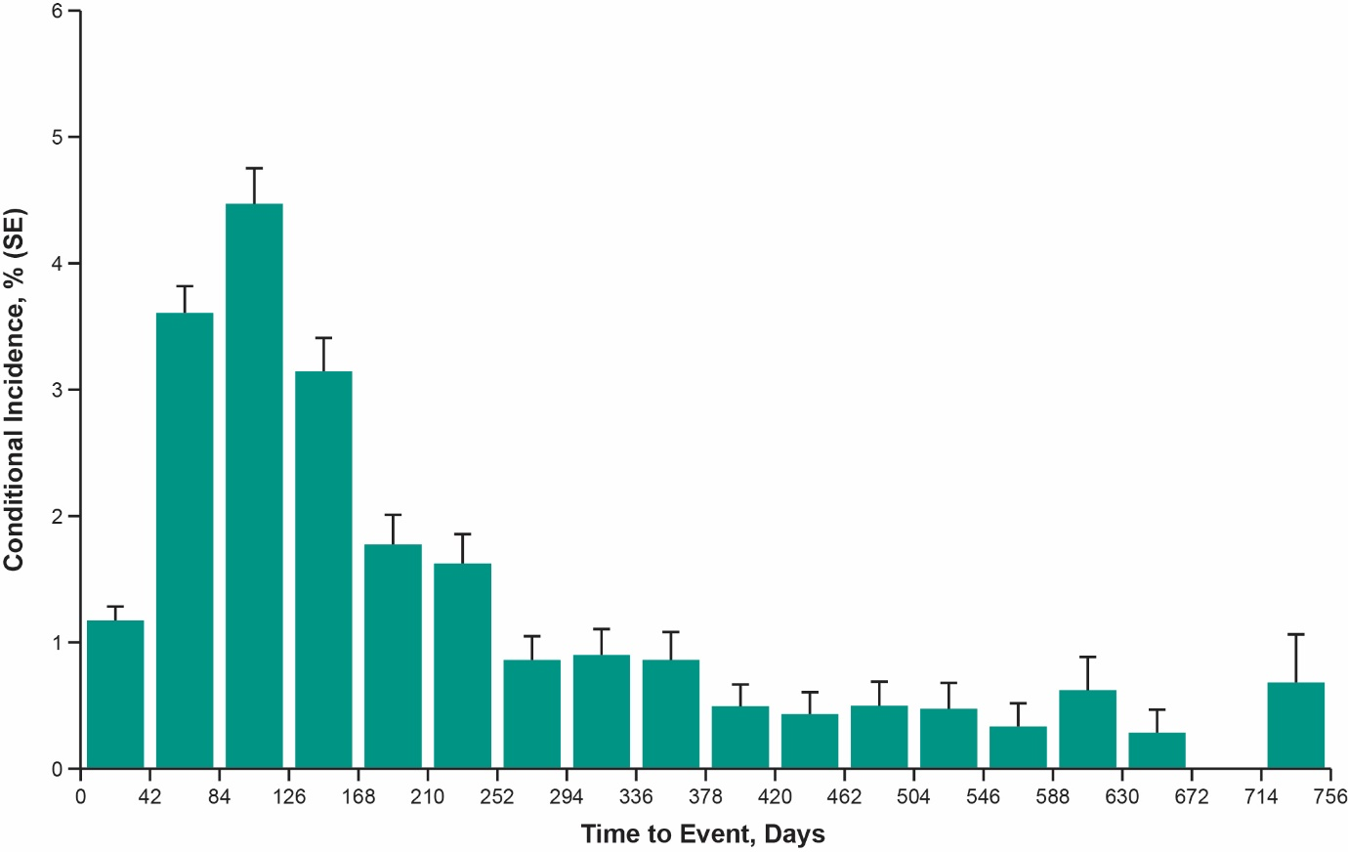

Figure A.2. Conditional incidence of pneumonitis.

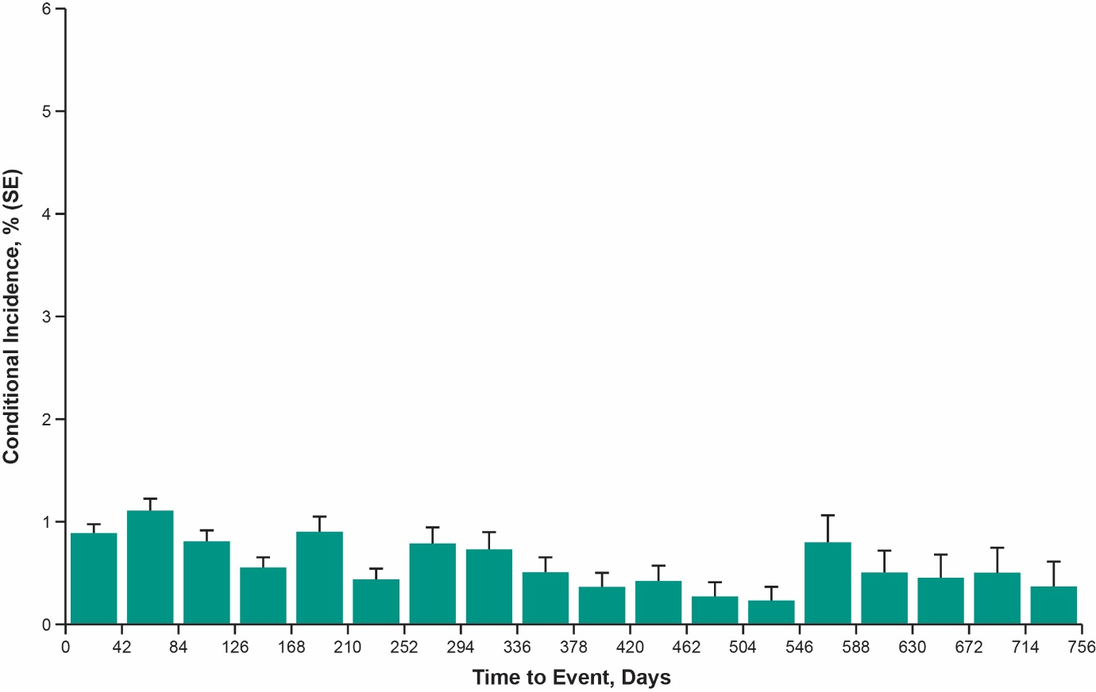
Appendix A References
1. Hamid, O., et al., Five-year survival outcomes for patients with advanced melanoma treated with pembrolizumab in KEYNOTE-001. Ann Oncol, 2019. 30(4): p. 582-588. doi: 10.1093/annonc/mdz011
2. Garon, E.B., et al., Five-year overall survival for patients with advanced non‒small-cell lung cancer treated with pembrolizumab: results from the phase I KEYNOTE-001 study. J Clin Oncol, 2019. 37(28): p. 2518-2527. doi: 10.1200/JCO.19.00934
3. Hamid, O., et al., Final analysis of a randomised trial comparing pembrolizumab versus investigator-choice chemotherapy for ipilimumab-refractory advanced melanoma. Eur J Cancer, 2017. 86: p. 37-45. doi: 10.1016/j.ejca.2017.07.022.
4. Robert, C., et al., Pembrolizumab versus ipilimumab in advanced melanoma (KEYNOTE-006): post-hoc 5-year results from an open-label, multicentre, randomised, controlled, phase 3 study. Lancet Oncol, 2019. 20(9): p. 1239-1251. doi: 10.1016/S1470-2045(19)30388-2.
5. Herbst, R.S., et al., Five year survival update from KEYNOTE-010: pembrolizumab versus docetaxel for previously treated, programmed death-ligand 1-positive advanced NSCLC. J Thorac Oncol, 2021. 16(10): p. 1718-1732. doi: 10.1016/j.jtho.2021.05.001.
6. Muro, K., et al., Pembrolizumab for patients with PD-L1-positive advanced gastric cancer (KEYNOTE-012): a multicentre, open-label, phase 1b trial. Lancet Oncol, 2016. 17(6): p. 717-726. doi: 10.1016/S1470-2045(16)00175-3.
7. Seiwert, T.Y., et al., Safety and clinical activity of pembrolizumab for treatment of recurrent or metastatic squamous cell carcinoma of the head and neck (KEYNOTE-012): an open-label, multicentre, phase 1b trial. Lancet Oncol, 2016. 17(7): p. 956-965. doi: 10.1016/S1470-2045(16)30066-3.
8. Plimack, E.R., et al., Safety and activity of pembrolizumab in patients with locally advanced or metastatic urothelial cancer (KEYNOTE-012): a non-randomised, open-label, phase 1b study. Lancet Oncol, 2017. 18(2): p. 212-220. doi: 10.1016/S1470-2045(17)30007-4.
9. Armand, P., et al., KEYNOTE-013 4-year follow-up of pembrolizumab in classical Hodgkin lymphoma after brentuximab vedotin failure. Blood Adv, 2020. 4(12): p. 2617-2622. doi: 10.1182/bloodadvances.2019001367.
10. Zinzani, P.L., et al., Safety and tolerability of pembrolizumab in patients with relapsed/refractory primary mediastinal large B-cell lymphoma. Blood, 2017. 130(3): p. 267-270. doi: 10.1182/blood-2016-12-758383.
11. Nghiem, P., et al., Durable tumor regression and overall survival in patients with advanced merkel cell carcinoma receiving pembrolizumab as first-line therapy. J Clin Oncol, 2019. 37(9): p. 693-702. doi: 10.1200/JCO.18.01896.
12. Reck, M., et al., Pembrolizumab versus chemotherapy for PD-L1-positive non-small-cell lung cancer. N Engl J Med, 2016. 375(19): p. 1823-1833. doi: 10.1056/NEJMoa1606774.
13. Frenel, J.S., et al., Safety and efficacy of pembrolizumab in advanced, programmed death ligand 1-positive cervical cancer: results from the phase Ib KEYNOTE-028 trial. J Clin Oncol, 2017. 35(36): p. 4035-4041. doi: 10.1200/JCO.2017.74.5471.
14. Doi, T., et al., Safety and antitumor activity of the anti-programmed death-1 antibody pembrolizumab in patients with advanced esophageal carcinoma. J Clin Oncol, 2018. 36(1): p. 61-67. doi: 10.1200/JCO.2017.74.9846.
15. Ott, P.A., et al., Pembrolizumab in patients with extensive-stage small-cell lung cancer: results from the phase Ib KEYNOTE-028 study. J Clin Oncol, 2017. 35(34): p. 3823-3829. doi: 10.1200/JCO.2017.72.5069.
16. Cohen, E.E.W., et al., Pembrolizumab versus methotrexate, docetaxel, or cetuximab for recurrent or metastatic head-and-neck squamous cell carcinoma (KEYNOTE-040): a randomised, open-label, phase 3 study. Lancet, 2019. 393(10167): p. 156-167. doi: 10.1016/S0140-6736(18)31999-8.
17. Mok, T.S.K., et al., Pembrolizumab versus chemotherapy for previously untreated, PD-L1-expressing, locally advanced or metastatic non-small-cell lung cancer (KEYNOTE-042): a randomised, open-label, controlled, phase 3 trial. Lancet, 2019. 393(10183): p. 1819-1830. doi: 10.1016/S0140-6736(18)32409-7.
18. Fradet, Y., et al., Randomized phase III KEYNOTE-045 trial of pembrolizumab versus paclitaxel, docetaxel, or vinflunine in recurrent advanced urothelial cancer: results of >2 years of follow-up. Ann Oncol, 2019. 30(6): p. 970-976. doi: 10.1093/annonc/mdz127.
19. Burtness, B., et al., Pembrolizumab alone or with chemotherapy versus cetuximab with chemotherapy for recurrent or metastatic squamous cell carcinoma of the head and neck (KEYNOTE-048): a randomised, open-label, phase 3 study. Lancet, 2019. 394(10212): p. 1915-1928. doi: 10.1016/S0140-6736(19)32591-7.
20. Vuky, J., et al., Long-term outcomes in KEYNOTE-052: phase II study investigating first-line pembrolizumab in cisplatin-ineligible patients with locally advanced or metastatic urothelial cancer. J Clin Oncol, 2020. 38(23): p. 2658-2666. doi: 10.1200/JCO.19.01213.
21. Bauml, J., et al., Pembrolizumab for platinum- and cetuximab-refractory head and neck cancer: results from a single-arm, phase II study. J Clin Oncol, 2017. 35(14): p. 1542-1549. doi: 10.1200/JCO.2016.70.1524.
22. Balar, A.V., et al., Pembrolizumab monotherapy for the treatment of high-risk non-muscle-invasive bladder cancer unresponsive to BCG (KEYNOTE-057): an open-label, single-arm, multicentre, phase 2 study. Lancet Oncol, 2021. 22(7): p. 919-930. doi: 10.1016/S1470-2045(21)00147-9.
23. Fuchs, C.S., et al., Safety and efficacy of pembrolizumab monotherapy in patients with previously treated advanced gastric and gastroesophageal junction cancer: phase 2 clinical KEYNOTE-059 Trial. JAMA Oncol, 2018. 4(5): p. e180013. doi: 10.1001/jamaoncol.2018.0013.
24. Shitara, K., et al., Pembrolizumab versus paclitaxel for previously treated, advanced gastric or gastro-oesophageal junction cancer (KEYNOTE-061): a randomised, open-label, controlled, phase 3 trial. Lancet, 2018. 392(10142): p. 123-133. doi: 10.1016/S0140-6736(18)31257-1.
25. Shitara, K., et al., Efficacy and safety of pembrolizumab or pembrolizumab plus chemotherapy vs chemotherapy alone for patients with first-line, advanced gastric cancer: the KEYNOTE-062 phase 3 randomized clinical trial. JAMA Oncol, 2020. 6(10): p. 1571-1580. doi: 10.1001/jamaoncol.2020.3370.
26. Chen, R., et al., Pembrolizumab in relapsed or refractory Hodgkin lymphoma: 2-year follow-up of KEYNOTE-087. Blood, 2019. 134(14): p. 1144-1153. doi: 10.1182/blood.2019000324.
27. Marabelle, A., et al., Association of tumour mutational burden with outcomes in patients with advanced solid tumours treated with pembrolizumab: prospective biomarker analysis of the multicohort, open-label, phase 2 KEYNOTE-158 study. Lancet Oncol, 2020. 21(10): p. 1353-1365. doi: 10.1016/S1470-2045(20)30445-9.
28. Maio, M., et al., Pembrolizumab in microsatellite instability high or mismatch repair deficient cancers: updated analysis from the phase II KEYNOTE-158 study. Ann Oncol, 2022. 33(9): p. 929-938. doi: 10.1016/j.annonc.2022.05.519.
29. Le, D.T., et al., Phase II open-label study of pembrolizumab in treatment-refractory, microsatellite instability-high/mismatch repair-deficient metastatic colorectal cancer: KEYNOTE-164. J Clin Oncol, 2020. 38(1): p. 11-19. doi: 10.1200/JCO.19.02107.
30. Armand, P., et al., Pembrolizumab in relapsed or refractory primary mediastinal large B-cell lymphoma. J Clin Oncol, 2019. 37(34): p. 3291-3299. doi: 10.1200/JCO.19.01389.
31. Diaz, L.A., Jr., et al., Pembrolizumab versus chemotherapy for microsatellite instability-high or mismatch repair-deficient metastatic colorectal cancer (KEYNOTE-177): final analysis of a randomised, open-label, phase 3 study. Lancet Oncol, 2022. 23(5): p. 659-670. doi: 10.1016/S1470-2045(22)00197-8.
32. Shah, M.A., et al., Efficacy and safety of pembrolizumab for heavily pretreated patients with advanced, metastatic adenocarcinoma or squamous cell carcinoma of the esophagus: the phase 2 KEYNOTE-180 Study. JAMA Oncol, 2019. 5(4): p. 546-550. doi: 10.1001/jamaoncol.2018.5441.
33. Kojima, T., et al., Randomized phase III keynote-181 study of pembrolizumab versus chemotherapy in advanced esophageal cancer. J Clin Oncol, 2020. 38: p. 4138-4148. doi: 10.1200/JCO.20.01888.
34. Kuruvilla, J., et al., Pembrolizumab versus brentuximab vedotin in relapsed or refractory classical Hodgkin lymphoma (KEYNOTE-204): an interim analysis of a multicentre, randomised, open-label, phase 3 study. Lancet Oncol, 2021. 22(4): p. 512-524. doi: 10.1016/S1470-2045(21)00005-X.
35. Kudo, M., et al., Updated efficacy and safety of KEYNOTE-224: a phase II study of pembrolizumab in patients with advanced hepatocellular carcinoma previously treated with sorafenib. Eur J Cancer, 2022. 167: p. 1-12. doi: 10.1016/j.ejca.2022.02.009.
36. Verset, G., et al., Pembrolizumab monotherapy for previously untreated advanced hepatocellular carcinoma: data from the open-label, phase II KEYNOTE-224 trial. Clin Cancer Res, 2022. 28(12): p. 2547-2554. doi: 10.1158/1078-0432.CCR-21-3807.
37. Powles, T., et al., Pembrolizumab alone or combined with chemotherapy versus chemotherapy as first-line therapy for advanced urothelial carcinoma (KEYNOTE-361): a randomised, open-label, phase 3 trial. Lancet Oncol, 2021. 22(7): p. 931-945. doi: 10.1016/S1470-2045(21)00152-2.
38. McDermott, D.F., et al., Open-label, single-arm phase II study of pembrolizumab monotherapy as first-line therapy in patients with advanced clear cell renal cell carcinoma. J Clin Oncol, 2021. 39(9): p. 1029-1039. doi: 10.1200/JCO.20.02365.
39. Hughes, B.G.M., et al., Pembrolizumab for locally advanced and recurrent/metastatic cutaneous squamous cell carcinoma (KEYNOTE-629 study): an open-label, nonrandomized, multicenter, phase II trial. Ann Oncol, 2021. 32(10): p. 1276-1285. doi: 10.1016/j.annonc.2021.07.008.

