Supplementary materials
Supplementary Material S1. Comprehensive workflow for automated fishing gear prediction from small-scale fishing vessel GPS data. The process begins with positional data downloaded from the Traccar Server, followed by standardization and trip identification according to the code provided by Mendo et al., 2024. Next, fishing events are defined (distinction between fishing = hauling / not_fishing = setting or navigation), validated by fishers, and labelled by gear, enabling the matching of paired setting/hauling events and calculation of soak time (code available from Mendo et al., 2023). The final stage involves the automatic recognition and prediction of fishing gears for each hauling event, the approach described in the present paper with the shared Python code at the Figshare repository (available at https://doi.org/10.6084/m9.figshare.29647448)(Lattanzi et al., 2025) .
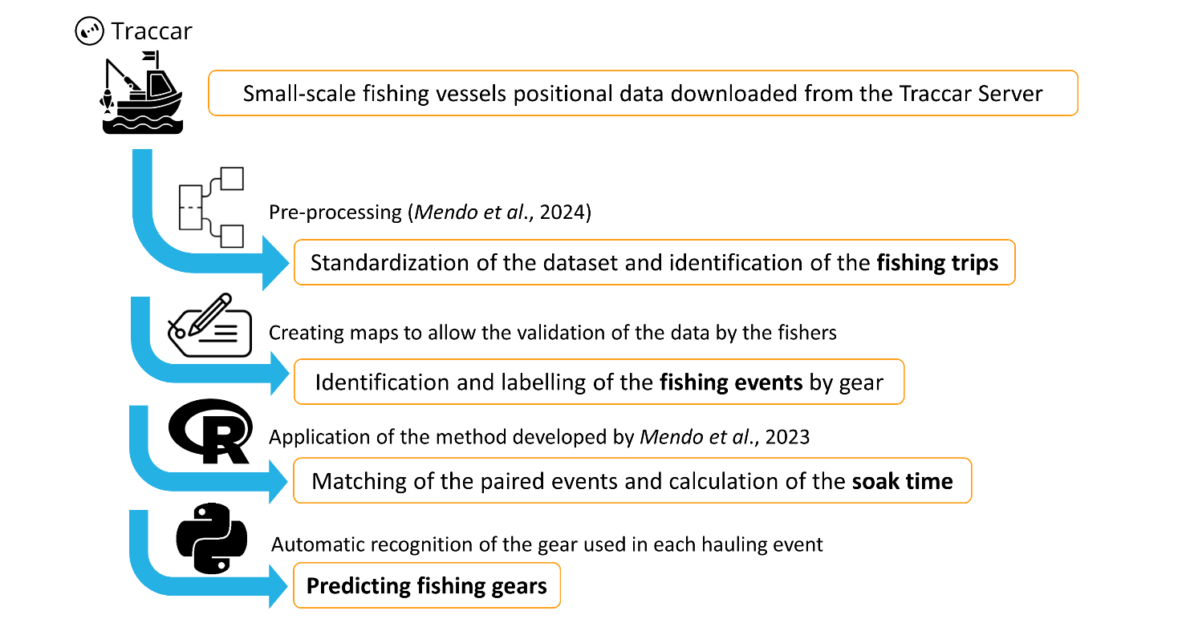

Supplementary Material S2. Per-Class Robustness Analysis Against Outliers - Per-Class Classification F1-Score by Model for both levels of analysis. The plots illustrate the mean F1-Score (bars) and performance stability (error bars = standard deviation) achieved for each specific fishing gear class during cross-validation. The models were trained with a class-weighted loss function, fewer predictors and optimized tuning hyperparameters, but without the logarithmic transformation of numerical variables. The red dashed line indicates a minimum acceptable score threshold (60%). The best performing model for each level of analysis is highlighted by the green box. This analysis confirms the robustness of the investigated models against potential outliers – demonstrating only minimal differences in stability and performance when compared to the corresponding figure where numerical predictors were logarithmically transformed (Supplementary Material S3).

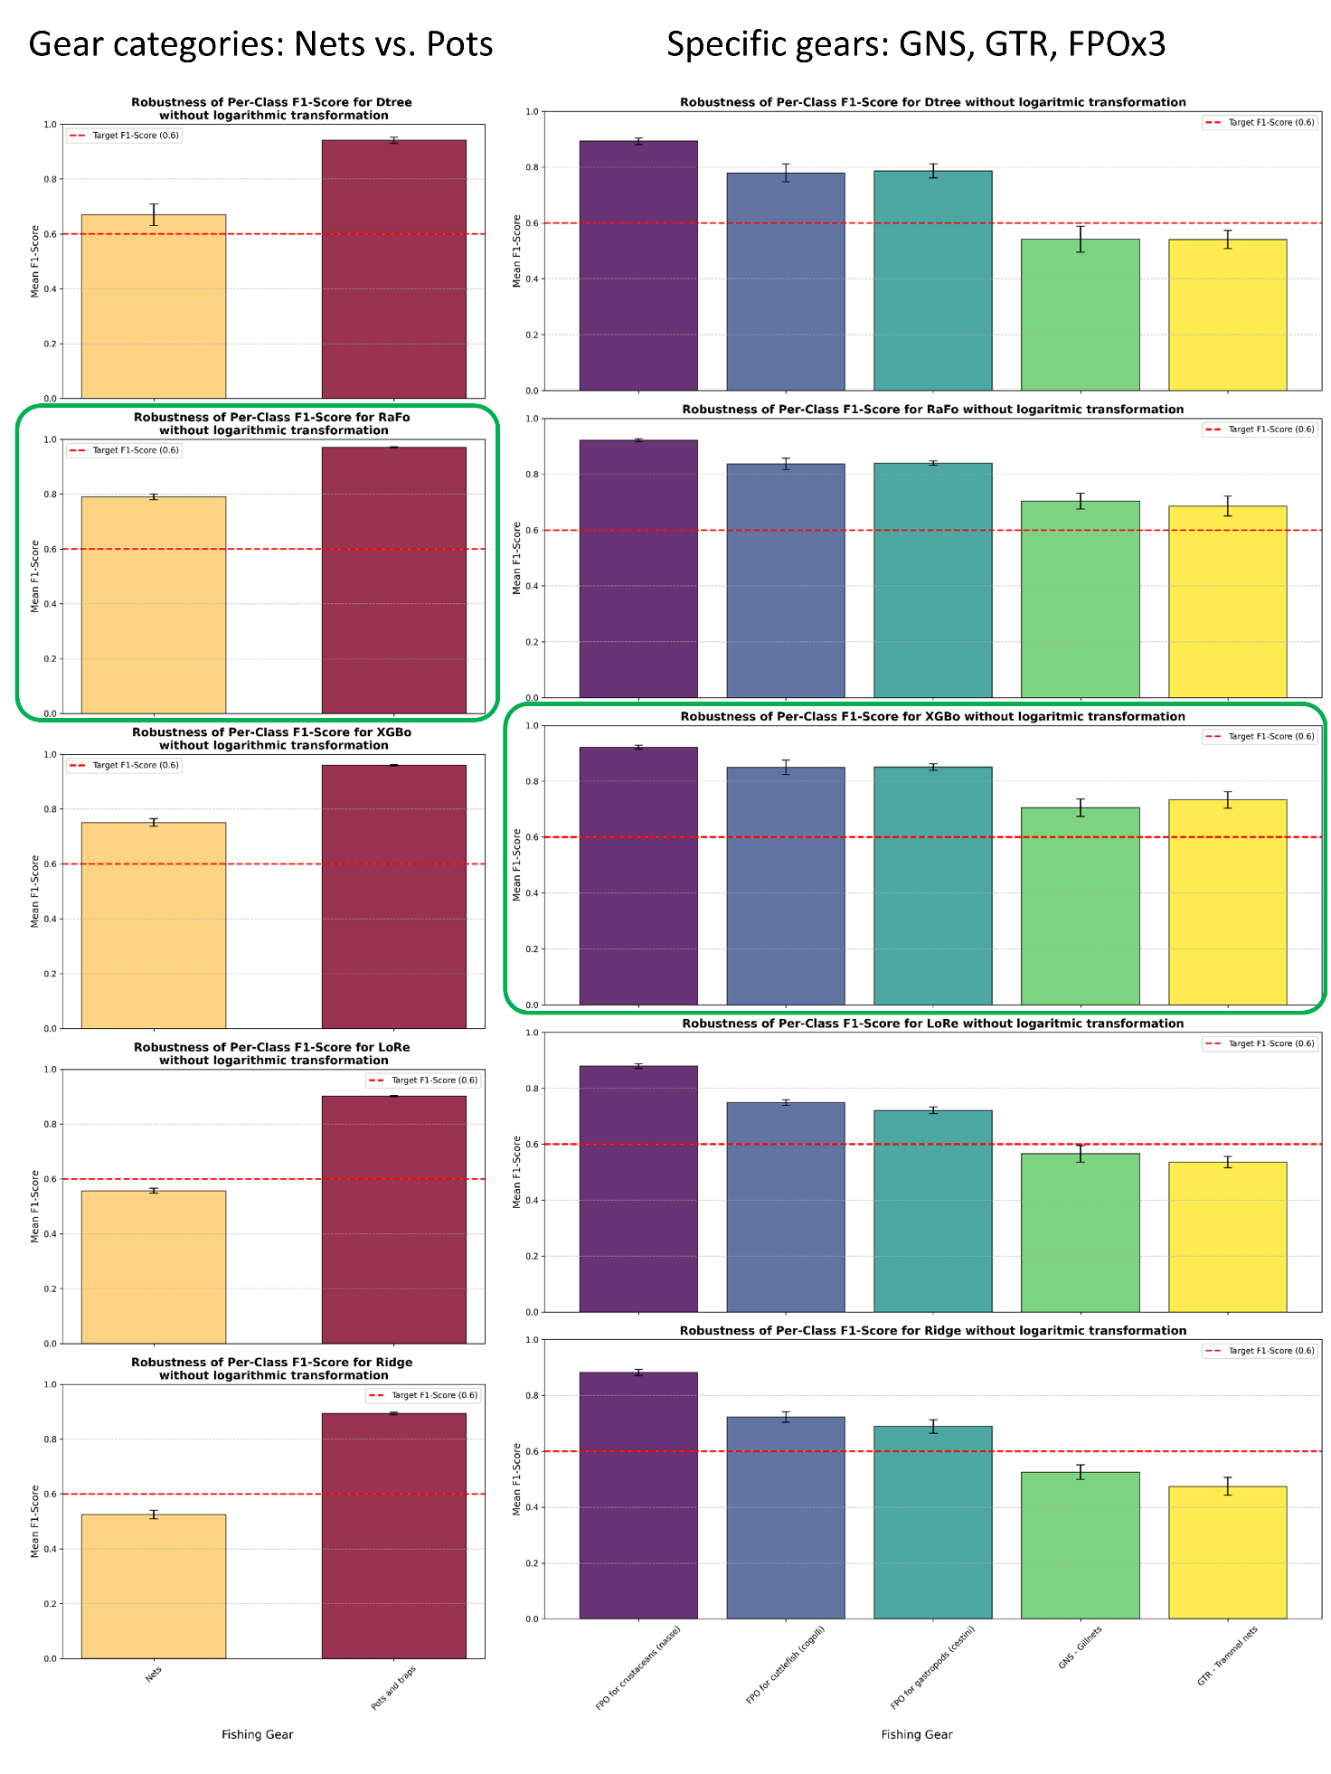

Supplementary Material S3. Per-Class Robustness Analysis of Class-Weighted Models - Per-Class Classification F1-Score by Model (all trained with fewer predictors and optimized tuning hyperparameters) for both the levels of analysis. The plots show the mean metric score (bars) and performance stability (error bars = standard deviation) for each fishing gear class during cross-validation. The red dashed line indicates a minimum acceptable score threshold (60%), allowing for easy visualization of classes where model performance falls short due to the lower number of observations available. The best performing model for each level of analysis is highlighted by the green box. This analysis confirms the robustness of the class-weighted training approach by demonstrating consistent, good performance across all categories, including those affected by class imbalance.
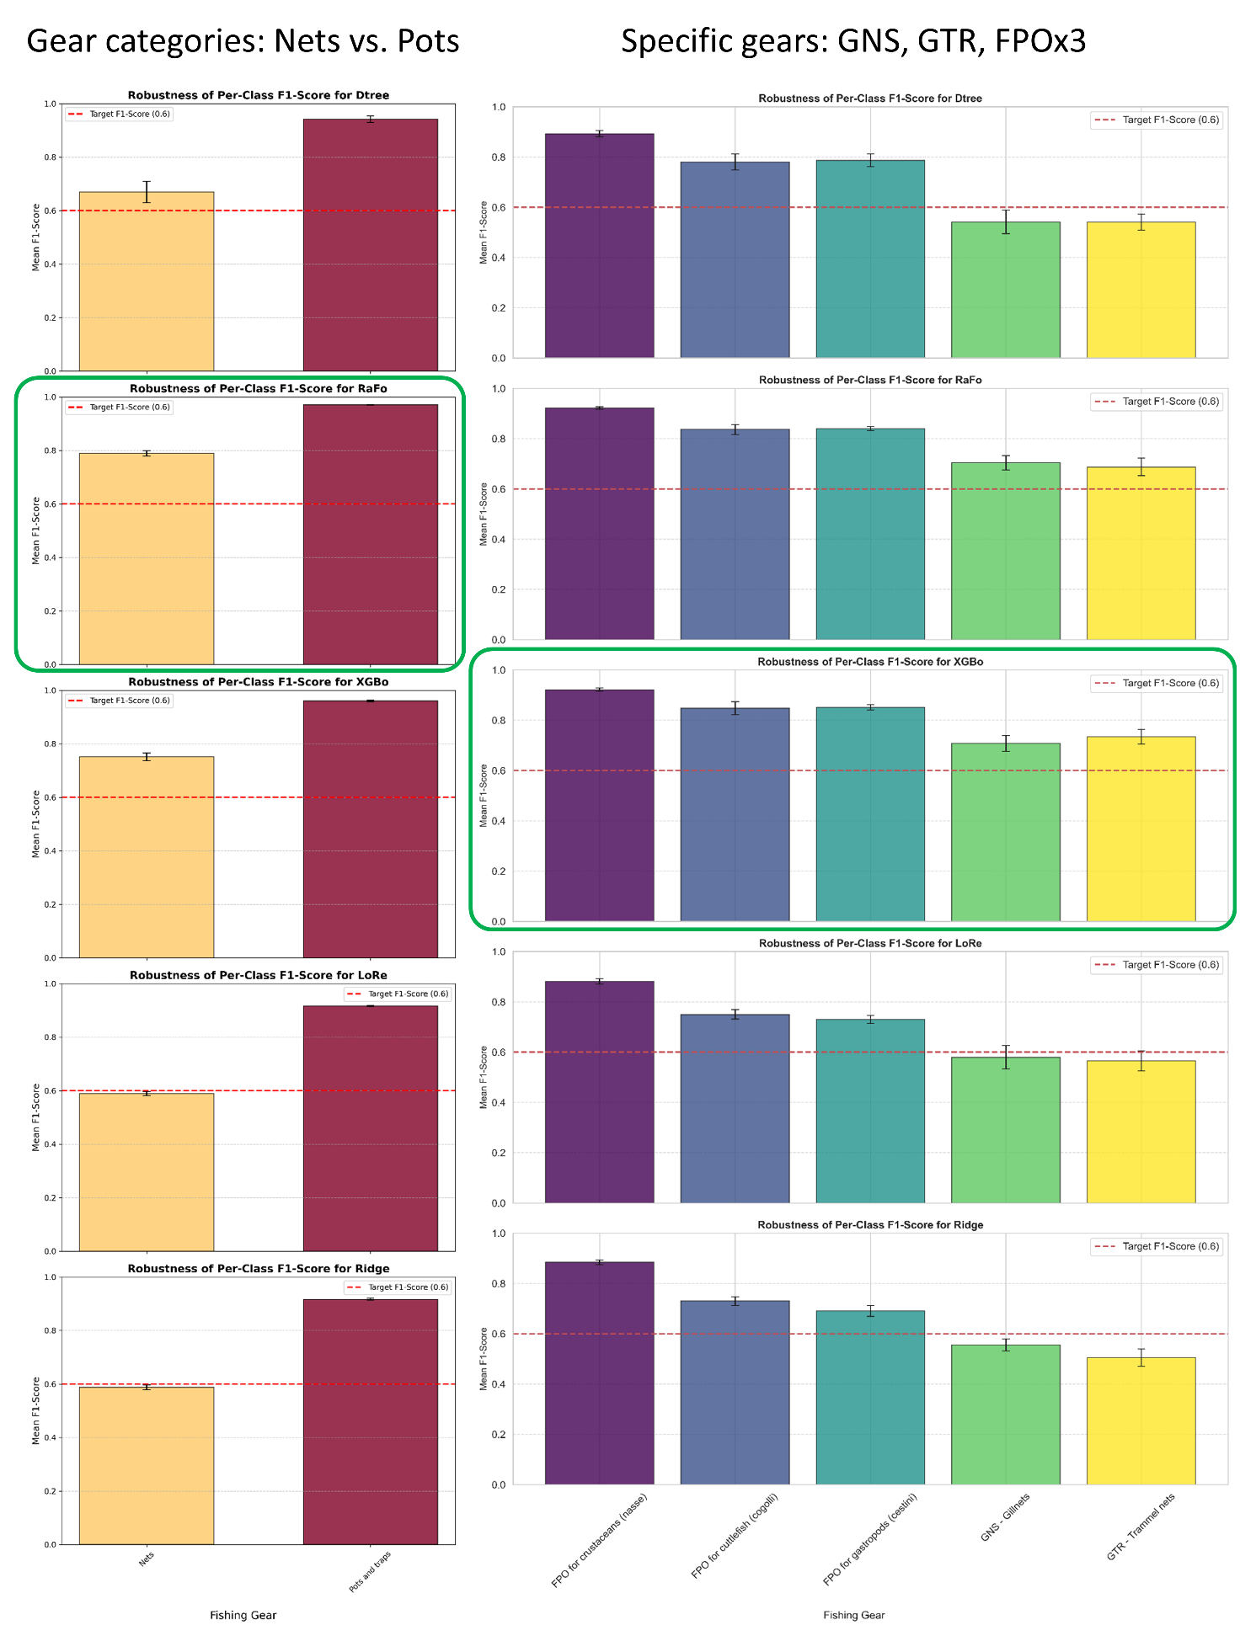

Supplementary Material S4. Pearson Correlation Heatmap of Model Predictors. The heatmap visualizes the Pearson correlation coefficients between the predictors. The numerical predictors were first log(x+1) transformed and subsequently scaled to the [0,1] interval before correlation analysis. Categorical variables (months, hours, main_substrate, and gear_change) were encoded into numerical representations using integer mapping to observe their linear relationships with other features. The colour scale ranges from -1 (strong negative correlation) to +1 (strong positive correlation).
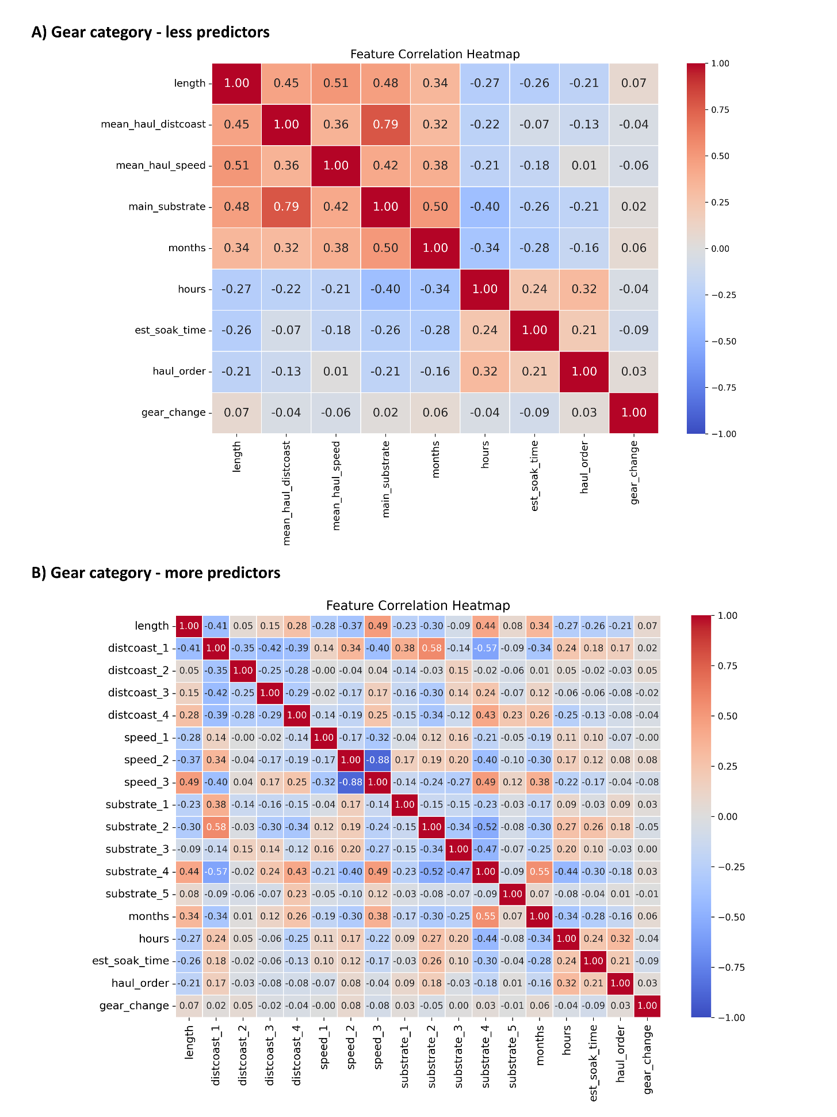
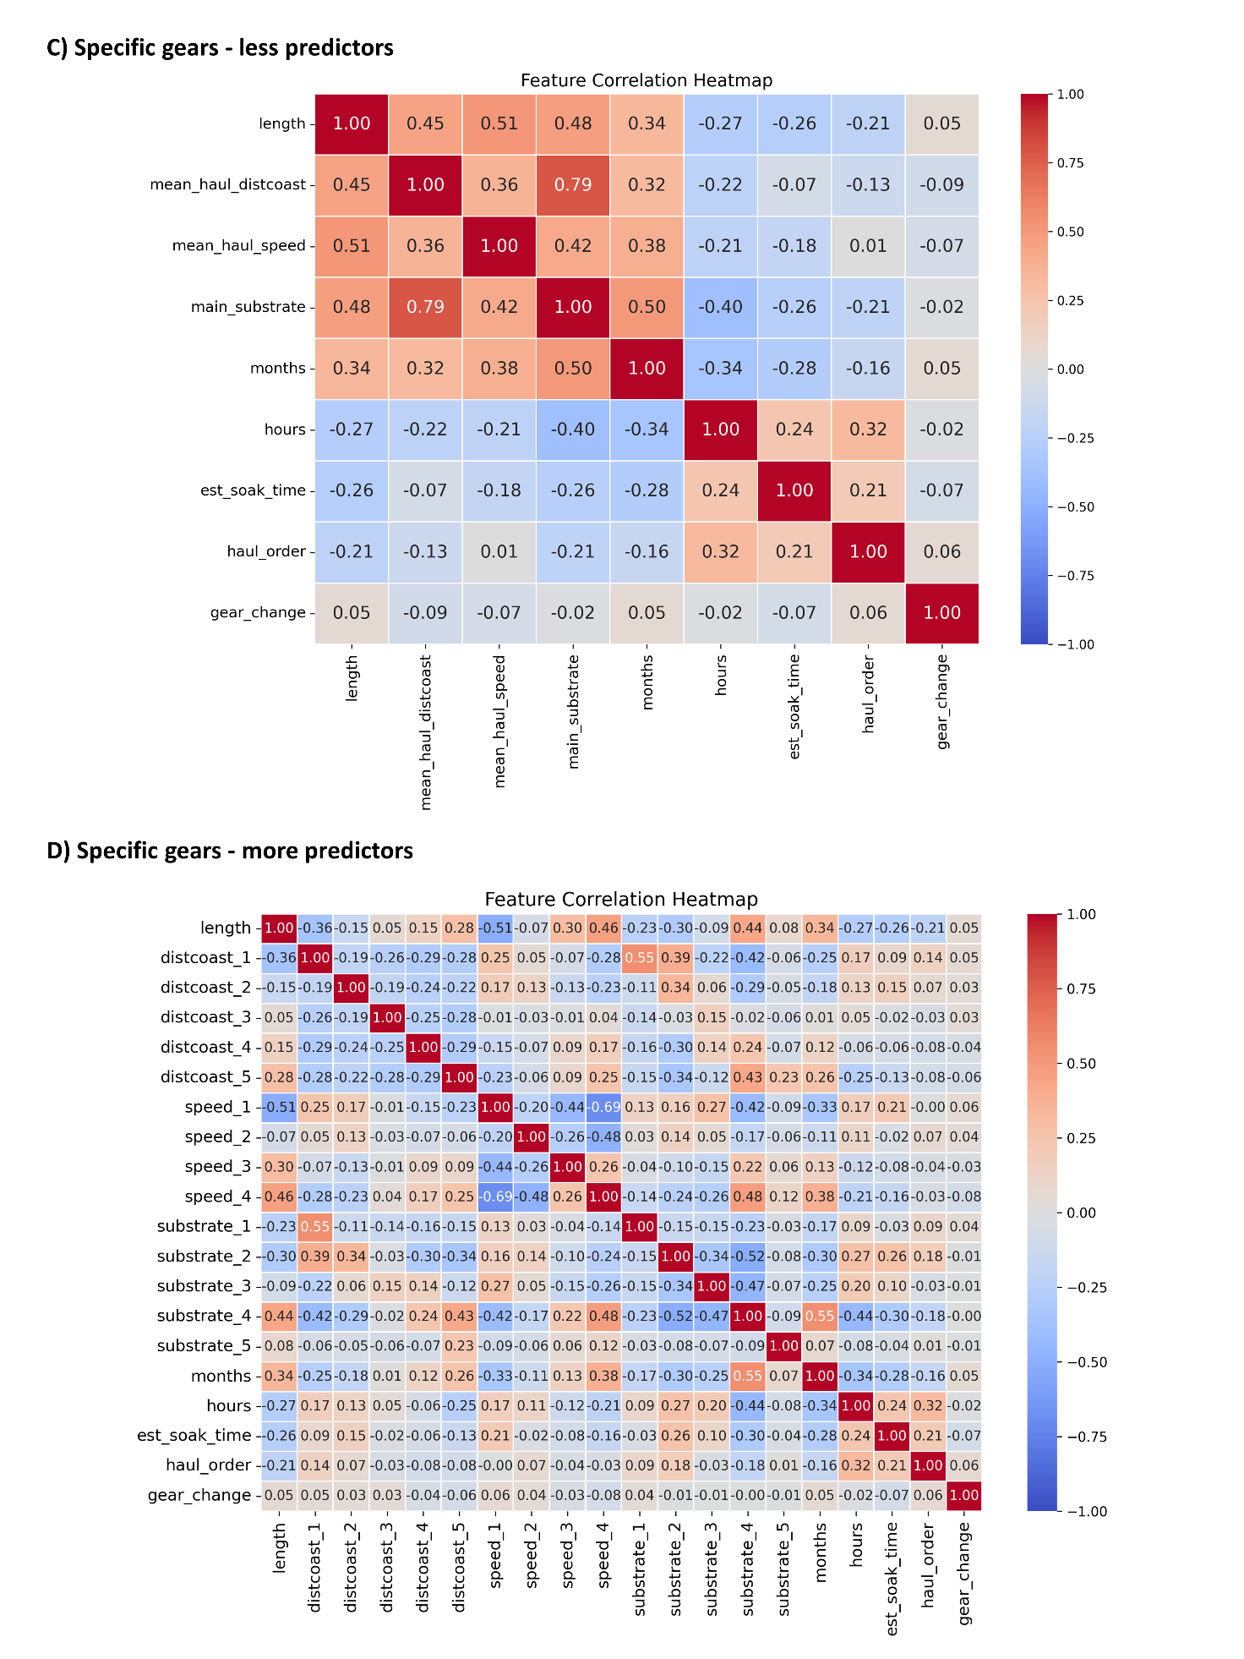

Supplementary Material S5. A visual analysis of the configuration and stability of the LoRe model for both gear-category and specific-gears prediction. A,B,C) Learning Curves track the model's mean performance (Accuracy, Error Rate, and Log Loss, respectively) as the training set size increases. Accuracy curves flattening near the maximum training size suggests that adding significantly more data is unlikely to yield substantial performance gains. The convergency of Training and CV curves demonstrates the low variance of the model, fitting quite well the cross-validation set and, thus, showing almost no overfitting. D) Confusion matrices of the described model for classification task on the test set, displaying normalized true label percentages and raw prediction counts.

