SUPPORTING INFORMATION

Triphenyl Acetic Glyceroate as a sustainable multifunctional additive for developing transparent, biodegradable, and flexible polylactide green alternative to polyethylene-based films for food packaging

Martina Ferri ^{a,b}, Luca Lenzi ^{a,b}, Micaela Degli Esposti ^{a,b}, Laura Martellosio ^{a,b}, José J. Benítez ^{c}, Jesús Hierrezuelo ^{d}, Montserrat Grifé-Ruiz ^{d}, Diego Romero ^{d}, Susana Guzmán-Puyol ^{e}, José A. Heredia-Guerrero ^{e*}, Davide Morselli ^{a,b*}, Paola Fabbri ^{a,b}

ª Department of Civil, Chemical, Environmental and Materials Engineering, University of Bologna, Via Terracini 28, 40131 Bologna, Italy
^{b} National Interuniversity Consortium of Materials Science and Technology (INSTM), Via Giusti 9, 50121 Firenze, Italy
^{c} Instituto de Ciencia de Materiales de Sevilla, Centro Mixto CSIC-Universidad de Sevilla, Calle Americo Vespucio 49, Isla de la Cartuja, Sevilla, 41092, Spain
^{d} Instituto de Hortofruticultura Subtropical y Mediterránea “La Mayora”, Universidad de Málaga-Consejo Superior de Investigaciones Científicas (IHSM, UMA-CSIC), Departamento de Microbiología, Bulevar Louis Pasteur 49, 29010 Malaga, Spain
^{e} Instituto de Hortofruticultura Subtropical y Mediterránea “La Mayora”, Universidad de Málaga-Consejo Superior de Investigaciones Científicas (IHSM UMA-CSIC), Bulevar Louis Pasteur 49, 29010, Malaga, Spain

* Corresponding Authors:
Davide Morselli (davide.morselli6@unibo.it); José Alejandro Heredia-Guerrero (ja.heredia@csic.es)

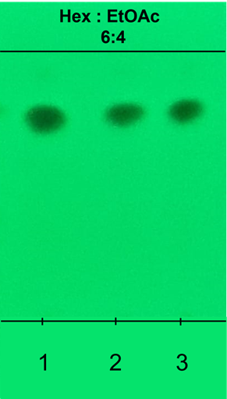
Figure S1. Thin layer chromatography of three different synthesis batches (indicated as 1, 2, and 3) of TPAG. Absence of by-products is confirmed.

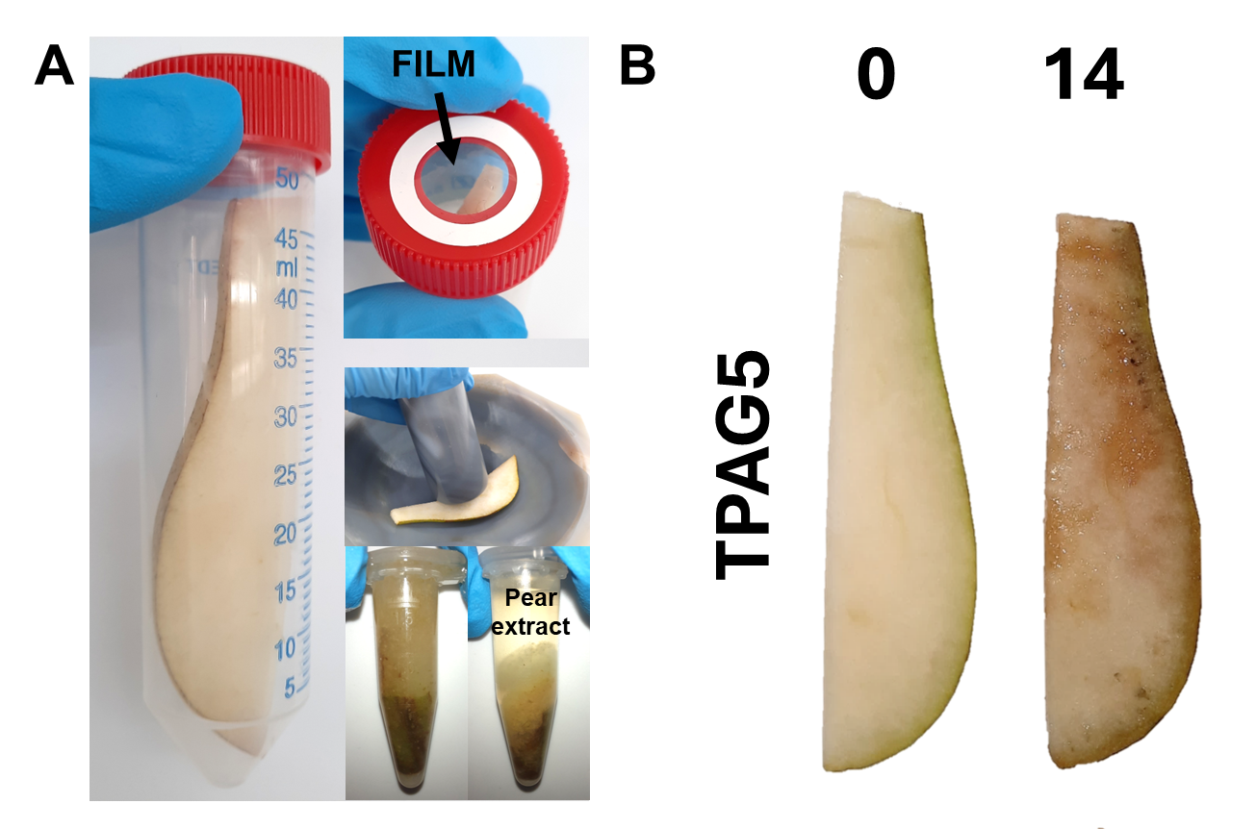
Figure S2. (A) Pear’s antioxidant activity loss experimental setup with detail on the smashing step and the pear’s extract after centrifugation. (B) Representative photos of pears before and after 14 days of storage with PLA-TPAG5.
Yields, 1H-NMR and 13C-NMR assignments of TPAG plasticizer
[[C₆H₅]CH₂C(=O)O]CH₂CH[(C₆H₅]CH₂C(=O)O]CH₂[(C₆H₅]CH2C(=O)O]. The compound was obtained as a yellowish oil (88% yield).
¹H-NMR (CDCl₃, 600 MHz): E δ = 7.3-7.2 (m, 15 H, [C₆H₅]CH₂C(=O)O), A δ = 5.24 (m, 1 H, CH₂CHCH₂), B and C δ = 4.26 (dd, 2 H, J = 12 Hz, J = 4 Hz, C(=O)OCH₂CHCH₂) and δ = 4.10 (dd, 2 H, J = 12 Hz, J = 6 Hz, C(=O)OCH₂CHCH₂), D δ = 3.54 (s, 4 H, [C₆H₅]CH₂C(=O)O), F δ = 3.52 (s, 2 H, [C₆H₅]CH₂C(=O)O).
¹³C-NMR (CDCl₃, 150 MHz): C δ = 170.93 ([C₆H₅]CH₂C(=O)O), F δ = 170.59 ([C₆H₅]CH₂C(=O)O), E δ = 133.56, 133.53, 129.24, 129.23, 128.62, 128.60, 127.24 ([C₆H₅]CH₂C(=O)O), A δ = 69.23 (CH₂CHCH₂), B δ = 62.33 (C(=O)OCH₂CHCH₂), D δ = 41.06 ([C₆H₅]CH₂C(=O)O), G δ = 41.00 ([C₆H₅]CH₂C(=O)O).

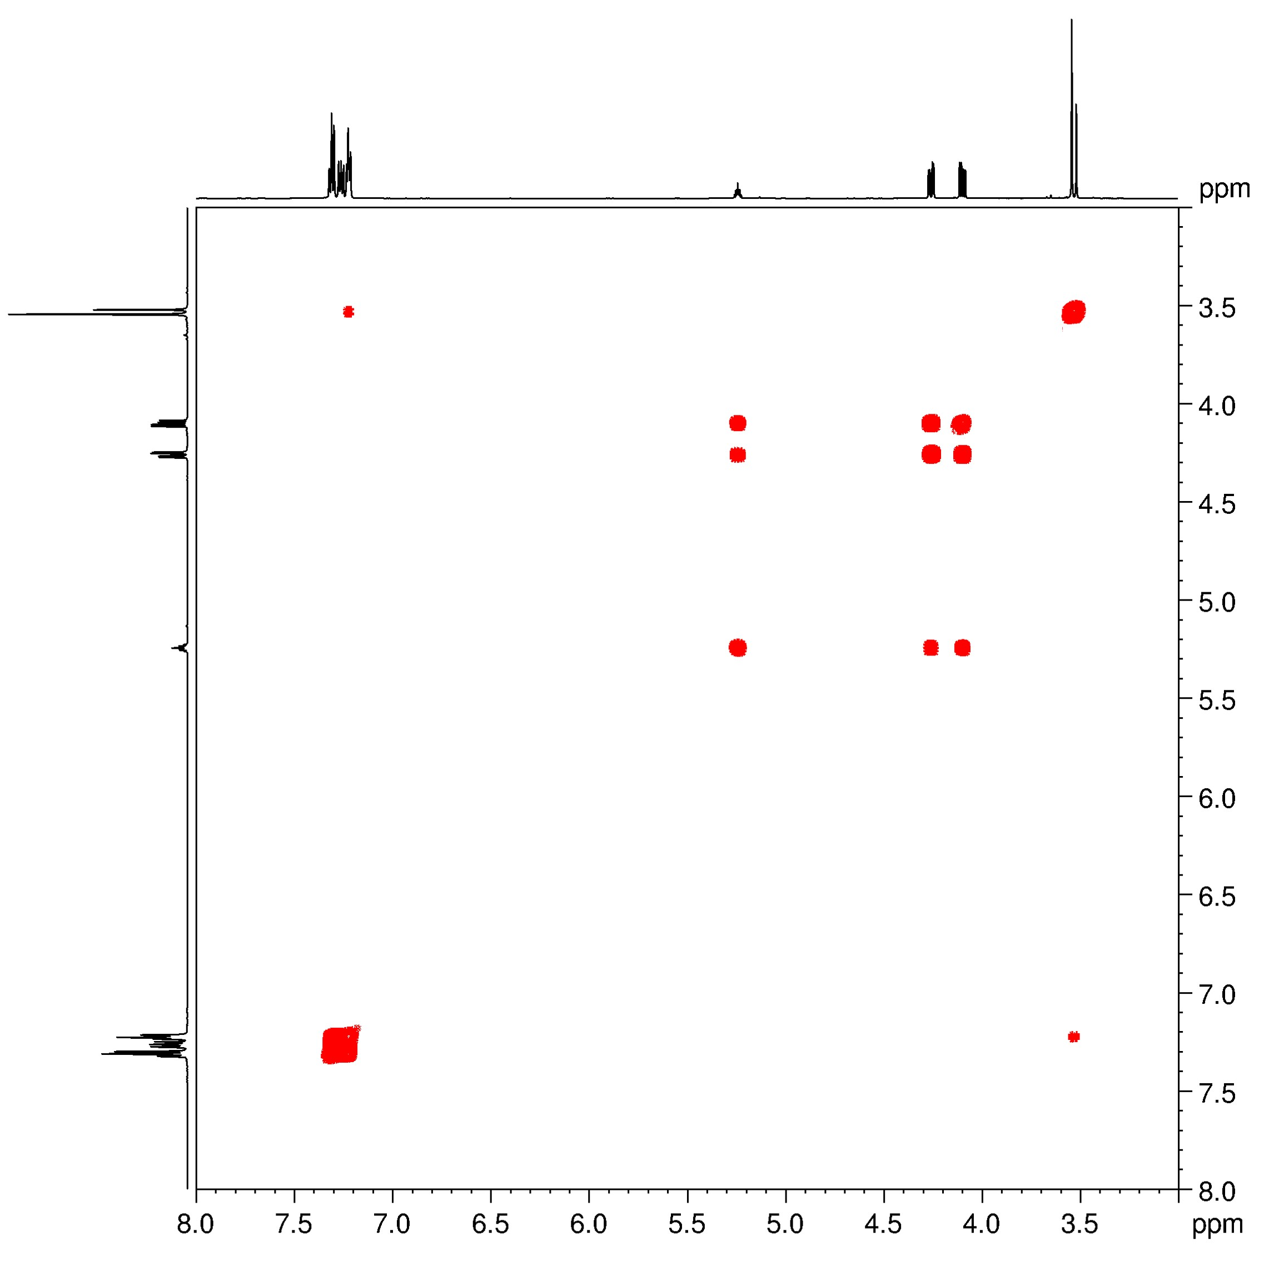
Figure S3. ¹H-¹H COSY spectrum of of TPAG plasticizer.

Figure S4. ¹H-¹³C HSQC spectrum of TPAG plasticizer.

Figure S5. ¹H-¹³C HMBC spectrum of TPAG plasticizer. The pulse sequence used for the HMBC experiment also provided direct one-bond correlations.
Fourier Transform Infrared (FT-IR) Spectroscopy experimental details. A PerkinElmer Spectrum Two spectrometer equipped with a diamond crystal operating in attenuated total reflectance (ATR) mode was used to analyze the films’ structure. Spectra were recorded in the wavenumber region between 4000 and 400 cm⁻¹ using a spectral resolution of 4 cm⁻¹ and 64 analysis scans. Spectral data were processed with Spectrum 10 software (PerkinElmer). Three replicates were recorded for each film sample.
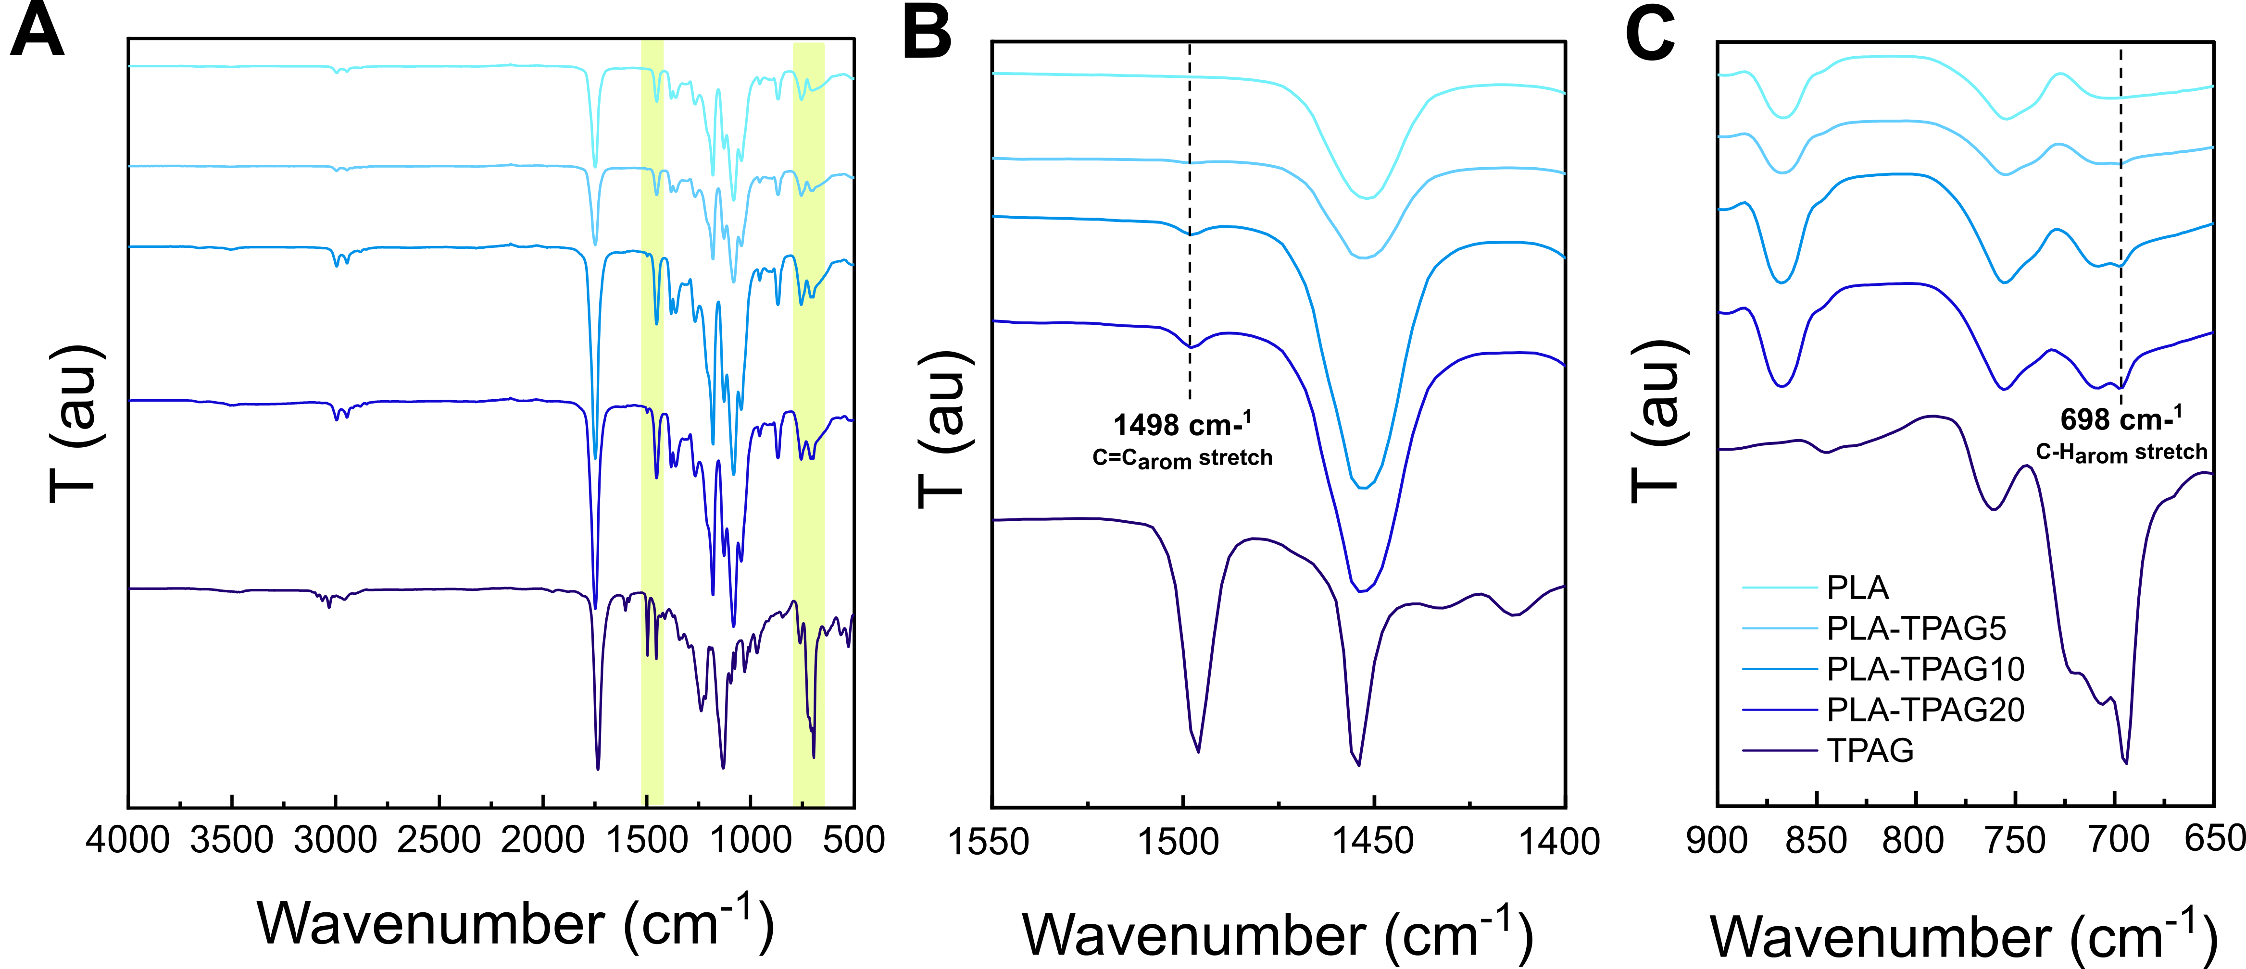
Figure S6. (A) FT-IR spectra of PLA and PLA-TPAG films. Yellow-shaded areas highlight the two regions of interest where aromatic signals appear. (B) Highlighted region of FT-IR spectra between 1500 and 1400 cm⁻¹. The dashed black line shows the increase in the band's intensity at 1498 cm⁻¹ (aromatic C=C stretching from TPAG molecule) [1] (C) Highlighted region of FT-IR spectra between 900 and 650 cm⁻¹. The dashed black line shows the increase in the band's intensity at 698 cm⁻¹ (aromatic C-H stretching) [1]

Table S1. Thermo-mechanical properties of PLA films compounded with TPAG. Glass transition temperature value extrapolated from DSC analysis (T_{g,DSC}), glass transition temperature value calculated from Fox equation (T_{g,FOX}), Young's modulus (E), elongation at break (ε_{b}), tensile strength (TS) and toughness (T) values obtained from tensile tests.
Sample | TPAG content  (phr) | T_{g,DSC}  (°C) | T_{g,FOX}  (°C) | E  (MPa) | ε_{b}  (%) | TS  (MPa) | T  (J∙cm³)
PLA | 0 | 57 | 57 | 1301 ± 47 | 11 ± 4 | 27 ± 3 | 3 ± 1
PLA-TPAG5 | 5 | 50 | 50 | 740 ± 50 | 286 ± 11 | 2 ± 1 | 11 ± 2
PLA-TPAG10 | 10 | 44 | 43 | 492 ± 64 | 452 ± 28 | 4 ± 1 | 15 ± 3
PLA-TPAG20 | 20 | 35 | 30 | 489 ± 55 | 599 ± 175 | 11 ± 4 | 22 ± 3
Table S2. Comparison of glass transition temperature (T_{g}), Young's modulus (E), elongation at break (ε_{b}) of PLAs plasticized with TPAG and other biobased plasticizers.
Matrix | Plasticizer | T_{g}  (°C) | E  (MPa) | ε_{b}  (%) | Ref.
PLA amorphous | TPAG (Triphenyl Acetic Glyceroate, 20 phr) | 35 | 489 | 599 | This work
PLA amorphous | GT (glycerol trilevulinate) | 29 | 230 | 470 | [2]
PLA amorphous | PEG400 (polyethylene glycol 400) | 19 | 630 | 200 | [3]
PLA amorphous | PEG1000 (polyethylene glycol 1000) | 22 | 290 | 303 | [3]
PLA amorphous | AGM (acetyl glycerol monolaurate) | 24 | 35 | 335 | [3]
PLA amorphous | DBS (dibutyl sebacate) | 26 | 430 | 269 | [3]
PLA semicrystalline | Cardanol | 22 | 83 | 30 | [4]
PLA semicrystalline | ECA (epoxidized cardanol acetate) | 32 | 410 | 50 | [4]
PLA semicrystalline | ATBC (acetyl tributyl citrate) | 29 | 69 | 503 | [5]

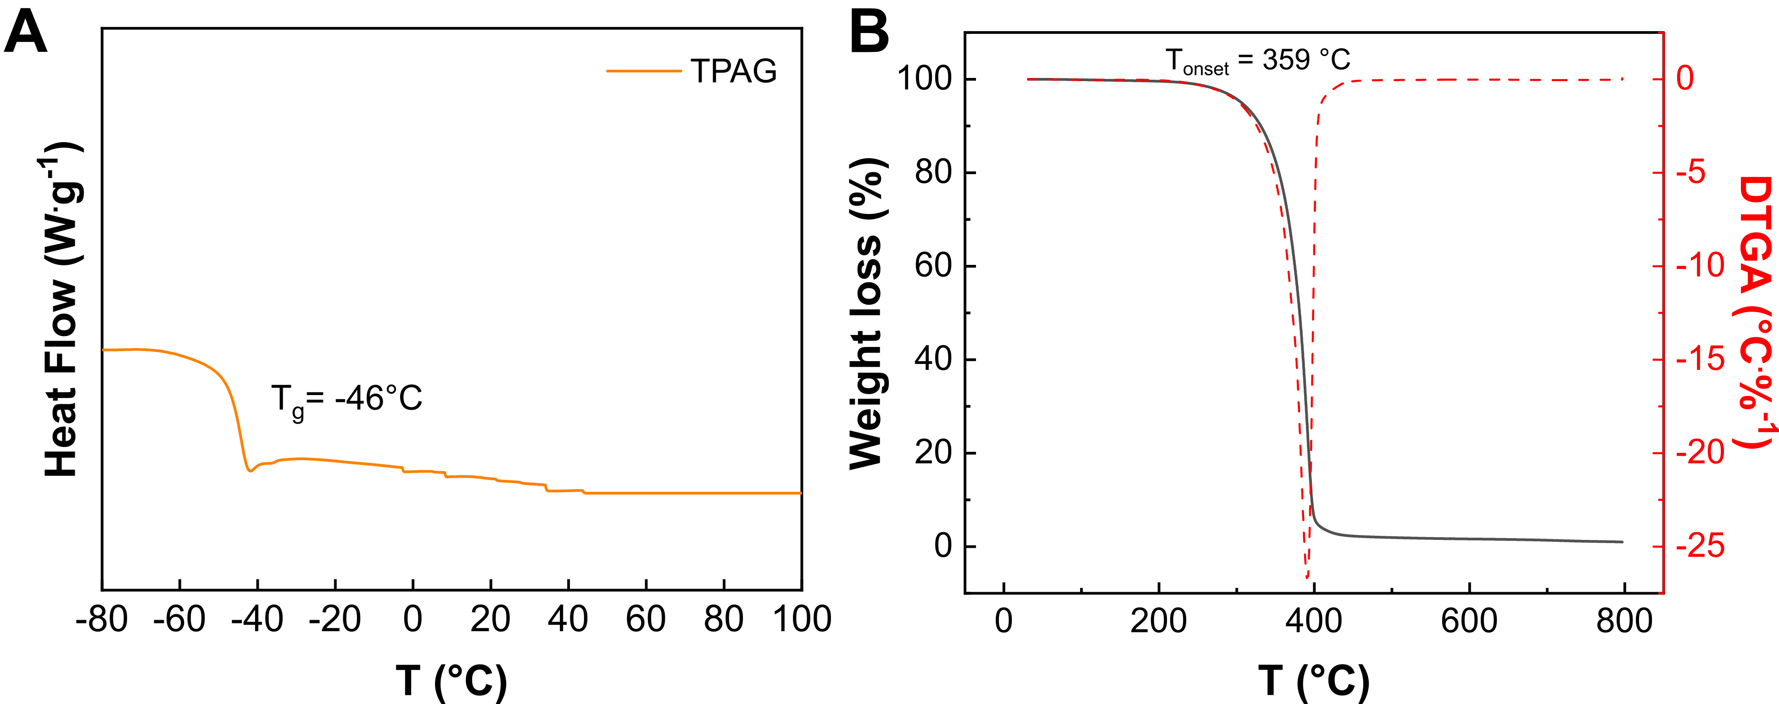
Figure S7. (A) DSC thermogram of the synthesized TPAG additive. (B) TGA (black line) and DTGA(dashed red line) of the synthesized TPAG additive.

X-ray diffraction (XRD) The crystallinity of PLA-TPAG films was analyzed by X-ray diffraction (XRD) using a Rigaku SmartLab X-Ray Diffractometer equipped with a copper rotating anode. The X-ray source was operated at 40 kV and 150 mA. A Gobel mirror was used to obtain a parallel beam and to suppress Cu Kβ radiation (1.392 Å). All measurements were performed using a 2θ scan.
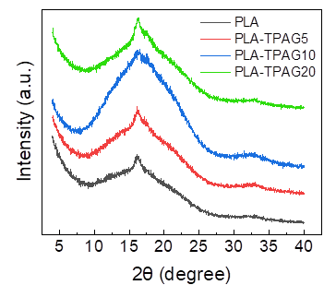
Figure S8. XRD spectra of PLA and PLA-TPAG compounds.

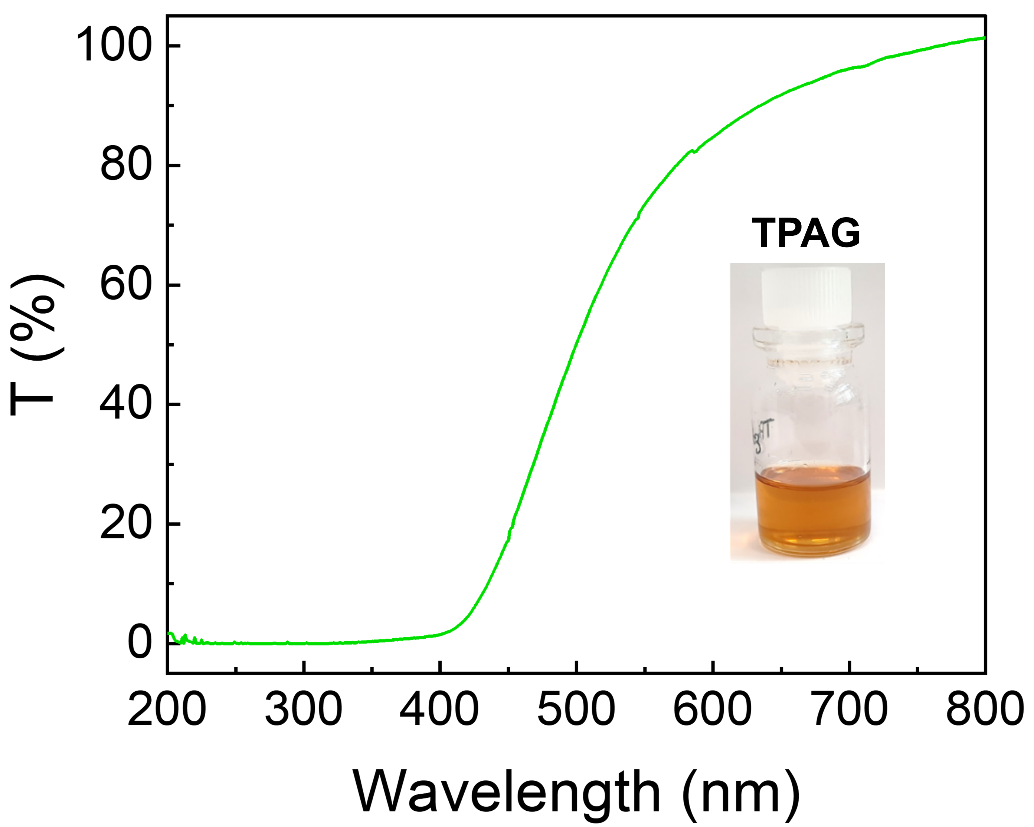
Figure S9. UV-Visible spectrum of TPAG.

Table S3. Values obtained from TGA and DTGA curves. Thermal degradation onset temperature (T_{onset}), maximum degradation rate temperature (T_{max}), temperature at 5% of weight loss (T_{d5}), temperature at 30% of weight loss (T_{d30}), heat resistance index (T_{s}).
Samples | T_{onset}  (°C) | T_{max}  (°C) | T_{d5}  (ºC) | T_{d30}  (ºC) | T_{s}  (°C)
PLA | 290 | 313 | 108 | 264 | 98
PLA-TPAG5 | 316 | 326 | 197 | 287 | 123
PLA-TPAG10 | 313 | 342 | 225 | 283 | 127
PLA-TPAG20 | 314 | 348 | 223 | 298 | 131

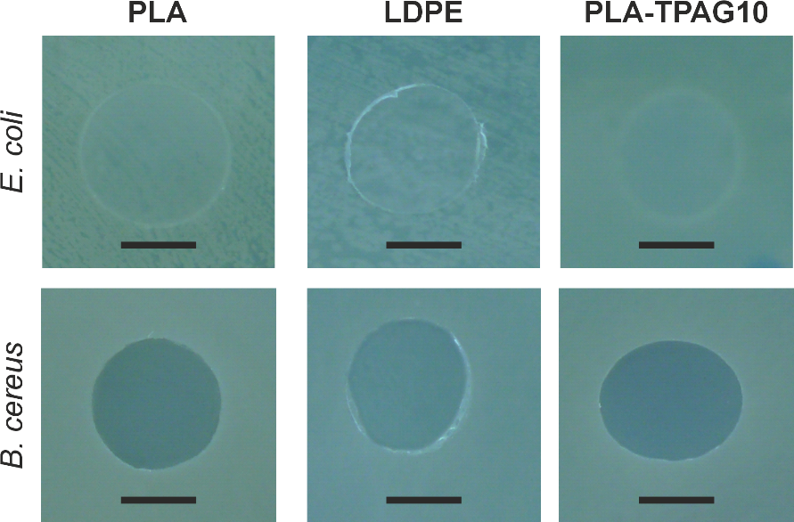
Figure S10. Photographs of PLA, LDPE, and PLA-TPAG10 showing the lack of bacterial inhibition halo for E. coli and B. cereus. Scale bar: 5 mm.

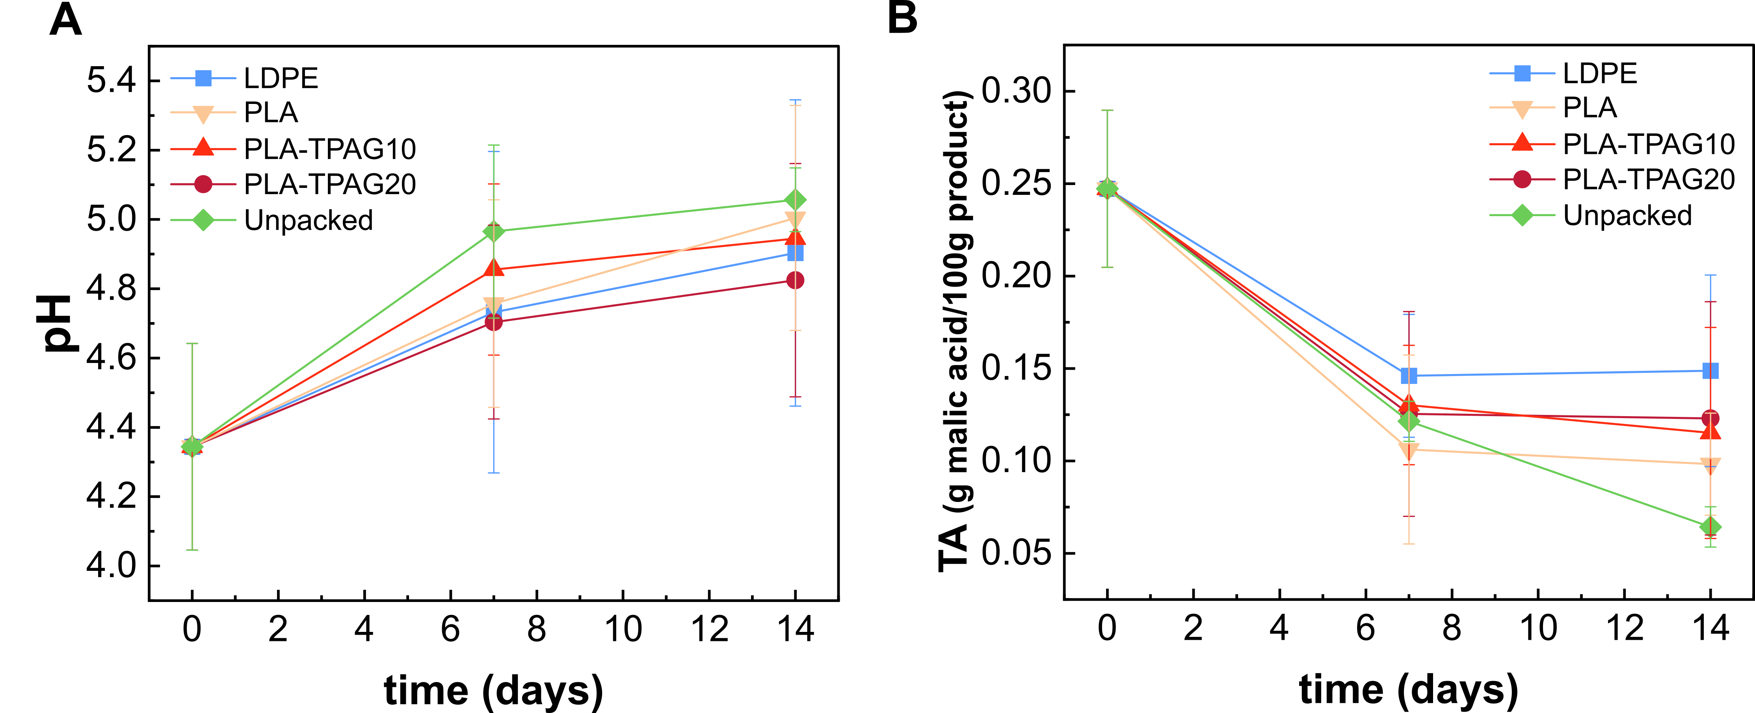
Figure S11. (A) pH and (B) Titratable acitidy (TA) of pears on the 1st , 7th and 14th day of preservation in tubes without a covering film (unpacked) and covered with PLA, PLA-TPAG10, PLA-TPAG20, and LDPE films as a function of time.

References
[1] S. Robert M., W. Francis X., K. Davide J., Spectrometric identification of organic compounds, 7th ed., John Wiley & sons, 2005.
[2] L. Lenzi, M. Degli Esposti, S. Braccini, C. Siracusa, F. Quartinello, G.M. Guebitz, D. Puppi, D. Morselli, P. Fabbri, Further Step in the Transition from Conventional Plasticizers to Versatile Bioplasticizers Obtained by the Valorization of Levulinic Acid and Glycerol, ACS Sustain Chem Eng 11 (n.d.) 9455–9469. https://doi.org/10.1021/acssuschemeng.3c01536.
[3] I. Pillin, N. Montrelay, Y. Grohens, Thermo-mechanical characterization of plasticized PLA: Is the miscibility the only significant factor?, Polymer (Guildf) 47 (2006) 4676–4682. https://doi.org/10.1016/j.polymer.2006.04.013.
[4] A. Greco, F. Ferrari, A. Maffezzoli, Processing of Super Tough Plasticized PLA by Rotational Molding, Advances in Polymer Technology 2019 (2019) 1–8. https://doi.org/10.1155/2019/3835829.
[5] C. Courgneau, S. Domenek, A. Guinault, L. Avérous, V. Ducruet, Analysis of the Structure-Properties Relationships of Different Multiphase Systems Based on Plasticized Poly(Lactic Acid), J Polym Environ 19 (2011) 362–371. https://doi.org/10.1007/s10924-011-0285-5.

