Supplementary data

Influence of the thickness of Symbiotic Culture of Bacteria and Yeast on purification and final properties of bacterial cellulose

Federica Daus^{1‡}, Devis Montroni^{1‡}, Laura Pesavento², Martina Bruschi², Anna Liguori¹*, Maria Letizia Focarete^{1,3}

¹Department of Chemistry “Giacomo Ciamician”, University of Bologna, via Selmi 2, 40126 Bologna, Italy.
²Bioniks srl, via della Segheria 1/H, 37141, Verona, Italy
³Health Sciences & Technologies (HST) CIRI, University of Bologna, Via Tolara di Sopra 41/E, 40064 Ozzano Emilia Bologna, Italy.
* anna.liguori@unibo.it

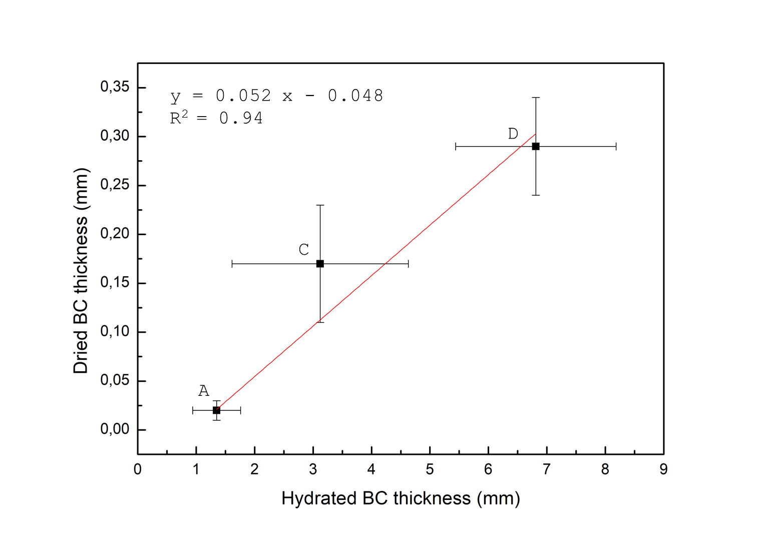
Figure S1. Linear correlation in terms of thickness between dried and hydrated BC samples for A, C, and D. The coefficient of determination (R²) is 0.94.
Figure S2. EDS analysis of SCOBY and BC samples. The images in the column on the right are magnification of the spectra reported in the column on the left.

Table S1. Water content of BC samples after 24 h in water. The analysis was performed in triplicate. The weight average values are reported and used for the determination of the water content.
Sample | m_{w}  (mg) | m_{d}  (mg) | Water content  (%)
A | 7.6 | 1.6 | 79
B | 11.5 | 2.9 | 73
C | 42.6 | 3.8 | 91
D | 141.2 | 6.4 | 95

Table S2: Elastic modulus, strain at break and stress at break of BC samples subjected to stress-strain measurements.
Sample | Elastic modulus  (MPa) | Strain at break  (%) | Stress at break  (MPa)
A | 2572 ± 661 | 2 ± 0 | 38 ± 9
B | 2823 ± 678 | 1 ± 1 | 23 ± 8
C | 620 ± 72 | 3 ± 1 | 16 ± 8
D | 282 ± 140 | 11 ± 2 | 19 ± 11

Table S3: Crystallinity indexes of BC samples subjected to XRD measurements.
Sample | Cristallinity index  (%)
A | 88 ± 3
B | 92 ± 1
C | 91 ± 2
D | 91 ± 2
SCOBY | 90 ± 4

Table S4: Thermal properties of BC samples and SCOBY determined by TGA analysis.
Sample | Weight loss at 100°C (%) | Residue at 600°C (%) | T_{max} (°C)
A | 4 ± 1 | 12 ± 2 | 370 ± 5
B | 4 ± 2 | 14 ± 2 | 358 ± 6
C | 4 ± 2 | 22 ± 3 | 337 ± 12
D | 4 ± 0 | 11 ± 1 | 358 ± 3
SCOBY | 4 ± 4 | 28 ± 1 | 198 ± 6  340 ± 8

