RISK ASSESSMENT IN PULMONARY ARTERIAL HYPERTENSION (PAH): INSIGHTS FROM THE GRIPHON STUDY

Olivier Sitbon, MD, Kelly M. Chin, MD, Richard N. Channick, MD, Raymond L. Benza, MD, Lilla Di Scala, PhD, Sean Gaine, MD, Hossein-Ardeschir Ghofrani, MD, Irene M. Lang, MD, Vallerie V. McLaughlin, MD, Ralph Preiss, MD, Lewis J. Rubin, MD, Gérald Simonneau, MD, Victor F. Tapson, MD, Nazzareno Galiè, MD, Marius M. Hoeper, MD

SUPPLEMENTARY MATERIAL

TABLE OF CONTENTS
Supplementary Methods | Definition of morbidity events, Calculation of REVEAL 2.0 score, Statistical analyses, Imputation rules for missing data | Pages  3-4
Table S1 | Baseline characteristics for patients in subgroups determined by number of low-risk criteria at baseline according to the non-invasive French risk assessment approach | Pages  5-7
Table S2 | Baseline characteristics for patients in subgroups determined by REVEAL 2.0 risk category at baseline | Pages  8-10
Table S3 | Number of morbidity/mortality events in subgroups defined by risk at baseline | Pages  11-12
Table S4 | Sensitivity analyses for the risk of a morbidity/mortality event in subgroups defined by risk at baseline | Pages  13-14
Table S5 | Sensitivity analyses for the treatment effect of selexipag versus placebo on time from randomization to first morbidity or mortality event in subgroups defined by risk at baseline and in time-dependent analysis | Pages  15-18
Figure S1 | Disposition of patients from GRIPHON by risk at baseline | Pages  19-20
Figure S2 | Time from randomization to first morbidity or mortality event based on risk at baseline | Pages  21-22
Figure S3 | Time from randomization to death up to end of study based on risk at baseline | Pages  23-24
References |  | Page 25

SUPPLEMENTARY METHODS
Definition of morbidity events (1)
Morbidity events included: Disease progression or worsening of pulmonary arterial hypertension (PAH) that resulted in hospitalization, initiation of parenteral prostanoid therapy or long-term oxygen therapy, or need for lung transplantation or balloon atrial septostomy. Disease progression was defined as a decrease from baseline of at least 15% in 6-minute walk distance (6MWD), together with worsening in World Health Organization functional class (WHO FC) (for patients with WHO FC II or III at baseline) or the need for additional PAH therapy (for patients with WHO FC III or IV at baseline).

Calculation of REVEAL 2.0 score
The REVEAL 2.0 score was calculated as previously described (2) using the following variables: WHO Group 1 subgroup, age, sex, estimated glomerular filtration rate (eGFR) (calculated from serum creatinine) or renal insufficiency (if eGFR was missing), WHO FC, systolic blood pressure, heart rate, 6MWD, N-terminal pro brain natriuretic peptide (NT-proBNP), pericardial effusion (from medical history), mean right atrial pressure, pulmonary vascular resistance and all-cause hospitalization during the previous six months. In GRIPHON, percent predicted DLCO (diffusing capacity of the lungs for carbon monoxide) was not available so this parameter was always missing. Hospitalizations were included in the time-dependent analysis and assessment of change in risk category from baseline to week 26. Right heart catheterization data were only included if collected within three months prior to baseline; older data were treated as missing. Patients were included in the analysis if they had at least seven parameters available (3). For REVEAL 2.0, parameters with missing data were assigned a points value of zero (3) .

Statistical analyses
Cox proportional hazard models included treatment and risk group as covariates and were either adjusted or unadjusted for other baseline covariates. Adjusted Cox proportional hazards models included as covariates treatment group, risk group at baseline, background PAH therapy, race, geographical region, sex, etiology and age as a continuous variable; the interaction between treatment group and risk group and age and risk group were also included. Time-dependent Cox proportional hazards models included risk subgroup as a time-dependent covariate and evaluated morbidity/mortality for each risk subgroup based on all data collected at all time-points (i.e. baseline, at weeks 4, 8, 16, and 26, and every 6 months thereafter). Adjusted time-dependent models included the same baseline covariates as mentioned above; the interaction between treatment group and risk group and age and risk group were also included.

Imputation rules for missing data
In all analyses using the non-invasive French risk assessment approach, any parameters with missing data were imputed as not low-risk. For assessment of change in REVEAL 2.0 category risk from baseline to week 26, imputations were performed for parameters that were present at baseline but missing at week 26: if a patient had experienced a primary endpoint event before week 26, missing data were imputed using the highest risk possible and if a patient had not experienced a primary endpoint event before week 26, missing data were imputed with the last observation carried forward.

Table S1. Baseline characteristics for patients in subgroups determined by number of low-risk criteria at baseline according to the non-invasive French risk assessment approach*
 | Number of low-risk criteria
 | 3 | 2 | 1 | 0
Characteristic | n = 41 | n = 254 | n = 419 | n = 442
Sex, female | 28 (68.3) | 205 (80.7) | 348 (83.1) | 342 (77.4)
Age, years | 42.6 ± 13.9 | 43.4 ± 14.8 | 47.5 ± 15.0 | 51.7 ± 15.3
Age distribution  <65 years old  ≥65 years old | 39 (95.1)  2 (4.9) | 231 (90.9)  23 (9.1) | 354 (84.5)  65 (15.5) | 325 (73.5)  117 (26.5)
Geographic region  Asia  Eastern Europe  Latin America  North America  Western Europe / Australia | 15 (36.6)  5 (12.2)  3 (7.3)  8 (19.5)  10 (24.4) | 64 (25.2)  66 (26.0)  30 (11.8)  37 (14.6)  57 (22.4) | 82 (19.6)  116 (27.7)  52 (12.4)  74 (17.7)  95 (22.7) | 67 (15.2)  117 (26.5)  25 (5.7)  74 (16.7)  159 (36.0)
Time since PAH diagnosis†, years  Mean ± SD  Median (range) | 2.3 ± 3.1  1.0 (0.0-13.8) | 2.6 ± 4.4  0.9 (0.0-37.3) | 2.4 ± 3.4  1.0 (0.0-22.7) | 2.3 ± 3.4  1.1 (0.0-38.9)
PAH etiology  Idiopathic  Associated with connective tissue disease  Associated with corrected congenital shunts  Associated with drug or toxin exposure  Heritable  Associated with HIV infection | 22 (53.7)  11 (26.8)  5 (12.2)  0  3 (7.3)  0 | 136 (53.5)  72 (28.3)  34 (13.4)  3 (1.2)  5 (2.0)  4 (1.6) | 231 (55.1)  117 (27.9)  46 (11.0)  9 (2.1)  11 (2.6)  5 (1.2) | 260 (58.8)  134 (30.3)  25 (5.7)  15 (3.4)  7 (1.6)  1 (0.2)
PAH background therapies  None  ERA monotherapy  PDE-5i monotherapy  ERA + PDE-5i | 5 (12.2)  7 (17.1)  16 (39.0)  13 (31.7) | 69 (27.2)  41 (16.1)  84 (33.1)  60 (23.6) | 101 (24.1)  62 (14.8)  140 (33.4)  116 (27.7) | 61 (13.8)  60 (13.6)  134 (30.3)  187 (42.3)
6MWD, meters**  Mean ± SD  Median (range) | 449.1 ± 9.9  447 (441-493) | 393.2 ± 58.8  410 (188-515) | 356.2 ± 71.3  373 (100-472) | 318.4 ± 83.4  338 (50-440)
WHO FC**  I  II  III  IV | 2 (4.9)  39 (95.1)  0  0 | 5 (2.0)  234 (92.1)  15 (5.9)  0 | 2 (0.5)  256 (61.1)  160 (38.2)  1 (0.2) | 0  0  432 (97.7)  10 (2.3)
NT-proBNP, ng/L‡** | 153.0 ± 82.7 | 293.5 ± 526.0 | 953.3 ± 1230.3 | 2073.0 ± 2274.3
*Continuous data are presented as mean ± standard deviation and categorical data as number (%), unless otherwise stated. †Confirmed by right heart catheterization. ‡At baseline, 14 patients (1.2%) had missing NT-proBNP data (6, 7, and 1 patient(s) in the 0, 1, and 2 low-risk criteria groups, respectively). **Low-risk criteria defined as: WHO FC I-II, 6MWD >440 m and NT-proBNP <300 ng/L. 6MWD=6-minute walk distance; ERA=endothelin receptor antagonist; HIV=Human immunodeficiency virus; NT-proBNP=N-terminal pro brain natriuretic peptide; PAH=pulmonary arterial hypertension; PDE-5i=phosphodiesterase type-5 inhibitor; SD=standard deviation; WHO FC=World Health Organization functional class.

Table S2. Baseline characteristics for patients in subgroups determined by REVEAL 2.0 risk category at baseline*
 | REVEAL 2.0 risk category
 | Low | Intermediate | High
Characteristic | n = 552 | n = 285 | n = 319
Sex, female‡ | 452 (81.9) | 233 (81.8) | 238 (74.6)
Age, years‡ | 45.0 ± 14.5 | 49.5 ± 14.9 | 52.1 ± 16.2
Age distribution  <65 years old  ≥65 years old | 498 (90.2)  54 (9.8) | 229 (80.4)  56 (19.6) | 222 (69.6)  97 (30.4)
Geographic region  Asia  Eastern Europe  Latin America  North America  Western Europe / Australia | 122 (22.1)  143 (25.9)  57 (10.3)  95 (17.2)  135 (24.5) | 46 (16.1)  79 (27.7)  31 (10.9)  51 (17.9)  78 (27.4) | 60 (18.8)  82 (25.7)  22 (6.9)  47 (14.7)  108 (33.9)
Time since PAH diagnosis†, years  Mean ± SD  Median (range) | 2.6 ± 4.1  1.0 (0.0-37.3) | 2.3 ± 3.0  1.0 (0.0-18.7) | 2.1 ± 3.3  1.0 (0.0-38.9)
PAH etiology  Idiopathic  Associated with connective tissue disease‡  Associated with corrected congenital shunts  Associated with drug or toxin exposure  Heritable‡  Associated with HIV infection | 323 (58.5)  125 (22.6)  75 (13.6)  11 (2.0)  9 (1.6)  9 (1.6) | 170 (59.6)  73 (25.6)  21 (7.4)  12 (4.2)  8 (2.8)  1 (0.4) | 156 (48.9)  136 (42.6)  14 (4.4)  4 (1.3)  9 (2.8)  0
PAH background therapies  None  ERA monotherapy  PDE-5i monotherapy  ERA + PDE-5i | 135 (24.5)  87 (15.8)  179 (32.4)  151 (27.4) | 52 (18.2)  34 (11.9)  96 (33.7)  103 (36.1) | 49 (15.4)  49 (15.4)  99 (31.0)  122 (38.2)
6MWD, meters‡  Mean ± SD  Median (range) | 380.8 ± 64.8  394 (142-515) | 357.2 ± 72.2  375 (100-471) | 301.8 ± 85.6  307(50-452)
WHO FC‡  I  II  III  IV | 9 (1.6)  357 (64.7)  185 (33.5)  1 (0.2) | 0  123 (43.2)  158 (55.4)  4 (1.4) | 0  49 (15.4)  264 (82.8)  6 (1.9)
NT-proBNP, ng/L‡** | 279.5 ± 278.3 | 1224.0 ± 1148.4 | 2785.6 ± 2441.5
Continuous data are presented as mean ± standard deviation and categorical data as number (%), unless otherwise stated *Risk category was defined by REVEAL 2.0 risk score at baseline: low (≤6), intermediate (7-8), high (≥9). †Confirmed by right heart catheterization. ‡Indicates parameters assessed by the REVEAL 2.0 risk score. **At baseline, 14 patients (1.2%) had missing NT-proBNP data (6, 6, and 2 patients in the low, intermediate, and high groups, respectively). 6MWD=6-minute walk distance; ERA=endothelin receptor antagonist; HIV=Human immunodeficiency virus; NT-proBNP=N-terminal pro brain natriuretic peptide; PAH=pulmonary arterial hypertension; PDE-5i=phosphodiesterase type-5 inhibitor; SD=standard deviation; WHO FC=World Health Organization functional class.

Table S3. Number of morbidity/mortality events in subgroups defined by risk at baseline
a) Number of low-risk criteria according to the non-invasive French risk assessment approach
 | Placebo |  |  |  | Selexipag
Number of low-risk criteria at baseline | 3 | 2 | 1 | 0 | 3 | 2 | 1 | 0
Morbidity/mortality events, n/N (%) | 3/17  (17.6) | 26/127 (20.5) | 69/198 (34.8) | 144/240 (60.0) | 1/24  (4.2) | 16/127 (12.6) | 51/221 (23.1) | 87/202 (43.1)
b) REVEAL 2.0 risk category
 | Placebo |  |  | Selexipag
REVEAL 2.0 category | Low | Intermediate | High | Low | Intermediate | High
Morbidity/mortality events, n/N (%) | 68/268  (25.4) | 70/140  (50.0) | 104/174  (59.8) | 41/284  (14.4) | 42/145  (29.0) | 72/145  (49.7)

n: number of events; N: number of patients in the subgroup. (a) Low-risk criteria defined as: WHO FC I-II, 6MWD >440 m, and NT-proBNP <300 ng/L. At baseline, 14 patients (1.2%) had missing NT-proBNP data (6, 7, and 1 patient(s) in the 0, 1, and 2 low-risk criteria groups, respectively). (b) REVEAL 2.0 risk category defined by REVEAL 2.0 risk score at baseline: low (≤6), intermediate (7-8), high (≥9). At baseline, data were missing for 3 risk parameters in 2 patients (0.2%), 4 risk parameters in 364 patients (31.5%), 5 risk parameters in 77 patients (6.7%), 6 risk parameters in 701 patients (60.6%), 7 risk parameters in 10 patients (0.9%) and 8 risk parameters in 2 patients (0.2%). 6MWD=6-minute walk distance; NT-proBNP=N-terminal pro brain natriuretic peptide; WHO FC=World Health Organization functional class.

Table S4. Sensitivity analyses for the risk of a morbidity/mortality event in subgroups defined by risk at baseline
(a) Number of low-risk criteria according to the non-invasive French risk assessment approach*
 | Number of low-risk criteria at baseline
 | 3 vs 0  HR (95%CI) | 2 vs 0  HR (95% CI) | 1 vs 0  HR (95% CI) | p-value
Main analysis† | 0.06 (0.01-0.31) | 0.20 (0.14-0.30) | 0.44 (0.35-0.56) | 0.0398
Unadjusted analysis** | 0.12 (0.05-0.34) | 0.21 (0.15-0.30) | 0.45 (0.36-0.56) | <0.0001
*Data shown for both treatment groups combined. At baseline, data were missing for one risk criterion (NT-proBNP) in 14 patients (1.2%) (6 selexipag patients and 8 placebo patients) and were imputed as not low-risk. †The model was adjusted for treatment group, background PAH therapy, geographical region, etiology, sex, race, age and number of low-risk criteria and included the interaction between treatment group and number of low-risk criteria, and age and number of low-risk criteria. **The model included treatment group and number of low-risk criteria only as covariates. Low-risk criteria defined as: WHO FC I-II, 6MWD >440 m, and NT-proBNP <300 ng/L. 6MWD=6-minute walk distance; CI=confidence interval; HR=hazard ratio; NT-proBNP=N-terminal pro brain natriuretic peptide; WHO FC=World Health Organization functional class.

(b) REVEAL 2.0 category*
 | Risk category at baseline
 | Low vs high  HR (95% CI) | Intermediate vs high  HR (95% CI) | p-value
Main analysis† | 0.22 (0.17-0.28) | 0.51 (0.40-0.66) | 0.0074
Unadjusted analysis** | 0.23 (0.18-0.30) | 0.54 (0.43-0.69) | <0.0001
*Data shown for both treatment groups combined. At baseline, data were missing for 3 risk parameters in 2 patients (0.2%), 4 risk parameters in 364 patients (31.5%), 5 risk parameters in 77 patients (6.7%), 6 risk parameters in 701 patients (60.6%), 7 risk parameters in 10 patients (0.9%) and 8 risk parameters in 2 patients (0.2%). †The model was adjusted for treatment group, background PAH therapy, geographical region, etiology, sex, race, age and REVEAL 2.0 risk category, and included the interaction between treatment group and risk category, and age and risk category. **Model included treatment group and REVEAL 2.0 risk category only as covariates. Risk category determined by REVEAL 2.0 risk score at baseline: low (≤6), intermediate (7-8), high (≥9). CI=confidence interval; HR=hazard ratio.
Table S5. Sensitivity analyses for the treatment effect of selexipag versus placebo on time from randomization to first morbidity or mortality event in subgroups defined by risk at baseline and in time-dependent analysis
(a) Number of low-risk criteria defined according to the non-invasive French risk assessment approach*
 | Number of low-risk criteria at baseline
 | 2  HR (95% CI) | 1  HR (95% CI) | 0  HR (95% CI)
Main analysis† | 0.58 (0.31-1.08) | 0.65 (0.45-0.93) | 0.59 (0.45-0.78)
Unadjusted analysis** | 0.58 (0.31-1.07) | 0.65 (0.45-0.94) | 0.61 (0.47-0.80)
 | Number of low-risk criteria in time-dependent analysis
 | 2  HR (95% CI) | 1  HR (95% CI) | 0  HR (95% CI)
Main analysis † | 0.80 (0.26-2.50) | 0.59 (0.36-0.96) | 0.82 (0.65-1.03)
Unadjusted analysis** | 0.79 (0.25-2.44) | 0.59 (0.36-0.96) | 0.80 (0.64-1.00)
*Hazard ratios could not be calculated in the subgroups of patients with 3 low-risk criteria because of the low numbers of morbidity/mortality events that occurred. At baseline, data were missing for one risk criterion (NT-proBNP) in 14 patients (1.2%) (6 selexipag patients and 8 placebo patients) and were imputed as not low-risk. †The model was adjusted for treatment group, background PAH therapy, geographical region, etiology, sex, race, age and number of low-risk criteria and included the interaction between treatment group and number of low-risk criteria, and age and number of low-risk criteria. **The model included treatment group and number of low-risk criteria only as covariates; the interaction between treatment group and risk group was also included. Low-risk criteria defined as: WHO FC I-II, 6MWD >440 m, and NT-proBNP <300 ng/L. 6MWD=6-minute walk distance; CI=confidence interval; HR=hazard ratio; NT-proBNP=N-terminal pro brain natriuretic peptide; WHO FC=World Health Organization functional class.

(b) REVEAL 2.0 category
 | Risk category at baseline
 | Low  HR (95% CI) | Intermediate  HR (95% CI) | High  HR (95% CI)
Main analysis † | 0.58 (0.39-0.86) | 0.47 (0.32-0.70) | 0.71 (0.52-0.96)
Unadjusted analysis* | 0.56 (0.38-0.83) | 0.51 (0.35-0.75) | 0.72 (0.53-0.97)
 | Risk category in time-dependent analysis
 | Low  HR (95% CI) | Intermediate  HR (95% CI) | High  HR (95% CI)
Main analysis † | 0.35 (0.17-0.73) | 0.46 (0.25-0.83) | 0.81 (0.63-1.04)
Unadjusted analysis* | 0.35 (0.17-0.74) | 0.45 (0.25-0.82) | 0.81 (0.64-1.04)
†The model was adjusted for treatment group, background PAH therapy, geographical region, etiology, sex, race, age and REVEAL 2.0 risk category and included the interaction between treatment group and risk category, and age and risk category. *Model included treatment group and REVEAL 2.0 risk category only as covariates; the interaction between treatment group and risk group was also included.
Risk category determined by REVEAL 2.0 risk score: low (≤6), intermediate (7-8), high (≥9). At baseline, data were missing for 3 risk parameters in 2 patients (0.2%), 4 risk parameters in 364 patients (31.5%), 5 risk parameters in 77 patients (6.7%), 6 risk parameters in 701 patients (60.6%), 7 risk parameters in 10 patients (0.9%) and 8 risk parameters in 2 patients (0.2%). CI=confidence interval; HR=hazard ratio.
Figure S1. Disposition of patients from GRIPHON by risk at baseline
a) Number of low-risk criteria according to the non-invasive French risk assessment approach
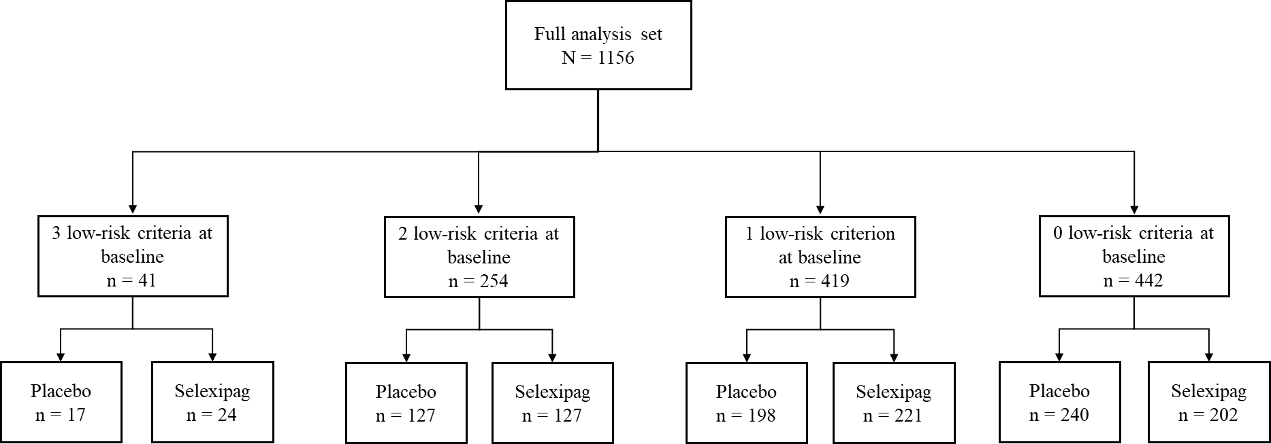

Low-risk criteria defined as: WHO FC I-II, 6MWD >440 m and NT-proBNP <300 ng/L. At baseline, data were missing for one risk criterion (NT-proBNP) in 14 patients (1.2%) and were imputed as not low-risk. 6MWD=6-minute walk distance; NT-proBNP=N-terminal pro brain natriuretic peptide; WHO FC=World Health Organization functional class.
b) REVEAL 2.0 risk category

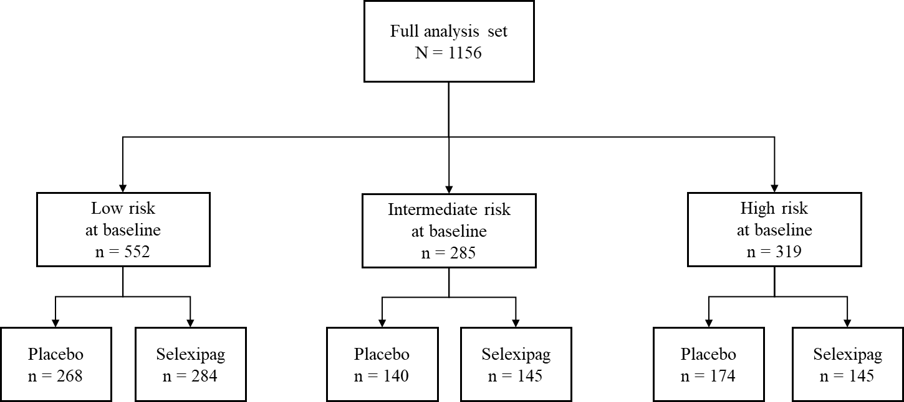
Risk category was defined by REVEAL 2.0 risk score at baseline: low (≤6), intermediate (7-8), high (≥9). At baseline, data were missing for 3 risk parameters in 2 patients (0.2%), 4 risk parameters in 364 patients (31.5%), 5 risk parameters in 77 patients (6.7%), 6 risk parameters in 701 patients (60.6%), 7 risk parameters in 10 patients (0.9%) and 8 risk parameters in 2 patients (0.2%).

Figure S2. Time from randomization to first morbidity or mortality event based on risk at baseline
a) Number of low-risk criteria b) REVEAL 2.0 risk category
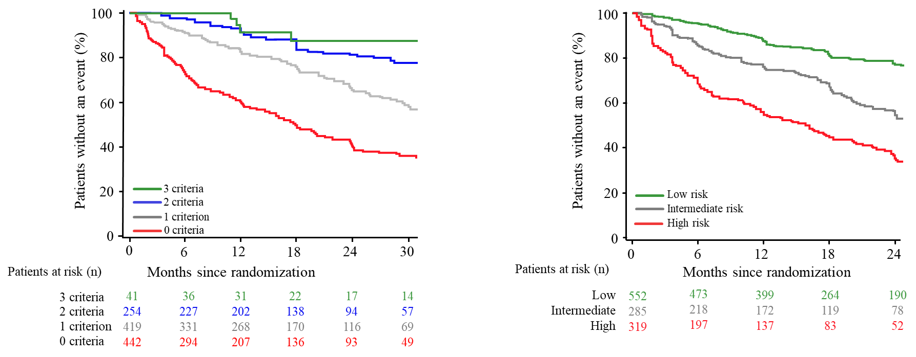

Kaplan-Meier estimates of time to first morbidity/mortality event are shown for the overall population (i.e. both treatment groups combined) for subgroups defined according to risk at baseline. (a) Number of low-risk criteria according to the non-invasive French risk assessment approach (WHO FC I-II, 6MWD >440 m, and NT-proBNP <300 ng/L). At baseline, data were missing for one risk criterion (NT-proBNP) in 14 patients (1.2%) (6 selexipag patients and 8 placebo patients) and were imputed as not low-risk. (b) REVEAL 2.0 risk score at baseline: low (≤6), intermediate (7-8), high (≥9). At baseline, data were missing for 3 risk parameters in 2 patients (0.2%), 4 risk parameters in 364 patients (31.5%), 5 risk parameters in 77 patients (6.7%), 6 risk parameters in 701 patients (60.6%), 7 risk parameters in 10 patients (0.9%) and 8 risk parameters in 2 patients (0.2%). For both graphs, Kaplan-Meier curves are truncated to the point at which the number of patients at risk falls below 10% of the number of randomized patients in one of the subgroups. 6MWD=6-minute walk distance; NT-proBNP=N-terminal pro brain natriuretic peptide; WHO FC=World Health Organization functional class

Figure S3. Time from randomization to death up to end of study based on risk at baseline
a) Number of low-risk criteria b) REVEAL 2.0 category
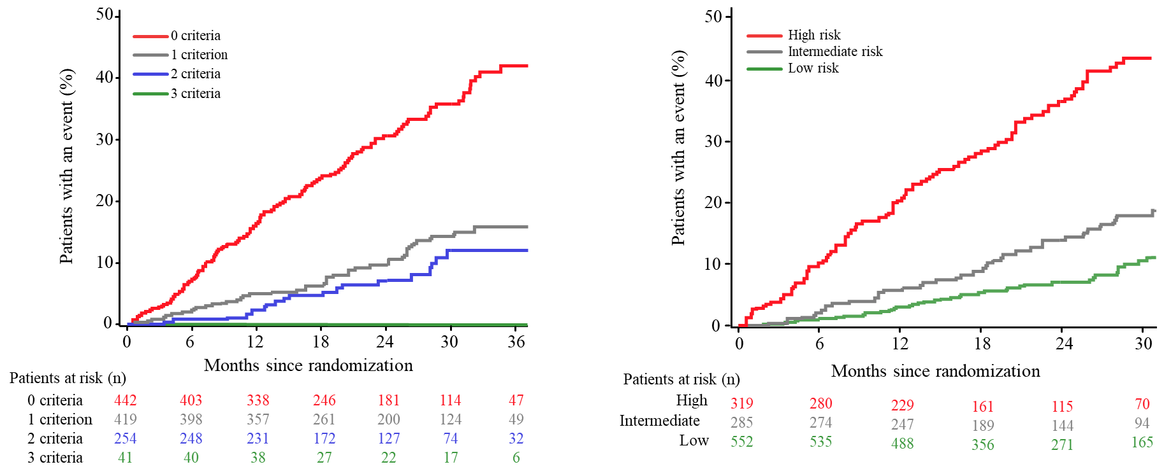

Kaplan-Meier estimates of time to death up to end of study are shown for the overall population (i.e. both treatment groups combined) for subgroups defined according to risk at baseline. (a) Number of low-risk criteria according to the non-invasive French risk assessment approach (WHO FC I-II, 6MWD >440 m, and NT-proBNP <300 ng/L). At baseline, data were missing for one risk criterion (NT-proBNP) in 14 patients (1.2%) (6 selexipag patients and 8 placebo patients) and were imputed as not low-risk. (b) REVEAL 2.0 risk score at baseline: low (≤6), intermediate (7-8), high (≥9). At baseline, data were missing for 3 risk parameters in 2 patients (0.2%), 4 risk parameters in 364 patients (31.5%), 5 risk parameters in 77 patients (6.7%), 6 risk parameters in 701 patients (60.6%), 7 risk parameters in 10 patients (0.9%) and 8 risk parameters in 2 patients (0.2%). Kaplan-Meier curves are truncated to the point at which the number of patients at risk falls below 10% of the number of randomized patients in one of the subgroups. 6MWD=6-minute walk distance; NT-proBNP=N-terminal pro brain natriuretic peptide; WHO FC=World Health Organization functional class

References
1. Sitbon O, Channick R, Chin KM, et al. Selexipag for the Treatment of Pulmonary Arterial Hypertension. N Engl J Med 2015;373:2522-33.
2. Benza RL, Gomberg-Maitland M, Elliott CG, et al. Predicting Survival in Patients With Pulmonary Arterial Hypertension: The REVEAL Risk Score Calculator 2.0 and Comparison With ESC/ERS-Based Risk Assessment Strategies. Chest 2019;156:323-37.
3. Anderson JJ, Lau EM, Lavender M, et al. Retrospective validation of the REVEAL 2.0 Risk Score with the Australian and New Zealand Pulmonary Hypertension Registry Cohort. Chest 2019:S0012-3692(19)33934-0.

