[Tectonics]
Supporting Information for

Oligocene Slab Break-Off and Pleistocene Glacial Erosion Shaped the Landscape of the Dent Blanche Tectonic System, Western Alps
Gemignani¹⁻², L., Sobel³, E.R., Zucali⁴, M., Albino¹, I., Stellato²⁻⁵, M., Glodny⁶, J., Kuiper⁷, K.
^{1.} Department of Biological, Geological, and Environmental Sciences (BIGEA), Università di Bologna, Bologna, Italy.
^{2.} Institut für Geologische Wissenschaften, Freie Univerität Berlin, Berlin, Germany.
^{3.} Institute of Geosciences, University of Potsdam, Potsdam, Germany.
^{4.} Dipartimento di Scienze della Terra "A. Desio", Università degli Studi di Milano, Milan, Italy.
^{5.} Department of Environmental Engineering, University of Calabria, Arcavacata di Rende, Italy.
^{6.} GFZ German Research Center for Geosciences, 14473 Potsdam, Germany.
^{7.} Faculty of Sciences, Vrije Universiteit Amsterdam, Amsterdam, the Netherlands.
Corresponding author: Lorenzo Gemignani (lorenzo.gemignani@unibo.it).

Contents of this file

Text S1 to S3
Figure S1 to S4

Additional Supporting Information

We present an updated Excel Table S1, summarizing all available low-temperature ages from various locations across the Western Alps. The data in Table S1 were utilized to recreate Figures 3 and 4 in the main text. This table updates a previous version from Vernon et al. (2009). Additionally, we provide comprehensive data repositories for the (U-Th-Sm)/He (Table S2) and ⁴⁰Ar/³⁹Ar analyses (Table S3). All datasets will be accessible upon publication via the following link: https://doi.org/10.6084/m9.figshare.25472383.v1.

Text S1. Zircon and Apatite (U-Th)/He dating (ZHe and AHe)

Bedrock samples were processed to extract aliquots of apatite, zircons, and white mica ranging from 63 to 500 μm using standard mineral separation techniques in the laboratory of the FU Berlin. Zircon and apatite crystals were handpicked under a binocular microscope equipped with a digital camera to record morphology, size and characteristics of the grains in the thermochronology laboratory of the University of Potsdam.
The zircon and apatite He-method relies on the radioactive decay of isotopes such as ²³⁸U, ²³⁵U, ²³²Th, and ¹⁴⁷Sm, and the retention of the daughter product, ⁴He, in a crystal below a specific closure temperature (Reiners and Brandon, 2006). The temperature ranges for the ZHe and AHe systems are 140–200 and 40–85°C, respectively, with typical closure temperatures being 185 and 70°C, respectively (Reiners et al., 2005). Influencing factors include crystal characteristics and radiation damage (Farley et al., 1996). In zircon crystals with high alpha damage densities, this temperature can be significantly lower (Guenthner et al., 2013). Standard analytical routines involve an alpha ejection correction to account for crystal size, morphology, and source zoning, while interactions between radiation damage and helium diffusivity are complex (Guenthner et al., 2013).
For He-analyses, two to five single-grain replicates per sample were loaded into Nb (for zircons) and Pt (for apatites) capsules, degassed by laser heating, and analyzed for He concentrations with an Alphachron quadrupole mass spectrometer system; abundances of U, Th, and Sm were determined using inductively coupled plasma mass spectrometry (ICP-MS) at the German Research Centre for Geoscience (GFZ) Potsdam (Galetto et al., 2021). Individual ages were calculated using the equations in Meesters and Dunai (2005), using alpha-ejection corrections assuming homogeneous U, Th, and Sm distributions (Farley et al., 1996; Ketcham et al., 2011; He and Reiners, 2022). Individual ages were calculated using equations from Meesters and Dunai (2005).

Text S2. Ms ⁴⁰Ar/³⁹Ar dating (MAr)

Muscovite grains ranging from 125-500 μm were weighted and wrapped in Al-foil packets for irradiation. The packages were stacked in 9 mm ID quartz tubes together with the monitor standard Drachenfels sanidine dated at 25.52 ± 0.03 Ma (Wijbrans et al., 1995). This value is compatible with the set of (Kuiper et al., 2008). Samples were irradiated at the Oregon State University TRIGA reactor in the (cadmium-lined) CLICIT facility for 12 h (batch VU123). After irradiation, samples were loaded in a 185 holes’ copper disk and heated overnight in an ultra-high vacuum sample housing at 200 °C to reduce contaminant air. Total fusion analyses of single muscovite grains were performed using a 25 W Synrad CO2 Laser Instrument. The released gas was first purified by a cold trap (−70 °C) to retain volatiles and then further cleaned in an ultra-high vacuum gas purification line by exposing the gas to SAES NP10 (Zr-Fe-V-alloy) getters. The Ar isotopes were measured by the ThermoFisher Helix MC plus and ARGUS PLUS mass spectrometers. Full analytical results are given in table S2.

Text S3: Inverse thermal modelling with QTQt

Multi-sample inverse thermal model was run using QTQt software v5.8 (Gallagher, 2012), employing a Bayesian transdimensional statistical approach. To assess the long-term cooling history since the Paleocene, we applied the radiation damage model (RDAAM) developed by Flower et al. (2009) to the AHe ages, and the annealing model by Guenthner et al. (2013) for ZHe ages. Only aliquots with reproducible AHe ages (<20% of the mean age) were included in the model.
In consideration of the geological context, we applied specific constraints to the model: samples V15-2 the youngest MAr cooling age (~29 Ma) was used as a constrain at a temperature (Tc-range) of 360±30°. For sample M17-1, we applied two constraints to the thermal model a) the youngest MAr age of the age distribution of 45 ± 5 at a temperature (Tc-range) of 360±30° and (b) AHe mean age of 21 ± 1 Ma and TC-range of 60±20°. For samples A13-2 and R13-3, we only used as constraints the MAr youngest age at 50 5 Ma and 40 10 Ma at a Tc-range of 360±30° respectively.
The summary of the expected model predictions computed in QTQt are plotted in Figures S1, S2 S3 and S4. Note that the vertical scale is arbitrary; the samples are assigned slightly different elevations to enhance legibility.

Figure S1. Expected model summary prediction for Sample V15-2, three AHe grains.

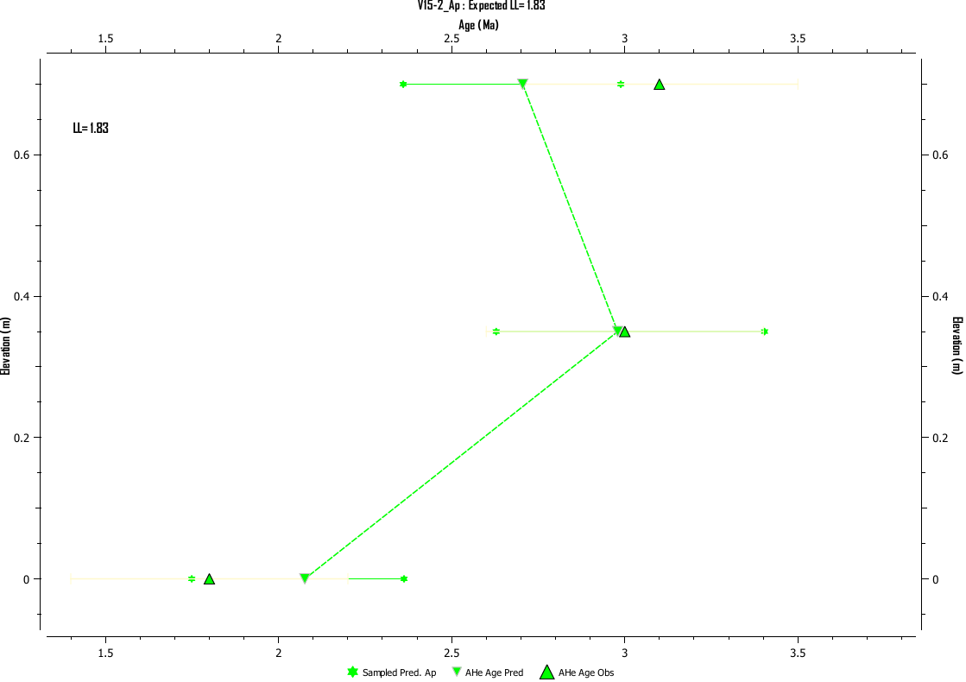

Figure S2. Expected model summary prediction for Sample M17-1, five ZHe grains.
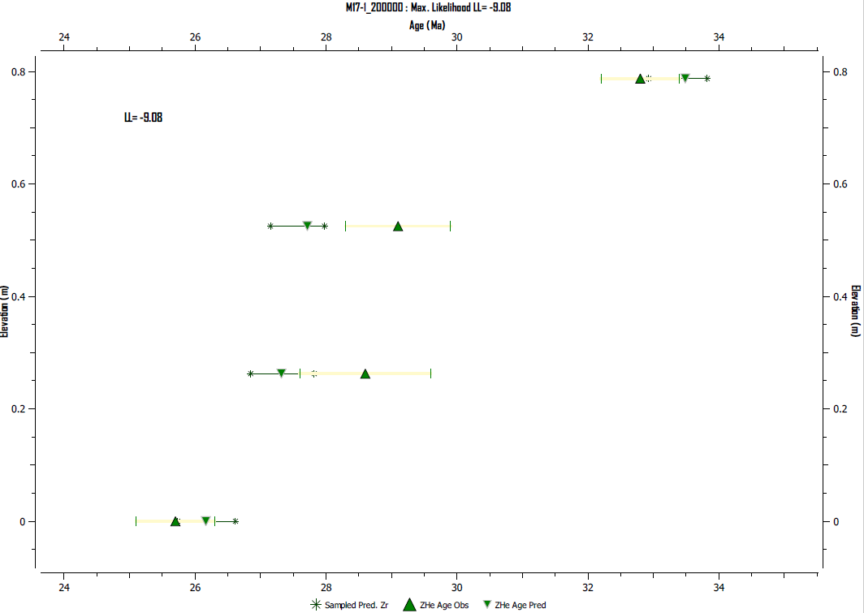

Figure S3. Expected model summary prediction for Sample A13-2, four ZHe grains.

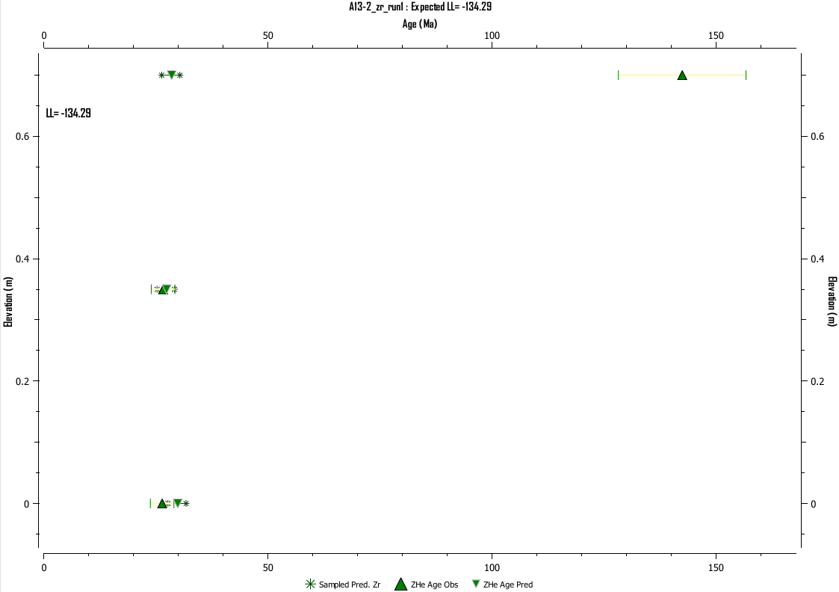

Figure S4. Expected model prediction for Sample A13-2, two ZHe grains.
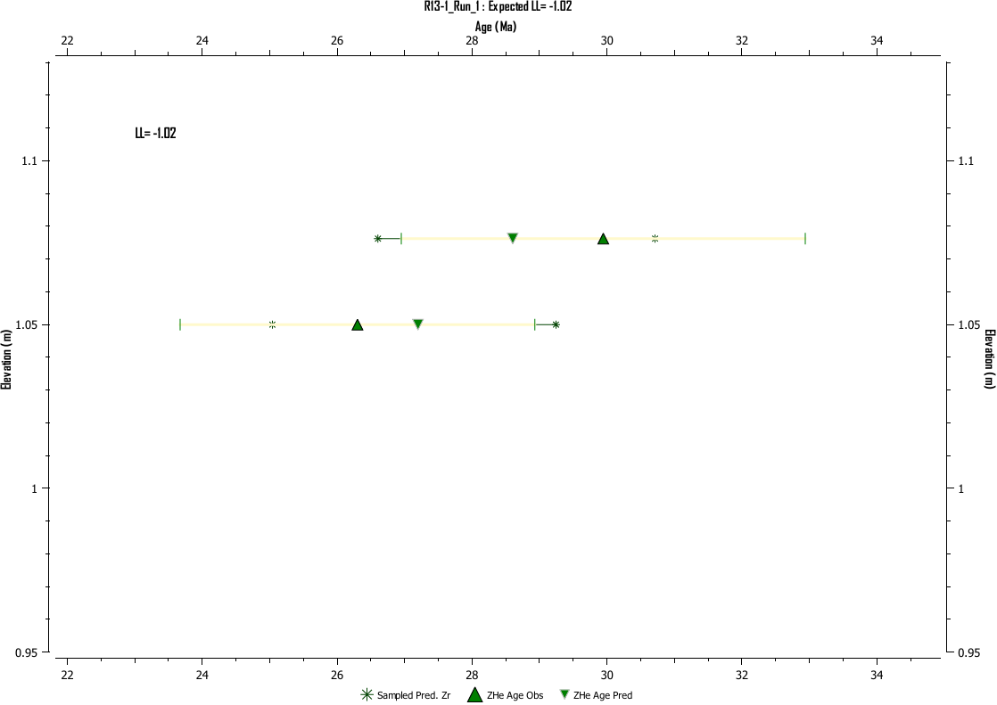

References:

Guenthner, W. R., Reiners, P. W., & Ketcham, R. A. (2013). Accuracy and precision of thermal history reconstruction from apatite triplets. Geochemistry, Geophysics, Geosystems, 14(2), 309-323.

Gallagher, K., 2012, Transdimensional inverse thermal history modeling for quantitative thermochronology: Journal of Geophysical Research: Solid Earth, 117(B2). https://doi.org/10.1029/2011JB008825.

Galetto, A., Georgieva, V., García, V.H., Zattin, M., Sobel, E.R., Glodny, J., Bordese, S., Arzadún, G., Bechis, F., Caselli, A.T., and R. Becchio, R., 2021. Cretaceous and Eocene rapid cooling phases in the Southern Andes (36°-37°S): Insights from low-temperature thermochronology, U-Pb geochronology, and inverse thermal modeling from Domuyo area, Argentina: Tectonics, v. 40, e2020TC006415. https://doi.org /10.1029/2020TC00641

Flowers, R., Ketcham, R., Shuster, D., and Farley, K. (2009). Apatite (U-Th)/He thermochronology using a radiation damage accumulation and annealing model, Geochimica et Cosmochimica Acta. 73. 10.1016/j.gca.2009.01.015.

Ketcham R. A., Carter A. C., Donelick R. A., Barbarand J. andHurford A. J. (2007). Improved modeling of fission-track annealing in apatite, Am. Mineral. 92, 799–810.

Kuiper, K. F., Deino, A. L., Hilgen, F. J., Krijgsman, W., Renne, P. R., & Wijbrans, J. R. (2008). Synchronizing rock clocks of Earth history. Science, 320(5875), 500–504. https://doi.org/10.1126/science.1154339

Meesters A. G. C. A., and Dunai T. J. (2002). Solving the production-diffusion equation for finite diffusion domains of various shapes Part II. Application to cases with a-ejection and non-homogeneous distribution of the source: Chem. Geol. (186), 347–363.

Reiners, P. W., & Brandon, M. T. (2006). Using thermochronology to understand orogenic erosion. Annual Review of Earth and Planetary Sciences, 34, 419-466. DOI: 10.1146/annurev.earth.34.031405.125202.

Vernon, A. J., van der Beek, P. A., & Sinclair, H. D. (2009). Spatial correlation between long-term exhumation rates and present-day forcing parameters in the western European Alps. Geology, 37(9), 859-862

Wijbrans, J.R. Pringle M.S.; Koppers A.A.P.; Scheveers R. (1995). Argon geochronology of small samples using the Vulkaan argon laserprobe. Proceedings of the Royal Netherlands Academy of Arts and Sciences. Volume 98, Issue 2, Pages 185 – 218.

