Appendix S3. Correlation matrix
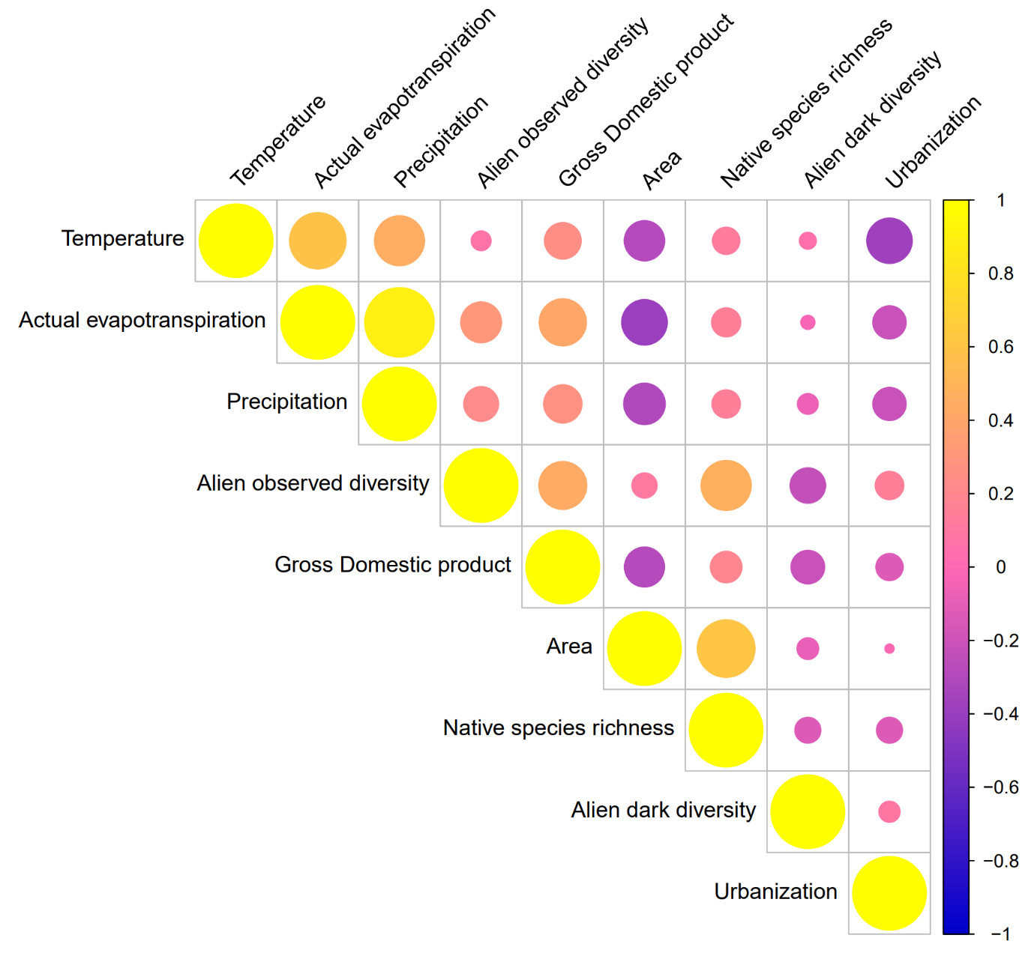
Fig. S2. Correlation matrix between all variables. All pairs of variables displayed a significant (p < 0.05) Spearman correlation.

