Oxidation of fatty acids in oils subjected to mild temperature stress: the case of grapeseed oil
Cesare Ravagli ª, Federica Pasini ^{a,b*}, Silvia Marzocchi ^{b}, Maria Fiorenza Caboni ^{a,b}
ª Department of Agricultural and Food Sciences and Technologies, University of Bologna, Piazza Goidanich 60, 47521 Cesena (FC), Italy.
^{b} Interdepartmental Centre of Industrial Agri-Food Research (CIRI Agroalimentare), University of Bologna, Via Quinto Bucci 336, 47521 Cesena, FC, Italy
*: corresponding author. E-mail address: federica.pasini5@unibo.it

Index of supplementary materials in this document
- Supplementary material 1: GC-FID chromatograms of the identified FAMEs in GSO sample.
- Supplementary material 2: SPME-GC-MS chromatograms of the identified volatile compounds in GSO sample.
- Supplementary material 3: HPLC-FLD chromatograms of the identified tocols in GSO sample.

.

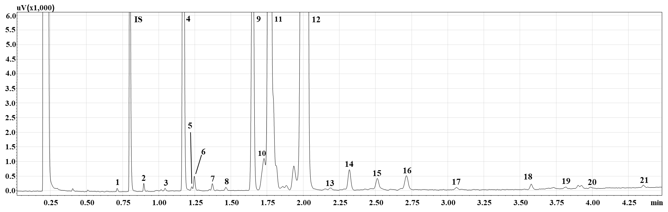
Supplementary material 1: GC-FID chromatograms of the identified FAMEs in GSO sample. Peaks: (1) C12:0; (2) C14:0; (3) C15:1; (4) C16:0; (5) C16:1 c n-7; (6) C16:1 c; (7) C17:0; (8) C17:1; (9) C18:0; (10) C18:1 t; (11) C18:1 c n-9; (12) C18:2 c n-6; (13) C19:1; (14) C18:3 c n-3; (15) C20:0; (16) C20:1; (17) C20:2 c n-6; (18) C22:0; (19) C22:1; (20) C22:2; (21) C24:0

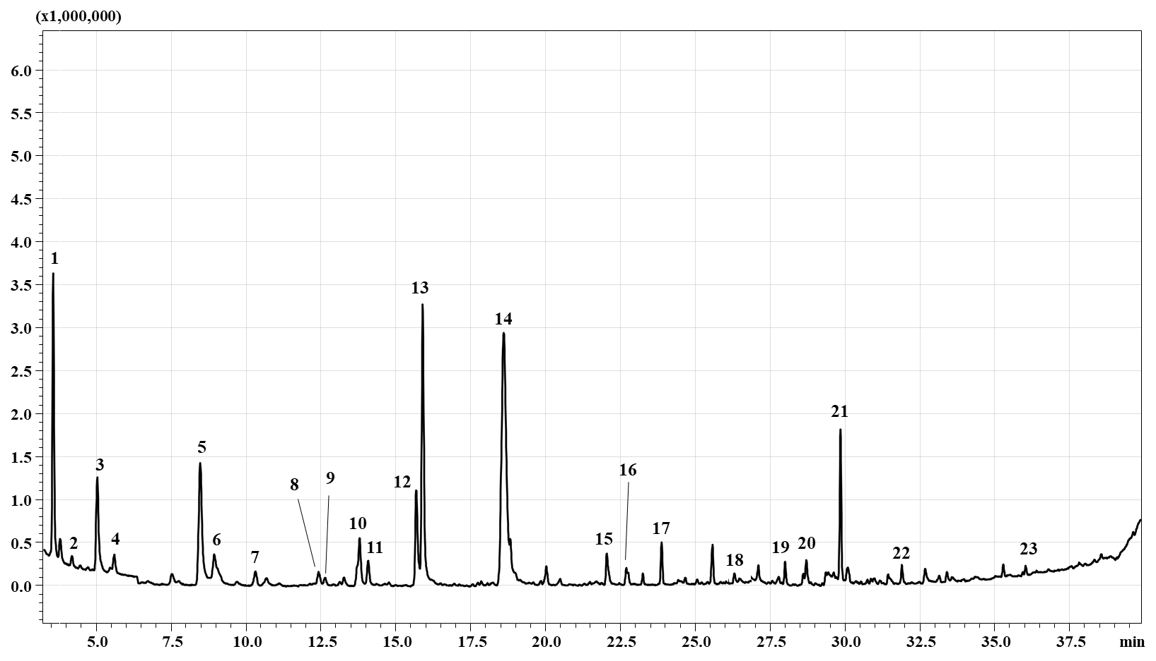
Supplementary material 2: SPME-GC-MS chromatograms of the identified volatile compounds in GSO sample. Peaks: (1) acetone; (2) 2-octene; (3) 2-methyl-2-propenal; (4) 2-butanone; (5) 2,4-dimethyl-furan; (6) 2-pentanone; (7) 4-methyl-2-pentanone; (8) 3-hexanone; (9) 2,3,5-trimethylfuran; (10) hexanal; (11) 5-hexen-2-one; (12) 3-penten-2-one; (13) ) 4-methyl-3-penten-2-one; (14) 2,4-pentanedione; (15) 1-hydroxy-2-propanone; (16) 2-heptenal; (17) 4-hydroxy-4-methylpentan-2-one; (18) acetic acid; (19) 2,5-hexanedione; (20) propanoic acid; (21) 1-(2,4-dimethyl-furan-3-yl)-ethanone; (22) 2,5-dihydro-3,5-dimethyl-2-furanone; (23) hexanoic acid.

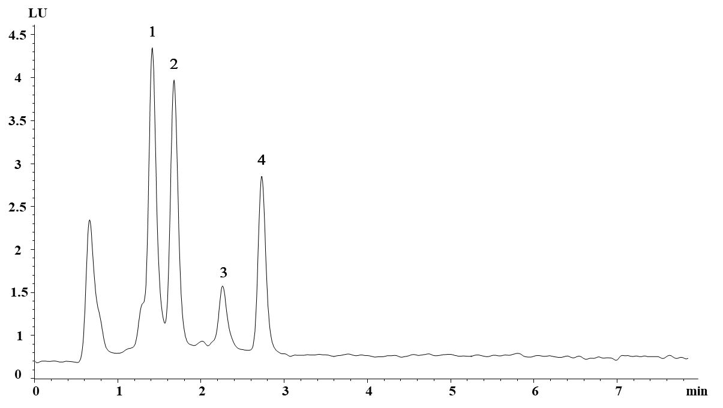
Supplementary material 3: HPLC-FLD chromatograms of the identified tocols in GSO sample. Peaks: (1) α-tocopherol; (2) α-tocotrienol; (3) γ-tocopherol; (4) γ-tocotrienol.

