SUPPLEMENTARY MATERIAL
Table S1. Subsequent therapeutic lines and relative hematological and renal responses
 | N | Overall | AL amyloidosis-MGRS | Other-MRGS | p-value
Second line
Treatment, N (%)  ASCT  Bortezomib-based  IMIDs  Melphalan-based  Daratumumab  Rituximab  Other | 22 |  |  |  | 0.3
 |  | 1 (4.5) | 1 (5.3) | 0 (0)
 |  | 12 (55) | 11 (58) | 1 (33)
 |  | 4 (18) | 3 (16) | 1 (33)
 |  | 1 (4.5) | 1 (5.3) | 0 (0)
 |  | 1 (4.5) | 1 (5.3) | 0 (0)
 |  | 1 (4.5) | 0 (0) | 1 (33)
 |  | 2 (9.1) | 2 (11) | 0 (0)
Hematological response*, N (%) | 18 |  |  |  | 0.5
CR |  | 4 (22) | 4 (27) | 0 (0)
VGPR |  | 4 (22) | 4 (27) | 0 (0)
PR |  | 3 (17) | 2 (13) | 1 (33)
SD |  | 7 (39) | 5 (33) | 2 (67)
Renal response**, N (%) | 21 | 13 (62) | 12 (67) | 1 (33) | 0.5
Third line
Treatment, N (%) | 10 |  |  |  | 0.5
Bortezomib-based |  | 2 (20) | 1 (13) | 1 (50)
IMIDs |  | 7 (70) | 6 (75) | 1 (50)
Melphalan-based |  | 1 (10) | 1 (13) | 0 (0)
Hematological response*, N (%) | 8 |  |  |  | 0.2
CR |  | 2 (25) | 2 (33) | 0 (0)
VGPR |  | 3 (38) | 3 (50) | 0 (0)
PR |  | 1 (13) | 0 (0) | 1 (50)
SD |  | 2 (25) | 1 (17) | 1 (50)
Renal response**, N (%) | 8 | 4 (50) | 3 (43) | 1 (100) | >0.9
Fourth line
Treatment, N (%) | 5 |  |  |  | 0.4
Bortezomib-based |  | 1 (20) | 0 (0) | 1 (5%)
IMIDs |  | 1 (20) | 0 (0) | 1 (50)
Daratumumab |  | 2 (40) | 2 (67) | 0 (0)
ASCT |  | 1 (20) | 1 (33) | 0 (0)
Hematological response*, N (%) | 4 |  |  |  | >0.9
PR |  | 3 (7) | 2 (100) | 1 (50)
SD |  | 1 (2) | 0 (0) | 1 (50)
Renal response**, N (%) | 3 | 1 (33) | 1 (100) | 0 (0) | 0.3
*assessed according to IMWG criteria
**defined as a decrease of >30% of 24 h proteinuria (in the absence of renal progression defined by progressive decrease of >25% of eGFR)

Abbreviations: ASCT, autologous stem cell transplantation; CR, complete response; IMIDs, immunomodulatory drugs; N, number; PR, partial response; SD, stable disease; VGPR, very good partial response

Table S2. Hematological and renal responses by upfront therapy
 | N | Overall  N = 60 | ASCT ± bortezomib  N=20 | Bortezomib-based, no ASCT  N = 24 | Melphalan-based  N = 13 | Rituximab-based  N = 3 | p-value
Hematological response*, N (%) | 50
CR |  | 18 (36) | 11 (55) | 1 (5.9) | 6 (60) | 0 (0) | 0.003
VGPR |  | 10 (20) | 3 (15) | 6 (35) | 1 (10) | 0 (0) | ns
PR |  | 15 (30) | 3 (15) | 9 (53) | 2 (20) | 1 (33) | ns
SD |  | 7 (14) | 3 (15) | 1 (5.9) | 1 (10) | 2 (67) | ns
≥VGPR |  | 28 (56) | 14 (70) | 7 (41) | 7 (70) | 0 (0) | ns
Renal response**, N (%) | 54 | 32 (59) | 15 (75) | 9 (45) | 7 (64) | 1 (33) | ns
*assessed according to IMWG criteria
**defined as a decrease of >30% of 24 h proteinuria (in the absence of renal progression defined by progressive decrease of >25% of eGFR)

Abbreviations: ASCT, autologous stem cell transplantation; CR, complete response; N, number; ns, not significant; PR, partial response; SD, stable disease; VGPR, very good partial response.
Table S3. Correlation between hematological and renal responses to the first line of therapy in the overall population.

Hematological response, N (%) | N | Overall  n=54 | Renal response |  |  | p-value
Hematological response, N (%) | N | Overall  n=54 | No  n=22 |  | Yes  n=32 | p-value
CR | 49 | 18 (37) | 3 (17) | 15 (48) |  | 0.026
VGPR | 49 | 10 (20) | 4 (22) | 6 (19) |  | ns
PR | 49 | 14 (29) | 4 (22) | 10 (32) |  | ns
SD | 49 | 7 (14) | 7 (39) | 0 (0) |  | <0.001
≥VGPR | 49 | 28 (57) | 7 (39) | 21 (68) |  | 0.049
Unknown |  | 5 | 4 | 1

Abbreviations: CR, complete response; N, number; ns, not significant; PR, partial response; SD, stable disease; VGPR, very good partial response.

Table S4. Hematological and renal responses to the first line of therapy according to different renal histotypes
 | N | Overall  N = 60 | AL amyloidosis  N = 42 | C3G with MG  N = 1 | Cryo GN  N = 1 | LCPT  N = 5 | MIDD  N = 7 | MFGN  N = 2 | PGNMID  N = 2 | p-value
Hematological response, N (%) | 50 |  |  |  |  |  |  |  |  | ns
CR |  | 18 (36) | 15 (42) | 0 (NA) | 0 (0) | 1 (25) | 2 (33) | 0 (0) | 0 (0)
VGPR |  | 10 (20) | 9 (25) | 0 (NA) | 0 (0) | 0 (0) | 1 (17) | 0 (0) | 0 (0)
PR |  | 15 (30) | 7 (19) | 0 (NA) | 1 (100) | 3 (75) | 2 (33) | 1 (50) | 1 (100)
SD |  | 7 (14) | 5 (14) | 0 (NA) | 0 (0) | 0 (0) | 1 (17) | 1 (50) | 0 (0)
≥VGPR |  | 28 (56) | 24 (67) | 0 (NA) | 0 (0) | 1 (25) | 3 (50) | 0 (0) | 0 (0) | ns
Unknown |  | 10 | 6 | 1 | 0 | 1 | 1 | 0 | 1
Renal response, N (%) | 54 | 32 (59) | 22 (56) | 0 (0) | 1 (100) | 2 (67) | 4 (67) | 1 (50) | 2 (100) | ns
Unknown |  | 6 | 3 | 0 | 0 | 2 | 1 | 0 | 0

Abbreviations: C3G, complement 3 glomerulopathy; CR, complete response; Cryo, cryoglobulinemic; GN, glomerulonephritis; LCPT, light chain proximal tubulopathy; MFGN, monoclonal fibrillary glomerulonephritis; MG, monoclonal gammopathies; MIDD, monoclonal immunoglobulin deposition disease; N, number; ns, not significant; PGNMID, proliferative glomerulonephritis with monoclonal immunoglobulin deposits; PR, partial response; SD, stable disease; VGPR, very good partial response.

Table S5. Univariate analysis for OS, by patient main baseline characteristics, therapies, and responses in the overall population and in different subgroups
Univariate Analysis in OS | Overall |  |  |  | Amyloidosis AL |  |  |  | Other-MGRS
Univariate Analysis in OS | N | HR | 95% CI | p-value | N | HR | 95% CI | p-value | N | HR | 95% CI | p-value
Age, yrs | 59 | 1.09 | 1.01-1.19 | 0.035 | 41 | 1.08 | 0.99-1.17 | 0.082 | 18 | 1.21 | 0.81-1.80 | 0.348
Serum M-protein, mg/dL | 43 | 1.00 | 0.99-1.01 | 0.445 | 27 | 0.99 | 0.97-1.02 | 0.518 | 16 | 1.00 | 0.99-1.01 | 0.966
K sFLC, mg/L | 60 | 1.00 | 1.00-1.00 | 0.544 | 42 | 1.00 | 1.00-1.00 | 0.752 | 18 | 1.00 | 0.98-1.01 | 0.581
λ sFLC, mg/L | 60 | 1.00 | 1.00-1.00 | 0.318 | 42 | 1.00 | 1.00-1.00 | 0.403 | 18 | 1.00 | 0.88-1.14 | 0.992
Type of renal lesion | 60 |  |  |  |  |  |  |  | 18
MIDD |  | 0.00 | 0.00-Inf | 0.999 |  |  |  |  |  | 1.00 | 0.00-Inf | >0.999
LCPT |  | 0.00 | 0.00-Inf | 0.999 |  |  |  |  |  | 1.00 | 0.00-Inf | >0.999
PGNMID |  | 3.84 | 0.46-32.13 | 0.215 |  |  |  |  |  | 16,537,034,053 | 0.00-Inf | >0.999
Monoclonal FGN |  | 0.00 | 0.00-Inf | >0.999 |  |  |  |  |  | 1.00 | 0.00-Inf | >0.999
C3G |  | 0.00 | 0.00-Inf | >0.999 |  |  |  |  |  | — | —
Cryo GN |  | 0.00 | 0.00-Inf | >0.999
Serum creatinine, mg/dL | 57 | 0.99 | 0.64-1.55 | 0.987 | 41 | 1.26 | 0.81-1.96 | 0.313 | 16 | 0.000 | 0.00-Inf | 0.997
eGFR, ml/min | 56 | 0.99 | 0.97-1.02 | 0.582 | 40 | 0.98 | 0.96-1.01 | 0.167 | 16 | 1.16 | 0.82-1.64 | 0.401
<30ml/min |  | — | — |  |  | — | — |  |  | — | —
≥60 ml/min |  | 1.62 | 0.17-15.58 | 0.678 |  | 0.75 | 0.08-7.18 | 0.800
30-60 ml/min |  | 5.32 | 0.59-47.90 | 0.136 |  | 2.68 | 0.27-26.29 | 0.398 |  | 5,682,308,411 | 0.00-Inf | >0.999
24h urine protein | 57 | 1.00 | 1.00-1.00 | 0.098 | 41 | 1.00 | 1.00-1.00 | 0.181 | 16 | 1.00 | 1.00-1.00 | 0.370
Dialysis, yes vs no | 56 | 0.99 | 0.20-4.95 | 0.994 | 40 | 1.10 | 0.21-5.68 | 0.911 | 16 | 0.00 | 0.00-Inf | >0.999
First-lines therapies | 60 |  |  |  | 42 |  |  |  | 18
ASCT upfront |  | 0.00 | 0.00-Inf | 0.999 |  | 0.00 | 0.00-Inf | 0.999 |  | 1.00 | 0.00-Inf | >0.999
Bortezomib-based + ASCT |  | 1.83 | 0.39-9.148 | 0.459 |  | 1.37 | 0.23-8.24 | 0.728 |  | 1,966,487,631 | 0.00-Inf | >0.999
Bortezomib-based w/o ASCT |  | — | — |  |  | — | — |  |  | — | —
Melphalan-based |  | 0.92 | 0.15-5.51 | 0.925 |  | 0.59 | 0.10-3.57 | 0.567
Rituximab-based |  | 0.00 | 0.00-Inf | >0.999 |  | 0.00 | 0.00-Inf | >0.999
ASCT, yes vs no | 56 | 1.09 | 0.24-4.90 | 0.907 | 40 | 0.77 | 0.14-4.23 | 0.765 | 16 | 1,363,379,458 | 0.00-Inf | >0.999
Hematological response ≥VGPR | 50 | 0.29 | 0.05-1.56 | 0.148 | 36 | 0.28 | 0.05-1.69 | 0.164 | 14 | 0.00 | 0.00-Inf | >0.999
Renal response | 54 | 0.50 | 0.12-2.00 | 0.323 | 39 | 0.36 | 0.08-1.63 | 0.183 | 15 | 1,027,621,176 | 0.00-Inf | >0.999
Median OS was not reached for any of the variables listed in the table either in the overall population or in the subgroups.
Abbreviations: ASCT, autologous stem cell transplantation; C3G, complement 3 glomerulopathy; CI, confidence interval; Cryo, cryoglobulinemic; eGFR, estimated glomerular filtration rate; FGN, fibrillary glomerulonephritis; GN, glomerulonephritis; HR, hazard ratio; LCPT, light chain proximal tubulopathy; MGRS, monoclonal gammopathy of renal significance; MIDD, monoclonal immunoglobulin deposition disorder; PFS, progression-free survival; PGNMID, proliferative glomerulonephritis with monoclonal IgG deposits; sFLC, serum free light chain; VGPR, very good partial response; w/o, without; yrs, years.

Figure S1. Multivariate analysis for PFS in the overall population
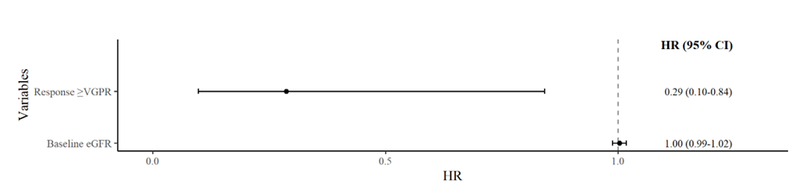
Events. 18, Global p-value (Log-Rank). 0.039750475
AIC. 104.08, Concordance Index. 0.69

Abbreviations: CI, confidence interval; eGFR, estimated glomerular filtration rate; HR, hazard ratio; VGPR, very good partial response.

Figure S2. Multivariate analysis for PFS in the subgroup of patients with AL amyloidosis-MGRS
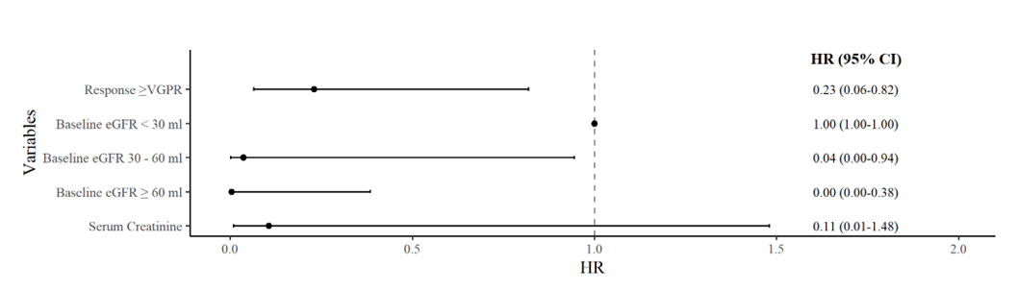
Events. 13, Global p-value (Log-Rank). 0.0068727731
AIC. 68.36, Concordance Index. 0.77

Abbreviations: CI, confidence interval; eGFR, estimated glomerular filtration rate; HR, hazard ratio; VGPR, very good partial response.

